University of Wales Trinity Saint David
PGCert Teaching in Higher Education
Teaching in Higher Education 1 (UNHE7005)
Matthew Peake (1503893)

Table of Contents:
Statement on Teaching and Learning | 3
Micro-Teaching Session with Reflection | 6
Reflective Report | 9
Teaching Observations | 18
CPD Reflections | 21
References | 27
Confirmation of Teaching Hours | 29
Appendices | 30
Statement on Teaching and Learning
I am Matthew Peake and I started working at the London campus of the University of Wales Trinity Saint David (UWTSD) in January 2018. I was initially hired as a Student Services Assistant, however, in June 2018 I was promoted to Student Services Officer. In March 2020, I was promoted to the role of Senior Student Experience Officer. I am also studying a part-time and distance learning masters in Bilingualism and Multilingualism through the Carmarthen campus of UWTSD.

The London campus of UWTSD has been operational since March 2012 with its original site in Islington. However, in October 2013 it relocated to Kennington Business Park in Oval. In February 2019, the London campus opened a second site in Holborn. As of February 2020, the London campus has over 2,000 students studying a range of Accounting, Computing and Business Management courses. The London campus of UWTSD has three intakes per year: February, June, and October. Each term consists of a 10-week teaching period, 2-week assessment period and then a term break. The academic staff mainly consist of hourly paid lecturers with full time lecturers acting as Programme Managers, each managing a portfolio of courses.

During the February 2019 term at the London campus of UWTSD, I began to shadow the hourly-paid lecturers as well as the Programme Manager teaching the Level 4 Certificate in Higher Education (CertHE) Skills for the Workplace programme in order to learn more about teaching & learning for professional development. In June 2019 with the acceptance of the Executive Dean & Head of London campus as well as the Programme Manager of the CertHE Skills for the Workplace (Health & Social Care) programme, I began to teach on the Academic & Employability Skills module. Within the CertHE Skills for the Workplace (Health & Social Care) programme there are six modules. Four modules are taught in Terms 1 and 2. These are:
- Academic & Employability Skills
- Digital Skills & Research Methods
- Professional Career Development
- Effective Team Working & Communication

There are a further two modules taught in Term 3. These are:
- Problem Solving & Decision Making
- Psychology for Health & Social Care
The CertHE Skills for the Workplace and CertHE Skills for the Workplace (Health & Social Care) programmes are more or less identical programmes with the exception two modules; Managing Enterprise in the 21st Century which is taught on the CertHE Skills for the Workplace programme and Psychology for Health & Social Care which is taught on the CertHE Skills for the Workplace (Health & Social Care) programme. Given my experience working with students for over two years, I believed teaching on the Certificate of Higher Education Skills for the Workplace (Health & Social Care) would be the best place to develop my teaching & learning skills.
According to the UWTSD London website, the entry criteria for CertHE Skills for the Workplace (Health & Social Care) programme is as follows; “we are interested in creative people that demonstrate a strong commitment to their chosen subject area and therefore we welcome applications from individuals from a wide range of backgrounds. The applicants will have to pass the written test and the interview with one of our academics in order to be accepted onto the programme” (Uwtsd.ac.uk, 2018). Given that there is no need for formal qualifications the educational backgrounds of the students vary. There are a high number of mature students as well as several traditional students. However, given the nature and content of the course, students already have experience within the subject areas but may not have developed the academic and professional skills associated within each discipline.
As previously mentioned, the students studying this programme are not traditional college leaving students, they are mainly mature students who have life experience but have not developed the academic skills needed in their professional lives. Personally, I was in full time education up until the age of 22. After which I worked and then returned to part time studies in February 2016. Given my educational background, I was able to relate to the students in some respects, but it was a challenge to understand how to incorporate their professional experience with traditional imparting of knowledge. Furthermore, it was a learning curve to deal with people who are confident outside of the lecture hall, but when it comes to the academic setting, their anxiety increases, and their self-esteem diminishes. Therefore, it was key for me to demonstrate that the lecture hall was a safe learning environment and a place of support and guidance, where making mistakes and learning from these mistakes are all part of the learning process. In terms of the educational setting, classes take place within a traditional classroom setting. Given the nature of the programmes, assessments generally take the form of assignments, presentations and/or group work at the end of the teaching period. However, formative feedback is usually given throughout the teaching period for students to gauge their progress.
On Thursday 20th June 2019, I began to teach the Academic & Employability Skills module to two groups of students from the CertHE Skills for the Workplace (Health & Social Care) programme. Group 1 from 9:00 - 11:00 and then Group 2 from 11:15 - 13:15, with each group consisting of around 25 students.

Micro-Teaching Session with Reflection
Introduction to Critical Thinking Skills (link): https://uwtsd.hosted.panopto.com/Panopto/Pages/Viewer.aspx?id=aa13890b-b4ee-4dde-8c6a-aba800c83a2d
Throughout the February 2020 term I was not able to engage in teaching activities, due to short staffing, and being in the process of obtaining a new role. However, I was keen to continue teaching somehow. When we moved to online teaching, I asked the CertHE Skills for the Workplace Programme manager, Sylvia Hoffmann, if there were any topics throughout the Academic & Employability Skills module that she would like me to cover.
I had experience as an online learner before, but I had not participated in online teaching. As a distance learner I have had experience of participating in webinars and listening to video tutorials, but not as the one delivering the material. Sylvia mentioned that “Critical Thinking Skills” could be a good topic, especially with the current COVID-19 pandemic and the spread of false information. Also, the importance of analysing what you read, write, and listen to, and, how this methodical process can be used when producing assignments.
As Sylvia had taught the topic within the teaching period, she already had a PowerPoint presentation prepared, and shared it with me. I had also taught the topic in previous terms within the same Academic & Employability Skills module. However, I did not feel comfortable with using Sylvia’s PowerPoint presentation. In order for me to teach a topic, I need to know that I have a clear understanding of the content, and the best way for me to do this is to create the PowerPoint presentation myself. Therefore, I returned to my original slides and re-worked them, after having taught the module for two terms. After having taught the topic previously, I had a better understanding of what worked and what did not work, however, the challenge now was to amend and consider the presentation for online use. Therefore, I had to use and value appropriate learning technologies.
Given the current pandemic and the students were level 4 students, I was conscious to only introduce the subject material. Furthermore, understanding the personal situations of some students, I wanted to record a video tutorial as I knew some students would struggle if there were to attempt to participate in a live tutorial, therefore respecting individual learners and providing equality of opportunity for learners.
I began to research the topic area and stumbled upon Stella Cottrell’s book “The Study Skills Handbook”. I was familiar with this book as I had previously used it when teaching the same topic previously. It is a useful book for students who are relatively new to higher education. Interestingly, she also had a chapter dedicated to “Critical Thinking Skills”. I was keen to use this resource as the way in which she explained the material was easy to understand and informative. After having read the chapter, I combined my subject knowledge with the understanding of the academic level of the students, therefore, I realised the importance of matching theory with professional experience, using real-life situations. Knowing how students learn, both generally and within their subject area, I knew it was key to combine their professional experience with academic theory.
Given that this was an online tutorial, I had to design and plan learning activities that were concurrent with online delivery. I wanted to make sure that the recording was not too long. If it were too long, I fear I would lose the interest of the student. Furthermore, the aim was not to be a complete guide to critical thinking skills. I wanted the student to be able to take what I had taught them and research into the topic. Therefore, I suggested additional materials for further reading. In essence, I wanted to introduce the topic of critical thinking skills. Through an introductory session, I supported the students’ independent learning and developed an effective learning environment where students were able to learn at their own pace.
As I have previously mentioned I was keen to give as many real-life examples as possible to link the theory and the practical applications, as Jarvis (2004: 94) states that “there can be no learning without experiencing”. Given that English is not the first language for a lot of the students, and understanding the diversity of the learning community as well as in order to promote equality of opportunity for learners, I wanted to make sure that key terminology and expressions were explained.
As a method for evaluating the effectiveness of teaching, before recording the session, I piloted the PowerPoint presentation to a family member who did not know much about the topic to ensure that what I was saying was understood and made sense. This went well and I recorded the session.
Another method for evaluating the effectiveness of teaching, therefore, after having recorded the session, I reflected and noted improvements for the next time I need to deliver an online session. I realised that next time I should slow down and allow for the information to be retrained. Furthermore, to be careful that I spoke clearly so that I was understood.

Reflective Report of Teaching Intervention Cycle
This report presents a teaching intervention cycle that took place at the London campus of the University of Wales Trinity Saint David during the teaching periods of the June 2019 and October 2019 terms. At the London campus of the University of Wales Trinity Saint David (UWTSD), there are three terms per year: February, June, and October. Each term consists of a 10-week teaching period, a 2-week assessment, and a term break. Throughout this report I will be using Gibbs (1998) reflective cycle to help guide my reflection. After having worked within the Higher Education sector for over four years, I am familiar with reflective practice in professional contexts. Additionally, given that I have an undergraduate degree and more recently, a postgraduate master’s degree as well as having worked for the last 10 years within education, I have specialist knowledge relating to academic & employability skills.

Description
In June 2019 I began teaching two groups of students studying the CertHE Skills for the Workplace (Health and Social Care) programme who were in their second term of their programme. Starting in October 2019, I also began teaching another two groups of students studying the CertHE Skills for the Workplace programme who were in their second term. Both programmes shared the same module called “Academic and Employability Skills”. The Academic and Employability Skills module aims to provide the student with the underlying study/research strategies and software skills to facilitate effective study in Higher Education; enable the student to take responsibility for their own learning; enable the student to gain confidence and competence as an effective employee by developing a range of employability skills such as reflection; and time management and presentation skills. Within this module students learn a range of academic and employability skills. Within week 2 of the teaching period, students study the topic ‘CV Writing’. In the June 2019 term, the topic was combined with ‘Job Interviews’, however, in the October 2019 term, the topic was solely focused on ‘CV writing’. The ‘Job Interview’ element was removed as it was felt that the content was covered in another module called “Professional Career Development”.
Feelings
I have only had limited teaching of students before. I had previously tutored a Year 10 student who was studying GCSE Spanish, but this was on a one-to-one basis. Furthermore, throughout my role as a Student Services Officer at the University, I had had experience of imparting knowledge to a large number of people, such as during the students’ registration process and their induction to the London campus. Therefore, I was not too worried about speaking in front of people. However, I was worried about imposter syndrome and the students not taking me seriously as I didn’t want them to think that because I am a member of the professional support staff that I did not have the ability or capability to teach. I overcame these initial fears by making sure that I was fully prepared. This involved taking the previously prepared materials and creating new materials to know exactly what I was about to teach, also making sure that the materials were accurate and up to date.
Prior to teaching the class, I showed my newly created materials to Sylvia Hoffmann (CertHE Skills for the Workplace Programme Manager). She was impressed with what I had created so this gave me additional confidence before teaching the class.
When I came to teach the same topic again in October 2019, given that I had already overcome the initial fears, I was confident to teach using the same materials again and I was happy to find out that Sylvia had continued to use the materials that I had created to teach her own groups. However, as previously mentioned, the ‘Job Interviews’ element of the session was removed so I was slightly hesitant as to how to ensure that the materials prepared would cover the whole session. Yet, Sylvia provided me with additional tasks to carry out throughout the class. She explained that she wanted students to focus more on their writing skills, so we had a task that covered this element.
Evaluation
When I first taught the topic of CV writing class in June 2019, I thought it went well. The feedback from the observation in June can be seen below:
Positive | Negative
Good preparation | Felt a bit rushed
Good knowledge of subject | Allow for information to sink in
Good use of slides/videos | Occasionally too fast
Good that you pointed students to relevant reading in book | More reinforcement needed
Helping out individual students | Instructions could be repeated
Good student-teacher rapport | Try asking more questions
As you can see from the feedback above, Sylvia believed that I had prepared well and had a good knowledge of the subject. This was key to ensure that I overcame the imposter syndrome that I had previously mentioned. Furthermore, Sylvia had mentioned to me that it was good to use videos in order to break up the class so that the students had a different voice to listen to. Furthermore, knowing that students learn in different ways I was conscious to point out that the students had an opportunity to follow up with what was being taught by reading the relevant chapters within the essential reading textbooks for the course. Additionally, knowing that some students struggle more than others, I was aware that I had to go around the class to ensure all students were engaged and understood what was being taught. Finally, as is the case with adult education, I wanted to make sure that there was a good student-teacher rapport and that the information that I was presenting was of relevance and practical use for the students.
In terms of the negative elements from the June 2019 class, I understand that I felt a bit rushed. This is because I was aware that there was a lot to cover in only 2 hours and I wanted to make sure that we covered everything. However, consequently, by rushing it did not allow for time for students to take in the information as pointed out by Sylvia on the feedback form. She also felt that more reinforcement was needed and to try to ask more questions. Because I was relying heavily on the slides, I didn’t give too much focus on engaging with the students.
When we take a look at the feedback form for the same topic for the October term, we can see a vast difference. The feedback from the observation form in October can be seen below:
Positive | Negative
Good preparation | It is better to ask students to read out their personal statements themselves - builds confidence
Good eliciting examples of skills from students
Clear instructions to students
Positive classroom atmosphere, most students engaged using humour
Many students volunteering to answer exercises
Allowing students to have a go at writing their own personal statements
Providing individual feedback/support to students
As you can see from the feedback above, Sylvia believed that I prepared well. The positive had slightly changed as I was able to elicit examples from students (I had listened to the previous point of asking more questions). Furthermore, I was able to give clear instructions and ensured that there was a positive atmosphere in the classroom which resulted in students volunteering to answer exercises. I allowed students to have a go at writing their own personal statements and continued to provide individual feedback/support to students. The only negative element was reading out a student’s personal statement. Sylvia suggested that it is better for a student to read out their own work in order to build confidence.
Analysis
In reflecting upon my practice as a teacher. It was importance to understand the difference in teaching adults and teaching children. The teaching of adults is very different to that of teaching children. Teaching adults, also known as “andragogy”, is “the art and science of helping adults learn, in contrast to pedagogy [which is] the art and science of teaching children” (Knowles, 1980:43). Andragogy is a term originally coined by German educationalist, Alexander Kapp, in 1833. Andragogy is most associated with the work of Malcolm Knowles. Knowles’ perspective on andragogy, according to Merriam, Caffarella, and Baumgartner (2007) and Forrest and Peterson (2006) (cited in Chan, 2010: 27), is based on six main assumptions:
1. Self-Concept: Adult learners are self-directed, autonomous, and independent.
2. Role of Experience: Repository of an adult’s experience is a rich resource for learning. Adults tend to learn by drawing from their previous experiences.
3. Readiness to Learn: Adults tend to be ready to learn what they believe they need to know.
4. Orientation to Learning: Adults learn for immediate applications rather than for future uses. Their learning orientation is problem-centred, task-oriented, and life-focused.
5. Internal Motivation: Adults are more internally motivated than externally.
6. Need to Know: Adults need to know the value of learning and why they need to learn.
A lot of the students that I taught were either already in employment, have been in employment or are looking for employment and I was very conscious to not try to reinvent the wheel when discussing the topic of CV writing. It should have been a topic that the students were familiar as they would have created or already have produced CVs within their professional lives, as Jarvis (2004: 94) states that “there can be no learning without experiencing”. Understanding how students learn, both generally and within their subject area, therefore, I was keen to ensure that there was a link between the theoretical knowledge that I was sharing with the practical application in terms of creating new CVs. As Knox (1977: 435, quoted in Jarvis, 2004) explains that “adults are more likely to retain information that they receive if it is meaningful to them and they are able to integrate it into the store of knowledge that they already have”. In order to effectively teach about CVs, it was key to elicit experiences of CV writing, as mentioned above that adults tend to learn by drawing from their previous experiences. Additionally, unlike children, adults have a readiness to learn and will be ready to learn what they believe they need to know. As writing CVs is a key part to economic success, this is something that the students need to know. Moreover, in terms of the orientation to learning, adults will see that by learning how to write CVs that this skill can have an immediate application through the action of applying for jobs. Also, they will also realise the value of CV writing and the need to learn it. This is also confirmed by Petty (2009: 512) who states, "learners must see that their efforts to learn have a clear and immediate purpose. They must experience success and get rewards if learning is to be successful". In this sense, the experience of CV writing will provide success in terms of job interviews and the reward will ultimately be financial.
Another issue when teaching adults is the importance of values. As Petty (2009: 513) states that teachers in the lifelong sector value:
- all learners, their progress and development, their learning goals and aspirations and the experience they bring to their learning.
- learning, its potential to benefit people emotionally, intellectually, socially, and economically, and its contribution to community sustainability
- equality, diversity, and inclusion in relation to learners, the workplace, and the community.
- reflection and evaluation of their own practice and their continuing professional development as teachers.
- collaboration with other individuals, groups and/or organisations with a legitimate interest in the progress and development of learners.
Having grown up within a working class town in Essex, as well as having learnt additional language myself at University, I am keen to respect individual learners and diverse learning communities. Moreover, it is important to me to promote participation in higher education and equality of opportunity for learners. As stated above, higher education can provide not only intellectual success, but also emotional, social, and economical. I acknowledge the wider context in which higher education operates and I recognise the implication for professional practice. For students, it is not just about the academic content of the course, it is also important to consider the professional application.
As previously mentioned, I was keen to ensure a safe and supportive learning environment for the students, as Hagenauer and Volet (2014: 379) state when discussing the importance of teacher-student relationships that students “enter university with unclear expectations and relatively high levels of uncertainty and anxiety”. A good teacher-student relationship is key for academic success, and particularly, at-risk students in terms of study retention or drop-out decisions.
One of the feedback suggestions given by Sylvia related to asking students more questions. As Ramsey et al. (1990: 421) state, “academic achievement of students is positively correlated with the number of clear academic questions posited by the teacher”. Therefore, by asking the students more questions, it will help with their academic achievement. Furthermore, that questions asked might be in accordance with one of the six levels of Bloom’s cognitive taxonomy of objectives. According to Krathwohl (2002: 212-213), the objectives within Bloom’s taxonomy are ordered from simple to complex and from concrete to abstract and represented a cumulative hierarchy; that is mastery of each simpler category was prerequisite to mastery of the next more complex one. Therefore, by asking questions, it will allow students to develop their cognitive skills from simple and concrete ideas to a more complex and abstract thinking.
Additionally a positive comment that Sylvia made was in relation to the reference to relevant reading in the module textbook. Given my understanding of how students learn, I was keen to ensure that students were able to process the information in different ways. For example, having an understanding of the VARK inventory meant that I had an awareness of the difference preference modalities such as Visual, Aural, Read/Write, and Kinesthetic (Li et al., 2019 :1067). By understanding the VARK inventory meant that I had an awareness that students preferred to learn in different ways, and therefore, was able to adapt my teaching strategies for effective teaching.
Moreover, as can be seen within the October feedback form, I slowed down and was more conscious of my pace. This aligns with what Jarvis (2004:96) explains when he says that “teachers of adults should provide opportunities during their teaching and learning sessions so that adults have time to begin the process of storing the information that they have gained”.
Conclusion
In conclusion, it is key for adult learning for the subject material to be taught drawing on past experiences. Furthermore, it is also important to design and planning learning activities as well as appropriate and various methods for teaching which are aimed at the level of the academic programme. As stated above, adult learners must know the value of learning and why they need to learn. Furthermore, through understanding how students learn, both generally and within their subject, I was able to effectively evaluate my teaching and support learning by asking questions and providing individual feedback. I believe I developed an effective learning environment with approaches to ensure appropriate student support and guidance through building teacher-student relationships. I continually engaged in continuing professional development incorporating research, scholarship, and the evaluation of my professional practice, using evidence-informed approaches and the outcomes from research. Finally, as Petty (2009) describes above, in alignment with my own values, I respected individual learners and diverse learning communities. I promoted participation in higher education and equality of opportunity for learners. I acknowledge the wider context in which higher education operates whilst recognising the implications for professional practice.
Action Plan
Taking the above into account, in terms of my own development, I will continue to learn how adults learn and to design and plan appropriate learning activities, using learning technologies and methods to evaluate the effectiveness of my teaching. I will also continue to promote equality of opportunity for all learners and will use practical applications of the theoretical knowledge by acknowledging the context in which higher education operates and its implications for professional practice. Finally, as Ramsey et al. (1990: 422) state that "asking successful questions in the classroom is a skill that requires knowledge of questioning techniques, planning and creativity. The art of successful questioning in the classroom can be cultivated through practice". Therefore, I will continue to ask meaningful questions to ensure that students are able to develop their cognitive thinking skills.

Teaching Observations
Appendix A – Observation by me (18/07/2019)
On 18th July 2019, I observed Sylvia Hoffmann (CertHE Skills for the Workplace Programme Manager) deliver two sessions to two groups of Level 4 students. The topic was ‘Introduction to Research Skills’. In the first class there were 16 students and in the second class there were 17. After having obtained two master’s degrees in English and Spanish, Sylvia is well aware of the subject material and has a familiarity with research skills. However, given the level of the students, she used appropriate methods for teaching and learning in the subject and at the level of the academic programme. For example, she used a video that compare research to cooking. English is not Sylvia’s first language, and it is also true of many of the students at the London campus. Knowing this, Sylvia was aware how students learn, both generally and within their subject area and therefore, she ensured that key terms were understood and explained such as literature, hypotheses, studious, and empirical. This shows her respect for individua learners and diverse learning communities as well as the equality of opportunity for learners. Additionally, she used and understood the value of appropriate learning technologies, such as using YouTube videos to help solidify learning. Moreover, through using a video, the students are engaged by hearing a different voice as well as breaking up the flow of the session. Keen to ensure that students were engaged, Sylvia designed and planned learning activities that met the students’ requirements. She used a PowerPoint presentation and encourage pair work and group work, thus developing an effective learning environment. Additionally, Sylvia understood how effective her teaching methods were by using the question and answer technique, not only to engage students, but to show they have understood.

Appendix B – Observation of me (24/10/2019)
On 24th October 2019, I was observed by Sylvia Hoffmann (CertHE Skills for the Workplace Programme Manager) delivering two sessions to two groups of Level 4 students. The topic was ‘CV Writing’. In the first class there were 20 students and in the second class there were 20. Having worked in professional settings for over 7 years, I had experience of writing CVs. Furthermore, through working in various industries, I also knew how to adapt my CV to fit these different industries. However, understanding how students learn, both generally and within their subject area, I know that a key part of learning is through the use of experience, therefore, I also used the students’ experience in order for them to learn more through their peers’ experiences too. I used appropriate methods for teaching and learning in the subject area as well as the level of the academic programme. I did not focus too heavily on academic theories and models, I used personal experience and students’ experience. I used appropriate learning technologies such as a PowerPoint presentation, provided handouts and exercises. I demonstrated the methods for evaluating effective teaching but asking the students to write their own personal statements to demonstrate what they have understood as well as asking lots of questions to get students to think and engage. I provided personal feedback to students through walking around the classroom which respected individual learners. I designed and planned learning activities to engage students as much as possible, for example, eliciting examples of skills from students by referring to the previous lesson. I was keen to demonstrate an effective learning environment, and my approach to students was friendly and I used humour to provide a positive classroom environment. I was commended by Sylvia that my good rapport with students was. one of the strongest elements. A suggested action point was to ask students to read their own personal statement to encourage confidence and therefore provide equality of opportunity for learners.

Appendix C – Observation of me (31/10/2019)
On 31st October 2019, I was observed by Sylvia Hoffmann (CertHE Skills for the Workplace Programme Manager) delivering two sessions to two groups of Level 4 students. The topic was ‘Cover letters’. In the first class there were 20 students and in the second class there were 20. Having worked in professional settings for over 7 years, I had experience of writing cover letters. Furthermore, through working in various industries, I also knew how to adapt my cover letter to fit these different industries. I designed and planned learning activities that were appropriate to the level of the students and their experience. I used appropriate learning technologies such as a PowerPoint presentation, gave out handouts (cover letter example) and organised exercises (write their own cover letter) to help concrete the students’ learning. Through the use of these various activities, I demonstrated respect for individual learners and diverse learning communities. Throughout the use of these learning activities, these were also appropriate methods for teaching and learning. Through understand how students learn, both general and within their subject area, I was keen to provide an additional resource (handout) to the PowerPoint presentation, as the majority of the students speak English as an additional language. I had an awareness of students’ individual needs, but as Sylvia mentioned that I should answer by addressing the whole class as other students may have the same doubts. As Sylvia explained that a variety of learning activities would be welcomed, such as a video. Furthermore, to evaluate the effectiveness of teaching from the last session, I recapped what was learnt in the last session, and summarised at the end of the session. A few action points would be the pace of the presentation within the first group that was a bit slow, and the clarity as it was affect by a falling intonation in the second group. Additionally, given the level of the academic programme, Sylvia suggested that the reinforcement of ideas could be stronger and to use emphasis more as well as the instructions, e.g. time frame, when providing the handouts. Sylvia also suggested to ask students to consider things in pairs before sharing them with the whole class. Sylvia also suggest I could refer the students to the materials and resources Moodle for further learning.

Continuing Professional Development (CPD) Reflections
CPD1
In light of the COVID-19 pandemic, I thought it would be interesting to participate in the AdvanceHE webinar titled ‘Global Perspectives - Igniting a spark: Creativity in higher education’. The webinar was chaired by Kathy Wright with panel members including Dr Gillian Judson (Simon Fraser University), Dr Jesse Stommel (University of Mary Washington) and Dr Chrissi Nerantzi (Manchester Metropolitan University).

The discussion focused on creativity in higher education. There were interesting discussions about the need for collaboration when working creatively. That creativity can be limited in one’s own imagination. However, with the assistance of collaborators, creativity is limitless.

Furthermore, given the current situation, Dr Nerantzi spoke of resourcefulness in times of adversity. Dr Judson feared that online classes were to be carbon copies of face-to-face teaching. However, what was discussed was that it is now that academics have the opportunity to be more creative in terms of their teaching and how to engage with students.

Dr Judson made a very interesting point that for many students at the moment, not much learning will be taking place. Students will be anxious and stressed while their routine lives have been reassembled. Therefore, a key element at the moment in terms of teaching should focus on the students’ wellbeing in terms of their emotional and mental health. It is important to respect individual learners and the diverse communities in which they exist. She also made a comment that learning takes place within emotional engagement. Understanding how students learn, both generally and within their subject, Dr Judson mentioned that teaching should be viewed as storytelling.
Creativity can be found in the designing and planning of learning activities, especially in terms of how the subject material is handled. There may be more effective methods to teach, more opportunities for students to learn or to support their learning. Additionally, Dr Stommel was arguing the need to remove standardised testing and highlighted the difference between assessment and grading. Assessments, he explained, take place on a daily basis. He used the analogy of a baby making an assessment when they walk; assessing the firmness of the floor when they walk. Following this, creativity is key when assessing and giving feedback to learners. As we are all aware that students learn in various ways and their motivations will be different. Creativity is most important in developing effective learning environments and approaches to student support and guidance. Learning can truly only take place when students are in a comfortable and engaging environment. Being creative with space for example is an easy way to change student behaviour. Finally, within the current pandemic, the ability to think creatively when using online learning technologies is crucial as well as a way to evaluate the effectiveness of teaching as a way to respect individual learners' circumstances and diverse learning communities.
CPD2
When researching potential opportunities for CPD events, I knew that FutureLearn would be a good place to start. FutureLearn is a private company jointly owned by The Open University and The SEEK Group. FutureLearn is a website that hosts many MOOC (Massive open online course) courses that are created by various educational institutions and agencies. It is a great place for teachers to engage in continuing professional development in terms of their pedagogy, where the online courses incorporate research, scholarship and the reflection/evaluation of professional practice.

When searching through the courses, I found a course developed by the University of York called ‘Returning to Education as a Mature Student’. Having first-hand experience of working with mature students, I thought this would be an interesting course to participate in. Throughout the course the following topics were explored: the history of mature learners and who they are now; what is involved in making the decision to return to education; the range of support systems available to mature learners such as finance, child care, mature learning networks, academic development skills; as well as what a mature learner may need to succeed in the learning environment.

The course was interesting as according to the British Government, any person over the age of 19 is a mature learner. Furthermore, the course explained that the modern concept of a mature learner is linked to the theory of Andragogy (leader of Man) as a response to the theory of ‘pedagogy’ from the Greek word ‘to lead a child’, which was first noted in the 7th century when monasteries established schools for children (Knowles, 1973). Andragogy was originally described by a German educator called Kapp in 1833 and promoted as a theory of adult education by Rosenstock-Huessy (1888-1973). However, it was Malcolm Knowles (1913-1997), who is perhaps most recognised for the term Andragogy. Andragogy asserts that adult learners are based on the six assumptions of:
1) The need to know: why do I need to know this?
2) Self-concept: levels of maturity and independence.
3) Adult learner experience: accumulation of knowledge and experience becomes a reservoir of resource.
4) Readiness to learn: a focus on developmental tasks. Instructions should be timely and relevant.
5) Orientation to learning: learning is focused on problem centeredness. Learning needs to be contextualised.
6) Motivation to learning: learning becomes internally motivated, must be worthwhile, self-satisfying, enjoyable and have an element of choice for the learner.
When I first heard about Knowles’ six assumptions, I began reflecting on the students that I’ve taught. When mature students, I was keen to ensure that the students knew the importance of what they were about to learn and what they have learnt could be used instantaneously for economic success.
Through this understanding of what mature students go through when they return to education, I was able to design and planning learning activities using appropriate methods for teaching and learning as well as using appropriate learning technologies. I was also able to evaluate my own teaching through informal verbal feedback.
Continuing on, Delors (1996: 11-12) proposed four ‘pillars’ of lifelong learning as we understand it today, or what he called ‘life-wide learning’:
- Learning to know (knowledge and understanding)
- Learning to do (skills and capabilities)
- Learning to live together (social cohesion)
- Learning to be (self-realisation and fulfillment)
Through understanding more about andragogy and how/why adult learner learns, I am able to respect individual learners, their learning communities as well as the equality of opportunity for learners. I was able to promote the importance of higher education as means to not only know, but to do, live and be.
CPD3
When researching potential opportunities for CPD events, I also came across another interesting course hosted through the FutureLearn website. Given the current COVID-19 pandemic and being experts in online teaching, FutureLearn created a course entitled “How to Teach Online: Providing Continuity for Students”. As the lockdown for the pandemic took place during the middle of the February 2020 teaching period, the London campus had to quickly move to online teaching. Therefore, I thought this course would be perfect to give me an insight into how to teach online and ensure that there was an element of continuity for our students.

An interesting concept that I have learnt is that of Pecha Kucha. A technique where when giving a presentation “the presenter has to follow a ‘20-20’ rule in that he or she is only allowed to present 20 slides and can only talk about each slide for 20 seconds before the slide automatically changes to the next one” (Husemann, 2016). By learning about alternative methods of presenting, it helped develop an effective learning environment where students are more engaged. Moreover, through the use of appropriate learning technologies to assist with these alternative methods, I am able to design and plan appropriate additional methods for teaching.

Through learning about how to teach online in a short period of time, there was a focus on the importance of designing and planning learning activities and/or programmes of study, then teaching and/or supporting learning and finally assessing and giving feedback to learners. In essence, online teaching is about developing effective learning environments and approaches student support and guidance where students feel comfortable. Additionally, engaging in continuing professional development in subjects/disciplines and pedagogy, incorporating research, scholarship, and the evaluation of professional practices, can assist in my development as an online teacher, especially with new software such as Microsoft Teams. The course demonstrated the use and value of appropriate learning technologies; especially when respecting individual learners and diverse learning communities as well as promoting participation in higher education and equality of opportunity for learners. The course helped me to understand the necessity to develop appropriate methods for teaching, learning, and assessing in the subject area and at the level of the academic programme. Not all students will be able to interact and engage with online learning and it is important to find appropriate methods that engages students with different levels of digital skills. Finally, what is important in online teaching, is the methods used for evaluation of the effectiveness of teaching. It is important to be able to reflect upon how a teaching session went in order to ensure that students are engaged and fully supported.

References
Statement on Teaching and Learning
Uwtsdlondon.ac.uk (2018). Certificate of Higher Education in Skills for the Workplace (Health & Social Care) [online]. Available at: https://www.uwtsdlondon.ac.uk/Programmes-of-Study/Certificate-of-Higher-Education-in-Skills-for-the-Workplace-Health--Social-Care/ (Accessed 8th May 2020)
Micro-Teaching Session with Reflection
Jarvis, P. (2004). Adult education and lifelong learning: theory and practice. London: Routledge Falmer.
Reflective Report
Chan, S. (2010). ‘Applications of Andragogy in Multi-Disciplined Teaching and Learning’, Journal of Adult Education, 39(2), pp. 25 – 35.
Hagenauer, G. and Volet, S.E. (2014) ‘Teacher-student relationship at university: an important yet under-researched field’, Oxford Review of Education, 40(3), pp. 370 – 388.
Jarvis, P. (2004). Adult education and lifelong learning: theory and practice. London: Routledge Falmer.
Krathwohl, D.R. (2002) 'A Revision of Bloom's Taxonomy: An Overview', Theory Into Practice, 41(4), pp. 212 - 219.
Li, J., Han, S., and Fu, S. (2019) ‘Exploring the relationship between students’ learning styles and learning outcome in engineering laboratory education’, Journal of Further and Higher Education, 43(8), pp. 1064 – 1078.
Petty, G. (2009). Teaching Today: A Practical Guide. 4th edn. Cheltenham: Nelson Thornes.
Ramsey, I., Gabbard, C., Clawson, K., Lee, L., and Henson, K.T. (1990) 'Questioning: An Effective Teaching Method', The Clearing House, 63(9), pp. 420-422.
Teaching Observations
CPD Reflections
Delors, J. (1996) Learning: The treasure within. International Commission on Education for the Twenty First Century
Knowles, M.S. (1973). The adult learner: A neglected species. Houston: Gulf Publishing Company.
Husemann, K. (2016) "Pecha What?" Exploring Pecha Kucha as Formative Assessment. [online]. Available at: https://intranet.royalholloway.ac.uk/staff/teaching/teaching-learning/pecha-what-exploring-pecha-kucha-as-formative-assessment.aspx (Accessed 25 April 2020)
Confirmation of Teaching Hours
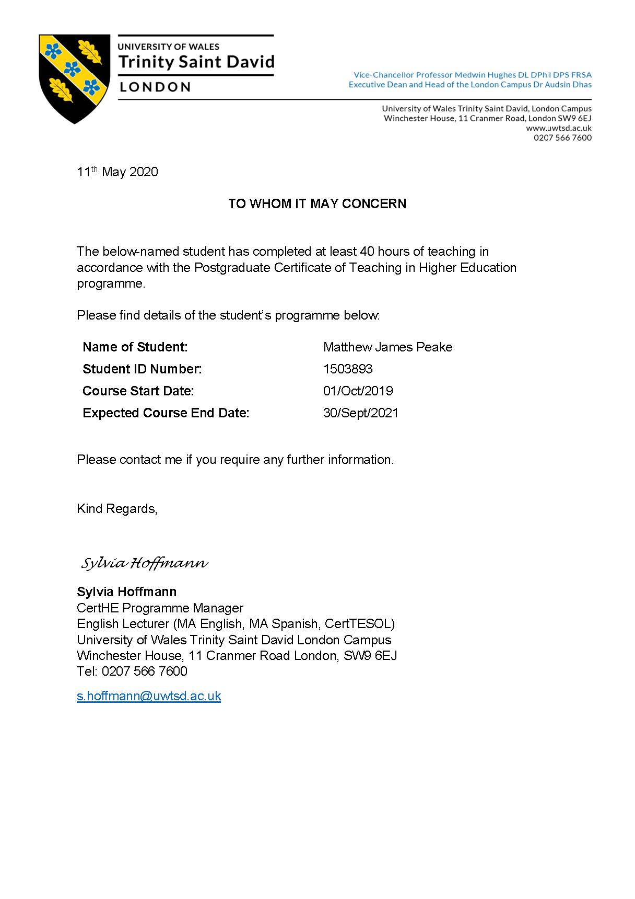
Appendix A – Observation by me (18/07/2019)
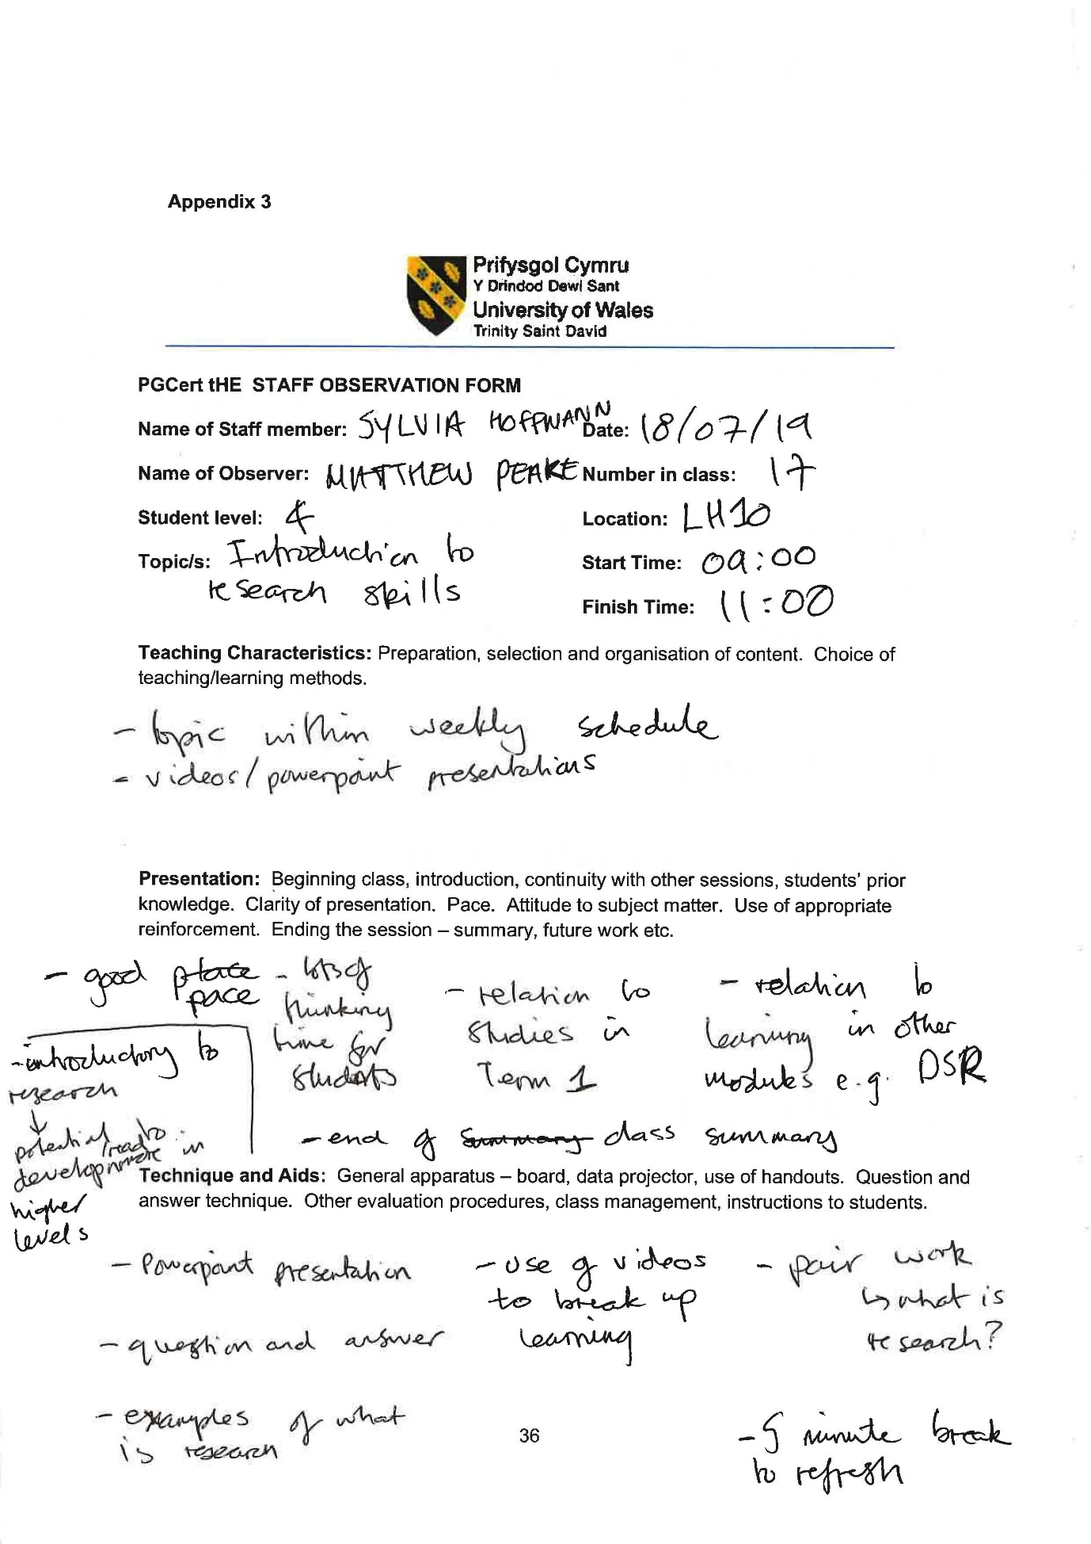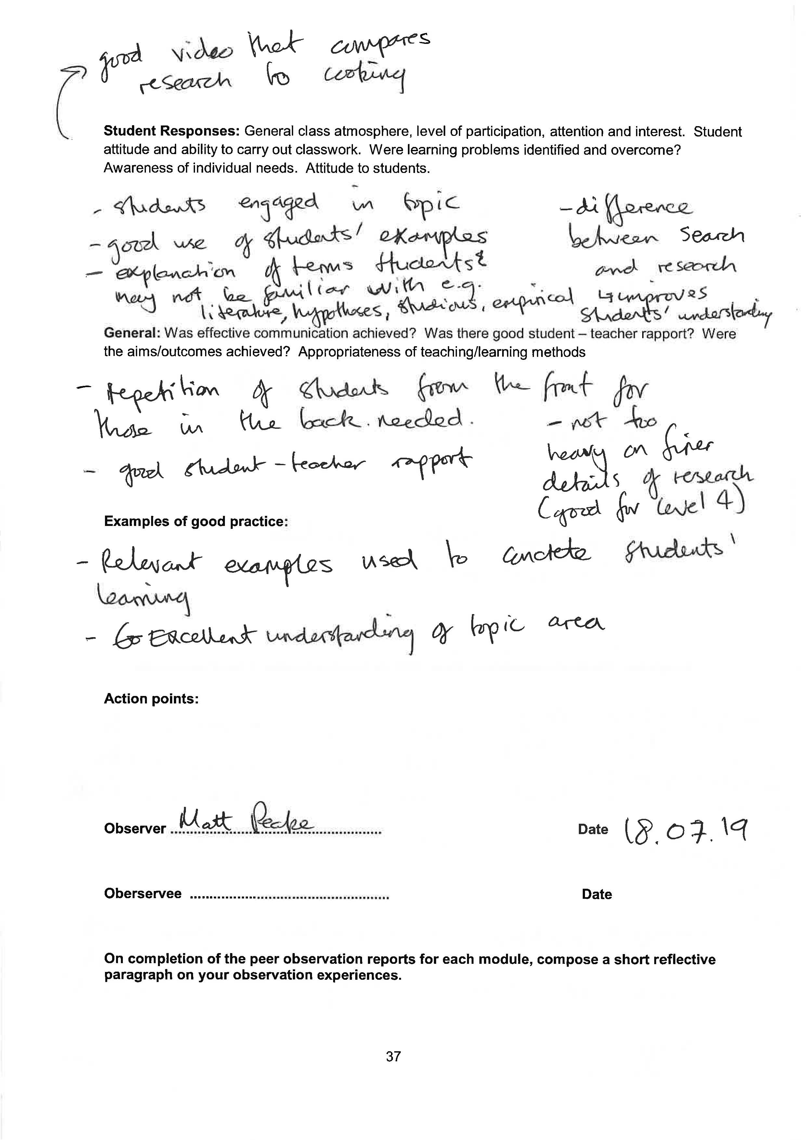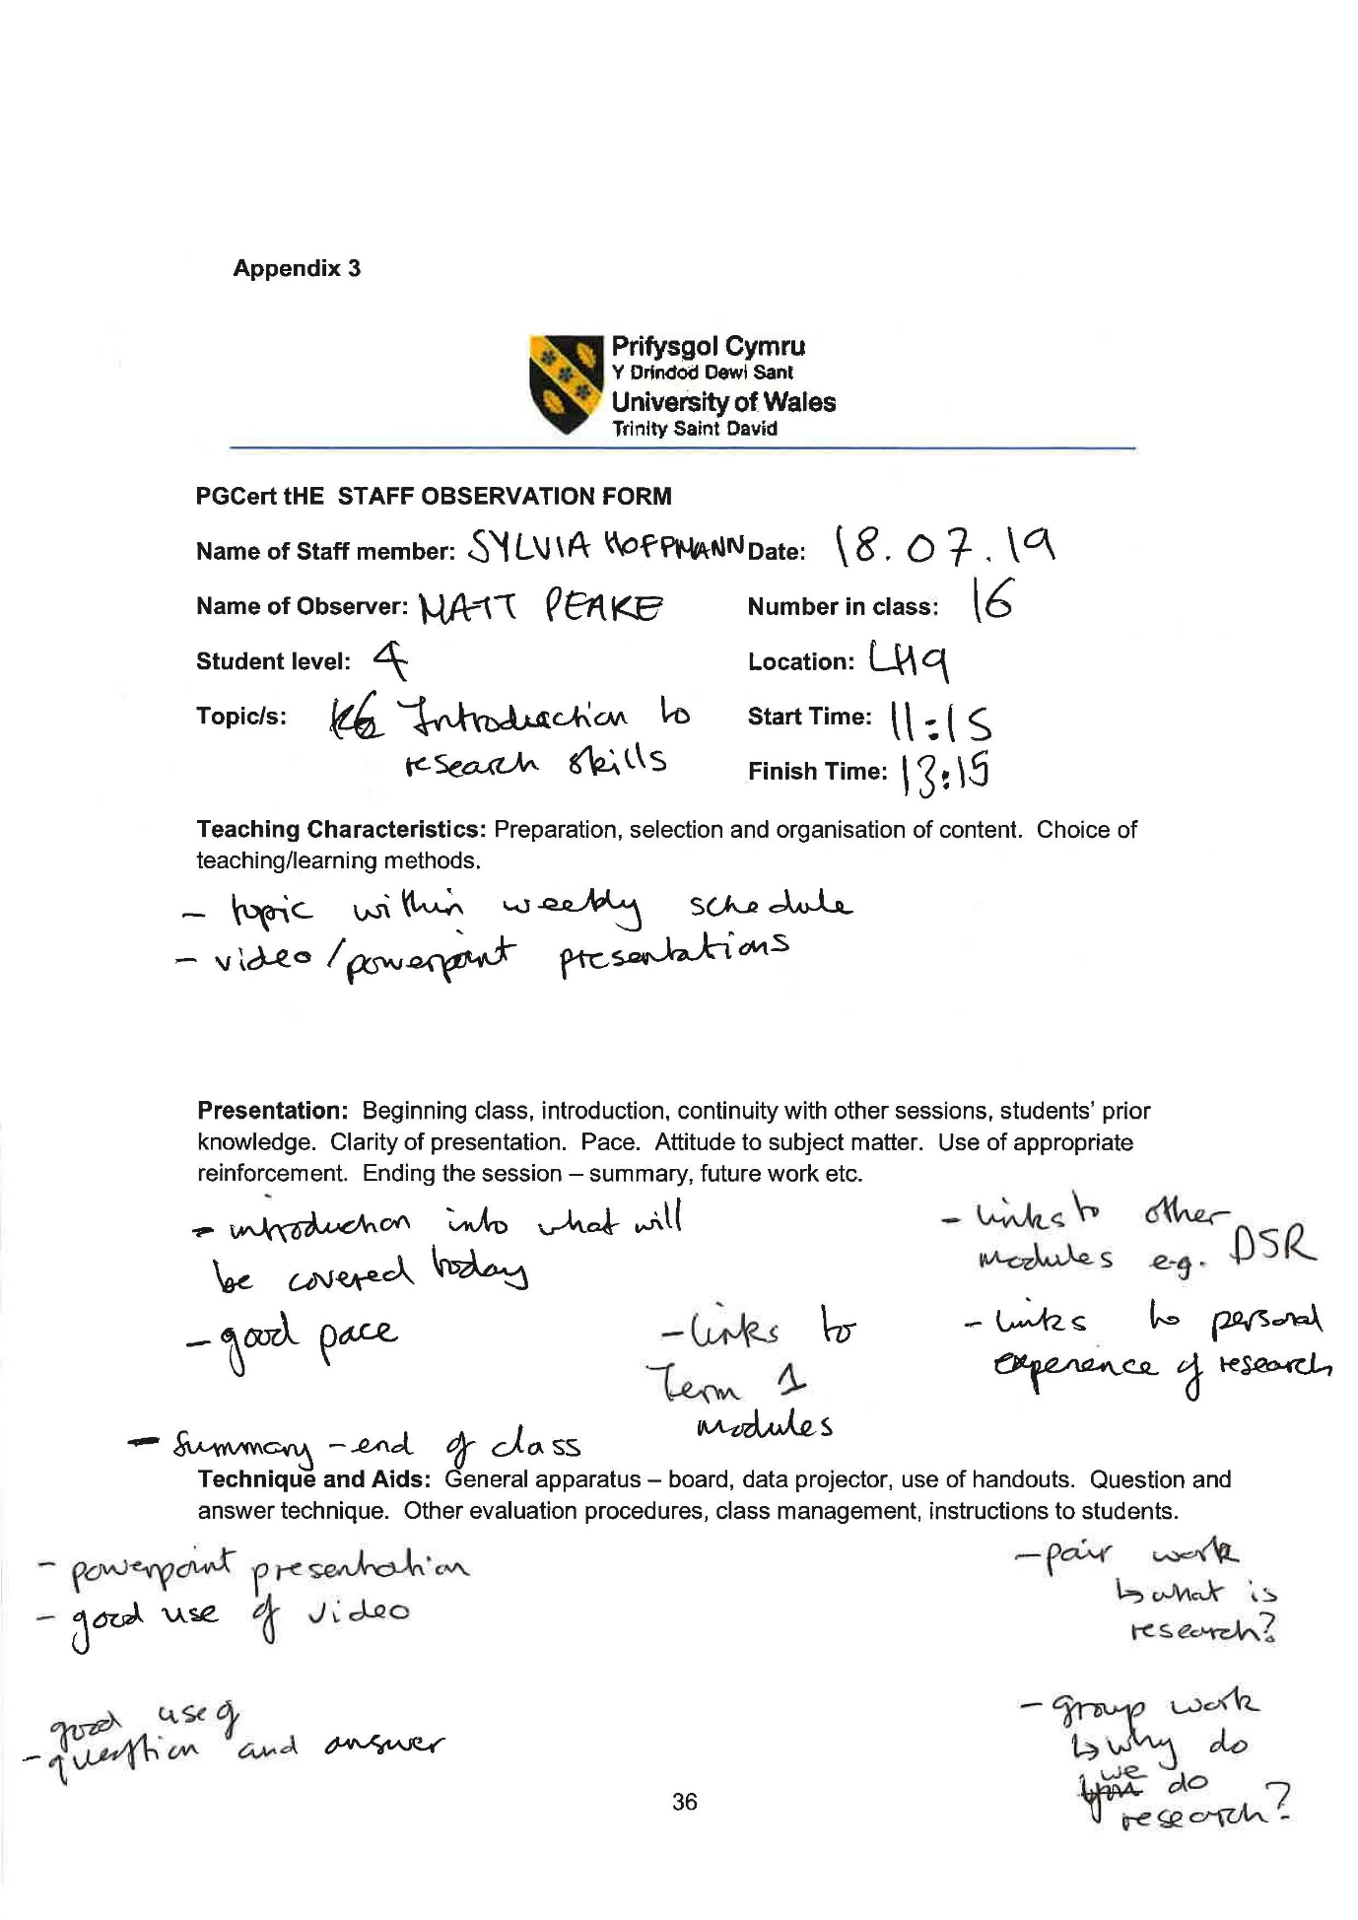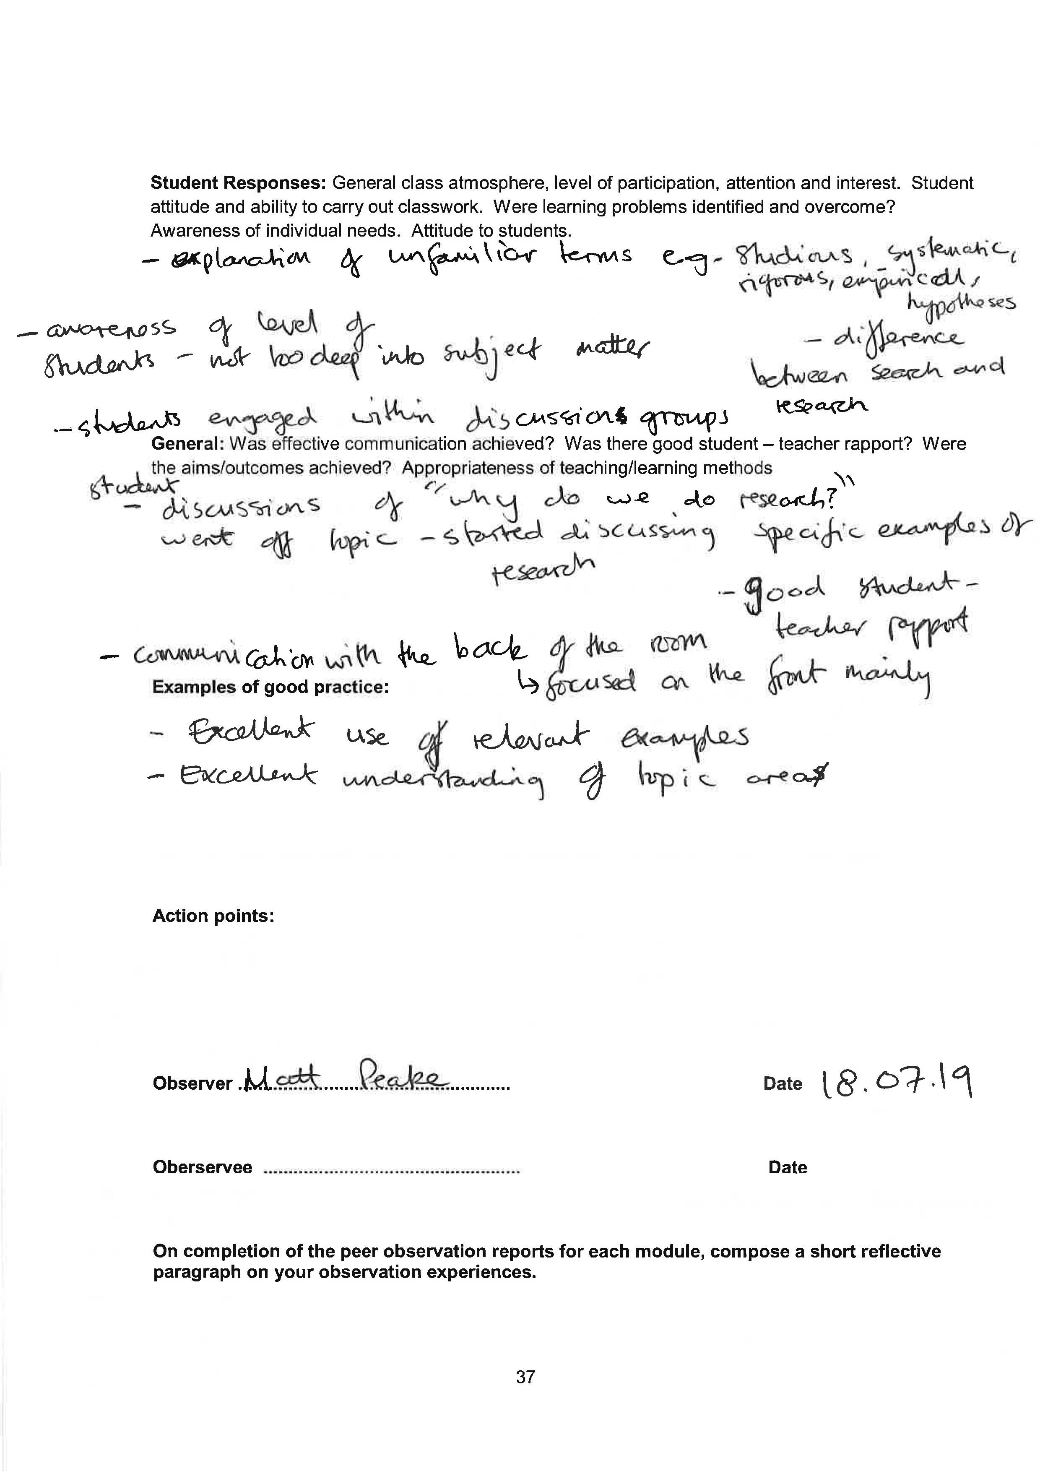
Appendix B – Observation of me (24/10/2019)
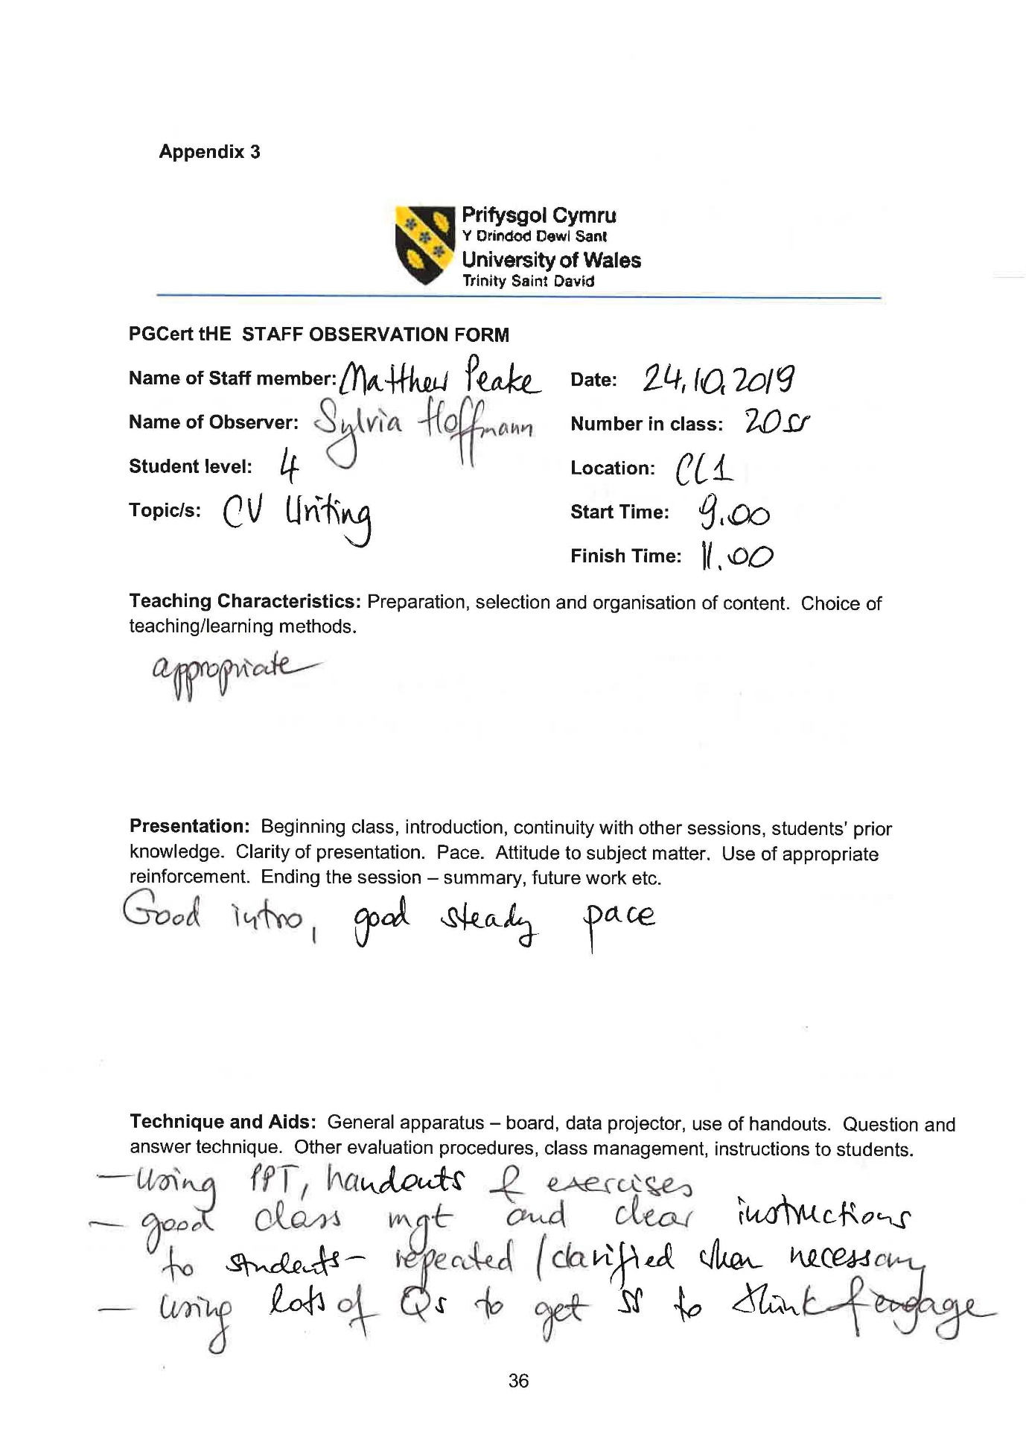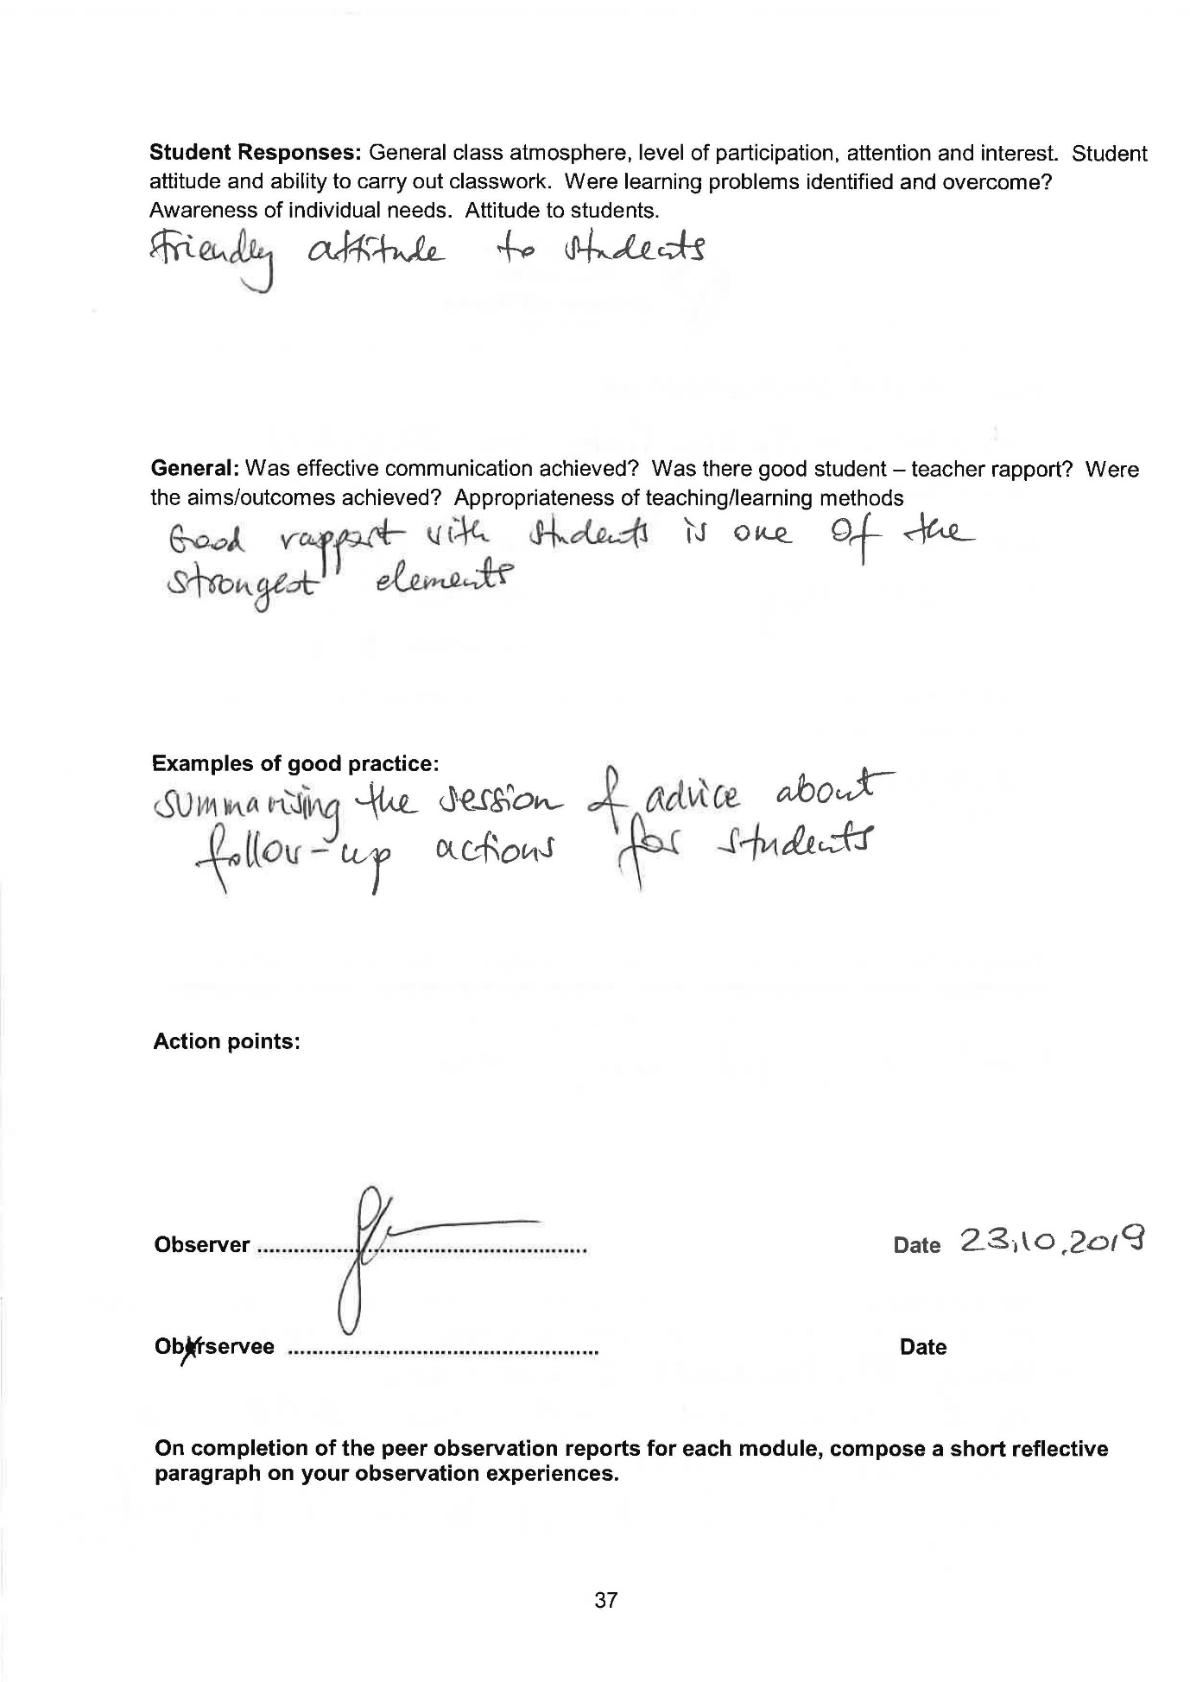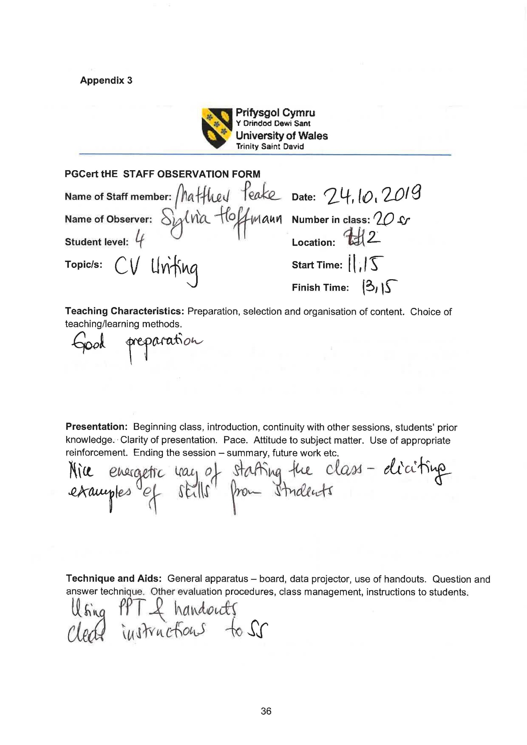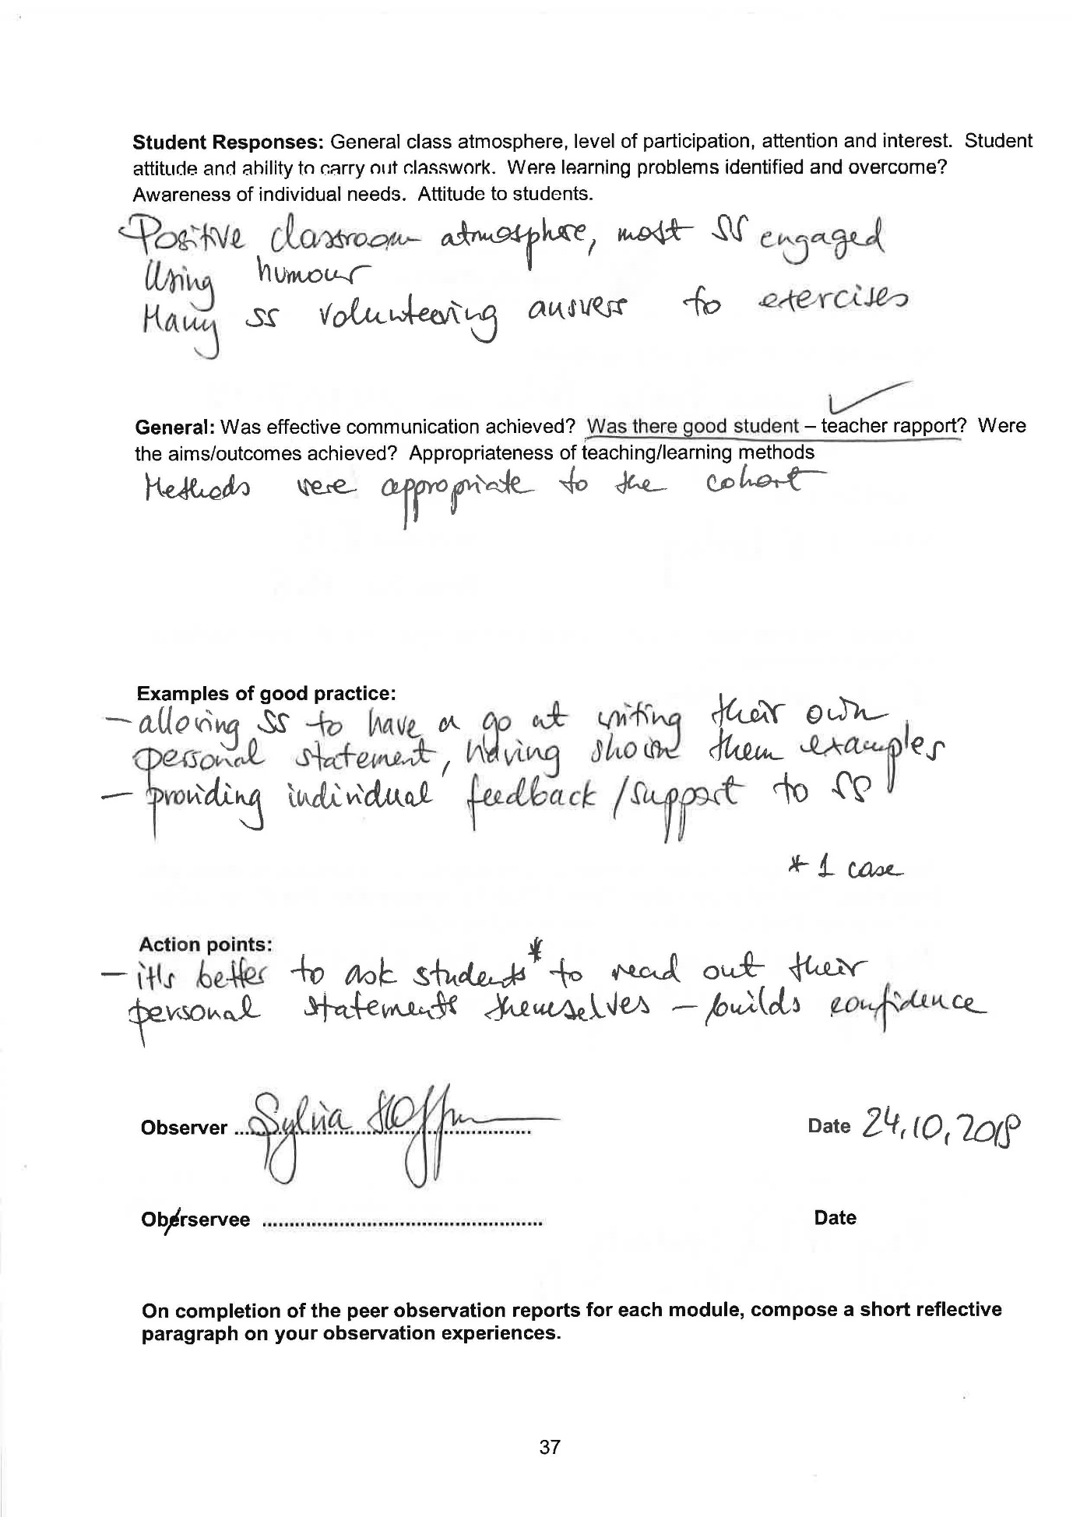
Appendix C – Observation of me (31/10/2019)
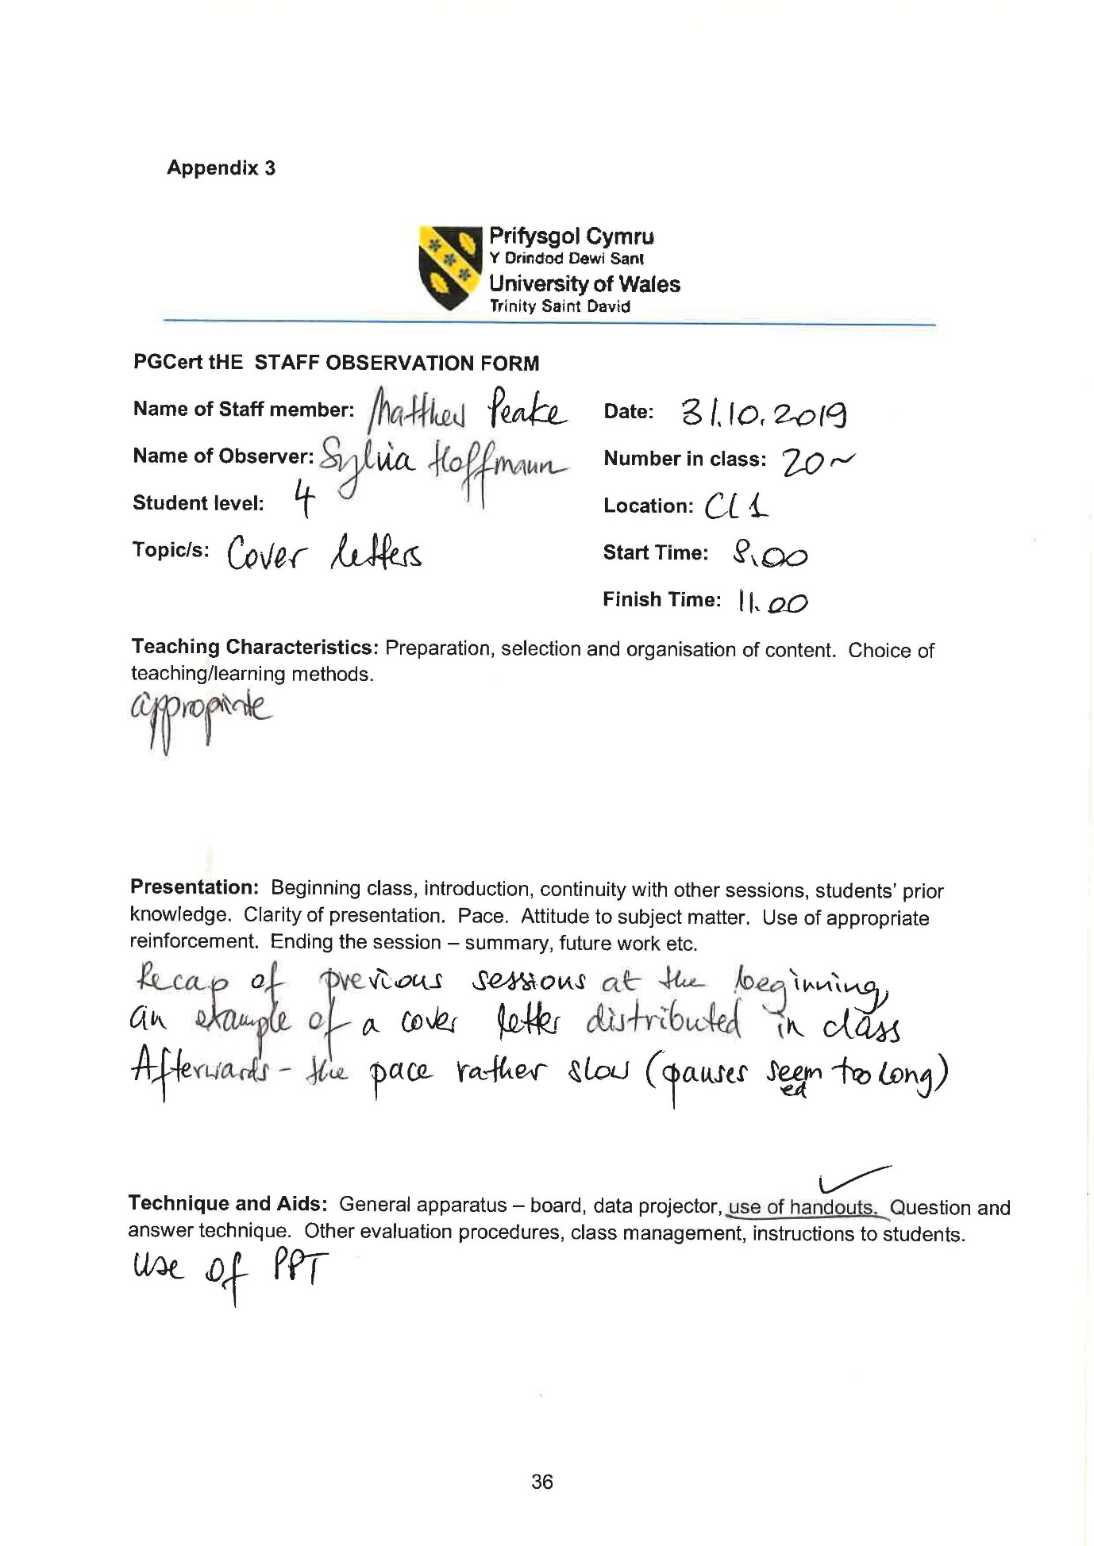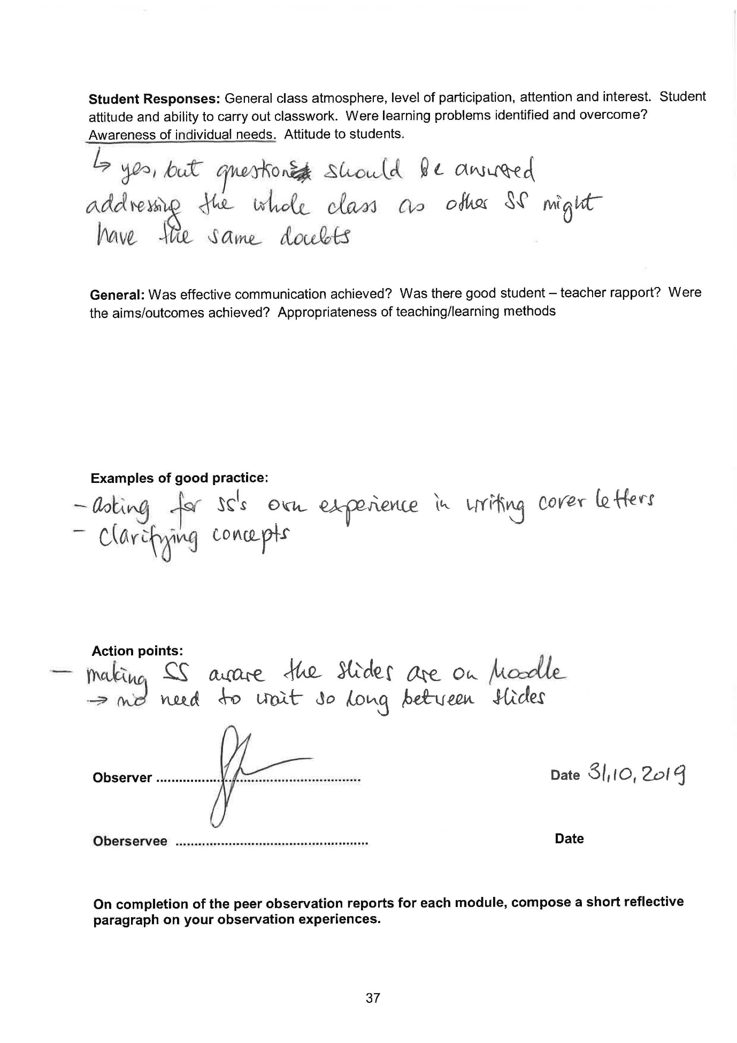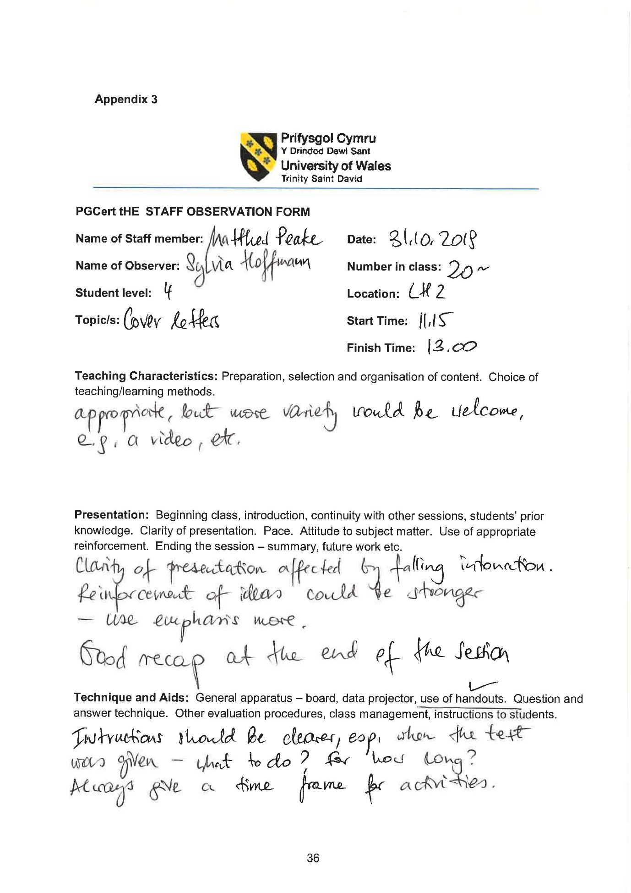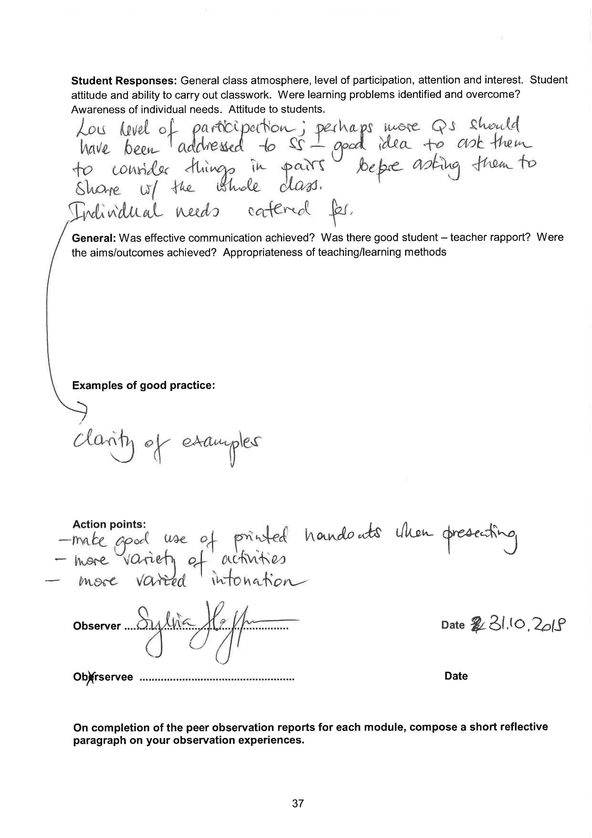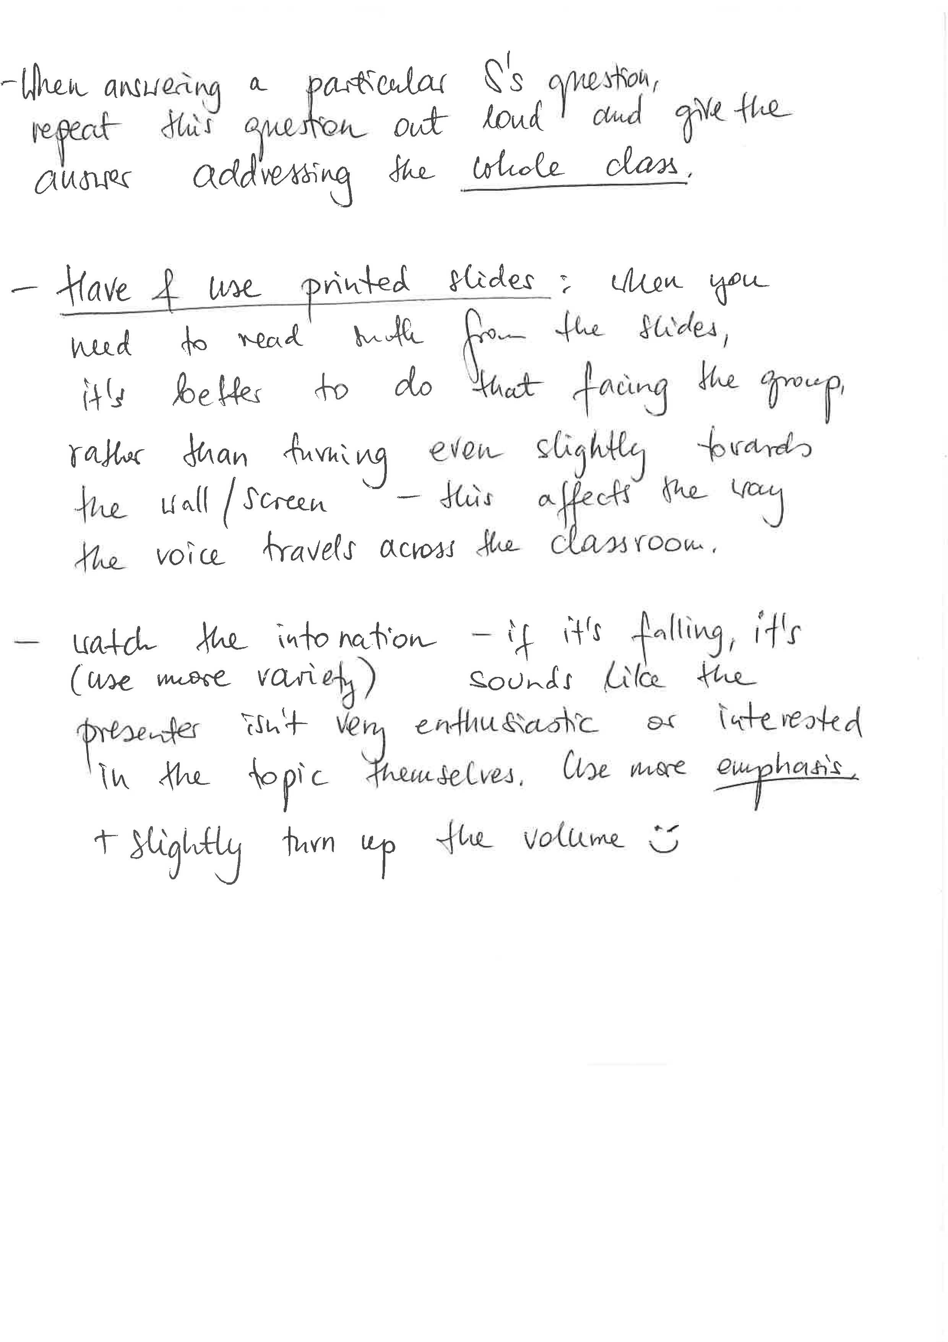
(Additional feedback from class observation – 31st October 2019 – 11:15 – 13:00)

