BEng (Hons) Engineering Portfolio
Quality Tools and Root Cause Analysis
L4 – Quality & Business Improvements
Introduction
Being brought into a manufacturing company as a consultant process improvement engineer to analyse the production of the base for a free standing pillar drill (figure 1). The component is produced using a sand casting process this is when a patten is created. The patterns created in this instance is the base, once this is created it is placed into a high temperature heat resistance refractory material to mould to the shape of the end product. Once the mould i
Defect data (Figure 2)
Worker | Surface finish | Defective finish | Blow hole | Improper shape | Others
A | 26 | 0 | 16 | 5 | 0
B | 48 | 0 | 17 | 8 | 0
C | 24 | 2 | 3 | 2 | 2
D | 26 | 4 | 6 | 5 | 2
s created the hot metal is poured into the mould and then left to cool. Following this casting is cut out and then finished e.g. grinding and polishing. Finally the top mounting holes and top surface main tube holes are machined using a vertical milling machine. There are two foundry workers and two machinists within this operation. Dave Olsen, marketing.metaltek.com [1]

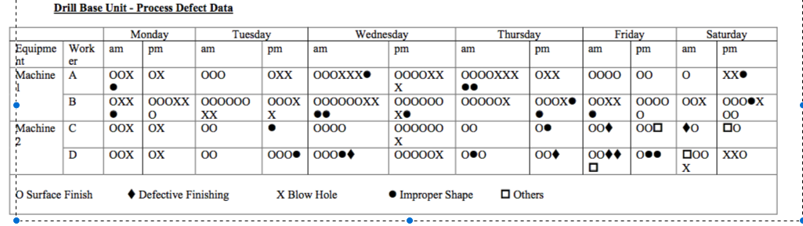
(figure 1)

Using the data set in (figure 1) I have re arranged the data (figure 2). Viewing this data shows there is a clear view with ‘surface finish’ that worker ‘B’ has created a lot more errors compared to workers ‘A’ ‘D’ and ‘C’ this shows incompetency or a lack of care in work believing that all machines are maintained well. The data shows defective finish only occurs during the vertical milling machine process. The most blow holes occur in the sand-cast process itself this could be because the environment that it is created in or the equipment itself. An example could be due to filling, as when filling, the fluidity of the metal will change when pouring and if slower then it will cool quicker causing things such as blow holes. Another part to the data is improper shape this shows slightly in the data with worker ‘B’ being the greatest contributor to this problem. On Wednesday am and pm we see a higher amount of defects than we do any other day of the week (figure 1). An assumption could be the workers are working extra hours on certain days of the week and they are tired. They could also be going out on a Tuesday night down the pub which would have an effect on Wednesday when the workers are in and then return to normal on a Thursday. The final part the data included is others these are other miscellaneous issues that occur but happen that are not listed in the data set.
Darsha" Dhanani, academia.edu [2]

Using the defect data provided the tools that can be applied in a Pareto chart to highlight types to aid discussion. The flow of the chart can indicate on the most significant failure types, we can then analyse the data and provide a frequency within the chart of the percentage. We should also look to see if the tool ‘5why’s’ could be added to see if there is a benefit within the system. This should allow us to determine why it could have defects in the process in specific areas. The last tool I will be using will be the fishbone diagram because this will help find the imperfections throughout the process and all the variations defects and failures. A focus will be directed to the surface finish because this is the largest failure type according to the table. With these tools will determine a prioritised corrective action plan to improve the process and reduce the risk of continued defects can be formulated.
Sonia Pearson, tallyfy.co.uk [3]

asq.org [4]

Tool 1

A pareto can help analyse what problems need attention first from left to right, it can also can show the cumulative effect. Creating this graph from the data set shows numerous defects within the process of operation 1. As seen the graph shows the highest frequency on the left with it lowering to the right. The percentage line then shows the worst 20%. In this chart surface finish is the worst with blow holes second. The frequency of this chart shows surface finish with 74 which is the highest defect. Blow holes is the second worst defect with a frequency of 33. Thirdly there is improper shape with 13. Defective finishing and others at 0. With these the best to try and improve would be surface finish. Because we have used this tool it has clearly shown the worst in the frequency chart. The next part which the graph shows is the percentage line which the lowest is surface finish at 62% and blow holes at 89% again this gives us another indication that it is these that need improving and investing to ascertain why this is the cause on machine 1 because improper shape defective finish. There could be numerous of that can be changed when these defects causes are understood.
“The surface finish for ferrous casts delivered by this process usually exceeds 125 RMS.”
As said in this web link/quote there is issues with the surface finish of the sand casting process and exceeds the roughness limit. Taking this into consideration we must find out why this is causing the worst defect on our process in operation 1 and help our workers achieve the best finish.
chinasavvy.com [5]

During Operation 2 the main defect is again surface finish again. The largest is surface finish with 50. The second highest is blow holes with 9. The third is Improper shape at 7. With defective finishing picking up 6. 4 Other defects also. The line graph does increase slowly with surface finish with 50%. Then blow holes with 67%, improper shape 81%, defective finishing 92% and other with 100%. This shows a close frequency all elements but again the issues that need to be addressed are surface finish and blow holes.
After looking at both charts for operation 1 there is a clear indication that surface finishing and blow holes need addressing. Assuming that these defects have come from operation 1 they could be carrying over to operation 2 and not checking in-between and therefore carrying the base through the whole process without being checked to make sure that it is up to standard. This can also show lack of care in the making of these as the figures are so high. We can use other tools to help us find the answers and to see if we can produce less defects over the upcoming weeks by taking more care in the process.

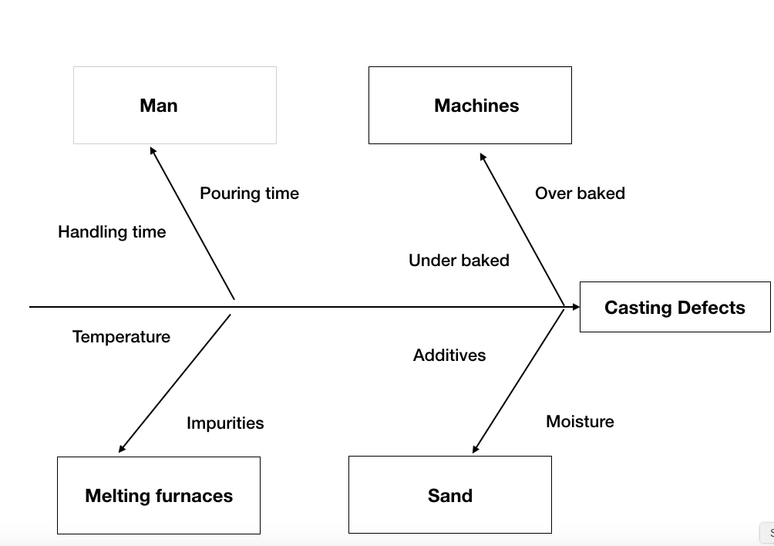
Tool 2

Following on from the Pareto tool, using the fishbone diagram tool we are able to pick out imperfections within the process whilst auditing the process and seeing how things are carried out. From the process there were imperfections picked up. The main imperfections that were picked up were the manning, within these there were 2 things, the handling time of the cast. Also the pouring time. The machines used in operation 1 noticed that the temperatures were either aimed to high or too low this caused defects within the casting process. Another was the furnaces these cause impurities and the temperature was not always correct there was a fluctuation. The sand that the company is using could be causing an effect overall on the process this could be the additives within the sand or moisture within also. This tool has allowed us to sort sections of the process and seek out the issues that are coming from these that we can work on and improve this has proven to be a very good useful tool to help us towards our improvements.

Tool 3
The final tool is the ‘5 why’s’ this tool will allow us to get the closest to the root cause of a particular defect by answering ‘why’ 5 times. This can allow the causes defects to be highlighted and then improved on. The problem is our surface finishing is very poor compared to other defects.
Why?
The surface finish is 172 overall between both operations
Why?
Machine 2 was down for maintenance.
Why?
It was not performing very well.
Why?
It had been used for a long period of time without maintenance
Why?
The parts were not ordered there were no parts to replace on maintenance.

This identifies the problem and clarified what had happened over the past week. Now that we know this we can take this away and resolve the issue. This tool allows us to dig deeper into the problem and ask why it happened or allow reasoning for these issues. As we can see there is a clear view that the machines were at fault. Knowing this we can assume that the machines are not maintained to a high enough standard to correct this flaw in the process. A plan needs to be created for this. Even though creating the base is the main part to the process we must also ensure that the maintenance and all the components, men, time that is put into to create the base is monitored to produce work to the companies highest standard at all times.

Action plan
Action Plan
Action | responsible | priority | start | end
Goal 1: working hours
standard Same hours every day | Management | High
order clocking in and out cards | Management | High
use of clocking in and out system | Workers | High
Goal 2 : maintenance plan
Create plan | Management | High
ordering of parts | Engineering | High
weekly maintenance | Engineering | High
Goal 3: Competence
Create standard operating procedures | Workers/Management | High
assessments/evidence of task | Workers | Medium

Conclusion
After looking into the defects that were found from the tools that were used. We are now able to create an action plan as shown above. This addresses all the items we can use to lower the defects levels. With these in place now and working towards these goals and targets we will hopefully see a lower level of defects. The reason for goal 1 is due to working different hours of the day every day and not a set pattern, with this in place everyone will now work the same hours every day. We will also introduce a clocking systems so that we can monitor work time attendance. Which will hopefully help lower the defects due to not working such prolonged hours. Goal 2 has been set due to the response from the ‘5 why’ exercise that was created where root cause was the maintenance on the machines. With a lack of maintenance a higher amount of defects will be seen on the bases created. Within this goal the targets that have been set are to create a plan for the maintenance to be carried out and identify where maintenance will be carried out on which day. The next target is ordering off the parts. There is now a delegated person to order parts as and when required. This allows us to have no waiting times required when needing maintenance on the machines. The final target is that weekly maintenance is carried out this will tie in with the plan and a tick box on the plan to show that maintenance was carried out on. The third and final goal set is competence. This goal has been set due to the differences in number of defects that workers had created. The targets for this are that standard operating procedures are created and they will be created by all the members this will then make sure that everyone is using the equipment the same this will then lower the chance of defects if everyone is using the same method to carry out their process. The second target will be that the workers will provide evidence of the work they have carried out so that they can be assessed on their knowledge of the process, once the process is more known by the workers they will then have a better understanding. This will hopefully allow us to experience less defects.
Reference -
[1]- https://marketing.metaltek.com/smart-blog/what_is_sand_casting_and_how_does_it_work
[2]- https://www.academia.edu/18934752/BLOWHOLE_DEFECT_IN_SAND_CASTING
[3]- https://tallyfy.com/definition-fishbone-diagram/
[4]- https://asq.org/quality-resources/pareto
[5]- https://www.chinasavvy.com/pros-and-cons-of-casting-processes

