Social and Ethical Marketing
Assignment 1
The relevance of ethics within marketing decisions for contemporary business

This Essay aims to explore the role and relevance of ethics within contemporary marketing decisions. Within this essay we will explore contemporary examples of marketing decisions and campaigns and look at the possible bearing that ethics may have had on the decision to run such marketing campaigns.
Marketing is defined as “the science and art of exploring, creating, and delivering value to satisfy the needs of a target market at a profit. Marketing identifies unfulfilled needs and desires. It defines, measures, and quantifies the size of the identified market and the profit potential. It pinpoints which segments the company is capable of serving best and it designs and promotes the appropriate products and services.” (Kotler, 2012)
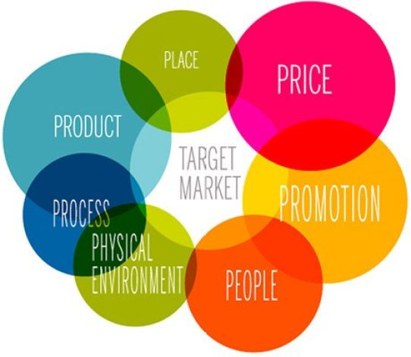
Business2Community.com
Marketing is served by key principles, which have changed and adapted over time to serve changes in attitudes and customer needs and wants, these principles stemming from the original ‘four Ps’ - product, price, place, and promotion; popularised by Neil Borden in the 1950s, the theory has evolved to also encompass people, process and physical evidence. (The 4 Ps of Marketing and How to Use Them in Your Strategy, 2022) – Marketing theory states that should you get all of these factors right, your product should be successful.
Historically, marketing traditionally focused on the product only, and traditional marketing methods included print, broadcasts (television and radio) direct mail and billboards. These methods were designed to reach a target audience but taking the example of a billboard; the business or marketing company could not control who travelled past that billboard, or how relevant the contents of the advertisement would be to that potential customer, there was also no direct way of measuring reach or influence, save asking the customer directly how they discovered the product. (Hardy, 2021)
Contemporary marketing is very different, and with the advancement of technology marketers have been able to refine their methods of reaching their target audiences, both in expanding traditional methods; for example, by moving from generic radio and TV advertising to location/region specific broadcast advertising or by using ‘teaser’ campaigns. (YtC studios, 2020) (made much simpler by the move away from traditional wood/paper signage and the emergence of digital signage and digital billboards)
The real change in contemporary marketing, however, has come with the internet boom, and it is this change in marketing, and the ethics within, that we must explore.
What is ethical marketing?
Since 2015, when all countries of the United Nations adopted the 17 Sustainable Development Goals (SDGs), businesses have had guidance about priorities to end poverty, protect the planet, and endeavour for all people enjoy peace and prosperity by 2030 (United Nations, 2020). Such sustainability-oriented efforts are regarded as ethical ones (Eagle and Dahl, 2015). Increasingly, ethical firms use the SDGs to revise their strategies, suggesting that ethical marketing is important to them, and that they wish to act, and be perceived as ethical businesses.
A company that concentrates only on how their commodities serve customers and gain profits, without considering whether they satisfy social obligations and handle various ethical challenges would be unlikely to be adhering to the UN guidance on ethical business practices. In the below section we will explore some examples of ethical and unethical marketing practices.

Patagonia (do not buy this jacket)
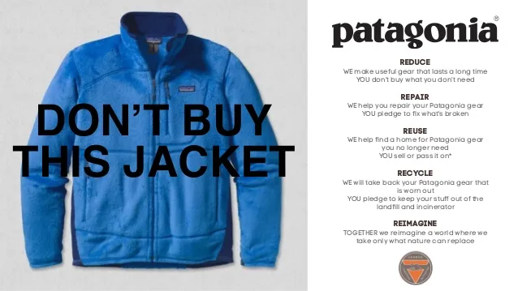
(Patagonia: 2011)
Patagonia, an outdoor clothing company, are widely viewed as a pioneer in corporate environmentalism, (Ventura, n.d.) the company publish all their ethical and sustainable policies on their website, with documents such as their ‘Supply Chain Environmental Responsibility Program’ (Patagonia, 2022) evidencing the high standards they require from their suppliers and manufacturers. Patagonia will only work with environmentally responsible supply chain partners and the company widely advertise their sustainable policies, offering free lifetime repairs on most items sold, as well as a ‘trade in’ policy, where a customer can return a well-worn item for store credit, allowing the company to repair it or reuse the materials, and they offer DIY repair guides on their website to allow customers to repair goods themselves. (Meltzer, 2021)
Patagonia is “in business to save the planet” (company mission statement) and took this a step further in 2019 when they made the (widely publicised) corporate decision that they would no longer supply their goods to or co-brand with companies they view to be ecologically damaging, such as fossil fuel firms. (Cantor, 2019)
In September 2022, the company announced that in a radical change and a first for businesses, the company will transfer 98% of shares to a non-profit organisation, with all sales profit going directly to combating environmental damage, protecting biodiversity and supporting communities, this means the billionaire founder and CEO is no longer a billionaire, but retains control and voting rights, and the company cannot be sold or made public, therefore as long as the company remains successful and profitable, the planet will benefit.
It could be argued that this is very clever marketing, it is undoubtably ethical, as the transparent supply chain and environmental credentials and commitments show, but modern consumers are generally more ethically minded, with ‘mindful consumption’ being the watch words of new generations of shoppers, so Patagonias clever (and environmentally friendly) marketing strategy, including such tactics as publicly denouncing the US government when national parks were threatened (nytimes.com, 2018) may have gone a long way in garnering support from this new brand of eco-shopper, while profit figures for Patagonia are not available, it is known than the company has cleared sales of over one Billion US Dollars for the last 3 years. It is interesting that the more the company rejects consumerism, and encourages its buyers to do the same, the more the brand sells. (Demkes, 2020)
Patagonia appear to successfully engage all seven ‘Ps’ in their marketing mix, while maintaining an ethical stance, and this seems to work effectively for the company, and demonstrate that truly ethical marketing can be successful and profitable.

Instant Gratification and The Rise of BNPL
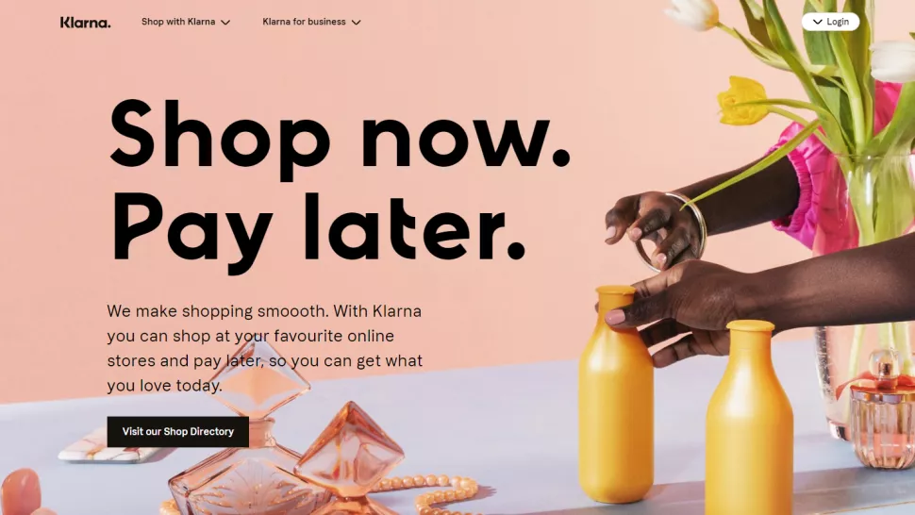
(Klarna)
Unaffordable consumer credit has been an issue for many years, and with the attempt to monitor and regulate this with introduction of the Consumer Credit Act in 1974 (HM Treasury, 2022) it was finally recognised as a problem- the issue with such legislation is it requires regular updating, and there are current calls for the regulations to be rewritten to further regulate Buy Now Pay Later (BNPL)
BNPL has boomed in recent years, with 11 billion US Dollars raised by PNPL firms in 2021 (Vandervelde, 2022) –by using BNPL consumers are given the option to purchase and own goods immediately with payments due over a set period of smaller, interest free instalments.
However, credit checks are not always utilised by the BNPL companies, and should the customer miss payments, or over commit on credit (there are multiple BNPL companies operating in the UK, as well as offerings from PayPal and ‘in house’ finance from companies such as Currys and IKEA, and customers are not limited to a single provider) they risk hefty charges.
So, is BNPL ethical? With provocative taglines such as “millennials are useless with money, “shopping just levelled up” (Klarna) and “shop now, pay later” (Afterpay) and targeted advertising with Klarna and Afterpay allocating nearly 80% and nearly 70% of their digital ad spend for May-July 2020, to Instagram, respectively (Ornelas, 2022) it could be argued that while they adhere to the current legislation governing their behaviour, these BNPL companies are not behaving in an ethical manner.
The use of social media, such as Instagram and Facebook direct advertising, celebrity ‘influencer’ partnerships, and banner headings on retail websites promoting the option to pay in instalments has ensured that at any stage along the purchase process, from noticing the product for the first time, to final payment, the consumer is being offered the option to pay in instalments, and with the ethos of ‘shop now, pay later’ the consumer is encouraged to embrace a potentially unaffordable, influencer led, unsustainable lifestyle- (Bowler, 2022)
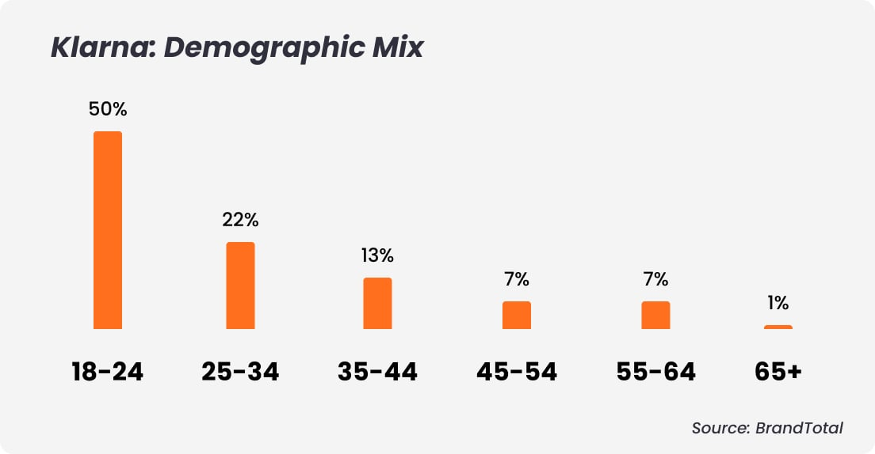
The BNPL companies are open about their target audience, the millennial and Gen Z consumers who perhaps have little experience with traditional credit, and the generations that are perhaps most invested in social media and the boom in influencers. (Payments & Payments, 2022) but in making the decision to target their marketing in such a way, they are not marketing in an ethical manner- according to research by the centre for Mental Health (Anxiety, Loneliness and Fear of Missing Out: The Impact of Social Media on Young People’s Mental Health | Centre for Mental Health, n.d.) the rise of social media is directly linked to increased anxiety and low mood, decreased life satisfaction and concentration and has a direct impact on the brain, both by creating increased compulsive behaviour and Its ‘addictive’ nature owing to the degree of compulsivity with which it is used. The ‘urge’ to check one’s social media may be linked to both instant gratification (the need to experience fast, short term pleasure) and dopamine production, the same dopamine ‘hit’ that is achieved by online shopping, and this is facilitated by the BNPL companies, by making the unaffordable accessible – Social media is said to be more addictive that cigarettes, and while advertising tobacco products was banned in the UK completely by 2002, (Tobacco Advertising and Promotion in the UK) social media, and companies such as Klarna, Afterpay and other BNPL that harness the power of social media to sell their products are allowed almost free reign in targeting potentially vulnerable consumers.
So far, Buy Now Pay Later companies have largely fallen outside of the scope of normal credit regulation, and therefore while all of their marketing and sales tactics, and following this, debt collection practices are legal, they could not be considered ethical.
It could be argued that BNPL firms are simply providing a service, and their responsibility to the consumer ends once a purchase is made, however their marketing teams would do well to consider the ethics of their marketing practices, as while their profits are growing year on year, and their current demographic of customers seem content to purchase fast fashion and the latest home or life gadget, these companies do not prioritise ethical business links, they work with ‘fast fashion’ firms and those that use sweatshop production, and are rapidly accentuating the problems of clothing and cheap textiles going to landfill.
A report by waste charity WRAP tells us 300,000 tonnes of used clothing goes to landfill in the UK every year (Bennett, 2021) and the ethical implications of helping to facilitate such damaging practices cannot be understated.
Klarna tells potential business partners via its website: “A customer’s order value increases by 55% when shopping with instalments” (Klarna UK ) and from this it is clear that true affordability is not being assessed when taking orders.

Ben and Jerrys- Ethics washing?
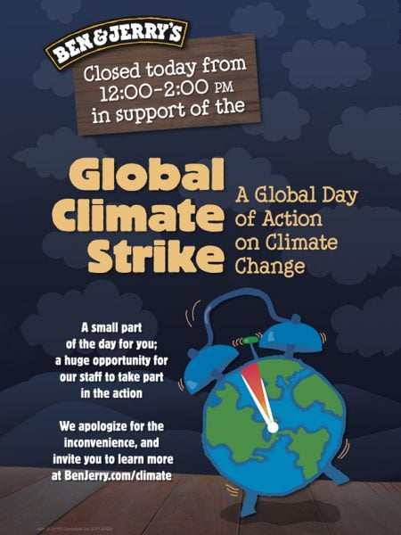
In 1978, two friends in Vermont set up an ice cream business, they believed in social responsibility, supporting Greenpeace and other charities with donations of 7.5% of their pre-tax earnings from 1985. (Benmelech, 2021) The company still operates today, and still donates 7.5% of pre-sale profits to a charitable foundation, the company reported sales of 936 million U.S. dollars for the year ended September 5, 2021. (Statista, 2022)
Ben and Jerrys declare that “we seek in all we do, at every level of our business, to advance human rights and dignity, support social and economic justice for historically marginalized communities, and protect and restore the Earth's natural systems” (benjerry.com 2021) and use social media campaigns and lobbying to support worthy causes, notably they have demonised the murder of George Floyd, supported the BLM movement, called for the impeachment of former POTUS Donald Trump and have been active campaigners for voters rights, climate justice and LGBTQ+ rights.
The company use Social media as a powerful marketing tool, ‘calling out’ companies and individuals that are acting in a manner that is unethical, or does not align with their values (Why Ben & Jerry’s Speaks Out, 2021) – according to an interview with the Harvard Business review, when asked about the impact this activism has had on sales, a spokesperson is quoted as saying “We’re seeing strong growth, and we’ve got some good data showing that our fans are aware of our social mission activities, which makes them more supportive of our business and vocal about it. Some of them buy more ice cream as a result.”
Is this ethical behaviour? it may be considered manipulative, therefore unethical, or is it simply marketing, using campaigns that the company identifies as important, and relevant in order to boost engagement and drive sales.
Ben and Jerrys are owned by parent company Unilever, following a buyout in 2000 – and Unilever environmental and social policies are a far cry from the companies ‘hippie’ roots, even prompting the original founders to claim that Unilever breached the terms of the deal when continuing to sell within franchises in the West bank and Jerusalem (Harvey, 2022) Ben and Jerrys (under Unilever) publish an annual ‘social and environmental assessment report’ -within the 2020 report (the last available) they company “set out to clearly articulate our goals, where we have them, on racial justice at Ben & Jerry’s, equity in dairy and non-dairy ingredient sourcing, global activism, climate, animal care, and packaging” (2020 SEAR Report ) – This they do, and they are transparent about the fact that the company are employing 93% white staff, that plastic use within the company is up 1.77 million pounds per year (from 2019) and while Ben and Jerrys pay a liveable wage, this only applies to employees in their Vermont manufacturing plant, and Unilever employees if they spend at least 80% of their time working on B&J products, as of 2020 this did not apply to any Unilever employee.
The company admit that their greenhouse emissions have grown, and while this is alleged to connect to an increase in sales and production, the company, who profess to be climate activist supporting and eco-friendly, are not on track to reduce their GHG output by 2040 as pledged.
Looking wider, and taking into account B&Js desire to advance human rights and dignity, it is interesting to note that in their sourcing of non-dairy ingredients, the company have “worked with each of the 4 cocoa cooperatives to refresh their child labour policies, including sensitization workshops with community and farming leaders” (2020 SEAR Report, n.d.) this appears to be merely paying lip service, rather than stating that they will not work with any provider who uses child labour.
Ben and Jerrys state in the SEAR report that in response to the companies’ statement on the murder of George Floyd, they received 3.3 million page views with an average time on site of 5.14 minutes.
I would argue that Ben and Jerrys are not ethical, talk is cheap, and they can say all the right things, but looking a little deeper there is minimal effort made to stand by their ‘principles’, they operate very clever marketing tactics, harnessing the belief of a ‘woke’ generation via social media, and retaining the loyalty of their original following, while under the surface they take very little action to back up their broad statements.
Conclusion
In 1970, Milton Friedman famously argued that the only social responsibility of business was to maximize profits (Friedman, 1970) and within this essay we have looked at some very different business models, one which appears to adhere completely to Friedmans famous statement, one which looks at business very differently, and one that only models itself as ethical and socially conscious, while making some steps towards change, all are profitable- but only one of our examples truly considers their impact on wider society, and the planet.
Marketing is not just advertising, in a modern age where access to information is at the touch of a button, not only information the consumer seeks out, but also their own information, which is so often for sale- it is the stance and decisions a company makes, the politics it aligns itself with and the clean or dirty supply chain it maintains.

(word count - 2680)

References
The 4 Ps of Marketing and How to Use Them in Your Strategy. (2022, June 24). Investopedia. Retrieved 15 October 2022, from https://www.investopedia.com/terms/f/four-ps.asp
THE 17 GOALS | Sustainable Development. (n.d.). Retrieved 15 October 2022, from https://sdgs.un.org/goals
2020 SEAR Report. (n.d.). https://www.benjerry.com. Retrieved 20 October 2022, from https://www.benjerry.com/about-us/sear-reports/2020-sear-report
Anxiety, loneliness and Fear of Missing Out: The impact of social media on young people’s mental health | Centre for Mental Health. (n.d.). Retrieved 17 October 2022, from https://www.centreformentalhealth.org.uk/blogs/anxiety-loneliness-and-fear-missing-out-impact-social-media-young-peoples-mental-health
Barwick, R. (2021, August 27). Brands are closing their doors in support of the global climate strike. Corporate Knights. Retrieved 18 October 2022, from https://www.corporateknights.com/climate-and-carbon/brands-closing-doors-support-global-climate-strike/
Ben & Jerry’s | Shop Ethical! company profile. (n.d.). Retrieved 18 October 2022, from https://guide.ethical.org.au/company/?company=2159
Benmelech, E. (2021, August 1). Ben & Jerry’s Social Responsibility: ESG Without The G. Forbes. Retrieved 18 October 2022, from https://www.forbes.com/sites/effibenmelech/2021/08/01/ben--jerrys-social-responsibility-esg-without-the-g/?sh=963f95f30842
Bennett, E. (2021, February 3). Are Buy Now, Pay Later Schemes Just Accentuating the Fast Fashion Problem? Eco-Age. Retrieved 17 October 2022, from https://eco-age.com/resources/are-buy-now-pay-later-schemes-just-accentuating-fast-fashion-problem/
Bowler, H. (2022, March 7). How ‘buy now, pay later’ marketing is shaking up the finance sector. The Drum. Retrieved 17 October 2022, from https://www.thedrum.com/news/2022/02/15/how-buy-now-pay-later-marketing-shaking-up-the-finance-sector
Cantor, M. (2019, April 4). Patagonia distances itself from tech bros with new branded vest policy. The Guardian. Retrieved 15 October 2022, from https://www.theguardian.com/fashion/2019/apr/03/patagonia-fleece-vest-tech-bro-uniform
Demkes, E. (2020, April 28). The more Patagonia rejects consumerism, the more the brand sells. The Correspondent. Retrieved 16 October 2022, from https://thecorrespondent.com/424/the-more-patagonia-rejects-consumerism-the-more-the-brand-sells
Eagle, L., & Dahl, S. (2015, October 29). Marketing Ethics & Society (1st ed.). SAGE Publications Ltd.
Fook, A. L. (n.d.). Click to Buy: The Impact of Retail Credit on Over-Consumption in the Online Environment. MDPI. Retrieved 8 October 2022, from https://www.mdpi.com/2071-1050/12/18/7322/htm
Friedman. (1970). The Social Responsibility of Business is to Increase its Profits. The New York Times Magazine.
Hardy, J. (2021, September 1). The History Of Marketing: From Trade to Tech. History Cooperative. Retrieved 9 October 2022, from https://historycooperative.org/the-evolution-of-marketing-from-trade-to-tech/
Harvey, S. (2022, September 20). Unilever ‘violated Ben & Jerry’s takeover deal’, ice-cream maker’s founders claim. Just Food. Retrieved 20 October 2022, from https://www.just-food.com/news/unilever-violated-ben-jerrys-takeover-deal-ice-cream-makers-founders-claim/
HM Treasury. (2022, June 16). UK commits to reform of the Consumer Credit Act. GOV.UK. Retrieved 16 October 2022, from https://www.gov.uk/government/news/uk-commits-to-reform-of-the-consumer-credit-act
Hollensen, S., & Opresnik, O. M. (2021). Marketing: Principles and practice: A management-oriented approach. Journal of Multidisciplinary Research, 13(1).
How To Tap Into The Buy Now Pay Later Market. (2022, May 31). Forbes. Retrieved 17 October 2022, from https://www.forbes.com/sites/forrester/2022/05/31/how-to-tap-into-the-buy-now-pay-later-market/?sh=2c04f0e81737
Katz, R. &. P. A. A. (n.d.). The Truth About Ben and Jerry’s (SSIR). Retrieved 18 October 2022, from https://ssir.org/articles/entry/the_truth_about_ben_and_jerrys
Keller, K., & Kotler. (2012, October 15). Framework for Marketing Management.
Klarna UK. (n.d.). Retrieved 17 October 2022, from https://www.klarna.com/uk/business/partners/
Less is more: is a green demarketing strategy sustainable? (n.d.). Taylor & Francis. Retrieved 9 October 2022, from https://www.tandfonline.com/doi/abs/10.1080/0267257X.2015.1059874?journalCode=rjmm20
Lyon, R. (2019, August 18). Selling the lifestyle rather than the product. Signet. Retrieved 9 October 2022, from https://signetbranding.com/news/selling-the-lifestyle-rather-than-the-product/
Meltzer, M. (2021, October 27). Patagonia and The North Face: saving the world – one puffer jacket at a time. The Guardian. Retrieved 15 October 2022, from https://www.theguardian.com/business/2017/mar/07/the-north-face-patagonia-saving-world-one-puffer-jacket-at-a-time
nytimes.com. (2018, May 5). Retrieved 15 October 2022, from https://www.nytimes.com/2018/05/05/business/patagonia-trump-bears-ears.html
Ornelas, J. (2022, April 26). Buy-now-pay-later advertisers bet on Instagram. Comperemedia. Retrieved 17 October 2022, from https://welcome.comperemedia.com/blog/consumer-financial-services/buy-now-pay-later-advertisers-bet-on-instagram/
Payments, T., & Payments, T. (2022, September 9). The Latest ‘Buy Now Pay Later’ Consumer Insights for Your Business. Trust Payments. Retrieved 17 October 2022, from https://www.trustpayments.com/blogs/the-latest-buy-now-pay-later-consumer-insights-for-your-business/
Shivani. (2021, December 15). Marketing Ethics: Meaning, Importance and Examples. InviteReferrals. Retrieved 8 October 2022, from https://www.invitereferrals.com/blog/marketing-ethics/
Staff, B. (n.d.). Social Ad Snapshot: “Buy Now, Pay Later”. Retrieved 17 October 2022, from https://blog.brandtotal.com/social-ad-snapshot-buy-now-pay-later
Statista. (2022, July 27). Sales of the leading ice cream brands of the U.S. 2021. Retrieved 18 October 2022, from https://www.statista.com/statistics/190426/top-ice-cream-brands-in-the-united-states/
Supply Chain Environmental Responsibility Program - Patagonia. (n.d.). Retrieved 15 October 2022, from https://www.patagonia.com/our-footprint/supply-chain-environmental-responsibility-program.html
Tobacco Advertising and Promotion in the UK. (n.d.). ASH. Retrieved 17 October 2022, from https://ash.org.uk/resources/view/tobacco-advertising-and-promotion-in-the-uk
Values. (n.d.). https://www.benjerry.com. Retrieved 18 October 2022, from https://www.benjerry.com/values
Vandervelde, S. (2022, October 13). From FOMO to de facto — tracking the rise of BNPL. Retrieved 16 October 2022, from https://www.checkout.com/resources/blog/tracking-the-rise-of-bnpl
Ventura, M. (n.d.). Green marketing impact on a companies success: Studying the case of patagonia [Dissertation]. universidade católica portuguesa.
Werhane, P., & Freeman, R. (n.d.). Business Ethics: The state of the art [PHD]. Darden School,University of Virginia.
Why Are Business Ethics Important? (2022, May 9). Investopedia. Retrieved 8 October 2022, from https://www.investopedia.com/ask/answers/040815/why-are-business-ethics-important.asp
Why Ben & Jerry’s Speaks Out. (2021, January 13). Harvard Business Review. Retrieved 18 October 2022, from https://hbr.org/2021/01/why-ben-jerrys-speaks-out
YtC studios (Director). (2020, July 20). Creating Brand Hype With A Teaser Marketing Campaign. YtC Studios. Retrieved 9 October 2022, from https://www.ytcstudios.com/blog/2020/7/16/steps-to-developing-a-teaser-campaign-grow-email-subscriber-list

