Methodology
What is research?
Research is defined by Qatar, 2018 “as any form of a careful consideration of a study concerning a problem that aims to contribute to a body of knowledge or theory by means of scientific methods.”
According to the site soas.ac.uk research is conducted so what we can get a better “understanding” of a problem and will assist people by providing them with “information and knowledge needed for problem solving and making decisions” (soas.ac.uk, 2019)
Kothari argues that one of the basic methods of research is quantitative vs qualitative. Kothari further suggests that quantitative research primarily focuses on ‘measurement of quantity or amount” and whereas qualitative research is “concerned with qualitative phenomenon, i.e., phenomena relating to or involving quality or kind” (Kothari, C.R., 2004)
In this chapter I will using a research method created by Saunders where he uses the diagram of an onion suggesting that research can be broken down into several layers.

The Onion
The Saunders Onion research method will be used to structure the methodology chapter. Within this method there are many layers and each layer will have a subheading and the researcher will work through each subheading from the outwards towards the centre on the onion. Each topic can ask a wide range of questions and choices from “high-level and philosophical to tactical and practical in nature” (Crossley and Jansen, 2021)

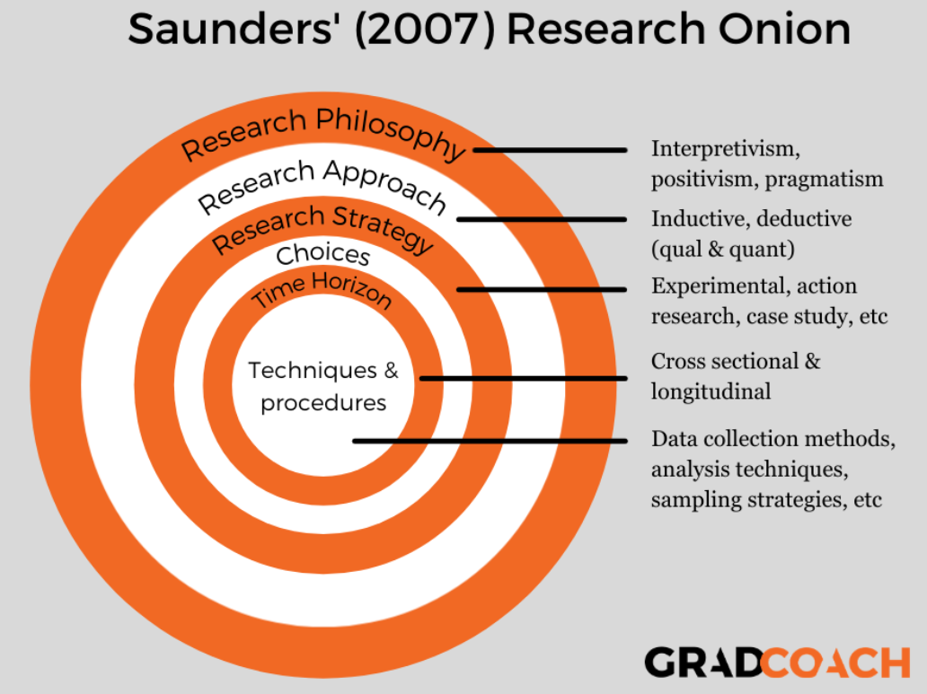

Philosophy
The research philosophy that has been chosen is interpretivism. This philosophy will allow the researcher to view the thoughts, opinions and ideas from group selected to partake in the study. As the study will focus on how Police officers respond to calls and issues concerned with mental health it is vital to gather information that is opinion. This philosophy will enable the researcher to gain an understanding of target groups feeling towards this subject. As well as questionnaires being sent out to Police officers the researcher intends to send a second questionnaire to approved mental health practitioners(AMHP) within south Wales, this will allow for an additional viewpoint as often both Police and AMPH’s work together on brief occasions but may not fully understand each other’s roles within the system.

Research Approach
The research approach that has been chosen to analyse the data will be an inductive approach. The reasons this approach has been used as the basis of the research is not based upon a pre-existing theory, as the inductive approach will hope to generate theories from the data of the research.
The inductive approach will be used as it can “condense raw textual data into a brief summary format” and “establish clear links between the evaluation or research objectives and summary of findings derived from the raw data”(Thomas, D. R. 2006)

Strategy
Within the strategy layer on Saunders onion, the researcher will write about how the research will conducted based upon on the aims of study itself. The research will conducted by using the method of questionnaires. By creating a questionnaire on the website surveymonkey.com. Once created, the questionnaire will be disseminated to supervisors within the Police to share with their team. Also, as the research focuses on AMPH’s opinions of the how the Police respond to mental health crisis, an email will be sent to Llandough Psychiatric unit asking whether their staff will be able to complete the questionnaire anonymously.
The reason as to why the method of questionnaires has been chosen is that it provides the researcher with a fairly simple task of creating a questionnaire by writing down each question on a word document and sending it to the receiver or target audience. In order for this method to yield quality responses, the researcher will need to develop the questions so that they flow and are not only a tick box exercise. The questionnaire will be developed to draw in the target audience into to the subject so that quality and honest answers can be received from both using direct and indirect questions.
Gillham states that one of the main weaknesses of the questionnaire “Is that they seek to get answers just by asking questions” therefore, the structure of the questionnaire will need to be considered carefully.

Choice
The researcher has chosen the mixed-method approach as both quantitative and qualitative data will be gathered from the analysis of the questionnaire. According to Rossman and Wilson a mixed method approach helps “seeing this world through multiple lenses”

Time horizon
In this subsection Saunders provides two options to the researcher. Whether the researcher uses cross-sectional or longitudinal ‘time horizon’.
What Saunders is referring to is whether the research will developed over time which will take weeks, months or years to develop in which case the research will be described as longitudinal.
On the other hand there is a second option called cross-sectional which will be used in this particular research, as the data the research is seeking to collect is from a fixed point in time which is the Police officers and AMHP’s opinions of the response police are playing in providing care and support to those suffering from mental health issues at this very point in time.

Techniques data collection and analysis
As alluded to in previous subsections of this chapter, the intention of the researcher is to conduct a primary research by creating a questionnaire. Primary research is described by SmartSurvey as “data which is obtained first-hand” The type of questions that the researcher is intending to use will be both open and closed questions. Giving the opportunity to the respondent to engage their opinions on the research question. To ensure that a positive number of questionnaires are completed the researcher has decided to not ask too many questions, this is to maintain the enthusiasm of the respondent to complete knowing it will only take a short time to complete.
The use of questionnaires has both advantages and disadvantages and the research will need to carefully construct and develop questions so that they are not misleading. A leading website assisting researchers called qualtrics suggest that certain words such as “would” “could” and “should” “may produce a 20% difference in agreement to a question” (Smith, 2018).

Reliability and validity

According to Roberts “Reliability and validity are ways of demonstrating and communicating the rigour of research processes and the trustworthiness of research findings” (Roberts, 2016)
Evaluating the quality of research is essential if findings are to be used in practice and incorporated into care delivery.
To ensure validity exists within the research it is important for the research to consider that a appropriate time scale has been selected, an appropriate methodology has been chosen for the characteristics of the study, a suitable sample has been selected and that the respondents should not be pressured in any way to select specific choices among the questions within the research questionnaire. Although threats to research reliability and validity can never be totally eliminated researchers need to strive to minimise this threat as much as possible.

Bias
According to the oxford dictionary bias is “an inclination or prejudice for or against one person or group, especially in a way considered to be unfair”
Bias exists in all research and is difficult to eliminate. It can occur at each stage of the research process and impact the validity and reliability of the study findings and mis-interpretation of data which can have important consequences for practice.
It is important that the research is seen to be trustworthy. This can depend on a number of features such as. The initial research question and how data are collected including when and from whom, how they are analysed and what conclusions are drawn.
The researcher should attempt to minimise bias, outlining potential sources of bias enables greater critical evaluation of the research findings and conclusions. Furthermore, the researcher brings to each study their experiences, ideas, prejudices and personal philosophies which if accounted for in advance of the study can enhance the transparency of possible research bias.

Conclusion
This now concludes and achieved the second objective of the dissertation;
‘The research methodology on how mental health issues are impacting on modern Policing’
This chapter has outlined a suitable methodology research method and detailed the most appropriate form of gathering data from the target audience. The next chapter will detail the results and analysis of data collected.

Reading list reference

‌Crossley, J. and Jansen, D. (2021). Saunders’ Research Onion: Explained Simply (+ Examples). [online] Grad Coach. Available at: https://gradcoach.com/saunders-research-onion/.

Gillham, B., 2008. Developing a questionnaire. A&C Black.

Kothari, C.R., 2004. Research methodology: Methods and techniques. New Age International Pp 3

Qamar, B.K., 2018. Research ethics. PAFMJ, 68(6), pp.1503-54.

ResearchGate, https://www.researchgate.net/figure/The-research-onion-Saunders-et-al-2015_fig4_318601237 (viewed 01/03/2022)

Roberts, P. and Priest, H. (2016). Reliability and validity in researchdx

Rossman, G. B. and Wilson, B. L. (1985) ‘Numbers and Words: Combining Quantitative and Qualitative Methods in a Single Large-Scale Evaluation Study’, Evaluation Review, 9(5), pp. 627–643.

SmartSurvey (2021). Primary Research Methods Explained | SmartSurvey. [online] www.smartsurvey.co.uk. Available at: https://www.smartsurvey.co.uk/articles/primary-research-methods.

Smith, S. (2018). Survey Questions 101: Write good questions with these tips | Qualtrics. [online] Qualtrics. Available at: https://www.qualtrics.com/blog/writing-survey-questions/.

Soas.ac.uk. (2019). 2.1 Why research? The role of information. [online] Available at: https://www.soas.ac.uk/cedep-demos/000_P506_RM_3736-Demo/unit1/page_15.htm

‌Thomas, D. R. (2006) ‘A General Inductive Approach for Analyzing Qualitative Evaluation Data’, American Journal of Evaluation, 27(2), pp. 237–246.
‌

