4/15/26
UNIVERSITY OF WALES TRINITY SAINT DAVID
London Campus
Module Name: Software Solutions for Business
Module Code: ACCA 4026

Student Name: Gamze Sertkaya
Student ID: 2529589
Group: 3

Lecturer’s Name: Kwame Assa Agyei

Assignment
  - Software Solutions for Business

Table of Contents
Introduction 1
1 E-Commerce Website Builders 1
1.1 Shopify 1
1.2 Wix 2
2 Mind Map of Contemporary Software Applications 2
2.1 Mind Map and Benefits 2
2.2 Create a Mind Map 3
3 Office Applications 4
3.1 Software Solutions for Business Operations 4
3.2 Practical Demonstration of Office Features 6
4 Communication and Collaboration Applications 10
4.1 Contemporary Communication and Online Collaboration Applications 10
4.2 Feature of Communication and Feature of a Collaboration Application 11
Conclusion 14
References 15

Introduction
In the modern digital workplace, software applications are essential for enhancing efficiency, communication, and informed decision-making. Businesses depend on a wide range of digital tools to streamline their daily operations and improve overall performance.
This report examines various types of software commonly used in today’s organisations, such as e-commerce systems, mind mapping applications, office productivity tools, and communication platforms. It also provides practical examples to demonstrate how these technologies are used in real-world business contexts.
The purpose of this assignment is to evaluate the ways in which these digital solutions support better workflows, strengthen collaboration, and contribute to improved organisational outcomes.

E-Commerce Website Builders

Shopify

Shopify stands out as one of the most influential companies in the e-commerce industry. Founded in 2004 by Tobias Lütke, Daniel Weinand, and Scott Lake, the company has grown from a small Canadian startup into a global technology powerhouse. [1]
Shopify has become one of the most important global players in the cloud-based e-commerce industry. Headquartered in Ottawa, the company offers a multi-channel platform designed to help businesses of all sizes launch, grow, promote, and manage their retail operations through a subscription-based software model. Its core strength lies in providing reliable, user-friendly tools that simplify the complexities of running an online business. [2]
Interestingly, Shopify was originally created out of necessity. In 2006, its current CEO, Tobias Lütke, wanted to start an online store selling snowboarding equipment. However, when he realized that existing e-commerce solutions were not meeting his needs, he and his partners decided to build their own platform. What started as a solution for a single store eventually evolved into the official launch of Shopify. [2]
Rather than operating as a traditional retailer, Shopify empowers entrepreneurs and businesses by giving them the tools they need to build and manage their own online stores. The platform offers ready-made templates and advanced technology that make it easier to handle everything from marketing and sales to payments and logistics. I think this comprehensive approach is one of Shopify’s greatest strengths, because it allows merchants to manage their entire business from a single ecosystem. [1]

Wix

A website builder is a practical tool that allows people to create websites without needing coding skills. Instead of writing code from scratch, users can rely on ready-made systems and templates to design and publish their sites. Website builders are generally divided into two types: online platforms and offline software. [3]
Online website builders operate through a web hosting service, which provides cloud storage and servers. Unlike offline programs, they do not require installation on a specific device. Users can simply access them through a web browser and an internet connection, making it possible to work from almost anywhere. This flexibility is one of their biggest advantages. [3]
Another key benefit is ease of use. Even individuals with no background in coding or web design can build a functional website. Most online builders offer tutorials, guides, and customer support to assist users. They also cover a wide range of needs, from personal blogs to social platforms and full e-commerce stores. With ready-to-use templates, users can quickly launch a professional-looking website with minimal effort. [3]

Mind Map of Contemporary Software Applications

Mind Map and Benefits
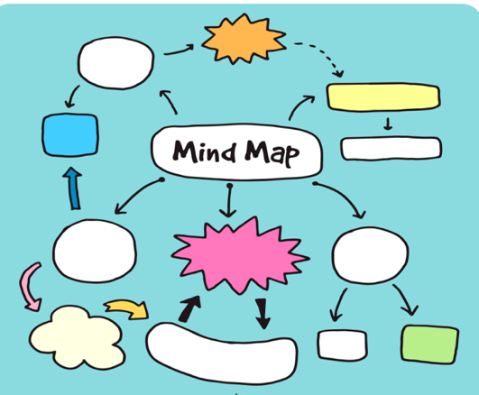
Mind mapping is a visual thinking tool that helps organize ideas around a central topic. In a mind map, the main concept is placed in the centre and related ideas branch out from it in a structured and connected way. This method allows individuals and teams to see relationships between different pieces of information more clearly.
In business operations, mind mapping offers several important benefits. First, it improves brainstorming and creativity. Teams can generate ideas freely and visually connect them, which often leads to innovative solutions. Second, it enhances problem-solving by breaking complex issues into smaller, manageable parts. This makes it easier to analyse situations and identify root causes. [4]

Create a Mind Map
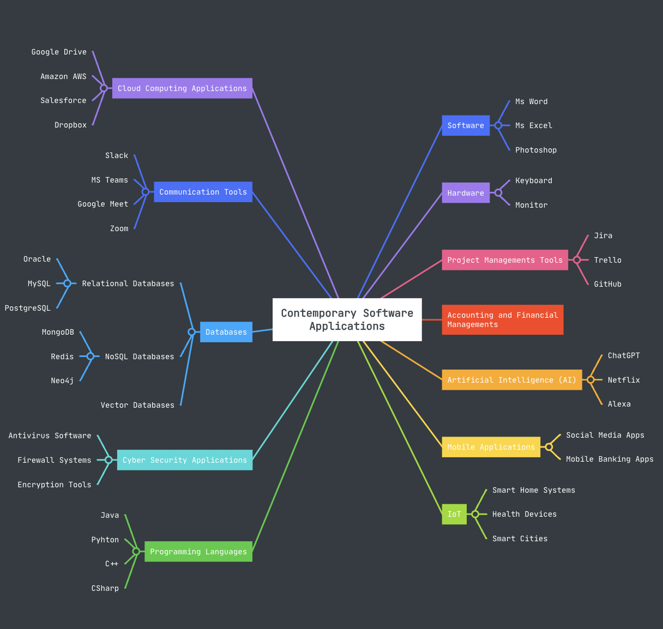

Office Applications

Software Solutions for Business Operations

MS Word

Microsoft Word is a word processing software developed by Microsoft. It is part of the Microsoft Office (also called Microsoft 365). It is widely used to create, edit, format, and share documents such as letters, reports, essays, and resumes.
Major Features:
Microsoft Word includes many powerful features that help users create and edit documents easily. It provides a wide range of text formatting tools that allow users to change fonts, sizes, colours, and paragraph styles to make documents clear and attractive. The software also includes spelling and grammar checking tools that help users write more accurately. In addition, Microsoft Word allows users to insert tables, pictures, charts, and shapes to make documents more informative and visually appealing.
Benefits:
Microsoft Word offers many benefits for students, teachers, and professionals. One of its main advantages is its user-friendly interface, which makes it easy to learn and use even for beginners. It also helps users create professional-looking documents with well-organized formatting and layout. Because Microsoft Word is widely used around the world, documents can easily be shared and opened by others. Furthermore, it integrates well with other Microsoft Office programs, which improves productivity and makes it easier to manage different types of work.

- MS PowerPoint

Microsoft PowerPoint is a presentation software developed by Microsoft and included in the Microsoft Office package. It is used to create visual presentations using slides. Each slide can contain text, images, charts, videos, and animations to help present information clearly to an audience. It is commonly used in schools, businesses, and meetings to explain ideas and share information in a structured and visual way.
Major Features:
Microsoft PowerPoint provides many tools for creating effective presentations. Users can design slides using different themes, layouts, and templates. It also allows the insertion of images, charts, tables, videos, and audio to make presentations more engaging. Another important feature is animations and slide transitions, which help make the presentation more dynamic and visually appealing
Benefits:
Microsoft PowerPoint helps users present information in a clear and organized way. It improves communication by combining text and visuals, making ideas easier for the audience to understand. The software is also easy to use and widely recognized, which makes sharing presentations simple. In addition, it supports collaboration, allowing multiple users to edit and review presentations together.

- MS Excel

Microsoft Excel is a spreadsheet software developed by Microsoft and included in the Microsoft Office suite. It is mainly used to organize, calculate, and analyse data using spreadsheets made of rows and columns. It is widely used in schools, businesses, and organizations for tasks such as budgeting, data analysis, and record keeping.
Major Features:
Microsoft Excel provides many tools for working with data efficiently. It allows users to enter and organize data in tables, perform calculations using formulas and functions, and create charts and graphs to visualize information. Excel also includes sorting and filtering tools that help users analyse large amounts of data quickly and accurately.
Benefits:
Microsoft Excel helps users manage and analyse data easily and efficiently. It improves productivity by performing automatic calculations and reducing manual work. The software also allows users to present data visually through charts and graphs, making information easier to understand. In addition, Excel is widely used and compatible with many other programs, making it easy to share and work with data

- MS Access

Microsoft Access is a database management software developed by Microsoft and included in the Microsoft Office suite. It is used to create and manage databases where large amounts of information can be stored, organized, and retrieved easily. It is commonly used by businesses and organizations to manage records such as customer information, inventory, and employee data.
Major Features:
Microsoft Access provides several tools for managing data efficiently. Users can create tables to store data, design forms for easy data entry, and generate queries to search and filter specific information. It also allows users to create reports that present data in an organized and readable format. These features help users manage and analyse large datasets more effectively.
Benefits:
Microsoft Access helps users organize and manage large amounts of data in a structured way. It improves efficiency by allowing quick searching, updating, and reporting of information. The software also integrates well with other Microsoft Office applications, making it easier to import or export data. Additionally, it provides a user-friendly interface that allows users with basic technical knowledge to build and manage databases.

Practical Demonstration of Office Features

- Mail Merge
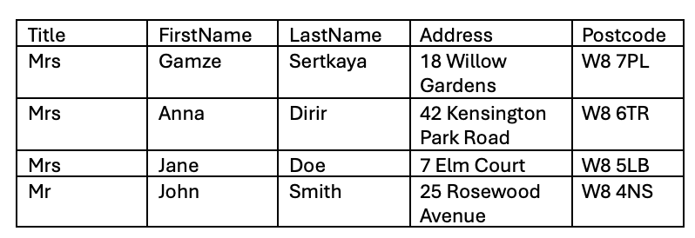

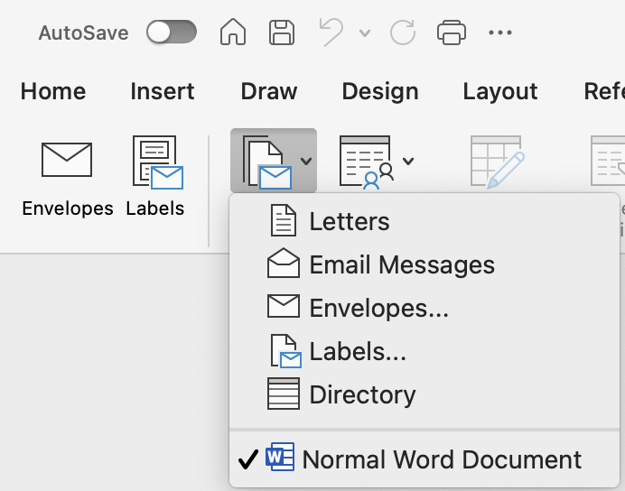

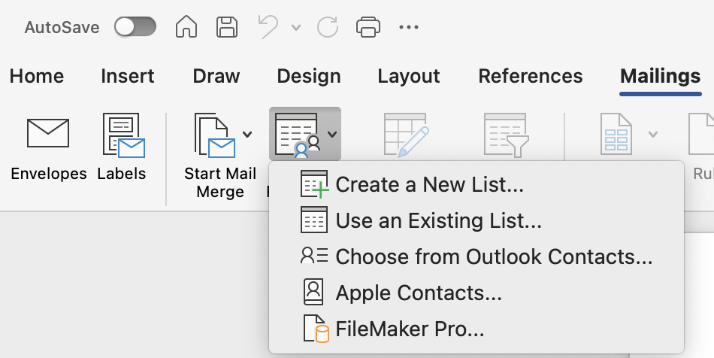

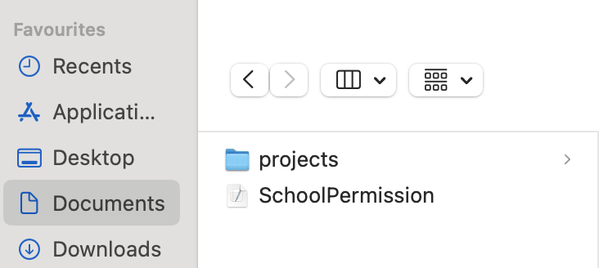

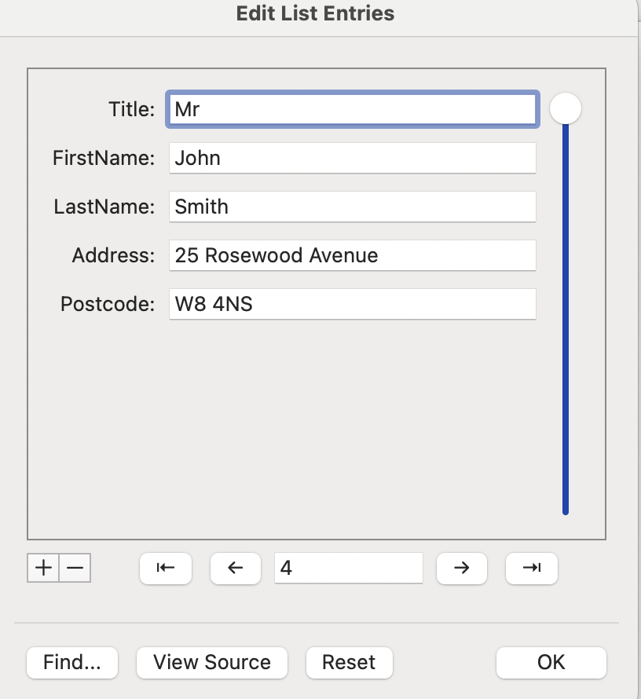
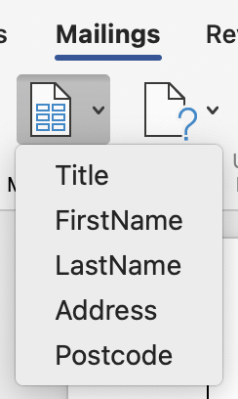

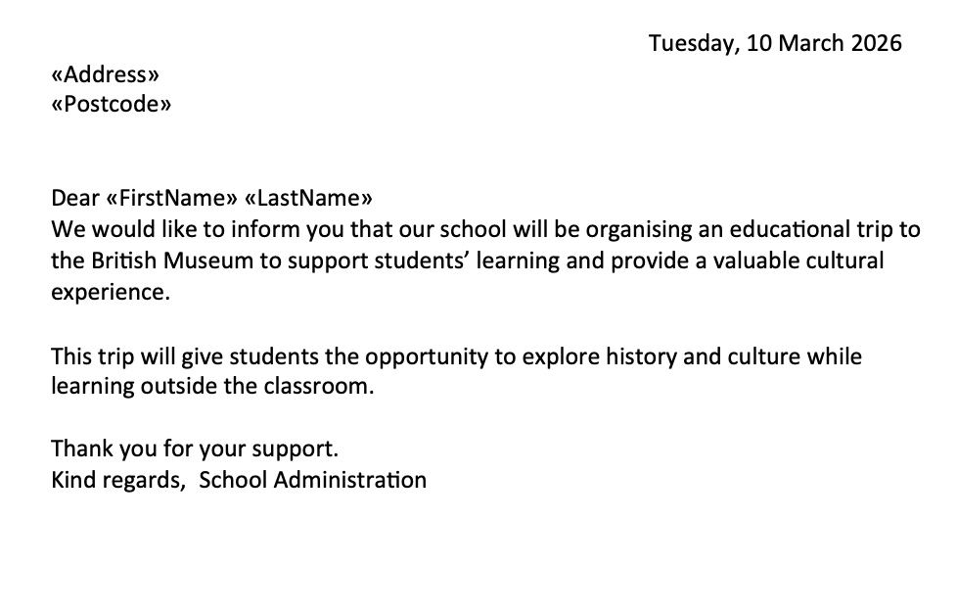

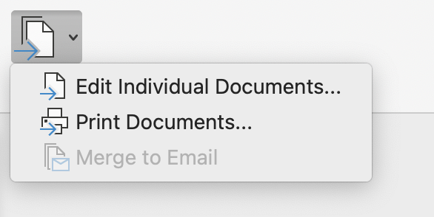



- If Statement



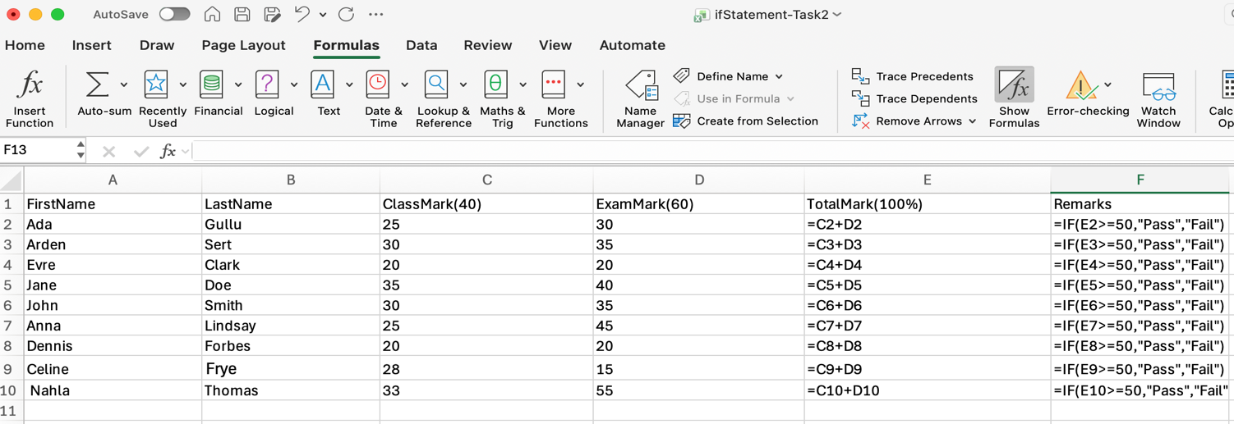

Communication and Collaboration Applications

Contemporary Communication and Online Collaboration Applications
- MS Outlook

Microsoft Outlook is a widely used email and productivity application that helps users manage emails, calendars, contacts, and tasks in one place. Its major features include email organization with folders and filters, calendar scheduling with reminders, contact management, task tracking, and integration with other Microsoft tools like Word and Teams. The benefits of Outlook include improved productivity, better time management, easy communication, and seamless collaboration, making it especially useful for both personal and professional use.
Major Features:
The major features of Microsoft Outlook include email management with folders, filters, and spam protection; a built-in calendar for scheduling meetings and setting reminders; contact management to store and organize personal and professional contacts; task and to-do list tracking; and integration with other Microsoft services like Teams, Word, and OneDrive for better productivity and collaboration.
Benefits:
The benefits of Microsoft Outlook include better organization of emails, improved time management with calendars and reminders, faster and more professional communication, easy access to contacts and tasks in one place, and smooth integration with other Microsoft applications, helping users work more efficiently and stay productive.

- MS Teams

Microsoft Teams is a communication and collaboration platform that allows users to chat, meet, call, and work together in one place. Its major features include instant messaging, video and audio meetings, file sharing, team channels, and integration with Microsoft 365 apps like Word, Excel, and Outlook. The benefits of Teams include improved teamwork, faster communication, easy remote collaboration, centralized work management, and increased productivity for both individuals and organizations.
Major Features:
The major features of Microsoft Teams include instant messaging for quick communication, video and audio meetings for virtual collaboration, team channels to organize conversations by topics or projects, file sharing and real-time document collaboration, integration with Microsoft 365 apps, and the ability to schedule and manage meetings directly within the platform.
Benefits:
The benefits of Microsoft Teams include improved teamwork through centralized communication, faster and more efficient collaboration, easy remote work with video meetings and chat, better organization of projects using channels, and seamless integration with Microsoft 365 tools, helping users stay productive and connected from anywhere.

Feature of Communication and Feature of a Collaboration Application

- MS Outlook
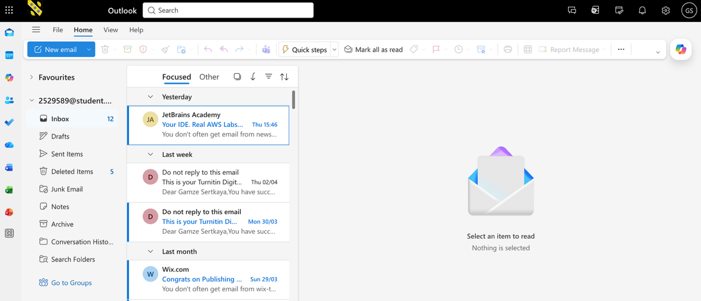

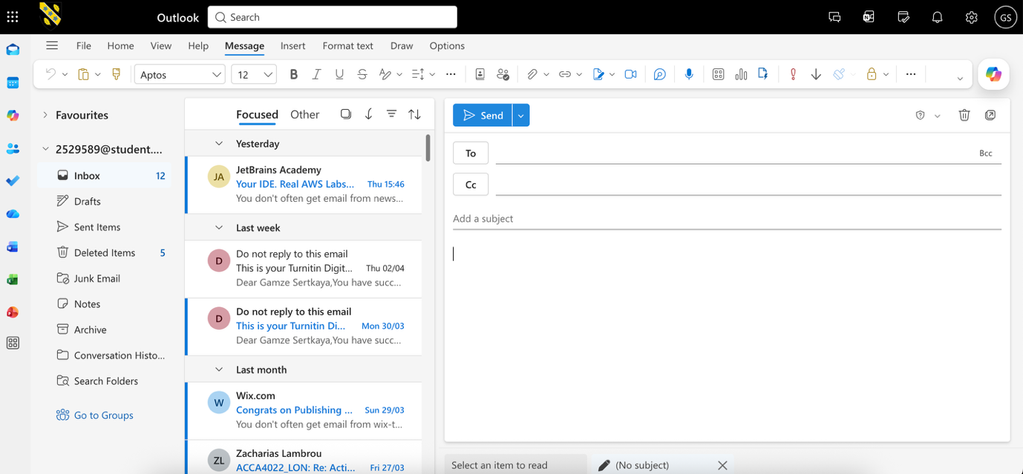
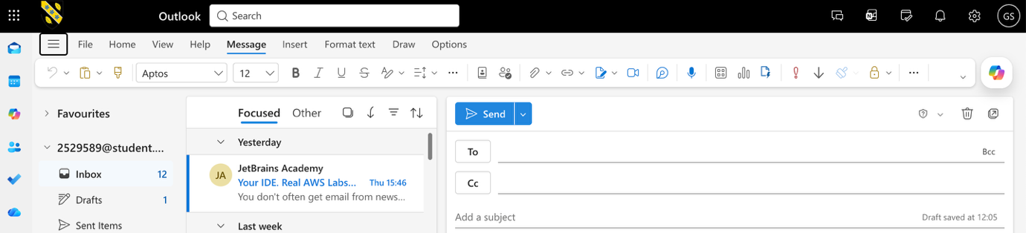

- MS Teams
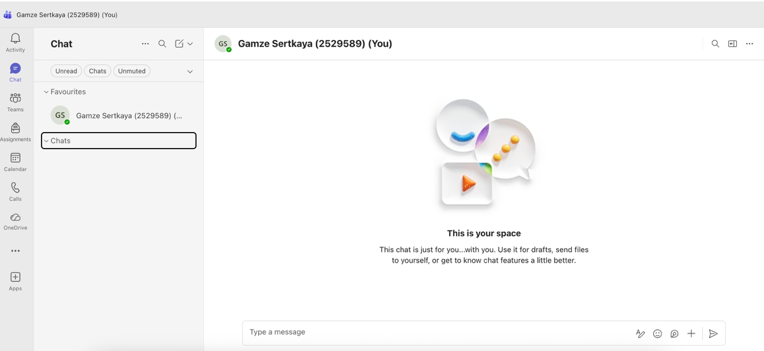
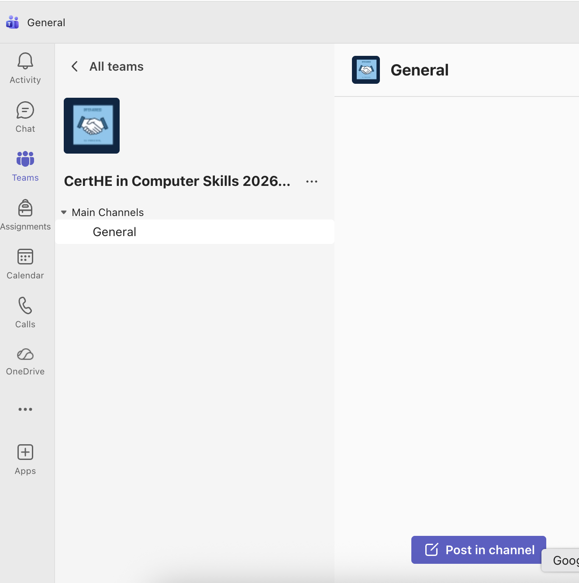

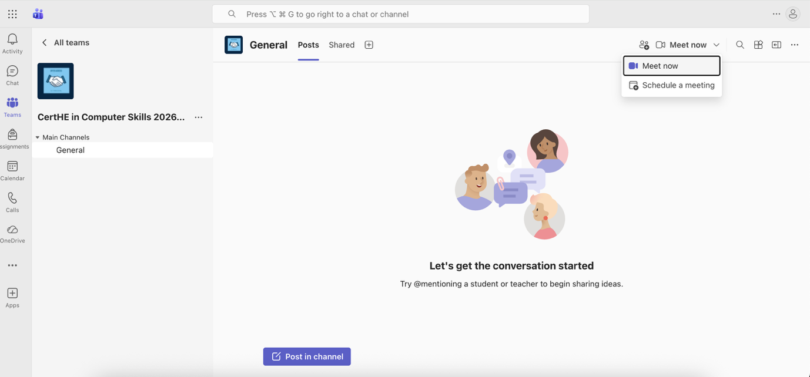
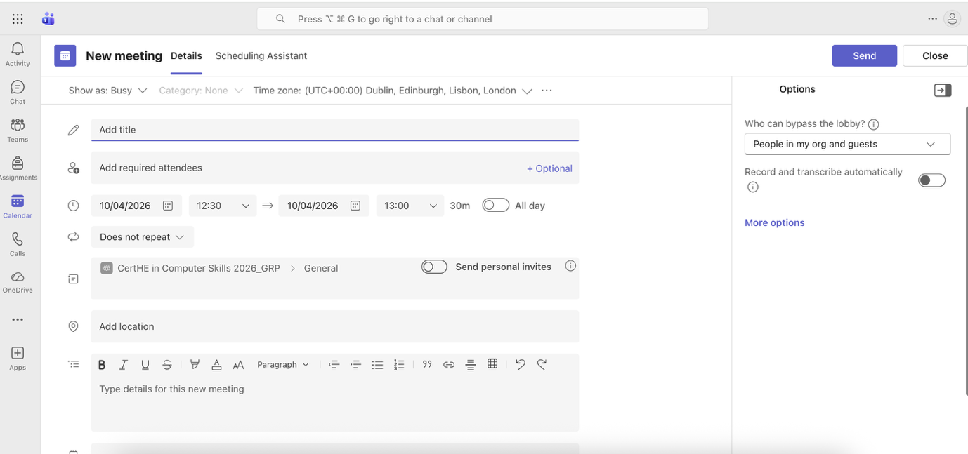

Conclusion
Office software is fundamental to the smooth functioning of contemporary businesses. Programs like Microsoft Word, Excel, PowerPoint, and Access each serve unique purposes that assist organisations in handling information efficiently.
Word is used for creating well-structured documents, Excel helps with analysing data and performing numerical calculations, PowerPoint supports effective communication through engaging visual slides, and Access is designed for organising and managing databases. When used together, these tools form an integrated system for producing, storing, interpreting, and sharing information within a company.
While each application has its own drawbacks, their combined use greatly enhances efficiency, teamwork, and informed decision-making. As a result, office applications remain indispensable in today’s business environments.

References

[1] | K. Lin, “A comparative analysis for emerging e-commerce business owners: Shopify & Amazon,” 16 December 2022. [Online]. Available: https://www.shs-conferences.org/articles/shsconf/pdf/2022/21/shsconf_emsd2022_01033.pdf. [Accessed 01 03 2026].
[2] | J. P. F. d. A. Pais, “Shopify equity research - staying ahead of the market,” 14 01 2022. [Online]. Available: https://run.unl.pt/entities/publication/6be7614f-92b7-4829-ad99-38d491dec203. [Accessed 01 03 2026].
[3] | H. Li, “Developing a Website for Nordic Inn Travel Oy by Wix,” 05 2020. [Online]. Available: https://www.theseus.fi/handle/10024/341852. [Accessed 01 03 2026].
[4] | S. O. A. Ph.D, “Effect of Mind-Mapping as a Self-Regulated Learning Strategy on Students’ Achievement in Basic Science and Technology,” July 2013. [Online]. Available: https://pdfs.semanticscholar.org/11b0/e828562f94f09fe10e4a5917f49e96172c3b.pdf. [Accessed 1 March 2026].

