

Skills for the Workplace
Module Assignment Submission
Student Name: | Emma Nightingale
Student Number: | 2008693
Module No: | BMSK4005
Module Title: | Professional Career Development

Statement of Confirmation of Authenticity
By the act of making this submission, the student declares that this is the work of the student named above. The work has not, in whole or in part, been knowingly presented elsewhere for assessment, or where assessment has been built on a previous assessment, this has been identified. Where materials have been used from other sources it has been properly acknowledged. If this statement is untrue, the student acknowledges that an assessment offence has been committed.
Attention is drawn to the plagiarism and unfair practice policies of both the University and of ILM.

Table of Contents
Section 1: Know how to identify development needs 3
1.1 Identify learning styles for self and another 3
1.2 Use a simple technique for identifying development needs for self & another 4
1.3 Identify potential barriers to learning for self and another. 6
1.4 Explain how these barriers to learning can be overcome. 6
Section 2: Know how to develop self & others to achieve organisational objectives 6
2.1 Analyse learning/development options to meet needs of self & another. 6
2.2 Identify support mechanisms for the development of self & another 7
2.3 Prepare development plans for self & another 7
Self 7
Person 2 8
2.4 Method used to monitor the development of self & another. 9
Section 3: Know how to prepare for the recruitment process 10
Reflection on the Recruitment Process 10
3.1 Description 10
3.2 Feelings 10
3.3 Evaluation 11
3.4 Analysis 11
3.5 Conclusion 11
3.6 Action Plan 11
References 12
Appendix A 12
Appendix B 12
Appendix C 12

Section 1: Know how to identify development needs

1.1 Identify learning styles for self and another

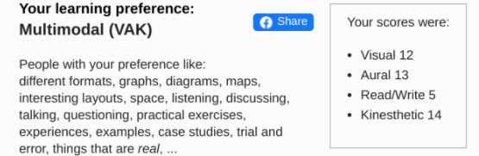

Vark results summary
I took part in a VARK test and on reviewing my results it has given me high scores & strong learning styles in VAK, Visual, Aural & Kinesthetic. I received a low score in Read/Write. I do agree with some of my results and believe most of it is a true representative of my learning preference. I have broken down my results below:-

Visual
I enjoy making tables and lists and always like to add colour and designs to my tables. I find it helps me process and retain the information much easier. I am very creative and love designing posters, which I do on a regular basis as a member of the Parent Council in my children's school. It helps me become more inspired and motivated when I am given new information to learn with lots of colour and diagrams included. I learnt my multiplications in school by using multiplication display flowers, I found this the easier method for me to retain the information. I could store the image in my head and I could recall the same image when needed. The school I work in is full of colour and inspirational quotes which encourages me to achieve and creates a great environment to develop my skills.

Aural
I agree with my results as I love to talk and ask questions. I also love to hear other people’s experiences and feelings on different subjects. I am a very good listener and believe you can learn a great deal from sitting back and observing conversations. In my current role we have regular brainstorming sessions and team meetings. This has always been a great time to learn from other colleagues and see things from their point of views. For example when I started as a School Clerk I had very little knowledge of some aspects of the job. For a couple of months I worked alongside a mentor. I spent a lot of time asking questions and making notes which helped me have a greater knowledge of new tasks and helped me develop a greater understanding. I was also a Legal secretary for 17 years and this involved audio typing so I used this style on a daily basis as I was required to listen and follow verbal instructions. I believe my preference for aural learning helped me in this role and I continue to use this on a daily basis.

Kinesthetic
I scored my highest in the Kinesthetics section and whilst I do feel I have some aspects of a Kinesthetics style I was surprised it was my highest score. I am not a very practical hands on learner. I would prefer to observe and listen. Nevertheless I do like to practice what I have learnt and see the concept coming to life. I believe my highest learning style is as a visual and aural learner.

Read/write
I agree and expected this learning style to be one of my lowest scores. I find too much reading material and written learning overwhelming, I believe this is due to dyslexia. However I have overcome this as my role as Clerk to the Governors by typing up my minutes during the meetings. I definitely agree this is not my preferred style of learning.

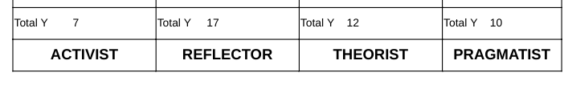
Honey & Mumford Summary
I took part in the Honey & Mumford quiz and I agree that some of my results are a true reflection of my learning style.

Activist
I am not surprised that my lowest score was under the activist section. I do not like to just "give it a go" when undertaking tasks on a professional or personal level. I would be concerned that I would not have enough knowledge of the task in hand to complete it sufficiently. I like to have all the facts in front of me and have time to plan otherwise I would feel I wasn’t able to give the task proper thought.

Reflection
This was my highest scoring category on the Honey & Mumford test. I completely agree with this and I believe I am a reflector in lots of aspects in my life. I have always been a person who would prefer to sit back and observe first. I like to follow step by step instructions and have a plan to cover lots of different scenarios. In my first job as an Office Junior I was given the task to store Wills & Deeds safely. I firstly spoke to other Will & Deed Clerks from different companies to ask what procedures they had in place. Following discussions I collaborated all the information I had received and came up with what I thought would be the best procedure for the safest and most efficient storage system in our company. I wrote detailed instructions explaining step by step process so everyone would have a clear understanding of the new system.

Theorist
This was my second highest score on the test. I believe this is why I am known as a perfectionist. I love to have everything running in a systematic manner. I love systems and use carefully planned procedures on a daily basis. As a School Clerk I have put in place an organised and methodised system. It helps me keep everything on track and ensures I keep good practice when running the school budget. Before I was promoted to Legal secretary in my previous employment I would often watch and ask questions of the secretaries so I felt I had a good understanding before I was given the job. I feel knowledge is power and it helped build my confidence in my abilities and had a positive impact on my work.

Pragmatic
My second lowest score was in this section. I did think I might have scored a bit higher in this category. I love to try new systems but only once I have researched and logically thought whether this is the best system for us. I also enjoy solving problems and putting plans together.

Person 2
VARK
Visual: 9
Aural: 10
Read/write: 13
Kinesthetics: 7

Honey & Mumford
TOTALS: Activist 10. Reflector 9. Theorist 11. Pragmatist 10

My work colleague also took the VARK and Honey & Mumford questionnaire.

Vark
She scored highest in the read/write category. She agreed with her results as she loves to read and definitely agreed this was her preferred style of learning. Her second highest score was 10. Like myself she likes to hear about other people's experiences and learn from them.

Honey & Mumford
She also agreed with the results as she feels she has aspects of all the areas learning. She likes to make lists and read all the facts but is also very comfortable to just try things out and see how they go first. She is very versatile and can adapt easily according to the task in front of her.

1.2 Use a simple technique for identifying development needs for self & another

SWOT Person 1

STRENGTHS  - Honesty  - Hardworking  - Creative  - Dedicated  - Approachable  - Adaptable  - IT skills ~ Legal secretary for 17 years.  - Running school budget.  - 'Can do' attitude  - Organised  - Willing to learn  - Caring  - Build good solid relationships  - Perfectionist  - Minute taking – clerk to Governors  - Multi-tasker  - Take pride in work.  - Ability to lead projects.  - Empathic.  - Compassionate. | WEAKNESSES  - People pleaser  - Lack confidence sometimes  - Supporting other colleagues with their task before completing my own.  - Dyslexia  - Public speaking.  - Get bored easily.  - Struggle to delegate jobs prefer to complete myself.  - Perfectionist.  - Don’t like to ask for help.  - Don’t always believe in myself.
OPPORTUNITIES  - Ability to research to improve skills  - Willing to seek further education  - Good relationships during working life  - Supportive family & work colleagues.  - I work full time in a school who are extremely supportive & will help me grow, achieve & believe in myself. | THREATS  - Self-doubt  - Family life  - Poor interview skills  - Unable to project my capabilities & promote myself.  - Nervousness  - Covid  - Get bored easily.  - Budget restrictions within school sectors.

On completing my SWOT I found it extremely helpful and useful. It has helped me to be able to see my Strengths, Weaknesses, Opportunities and Threats all together. I can turn some of my weaknesses into Strengths and my threats into opportunities. I have listed some examples below:-

Weaknesses/strengths
People pleaser ~ I believe this could also be positive in some aspects as it makes me a very good team member and will help me build good relationships and help achieve good morale in the workplace. I feel my strength of caring contributes to my weakness to be a please pleaser. When I am in a leadership position I will ensure my work life relationships are professional but I do want to have an honest and approachable work ethos.

Supporting other colleagues with their tasks before my own ~ This is one of my weaknesses but I can draw on my strength of being a good multitasker and well organised to help combat this weakness.

Struggle to delegate jobs prefer to complete myself, perfectionist & don’t like to ask for help ~ I believe these three weaknesses are all interlinked and comes down to me being a perfectionist. Being on this course can help me overcome these weaknesses. When I am in a leadership role I will be able to use the VARK, Honey & Mumford and SWOT analysis tests/formats, I will be able to delegate tasks to members of staff that have the best learning styles and skills to meet the task requirements. I think this will help build good solid relationships and help with morale and encourage good staff personal development to allow members of staff to feel valued.

Threats/opportunities
Poor interview skills/nervousness, unable to project my capabilities & promote myself ~ continuing on this course will help me build confidence in my ability and give me the confidence and skills to be able to deliver a confident and good interview. I will have a clearer understanding of the recruitment process. I can also apply this when I am in a leadership and management position when interviewing others.

Covid ~ I believed this was a threat however since creating the SWOT results I have had covid19, I missed a few sessions but thankfully our Tutor records all sessions and I was able to watch these and catch up. I felt overwhelmed initially but with the support of my tutor & family I was able to complete all tasks and catch up.

Budget restrictions within school sectors ~ This could be a threat to becoming a School Business Manager. However I have built many solid working relationships during my working life and I am very adaptable so I feel this could potentially open up doors in different professions if required.

SWOT Person 2

STRENGTHS  - Good at communicating  - Adaptable  - Team player  - Good at delegating  - Well organised  - Friendly  - Approachable  - First Aider | WEAKNESSES  - Self-belief  - Numeracy  - Confidence  - Impulsive  - Organisational skills  - IT skills
OPPORTUNITIES  - Good working relationships  - Worked in School environment for many years – good understanding  - Experience covering as manager for 6 months | THREATS  - Financial  - Lack of family support  - Covid  - Lack of free time  - Commitments

1.3 Identify potential barriers to learning for self and another.

Myself

Childcare ~ I am a mum of 2 young children.

Work life/family life balance ~ I work full time and it can be an extremely busy & demanding environment.

Self-belief.

Confidence.

Dyslexia.

Person 2

Childcare ~ She is a mum to 3 young children.

Family support ~ She is a single parent with elderly parents.

Work life/family commitments.

Self belief.

1.4 Explain how these barriers to learning can be overcome.

Childcare ~ I am a mum to two young children.
Overcome ~ Whilst the course continues online this is not an issue. However when returning to face to face meetings this could become a problem. My husband is a lorry driver but is extremely supportive so he will be there to look after the children. However, if he is unable due to unexpected work commitments I have my two sisters who would happily provide childcare for me. I feel this barrier can be overcome with the plans I have put in place.

Work life/family life balance
Overcome ~ I work full time as a School Clerk and Clerk to the Governors both roles can be extremely demanding. I am also a mum and wife. I feel a good work life/family life balance is extremely important. I feel I can overcome this barrier as I only work term time so all school holidays I can make sure I have a healthy balance. I also have an extremely supportive family which I believe is very important to overcome this barrier.

Self-belief & confidence
Overcome ~ I lack self-belief and confidence sometimes and I believe this is due to lack of experience. I must learn to believe in myself much more as this will be betrayed in my leadership skills. I believe attending this course will help me achieve this and give me confidence in my own ability.

Dyslexia
Overcome ~ I have always suffered with dyslexia and this does affect my confidence sometimes, however I believe it does not stop me achieving having been a legal secretary for 17 years. I think it can make you more determined and focused to achieve your goals. I believe this helps me be more empathic and more patient with fellow colleagues. This can be overcome with ensuring I am organised and give myself enough time to proofread all my work and process the information.

Person 2
My fellow work colleague identifies the following potential barriers:-

Childcare ~ She is a mum to 3 young children so it can be difficult to find reliable support. She could speak to friends and local childminders/babysitters to seek support and childcare.

Family support ~ She is a single parent with elderly parents she doesn't have a massive support network. Again, as above she could reach out to friends and family members to ask for more support.

Work/family commitments ~ She works full time and is a single parent so it can be extremely difficult to juggle work and family commitments. She could improve her organisational skills and ensure she has a healthy balance and hopefully by reaching out to friends and creating a good support network this will help.

Financial ~ This could be a barrier but she could apply for a grant to cover the fee of such a course and apply for a grant to help cover additional costs such as childcare etc.

Section 2: Know how to develop self & others to achieve organisational objectives

2.1 Analyse learning/development options to meet needs of self & another.

Writing Skills ~ I feel my writing skills are not as good as they could be due to the fact that I have not been in education for many years. I can develop this skill by continuing on the course and learning this skill.

Confidence/anxiety ~ I lack confidence sometimes which can cause anxiety in my abilities and I feel this is due to lack of experience. I must learn to believe in myself much more as this will portrayed in my leadership skills. I am thinking of researching and attending a relaxation and mindful course to help me overcome this mindset.

Public speaking/presentation skills ~ this is definitely something I have always struggled with. I believe it comes down to my confidence. In my current job I have been lucky enough to be surrounded by extremely positive and inspirational people who are reinforcing the belief in myself that I have been lacking in previous positions. I am able to use and create PowerPoints so I feel confident in my ability to produce and deliver a successful PowerPoint presentation. Regarding public speaking I need to build on this aspect. I feel I can overcome this with maybe running through my presentation a number of times with family and friends. I feel I would benefit from learning and researching breathing techniques that help me deliver a presentation in a more professional and confident manner.

Person 2
Writing skills ~ Like myself my colleague feels this could be improved and believed joining this course next year could help her improve this.

HR skills ~ She doesn’t feel her HR knowledge is strong. She could attend training courses run through the school and governors support.

IT skills ~ My colleague feels her IT skills are not as good as they could be. She feels enrolling on an IT course would help develop these skills and give her confidence.

2.2 Identify support mechanisms for the development of self & another

My support mechanisms

Husband.

Family i.e. parents, sisters etc.

Tutor.

HWB.

Library online.

Employer.

Friends.

Person 2

Parents.

Friends.

Work colleagues

Manager.

School.

2.3 Prepare development plans for self & another

Self
Part 1: Personal Analysis
See SWOT Analysis in 1.2
Part 2: Setting Goals
What do I want to learn? | What do I have to do? | What support and resources will I need? | How will I measure success? | Target Date for Review
Skills in the workplace – Leadership & Management ~ level 4 | Attend course regularly and complete all assignments | Tutor, Library online & Hwb | Completing the year course & achieving the qualification | Sept 2021
Mindful/relaxation course | Research online and complete a plan | Internet & laptop | Building confidence in my skills including delivering presentations. | Sept 2021
Intense Excel course | Research online and book on an intense Excel course | Internet & laptop & Excel package | Develop more skills and greater understanding of more detailed formulas and tips getting the best out of Excel package | Sept 2022
BA Leadership & Management – Level 5 | Successfully complete Skills in the workplace – Leadership & Management ~ level 4 | Tutor, Library online & Hwb | Being accepted on the course, completing and achieving a qualification | 2023

Part 3: Personal Objectives

Short Term Goals (next 12 months)
I would like to successfully complete Level 4 Skills in the Workplace – Leadership and management course.

I wish to attend a mindful & relaxation course online to help build my confidence.

Medium Term Goals (2-3 years)
I would like to be able to continue with the BA Leadership & Management course and achieve a Degree.

I also like to book an Intense Excel course to have a more in depth understanding and get the best out of the programme.

Attend additional courses to develop my HR skills.

Long Term Goals (3-5 years)
My long term goal would be to be a School Office Manager.

Part 3: Personal Objectives

Person 2
Part 1: Personal Analysis
See SWOT Analysis in 1.2
Part 2: Setting Goals
What do I want to learn? | What do I have to do? | What support and resources will I need? | How will I measure success? | Target Date for Review
Meditation skills | Search online courses | Internet & Laptop | Completion & gain skills | Dec 2021
Level 4 skills for the workplace | Enrol on course | Tutor, Library online & Hwb | Completing course | Sept 2022
IT course | Search online and enrol on course | Laptop & internet | Completing course & become confident with IT | Sept 2023
BA Leadership & Management | Enrol on course | Tutor, Library online & Hwb | Completing course successfully | Sept 2024

Part 3: Personal Objectives

Short Term Goals (next 12 months)
To enrol on a meditation course to gain the skills to allow me relax and stay focused.
Medium Term Goals (2-3 years)
I would like to enrol and successfully complete the level 4 skills for the workplace course. I will seek out a suitable IT course for me to gain confidence in IT.
Long Term Goals (3-5 years)
To be able to enrol and complete the BA Leadership and Management course. To become a Flying Start Manager.

2.4 Method used to monitor the development of self & another.
Person 1
I will review my PDP on a 6 monthly basis to ensure that I am on target and if not it will give me the opportunity to identify why and it will help bring me back on track. I think it is extremely important to keep reviewing on a regular basis to allow you to adapt or add new targets as new opportunities arise. I believe it is good practice and something that will help me during my professional career.

Person 2
My colleague said she would review her PDP on a regular basis to ensure she is on track. She can review and update her PDP if required. She agreed a PDP was extremely helpful to see her targets written down.

Section 3: Know how to prepare for the recruitment process

Reflection on the Recruitment Process

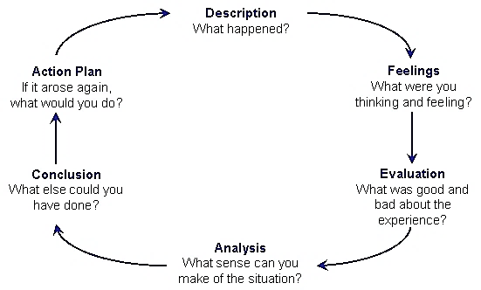
Gibbs (1988)

3.1 Description
I researched the job application process as listed below:-

Covering letter
I have researched on reed.co.uk to look at points of what is required to add into a covering letter and the dos and don’ts.

Personal Statement
I have researched on Eteach website.

Job Advert
I found the relevant job advert on Eteach and read the job description. I also researched Prospects regarding tips on how to complete a form and the correct information to include. I also looked on the school website of the job vacancy I was applying for.

Interview process
I looked at and read about the STAR method.

3.2 Feelings

Prior to conducting my research I was nervous and concerned. At the very beginning of my research I became slightly overwhelmed.

After conducting my research I felt it was extremely informative and I felt more knowledgeable and had a clearer understanding.

I am very apprehensive and lack confidence when it comes to interviews.

3.3 Evaluation

I did struggle to find a suitable job advert in my area and it took some time and searching of various websites. After searching indeed unsuccessfully I did find a suitable job on the Eteach in a different area. I found the website easy to use and it gave a lot of information on the job available and helpful tips on completing applications.

I believe my research into the CVs and covering letter went well and helped me write more focused and meaningful documents. There was a lot of information on a number of webpages. Prospects were extremely helpful on tips and dos and don’ts. I spent a lot of time reading the job specification to have a true understanding of the role. I also researched the school by looking at their website and finding out about their school ethos which was extremely beneficial.

On researching the STAR method online and in class I felt I had a better understanding of what to expect and how best to deliver in an interview.

3.4 Analysis

At the beginning of the process I was concerned because I felt I didn’t have enough personal experience in preparing CVs, covering letters and job applications. I think this is due to lack of confidence as I have only had 2 long term jobs during my working life. I also started to feel overwhelmed at the start of my research as it was a lot to take in and I felt it was slightly daunting. I overcome this by focusing my attention on one task at a time and making notes as I progressed through the process.

After I had completed my research my confidence grew and I felt more knowledgeable and competent in completing the relevant documents. I felt my writing skills and my understanding of what information employers required improved as a direct result of my research.

Interview process ~ I have very little experience in interviews. I find it very difficult to talk when put on the spot and especially when nervous. I find it hard to talk about myself on a positive note and I am very self-critical. In my current post I had volunteered for 6 months on a part time basis. During my interview for a full time employed position I found it extremely hard to talk about my new learnt skills and how I could be an asset to the School.

3.5 Conclusion

I feel I could have tried different research methods such as textbooks.

I learnt that the covering letter is extremely important which I have never had to complete before and the importance of catching the potential employers attention. I also learnt that you need to be concise and clear on your CV and the importance in researching the companies you are applying for.

On reading up on the STAR interview method if I was to apply for a job I would feel I would have a much better understanding of what to expect and to be able to give a more clear and confident answer and the ability to back up my claimed skills. I now understand how I would need to draw on my experience and elaborate on these during the interview. This will help me be more prepared in future interviews.

3.6 Action Plan

In the future I will definitely be applying my new knowledge and skills when I apply for new jobs. I understand the importance of drawing on your strengths at all times and having the ability to promote your skills to create a positive and eye catching CV. I feel it is extremely important that you research and take a lot of time to peruse the job specification and have a real good understanding of what it is required for the post. After checking out the website of the school with the vacancy. I realised my current school and the school I was applying for had lots of similarities so I was able to draw on these and highlight them in my covering letter and job application. Your CVs should be tailored to the job you are currently applying for to meet their needs and to catch your potential employer’s attention so any opening statement/summary should be eye catching and informative so they want to read more about you.

I would revisit the STAR method if I was to have an interview and I would compile a list of examples I would draw from my previous experiences as to why I would be a good fit for their Company so I was prepared. This would allow me to deliver them in a prompt and professional manner when prompted in interviews.

References
Gibbs, G. (1988) Learning by doing; A guide to teaching and learning methods. London: FEU
Add more references here from your research into CVS, interview techniques etc

Job Advert ~ Eteach
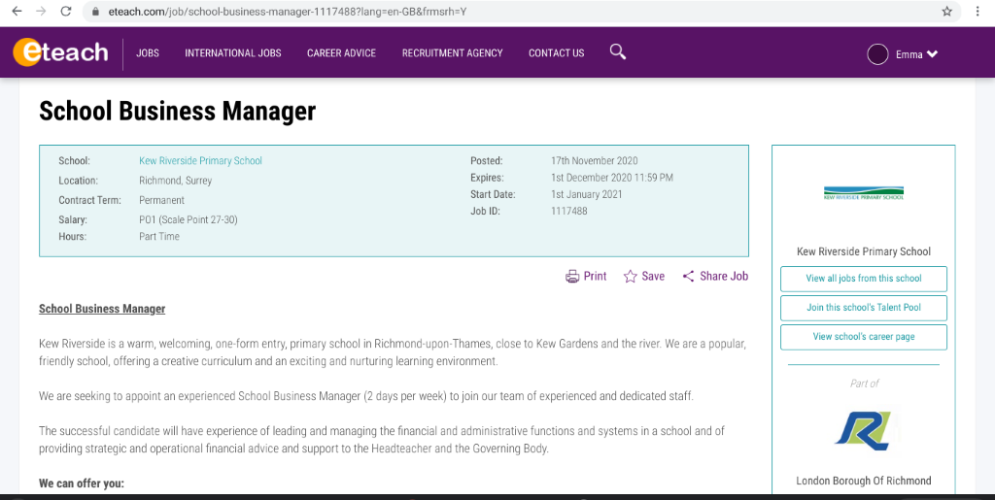

Kew Riverside Primary School Website
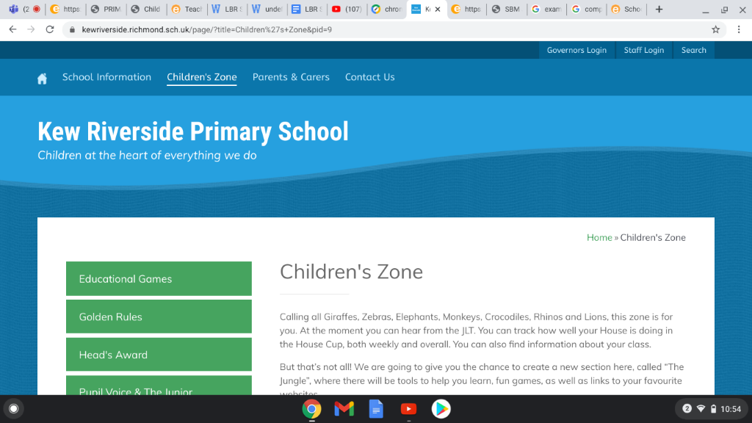

Job application
https://www.prospects.ac.uk/careers-advice/applying-for-jobs/write-a-successful-job-application

Appendix A

Job Application Form - Confidential

JOB TITLE: School Business Manager

VACANCY REFERENCE: Kew Riverside Primary School

CLOSING DATE: 1st December 2020
Please complete this form electronically or in black ink.  Please return your completed application form by:  - E-mail to: info@kewriverside.richmond.sch.uk | For HR department use only  Applicant considers themselves as disabled:  Yes ☐ No ☐
 | HR Signature
 | Date
 | Applicant ID

Please refer to our Privacy Notice for further information on how we process the personal data you provide in this form

- Qualifications

Beginning with the most recent, please provide details of your qualifications (academic,
professional and / or vocational) that are relevant to this application. Please continue on a
separate sheet(s) if necessary. Please note: Original documents may need to be provided.
Education Establishment / Training Provider | Qualification(s) obtained (including grade if applicable) | Date Awarded
University of Wales Trinity Saint David  University of Wales Trinity Saint David  Swansea College (Evening Classes)  Swansea College (Evening Classes)  Pentrehafod School | BA Leadership & Management Skills for the Workplace  Level 4 Certificate of Higher Education skills for workplace  Word Processing Level 3  Word Processing Level 2  English  Maths  Science  IT  Art  Childcare | 2020  2018  2002  2001  1999

- Training and Development
Please provide details of any relevant training and development courses that you have attended.

Training Provider | Name of Training / Development Course | Date
Hwb | Data Protection | 2020
Hwb | Bullying & Harassment | 2020
Hwb | Fire Marshall | 2020
Hwb | Health & Safety | 2020
City & County of Swansea ~ Social Services | Child Protection | 2020
City & County of Swansea ~ Social Services | Safeguarding | 2020
Hafod Primary School (In house) | Google Classroom | 2019
Pupil & Governors Team ~ City & County of Swansea | Clerk to the Governors | 2019
DJM Solicitors in house Training | Money Laundering (Yearly) | 2017
DJM Solicitors in house Training | GDBR training (Yearly) | 2017

- Membership of Professional Bodies
Please list your membership(s) of Professional Body / Bodies (if applicable)

Not applicable

- Current or Most Recent Employment

Name and address of employer:
Hafod Primary School

Job Title:
School Clerk & Clerk to the Governors
Start date:  September 2018 | Basic Salary:  £20,000 pa
Brief description of duties:
- Ensuring the correct running of our school budget, Financial System (FMS) including placing all purchase Orders, record keeping, processing Bank statements and issuing all invoices.
- Processing invoices and completing cheque runs in a timely manner.
- Monitoring school funds.
- Completing all statutory returns e.g. PLASC, SWAC etc as required.
- Monitoring all policies and amending and updating when required.
- Taking minutes in any meetings required by the Senior Management team.
- Completing new staff members paperwork including contracts and making sure all their paperwork is correct before their start date.
- Ensuring all staff paperwork including DBS are up to date and stored correctly in line with GDPR guidelines.
- Keeping all pupils records and SIMS up to date including attendance.
- Enrolling new pupils and providing families with the correct information regarding our school and supporting them and completing the necessary paperwork for all leavers.
- Communicating with all parents/carers and visitors and helping with all queries and providing them with support if necessary.
- Signing in all visitors and contractors into the school safely.
- Clerking and attending all Governing Body meetings and providing support to the Chair of Governors as required.
Reason for leaving: New challenge | Period of notice required:  1 month
Current employer? Yes X No ☐

If no, please state your end date of employment:

- Employment History

Beginning with the most recent, please provide a summary of all other employment, including previous posts held with your current or most recent employer. Please continue on a separate sheet(s) if necessary.
From / To | Name and address of employer |  | Job title, brief description of duties and reason for leaving
August 2001 ~ Sept 2018 | DJM Law Ltd  16 Axis Court  Mallard Way  Swansea Vale  Swansea  SA7 0AJ | Legal Secretary  - Typing all letters, Court documents and attendance notes using audio.  - Filing and keeping all files up to date.  - Answering all telephone calls and emails for the department.  - Booking appointments and meetings.  - Covering reception and switchboard when required.  - Complying with Money Laundering and GDPR regulations.  - Reason for leaving ~ Opportunity to work in an inspirational environment.
Sept 1999 ~ August 2001 | DJM Law Ltd  16 Axis Court  Mallard Way  Swansea Vale  Swansea  SA7 0AJ | Office Junior  - Photocopying Court bundles.  - Covering reception and switchboard.  - Completing deliveries.  - Taking clients to have Affidavits sworn.  - Supporting secretaries with filing when required.  - Providing board meetings with refreshments.  Reason for leaving ~ Promotion

6. Language Skills

Are you a Welsh speaker?

Yes ☐ No X

If yes, please state your level of fluency in Welsh: | N/A
Are you fluent in any other languages?
Yes ☐ No X

If yes, please specify: | N/A

7. Employment Related Referees
Please provide details of two work related referees. The first of these should be your line manager from your current or most recent employer. All offers of employment are conditional upon receipt of satisfactory references. References will only be sought upon an offer being made to a successful candidate.

*Please refer to section 8 if you are unable to complete this section.

1st Work Reference

Name
Mrs Nicola Fredrickson

Address
Hafod Primary School, Odo Street, Hafod, Swansea, SA1 2LT

Telephone number
01792461356

E-mail address
FredricksonN@swansea-edunet.gov.uk

Position held by referee
Headteacher

Employment relationship
Manager/Headteacher

2nd Work Reference

Name
Mr Barry Davies

Address
DJM Law Ltd, 16 Axis Court, Mallard Way, Swansea Vale, Swansea, SA7 0AJ
Telephone number
01792650000

E-mail address
Bjd@djm.law.co.uk

Position held by referee
Office Manager

Employment relationship
Manager

8. Character Referee

If you are unable to provide two work related referees, please provide details of someone who can offer a character reference about you.

Character Referee

Name
Address
Telephone number

E-mail address

Your relationship with the referee

9. Supporting Statement
Please provide a supporting statement to show how you meet the Person Specification criteria, wherever possible relating this to the duties in the Job Description. You are encouraged to provide relevant and explicit examples (obtained from the workplace, voluntary or community work or any other appropriate situation) so that the short-listing panel is able to clearly identify where your experience, knowledge and skills match the criteria identified in the post and understand what qualities you can bring to the role.

Please note, CV’s will only be accepted as supporting documentation to the application form.
I am delighted to have the opportunity to apply for School Business Manager at your wonderful school and thank you for your time in considering my application.

About me
I have recently successfully completed a BA Leadership and Management Degree. I feel this has been extremely helpful and beneficial. It has definitely helped me to grow and I have been able to apply my new knowledge and skills to my current post. It has given me more confidence in my leadership and management styles. I am a very approachable person and I believe in an open door policy. I have always had strong links with the school I am currently employed as I have been part of the Schools Parent Council for some years which is an extremely rewarding role.

The school I am currently employed at is a multicultural school and has a very strong Children's Rights ethos and I feel this meets the same ethos as Kew Riverside Primary School. I completely feel children should be at the heart of every decision and that we can all work together as a team to give the children the best environment to continue to nurture and grow.

Transferable skills
I pride myself in my work ethics and I have listed some of my skills below which I can offer your school:-

- Ability to build good working relationships ~ I feel this is a key skill to being a successful manager. I am an extremely approachable and empathic person and a good listener which I feel is important to build good solid relationships with staff, pupils and parents/carers.
- Adaptable ~ School life can be an extremely fast place and I can adapt to and respond appropriately to all situations as this arises. Whether this is part of a team or on my own initiative.
- Professional ~ Whilst I can work very well as part of a team and I can also work successfully on an individual basis. I am extremely professional and take confidentiality very seriously. I have always demonstrated this within my current and previous employment.
- IT skills ~ I have always worked with IT and have a good knowledge on office and school based software. I am very confident and can adapt to new software successfully.
- Passionate & dedicated~ I am an extremely passionate and dedicated person and always willing to give every task 100%.
- Organised ~ I am a very organised individual. I like to be prepared and organised. I feel this helps me get the best out of every day and have good timekeeping skills.
- Enthusiastic to continue to learn ~ I am extremely enthusiastic to continue developing my skills and happy to attend all courses that would be beneficial to your school as I understand schools are changing all the time and as a team we need to embrace all change so we can continue to grow and develop.

Thank you once again for your time and consideration for the above position at your school. I feel extremely excited and passionate at the potential of becoming part of your team and continuing to achieve fairness and good working ethics within Kew Riverside Primary School.

Personal Details and Monitoring Form - Confidential

Applicants are requested to provide the following information for records purposes, and to enable the University to meet our statutory equality obligations. The information provided will be processed in accordance with the Data Protection Act 2018 and will not be used in the selection process.

- Vacancy Details (HR Department use only)

Position applied for: | School Business Manager
Vacancy Reference:
Applicant ID:

- Personal Details

Title: Mr ☐ Mrs X Miss ☐ Ms ☐ Dr ☐ Prof ☐ Other ............

Forename(s):  Emma Leanne | Surname:  Nightingale
Home Address:
149 Middle Road, Cwmbwrla, Swansea, SA5 8HE

Home Telephone:  01792511247 | Mobile Telephone:  07999890949
Email Address:  Emmanightingale11@gmail.com | Date of Birth:  06/02/83
National Insurance Number:
JA125623A

- Gender
Please indicate your gender:
Male ☐ Female X Other ☐

- Ethnicity

Please indicate your ethnicity:
X White  ☐ White - Scottish  ☐ Irish Traveller  ☐ Gypsy or Traveller  ☐ Other White background  ☐ Black or Black British - Caribbean  ☐ Black or Black British - African  ☐ Other Black background  ☐ Asian or Asian British - Indian  ☐ Asian or Asian British - Pakistani  ☐ Asian or Asian British – Bangladeshi | ☐ Chinese  ☐ Other Asian background  ☐ Mixed - White and Black Caribbean  ☐ Mixed - White and Black African  ☐ Mixed - White and Asian  ☐ Other mixed background  ☐ Arab  ☐ Other ethnic background  ☐ Not known  ☐ Prefer not to say

- Religion and Belief

Please indicate your religion / belief:

☐ No religion  ☐ Buddhist  ☐ Christian  ☐ Christian - Church of Scotland  X Christian - Roman Catholic  ☐ Christian - Presbyterian Church in Ireland  ☐ Christian - Church of Ireland  ☐ Christian - Methodist Church in Ireland | ☐ Christian - Other denomination  ☐ Hindu  ☐ Jewish  ☐ Muslim  ☐ Sikh  ☐ Spiritual  ☐ Any other religion or belief  ☐ Prefer not to say

- Sexual Orientation
Please indicate your sexual orientation:

☐ Bisexual  ☐ Gay  ☐ Lesbian | X Heterosexual  ☐ Other  ☐ Prefer not to say

7. Disability

Under the Equality Act 2010, you are considered disabled “if you have a physical or mental impairment that has a ‘substantial’ and ‘long-term’ negative effect on your ability to do normal daily activities.”
- ‘Substantial’ is more than minor or trivial, e.g. it takes much longer than it usually would to complete a daily task like getting dressed
- ‘Long-term’ means 12 months or more

Do you consider yourself to be a disabled person? Yes ☐ No X

If yes, please indicate your disability:  ☐ No known disability  ☐ Two or more impairments and/or disabling medical conditions  ☐ A specific learning difficulty such as dyslexia, dyspraxia or AD(H)D  ☐ General learning disability (such as Down's syndrome)  ☐ A social/communication impairment such as Asperger's syndrome/other autistic spectrum disorder  ☐ A long standing illness or health condition such as cancer, HIV, diabetes, chronic heart disease, or epilepsy | ☐ A long standing illness or health condition such as cancer, HIV, diabetes, chronic heart disease, or epilepsy  ☐ A mental health condition, such as depression, schizophrenia or anxiety disorder  ☐ A physical impairment or mobility issues, such as difficulty using arms or using a wheelchair or crutches  ☐ Deaf or serious hearing impairment  ☐ Blind or a serious visual impairment uncorrected by glasses  ☐ A disability, impairment or medical condition that is not listed above  ☐ Prefer not to say

8. Work Permit
Do you require a work permit to work in the UK? Yes ☐ No X

If yes, do you currently hold a work permit to work in the UK? Yes ☐ No ☐

If yes, please state the nature of your work permit and its expiry date:

9. Rehabilitation of Offenders
Do you have any convictions, cautions, reprimands or final warnings that are unspent under the Rehabilitation of Offenders Act 1974 and which are not “protected” as defined by the Rehabilitation of Offenders Act 1974 (Exceptions) Order 1975 (as amended in 2013)?

Yes ☐ No X

Where a job falls within one of the excluded categories under the Rehabilitation of Offenders Act 1974, disclosure of any spent convictions is required and any offer of employment, if made, will be subject to a DBS (Disclosure and Barring Service) check.

Further information can be found on the Government website: Updated guidance on the Rehabilitation of Offenders Act 1974.

10. Source

Please indicate where you first saw this job advertised:
☐ Website  ☐ Job Centre (Find a Job)  ☐ Internal email  ☐ Golwg360  ☐ Fish4jobs  ☐ Indeed  ☐ Totaljobs | ☐ Newspaper  ☐ Jobs.ac.uk  ☐ Lleol.net  ☐ Times Higher Education  ☐ Word of mouth  X Other (please specify)  Eteach

11. Declaration
By signing here, I confirm that:
- The information given in this application is, to the best of my knowledge and belief, true and accurate;
- I have read the Job Applicant Privacy Notice; and
- I understand that, if an offer of employment is made to me, XXXX will seek references from the referees I have provided.

Applicant Signature: Date: 20.11.2020

(Electronic or Handwritten)

Appendix B

Emma Nightingale

149 Middle Road, Cwmbwrla, Swansea, SA5 8HE
Emmanightinale11@gmail.com | 07999890949
Summary
I have recently successfully completed a BA Leadership and Management Degree. I feel this has been extremely helpful and beneficial. It has definitely helped me to grow and I have been able to apply my new knowledge and skills to my current post. I have a confident leadership and management style. I am a very approachable person and I believe in an open door policy.

I work in a multicultural school and it has a very strong Children's Rights ethos and I feel this meets the same ethos at your school also. I completely feel children should be at the heart of every decision and that we can all work together as a team to give the children the best environment to continue to nurture and grow. I feel very passionate about this.

Experience
SCHOOL CLERK & CLERK TO THE GOVERNORS
Hafod Primary School ~ 2018 to current
- Ensuring the correct running of our school budget, Financial System (FMS) including placing all purchase Orders, record keeping, processing Bank statements and issuing all invoices.
- Processing invoices and completing cheque runs in a timely manner.
- Monitoring school funds.
- Completing all statutory returns e.g. PLASC, SWAC etc. as required.
- Monitoring all policies and amending and updating when required.
- Taking minutes in any meetings required by the Senior Management team.
- Completing introductions for new staff members including ensuring all required paperwork is correct. Drafting contracts and performing inductions and ensuring new staff are up to date with all school policies.
- Ensuring all staff paperwork including DBS are up to date and stored correctly in line with GDPR guidelines.
- Keeping all pupils records and SIMS up to date including attendance.
- Enrolling new pupils and providing families with the correct information regarding our school and supporting them and completing the necessary paperwork for all leavers.
- Communicating with all parents/carers and visitors and helping with all queries and providing them with support if necessary.
- Signing in all visitors and contractors into the school safely.
- Clerking and attending all Governing Body meetings and providing support to the Chair of Governors as required.

LEGAL SECRETARY
DJM Law Ltd ~ 2001 to 2018
- Typing all letters, Court documents and attendance notes using audio.
- Filing and keeping all files up to date.
- Answering all telephone calls and emails for the department.
- Booking appointments and meetings.
- Covering reception and switchboard when required.
- Complying with Money Laundering and GDPR regulations.
- Photocopied all correspondence, documents and other printed materials.
- Being the first form of contact and liaison between clients, solicitors and barristers.
- Processed and distributed invoices for clients in a timely manner.
- Received and disbursed all incoming posts.

OFFICE JUNIOR
DJM Law Ltd ~ 1999 to 2001
- Photocopying Court bundles.
- Covering reception and switchboard.
- Completing deliveries.
- Taking clients to have Affidavits sworn.
- Supporting secretaries with filing when required.
- Providing board meetings with refreshments.
Skills
- Excellent Financial management Skills
- Good Multitasking and ability to prioritise workload
- Approachable & adaptable
- Good leadership skills
- Excellent team player & able to work on an individual basis
- Enthusiastic, passionate & committed
- Excellent IT skills.
- Drive to learn and develop skills further

Education
University of Wales Trinity Saint David ~ 2020
BA Leadership & Management

University of Wales Trinity Saint David~ 2018
Certificate of Higher of Education in the workplace Level 4

Swansea College ~ 2002
NVQ Level 3 Word Processing

Swansea College ~ 2001
NVQ Level 2 Word Processing

Pentrehafod Comprehensive School ~ 1999
GCSE Maths, English, Science, IT, Art, Childcare

Appendix C
Mrs Emma Nightingale
149 Middle Road
Cwmbwrla
Swansea
SA5 8HE
07999890949
20th November 2020

Kew Riverside Primary School
37 Courtlands Avenue
Kew
Surrey
TW9 4ES

Dear Mr N Webb ~ Headteacher & Mr S Hyams ~ Chair of Governors

Re: School Business Manager Vacancy

I am extremely privileged and passionate to be applying for the current vacancy at Kew Riverside Primary School as such I enclose my CV for your perusal and consideration.

As you can see within my CV I have successfully completed a BA Leadership & Management Degree. I feel this has been extremely beneficial to me and it has provided me with the knowledge to be able to build and grow my leadership and management skills which I put into practice on a daily basis. I have worked in a school environment for the last 2 years which has been an extremely rewarding and a fulfilling role.

As you will see I have successfully run and managed the school budget in my current post for the last 2 years. We use an FMS programme which I am completely competent and knowledgeable of. However, I am very adaptable and able to transfer my skills and learn new IT programmes quickly. We also use SIMS for pupils' details which I am responsible for. I understand the importance of GDPR and I am extremely knowledgeable of the regulations surrounding this Policy and take this very seriously.

During my working life I have learnt that working as a team can be paramount to successfully succeed. I believe an open day policy and being extremely approachable can help staff morale and help achieve great results and encourage all stakeholders to feel valued and part of the team. I believe it is extremely important to have a clear vision and that all stakeholders are part of the planning and the vision so together as a team we can achieve great things with the children's wellbeing and education at the heart of everything we do.

I take this opportunity to thank you for your time and the opportunity to apply for the current position. If you have any queries or would like more details or clarification please do not hesitate to contact me. I look forward to hearing from you and potentially meeting with you in the future.

Yours sincerely


Mrs Emma Nightingale

