Rheumatoid Arthritis: An In-depth Analysis of Its Impact and Management

NAME : MAHAMADFARAZ HANIFBHAI BELIM

STUDENT NUMBER : 2504518

MODULE CODE AND TITLE : LCHS7003 ,
COMMUNITY CARE AND MANAGEMENT OF LONGER-TERM CONDITION.

LETURER’S NAME : DR.AISHAT BAKRE

ASSIGNMENT TITLE : COMPONENT 1 INFORMATION BOOKLET OF LING-TERM CONDITION MANAGEMENT

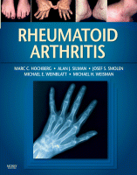

(‘Rheumatoid Arthritis’ 2009)
Rheumatoid Arthritis: An In-depth Analysis of Its Impact and Management
Introduction
Rheumatoid arthritis (RA) is a chronic autoimmune disease that devastates the physical, mental, and social well-being of people, and approximately 400,000 people in the UK are affected. It is characterized by immobility, inflammation, and stiffness of joints and makes even the most basic tasks that people should complete, e.g., brushing their teeth and changing clothes, extremely difficult. While not common, RA is a complex disease, as it arises from the body's immune system mistakenly attacking its own tissues, leading to inflammation, pain, and permanent damage (Perpetual Uke et al., 2025, p. 102036). It is mainly found in women aged between 30 and 60, but can be found at any age and gender. RA is also a huge disability cause in the world, with the prevalence rate of about 1 percent of the world population (American College of Rheumatology, 2022). Such a multidisciplinary approach to RA is necessary not only to deal with physical symptoms, but also to concentrate more on the general psychological and social problems RA causes. This paper explores the prevalence, risk factors, and outcomes of RA, not excluding its physical, psychological, and social impacts. It also evaluates the current practice within the treatment of patients in the UK, consults the theoretical frameworks that aim to assist in enhancing the patient outcome, and discusses the implications of the policy within the relationship to contributing to the enhancement of person-centred care. Lastly, recommendations on how to reduce the RA administration and address lapses in care are provided.
Definition, Prevalence, and Risk Factors.
Definition
RA is an autoimmune disease, which means that the immune system mistakenly attacks the body against a pathological agent, specifically the synovial membranes that are connected to joints. It causes inflammation and degeneration, resulting in joint pain, which may be excruciating, stiffness, and swelling (Arleevskaya et al., 2021, p. 100119). Lastly, RA may cause disability. ( National Institute for Health and Care Excellence [NICE], 2023).
Prevalence
RA is a condition that is prevalent in 1 percent of the population across the world ( American College of Rheumatology, 2022). According to estimates from the UK, RA affects approximately 400,000 people (Arthritis Research UK, 2021). The ratio is approximately 3:1, and it is virtually nonexistent in males, as estimated. It is a diagnosable disease whose patients can be of any age; though, patients between 30-60 years old are the most diagnosed individuals (Mayo Clinic, 2023).
Risk factors
Key risk factors include:
Non-Modifiable Risk Factors
1. Genetics: In a family history, RA increases the risk of contracting the disease (Scherer et al., 2020, p. 102400).
2. Hormonal Factors: It is more likely that women have RA, and in such cases, it could be that hormones are related to the immune system (Kawahito et al.,2022, p. 21).
3. Age: The majority of the RA cases are observed in 40-60-year-olds.
Modifiable Risk Factors
Environmental Factors (Smoking): Smoking is one of the significant environmental factors that may trigger or aggravate RA, particularly in genetically inclined individuals (Kawahito et al.,2022, p. 21).
Obesity: Overweight leads to the risk of getting RA because fat tissue may support the inflammatory process, which will cause or aggravate the symptoms of RA.
Diet: An incorrect diet, especially one that is rich in processed foods and low in antioxidants, may also lead to inflammation, and this may be a risk factor for RA.
Impact of RA
The effects on physical symptoms are not the only impacts on mental health and social welfare, as the effects of RA are massive.
- Physical Impact: RA leads to the principal influence on joint inflammation, thus making them more painful, swollen, and stiff, in addition to becoming less mobile. In worst-case scenarios, the joints could be curved and fractured, rendering them unable to perform their daily operations. The Arthritis Foundation (2023) also emphasizes that one of the most common symptoms is fatigue, which is also a factor contributing to a lower quality of Life (Kronzer et al., 2020, p.656).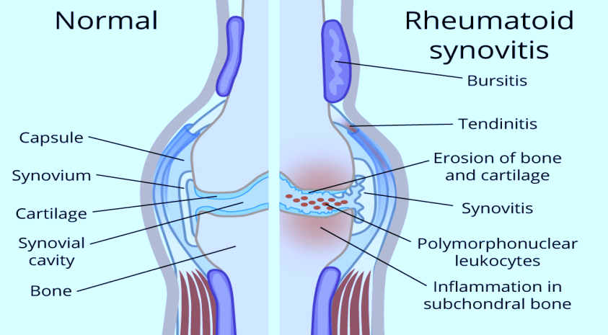
Figure 1 Comparison of a Normal Joint and a Joint with Rheumatoid Synovitis (Rheumatoid Arthritis - OrthoInfo - AAOS 2016)
- Psychological impact: Co-morbidity. The psychological influence could be the comorbid chronic and debilitative disease, e.g., RA. They discover that the patients of the RA 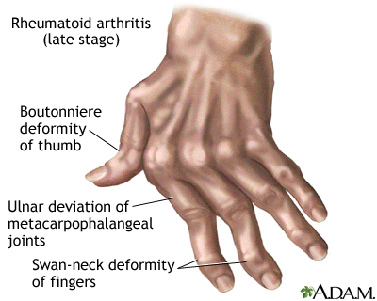
Figure 2 Deformities of the Hand in Late-Stage Rheumatoid Arthritis. (Hand Rheumatoid Arthritis 2016)
are at high riskof anxiety and depression. 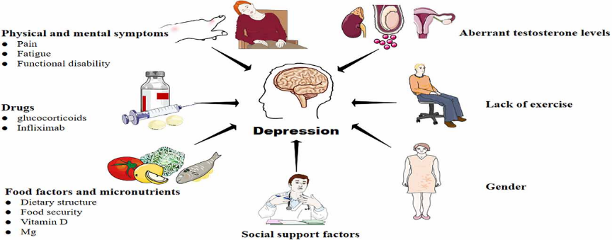
Figure 3 Factors Contributing to Depression (Liu et al. (2023)
(Mueller et al. 2021,p.3017). This is further augmented by the fact that physical impairments are irreversible and the temper is unpredictable, which adds to hopelessness and despair. The results of one of the studies conducted by Kronzer et al. (2020, p. 656) tend to correlate emotional distress with the severity of the joint pain and disability.

Social Impact: RA causes physical limitations that hinder social relationships, family life, and leisure activities, often leading to isolation and unemployment (Lwin et al., 2020, p. 457). There is also stress in the caregivers as they help them to move around and carry out simple tasks (McQueenie et al., 2020, p. e038829).
Evidence-Based Treatment.
The RA management should be multi-modal, and it should entail the use of drugs, physical activities, and lifestyle changes.
- Drugs: The most significant drugs in RA treatment include disease-modifying antirheumatic drugs (DMARDs), which encompass both inflammatory-inhibiting medications and those that reduce the rate of disease progression. In successful DMARDs (and vice versa), biologic agents (e.g., TNF inhibitors (adalimumab, infliximab), which are specifically targeting the components of the immune system) can also be used in the case of ineffective DMARDs (and vice versa), too (Scott et al., 2022, p. 100519).
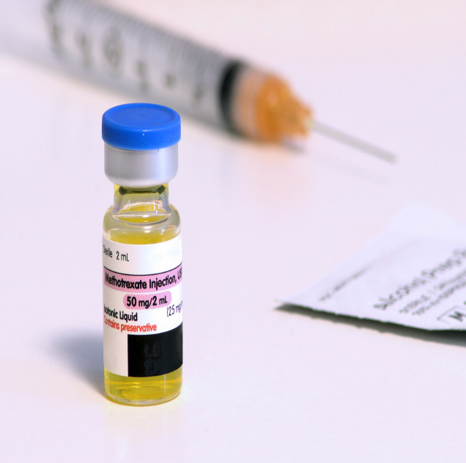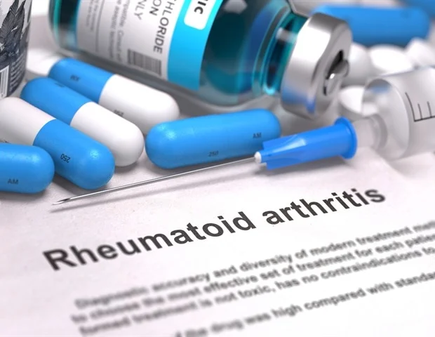
Figure 4 &5 Medical Management of Rheumatoid Arthritis (Mandal, 2013)
- Physical Therapy: Regular joint mobilization helps reduce stiffness and improve mobility. Consistent body therapy is effective in preventing idleness and supporting patients in restructuring occupational therapy activities to support their everyday lives (Hochberg et al., 2020, p. 567).
- Surgical surgery or removal of the inflammatory tissue (synovectomy): may also be required to not only cure the symptoms that were not overcome but also prevent additional damage to the joints (Black et al., 2023, p. e594) 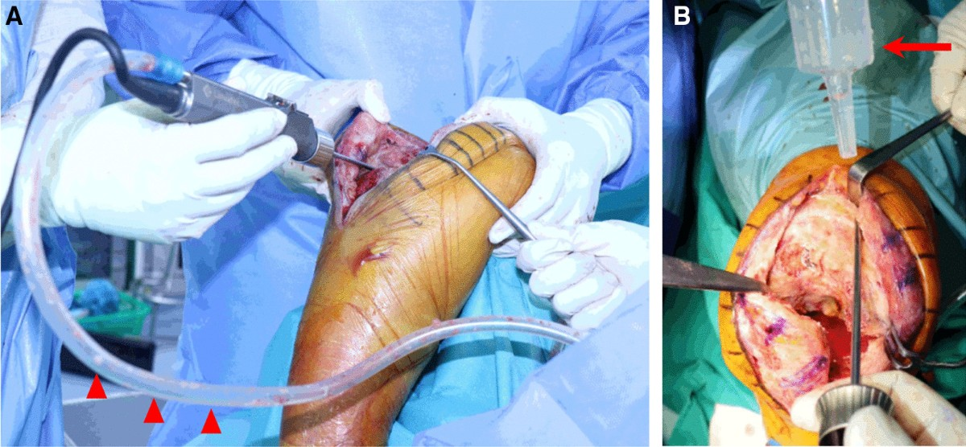
Figure 5 Open synovectomy procedure technique (Shon, Lee & Kim 2022)
- Lifestyle changes: Lifestyle modifications also form part of RA treatment; among them are the cessation of smoking, maintaining a healthy weight, and engaging in regular exercise. The changes can be implemented to reduce the amplification of symptoms and will be more inclined to advance the overall performance of human beings.
Rheumatoid Arthritis Management Frameworks and Theoretical Models.
The management of Rheumatoid Arthritis (RA) should be a combination of physical, psychological, and social approaches (Gavan et al., 2020). Two of these models are the House of Care model and the Chronic Care Model (CCM), which focus on the multidisciplinary application of teams and person-oriented care as a method of achieving superior patient outcomes (Bay et al., 2020, p. 450).
House of Care Model (UK NHS Long-term Plan).
The model developed by the NHS is the Housing of Care model, which is based on the course of long-term conditions, including RA. It is made up of six valuable elements:
1.Engaged, Informed Individuals and Carers: Expert, participatory People and carers Self-management and service access in patients and carers.
2. Person-Centred Coordinated Care: Person-centred meaning of care.
3.Organisational and Supporting Processes: Evidence-based care services user-involvement.
4.Their loyalty to partnering working: Continuous relations of medical workers.
5. Commissioning: It increases the performance of the system by cycling (Zanten et al.,2020, p. 284).
6. Whole-System Approach: The given technique is one among the strategies and, in fact, combines health care services, which are attributed to producing a holistic impact of providing complete care to a patient.
The provided model is positive because it assumes the help of psychologists, who consider the emotional character of RA. Rheumatologists, physiotherapists, and psychologists are the healthcare professionals who work together to provide holistic care (NHS England, 2023).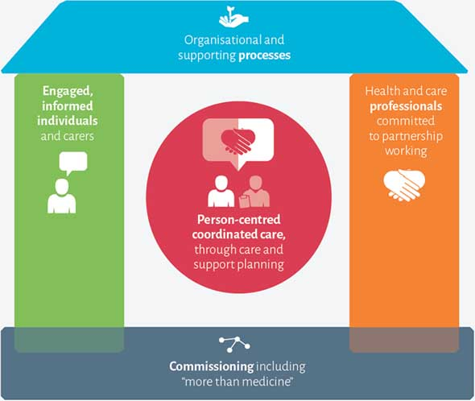
Figure 6 House of Care Model (UK NHS Long-term Plan).(NHS,2022)

Chronic Care Model (CCM): International model
The concept currently employed in the management of chronic diseases, such as rheumatoid arthritis (RA), is prevention-based, along with early detection and self-management, and is referred to as the Chronic Care Model (Ye et al., 2021, p. e038137). Its six components include:
1. Community Resources and Policies: Mobilisation and resources to increase chronic care.
2. Health System Organization: Care integration in the healthcare systems.
3. Self-Management Support: The channels of equipping the patients with the tools to manage their health.
4. Delivery System Design: Design Proactive interdisciplinary care.
5. Decision Support: Guidelines based on the insight to make care decisions.
6. Clinical Information Systems: The combination of information to make an informed treatment.
CCM addresses long-term disease treatment, patient engagement, and integrated care, as well as coordinated care (Ye et al., 2021, p. e038137).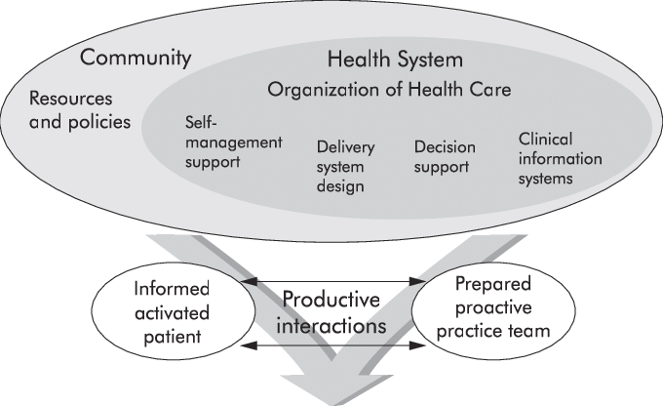
Figure 7 Chronic Care Model (CCM) (Wagner et al., 2020)

Integration of the Models
The two models are interpersonal and teamwork. They ensure comprehensive care for patients in terms of their physical, emotional, and social needs during the RA management process. The two models are both beneficial in encouraging patient education through the use of self-management support and holistic care, aided by multidisciplinary teams. The looseness of care between levels of care is emphasized, which is particularly important during the treatment of chronic conditions, such as RA.
RA Management Application and Integration.
The NHS Long-Term Plan and the Chronic Care Model provide information about the models of RA management. They also raise concerns about the topicality of the patient-centred approach, where the active role of self-care and the provision of required support to bear the symptoms are a matter of concern. The application of multidisciplinary teams, early intervention, and self-management would prove beneficial to a RA patient(Favalli et al. 2020,p.102523). By utilizing such models, healthcare systems will be better equipped to provide patients with integrated, coordinated, and continuous care, given the complexity and multifaceted nature of RA (Pinto et al., 2023, p. 3944).
In conclusion, the NHS Long-Term Plan application implemented in the UK and the Chronic Care Model application used in the rest of the world suggest a promising system for the effective treatment of RA. The models also enable and encourage patients to deliver care in an integrated and holistic manner, which is relevant to improving the quality of Life and long-term outcomes in patients with rheumatoid arthritis (Pinto et al.,2023, p. 3944).
Rheumatoid arthritis: Political: Health and Social Care Agendas.
A significant component of the management and treatment of rheumatoid arthritis (RA) is also the health policies in the area and nation, and patients with this type of disorder are under universal coverage of care as per their needs. The policies were presumed to address the multi-layered requirements of patients with RA who desire to be diagnosed and treated in the initial stages and continue the battle with the illness as well (Ryan et al., 2022, p. e056555). The plan of strategic management of chronic conditions, including RA, is provided in the NHS Long-Term Plan (2019). The strategy will provide customised care, considering personal needs, thereby ensuring that individual patients receive personalised care. One of the primary benefits of the plan, which aims to enhance individual active engagement in managing their own conditions, is patient empowerment (Takanashi & Kaneko, 2024, p. 7594). The NHS provides patients with the knowledge and capability of self-management, the means to regulate the process, and educational and assistance materials, teaching them to take responsibility for their health state and the quality of their lives. The plan also focuses on the multidisciplinary healthcare team, wherein specialists, physiotherapists, occupational therapists, and other mental health professionals will be needed to liaise in the delivery of holistic care to RA patients. Only this holistic model of care will provide patients with the opportunity to receive comprehensive treatment that considers both the physical/psychological aspects of the illness (Reuter et al., 2021). Early diagnosis and intervention have been shown to play a significant role in the management of RA, as they help prevent the devastating effects on the joints (Sretko Lukovic et al., 2024, p. 1600). National policies are concerned with the significance of early diagnosis and intervention techniques in the pathogenesis of diseases and the prevention of chronic disability (Harigai et al.,2025, p. 387). With the early detection of RA, medical teams can develop treatment programs that allow for the gradual reduction of disease reducing the chances of joint deformity and functional impairment (NHS England), addition to the national policy, the kind of services that are provided by the Public Health England and the local health organisations to the affected people with the RA are good community support services. The following services will be offered, including physiotherapy to enhance mobility and reduce pain, as well as occupational therapy benefits that will help patients perform daily activities (Harigai et al.,2025, p. 387). The antiprotective mechanisms and pain management interventions are also applied to decrease chronic pain, which include both pharmacological and non-pharmacological approaches. The locally based activities must be such that they can provide long-term life support and improve the lives of RA individuals (Public Health England, 2020).
In conclusion, the NHS Long-Term Plan and other interventions being implemented by the political health and social care policy will contribute significantly to ensuring that RA patients receive the required, comprehensive, and individualized treatment. The policies can help improve RA management and the lives of individuals already living with the condition by focusing on multidisciplinary care and community support services, as well as early diagnosis and treatment (Fraenkel et al.,2021, p. 924).

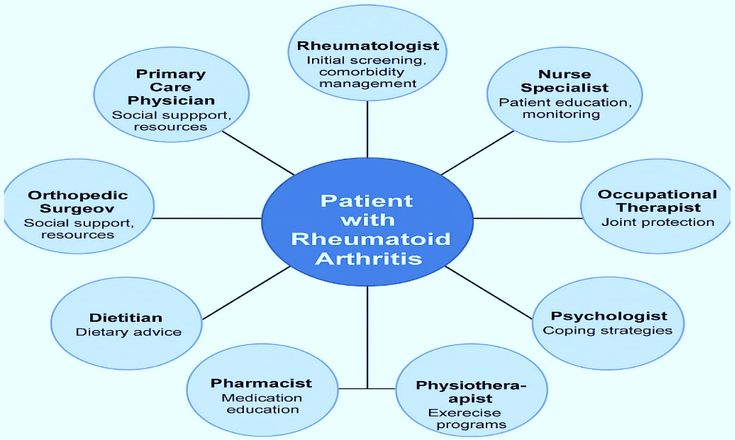
Figure 8 Multidisciplinary Team Involvement in Rheumatoid Arthritis Care. (Vlad et al. 2025)
Recommendations on Person-Centred Care in Rheumatoid Arthritis.
It would prefer to adopt a person-centred approach to managing patients with rheumatoid arthritis (RA), which extends beyond the traditional medical paradigm and encompasses the multidimensional process of RA in patients (Fautrel et al., 2024, p. 105790). The suggestions that are as follows will help in the improvement of the quality of Life of the affected population of this chronic condition:
1. The Self-Management Programs: Expansion:
The RA patients need to be supplied with a mechanism and capacity to cope with the symptoms. Self-management programs are essential in enabling patients to take control of their condition. The main points that should be emphasised in such programs are education, during which patients are informed about the disease and its progression, exercise, which can help reduce the inflexibility of tense joints, and stress management, as the symptoms of RA can be exacerbated by stress (Smolen et al.,2020, p. 685). Planned programs can reduce all of that and, in turn, contribute significantly to the overall improvement of the patient's wellbeing, thereby preventing flare-ups. Additionally, introducing a practice where patients regularly report their symptoms will promote the early identification of potential exacerbations and prevent joint damage (Venetsanopoulou et al.,2023, p. 404)
2. Tailored End-of-Life Care:
These are supposed to provide such patients with individual end-of-life care in those scenarios that the patients are highly aware of RA when the joints or other complications crippling the patients are highly deformed. Management of pain should also be considered, where individuals should be subjected to minimal pain that can be alleviated through the application of pharmacological and non-pharmacological pain management systems, incorporating palliative care approaches (Smolen et al., 2020, p. 685). Moreover, the emotional and psychological fears associated with end-of-life care will also be taken into account to ensure that the patient does not suffer loss of dignity and quality of Life. The palliative care teams will be expected to meet with the patient and their family, providing them with holistic care that includes psychosocial counselling and spiritual care (Luo et al., 2025, p.13)
3. The use of the Person-Centred Approach is one of the priorities:
Person-centred care should also incorporate patients' decision-making in formulating plans for how treatment will be administered. RA patients should feel that they can determine the therapies that best suit their lives. The hospital workers should also be taught to understand the psychological cost of being a victim of an ongoing disease such as RA (Fraenkel et al.,2021, p. 924). It will also presume the mental health support of the patient, and in the given instance, it will be assumed that the issues of anxiety, depression, and stress cannot be separated when it comes to RA. Cognitive behavioural therapy (CBT), support groups, and counselling services can also be used to help patients unload the emotional burden of a chronic illness and eventually live a better life (Mueller et al. 2021,p.3017). Lastly, complex and multifaceted care should also be part of the RA strategy, as it is founded on self-management education, end-of-life care, and a focus on supporting mental health, providing a holistic approach (Lukovic et al., 2024, p. 1600). As patients in the RA community face not only physical but also emotional demands, medical workers will be able to ensure that the patients in question receive the support they require to improve their Quality of Life and overall state of living (Vlad et al., 2025, p. 103).
Conclusion
In conclusion, rheumatoid arthritis (RA) is not a life-altering disease, but a disease in the body because it is manifested in the emotional level, social level, and physical level. In particular, the fact that the prevalence rates of RA are large in women at the age of 30-60 years is another significant piece of information that one should consider regarding the early development, as well as the questions of their treatment. As soon as it starts showing, the impact of RA is much greater in comparison to the joints, and it affects the mental health and the family life, as well as the ability to participate in the daily processes of Life. It is also a blessing in itself that they have already-prepared management options (DMARDs, biologics, and physical therapy) that are receiving some attention, and that the process of RA management is a complex one that controls both physical symptoms and mood. Moreover, it is possible to provide recommendations on how work with RA patients may be enhanced by referencing theoretical frameworks such as the NHS Long-Term Plan and the Chronic Care Model, with a focus on self-management, early intervention, and multidisciplinary care. These political interests include NHS interests in the UK. They are most decisive in healthcare settings in RA, ensuring that patients are incorporated into the care setting and their multifaceted demands are met. Self-management programs, provision of access to treatment, and more person-centred types of care can help reduce the burden of RA on patients and their relatives in the future. Finally, rheumatoid arthritis is one of the long-term investments made by medical practitioners and policymakers to improve the quality of Life for victims. With the introduction of new forms of treatment and the most beneficial systems of support, one could have made RA not only treatable but also accessible at all levels of care.

References list
American College of Rheumatology. (2022). Rheumatoid Arthritis: Prevalence and Statistics. (www.rheumatology.org)
Arthritis Foundation. (2023). Rheumatoid Arthritis: Symptoms and Diagnosis. (www.arthritis.org)
Arleevskaya, M, Takha, E, Petrov, S, Kazarian, G., Novikov, A., Larionova, R., Valeeva, A., Shuralev, E, Mukminov, M, Bost, C, & Renaudineau, Y. (2021). 'Causal risk and protective factors in rheumatoid arthritis: A genetic update', Journal of Translational Autoimmunity, vol. 4, Elsevier BV, p. 100119, viewed 14 October 2025, (https://www.sciencedirect.com/science/article/pii/S2589909021000393.)
Bay, LT, Ellingsen, T, Giraldi, A, Graugaard, C & Nielsen, DS (2020). '"To be lonely in your own loneliness": The interplay between self‐perceived loneliness and rheumatoid arthritis in everyday Life: A qualitative study', Musculoskeletal Care, vol. 18, Wiley, no. 4, pp. 450–458, viewed 14 October 2025, (https://pubmed.ncbi.nlm.nih.gov/32491275/)
Fautrel, B, Kedra, J, Juge, P.-A., Rempenault, C, Drouet, J, Jérôme Avouac, Athan Baillet, Olivier Brocq, Alegria, GC, Constantin, A, Emmanuelle Dernis, Cécile Gaujoux-Viala, Goëb, V, Jacques-Eric Gottenberg, Goff, BL, Marotte, H, Christophe Richez, Salmon, J-H, Alain Saraux & Senbel, E (2024). '2024 update of the recommendations of the French Society of Rheumatology for the diagnosis and management of patients with rheumatoid arthritis', Joint Bone Spine, vol. 91, Elsevier BV, no. 6, pp. 105790–105790, viewed 14 October 2025, (https://www.sciencedirect.com/science/article/pii/S1297319X24001015.)
Fraenkel, L, Bathon, J., England, BR, St.Clair, EW, Arayssi, T, Carandang, K, Deane, KD, Genovese, M, Huston, KK, Kerr, G, Kremer, J, Nakamura, MC, Russell, LA, Singh, JA, Smith, BJ, Sparks, JA, Venkatachalam, S, Weinblatt, ME, Al‐Gibbawi, M & Baker, JF (2021). '2021 American College of Rheumatology Guideline for the Treatment of Rheumatoid Arthritis', Arthritis Care & Research, vol. 73, Wiley, no. 7, pp. 924–939, viewed 14 October 2025, (https://pmc.ncbi.nlm.nih.gov/articles/PMC9273041/.)
Gautam, S, Kumar, M, Kumar, U., & Dada, R. (2020). 'Effect of an 8-Week Yoga-Based Lifestyle Intervention on Psycho-Neuro-Immune Axis, Disease Activity, and Perceived Quality of Life in Rheumatoid Arthritis Patients: A Randomized Controlled Trial', Frontiers in Psychology, vol. 11, Frontiers Media, viewed 14 October 2025, (https://pubmed.ncbi.nlm.nih.gov/32982898/.)
Gavan, SP, Jani, M, Bluett, J, Payne, K & Barton, A (2020). 'Therapeutic monitoring of TNF inhibitors for rheumatoid arthritis: evidence required following NICE's recommendations', Rheumatology Advances in Practice, vol. 4, Oxford University Press, no. 2, viewed 14 October 2025, (https://pubmed.ncbi.nlm.nih.gov/32914047/.)
Harigai, M, Kaneko, Y, Tanaka, E, Hirata, S, Kameda, H, Kaneko, K, Kishimoto, M, Kohno, M, Kojima, M, Kojima, T, Morinobu, A, Nakajima, A, Sugihara, T, Fusama, M, Yajima, N, Yanai, R & Kawahito, Y (2025). '2024 Update of the Japan College of Rheumatology Clinical Practice Guidelines for the Management of Rheumatoid Arthritis: Secondary publication', Modern Rheumatology, vol. 35, Oxford University Press (OUP), no. 3, pp. 387–401, viewed 14 October 2025, (https://pubmed.ncbi.nlm.nih.gov/39820350/.)
Hochberg, M. C., et al. (2020). Physical Therapy in Rheumatoid Arthritis. The Journal of Rheumatology, 47(3), 567-574.
Kawahito, Y, Morinobu, A, Kaneko, Y, Kohno, M, Hirata, S, Kishimoto, M, Seto, Y, Sugihara, T, Tanaka, E, Ito, H, Kojima, T, Matsushita, I, Nishida, K, Mori, M, Murashima, A, Yamanaka, H, Nakayama, T, Kojima, M & Harigai, M (2022). 'Drug treatment algorithm and recommendations from the 2020 update of the Japan College of Rheumatology clinical practice guidelines for the management of rheumatoid arthritis—secondary publication', Modern Rheumatology, vol. 33, Oxford University Press (OUP), no. 1, pp. 21–35, viewed 14 October 2025, (https://pubmed.ncbi.nlm.nih.gov/35297492/.)
Kronzer, V., Huang, W, Dellaripa, P., Huang, S, Feathers, V, Lu, B, Iannaccone, C., Gill, R., Hiroto Hatabu, N., M Crowson, CS, Davis, J.M., Weinblatt, ME, Shadick, N.A., Doyle, T.J., & Sparks, J.A. (2020). 'Lifestyle and Clinical Risk Factors for Incident Rheumatoid Arthritis-associated Interstitial Lung Disease', The Journal of Rheumatology, vol. 48, The Journal of Rheumatology Publishing Company Limited, no. 5, pp. 656–663, viewed 14 October 2025, (https://pubmed.ncbi.nlm.nih.gov/33191286/.)
Lukovic, S, Baralic, M, Tomonjic, N, Mihailovic, J, Neskovic, A, Sestakov, MV, Pavlovic, I., Barac, B, Zivanovic Radnic, T, & Ostojic, P 2024, 'Do Patients with Rheumatoid Arthritis Have an (In)Adequate Level of Physical Activity? A Latent Class Analysis Approach', Life, p. 1600, viewed 14 October 2025, (https://www.mdpi.com/2075-1729/14/12/1600.)
‌Luo, L, Hee, JY, Zang, S, Liu, Z, Tang, K, Zhang, X & Li, C (2025). 'Natural environmental factors at birth on risk for rheumatoid arthritis: the impact of season, temperature, latitude, and sunlight exposure', BMC Public Health, vol. 25, BioMed Central, no. 1, viewed 14 October 2025, (https://pubmed.ncbi.nlm.nih.gov/40181317/.)
Lwin, MN, Serhal, L, Holroyd, C & Edwards, CJ (2020). 'Rheumatoid Arthritis: The Impact of Mental Health on Disease: A Narrative Review', Rheumatology and Therapy, vol. 7, Adis, Springer Healthcare, no. 3, pp. 457–471, viewed 14 October 2025, (https://pmc.ncbi.nlm.nih.gov/articles/PMC7410879/)
Mayo Clinic. (2023). Rheumatoid Arthritis Symptoms. (www.mayoclinic.org)
McQueenie, R, Nicholl, B.I., Jani, B., Canning, J, Macdonald, S, McCowan, C, Neary, J, Browne, S, Mair, F.S., & Siebert, S (2020). 'Patterns of multimorbidity and their effects on adverse outcomes in rheumatoid arthritis: a study of 5658 UK Biobank participants', BMJ Open, vol. 10, BMJ, no. 11, pp. e038829 e038829, viewed 14 October 2025, (https://pubmed.ncbi.nlm.nih.gov/33234629/).
Mélanie Auréal, Machuca-Gayet, I & Coury, F 2020, ‘Rheumatoid Arthritis in the View of Osteoimmunology’, Biomolecules, vol. 11, Multidisciplinary Digital Publishing Institute, no. 1, pp. 48–48, viewed 18 October 2025, (https://www.mdpi.com/2218-273X/11/1/48).
Mueller, A-L, Payandeh, Z, Mohammadkhani, N, Mubarak, SMH, Zakeri, A, Alagheband Bahrami, A, Brockmueller, A & Shakibaei, M 2021, ‘Recent Advances in Understanding the Pathogenesis of Rheumatoid Arthritis: New Treatment Strategies’, Cells, vol. 10, MDPI AG, no. 11, p. 3017, viewed 18 October 2025, (https://www.mdpi.com/2073-4409/10/11/3017).
National Institute for Health and Care Excellence. (2023). Rheumatoid Arthritis: Diagnosis and Management. NICE Guideline NG100. (www.nice.org.uk)
NHS England. (2023). The NHS Long-Term Plan. (www.england.nhs.uk)
Perpetual Uke, Maharaj, A., & Adewale Adebajo, 2025, 'A review on the epidemiology of rheumatoid arthritis: An update and trends from current literature', Best Practice & Research Clinical Rheumatology, Elsevier BV, pp. 102036–102036, viewed 14 October 2025, (https://pubmed.ncbi.nlm.nih.gov/39939219/).
‌ Pinto, AJ, Rezende, D, Sieczkowska, SM, Meireles, K, Bonfiglioli, K, Cristina, A, Bonfá, E, Owen, N, Dunstan, DW, Roschel, H & Gualano, B (2023). 'Increased Prolonged Sitting in Patients with Rheumatoid Arthritis during the COVID-19 Pandemic: A Within-Subjects, Accelerometer-Based Study', International Journal of Environmental Research and Public Health, vol. 20, Multidisciplinary Digital Publishing Institute, no. 5, pp. 3944–3944, viewed 14 October 2025, (https://www.mdpi.com/1660-4601/20/5/3944).
Favalli, EG, Ingegnoli, F, De Lucia, O, Cincinelli, G, Cimaz, R & Caporali, R 2020, ‘COVID-19 infection and rheumatoid arthritis: Faraway, so close!’, Autoimmunity Reviews, vol. 19, Elsevier BV, no. 5, p. 102523, viewed 21 October 2025, (https://www.sciencedirect.com/science/article/pii/S1568997220300781).
Radu, A-F & Bungau, SG 2021, ‘Management of Rheumatoid Arthritis: An Overview’, Cells, vol. 10, Multidisciplinary Digital Publishing Institute, no. 11, pp. 2857–2857, viewed 18 October 2025, (https://www.mdpi.com/2073-4409/10/11/2857).
Reuter, K, Atul Deodhar, S. M., Zimmer, M, Berenbaum, F, & Nikiphorou, E (2021). 'The impact of the COVID-19 pandemic on people with rheumatic and musculoskeletal diseases: insights from patient-generated data on social media', Lara D. Veeken, vol. 60, Oxford University Press, no. SI, pp. SI77–SI84, viewed 14 October 2025, (https://pubmed.ncbi.nlm.nih.gov/33629107/).
Russell, M., Galloway, JB, Andrews, CD, MacKenna, B, Goldacre, B, Mehrkar, A, Curtis, HJ, Butler-Cole, B, O'Dwyer, T, Qureshi, S, Ledingham, JM, Mahto, A, Rutherford, AI, Adas, MA, Alveyn, E, Norton, S, Cope, AP, & Bechman, K (2022). 'Incidence and management of inflammatory arthritis in England before and during the COVID-19 pandemic: a population-level cohort study using OpenSAFELY', The Lancet Rheumatology, vol. 4, Elsevier BV, no. 12, pp. e853-e863, viewed 14 October 2025, (https://www.thelancet.com/journals/lanrhe/article/PIIS2665-9913(22)00305-8/).
Ryan, S, Campbell, P, Paskins, Z., Hider, S, Manning, F, Rule, K, Brooks, M, & Hassell, A (2022). 'Exploring the physical, psychological and social wellbeing of people with rheumatoid arthritis during the coronavirus pandemic: a single-centre, longitudinal, qualitative interview study in the UK', BMJ Open, vol. 12, BMJ, no. 7, pp. e056555–e056555, viewed 14 October 2025, (https://pubmed.ncbi.nlm.nih.gov/35882463/).
Satoshi Takanashi & Kaneko, Y (2024). 'Unmet Needs and Current Challenges of Rheumatoid Arthritis: Difficult-to-Treat Rheumatoid Arthritis and Late-Onset Rheumatoid Arthritis', Journal of Clinical Medicine, vol. 13, Multidisciplinary Digital Publishing Institute, no. 24, pp. 7594–7594, viewed 14 October 2025, (https://www.mdpi.com/2077-0383/13/24/7594).
‌Scherer, HU, Häupl, T & Burmester, GR (2020). 'The etiology of rheumatoid arthritis', Journal of Autoimmunity, vol. 110, Elsevier BV, p. 102400, viewed 14 October 2025, (https://pubmed.ncbi.nlm.nih.gov/31980337/).
Scott, IC, Whittle, R, Bailey, J, Twohig, H, Hider, SL, Mallen, CD, Muller, S, & Jordan, K. (2022). 'Rheumatoid arthritis, psoriatic arthritis, and axial spondyloarthritis epidemiology in England from 2004 to 2020: An observational study using primary care electronic health record data', The Lancet Regional Health - Europe, vol. 23, Elsevier BV, p. 100519, viewed 14 October 2025, (https://pubmed.ncbi.nlm.nih.gov/36246147/).
Smolen, JS, Landewé, RBM, Johannes, Burmester, GR, Maxime Dougados, Kerschbaumer, A, McInnes, IB, Alexandre Sepriano, Ronald, Wit, M de, Aletaha, D, Aringer, M, Askling, J, Balsa, A, Boers, M, den, A, Buch, MH, Buttgereit, F, Caporali, R & Cardiel, MH 2020, ‘EULAR recommendations for the management of rheumatoid arthritis with synthetic and biological disease-modifying antirheumatic drugs: 2019 update’, Annals of the Rheumatic Diseases, vol. 79, BMJ, no. 6, pp. 685–699, viewed 14 October 2025, (https://pubmed.ncbi.nlm.nih.gov/31969328/).
Sretko Lukovic, Marko Baralic, Tomonjic, N, Mihailovic, J, Aleksandra Neskovic, Sestakov, MV, Pavlovic, I, Barac, B, Tatjana Zivanovic Radnic & Ostojic, P 2024, ‘Do Patients with Rheumatoid Arthritis Have an (In)Adequate Level of Physical Activity? A Latent Class Analysis Approach’, Life, vol. 14, Multidisciplinary Digital Publishing Institute, no. 12, pp. 1600–1600, viewed 14 October 2025, (https://www.mdpi.com/2075-1729/14/12/1600).
Venetsanopoulou, AI, Yannis Alamanos, Voulgari, PV & Drosos, AA (2023). 'Epidemiology and Risk Factors for Rheumatoid Arthritis Development', Mediterranean Journal of Rheumatology, vol. 34, no. 4, pp. 404–404, viewed 14 October 2025, (https://pubmed.ncbi.nlm.nih.gov/38282942/).
Vlad, AL, Popazu, C, Alina-Maria Lescai, Doina Carina Voinescu & Anastasia, A (2025). 'Where Do We Stand in the Management of Rheumatoid Arthritis Ahead of EULAR/ACR 2025?', Clinics and Practice, vol. 15, PAGEPress (Italy), no. 6, pp. 103–103, viewed 14 October 2025, (https://www.mdpi.com/2039-7283/15/6/103).
Ye, D, Mao, Y, Xu, Y, Xu, X, Xie, Z & Wen, C (2021). 'Lifestyle factors associated with incidence of rheumatoid arthritis in US adults: analysis of National Health and Nutrition Examination Survey database and meta-analysis', BMJ Open, vol. 11, BMJ, no. 1, pp. e038137 e038137, viewed 14 October 2025, (https://pubmed.ncbi.nlm.nih.gov/33500279/).
Zanten, van, Fenton, SAM, Brady, S, Metsios, GS, Duda, JL & Kitas, GD (2020). 'Mental Health and Psychological Wellbeing in Rheumatoid Arthritis during COVID-19 – Can Physical Activity Help?', Mediterranean Journal of Rheumatology, vol. 31, no. Suppl 2, pp. 284–284, viewed 14 October 2025, (https://pubmed.ncbi.nlm.nih.gov/33196006/).

