
Student Name: Kamran Akhtar
Student ID: 2433466
Module Code: LCMB7002
Module Title: Financial Management
Teacher name:
Word Count:5000
Submission Date: 22/12/2025

1. Introduction 3
2. Ratio Analysis 3
1. Profitability Ratios 3
Gross Profit Margin: 4
Operating Profit Margin: 4
Net Profit Margin: 4
2. Liquidity Ratios 4
Current Ratio: 4
Quick Ratio: 5
3. Efficiency Ratios 5
Receivables Turnover: 5
Inventory Turnover: 5
4. Gearing Ratios 6
Debt-to-Equity Ratio: 6
Interest Coverage Ratio: 6
5. Investment Ratios 6
Return on Assets (ROA): 6
Return on Equity (ROE): 6
Corporate Failure Prediction: Altman Z-Score 7
3. Working Capital Management Analysis 7
1. Cash Operating Cycle 7
Key Observations: 8
2. Strategies to Improve Liquidity Through Working Capital Reforms 8
Days Sales Outstanding (DSO) 8
Days Inventory Outstanding (DIO) 8
Days Payables Outstanding (DPO) 9
Short-term financing 9
Long-Term Financing Options 10
Final Recommendations 10
5. Strategic Financial Restructuring Plan 11
1. Debt Restructuring 11
Renegotiating Terms with Creditors: 11
Debt-for-Equity Swap: 11
Effect on Shareholder Value: 11
2. Equity Financing and Capital Injection 11
Rights Issue: 11
Private Equity Investment: 11
Effect on Shareholder Value: 12
3. Divestiture of Non-Core Assets 12
Asset Sales: 12
Focus on the Core Competencies: 12
Impact on Shareholder Value: 12
4. Merger or Acquisition 12
Merger of Strategy: 12
Acquisition of a Complementary Company: 13
Impact on Shareholders Value: 13
Impact on Debt Structure, Operational Flexibility, and Shareholder Value 13
Debt Structure: 13
Operational Flexibility: 13
Shareholder Value: 13
International and Ethical Considerations 13
Taxation: 13
Currency Risk: 14
Inflation: 14
Corporate Social Responsibility (CSR): 14
6. Investment Appraisal and Capital Budgeting 14
Investment Projects Overview 14
Investment Appraisal Using Key Financial Metrics 15
Payback Period (PBP) 15
Accounting Rate of Return (ARR) 16
Net Present Value (NPV) 16
Profitability Index (PI) 17
Internal Rate of Return (IRR) 17
Recommendation 17
5. Justification 18
Conclusion 18
References 19
Appendix 19
Profitability Ratios 19
Gross Profit Margin 19
Operating Profit Margin 20
Net Profit Margin 21
3.2. Liquidity Ratios 22
Current Ratio 22
Quick Ratio 23
3.3 Efficiency Ratios 24
Receivables Turnover 24
Inventory Turnover Ratio 25
3.4 Gearing Ratio 26
Debt to Equity Ratio 26
Interest Coverage Ratio 27
3.5 Investment Ratio 28
Return on Assets 28

29
3.6 Cash Flow 30
Operating Cash Flow Ratio 30
3.7 Altman Z score 31
COC Calculation 33
Investment Appraisal Calculation 35

Introduction
General Electronics is a market leader in the electronics sector, with a good market share and profitability. Nonetheless, the company had experienced serious financial difficulties over the past few years. General Electronics experienced a 20 percent decline in sales revenue during 2020-2024, with sales revenue declining by 11.8-9.4 billion dollars, showing that it is not easy to keep the growth going as competition lags. At the same time, the net profit margin of the business became negative -6.08 in 2024, compared to 6.27 in 2020, which indicates operational inefficiencies and increasing costs that have consumed profitability.
With a current ratio of 1.53 in 2024 versus 1.82 in 2020, General Electronics has faced the liquidity issue facing a diminished capacity to meet its immediate liabilities. In 2024, its current ratio has fallen to a repulsive 0.09, indicating that the company is struggling to settle its short-term liabilities without selling its stocks. Furthermore, its debt-to-equity ratio has increased to 0.63 in 2020 to 1.11 in 2024 indicating that the company has become increasingly reliant on debt financing a tendency that predisposes it to financial risk..
Considering these obstacles, it is clear that General Electronics needs to invest strategically to rationalize its financial standing. This report aimed to compare three proposed investment projects (Project A, Project B and Project C) using financial appraisal models like Payback Period (PBP), Accounting rate of return (ARR), Net present value (NPV), Profitability Index (PI) and Internal rate of return (IRR). Since the company has a capital-rationing limit of 60 million, it needs to invest in a cautious prioritization to earn the best returns to resolve its liquidity and profitability problems.
This evaluation shall be used to guide General Electronics in selecting the most plausible undertakings, which shall underpin its recovery aims and financial viability.

Ratio Analysis

2.1. Profitability Ratios
Profitability ratios are significant pointers that help determine the level at which the company is making a profit relative to sales, assets, and equity (Rashid, 2021). In the case of General Electronics, we will address three key profitability ratios: Gross Profit Margin, Operating Profit Margin and Net Profit Margin..

Gross Profit Margin:
The gross profit margin at General Electronics has not changed significantly over the last five years, with a range between 28.64 and 28.87 in 2020 and 2024 respectively. The advantageous aspect of this consistency is that it means that the firm has managed to control the cost of its production despite a decrease in its sales. The gross profit margin reflects the capacity to manufacture at a low price, and it indicates that General Electronics has been successful in managing the actual cost of production. Nevertheless, this ratio has not changed, but it is insufficient to consider the bigger picture of the business, including the increased operating costs and the higher cost of servicing debts.

Operating Profit Margin:
Operating profit margin, which is the amount of revenue left after operating expenses, has dropped drastically by 6.06 in 2020 to -3.87 in 2024. This drastic reduction is frightening, because it suggests that General Electronics is losing control of its operation expenses. The company has witnessed operational inefficiencies seeping into the main business with consistent gross margins, increasing administrative and selling costs, which have consumed profits. This negative margin in 2024 is a strong indicator of alarm as it indicates that the company is making losses in its core operations and is unable to make profit in its daily operations..

Net Profit Margin:
Its net profit margin has also worsened, with a value of -6.08% in 2024, as opposed to 6.27% in 2020. This adverse trend is the direct outcome of the enhanced inefficiencies of operation, rising interest rates and debt service expenses. Even when the firm calculates the cost of production, it cannot convert its sales into net profits. A negative net profit margin indicates that General Electronics does not utilize all elements of its financial structure and it is incapable of collecting sufficient returns on its revenues.

2.2. Liquidity Ratios
Liquidity ratios are significant in the process of assessing how a company may meet its short-term obligations using the liquid assets at hand (Gunawan, 2023). Two key liquidity ratios, including current ratio and quick ratio, are used to evaluate the short-term financial health of General Electronics..

Current Ratio:
Current ratio is a decision of whether the company is able to cover its short-term liabilities using the short-term assets. The current ratio value has decreased, as it was 1.82 in 2020 and 1.53 in 2024. Even though the current ratio of the company is more than 1 (which indicates that the company can theoretically cover its short-term liabilities using its short-term assets), the decreasing trend is concerning. A fall in the current ratio shows that the company is gradually losing its liquidity cushion against its immediate debts. This diminishing liquidity position can subject General Electronics to financial strains in the event of further economic shocks or unforeseen setbacks as sales keep falling and profitability becomes even more negative.

Quick Ratio:
The quick ratio is a more stringent and liquidity-oriented ratio, excluding inventory as part of current assets and providing a more true picture of the extent to which the company can meet the short-term liabilities using the most liquid assets. The current ratio of General Electronics has fallen drastically to 0.09 in 2024 against 1.15 in 2020. A low quick ratio, below 1, reflects that the company does not have enough liquid assets (in the form of cash or receivables) to meet its short-term debts. It implies acute liquidity crisis, which can force the firm to resort to external financing or even liquidating its assets to meet its immediate debts. The rapid decline in the quick ratio is a worrying sign that the business is not surviving well in the short-term.

2.3. Efficiency Ratios
Efficiency ratios are those that determine the ability of a company to maximize its sales and profits using both its liabilities and assets (Alarussi, 2021). The most pertinent efficiency ratios in General Electronics are the receivables turnover and inventory turnover.

Receivables Turnover:
The receivables turnover ratio indicates the effectiveness of a firm to collect its debts. General Electronics has lost efficiency in collecting its receivables, with the receivable's turnover in 2024 of 3.48 as compared to 4.76 in 2020. This ratio is also trending down, and this is a sign that the company itself is undergoing a long period in collection and that it is also accumulating more outstanding receivables that are tying down valuable capital that could otherwise be used in other company activities. This poor control of accounts receivable can also exacerbate the already poor cash flow scenario and exert greater liquidity pressure.

Inventory Turnover:
Inventory turnover ratio is a measure of how the company sells and replaces its inventory. Inventory turnover of General Electronics decreased to 3.34 in 2024 as opposed to 3.62 in 2020, indicating that the business is holding on to its inventory. This reduction in inventory turnover means that General Electronics is either slowing down in sales or is not managing its inventory effectively. Long-obsolescence is also aggravated by long inventories, and an unfavorable effect on cash flows and profitability is more expensive storage.

2.4. Gearing Ratios
Gearing ratios are derived to provide the picture of how a company is being funded by debt and whether it is risky or not (Tulung, 2024). Debt-to-equity ratio and interest coverage ratio are important measures of financial leverage and the ability of General Electronics to pay its debts.

Debt-to-Equity Ratio:
Debt-to-equity is a percentage value of the debt that the company uses to finance its assets compared to shareholder equity. The debt-to-equity ratio of General Electronics in 2024 is 1.11, as compared to 0.63 in 2020, indicating that the business is more prone to borrowing. Such increased debt burden increases the financial risk of the company, particularly considering its dwindling profitability and deteriorating liquidity. The debt level is very large and hence the company is prone to any change in interest rates and economic crisis and this will only worsen the financial performance..

Interest Coverage Ratio:
The interest coverage ratio is used to determine whether the company is able to pay the interest on the operating income. In General Electronics, the interest coverage ratio has declined significantly -4.55 in 2024 compared to 26.23 in 2020. This decrease is severe and means that the company is not making enough operating income to pay its interest payments. The unfavorable ratio is a clear indication that the corporation will not be able to pay its debts, defaulting the company, and indicating the company will become bankrupt unless it is restructured.

2.5. Investment Ratios
Investment ratios are the measurements of the efficiency with which the company utilizes assets and equity to generate returns. The vital ones in this sense are Return on Assets (ROA) and Return on Equity (ROE).

Return on Equity (ROE):
Similarly, the ROE decreased to -15.7% in 2024 compared to 12.3% in 2020; this shows that General Electronics does not pay its shareholders. A low ROE denotes a significant loss in shareholder value and may lead to the loss of investor confidence and subsequent capital-raising issues..

Return on Assets (ROA):
General Electronics ROA has also decreased to 7.57 percent in 2020 and -7.44 percent in 2024, indicating poor utilization of assets. A low ROA means that the company is not efficiently using its assets to generate profits, which can be a sign of inefficiency of its work and inefficient use of assets.

2.6 Altman Z-Score
Corporate Failure Prediction: Altman Z-ScoreThe Altman Z-Score is a predictive tool to approximate the probability of a business going under. This has drastically reduced, Z-Score -12.64 in 2024 compared to 27.22 in 2020 high likelihood of bankruptcy. General Electronics is located in the distress zone, with the Z-Score of -12.64, which implies that the company risks insolvency unless radical measures are implemented.
Significant changes in key profitability, liquidity, efficiency and investment ratios have been declining over the last five years; the financial condition of General Electronics has worsened at a fundamental level. The poor profitability ratio, low liquidity, and the high dependency on debt make the business vulnerable to financial distress. The Altman Z-Score reinforces this worry with a high probability of close-term bankruptcy. The urgent steps that need to be taken to secure the survival of the enterprise and its long-term success include debt restructuring, enhancement of working capital, and new financing.
The financial health analysis indicates that General Electronics needs a drastic reorganization of its finances to minimize its debt-based dependence, to streamline operations, and to rebuild liquidity.

Working Capital Management Analysis
The management of working capital is a key element in the liquidity, efficiency of operations, and the sustainability of a company. In the case of General Electronics, a firm that is facing liquidity concerns, working capital optimization is critical in enhancing cash flow, satisfying short term commitments, and getting itself in a growth position. In this part, we are going to evaluate cash operating cycle of the company, suggest approaches to enhance liquidity, and compare short-term and long-term financing sources

1. Cash Operating Cycle
The Cash Operating Cycle (COC) is an important ratio of how quickly a firm turns its investments in inventory and other operating assets into sales cash flows. The COC represents the product of three important factors: Days Inventory Outstanding (DIO), Days Sales Outstanding (DSO) and Days Payables Outstanding (DPO)
$$COC=DIO+DSO-DPO$$

Key Observations:
The Days Inventory Outstanding (DIO) in 2024 stands at 108.91 days, indicating that the company has a high level of holding inventory that may be attributed to production inefficiency or stock that is moving slowly.
The 2024 DSO (Days Sales Outstanding) stands at 104.80 days, indicating that the company is taking too long to receive its own cash in terms of collecting payments, which represents a cash tie-up.
The payment to suppliers are being extended as the company has a DPO (Days Payables Outstanding) of 83.85 days in 2024. Although this is effective in saving cash in the short term, it may be detrimental to supplier relations in the long run.

2 Strategies to Improve Liquidity Through Working Capital Reforms
The key weaknesses that General Electronics needs to address are liquidity, particularly since the company is seeing declining ratios, such as the current ratio and the quick ratio. In order to maximize working capital, there are certain areas of the firm that should be put in special efforts, in order to maximize it. General Electronics can enhance its liquidity and reduce financial strain by concentrating on the three key areas of receivables management, inventory management, and payables management.

Days Sales Outstanding (DSO)
Receivables management is vital to credit tightening. General Electronics should only credit good paying customers, shorten the term of credit, and offer incentives to pay on time, such as a 2 percent discount on payment within 10 days. Further, stronger collection procedures, as adopted by automated reminders and special teams, will reduce Days Sales Outstanding (DSO) and boost cash flow.

Days Inventory Outstanding (DIO)
Regarding inventory management, the company ought to think about adopting a Just-in-Time (JIT) system to shorten the amount of stock and to lower Days Inventory Outstanding (DIO). General Electronics can reduce its storage costs and avoid over-stocking by only ordering when production is required. The company would benefit by improving demand forecasting to ensure that inventory is made to match customer demand and cash is not locked up in slow moving inventory. Working with suppliers to enhance lead times and inventory turnover will mitigate DIO and increase liquidity too.

Days Payables Outstanding (DPO)
The suppliers in payables management can negotiate with General Electronics to provide more desirable terms of payment, minimizing Days Payables Outstanding (DPO) and cash retention. However, the company should avoid ruining supplier relationships. Alternatively, good relations with suppliers can be maintained through reverse factoring/supplier financing, which allows the company to extend payment terms without affecting business.
General Electronics can develop a better working capital structure by concentrating on the receivables management process, rightsizing inventory, and better coordinating payables smartly. Such reforms would enable the company to control its bound better, decreasing the risk of insolvency and offer a more stable platform on which the company can grow in the future.

Short-term financing
Short-term financing is often sponsored to address a short-term liquidity requirement and provide quick cash. It is however more inclined to come with both higher interest rates and low repayment conditions hence it can strain the company financially once it is used regularly. General Electronics can utilize overdrafts or lines of credit to fund the short-term cash flow gaps. These options enable the company to access funds directly and this may help it manage its operational costs. However, the interest rates charged on these tools can increase the cost of capital in the long term and can create an extra burden of a liquidity strain in case of overuse.

Alternatively, the factoring of receivables wherein General Electronics can sell its accounts receivable to a third-party financial institution at a discount to receive cash immediately is a short-term solution. It is a quick stream of liquidity at the cost of reduced revenue in terms of factoring fees. It is suitable in cases of an urgent cash need but must be utilized sparingly since it reduces the overall revenue collection because of sales.
Other options involve trade credit, whereby General Electronics gets to extend its Days Payable Outstanding (DPO), which allows the business to delay payments to suppliers. It is a short time cash saving measure, but over dependence can hurt supplier relationship and lead to loss of early payment concessions.

Long-Term Financing Options
Long-term financing is more predictable and, in most cases, carries less interest as compared to short-term financing. It is appropriate in capital needs, long term and strategic growth investments. General Electronics should also consider long term lending where the interest rate is lower, and repayment period can be fixed without affecting the cash flow. Such loans can be used in reorganizing debts or capital investments.
Another long-term alternative is equity financing where General Electronics can raise capital by issuing new shares. This would reduce its debt burden and enhance its capital base at the expense of the stakeholders in the company. A second alternative means to collect large amounts of capital is to issue bonds, which tend to be less costly than short-term debt. The company can however manage to cover its interest payments without destroying its financial position.

Final Recommendations
Given the current financial constraints, General Electronics should depend on temporary sources of funds, including lines of credit and factoring receivables, to fulfill the short-term liquidity needs. However, in the long run, the company would prudently contemplate equity financing or taking long-term loans to address the issue of capital structure and enable sustainable growth without high-interest loans.
In addition, working capital reforms such as the tightening of credit measures, optimization of inventory control, and better payment terms with suppliers will also boost liquidity. These reforms will not only increase cash flow in the short term, but will also provide the financial flexibility necessary to meet both short term and long term objectives bringing General Electronics into a more sound financial standpoint.

4. Strategic Financial Restructuring Plan

1. Debt Restructuring
One of the most direct and effective ways of unloading General Electronics is through debt restructuring. Its greater reliance on debt, which is evident in the higher debt-to-equity ratio, has made the company more financially risky, with low interest coverage. The company has a negative interest coverage and is struggling to meet its debt requirements.

Renegotiating Terms with Creditors:
General Electronics can negotiate with its creditors to lengthen its loan maturities, lower interest rates or convert short-term debt to long-term debt. This would be instant relief in that it would reduce the interest burden and spread the debt repayment period over a longer period, allowing the company to have more space to work on its operations.

Debt-for-Equity Swap:
The company can enter into negotiations with creditors and replace its total debt with equity. This would reduce the debt-to-equity ratio and improve the financial position of the company. This would water down the ownership of existing shareholders, but it would enhance the creditworthiness and financial stability of the company.

Effect on Shareholder Value:
Debt restructuring may have a positive impact on shareholder value in the long term through enhancement of financial risk. But when a debt-for-equity swap is executed, the current shareholders would feel their ownership being diluted, leading to short-term discontent. The long-term gains, though, would be the lightened load on finances and possible more sustainable growth.

2. Equity Financing and Capital Injection
Alternatively, General Electric can capitalise via equity financing by issuing new shares or a rights issue. This would give the company the liquidity it badly needed to settle its debts and invest in operational enhancements without adding to its debt ratio.

Rights Issue:
A rights issue would enable a company to raise capital by giving its current shareholders the right to acquire more shares at a reduced price thereby raising capital without the excessive dilution of control. It would also provide existing investors with the opportunity to retain their proportionate ownership in the company.

Private Equity Investment:
In case a rights issue fails to raise adequate capital, the company can consider the option of private equity investment. A private equity firm may inject significant capital in the company, at the expense of stake in the business. This would give General Electronics the capital to grow on and less dependence on debt.

Effect on Shareholder Value:
Equity financing has the potential to enhance the capital structure by lowering the debt-to-equity ratio. Nevertheless, a new issue or a call of private equity would dilute the equity of existing shareholders and decrease their influence in the company. Although this can adversely affect the sentiment of shareholders in the short term, the long-term advantage is the increased financial stability and growth potential.

3. Divestiture of Non-Core Assets
General Electronics also has options such as selling non-core assets to create capital and cut debt. This would entail disposing of the assets that are not directly related to the core business and investing the proceeds elsewhere that are more lucrative, like its core business units or strategic initiatives.

Asset Sales:
The firm can liquidate unproductive units or assets that are not necessary to generate cash. This may be utilized to settle debts or invest in more profitable projects or enhance liquidity

Focus on the Core Competencies:
Through the sale of non-core assets, General Electronics would be in a position to concentrate on its core business more and streamline operations. Long term competitive advantage and profitability may be created through such strategic orientation.

Impact on Shareholder Value:
The sale of assets would have a short-term shareholder value linked to the sale of the assets, yet could also limit possible future business expansion in certain markets. Such a strategy, when executed correctly, can not only improve the balance sheet and shareholder value of the company by reducing debt levels but also focusing more on what is making it profitable.

4. Merger or Acquisition
An acquisition or a merger would also be considered as a strategic financial restructuring, especially in cases where General Electronics cannot raise the necessary capital on its own.

Merger of Strategy:
Bigger merger or more financially sound company may generate capital inflows in order to address liquidity and debt issues and to increase market share and operational synergies. The combined entity would enjoy the economies of scale, greater financial capital and a stronger market presence.

Acquisition of a Complementary Company:
The company can also buy another company that is larger and has better access to the capital markets and the company stands to gain the funds that will turn around its financial position.

Impact on Shareholders Value:
A merger or acquisition can lead to an increase in shareholders value by establishing synergies, financial stability of the company and market presence. However, depending on the structure of the transaction, the process may result in dilution or loss of control to the current shareholders.

Impact on Debt Structure, Operational Flexibility, and Shareholder Value

Debt Structure:
All the proposed restructuring options will raise the debt-to-equity ratio and reduce company reliance on debt. Reorganization of the debts would ease the burden of debts by extending the maturity and reducing the interest rate. Equity injection would also increase capital without the growth of debt thereby increasing capital structure. This would result in a more manageable debt structure, which would decrease the financial risk and the ability of the company to service its debt.

Operational Flexibility:
By reducing debt and increasing the capital structure, General Electronics would have greater operational flexibility. The reduction of financial strain would enable the firm to make more strategic decisions, invest in future expansion, and seek cost reduction strategies. Disposing non-core assets would help the company focus on what it is doing best and improve efficiency and profitability. This would give the company the leeway to channel resources and concentrate on its business strengths.

Shareholder Value:
Which type of restructuring will be what determines the impact on shareholder value. In the short term, equity financing or merger/acquisition will dilute the shareholder ownership but the long run advantages of improved financial stability and growth opportunities will most likely exceed this loss. Such alternatives will also enhance financial stability and will provide shareholders with more comfortable long-term investment since it reduces the debt load.

International and Ethical Considerations

Taxation:
Tax strategies will be essential in the restructuring process. Debt financing tax shields can be provided by deducting interest expenses. However, excessive reliance on debt can increase financial risk, which may have a negative impact on the tax status of the company in the long-term perspective. Equity financing, however, has no relation to those tax benefits, but it reduces the debt burden of the business, improving its financial position.

Currency Risk:
It is also pertinent to mention that due to the fact that General Electric is an international company, currency risk is another issue that should be considered especially when an international company like General Electric is engaging in international business or operations. When the company is exposed to foreign exchange risks, a foreign merger or acquisition can give rise to a currency risk. To counter this, it ought to hedge to reduce the effects of currency volatility.

Inflation:
Inflation is one of the most important factors, which should be considered in the measurement of the investment that is, it may easily destroy the value of the future cash flow. Strategic choices on financing and investments will take into account the inflation risk by the firm. Inflation may render the debt financing costly and the equity financing preferable since it will not pay any interest payments.

Corporate Social Responsibility (CSR):
In the contemporary business context, ethical issues especially CSR are increasingly gaining prominence. General Electronics ought to align its restructuring process with responsible governance and sustainable operations. Through ethical sourcing, minimizing its environmental impact, and engaging in social responsibility, the company can improve its reputation and appeal to socially responsible investors. Moreover, an effective CSR policy can enhance customer, investor and supplier relationships leading to long term profitability.

5. Investment Appraisal and Capital Budgeting

Investment Projects Overview
General electronics has three possible investment opportunities that require different amounts of cash inflow and initial investment. The projects are different in terms of their cash flow profile, and it is necessary to discuss them according to their own features to define which investment has the highest profitability in the capital rationing constraint.
Project A will need initial investment of £40 million. The project will yield net cash inflows of £10 million in the first year, 12 million in the second year, 14 million in the third year, 10 million in the fourth year, and 8 million in the fifth year. The changing cash flows during this time indicates a combination of constant and fluctuating returns with a reduction in cash inflows towards the end of the project life.
Project B requires an initial capital outlay of 30 millions of pounds with a steady annual net cash inflow of 6 million dollars over the five years. This consistent cash flow implies that the project will provide foreseeable and consistent returns throughout its lifetime, making it possibly a less risky investment with a smaller upside to other projects.
Project C has the highest initial investment of £50 million. The cash inflows of this project are projected to fluctuate widely within the five-year period: in the first year, it is projected to be 5 million, in the second year, 10 million, in the third year, 20 million, and in the fifth year, 15 million. Project C cash flows show greater potential growth and bigger returns during the mid-years though with a measure of volatility.
In all three projects, the discount rate used is 10 percent to determine the present value of future cash flows and straight-line depreciation is taken on the initial investment over the life of the project, so that the value of the initial outlay becomes zero at the end of the project. By these financial measurements, the attractiveness of each investment opportunity will be determined based on both the profitability of the company and the capital rationing available.

Investment Appraisal Using Key Financial Metrics
In order to assess the three projects, we would calculate some important financial metrics that would help us compare the profitability, risk and the potential returns of each alternative. These include the Payback Period (PBP), Accounting rate of Return (ARR), Net Present Value (NPV), Profitability Index (PI), and the Internal rate of Return (IRR). All measures provide valuable insight into the financial viability of a project, and it may be utilized to determine which investment is most suitable within the capital rationing constraints.

Payback Period (PBP)
The payback period is the time frame during which the investment can cover the initial cost in comparison with the net cash inflows acquired by the investment (Dai, et al., 2022). The payback period is also shorter, which implies less risk as the investment is recovered sooner.
Project A uses the same payback period, which is computed by adding the cash inflows received per year until the initial investment of 40 million has been recovered. Project A cash inflows are: 10 million, 12 million, 14 million, 10 million and 8 million. The payback period is 3 years, and the company will recover the investment of 40 million pounds in the third year. A relatively short period to recover the investment implies that the project is somewhat risky.
Project B shows frequent cash inflows of 6 million per year. After 5 years, the project will pay off the entire investment cost of 30 million pounds. Though the cash flows of this project are stable, the longer payback period implies that the project is a risk-less but slower-paying investment than others.
Project C has greater variable cash inflows of 5 million pounds, 10 million pounds, 20 million pounds, 25 million pounds, and 15 million pounds. The cumulative inflows during Year 4 exceed the initial investment of 50 million pounds, which shows that the payback period of Project C is 4 years. Project C, however, recovers its cash flow more rapidly than Project B, but more gradually than Project A because of the fluctuating cash flows.

Accounting Rate of Return (ARR)
Another significant profitability measure is the Accounting Rate of Return (ARR) that is calculated by dividing the accounting profit after a year of investment by the investment itself (Penman and Zhang, 2021). It signifies the ability of the project to yield returns in relation to investment cost.
In Project A, the mean annual profit is calculated by averaging the net cash inflows in the five-year cycle. The ARR of this project is 27 which suggests a good payoff in relation to the original investment. This cash inflows variation reflects that the project has a good profitability profile, which means that it has the potential to provide a high level of returns throughout its lifetime.
Project B offers consistent cash flows at 6 million pounds per year, which gives it an ARR of 20 percent. This is a consistent yield though lower than Project A. A low ARR implies that the project is not as profitable as other opportunities and the cash flows are not as high as in the alternative, implying that the project is not as profitable as the alternative.
The project C is the most profitable investment, considering the amount invested and returns of 30. Project C has larger payoff than both Project A and B because its cash inflows fluctuate and increase with time. This means that the project with a higher initial investment would have a significant potential profitability and value creation in the long-term perspective.
All in all, the most profitable investment is Project C, followed by Project A and B.

Net Present Value (NPV)
NPV is a key financial metric that is used to determine the profitability of an investment project (Dobrowolski & Drozdowski, 2022). It calculates the present value of cash flows in and out of the future and discounts them by the cost of capital to the company and calculates the difference between the original investment. A positive NPV indicates the project will be value adding to the business.
The NPV of Project A is positive, approximately 2.99 million pounds which means that the project will have more value than the amount invested in the project, and the project is viable. This positive NPV indicates that Project A will create value to general electronics and therefore is worth investing because it exceeds the cost of capital of the company.
Project B on the other hand, has a negative NPV of approximately, -0.76 million pounds implying that the project would also translate to a loss. This means that the current cash in-flows of the project are not justified by the initial capital expenditure and pursuing Project B would destroy company value. It would not meet the financial needs and would not be a prudent investment under the current conditions of capital rationing.
Project C has the most attractive NPV as it is positive with an approximate value of 7.75 million. The high NPV implies that Project C will yield a lot of value to General Electronics, far more than the initial investment. The positive NPV shows the project will not only payback but will also yield good returns to the company making it a very profitable project to undertake.
To recap, Project A and Project C have an acceptable NPV, i.e. they will result in value to the business, but Project B is not cost-effective since it has a negative NPV.

Profitability Index (PI)
The Profitability Index (PI) is the profitability of an investment relative to its price (Al-Rikabi, 2021). A PI above 1 implies that the project will generate more than the cost of investment, hence a good option. Project A has PI = 0.075 and therefore has extremely low profitability against the initial outlay. The low value connotes that the project is not an efficient use of the company resources, since it is not providing sufficient returns in relation to the capital invested. The PI of project B is negative: -0.025; this again proves that project B would not create value but destroy it, and therefore it is not a good investment choice. On the other hand, the PI of Project C is 0.155, which implies that it is highly profitable and has the most attractive payoff based on its start-up cost. The PI is high, meaning a large value might be created, and Project C is the most attractive of all the three projects.

Internal Rate of Return (IRR)
The internal rate of return (IRR) is the discounting rate where the Net Present Value (NPV) of a project becomes zero (Wangchuk, 2022). The higher the IRR, the more attractive the project is, as the higher the return on investment. Project A has an IRR of 12.5, above the discount rate of the company (10), and therefore a good, though not the best investment. Project B has an IRR of 6, which is less than the company discount rate, meaning the project is not appealing in terms of returns and is not a good decision. Project C, with the largest IRR of 18, is far more attractive than more than the discount rate, so this is the most attractive to invest in. Project C is therefore the most profitable investment and thus the most desirable of the three projects.

Recommendation
Considering that capital is rationed by a limitation of £60 million, General Electronics can afford to invest in two out of the three projects. According to the financial ratios-NPV, ARR, PBP, IRR, and PI, Project A and Project C are the most feasible projects. Project A has a good NPV, a nice ARR and a suitable payback period. Although the IRR is lower than Project C, it remains a good return considering the investment. Project C offers the best chance to create long-term value because it has the largest NPV, ARR, and IRR. Its cash flows will also increase and provide high returns during the later years of the investment. Project B cannot be considered because it has a negative NPV, low IRR, and low PI. It fails to satisfy the financial requirements of investment, particularly during capital rationing.

5. Justification
The Project A and Project C investment can be aligned with the financial goals of the General Electronics that guarantees the improvement of profitability, maximizing shareholder value and mitigating risk. Both projects have good NPV, high IRR and good payback period and hence both are economically feasible and can stimulate growth. Through the selection of these projects, General Electronics can improve its cash flow, liquidity, and position itself as a body to expand gradually in the competitive electronics market.
The choice of these projects would also help the company lower their financial risk, by diversifying their investment portfolio and by having the company investing in projects whose characteristics are to produce high cash inflows over time. This means that Project A and Project C are the most strategically viable decisions that can be made to improve the overall financial health of General Electronics.

Conclusion
Project A and Project C investment can be aligned with the financial goals of the General Electronics that guarantees the maximization of profitability, shareholder value maximization, and minimization of risk. The NPV of the two projects is positive, their IRR is large and the payback period is good and hence both are economically feasible and can spur growth. Through such projects, General Electronics can boost its cash flow, liquidity, and emerge as a player who can grow in proportion in the competitive electronics market.
This choice of these projects would also help the company to lessen their financial risk in that they would be diversifying their portfolio of invested projects and in that they would be having the company investing in projects whose nature would be to generate high cash inflows over time. This means that, Project A and Project C are the most strategic decisions that can be made to improve the overall financial health of General Electronics..

References
Al-Rikabi, N. S. (2021). Profitability index and its impact on short and long-term decisions. Pt. 2 J. Legal Ethical & Regul. Isses, 24, 1.
Alarussi, A. S. A. (2021). Financial ratios and efficiency in Malaysian listed companies. Asian Journal of Economics and Banking, 5(2), 116-135
Dai, H., Li, N., Wang, Y., & Zhao, X. (2022, March). The analysis of three main investment criteria: NPV IRR and payback period. In 2022 7th International Conference on Financial Innovation and Economic Development (ICFIED 2022) (pp. 185-189). Atlantis Press.
Dobrowolski, Z., & Drozdowski, G. (2022). Does the net present value as a financial metric fit investment in green energy security?. Energies, 15(1), 353.
Gunawan, E. (2023). Liquidity Ratio Analysis in Financing Short Term Liabilities. International Journal of Health, Economics, and Social Sciences (IJHESS), 5(2), 157-162.
Penman, S. H., & Zhang, X. J. (2021). Connecting book rate of return to risk and return: The information conveyed by conservative accounting. Review of Accounting Studies, 26(1), 391-423.
Rashid, C. A. (2021). The efficiency of financial ratios analysis to evaluate company’s profitability. Journal of Global Economics and Business, 2(4), 119-132.
Tulung, J. E., Sondakh, J. J., Wangke, S. J. C., & Posumah, R. F. K. (2024). EFFECTS OF CAPITAL RATIO, QUALITY OF RECEIVABLES, LIQUIDITY, AND GEARING RATIO ON PROFITABILITY: A STUDY FINANCIAL INSTITUTIONS’GOVERNANCE. Journal of Governance and Regulation/Volume, 13(3).
Wangchuk, P. (2022). Application of depreciation net present value and internal rate of return in engineering projects a brief literature review. Journal of Applied Engineering, Technology and Management, 2(1), 25-30

Appendix

Profitability Ratios

Gross Profit Margin
$$Gross\operatorname{Pr}{o}fitM\arg{i}n=\frac{Gross\operatorname{Pr}{o}fit​}{Net Sales}×100$$

Year | Gross Profit | Net sales | Calculations | Gross Profit Margin
2024 | 113,994 | 394,879 | $$\frac{113,994​}{394,879}×100$$ | 28.87%
2023 | 97,560 | 420,457 | $$\frac{97,560​}{420,457}×100$$ | 23.23%
2022 | 152.292 | 542,751 | $$\frac{152.29​}{542.75}×100$$ | 28.05%
2021 | 173,016 | 601,602 | $$\frac{173.02​}{601.60}×100$$ | 28.74%
2020 | 176,256 | 614,680 | $$\frac{176.26​}{614.68}×100$$ | 28.64%
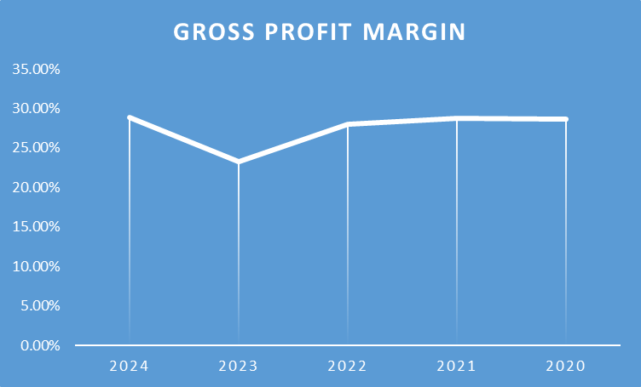

Operating Profit Margin
$$Operating\operatorname{Pr}{o}fitM\arg{i}n=\frac{Operating Income​}{Net Sales}×100$$
Year | Operating Income | Net sales | Calculations Operating | Operating Profit Margin
2024 | −15.30 | 394,879 | $$=\frac{-15.30}{394,879}×100$$ | −3.87%
2023 | −85.30 | 420,457 | $$=\frac{-85.30}{420,457}×100$$ | −20.3%
2022 | 14.55 | 542,751 | $$=\frac{14.55}{542,751}×100$$ | 2.68%
2021 | 23.25 | 601,602 | $$=\frac{23.25​}{601,602}×100$$ | 3.87%
2020 | 37.27 | 614,680 | $$=\frac{37.27​}{614,680}×100$$ | 6.06%

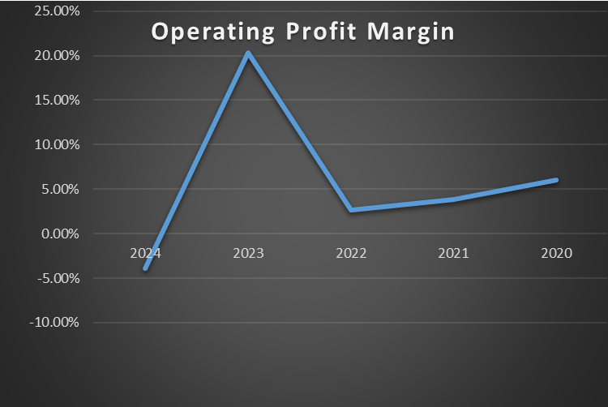

Net Profit Margin
$$Net\operatorname{Pr}{o}fit M\arg{i}n=\frac{Net Income​}{Net Sales}×100$$
Year | Net Income | Net sales | Calculations | Net Profit Margin
2024 | −24.03 | 394,879 | $$\frac{-24.03}{394,879}×100$$ | −6.08%
2023 | −98.24 | 420,457 | $$\frac{-98.24}{420,457}×100$$ | −23.38%
2022 | 0.41 | 542,751 | $$\frac{0.41}{542,751}×100$$ | 0.08%
2021 | 5.30 | 601,602 | $$\frac{5.30}{601,602}×100$$ | 0.88%
2020 | 38.57 | 614,680 | $$\frac{38.57}{614,680}×100$$ | 6.27%

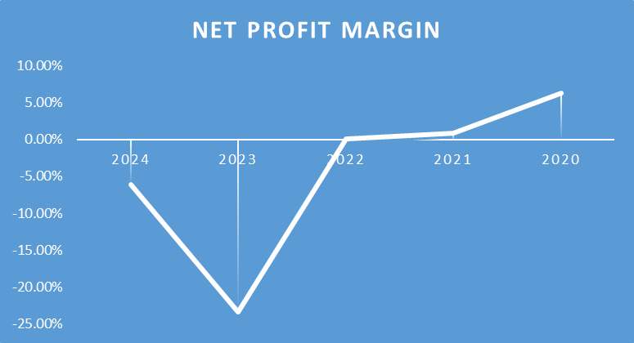

Liquidity Ratios

Current Ratio
$$CurrentRatio=\frac{Current Assets​}{Current Liabilities}$$
Year | Current Assets | Current Liabilities | Calculations | Current Ratio
2024 | 242.49 | 158.29 | $$\frac{242.49​}{158.29}$$ | 1.53
2023 | 258.85 | 161.15 | $$\frac{258.85​}{161.15}$$ | 1.60
2022 | 338.04 | 216.47 | $$\frac{338.04​}{216.47}$$ | 1.56
2021 | 337.15 | 216.79 | $$\frac{337.15}{216.79}$$ | 1.56
2020 | 326.84 | 179.51 | $$\frac{326.84​}{179.51}$$ | 1.82

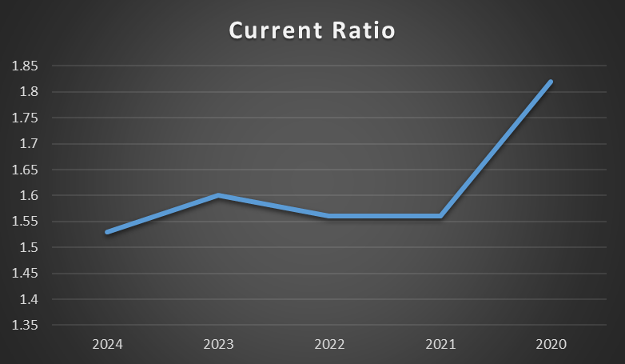

Quick Ratio
$Quick Ratio=\frac{Current Assets-Inventories​}{Current Liabilities}$
Year | Current Assets | Current Liabilities | Inventories | Calculations | Quick Ratio
2024 | 242.49 | 158.29 | 79.36 | $$\frac{242.49-79.36​}{158.29}$$ | 1.03
2023 | 258.85 | 161.15 | 88.27 | $$\frac{258.85-88.27​}{161.15}$$ | 1.06
2022 | 338.04 | 216.47 | 140.18 | $$\frac{338.04-140.18​}{216.47}$$ | 0.92
2021 | 337.15 | 216.79 | 134.47 | $$\frac{337.15-134.47​}{216.79}$$ | 0.94
2020 | 326.84 | 179.51 | 120.43 | $$\frac{326.84-120.43​}{179.51}$$ | 1.15

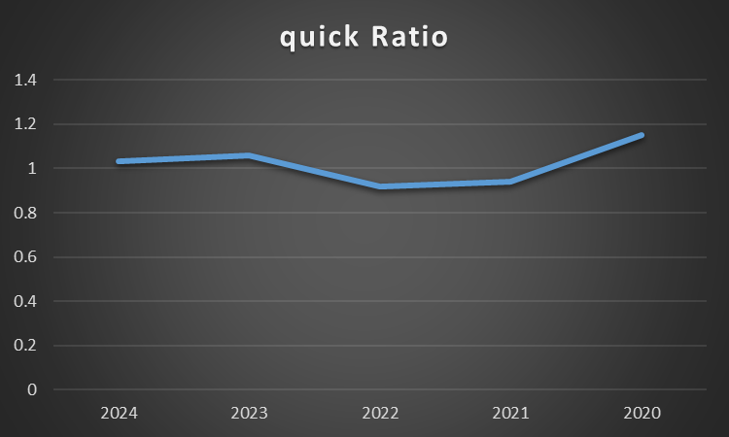

Efficiency Ratios
3. Efficiency Ratios

Receivables Turnover
$ReceivablesTurnover=\frac{Net Credit Sales​}{Average Accounts Receivable}$

$AverageAccountsReceivable_{2024}=\frac{114.18+112.60​}{2}=113.39million$
$$AverageAccountsReceivable_{2023}=\frac{112.60+112.35​}{2}=112.475million$$
$$Average Accounts Receivable_{2022}=\frac{112,596+112,346}{2}=112,471million$$
$$Average Accounts Receivable_{2021}=\frac{112,346+129,215}{2}=120,780.5million$$

Year | Net Credit Sales | Average Accounts Receivables | Calculations | Receiveables Turnover
2024 | 394.88 | 113.39 | $$\frac{394.88}{113.39}$$ | 3.48
2023 | 420.46 | 112.457 | $$\frac{420.46}{112.475}$$ | 3.74
2022 | 542,751 | 112,471 | $$\frac{542,751}{112,471}$$ | 4.82
2021 | 601,602 | 120,780.5 | $$\frac{601,602}{120,780.5}$$ | 47.07
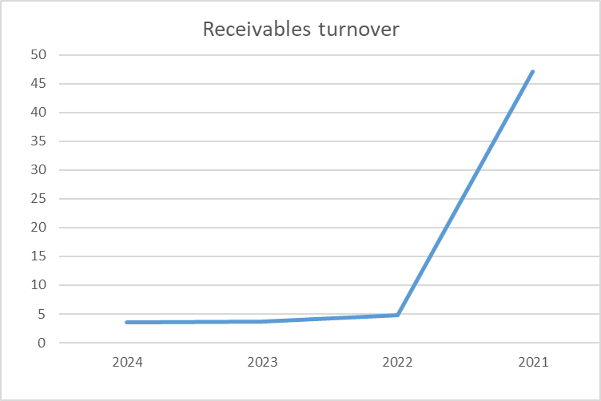

Inventory Turnover Ratio
$$Inventory Turnover=\frac{COGS​}{Average Inventory}$$
Year | COGS (in millions) | Inventory (in millions) | Average Inventory (in millions) | Calculation | Inventory Turnover
2024 | 280.89 | 79.36 | (79.36 + 88.27)/2 = 83.815 | $$\frac{280.89}{83.815}$$ | 3.34
2023 | 322.90 | 88.27 | (88.27 + 140.18)/2 = 114.23 | $$\frac{322.90}{114.23}$$ | 2.83
2022 | 390.46 | 140.18 | (140.18 + 134.47)/2 = 137.325 | $$\frac{390.46}{137.325}$$ | 2.84
2021 | 428.58 | 134.47 | (134.47 + 120.43)/2 = 127.45 | $$\frac{428.58}{127.45}$$ | 3.36
2020 | 438.42 | 120.43 | (120.43 + 121.67)/2 = 121.05 | $$\frac{438.42}{121.05}$$ | 3.62

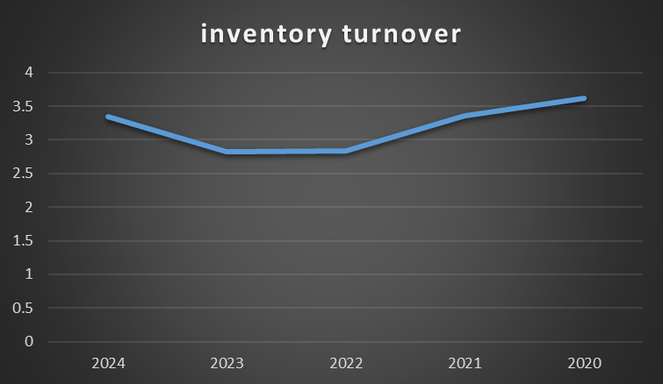

Gearing Ratio

Debt to Equity Ratio
$$DebttoEquityRatio=\frac{TotalDebt}{TotalEquity}​$$

Year | Total Debt (in millions) | Total Equity (in millions) | Calculation | Debt to Equity Ratio
2024 | 170.25 | 153.10 | $$\frac{170.25}{153.10}$$ | 1.11
2023 | 176.95 | 178.92 | $$\frac{176.95}{178.92}$$ | 0.99
2022 | 235.76 | 268.41 | $$\frac{235.76}{268.41}$$ | 0.88
2021 | 234.40 | 275.95 | $$\frac{234.40}{275.95}$$ | 0.85
2020 | 196.99 | 313.30 | $$\frac{196.99}{313.30}$$ | 0.63

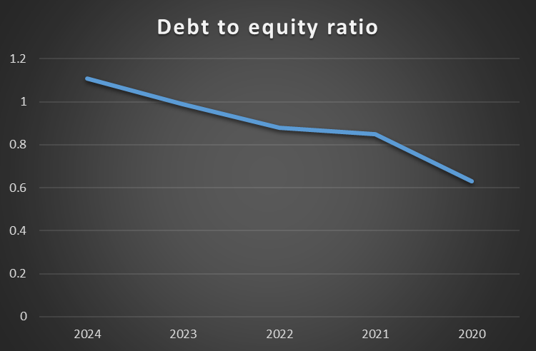

Interest Coverage Ratio
Year | Operating Income (in millions) | Interest Expenses (in millions) | Calculation | Interest Coverage Ratio
2024 | -15.30 | 3.36 | $$\frac{-15.30}{3.36}$$ | -4.55
2023 | -85.30 | 4.33 | $$-\frac{85.30}{4.33}$$ | -19.7
2022 | 14.55 | 2.20 | $$\frac{14.55}{2.20}$$ | 6.61
2021 | 23.25 | 0.57 | $$\frac{23.25}{0.57}$$ | 40.79
2020 | 37.27 | 1.42 | $$\frac{37.27}{1.42}$$ | 26.23

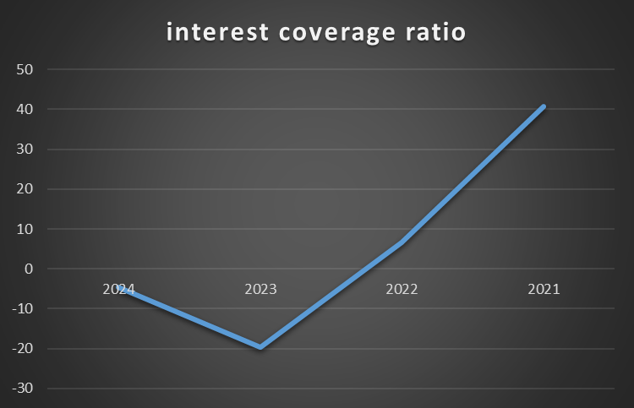

Investment Ratio

Return on Assets
$ROA=\frac{NetIncome​}{TotalAssets}×100$
Year | Net Income | Total assets | Calculation | ROA
2024 | −24.03 | 323,354 | $$\frac{-24.03​}{323.35}×100$$ | −7.44%
2023 | −98.24 | 355,872 | $$\frac{-98.24​}{355.87}×100$$ | −27.64%
2022 | 0.41 | 504,163 | $$\frac{0.41}{504.16}​×100$$ | 0.08%
2021 | 5.30 | 510,348 | $$\frac{5.30​}{510.35}×100$$ | 1.04%
2020 | 38.57 | 510,290 | $$\frac{38.57​}{510.29}×100$$ | 7.57%

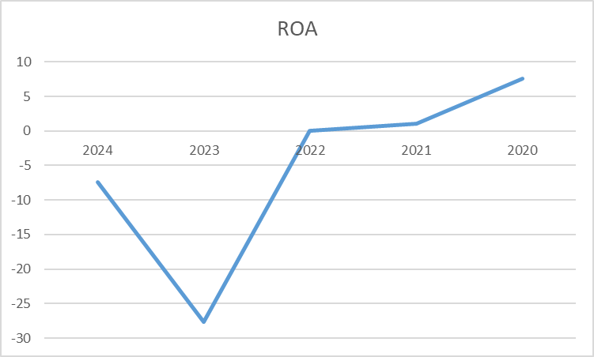

Return on Equity

$ROE=\frac{Net Income​}{Total Equity}×100$

Year | Net Income | Total Equity | Calculation | ROE
2024 | −24.03 | 153,105 | $$\frac{-24.03​}{153.10}×100$$ | −15.7%
2023 | −98.24 | 178,920 | $$\frac{-98.24​}{178.92}×100$$ | −54.9%
2022 | 0.41 | 268,406 | $$\frac{0.41​}{268.41}×100$$ | 0.15%
2021 | 5.30 | 275,949 | $$\frac{5.30}{275.95}​×100$$ | 1.92%
2020 | 38.57 | 313,301 | $$\frac{38.57​}{313.30}×100$$ | 12.3%

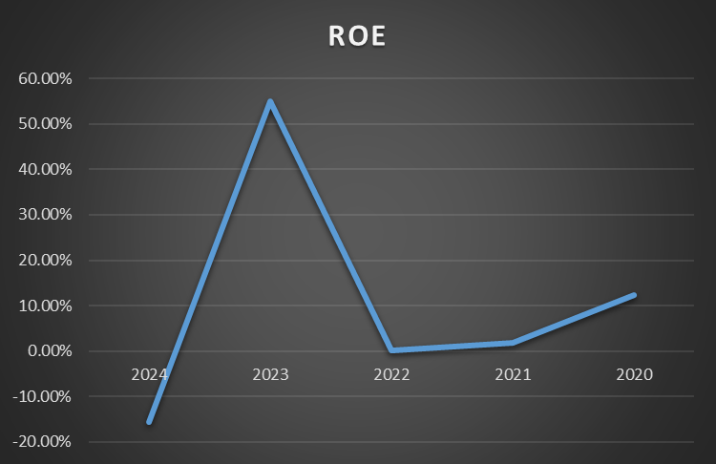

Cash Flow

Operating Cash Flow Ratio
$$Operating Cash Flow Ratio=\frac{Operating Cash Flow}{Current Liabilities}​$$

Year | Operating Cash Flow | Current Liabilities | Calculation | Operating cash flow
2024 | 14,822 | 153,105 | $$\frac{14,822​}{158,291}$$ | 0.094
2023 | 25,190 | 178,920 | $$\frac{25,190​}{178,920}$$ | 0.156
2022 | 10,926 | 268,406 | $$\frac{10,926}{268,406}$$ | 0.0505
2021 | 40,283 | 275,949 | $$\frac{40,283}{275,949}$$ | 0.186
2020 | 73,392 | 313,301 | $$\frac{73,392}{313,301}$$ | 0.408

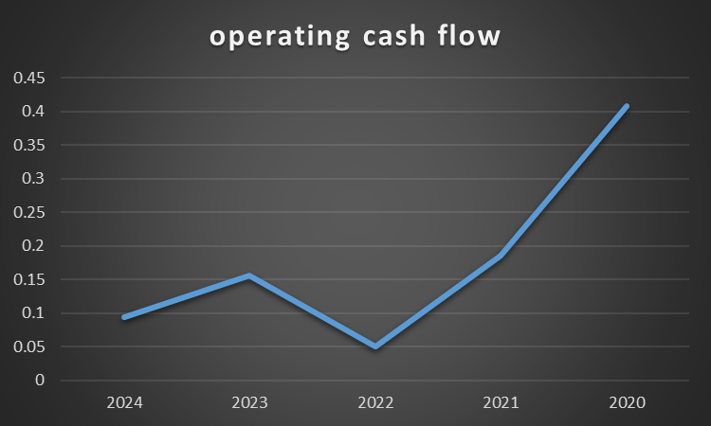

Altman Z score
$$Z=1.2×\frac{WorkingCapital​}{TotalAssets}+1.4×\frac{RetainedEarnings}{TotalAssets}​+3.3×\frac{EBIT​}{TotalAssets}+0.6×\frac{MarketValueofEquity}{TotalLiabilities}​+1.0×\frac{Sales​}{TotalAssets}$$
- Working Capital = Current Assets - Current Liabilities
- Retained Earnings = Accumulated earnings retained in the business (available on the balance sheet)
- EBIT = Earnings Before Interest and Taxes (Operating Income)
- Market Value of Equity = Market Capitalization (if data is available, calculated as shares outstanding × share price) book value of equity is used here
- Total Liabilities = Current Liabilities + Long-term Debt
- Total Assets = Total Assets (from the balance sheet)
- Sales = Net Sales (from the income statement)
Year | Current Assets | Current Liabilities | Working Capital | Retained Earnings | Operating Income | Total Equity | Total Liabilities | Total assets | Net sales
2024 | 242,494 | 158,291 | 84,203 | 208,431 | −15.30 | 153,105 | 170,249 | 323,354 | 394,879
2023 | 258,851 | 161,148 | 97,703 | 232,460 | −85.30 | 178,920 | 176,952 | 355,872 | 420,457
2022 | 338,040 | 216,473 | 121,567 | 330,698 | 14.55 | 268,406 | 235,757 | 504,163 | 542,751
2021 | 337,146 | 216,787 | 120,359 | 330,291 | 23.25 | 275,949 | 234,399 | 510,348 | 601,602
2020 | 326,843 | 179,510 | 147,333 | 324,990 | 37.27 | 313,301 | 196,989 | 510,290 | 614,680

2024
$$Z_{2024}=1.2×\frac{84.20}{323,354}​+1.4×\frac{208,431}{323,354}+3.3×\frac{-15.30}{323,354}+0.6×\frac{153,105}{170,249}+1.0×\frac{394,879}{323,354}​$$
$$Z_{2024}=1.2×0.26​+1.4×0.644+3.3×-4.73+0.6×0.899+1.0×1.22$$
$$Z_{2024}=0.312+0.9016+\left(-15.609\right)+0.539+1.22$$
= −12.6364
2023
$$Z_{{2023}_{}}=1.2×\frac{97,703}{355,872}+1.4×\frac{232,460}{355,872}+3.3×\frac{-85.30}{355,872}+0.6×\frac{178,920}{176,952}+1.0×\frac{420,457}{355,872}$$
$$Z_{2023}=1.2×0.274+1.4×0.653+3.3×\left(-0.000239\right)+0.6×1.011+1.0×1.18$$
$$Z_{2023}=0.3288+0.9142+\left(-0.000788\right)+0.6066+1.18$$
=3.0288

2022
$$Z_{2022}=1.2×\frac{121,567}{504,163}+1.4×\frac{330,698}{504,163}+3.3×\frac{14.55}{504,163}+0.6×\frac{268,406}{235,757}+1.0×\frac{542,751}{504,163}$$
$$Z_{2022}=1.2×0.241+1.4×0.655+3.3×2.885+0.6×1.138+1.0×1.076$$
$$Z_{2022}=0.2892+0.917+9.5205+0.6828+1.076$$
=12.4855

2021
$$Z_{2021}=1.2×\frac{120,359}{510,348}+1.4×\frac{330,291}{510,348}+3.3×\frac{23.25}{510,348}+0.6×\frac{275,949}{234,399}+1.0×\frac{601,602}{510,348}$$
$$Z_{2021}=1.2×0.235+1.4×0.6471+3.3×4.551+0.6×1.177+1.0×1.178$$
$$Z_{2021}=0.282+0.90594+15.0183+0.7062+1.178$$
= 18.09044

2020

$$Z_{2020}=1.2×\frac{147,333}{510,290}+1.4×\frac{324,990}{510,290}+3.3×\frac{37.27}{510,290}+0.6×\frac{275,949}{234,399}+1.0×\frac{601,602}{510,348}$$
$$Z_{2020}=1.2×0.288+1.4×0.636+3.3×7.303+0.6×1.177+1.0×1.178$$
$$Z_{2020}=0.3456+0.8904+24.0999+0.7062+1.178$$
=27.2201
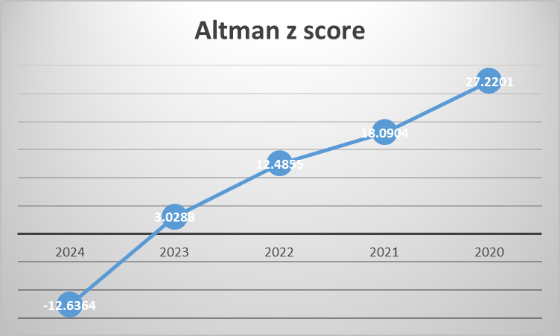

COC Calculation
$$COC=DIO+DSO-DPO$$

Year | Inventories | Net Sales | Accounts Payable | Account  Receivables | Cost of Sales (COGS) | COGS per Day (COGS/365) | Average Inventories | Net sales per day | Average Account Payable | Average account receivable
2024 | 79,355 | 394,879 | 72,031 | 114,182 | 280,885 | 769.54 | 83,814 | 1081.86 | 64,532 | 113,389
2023 | 88,273 | 420,457 | 57,033 | 112,596 | 322,897 | 884.64 | 114,227 | 1151.93 | 64,203 | 112,471
2022 | 140,181 | 542,751 | 71,373 | 112,346 | 390,459 | 1069.75 | 137,325 | 1486.98 | 82,040 | 120,780.5
2021 | 134,469 | 601,602 | 92,707 | 129,215 | 428,586 | 1174.20 | 127,499.5 | 1648.22 | 87,968 | 129,324
2020 | 120,430 | 614,680 | 83,229 | 129,433 | 438,424 | 1201.16 |  | 1684.05

$$DIO=\frac{AverageInventory​}{COGS perday}$$
Year | Average Inventories | COGS per Day (COGS/365) | DIO
2024 | 83,814 | 769.54 | 108.91
2023 | 114,227 | 884.64 | 129.12
2022 | 137,325 | 1069.75 | 128.37
2021 | 127,499.5 | 1174.20 | 180.58

$$DSO=\frac{AverageAccountsReceivable​}{NetSalesperday}$$
Year | Average account receivable | Net sales per day | DSO
2024 | 113,389 | 1081.86 | 104.80
2023 | 112,471 | 1151.93 | 97.63
2022 | 120,780.5 | 1486.98 | 81.22
2021 | 129,324 | 1648.22 | 78.46

$$DPO=\frac{Average Accounts Payable​}{COGS perday}$$

Year | Average Account Payable | COGS per Day (COGS/365) | DPO
2024 | 64,532 | 769.54 | 83.85
2023 | 64,203 | 884.64 | 72.57
2022 | 82,040 | 1069.75 | 76.69
2021 | 87,968 | 1174.20 | 74.91

Year | Calculation | COC
2024 | $$108.91+104.80-83.85$$ | 129.86
2023 | $$129.12+97.63-72.57$$ | 884.64
2022 | $$128.37+81.22-76.69$$ | 132.9
2021 | $$180.58+78.46-74.91$$ | 184.13

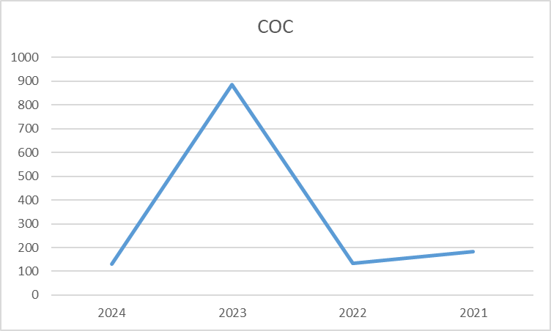

Investment Appraisal Calculation


