  Component One: Student Journal (learning log) 750 words +/- 10%  Contribution to Overall Module Assessment: 25% | Student No: | 2241871
 | Module Title: | Hotel Placement – Operating Hotel Facilities.
 | Module Code: | BMIH4006
 | Lecturer: | Daniel Payne
Placement Experience at Ibis Budget Newport Hotel - Housekeeping Department

Gibbs's reflective model is one of the effective frameworks which is used for assessing own experience in a related field (Main, 2023).
Description: During my placement at Ibis Budget Newport Hotel within the housekeeping department, I engaged in a variety of tasks which are essential for maintaining the cleanliness and orderliness of guest spaces. These duties included bedmaking, vacuuming, dusting, and stocking amenities. Every meticulous task contributed significantly to improving the overall guest service experience by highlighting the significance of paying attention to details in maintaining the hotel’s standards. The fast-paced environment provided both challenges and opportunities for the hospitality sector as the industry has been facing high turnover rates, work-life balance issues and many more (Andrade et al., 2021). I consider myself to be highly attentive to details and adaptable to new situations. However, I need to focus on improving my time management to become a more effective performer.
Feeling: The time I spent at the Ibis Budget Newport Hotel was both exciting and pressurizing. While I was eager to learn and participate, the fast-paced atmosphere caused some stress. A well-managed workforce in housekeeping leads to organised performance, increased productivity, financial success, innovative solutions, and efficient task rotation (Jawabreh et al., 2020). I take pride in my attention to detail, which has helped me identify my areas of weakness and develop strong concentration skills. Although I have struggled with time management, I have been able to compensate by effectively communicating with my team, which has helped me to learn valuable problem-solving skills. Overall, I have enjoyed my learning experience in the hospitality industry.
Evaluation: Total Quality Management is crucial in the hospitality industry as it ensures high levels of customer satisfaction (Hussain and Khan, 2020). During my placement experience with the housekeeping department, I had an extraordinary journey that helped me realize the vital role cleanliness plays in guest satisfaction. The hands-on tasks I performed during this experience helped me develop even more my attention to detail, which ultimately had a beneficial effect on the overall guest service experience. The experience of working in a highly dynamic environment taught the lessons of adaptability and communication with fellow team members as teamwork is highly necessary for learning (Koseoglu et al., 2020). The assessment of my performance revealed both strengths, such as attention to detail, and areas for improvement, particularly in time management. I can confidently say that this experience has significantly improved my practical skills and has provided me with a comprehensive understanding of the intricacies involved in the hospitality industry.
Analysis: I have had a deep learning experience while working in the Hotel. Internships are one of the important parts of hospitality students as they provide learning experiences to students (Kukreti and Dani, 2020). Through daily tasks and activities, I developed critical thinking skills that directly improved my problem-solving efficiency. The fast-paced environment presented challenges that enhanced my time management, adaptability, and communication skills. Working with the hotel team helped me understand the importance of efficient teamwork, especially during high seasons. I also identified areas that need improvement, such as time management. The practical sessions were the highlight of my working experience, as they provided me with hands-on experience that will benefit me both personally and professionally.
Conclusion: I have completed my placement at the Ibis Budget Newport Hotel's housekeeping department, and it has been a valuable learning experience. I have realized the significance of paying close attention to detail in creating guest satisfaction and shaping the hotel's image, which is an important part of my professional growth and development. Despite facing difficulties such as time pressure, this experience has enhanced my technical skills and problem-solving abilities. The hospitality industry should effectively manage personnel by including training programs and reward systems for getting organisational goals accomplished (Edeh et al., 2022).
Action Plan: I have developed a strategic plan to continuously grow and improve my skills in housekeeping to strengthen my career in the hospitality industry. I plan to participate in more advanced training sessions to enhance my time management skills and efficiency without compromising quality. This plan will be executed by getting regular feedback from colleagues and supervisors so that I can able to get valuable knowledge into areas that need strong improvement for my professional growth (Pham et al., 2020). I will try to actively participate in industry conferences and workshops as it will keep me informed about the latest trends and standards in housekeeping. I believe that these plans will help me gain valuable knowledge which will be beneficial for my professional development.

Component Two: Health and Safety Guide
Contribution to Overall Module Assessment: 25%
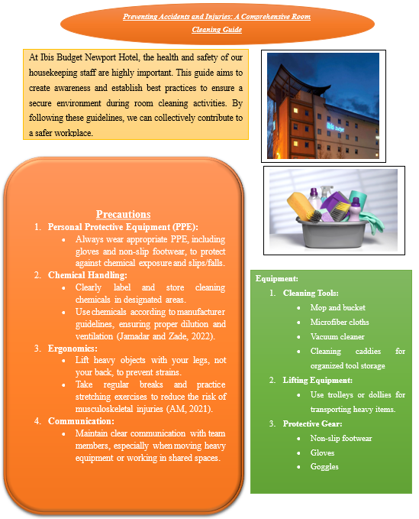
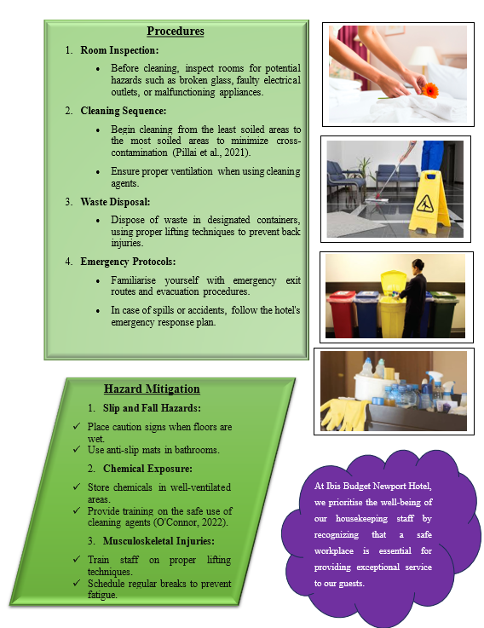

Reference List

AM, S., 2021. Occupational health hazards in the hospitality industry and their prevention. Egyptian Journal of Occupational Medicine, 45(1), pp.65-80.
Andrade, M.S., Miller, D. and Westover, J.H., 2021. Job satisfaction factors for housekeepers in the hotel industry: a global comparative analysis. International Hospitality Review, 35(1), pp.90-108.
Edeh, F.O., Zayed, N.M., Perevozova, I., Kryshtal, H. and Nitsenko, V., 2022. Talent management in the hospitality sector: predicting discretionary work behaviour. Administrative Sciences, 12(4), p.122.
Hussain, M. and Khan, J., 2020. Key success factors of Total Quality Management (TQM) for the hospitality sector: A critical review of the literature. European Journal of Hospitality and Tourism Research, 8(2), pp.1-17.
Jamadar, J., & Zade, A. (2022). Post-pandemic protocols & practices adopted by housekeeping in Five Star hotels. International Journal of Health Sciences, 6(S6), 10345– 10357.
Jawabreh, O., Mahmoud, R. and Hamasha, S.A., 2020. Factors influencing the employee's service performances in hospitality industry case study AQBA five stars hotel. Geo Journal of Tourism and Geosites, 29(2), pp.649-661.
Kukreti, R. and Dani, R., 2020. Individual factors and internship satisfaction of hotel management graduates. International Journal of Advanced Science and Technology, 29, pp.878-884.
Köseoglu, M.A., Altin, M., Chan, E. and Aladag, O.F., 2020. What are the key success factors for strategy formulation and implementation? Perspectives of managers in the hotel industry. International Journal of Hospitality Management, 89, p.102574.
Main, P., 2023. Gibbs’ Reflective Cycle. [online] Structural-learning.com. Available at: https://www.structural-learning.com/post/gibbs-reflective-cycle. [Accessed 5 Feb. 2024].
O'Connor, G., 2022. Mitigating Hospitality Risks as Travel Increases. Risk Management, 69(2), pp.10-12.
Pham, N.T., Vo-Thanh, T., Shahbaz, M., Huynh, T.L.D. and Usman, M., 2020. Managing environmental challenges: Training as a solution to improve employee green performance. Journal of Environmental Management, 269, p.110781.
Pillai, S.G., Haldorai, K., Seo, W.S. and Kim, W.G., 2021. COVID-19 and hospitality 5.0: Redefining hospitality operations. International Journal of Hospitality Management, 94, p.102869.

