Student name: Louis Burrows
Student number: 2104668
Tutors name: Delyth Lloyd-Evans
Word count: 2500
Key words: The Beginnings, Graphic novel, Horror
Context
For my research project I will be using three key words: Fairy tales, Re-vision and Genres to aid in my exploration into the story of Little Red Riding Hood, using these three key words I will look at the first publication of this fairy tale to another re-telling of the tale by the brothers Grimm, how their story of a similar theme but what also separate them from each other. Looking into the modern-day re-vision of the story, with the third key word genre I will be researching into specific type of genre that being horror, how it affects, why we like being scared. With these keywords they will lead to my question, how they will inform my practice.
Fairy Tales
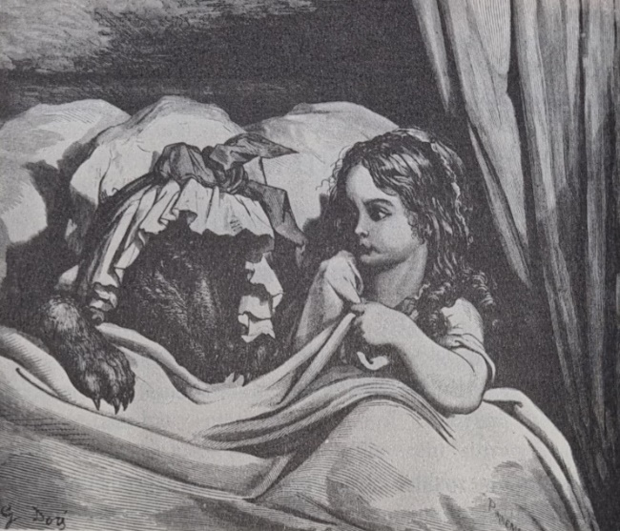
“A girl, a wolf, a meeting in the woods. Who does not know the story of Little Red Riding Hood? She is the age old star of bedtime drama, symbol of childhood innocence.” (Orenstein, 2002, p. 3). For most people they probably only read one vision of the story of Little Red Riding Hood but that is not the case there are many different versions of the story of from Le petit chaperon rouge (Little Red Riding hood) by Charles Perrault to Little Red Cap by Jacob and Wilhelm.

Fig. 1, Gustave Dore 1862
First publication of the story of Little Red Riding Hood by Charles Perrault in 1697 it should be stated that Charles Perrault did invent the tale as written in the Little Red Riding Hood A casebook edited by Alan Dundes “Modern scholarship has established that Perrault did not invent the tale, but rather he adapted one that was already popular in French oral tradition” (Dundes, 1989, p. 3).
The beginning of the Charles Perrault version of Little Red Riding Hood starts where most fairy tale start with once upon a time, to summarize this story the mother bakes some cakes for the grandmother because she is not feeling well, send Little Red Riding Hood off into the woods, she comes across “Old neighbour wolf, who wanted very much to eat her” (Orenstein, 2002, p. 19), where she tell the wolf where she going, who she is going to see that being the grandmother, the wolf goes off to the grandmother house, devoured her, disguised himself as the grandmother, pretends to be the grandmother to draw Little Red Riding Hood closer to him, to where she undress, climb into bed with him as seen in fig 1 and where we get vision of the famous lines from Little Red Riding Hood
“Why, Grandmother, what big arms you have!”
“The Better to hug you with, my child.”
“Grandmother, what big legs you have!”
“The better run with, my child.”
“Grandmother, what big ears you have!”
“The better to hear you with, my child.”
“Grandmother, what big eyes you have!”
“The better to see you with, my child.”
“Grandmother, what big teeth you have!”
“The better to eat you!”
“And with that, wicked wolf threw himself upon Little Red Riding Hood and ate her up.” (Orenstein, 2002, p. 21).
Buy why end this way with Little Red Riding Hood death unlike oral tradition which is to believe have been along the line as “Red Riding Hood” did more than symbolize the child’s ability to defeat danger and evil by resorting to cunning: it also demonstrated the importance of women’s knowledge to survival” (Bacchilega, 1997, p. 56). But this only one interpretation of the oral story of Little Red Riding Hood because there are some different tales for example The story of grandmother or About a Girl saved from Wolfcubs.
What is the moral of Charles Perrault Little Red Riding Hood, why end the story with the character being eat could it be to scare the child that is reading this story, or could it be the way the story ends with Little Red Riding Hood be eaten reinforced the moral of the story that being “Never trust a stranger-friend” (Orenstein, 2002, p. 21). Which again a theme that is carried over to another retelling of this tale but unlike Little Red Cap by Jacob and Wilhelm Grimm in the case of the brother grim story it has a somewhat a happy ending “as many scholars have asserted, the most salient differences between Perrault and the Brothers Grimm lie in the tone of texts, ironic versus naïve, and in the ending, happy versus tragic” (Dundes,1989, p. 147) in Brother Grimm story of Little Red Cap the grandmother tells Little Red Riding Hood to take the water that she boiled the sausages, pour into the trough , this is where the wolf smells the food, “ He went right down the roof into the trough and was drowned” (Tatar, 1999, p. 16). And with this story has happy ending with Little Red Cape surviving the wolf but as the same as Charles Perrault the moral is still the same but because this story has a happy ending this has become the version of Little red riding that has told in some older children picture book for a long time or the version most people have heard of, that lead some scholars long considered Little Red Cap to be the authentic version of the tale “ Because the Grimm’s restored a happy ending to the tale, scholars long considered their” Little Red Cape to be the authentic vision of the tale” (Orenstein, 2002, p. 61) but further in this book its written that until twentieth century folklorist proved the them wrong “As it turns out, the Grimms story, and its lessons, could hardly differ more from the oral folk traditions that spawned it. Long ago” (Orenstein, 2002, p.61) but what does this show, it shows that even in the 20th century there was still debate between scholars, and folklorists of what is authentic to the oral telling of little Red Riding Hood.
Re-vison
With some understanding of the story Little Red Riding Hood in the past, now looking to the present day, how the story of little red riding hood has been translated in the modern age in this re-vision of the story, this book is tilted Little Red Ronin by Garret Gunn a story that use the same premise as Charles Perrault Little Red Riding Hood that meaning a character wearing red, big bad wolf and the grandmother. How does this graphic novel count as a re-vision in The postmodern Fairytale Folkloric Intertexts in Contemporary by Kevin Paul Smith writes “Any ‘new’ version of fairytale counts as re-vision” (Smith, 2007, p. 34) but further on it is written there is helpful definition?
According to the Oxford University Dictionary, revise means “To look or read carefully over, with a view to improving or correcting 1611,’ To go over again, re-examine, in order to improve or amend.’ The purpose of producing a revised fairy tale is to create something new that incorporates the critical and creative thinking of the producer and corresponds to change demands and tastes of audiences.
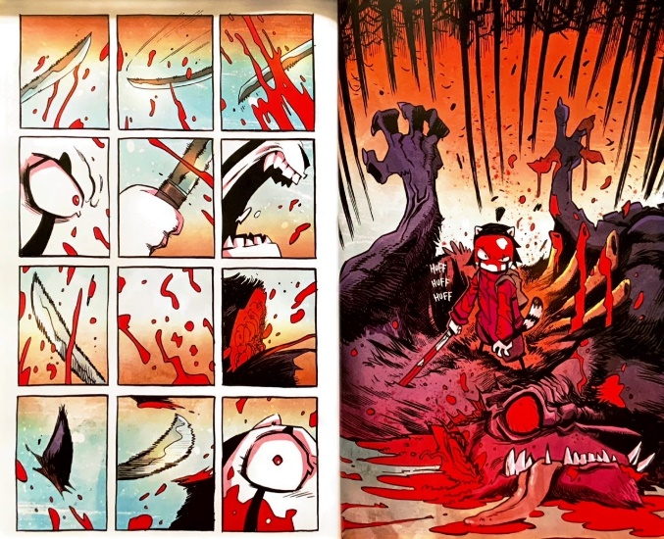
Smith, 2007, p. 3

Fig. 2, Little Red Ronin, Garret Gunn

With this definition how does it relate to the graphic novel of Little Red Ronin it relate that this is something new it takes the story little red riding hood which is more of a children’s story, turns it into a story for young adults the story is all the townsfolk believes the main character Red is crazy for believing her grandmother’s tail about the great wolf, her hopes exonerating her grandmother Red goes off to prove the great wolf exist , what is the interesting thing about this story is that it may be a re-vision of Little Red Riding Hood but it could be more in line with the oral telling of the story because the story does not end with Red being saved by the woodcutter or the wolf falling to his death or have red being eat up by the big bad wolf , it ends with Red killing the wolf see fig 2 which brings us to a question is this true re-vision of Little Red Riding Hood or a story going back toward the oral telling of the story in which it is she who save herself from the wolf but this is not a character who is not helpless unlike Charles Perrault vison of Little Red Riding Hood, this book show why the character of little Red Riding Hood IS still popular “ Little Red Riding Hood’s Perennial popularity is due in part to ability to adapt to the times. Every year, reincarnations of the story pop up in print” (Orenstein, 2002, p.6)
A theme that runs through this graphic novel is the use of the colour red, the way it is used on the character Red see in fig 2 the red is not only used in the colouring of the main character but used in the shading of the character which add more to the expression in the character face see in fig 2 this show how colour can be used to create more meaning for example colour have many different meaning for example red can be seen as a warm colour or It can be used as the colour of love or anger “Colour’, runs, a useful standard definition ‘is the attribute of visual experience that can be describe as having quantitively specifiable dimensions of hue, saturation, and brightness (Gage, 2000, p. 11), in the case of Little Red Ronin the colour red add more to her facial expression which bring an interesting idea to mind can you tell a create a new vision of Little Red Riding Hood with just using one colour
Why chose a graphic novel for the format of next years practice base work, one reason it’s a format that I knew about a lot about being a consumer of graphic novels for many years, but also the graphic novel has risen in popularity for many years, giving inspiration to many people to become writer or illustrators “influenced many generations across their spectrum -from reading for children to inspiration for mature artist and illustrator” (Bettley, 2001, p. 122)
Genres
“Sometimes art provokes outrage, fear, and disgust. In the case of horror, that is the point” ( Fahy, 2012, p. 14) with the this quote it is not my intent to create a graphic novel that provokes outrage or disgust but a sense of fear and tension but why horror, the reason is horror is an odd genre you either love it or hate it but even when you watch or read something with a jump scare in it after that moment you chuckle to yourself or even have sense of relief but why? in the book The philosophy of horror by Thomas Fahy it written “ the anticipation of terror, the mixture of fear and exhilaration as events unfold, the opportunity to confront the unpredictable and dangerous, the promise of relative safety”(Fahy, 2012. P. 1) the part of this quote that I am drawn to is events unfold part of the quote this idea of building up tense of story.
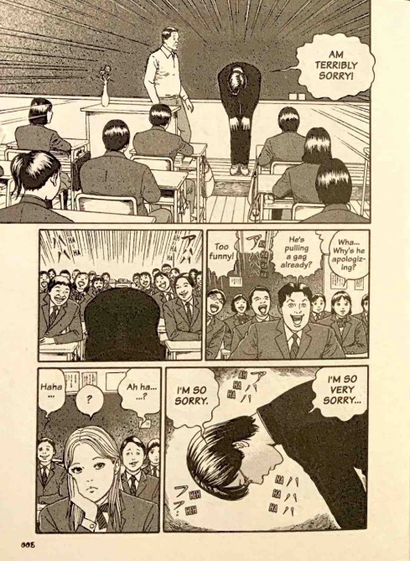
Why horror for the theme of the graphic novel that is going to be made and the reason is I came across video on TEDx Talks about horror titled What Use Is Horror by Benjamin James now in this video he does talk about horror in films but there still things to talk away from this video that can be applied to this proposal in the video he says “ what if we think of our fears as a kind of unintentional storytelling” (James, 2018), I think the interesting part of the quote how it can relate to the way we tell story because like Little Red Riding Hood by Charles Perrault it may not be trying to scare the child but it falls that sort of theme of don’t talk to strange or something bad will happen but in my story of little red riding hood it’s not the fear of talking to a stranger but the fear of something behind you, something in your periphery that feeling sometimes you get when walking down the street, feel like something is following you that’s the fear and tension I want to bring to my graphic novel.

Fig. 3, Dissolving Classroom, Junji Ito, 2015
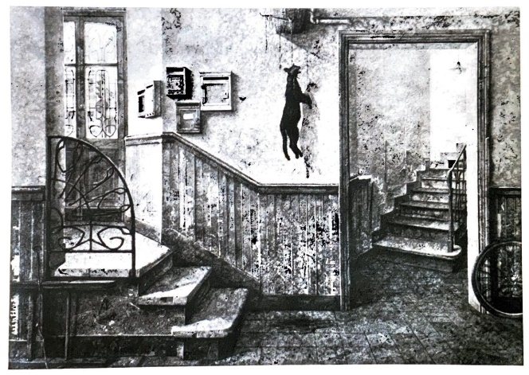
My story of Little Red Riding Hood will have a horror element to it but why horror, the reason is horror is a genre that’s very popular not just in literature, cinema , video games , graphic novel, art for the first example the work by Junji Ito a known horror artist, writer one of my favourite book Dissolving Classroom but how does this book relate to the creation of my graphic novel it relate in the way this book shows the horror in fig shows the story off in small steps to build the tension, anxieties see fig 3 top panel you have one of the character say sorry for no reason, but this can also be send about art works that play with tension, anxiety another example is Jean-Maire Poumeyrol. The Revenge II. 1975 seen fig 4 this piece immediately make you feel anxious, uneasy “This artist depicts anxieties that have their roots in disgust, in revulsion against ab ugly and hostile ambiance.” (Schiff, 1980, p. 12) like Junji work where the tension builds but that is the benefit of it being a graphic novel.

Fig. 4, The Revenge II, Jean-Marie Poumeyrol
With the research into the three key words Fairy Tales, Re-vision, Genres has led me into the direction for the next year’s project, how this word can be related to each other is how the story of Little Red Riding Hood has been re-told or re-imagined from its first publication to the present day, how present-day re-telling’s of Little Red Riding Hood have taken the story and fused it together with other genres.
Key Question
The key question I have come to is: How re-tell the story of Little Red Riding Hood for modern audience where time are changing no longer female character are put In peril, need to be saved by someone else but where they can save there self, where fairy tales are starting to branch out from the fantasy-based theme but take on new genres with a sub question being why are some many tale about Little Red Riding Hood and what links them.
My Practice
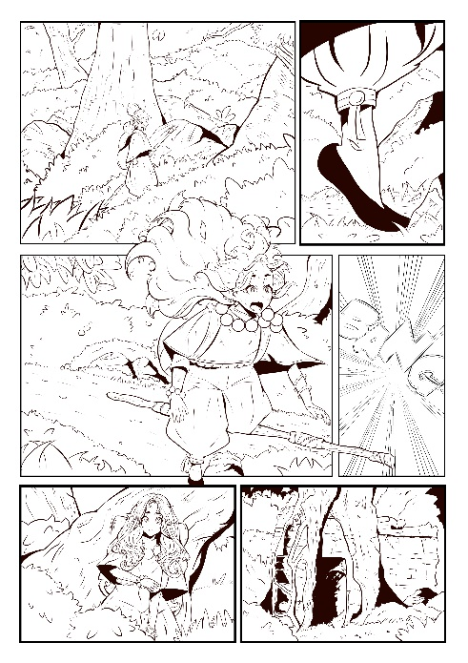
For my practice I will be creating a graphic novel, it will be a re-vision of the story of Little Red Riding Hood set in modern day, it will have a horror theme to the story it will be present in the same way as the graphic novel I made in second year of university see fig 5, it will be around eight to ten pages long, will consist of illustrations and text done in the style of the graphic novel.

Fig 5

Bibliography/ Referencing list
Bacchilega. (1997). Postmodern fairy tales: gender and narrative strategies. University of Pennsylvania Press.
Bryant, & Vorderer, P. (2011). Psychology of entertainment. Routledge.
Doonan. (1993). Looking at pictures in picture books. Thimble Press
Dundes. (1989). Little Red Riding Hood: a casebook. University of Wisconsin Press.
James (2018) What Is The Use of Horror. Available at: (171) What Use Is Horror? | Benjamin James | TEDxUIdaho - YouTube (Accessed: April 5 Wednesday 2023)
Joosen. (2011). Critical and creative perspectives on fairy tales: an intertextual dialogue between fairy-tale scholarship and postmodern retellings. Wayne State University Press.
Orenstein. (2002). Little Red Riding Hood uncloaked: sex, morality, and the evolution of a fairy tale. BasicBooks.
Schiff. (1980). Image of horror and fantasy. Academy Editions
Smith. (2007). The postmodern fairytale: folkloric intertexts in contemporary fiction. Palgrave Macmillan.
Tatar, & Tatar, M. (2019). The hard facts of the Grimms’ fairy tales (Expanded edition.). Princeton University Press.
Tatar. (1999). The Classic fairy tales: texts, criticism. Norton.
Smith. (2007). The postmodern fairytale: folkloric intertexts in contemporary fiction. Palgrave Macmillan.
Zipes. (2006). Why fairy tale’s stick: the evolution and relevance of a genre. Routledge.

List of Figures
Fig. 1, Tatar, M. (2019) The hard facts of Grimms Fairy Tales
Fig. 2, Gunn, G. (2022) Little red ronin
Fig. 3, Ito, J. (2015) Dissolving classroom
Fig. 4, Schiff, G. (1980) Image of horror and fantasy

