University of Wales Trinity Saint David
School of engineering

Engineering Design - ACMA4008
Joseph Tobin
2317637

Contents
2 Abstract 1
3 Introduction 2
4 Wet vs Dry sump 2
5 Dry Sump design process 4
5.1 Problem Identification – Quality Function Deployment (QFD) 4
5.1.1 Customer Needs Identification: 4
5.1.2 Quality Characteristics Establishment: 5
5.1.3 Target or Limit Values Setting: 5
5.1.4 Difficulty Level Assessment: 5
5.1.5 Weight/Importance: 5
5.1.6 Competitive Analysis: 5
5.2 Kano model 6
5.3 Product design specification – Dry sump pan and oil pickup adaptor Design 7
5.3.1 Customer Requirements 7
5.3.2 Performance 7
5.3.3 Appearance 7
5.3.4 Environment 7
5.3.5 Installation 8
5.3.6 Product Cost 8
5.3.7 Competitors 8
5.3.8 Maintenance 8
5.3.9 Materials 9
5.3.10 Quality and Reliability 9
5.3.11 Standards and Specifications 9
5.3.12 Testing 9
5.3.13 Legal Considerations 9
5.3.14 Documentation 9
5.3.15 Disposal 9
5.4 CAD design concepts 10
5.5 CAD design discussions 10
5.6 Final design 10
5.7 Evaluation Framework 10
6 Conclusion 10

List of Figures
Figure 1- Typical wet sump oiling system 2
Figure 2- This illustration shows the major components of a dry sump system 3
Figure 3 - The KANO model, The Four Categories of Features 6

Abstract
In the realm of motorsport, where every fraction of a second counts, engine performance stands as a pinnacle concern. This report meticulously dissects the comparative efficacy of two lubrication systems, the conventional 'wet sump' and the advanced 'dry sump,' within the context of high-performance racing cars. Recognizing the limitations of the wet sump system under extreme racing conditions, the study advocates for the paradigm shift offered by the dry sump alternative.
By scrutinizing customer needs through methodologies such as Quality Function Deployment (QFD) and the Kano model, the report delineates key requirements and performance criteria, ranging from lightweight design to environmental resilience. Furthermore, it scrutinizes competitive offerings to inform design decisions, emphasizing the importance of reliability, performance, and cost-effectiveness.
The report concludes by outlining a comprehensive evaluation framework, integrating theoretical analysis, computational modelling, and practical testing to validate and refine the dry sump system's performance and reliability. Through rigorous testing and iterative refinement, the study underscores the potential of the dry sump system to revolutionize engine lubrication in motorsport, promising enhanced performance, reliability, and endurance on the track.

Introduction
In the fiercely competitive world of motorsport, achieving optimal performance from a racing car's engine is paramount. Manufacturers and engineers constantly seek innovative solutions to enhance engine efficiency, durability, and reliability under the extreme conditions of track competitions. One critical aspect of engine design that significantly influences performance is the lubrication system. In this assignment, we delve into the comparative analysis of two lubrication systems: the conventional 'wet sump' system and the advanced 'dry sump' system, particularly concerning their application in high-performance motorsport racing cars. (IGER, 2021)

Wet vs Dry sump
A wet sump system, commonly found in production vehicles, utilizes a single oil pan located beneath the engine to store and circulate lubricating oil. However, in high-performance racing conditions, the wet sump's limitations become apparent. During aggressive cornering or acceleration, the oil within the sump can slosh away from the pickup, leading to oil starvation and potential engine damage. Additionally, the confined space within the engine compartment restricts the size and capacity of the oil pan, limiting oil cooling and increasing the risk of overheating under sustained high speeds. On the contrary, a dry sump system represents a paradigm shift in lubrication technology tailored for the demands of motorsport racing. (Cars Blog, n.d.)
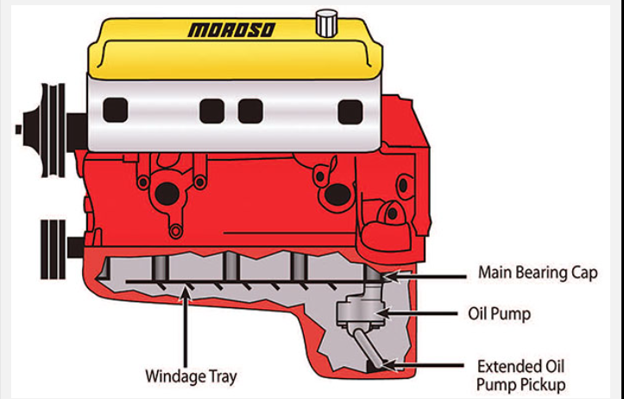 (tech, n.d.)
Figure 1- Typical wet sump oiling system
In a dry sump setup, oil is scavenged from the engine's crankcase and stored in a remote reservoir, eliminating the constraints of a single oil pan. This not only allows for larger oil capacities but also enables better control over oil levels and distribution, mitigating the risk of oil starvation during extreme manoeuvres. Furthermore, the separation of the oil reservoir from the engine compartment facilitates efficient cooling through external oil coolers, maintaining optimal operating temperatures and preserving lubricant integrity even under prolonged racing conditions. Overall, the transition from a wet sump to a dry sump system in motorsport racing represents a quantum leap in engine lubrication technology, offering enhanced performance, reliability, and endurance on the track. (Moroso, 2020)
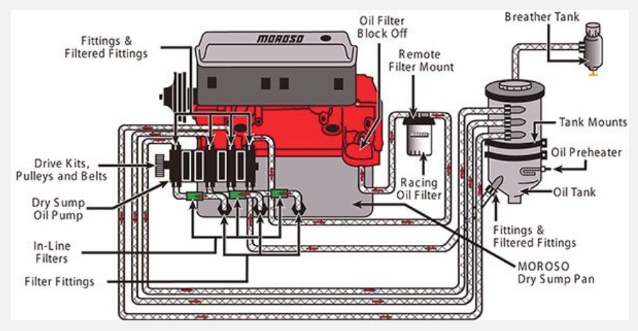 (tech, n.d.)
Figure 2- This illustration shows the major components of a dry sump system

Dry Sump design process

Problem Identification – Quality Function Deployment (QFD)
(Jenkins)
QFD - house of quality

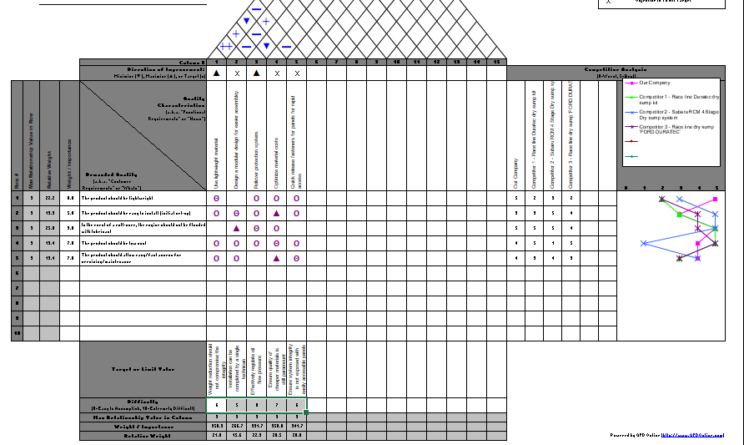

The House of Quality (HoQ) reveals several insights

Customer Needs Identification:

The most critical customer needs identified are:
Lightweight product (importance rating: 8.0)
Engine protection during rollover (importance rating: 9.0)
Low cost (importance rating: 7.0)
Easy/fast access for servicing/maintenance (importance rating: 7.0)
These needs are prioritized based on their importance to customers.

Quality Characteristics Establishment:

Engineering characteristics have been established to address these needs, such as lightweight material usage, modular design for easy assembly, a rollover protection system, optimization of material costs, and integration of quick-release fasteners.
Relationship Correlation Analysis:

Relationships between customer needs and engineering characteristics are analyzed, revealing strong correlations between lightweight material and lightweight product, engine protection, and low-cost product. Moderate relationships exist between easy installation and low cost, as well as easy/fast access for servicing/maintenance and low cost.

Target or Limit Values Setting:

Target or limit values are set for each engineering characteristic to ensure they meet customer needs without compromising product integrity or quality. For instance, weight reduction should not compromise integrity.

Difficulty Level Assessment:

The difficulty level of addressing each customer need is assessed, providing insight into potential challenges during product development. For example, ensuring engine protection during a rollover may be more difficult than achieving lightweight design.

Weight/Importance:

Each customer need is weighted based on its importance, indicating where emphasis should be placed during product development. For instance, engine protection during a rollover carries significant weight.

Competitive Analysis:

Our company's product is compared to competitors, highlighting areas where we excel or lag behind. For example, our product scores high on lightweight design compared to competitors but slightly lower on ease of installation.
Overall, the HoQ provides a comprehensive understanding of customer needs, engineering characteristics, their relationships, target values, difficulty levels, and competitive positioning. It serves as a valuable tool for guiding product development decisions to ensure alignment with customer requirements and competitive differentiation.

Kano model
 (Folding burritos, 2015)
Figure 3 - The KANO model, The Four Categories of Features
The Kano Model is a framework for understanding and categorizing customer preferences based on the impact of product features on satisfaction. It categorizes these preferences into five main areas: Basic Needs (essential features), Performance Needs (linearly related to satisfaction), Excitement Needs (delighters), Indifferent Needs (neither increase nor decrease satisfaction), and Reverse Needs (features that lead to dissatisfaction when absent). By analysing these categories, businesses can prioritize features effectively, focusing on what truly delights customers rather than just meeting basic requirements. This model helps companies innovate and differentiate their products, enhancing customer satisfaction and loyalty. (Folding burritos, 2015)

Product design specification – Dry sump pan and oil pickup adaptor Design
(UWTSD)

Customer Requirements
Based on initial market research and customer feedback, the following requirements have been identified:
• Importance Rating (1-10)
○ Lightweight design: 8
○ Easy installation (initial set-up): 5
○ Prevention of engine flooding during roll-over: 9
○ Low cost: 7
○ Easy/fast access for servicing/maintenance: 7

Performance
The dry sump system and oil adaptor should meet the following performance criteria:
- Efficient scavenging of oil from the sump pan to prevent oil starvation during high-speed cornering and acceleration.
- Compatibility with the separate, external oil pump for oil scavenging and delivery to a remote reservoir/tank.
- Adequate oil flow rate to ensure proper lubrication of engine components under racing conditions.
- Durability to withstand high temperatures and mechanical stresses experienced during motorsport competitions.
- Compatibility with various engine configurations commonly used in motorsport applications.

Appearance
While functionality is paramount, considerations for the appearance of the dry sump system and oil adaptor should not be overlooked. A sleek, compact design that complements the engine's aesthetics is desirable.

Environment
The system should be designed to operate reliably in the demanding environmental conditions typical of motorsport racing, including:
• High temperatures
• Vibration and mechanical shock
• Exposure to corrosive fluids (e.g., fuel, coolant)
• Dust and debris

Installation
The dry sump system and oil adaptor should be designed for easy installation, with clear instructions provided to ensure proper setup by the end-user. Compatibility with a wide range of engine configurations and chassis layouts should be considered.

Product Cost
Cost-effectiveness is essential to ensure the system remains accessible to motorsport enthusiasts and teams. Design decisions should prioritize affordability without compromising performance or reliability.

Competitors
Race line supply a dry sump called ‘Duratec Dry Sump kit’ where they specify their product is ‘market leading in both cost and performance’.
This product is priced at £1,275 (Raceline, n.d.)
RCM 4 Stage Dry sump system – This system is present in a Subaru EJ engine where its design has been refined and is present in championship winning cars. It is also corrosion resistant which assists with smooth efficient coolant movement. It is also user friendly installation which doesn’t require engine removal and it is also a reliable product.
This product is priced at £4,619.99 (RCM, n.d.)
Burton supply a Race line dry sump oil pump kit for ‘FORD DURATEC’, This is considered a market leading product as this concept has been replicated by other competitors. It is considered to have superior performance and cost effective, its compact dimensions make it suitable for inline applications.
This Product is priced at £1,530. (Burton, n.d.)

Maintenance
The system should allow for easy access to components for routine servicing and maintenance. Critical components should be designed for durability and longevity, minimizing the need for frequent replacements or repairs.

Materials
High-quality materials should be selected to ensure the durability and performance of the dry sump system and oil adaptor. Considerations for weight reduction should not compromise structural integrity or reliability.

Quality and Reliability
The system should adhere to strict quality standards to ensure reliability and performance consistency under extreme racing conditions. Quality control measures should be implemented throughout the manufacturing process to detect and rectify any defects.

Standards and Specifications
Compliance with relevant industry standards and specifications, such as those related to materials, manufacturing processes, and safety, should be ensured to meet regulatory requirements and ensure product quality.

Testing
Rigorous testing should be conducted to validate the performance, durability, and reliability of the dry sump system and oil adaptor under simulated racing conditions. Testing protocols should be comprehensive and include real-world track testing where feasible.

Legal Considerations
Any legal implications, such as intellectual property rights or product liability, should be addressed to ensure compliance with relevant laws and regulations in the target market(s).

Documentation
Comprehensive user manuals and technical documentation should be provided to assist customers with installation, operation, and maintenance of the dry sump system and oil adaptor. Clear labelling and instructions are essential for user safety and product reliability.

Disposal
Considerations for environmentally responsible disposal of the product at the end of its lifecycle should be incorporated into the design, including the use of recyclable materials and proper disposal procedures for components.
15. Conclusion
The successful design of the dry sump system and oil adaptor will require careful consideration of customer requirements, performance criteria, environmental factors, and regulatory compliance. By prioritizing functionality, reliability, and affordability, the system can meet the demanding needs of motorsport racing while ensuring ease of use and maintenance for end-users.

CAD design concepts

CAD design discussions

Final design

Evaluation Framework
Evaluating a dry sump design involves a combination of theoretical analysis, computational modelling, and practical testing.

Theoretical Analysis - Fluid Dynamics Simulation:
Employ computational fluid dynamics (CFD) software to simulate oil flow within the dry sump system. This helps analyse the efficiency of oil scavenging, air-oil separation, and overall fluid dynamics. (maccioni, 2020)

Computational Modelling – Finite Element Analysis (FEA)
Utilise FEA software to assess structural integrity and durability of system components. Evaluate stress concentrations, fatigue life, and deformation under operating loads. (Principessa, 2006)

Practical Testing – Rig testing
Use engine test rigs or chassis dynos to assess the overall performance of the dry sump system in a simulated vehicle environment. Monitor oil pressure, temperature, and system response during dynamic testing scenarios. (Bell, 2023)

Data Analysis and Validation
Analyse data collected from theoretical analysis, computational modeling, and practical testing to validate design assumptions and identify areas for optimization. Compare simulation results with experimental data to ensure consistency and accuracy in predicting system behaviour. Iterate on the design based on test results and feedback to refine performance, reliability, and overall effectiveness of the dry sump system.

Bibliography
Bell, L. (2023). Porsche's Oil-Sump Test Rig Is a Sight to Behold.
Burton. (n.d.). Retrieved from https://www.burtonpower.com/raceline-dry-sump-oil-pump-kit-ford-duratec-he-i4-2-0-fd200.html
Cars Blog. (n.d.). Dry Sump Vs Wet Sump Oil System. Retrieved from https://www.dubizzle.com/blog/cars/dry-sump-vs-wet-sump/
Folding burritos. (2015). Retrieved from https://foldingburritos.com/blog/kano-model/
IGER, B. (2021, February 1). MAKE THE CASE: WET-SUMP VS. DRY-SUMP SYSTEMS. Retrieved from https://www.performanceracing.com/magazine/columns/02-01-2021/WET-Sump-Vs-DRY-Sump-Systems
Jenkins, U. J. (n.d.). Quality Functional Deployment (QFD).
maccioni, D. l. (2020). Computational Fluid Dynamics Applied to Lubricated Mechanical Components: Review of the Approaches to Simulate Gears, Bearings, and Pumps.
Moroso. (2020). WET SUMP VS DRY SUMP OILING SYSTEMS.
Principessa. (2006). Stress to impress - stress analysis.
Raceline. (n.d.). Raceline.
RCM. (n.d.). Retrieved from https://rogerclarkmotorsport.co.uk/products/rcm-4-stage-dry-sump-system-ej202225
tech, H. r. (n.d.). Retrieved from https://hotrodenginetech.com/how-to-build-racing-engines-wet-sumps-and-dry-sump-oiling-systems/
UWTSD. (n.d.). How to write a PDS.

