

MASTER OF BUSINESS ADMINISTRATION
ASSESSMENT COMPONENT: ANALYSIS AND SUSTAINABILITY EVALUATION OF TESLA
STUDENT NAME: MAULIK POSHIYA
MODULE: STRATEGIC MANAGEMENT
MODULE CODE: LCMB7003
STUDENT ID: 2511036

Executive Summary
This report provides a detailed strategic report of Tesla, Inc., which is one of the most successful electric vehicles and clean energy companies globally. Applying the PESTEL framework, the external environment is studied in the context of political, economic, social, technological, environmental, and legal factors, indicating that there are intense pressures potentially posed by tariff fluctuations, subsidies withdrawal, and reputational pressures in Europe and positive technological wind in AI and battery developments.
The VRIO framework within Tesla shows that the 4680 battery technology, FSD autonomous driving infrastructure, and Supercharger network are the sources of the sustained competitive advantage. On a financial, customer, internal process and learning front, Balanced Scorecard (Kaplan and Norton, 1992) is used to evaluate performance holistically in an organisation.
Strategic analysis uses a SWOT analysis and a Matrix created by Ansoff to examine the possibilities of penetrating the market, developing the product, expanding into new markets and product diversification utilizing Porters Competitive Advantage theory to justify the use of the dual cost leadership and differentiation strategy by Tesla.
The reflective section uses Gibbs Reflective Cycle to critically assess the process of learning that was completed during this assignment and combines theory and practice in a work-effective manner.
Table of Contents
Section 1: Strategic Analysis 5
1. Organisational Context and Overview 5
1.1 Introduction to Tesla 5
1.2 Historical Development 5
1.3 Mission and Vision 6
1.4 Business Model 6
1.5 Industry Overview 6
1.6 Key Competitors 7
2. External and Internal Environment Analysis 7
2.1 External Environment Analysis (PESTEL Framework) 8
2.2 Critical Success Factors 12
2.3 Strategic Challenges in External Environment 14
2.4 Internal Environment Analysis 15
2.5 VRIO Framework Analysis 16
2.6 Internal Strengths and Competitive Advantage 18
3. CSR and Sustainability Objectives 18
3.1 Overview of Tesla’s CSR Strategy 19
3.2 Alignment with Business Objectives 20
3.3 Critical Evaluation 20
4. Comprehensive and Holistic View: Balanced Scorecard 21
4.1 Introduction to Balanced Scorecard 21
4.2 Financial Perspective 21
4.3 Customer Perspective 22
4.4 Internal Business Processes 23
4.5 Learning and Growth 24
5. Strategic Choices and Implementation 24
5.1 Business-Level Strategies 24
5.2 Corporate-Level Strategies 25
5.3 Recommended Strategic Choices 26
5.4 Change Management Assessment 26
5.5 Impact on Strategic Implementation 27
6. Strategic Evaluation and Recommendations 27
6.1 SWOT Analysis 27
6.2 Ansoff's Matrix Analysis 29
6.3 Strategic Recommendations 29
6.4 Justification of Recommendations 30
Section 2: Reflective Account 30
7. Reflection Using Gibbs Reflective Cycle 30
7.1 Introduction to the framework 30
7.2 Application of the framework 30
Reference List 34

Section 1: Strategic Analysis

1. Organisational Context and Overview

1.1 Introduction to Tesla
Tesla, Inc. is an American electric vehicle and clean energy company, headquartered in Austin, Texas. Elon Musk was co-founded in 2003 by Martin Eberhard and Marc Tarpenning and Elon Musk joined as Chairman and lead investor in 2004 and as CEO in 2008. Tesla has sold a total of 7.2 million vehicles, and it currently employs approximately 125,000+ people all over the world as of 2025 (Tesla, 2025).

1.2 Historical Development
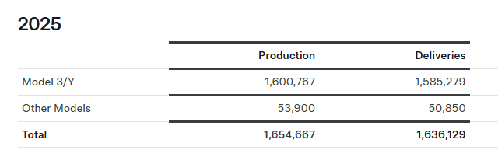
Figure 1: Tesla Production and Deliveries
(Source: Tesla, 2026)
Tesla launched its first vehicle, the Roadster, in 2008, followed by the Model S (2012), Model X (2015), Model 3 (2017), and Model Y (2020). In 2025 Tesla will sell 1,585,279 of its Model 3/Y, 50,850 of its Model X/S, Cybertruck, and Semi cars (Tesla, 2026).

1.3 Mission and Vision
Tesla has a mission of accelerating the process of the world transitioning to sustainable energy and the vision of full vehicle, energy storage, and autonomous software is one of the bases that facilitate this mission

1.4 Business Model
The sales model of Tesla is direct-to-consumer making it not to include dealerships. Vehicle sales, energy products and software (Autopilot/FSD) are the sources of revenues. The diversification initiatives are not to imply that Tesla will not have EVs that will add about 75% of its revenue by the year 2025. In Q3 2025, revenue in energy generation and storage boosted its revenue year-over-year by 44% to $3.4 billion (Investing.com, 2025).

1.5 Industry Overview
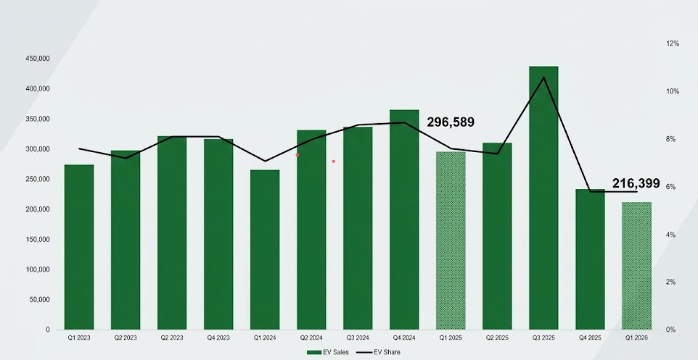
Figure 2: US electric vehicle sales
(Source: Cox Automotive Inc., 2026)
The year-over-year sales decline by most major automakers is significant – many saw sales down 60%-to-70% or more in Q1 (Cox Automotive Inc., 2026). However, in the first quarter of 2026, without federal government incentives, US EV attained 5.8% market share.

1.6 Key Competitors
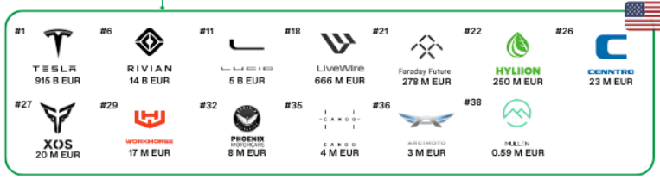
Figure 3: TESLA competitor analysis
(Source: Worldwidemobility.io, 2025)
Tesla is challenging more traditional auto-manufacturers like Toyota and Ford and pure-play EV competitors. The largest Tesla rival is BYD that is currently registered at more than 2 million vehicles sold in 2025 as competitors such as Xiaomi and Geely continue to grow in Asia and Europe. Tesla is also one of the largest automakers in the world by 2025 with its market capitalization of over $915 billion; it is a clear cut at being the world leader in the premium EV, even as more competitors emerge (Worldwidemobility.io, 2025).

2. External and Internal Environment Analysis

2.1 External Environment Analysis (PESTEL Framework)
Political Factors
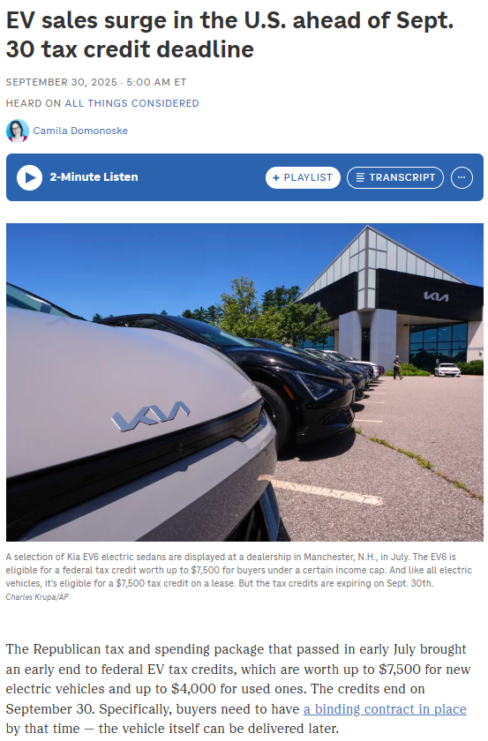
Figure 4: Tax credit
(Source: NPR, 2025)
Tesla experienced a dramatic shift in its politics in 20252026. The largest demand-side shock in the history of the US EV industry was the expiration of the September 30, 2025 federal EV tax credit and up to 16% to 38% reduction in EV sales in the first half of 2026 were estimated (NPR, 2025). The trade policy contributed to this pressure: the US kept its 100% tariff on Chinese-made EVs, but the EU implemented a tiered countervailing duty system, with a lower duty of 7.8% on Tesla cars (Henry, 2025). China announced on Friday (April 4, 2025) that it will impose a 34% tariff on imports of all US products beginning April 10 (AP, 2025).
Economic Factors
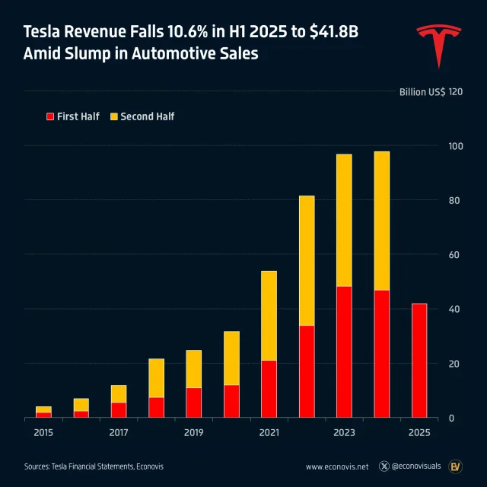
Figure 5: Tesla Revenue Dip
(Source: Soltani, 2025)
Tesla 2025 revenue slipped by 3% to $94.8 billion in 2025 and was the first annual decline in the company's history. However, the recovery was evident: Q1 2026 revenue reached 22.4 billion which is a 16% increase compared to the past year, outpacing the market expectations of the revenue level of 22.3 billion and the growth of 14%. Consumer buying power and affordability of EVs were a structural challenge and high interest rates continued to suppress consumer buying power (Neves, 2026). It is estimated that the battery price drop will cause a reduction in the price of EV by 20-30% over 10 years, which will be a tailwind to the demand in the long term (Soltani, 2025).
Social Factors
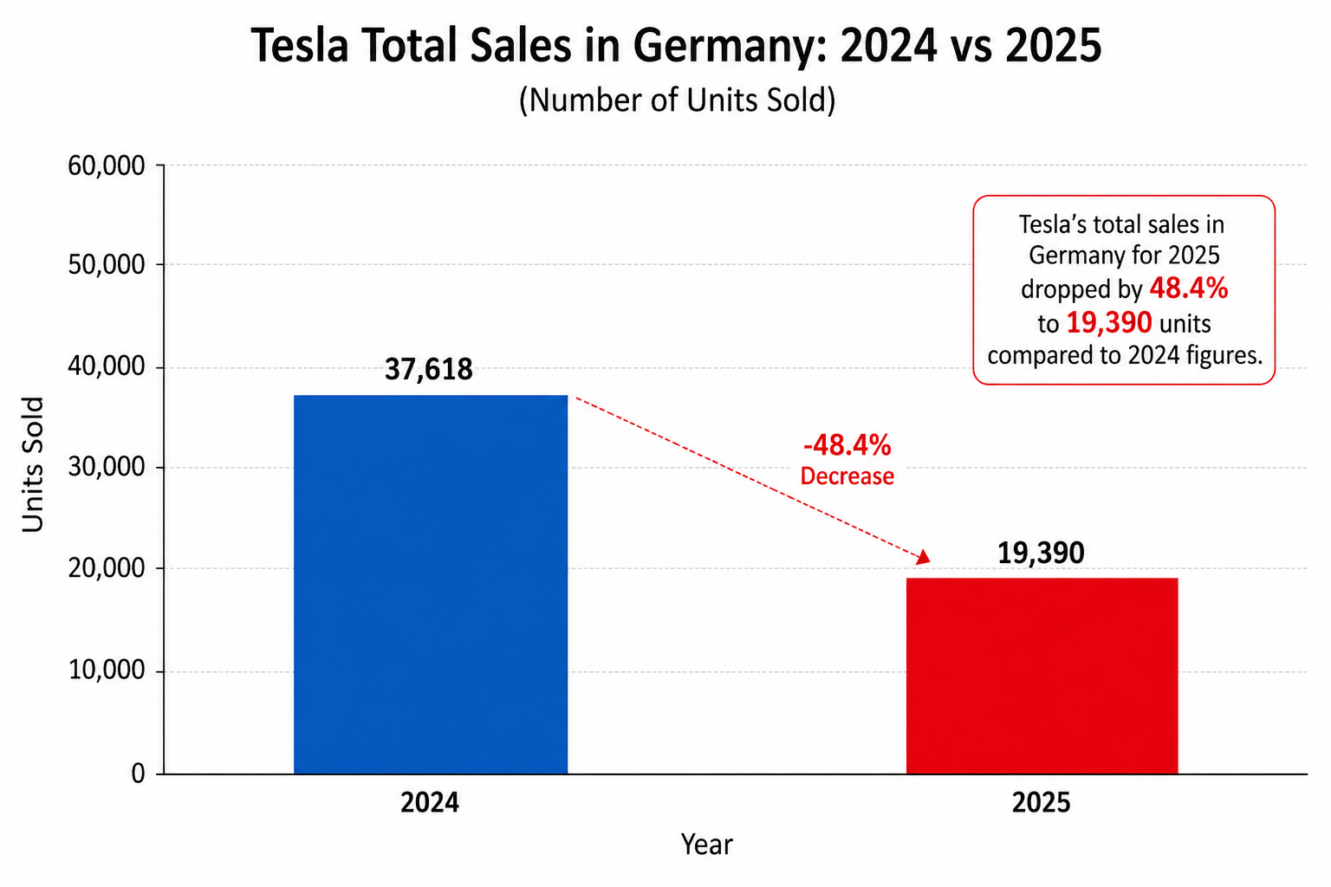
Figure 6: Tesla sales drop in Germany
(Source: Investing.com, 2026)
Foresight a 2025-26 consumer climate is a polarised and more conscious sustainability awareness. Elon Musk's polarising political remarks negatively impacted Tesla brand image in Europe, which made it more difficult to sell in the region as BYD European registrations had improved 225% in one year compared to Tesla, up 40% (Reed, 2025). Tesla's total sales in Germany for 2025 dropped by 48.4% to 19,390 units compared to 2024 figures (Investing.com, 2026).
Technological Factors
The most valuable strategic asset of Tesla can be considered to be technological position in 20252026. The 4680 battery cell programme was capable of producing 40 GWh of battery cell in Gigafactory Texas and Tesla currently produces battery packs in Model Y using domestically produced battery cells and a simpler and less expensive process which is environmentally friendly (BASENOR Team, 2026). In April 2026 Tesla began autonomous Robotaxi trips in Dallas and Houston on autonomy and its Cortex AI training cluster reached 100,000 H100 industry-equivalent GPUs.
Environmental Factors
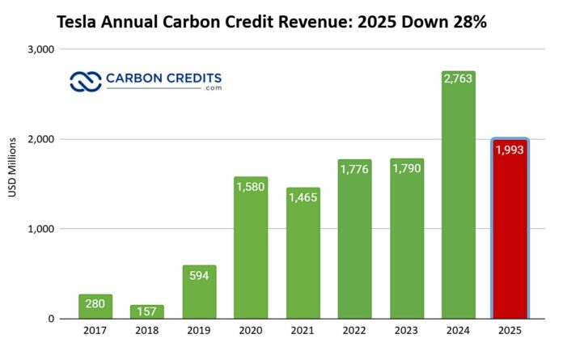
Figure 7: Tesla annual carbon Revenue
(Source: Jennifer, 2026)
International climate regulation continues to offer Tesla with structural tailwinds of its zero-emission product range. Plans of EU Green Deal impose accelerating CO₂ fleet-average targets on all automakers towards its benefit automatically, which is in favor of Tesla. However, regulatory credit-driven revenue declined in 2025, although with legacy automakers making more of their own electrification offerings, it reduced their dependency on purchasing credits with Tesla, a revenue stream that had previously provided a disproportionate support in the marginal car downturns (Jennifer, 2026).
Legal Factors
The autonomous driving law remains controversial and disjunctive. Regulatory challenges have arisen in Europe and China, and legal barriers to expansion beyond geofenced operating areas in the United States due to legal challenges on safety claims have been encountered by the Tesla Robotaxi service (Brennan, 2026). An example of the country-by-country regulatory burden can be seen in April 2026 when FSD was approved by the regulators in the Netherlands. The Tesla NHTSA investigations into Incidents involving Autopilot are not complete, thus providing Tesla with a legal overhang to its method of generating revenue through autonomy (Sterling and Sriram, 2026).

2.2 Critical Success Factors
Four major success factors are informed by the Tesla PESTEL environment. As per Machucho and Ortiz (2025) innovative abilities are the greatest strength against political and competitive pressures - the non-negotiable strategic requirements are AI, battery, and autonomy investment.
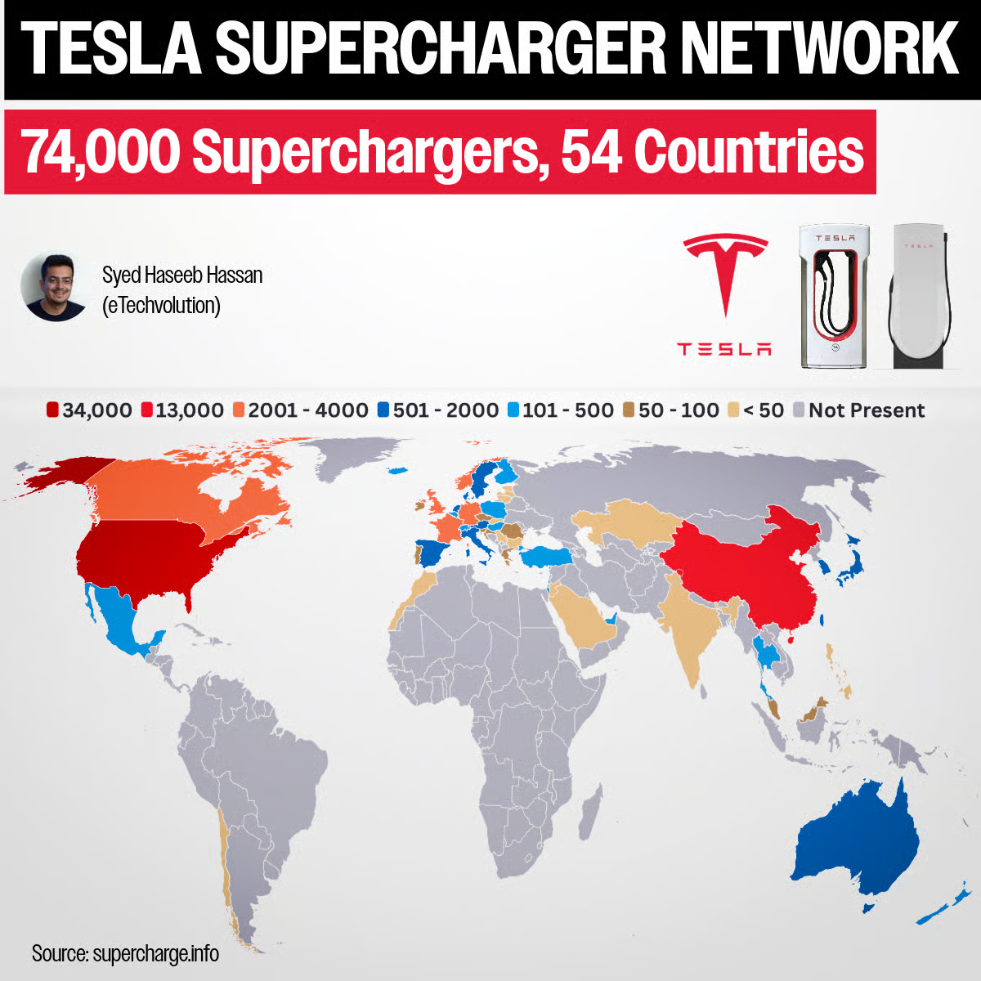
Figure 8: Tesla Supercharger
(Source: Hassan, 2025)
Brand image must be actively managed as opposed to the documented social backlash that was registered in the European markets in 2025 whereby, political identification with the CEO Elon Musk was the evident cause of the lack of demand. The availability of charging infrastructure will favor consumer adoption confidence, as per Hassan (2025), Tesla has created an extensive network of over 74,000 station Superchargers around the world, which serves as a structural moat no one has adopted on the same scale.
Finally, as per the nbcellenergy (2026), the battery cost-effectiveness is directly antithetical to the economic stressor of subsidy discontinuities, and the 4680 cell programme and domestic refinery of lithium are vital enablers to the resilience of margin at scale in the future.

2.3 Strategic Challenges in External Environment
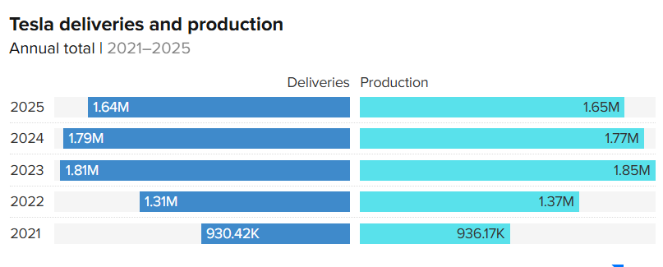
Figure 8: Tesla deliveries and production
(Source: Kolodny, 2026)
There are four compound external challenges that Tesla is confronted with. BYD emerged the global leader in total deliveries in the number of units delivered annually at the end of 2025 with 2.26 million vehicles shipped against 1.64 million during the year with Tesla, which is an enormous shift in the competitive landscape. Regulatory risk in autonomous driving regulations across different jurisdictions slows the Robotaxi scaling and FSD revenue collection (Kolodny, 2026).
The supply chain fragility has revealed the Cybercab volume production risk because the US-China tariff volatility has the effect of Tesla relying on Chinese parts particularly in the Cybercab and Semi programmes where the threat of tariffs rebounding to 145% has threatened to delay the volume production of the Cybercab (Lu, 2025).

2.4 Internal Environment Analysis
Key Resources
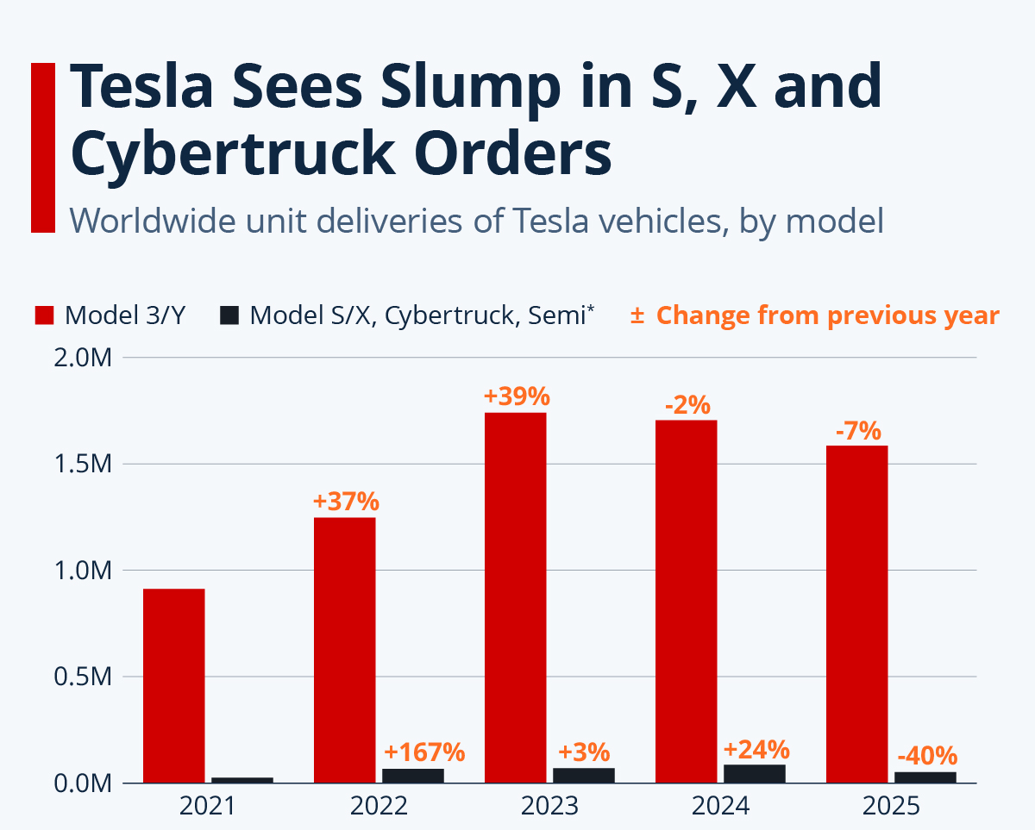
Figure 9: Tesla Categorywise distribution
(Source: Gaudiaut, 2026)
Tesla boasts of five Gigafactories in operation. Unit distribution per vehicle is more than 550,000 in California, 950,000 + in Shanghai, 375,000 + in Berlin, 250,000 + in Texas, and 125,000 Cybertruck units per year is one of the most disseminated proprietary EV production footprint around the globe (SEC, 2025). On the financial side, Tesla has enjoyed a liquidity position in creating operating cash flow of 3.9 billion in Q1 2026 to deploy the funds to fund more future innovation programmes (SEC, 2025).
Capabilities
Tesla has both hardware and software that are vertically integrated as part of its R&D. As the Cortex supercomputer can calculate billions of real driving miles annually, it creates a self- enhancing, data advantage over its competitors who are attempting to devise alternative autonomy implementations. The core of manufacturing efficiency lies in the proprietary die-casting technology, whereby the supply chain of the sources of raw materials is becoming increasingly local (Dany Kitishian, 2025).
Core Competencies
Three old-established foundational competencies of Tesla can be summarized as battery technology (leader, proven using the 4680-cells manufacturing and in-house lithium refining), autonomous driving systems (it had been trained on 4680-cells billions of miles), and vertical integration to energy, cars, and artificial intelligence, an ecosystem that not many competitors had been able to capture in a comprehensive manner (Morris, 2026).

2.5 VRIO Framework Analysis
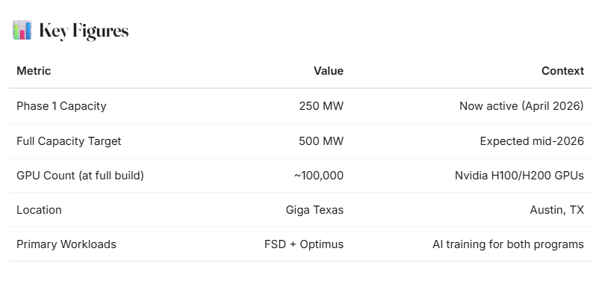
Figure 10: Cortex cluster with 100,000+ H100e GPUs
(Source: BASENOR Team, 2026b)
Resource / Capability | Valuable? | Rare? | Inimitable? | Organised? | Competitive Implication
4680 Battery Technology & Domestic Lithium Refining | Yes — reduces per-unit cost and improves range | Yes — proprietary cell architecture | Yes — unique manufacturing processes and IP | Yes — scaled at Gigafactory Texas (40 GWh) (Lambert, 2022) | Sustained Competitive Advantage
FSD & Autonomous Driving Data Infrastructure | Yes — unlocks high-margin software revenue streams | Yes — billions of fleet miles unmatched globally | Yes — years of irreplicable real-world data collection | Yes — Cortex cluster with 100,000+ H100e GPUs (BASENOR Team, 2026b) | Sustained Competitive Advantage
Global Supercharger Network (50,000+ stations) | Yes — directly influences purchase decisions | Yes — largest proprietary EV network globally | Partially — competitors investing but remain far behind | Yes — deeply integrated into vehicle UX and sales | Temporary to Sustained Advantage
Brand & Innovation Perception | Yes — supports premium pricing | Partially — eroding in European markets in 2025 | Partially — CEO reputational risk is an external variable (Pahud De Mortanges, 2025) | Yes — product and marketing aligned globally | Temporary Competitive Advantage
Table 1: VRIO Analysis

2.6 Internal Strengths and Competitive Advantage
Internal Strengths: As per Moradian et al. (2025), Tesla, Inc. exhibits a high level of internal resources in terms of its own innovation in batteries and a slowly localized supply of lithium that allows the control of costs more carefully. Its state-of-the-art AI ecosystem, such as Cortex infrastructure speeds up the development of autonomous driving. Moreover, the integrated energy business enhances diversification and operational resilience by Tesla.
Competitive Advantage: These strengths are translated into long-term benefits. According to Liu, Boothman and Graham (2025), Tesla experiences decreasing per-unit costs with competitors having to depend on external suppliers. Its AI advancement in autonomy development is more advanced than its traditional counterparts which do not have the same level of investment. As per Team Ackodrive (2025) energy revenue, which increased to more than 40%, offers a high margin buffer to reduce dependence on vehicle sales and maintain financial stability over the long term.

3. CSR and Sustainability Objectives

3.1 Overview of Tesla’s CSR Strategy
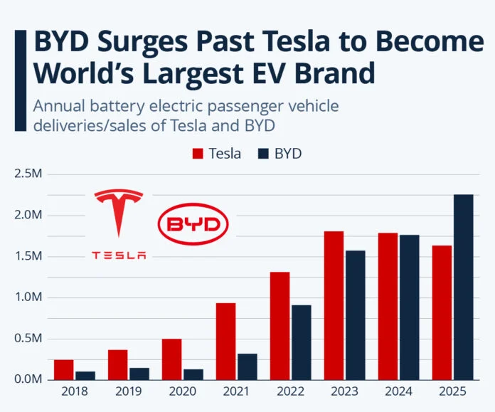
Figure 11: Tesla Sales
(Source: Jennifer, 2026a)
The CSR plan of Tesla is deeply embedded in its mission to hasten the process of global productivity to sustainable energy. By 2025, Tesla sold about 1.64 million electric vehicles, which were estimated to save about 20 million metric tons of CO₂ annually in comparison to internal combustion equivalents (Reuters, 2026). Its energy segment increased at a steep rate with 2025 deploying over 14 GWh of energy storage alone and year-on-year solar deployments increasing by circa 30% through early 2026. Tesla also cited that its Giga factories are more heavily based on renewable energy and that some of the facilities are aiming to achieve greater than 80% clean energy utilization (Jennifer, 2026a).

3.2 Alignment with Business Objectives
The sustainability programs by Tesla are directly related to the growth and revenue creation. The energy division has made the energy division bring in revenue of more than 3 billion in Q3 2025, which illustrates the relationship between environmental goals and financial performance (Colthorpe, 2025).
Moreover, recycling of batteries reclaimed as much as 92% of important raw materials by 2026, both lowering costs and supply risk. This congruency determines that sustainability is not a marginal process but a key driver of competitiveness and scalability of Tesla (Morris, 2025).

3.3 Critical Evaluation
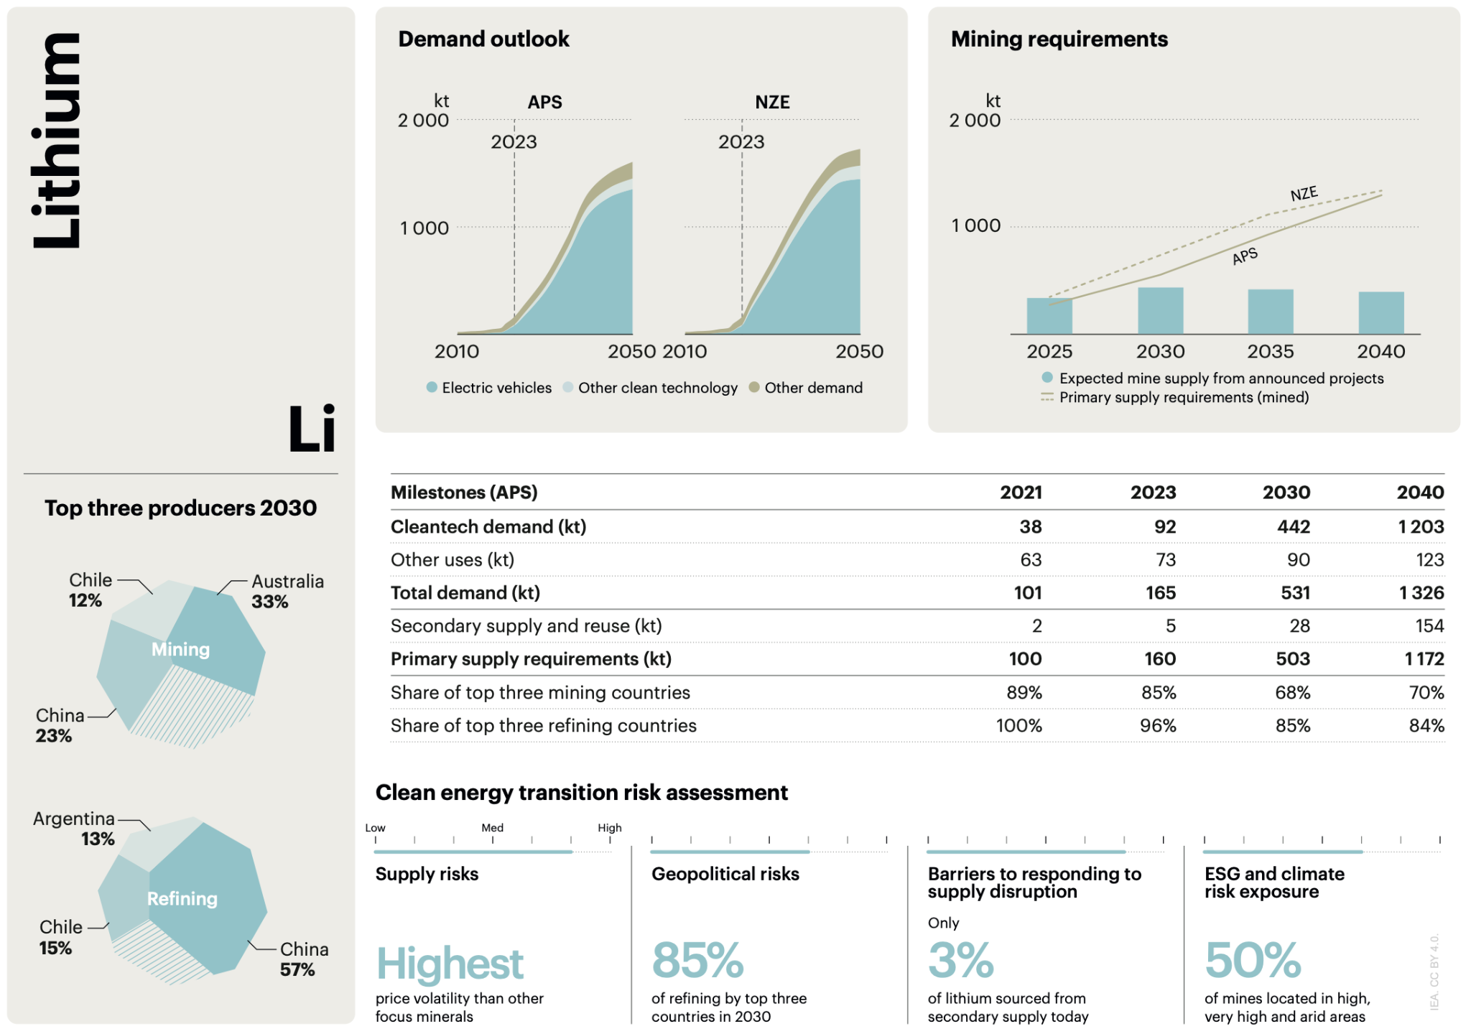
Figure 12: Lithium Market
(Source: EVBoosters, 2025)
Tesla also has CSR issues in spite of the good performance. Emissions of lithium supply chain and ethical sourcing issues are also still major issues, especially with the demand of 1.2 million tons of the lithium in the globe in the year 2025. Also, there is still scrutiny of labor practices and governance transparency (EVBoosters, 2025). Although Tesla is the most environmentally responsible, the challenge between rapid growth and complete social responsibility is a strategic issue that is yet to be resolved.

4. Comprehensive and Holistic View: Balanced Scorecard

4.1 Introduction to Balanced Scorecard
The Balanced Scorecard is a strategic approach to performance management created in 1992, by Robert S. Kaplan and David P. Norton, which analyses organisational success using four related perspectives: financial, customer, internal business processes, and learning and growth. In the case of Tesla, the structure unites its innovations-driven business with its overarching aim of propelling the global shift to sustainable energy (Hajji, Chtaoui and Bouhmala, 2025).

4.2 Financial Perspective
Objectives
- The organisation plans to recover growth of revenue and cut the cost systemic of automotive and energy division by 3%.
- It dwells on enhancing financial resilience through the enhancement of operational efficiencies and in diversifying high-margin revenues streams.
KPIs
- Key performance indicators are the total revenue, automotive gross margin, and increase rate of energy segment.
- Tesla has witnessed a 16% annual growth in revenues which is an indication of early financial recuperation (Smith, 2026).

Targets
- The company targets to achieve a revenue of over 100 billion a year and a gross margin of 20% again.
- These goals are backed by saving of costs in production of 4680 batteries and by achieving economies of scale.
Initiatives
- Tesla has and is planning to increase global Gigafactory capacity so they can produce more and decrease the cost per-unit.
- The company is diversifying its energy storage business, commercialising Full Self-Driving (FSD) as a subscription model to increase margins (Petrova, 2026).

4.3 Customer Perspective
Objectives
- Tesla aims at ensuring the high level of customer satisfaction and the brand loyalty and it is especially in Europe where registration dropped by 17%.
- The company seeks to reestablish brand perception which has been damaged due to reputational issues associated with Elon Musk (Meredith, 2026).
KPIs
- The main customer satisfaction and retention measures are the Net Promoter Score (NPS) and customer retention rate.
- The Tesla score on NPS is always over 70 in all markets, indicating customer advocacy in major markets.
Targets
- The organisation will stabilise NPS to above 70 in all the key regions.
- It aims at retaining its first place in automotive customer loyalty survey globally.
Initiatives
- Tesla keeps providing an over-the-air software upgrade to improve the performance of their vehicles and customer experience.
- The increase in the number of Supercharger and better service centre responsiveness will decrease ownership friction.

4.4 Internal Business Processes
Objectives
- Tesla aims at optimisation of workflow in Gigafactories to enhance efficiency and decrease bottlenecks during production.
- It seeks to fast-track innovation channels in energy products and autonomous driving.
KPIs
- The measurements of performance are done in terms of time taken to complete production cycles, defects, and facility output (Monika, 2025).
Targets
- The company targets to increase the scale of the Cybercab production in 2026 and reach the full LFP battery capacity in Nevada.
- It intends to finish the Megapack factory in Texas to help in expansion of energy business.
Initiatives
- Tesla is expanding automation on production lines and is incorporating AI-based systems of quality controls.
- The corporation is speeding up its supply chain of 4680 batteries and work on Optimus humanoid robots production lines.

4.5 Learning and Growth
Objectives
- Tesla is committed to developing AI, engineering, and software development capabilities that are leaders in the industry.
- It is geared towards developing an organizational culture of sustained innovation and learning in international operations.
KPIs
- Key indicators are the employee performance, R&D output and the capacity of AI infrastructure.
- Internal assessment has to done to gather better information about the organisational changes.
Targets
- With a strategy to expand its scale to over 130,000 H100-equivalent GPUs and expand AI-based innovation, the company will do so.
- It is also geared towards commercialization of the Optimus robot.
Initiatives
- Tesla is making strategic investments in AI, battery and autonomy engineering talent.
- The company is also working with Samsung to produce the next-generation AI chips (ET Enterprise AI, 2026).

5. Strategic Choices and Implementation

5.1 Business-Level Strategies
The hybrid approach of cost leadership and differentiation is also not common, and Tesla pursues such a strategy. It has cost leadership which is driven by its economies of scale and process innovation. By early 2026, the total Tesla global manufacturing capacity had topped 3 million per year, and the complexity of producing this had been reduced as much as 70-percent in certain areas by gigafinding (Trending Now Plant and Machinery, 2026). It lowered the year 2025 cost per vehicle of operation by an average of 8% despite the pressures on costs experienced by the world.
At the same time, the degree of differentiation is maintained in Tesla, and it is a highly-developed brand positioning and technology. Its vehicles are powered by proprietary software, over 85% of the consumers in North America purchased free software in 2025. (D Washington, 2025)

5.2 Corporate-Level Strategies
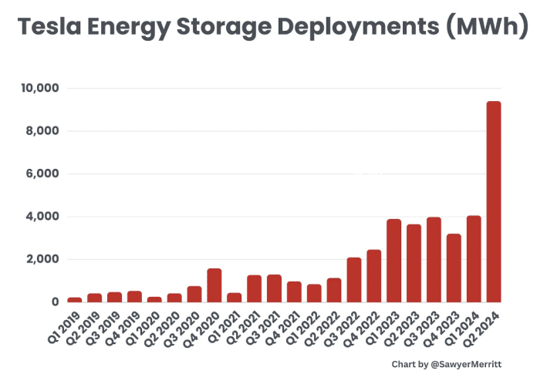
Figure 13: Tesla Energy Storage Deployments
(Source: Jennifer, 2024)
Tesla is diversified in the automotive industry as well as the energy industry and artificial intelligence. The Tesla Megapack backlog amounted to more than 25 GWh which was equivalent to the skyrocketing demand in grid-scale storage (Jennifer, 2024). Investments in AI are also of importance; Tesla invested more than 2 billion specifically in the infrastructure, system training of AI in 2025 and enhances its dreams of autonomy. As the new markets opened, and the policy support, Tesla has increased its activity in new markets as sales in India and Southeast Asia have increased over 60% in the first half of 2026 (PTI, 2026).

5.3 Recommended Strategic Choices
Tesla should be patient about its cost leadership through vertical integration and improvement of AI-based differentiation. The EV market is also targeted at exceeding 22 million units in the world in 2026 to further intensify the price competition (Honig, 2026). The low-cost production can ensure volume leadership, and the AI capabilities can be enhanced to develop differentiation in the long run. Increasing storage of energy will also fulfill the demands of the world electricity which will continue to grow and grow by an average of 3.5% annually until 2030 (Tundys and Wiśniewski, 2026).

5.4 Change Management Assessment
Put differently, Tesla, Inc. can be defined as a firm that is fast in change management and that the management is centralized with Elon Musk. The company can implement changes in its products within weeks whereas other traditional car manufacturers can only change the product in years because of the low decision-making speeds. Tesla is never short of innovation, which is seen in the conflicting advances of cars, over 50 major over-the-air updates at the global level, enhanced vehicle activities, security, as well as provisions, extensively in 2025 ( PredictStreet, 2025). The relatively flattened organisational structure also enables it to implement prompt and be adaptable to a highly dynamic industry. The latter structure however presents an excessive dependence on the top management on strategic direction which could prove to be risky in the leadership concentration context and potential bottlenecks in key decision making areas (Fortune, 2025).

5.5 Impact on Strategic Implementation
The plan assists Tesla to attain unprecedented levels of innovation, a fact that reduces the time of product development, by nearly 30%, than traditional manufacturers. Dangers are introduced with this speed, though. The overbuilding of capacities has become a reality thus it is vulnerable to variability in capacity utilization with some facilities being unable to run at less than 80% efficiency in 2025 (Ghar, 2024). In addition, high speed scaling creates complexity to operations and quality and control difficulties.

6. Strategic Evaluation and Recommendations

6.1 SWOT Analysis
Strengths: Tesla possesses a distinct Supercharger network, vertically integrated supply chain between lithium refining to finished vehicles and an automotive NPS continuously above 70 in the entire world are enduring competitive advantages. Services and other revenue grew 25% each year in Q3 2025 to $3.5 billion, an indication of grossly successful diversification of revenues beyond the core business of vehicle sales (Team Ackodrive, 2025).
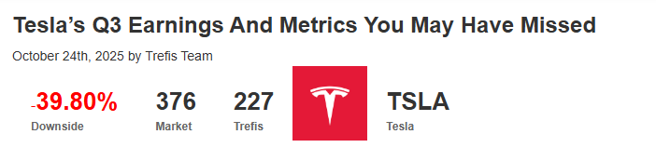
Figure 14: Tesla’s Declining Market hold
(Source: Trefis Team, 2025)
Weaknesses: The operating income decreased drastically into approximately 1.2 billion in Q2 2025 and is a result of continued pressure in margins due to ability to price aggressively and rising operational expenses. What is more, brand recognition issues associated with Elon Musk also helped to have weaker demand in Europe, which has an impact on the sales velocity, the attitude of customers, and the competitiveness on the market, in general (Trefis Team, 2025).
Opportunities: With the Optimus programme, Tesla could reach 50,000-100,000 units in 2026 and conservative analysts' models indicate that Cybercab will be generating revenues of 54 billion by 2030 (Magliocco, 2025). The deal with India Gigafactory and the regulation of FSD in Europe, as a whole, are key growth vectors that can be discussed.
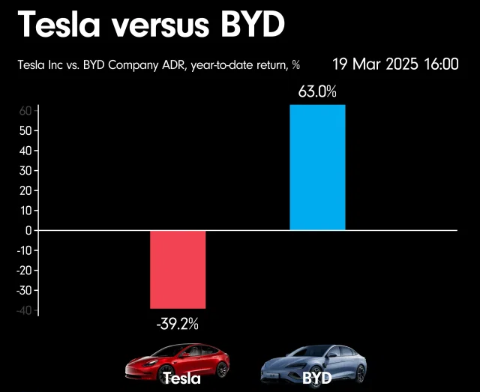
Figure 15: Tesla Versus BYD
(Source: Eagle, 2025)
Threats: BYD directly faces the threat; its 2.26 million annual units in 2025 will be a direct threat to the global volume leader Tesla. Persistent tariff variability - 30-145% US-China tariffs, raised through 2025 - and permanent cancelling the $7,500 federal EV tax credit would lead to persistent structural demand headwinds in early 2026 (Farooque, 2026).

6.2 Ansoff's Matrix Analysis
Strategy | Application to Tesla
Market Penetration | Model Y, scale Supercharger network to accommodate high volume models, competitive prices. Refreshed Model Y with 54.2% US EV share in Q1 2026 (Shvartsman, 2026).
Product Development | Cybercab robotaxi and Optimus robot - with a target of 50-100,000 by 2026 - are Tesla extensions to autonomous mobility and humanoid robotics.
Market Development | India Gigafactory and FSD regulatory approvals in Europe conversations generate new geo-based revenue streams of the already existing vehicle and energy products lines (MarketWatch, 2026).
Diversification | Megapack energy storage, Samsung partnership, development of Optimus robotics, development of AI inference chip are real non-automotive diversification.
Table 2: Ansoff matrix

6.3 Strategic Recommendations
Innovation Investment: Tesla should hasten the commercialisation of Cortex AI and Optimus. Elon Musk believes 80% of the minimum long term value of Tesla will be robotics and that by 2026 Tesla will have added six new production lines of vehicles, robots, energy storage and batteries at the same time (Trudell, 2025).
Market Expansion: Tesla ought to target India Gigafactory and European brand recovery, by restructuring their corporate governance and rupturing the connection between company and political scandals spearheaded by their CEO in 2025 would directly fix the problem of the 39% European registration failure in 2025 (Dahl, 2026).
Cost Optimisation: Full onshoring of 4680 cell supply chain and additional speeding up of cathode production in the country ensures that the long-term exposure to input cost volatility caused by tariffs is mitigated.

6.4 Justification of Recommendations
These recommendations align with the Ansoff diversification and market development quadrants, the Competitive advantage theory of Porter which emphasizes on cost leadership through vertical integration and the learning and growth perspective of Kaplan and Norton. This way is followed by practical precedent: Tesla is in the footsteps of Amazon that have turned e-commerce retail into AWS cloud computing, where an ability in the company became a distinct, globally dominant revenue generator generating over 100 billion dollar revenues annually (Cimino, 2026). Optimus also represents a perceived attempt of Tesla to turn the acquired AI and manufacturing know-how to a wholly new business market, systematic de-cyclization of its future dependence on the automotive demand cycle (Fortugno, 2026).

Section 2: Reflective Account

7. Reflection Using Gibbs Reflective Cycle

7.1 Introduction to the framework
In this reflective account, I have used the design of Gibbs Reflective Cycle, introduced by Graham Gibbs, as a plan in assessing my learning process. The variety of stages in this framework is six, including description, feelings, evaluation, analysis, conclusion, and action plan (Galli and New, 2022). I have chosen this model as it offers systematic reflectivity on experiences and outcomes as well as making it possible to learn more profoundly. It also enables me to relate theoretical knowledge with hands-on experience, which is especially vital in a strategic management project in a complicated organisation such as Tesla, Inc. Applying this theory assisted me in going beyond just completing the task, to taking an active analysis of the process I followed in the research, the obstacles I experienced and how in the future I can work on my academic and analytical capabilities (Main, 2023).

7.2 Application of the framework
Description
This assignment entailed a thorough strategic assessment of Tesla. I analysed its organisational environment, external and internal environments based on the models like PESTEL and VRIO and analysed its CSR strategy. I also used the Balanced Scorecard to evaluate the performance and evaluated business and corporate strategic decisions (Eze, 2023). I formulated the recommendations relying on such strategic models as SWOT and the Matrix of internal and external environmental factors as proposed by Ansoff. It required a considerable amount of research based on recent 2025-2026 data, so that my analysis would contain relevant data about recent industry dynamics. I have based my assignment on the academic requirements, combining theory with evidence on real-life to reinforce my points (Peterdy, 2025).
Feelings
Initially, I was not worried that I was about to struggle with the force of the assignment but felt confident in my knowledge of strategic management theories. It is not an easy task to analyse such a dynamic company as Tesla, especially to sort out the data that is relevant and up to date. The initial inability to strike a balance between descriptive information and critical analysis was an issue I also struggled with, since there was a tendency to pay more attention to the explanation of concepts than the evaluation of them (Indeed Career Guide, 2025). Nevertheless, as I advanced, I was more relaxed about combining theory and evidence. There was also a certain pressure on me to make sure that the information was sufficient, up-to-date, and not repetitive particularly when working with bulk data on statistics (Arnold, Goldschmitt and Rigotti, 2023).
Evaluation
The use of various strategic frameworks was one of the strengths of my approach as it enabled me to analyse Tesla in various perspectives. I could identify external influences with internal strengths, indicating a comprehensive grasp of strategy (Ma, 2025). Also, the inclusion of more recent statistics enhanced the overall credibility of my analysis and made my arguments sound more convincing. But there were places that were not as good. Time management was another issue especially at the time of conducting research because I used a lot of time in making sure that the data has been verified. Sometimes I also had some issues with keeping a steady degree of critical depth throughout all parts, where some were more analytical than others. Also, it was necessary to smoothly integrate all the frameworks, which was initially challenging to me (Ahmed et al., 2025).
Analysis
In the process, I was able to make invaluable observations about the application of theoretical frameworks to real life situations. As an illustration, PESTEL allowed me to comprehend the role of external forces like regulation and technology in strategic choice and VRIO provided perspective on the role of internal capabilities of maintaining the competitive edge (Citilci and Akbalik, 2019). I learnt that none of the frameworks offers a complete perspective; however, the combination of the tools offers a more in-depth analysis.
I also gained a more profound understanding of the value of data as the element of strategic decision-making. The examination of the latest statistics helped me to see the tendencies and estimate the performance of Tesla more objectively (Zheng, 2026). Furthermore, I realized the necessity of critical thinking because it is quite important to demonstrate information without evaluating its implications. This experience has helped me become more able to relate theory to practice as well as to think in a strategic manner.
Conclusion
Overall, this assignment allowed me to improve my knowledge of strategic management and practice of applying theoretical knowledge. I was taught on how to conduct a systematized research, to analyze information critically, and to support arguments. It highlighted the importance of striking a balance between the descriptive content and the presentation to come up with meaningful conclusions. I also acquired confidence in tackling complicated business scenarios and making meaning out of the numbers to make strategic decisions (Veríssimo et al., 2024). It has also taught me to think critically and has also helped to keep in mind the orderedness of structures in evaluating the performance and strategy of organisations, and now is well placed to take up later advanced academic tasks as well as real life problem solving situations in the future.
Action Plan
To better my time management skills, I would contribute to the research initial process and establish clear milestones of each part in the future. I will also be keen on improving my critical analysis competencies through challenging assumptions and trying different views. To improve upon my academic writing, I will employ more varied sources and make better integration of theory and evidence (Ayala, Fuertes and Jarrin, 2024). Besides, I will also improve on the principles of synthesising information to establish repetition that will not be justified.
Lastly, I want to learn more about strategic frameworks through using them across the industries and organisations. It will enable me to become versatile in my analysis and be equipped to tackle more difficult academic and professional problems.

Reference List
PredictStreet (2025). Deep Dive: Tesla (TSLA) – Navigating the Future of AI, Autonomy, and Energy. [online] Financialcontent.com. Available at: https://markets.financialcontent.com/wral/article/predictstreet-2025-12-17-deep-dive-tesla-tsla-navigating-the-future-of-ai-autonomy-and-energy.
36kr.com. (2026). Tesla Reports $477M Net Profit in Q1: Elon Musk Complains While Telling Stories. [online] Available at: https://eu.36kr.com/en/p/3779016535806980
Ahmed, S.K., Mohammed, R.A., Nashwan, A.J., Ibrahim, R.H., Abdalla, A.Q., Ameen, B.M.M. and Khidhir, R.M. (2025). Using Thematic Analysis in Qualitative Research. Journal of Medicine, Surgery, and Public Health, [online] 6(6), p.100198. doi:https://doi.org/10.1016/j.glmedi.2025.100198.
AP (2025). China imposes 34% tariff on imports of all U.S. products starting April 10; Trump says Beijing played it wrong. [online] The Hindu. Available at: https://www.thehindu.com/news/international/china-imposes-a-34-tariff-on-imports-of-all-us-products-starting-april-10/article69412388.ece.
Arnold, M., Goldschmitt, M. and Rigotti, T. (2023). Dealing with information overload: A comprehensive review. Dealing with Information Overload: a Comprehensive Review, [online] 14(1122200). doi:https://doi.org/10.3389/fpsyg.2023.1122200.
Ayala, E., Fuertes, W. and Jarrin, F. (2024). Critical Thinking Skills in Research Process, a Literature Review. An Input to Propose a New Measurement Instrument to Gauge Critical Thinking. International journal of religion, 5(11), pp.1–14. doi:https://doi.org/10.61707/pwy5df19.
BASENOR Team (2026a). Tesla 4680 Battery Cell Production Is ‘Getting Good’: What It Means. [online] BASENOR. Available at: https://www.basenor.com/blogs/news/tesla-4680-battery-cell-production-is-getting-good-what-it-means?srsltid=AfmBOoqRjA3UxVq1-nRPp0d4HJSpPjANXl-paBj3jA0PX3Xn_y2gf1lV
BASENOR Team (2026b). Tesla Cortex 2 AI Cluster Is Live and Running Workloads. [online] BASENOR. Available at: https://www.basenor.com/blogs/news/tesla-cortex-2-ai-cluster-is-live-and-running-workloads?srsltid=AfmBOooxVqmkLmNFzOCGPeMijmEf6VKjMHtdVO_uBLjh_RbqU933-UlI
Brennan, A. (2026). ‘Regulatory, Legal and Safety Headwinds’ Tesla’s Autonomous Driving Ambitions Pressured, Breakthrough Hinges on Data Accumulation? [online] The Economy. Available at: https://economy.ac/news/2026/02/202602288331.
Cimino, A. (2026). Amazon Has Become an E-commerce and Cloud Computing Behemoth. Now It’s Set Its Sights on Another Billion-Dollar Market. And It Could Spell Trouble for Nvidia. [online] The Motley Fool. Available at: https://www.fool.com/investing/2026/04/13/amazon-has-become-an-e-commerce-and-cloud-computin/.
Citilci, T. and Akbalik, M. (2019). The Importance of PESTEL Analysis for Environmental Scanning Process. Advances in Marketing, Customer Relationship Management, and E-Services, [online] pp.336–357. doi:https://doi.org/10.4018/978-1-7998-2559-3.ch016.
Colthorpe, A. (2025). Tesla reports record energy storage deployments and profit ahead of vote on Musk’s monster pay proposal. [online] Energy-Storage.News. Available at: https://www.energy-storage.news/tesla-reports-record-energy-storage-deployments-and-profit-ahead-of-vote-on-musks-monster-pay-proposal/.
Cox Automotive Inc. (2026). EV Sales Decline Slows in First Quarter of 2026, Share Stabilizes Near 6% - Cox Automotive Inc. [online] Available at: https://www.coxautoinc.com/insights/q1-2026-ev-sales-report-commentary/.
D Washington (2025). UNITED STATES SECURITIES AND EXCHANGE COMMISSION. [online] Available at: https://ir.tesla.com/_flysystem/s3/sec/000162828026003952/tsla-20251231-gen.pdf.
Dahl, J. (2026). How Elon Musk cost Tesla the European market. [online] POLITICO. Available at: https://www.politico.eu/article/how-elon-musk-cost-tesla-european-market/.
Dany Kitishian (2025). Tesla’s AI Supremacy: An Analytical Report on AI Dominance - Klover.ai. [online] Klover.ai - Klover.ai. Available at: https://www.klover.ai/tesla-ai-supremacy-analytical-report-ai-dominance/.
Eagle, J. (2025). BYD leaves Tesla in the dust this year. [online] Voronoiapp.com. Available at: https://www.voronoiapp.com/investing/BYD-leaves-Tesla-in-the-dust-this-year-4493.
ET Enterprise AI (2026). Tesla deepens chip push, AI6 to be built on Samsung’s 2nm process. [online] ETEnterpriseai.com. Available at: https://enterpriseai.economictimes.indiatimes.com/news/industry/tesla-set-to-revolutionize-ai-chip-technology-with-samsungs-2nm-process/130325718
EVBoosters (2025). Lithium demand soars as Electric Vehicle industry accelerates. [online] EVBoosters. Available at: https://evboosters.com/ev-charging-news/lithium-demand-soars-as-electric-vehicle-industry-accelerates/.
Eze, M. (2023). An Analysis of Tesla’s Internal and External Environment and Proposed Entry into the Nigerian Market. [online] Available at: https://www.researchgate.net/publication/376613538_An_Analysis_of_Tesla%27s_Internal_and_External_Environment_and_Proposed_Entry_into_the_Nigerian_Market.
Farooque, F. (2026). Tesla Faces Loss of Global EV Crown to BYD as 2025 Sales Slide. [online] Yahoo Finance. Available at: https://finance.yahoo.com/news/tesla-faces-loss-global-ev-150150998.html
Fortugno, R. (2026). Tesla’s Optimus Revolution: Navigating Technical Hurdles and Market Dynamics in Humanoid Robotics - Applying AI. [online] Applying AI. Available at: https://applyingai.com/2026/01/teslas-optimus-revolution-navigating-technical-hurdles-and-market-dynamics-in-humanoid-robotics/
Fortune. (2025). Tesla, JPMorgan, and Meta are among companies that face ‘key-person’ risk. [online] Available at: https://fortune.com/2023/01/20/tesla-jpmorgan-meta-how-companies-that-rely-too-much-on-one-leader-put-their-operations-at-risk/.
Galli, F. and New, C. (2022). Gibbs’ Cycle review. Emotions as a Part of the Cycle. e-Motion: Revista de Educación, Motricidad e Investigación, 19(19), pp.92–101. doi:https://doi.org/10.33776/remo.vi19.7224.
Gaudiaut, T. (2026). Infographic: Tesla Dumps Some Car Models To Make Room for Robots. [online] Statista Daily Data. Available at: https://www.statista.com/chart/35779/annual-worldwide-unit-deliveries-of-tesla-vehicles-by-model/?srsltid=AfmBOoo-wCh3b0iKrDKS1mLV72HHp9vuLyNLLoKmsf_1AuGUaSMXMaDN
Ghar, S. (2024). Tesla’s International Business Strategy. International Journal for Research in Engineering Application & Management (IJREAM), [online] 10, p.2. doi:https://doi.org/10.35291/2454-9150.2024.0132.
Hajji, Z., Chtaoui, A. and Bouhmala, A. (2025). Balanced Scorecard and Performance Management: A literature Review. International Journal of Research in Economics and Finance, 2(3), pp.14–25. doi:https://doi.org/10.71420/ijref.v2i3.75.
Hassan, S.H. (2025). Tesla Supercharger Network 2025: 74,000 Chargers Across 54 Countries. [online] eTechvolution. Available at: https://www.etechvolution.com/p/tesla-s-global-supercharger-network-74-000-chargers-across-54-countries.
Henry, I. (2025). BP 82 – Trade Policy and the Production of Electric Vehicles. [online] UKTPO. Available at: https://www.uktpo.org/briefing-papers/trade-policy-and-the-production-of-electric-vehicles/.
Honig, R. (2026). How AI Will Revolutionize EV Charging in 2026: Challenges, Predictions, and Opportunities - Driivz. [online] Driivz. Available at: https://driivz.com/blog/how-ai-will-revolutionize-ev-charging-in-2026/.
Indeed Career Guide. (2025). The 5-Step Strategic Management Process. [online] Available at: https://www.indeed.com/career-advice/career-development/strategic-management-process.
Investing.com (2025). Tesla Q3 2025 slides: Record revenue and deliveries amid margin pressure. [online] Investing.com. Available at: https://www.investing.com/news/company-news/tesla-q3-2025-slides-record-revenue-and-deliveries-amid-margin-pressure-93CH-4303254.
Investing.com (2026). Tesla sales in Germany plummet nearly 50% in December. [online] Investing.com India. Available at: https://in.investing.com/news/stock-market-news/tesla-sales-in-germany-plummet-nearly-50-in-december-93CH-5173896
Jennifer (2026a). BYD Overtakes Tesla as World’s Biggest EV Seller in 2025. [online] Carbon Credits. Available at: https://carboncredits.com/byd-overtakes-tesla-as-worlds-biggest-ev-seller-in-2025/.
Jennifer (2026b). Tesla Reports First-Ever Annual Revenue Drop in 2025, Carbon Credit Sales Also Dip 28%. [online] Carbon Credits. Available at: https://carboncredits.com/tesla-reports-first-ever-annual-revenue-drop-in-2025-carbon-credit-sales-also-dip-28/.
Jennifer (2024). Tesla Signs A Landmark Multi-Billion Dollar 15 GWh Megapack Deal. [online] Carbon Credits. Available at: https://carboncredits.com/tesla-signs-a-multi-billion-dollar-15-gwh-megapack-energy-contract/.
Kolodny, L. (2026). Tesla reports 418,227 deliveries for the fourth quarter, down 16%. [online] CNBC. Available at: https://www.cnbc.com/2026/01/02/tesla-tsla-q4-2025-vehicle-deliveries.html.
Lambert, F. (2022). Tesla ramps up Gigafactory Texas to thousands of units per week, adds new Model Y version. [online] Electrek. Available at: https://electrek.co/2022/06/29/tesla-ramps-up-gigafactory-texas-new-model-y-version/.
Liu, C.C., Boothman, S.G. and Graham, J.D. (2025). The Rise and Recent Decline of Tesla’s Share of the U.S. Electric Vehicle Market. World Electric Vehicle Journal, [online] 16(2), pp.90–90. doi:https://doi.org/10.3390/wevj16020090.
Lu, G. (2025). The Tariff Window Is Open — And So Is a Rally Opportunity. [online] tradingkey.com. Available at: https://www.tradingkey.com/analysis/stocks/us-stocks/250654260-tariff-window-is-open-and-so-is-a-rally-opportunity-tradingkey-georginalu
Ma, Z. (2025). Analysing the Challenges and Opportunities of Tesla: a SWOT Approach. Advances in economics, business and management research/Advances in Economics, Business and Management Research, [online] pp.670–675. doi:https://doi.org/10.2991/978-94-6463-811-0_70.
Machucho, R. and Ortiz, D. (2025). The Impacts of Artificial Intelligence on Business Innovation: A Comprehensive Review of Applications, Organizational Challenges, and Ethical Considerations. Systems, [online] 13(4), p.264. doi:https://doi.org/10.3390/systems13040264.
Magliocco, C. (2025). Tesla: Monetizing Cybercab And Optimus Isn’t A Futurist Concept. [online] Seeking Alpha. Available at: https://seekingalpha.com/article/4851408-tesla-monetizing-cybercab-optimus-isnt-a-futurist-concept
Main, P. (2023). Gibbs’ Reflective Cycle. [online] Structural Learning. Available at: https://www.structural-learning.com/post/gibbs-reflective-cycle.
MarketWatch. (2026). Tesla’s stock surrenders gains after earnings. Here’s what to know. [online] Available at: https://www.marketwatch.com/livecoverage/tesla-earnings-stock-results-elon-musk-robotaxi/card/europe-s-regulators-are-set-to-soon-begin-reviewing-tesla-s-fsd-YmFmUFcwbTp3RVNlHIEj
Meredith, S. (2026). Tesla’s Europe problem keeps getting worse. Here’s why. [online] CNBC. Available at: https://www.cnbc.com/2026/02/24/tesla-car-sales-elon-musk-europe-autos-trump-evs.html.
Monika (2025). Gasgoo Daily: Tesla Gigafactory Shanghai hits production milestone of 4 million vehicles. [online] Gasgoo Auto News. Available at: https://autonews.gasgoo.com/articles/news/gasgoo-daily-tesla-gigafactory-shanghai-hits-production-milestone-of-4-million-vehicles-70039846
Moradian, J.M., Ali, A., Yan, X., Pei, G., Zhang, S., Naveed, A., Khurram Shehzad, Zohreh Shahnavaz, Ahmad, F. and Yousaf, B. (2025). Sensors Innovations for Smart Lithium-Based Batteries: Advancements, Opportunities, and Potential Challenges. Nano-Micro Letters, 17(1), pp.279–279. doi:https://doi.org/10.1007/s40820-025-01786-1.
Morris, C. (2025). Tesla says new recycling process recovers 92% of battery materials. [online] Charged EVs. Available at: https://chargedevs.com/newswire/tesla-says-new-recycling-process-recovers-92-of-battery-materials/.
Morris, C. (2026). Forget about X, AI and robots—Tesla is quietly building a complete EV battery supply chain. [online] Charged EVs. Available at: https://chargedevs.com/features/forget-about-x-ai-and-robots-tesla-is-quietly-building-a-complete-ev-battery-supply-chain/.
nbcellenergy (2026). Analysis of Lithium-ion Battery Price Trends from 2026 to 2027 - NBCELLENERGY. [online] NBCELLENERGY. Available at: https://nbcellenergy.com/analysis-of-lithium-ion-battery-price-trends-from-2026-to-2027/.
Neves, R. (2026). Tesla Posts First Revenue Decline, Bets on xAI. [online] Yahoo Finance. Available at: https://finance.yahoo.com/news/tesla-posts-first-revenue-decline-161438646.html.
NPR. (2025). EV sales surge in the U.S. ahead of Sept. 30 tax credit deadline. [online] Available at: https://www.npr.org/2025/09/30/nx-s1-5557153/ev-tax-credit-sales-spike.
Pahud De Mortanges, C. (2025). The CEO as Brand Risk: Assessing and Restoring Tesla’s Brand Image. [online] Available at: https://orbi.uliege.be/bitstream/2268/333797/1/TESLA%20-%20The%20CEO%20as%20Brand%20Risk.pdf.
Peterdy, K. (2025). Ansoff Matrix. [online] Corporate Finance Institute. Available at: https://corporatefinanceinstitute.com/resources/management/ansoff-matrix/.
Petrova, V.I. (2026). Tesla’s 2025 energy storage deployments hit all-time high of 46.7 GWh. [online] Renewables Now. Available at: https://renewablesnow.com/news/teslas-2025-energy-storage-deployments-hit-all-time-high-of-46-7-gwh-1289136/.
PTI (2026). Electric carmaker Tesla to expand supercharging network in India. [online] The Hindu. Available at: https://www.thehindu.com/business/Industry/electric-carmaker-tesla-to-expand-supercharging-network-in-india/article70901082.ece
Reed, S. (2025). Tesla’s Regulatory Challenges and Their Implications for EV Market Leadership. [online] Ainvest. Available at: https://www.ainvest.com/news/tesla-regulatory-challenges-implications-ev-market-leadership-2509/.
Reuters (2026). Tesla sales slip as it loses EV crown to China’s BYD in 2025. [online] The Hindu. Available at: https://www.thehindu.com/sci-tech/technology/tesla-sales-slip-as-it-loses-ev-crown-to-chinas-byd-in-2025/article70466454.ece.
SEC (2025). exhibit991. [online] Sec.gov. Available at: https://www.sec.gov/Archives/edgar/data/1318605/000162828025035738/exhibit991.htm
Shvartsman, D. (2026). Tesla Growth and Production Statistics: How Many Vehicles Are Sold Across the Globe? [online] Investing.com. Available at: https://www.investing.com/academy/statistics/tesla-facts/.
Smith, H. (2026). Tesla Just Shocked Wall Street With $22.4 Billion in Revenue. Here Are 3 Other Takeaways From the EV Giant’s Latest Quarterly Results. [online] Yahoo Finance. Available at: https://finance.yahoo.com/markets/stocks/articles/tesla-just-shocked-wall-street-135603045.html
Soltani, E. (2025). 📈 Tesla Revenue Falls 10.6% in H1 2025 to $41.8B Amid Slump in Automotive Sales. [online] Voronoiapp.com. Available at: https://www.voronoiapp.com/markets/-Tesla-Revenue-Falls-106-in-H1-2025-to-418B-Amid-Slump-in-Automotive-Sales-5949.
Sterling, T. and Sriram, A. (2026). Dutch regulator to seek EU approval for Tesla’s self-driving software. Reuters. [online] 13 Apr. Available at: https://www.reuters.com/business/dutch-regulator-notifies-european-commission-plan-seek-eu-approval-teslas-fsd-2026-04-13/.
Team Ackodrive (2025). Tesla Posts Record Revenue in Q3 2025, Expands EV Lineup; Eyes India Growth. [online] AckoDrive. Available at: https://ackodrive.com/news/tesla-posts-record-revenue-in-q3-2025-expands-ev-lineup-eyes-india-growth/.
Tesla (2025). About Tesla. [online] Tesla. Available at: https://www.tesla.com/about.
Tesla (2026). Tesla Fourth Quarter 2025 Production, Deliveries & Deployments. [online] Tesla.com. Available at: https://ir.tesla.com/press-release/tesla-fourth-quarter-2025-production-deliveries-deployments.
Trefis Team (2025). Tesla’s Q3 Earnings And Metrics You May Have Missed. [online] Trefis. Available at: https://www.trefis.com/stock/tsla/articles/579923/teslas-q3-earnings-and-metrics-you-may-have-missed/2025-10-24
Trending Now Plant and Machinery. (2026). Tesla claims boost Giga Berlin production 20%, but numbers don’t add up. [online] Available at: https://www.plantandmachinery-now.com/article/263588/tesla-claims-boost-giga-berlin-production-20-but-numbers-dont-add-up?utm_source=plantandmachinery&utm_medium=newsfeed&utm_campaign=plantandmachinery-articleId-263588
Trudell, C. (2025). Tesla Will Derive 80% of Its Value From Optimus Robot, Musk Says. [online] Bloomberg.com. Available at: https://www.bloomberg.com/news/articles/2025-09-02/tesla-will-derive-80-of-its-value-from-optimus-robot-musk-says
Tundys, B. and Wiśniewski, T. (2026). Who Wins the Energy Race? Artificial Intelligence for Smarter Energy Use in Logistics and Supply Chain Management. Energies, [online] 19(2), p.305. doi:https://doi.org/10.3390/en19020305.
Veríssimo, C., Pereira, L., Fernandes, A. and Martinho, R. (2024). Complex problem solving as a source of competitive advantage. Journal of Open Innovation: Technology, Market, and Complexity, 10(2), p.100258.
Worldwidemobility.io. (2025). Most Valuable EV automakers by marketcap 2025. [online] Available at: https://worldwidemobility.io/blog/most-valuable-ev-automakers-2025.
Zheng, C. (2026). Research and Analysis of Tesla Stock Price Prediction Based on ARIMA and LSTM Models. ITM Web of Conferences, 84, p.02010. doi:https://doi.org/10.1051/itmconf/20268402010.

