Student Name: | Anthony Steven Udealor
Student Number:  Lecturer:  Date: | 1706375  Zee Zook  January 2018
Module No: | BMSK4003_Lon
Module Title: | Digital Skills and Research Method

The Effectiveness of the use of modern technologies within the workplace

Contents

. Introduction
. Discussion
. Impact of social Networks on employee
. Digital Networks and workplace relationships
. Dropbox and Microsoft OneDrive
. Use of social media in workplace
. Positive use of social media in workplace
. Social media and workplace management
. Responsible use of social Networks
. References
. Evidence of social Network

1
Introduction
Digital skills are highly valued in the modern workplaces. With the current trend in technology, it is expected that in future digital skills will be required in almost all sectors. With the world becoming more digitally conscious, businesses and organizations will have no option but to follow suit. One of the biggest problem facing modern workplaces is limitation in regard to information technology knowledge. A few years ago, Microsoft office suite was developed for businesses. It was considered to be a very powerful tool for various operations as it solved the business needs effectively. Today, things have changed. Emphasis is mainly on enhancing, improving and expanding digital skills to develop workplaces. As organizations train their employees, they must be aware that the current generation values communicating using platforms such as professional forums, websites, and social networks among others (Oyza, & Edwin, 2015, p.5). Traditionally, customers would be served entirely with adverts on TV and print media. However, the situation has changed as customers have migrated online. They can be reached through social media sites such as Facebook, LinkedIn, Twitter, Instagram, websites, and Blogspots. Oyza and Edwin (2015) observed that organizations must ensure that they rightly utilize a wide range of digital skills including proper use of social media, ability to upload and manage content in websites, and a comprehension of search engine optimization (SEO).

2
Discussion
Consumers exhibit different behaviors in the use of social media. Companies need to carefully observe and analyze the trends in different kinds of content including the number of shares, likes, views, comments/feedbacks. By converting this informations,Organizations can better understand consumer needs, areas of improvements, and products to eliminate from the market (Oyza, & Edwin, 2015, p.8). Effective analysis of social media
Helps in understanding people’s cultures, and correctly integrates social networks contents that would favor the majority while ensuring profits in the workplaces.
Impact of Social Networks on Employees
In a study by Evolv, it was found that the social media ‘power-users’ workforce were more productive than the other employees at their workplace. They were more satisfied likely to remain in their positions of employment much longer. The research disqualifies the myth that the social media distraction is detrimental to overall productivity among employees. The study evaluated 100,000 employees with 33,000 active on 1-4 social networks, and 1,300 active daily on more five social networks (Wankel, 2010, p.4). The study found an empirical evidence of 2.8% reduced average call times and 1.6% higher sales conversions in the group that was active in more than five social networks at the workplace. Therefore, it is clear that the increased ability multitask, get social, and enhanced comfort with software are some indicants to the success of top workforce performers. According to Wankel (2010), skills that enhance better performance in workplaces can be improved over time due to activity in social media. Nevertheless, the uses may be detrimental if not moderated for the best possible outcome.
3
Digital Networks and Workplace Relationships
Facebook, Twitter, YouTube, LinkedIn, Instagram among other social media platforms facilitate social growth and relationship among people from various backgrounds
and cultures, and offer opportunities to share activities, real-life connections, as well as interests among others. Today, the use of social media platforms in the workplace is very vital in the marketing, advertisements, and help in connecting with prospective and existing customers (Wankel, 2010, p. 6). Customers can use these networks to communicate their thoughts online, exchange information, and give product reviews and comments beyond marketers’ control. The internet is a go zone for marketers who want to raise the visibility of their products, and promote the necessary services. A consumer who needs to know more or even order a product seeks for information from social networks before making any purchases. The popularity of an item, a good or a service in social networks is believable. This is because most likely, the sources are peer groups. Knowledge on these products is likely to spread faster through shares and retweets. Furthermore, several other online tools can be utilized in a workplace to enhance the productivity and efficiency of a workplace. Some of the essential tools in this regard are the Dropbox and Microsoft OneDrive.

4
Dropbox
Dropbox assist the colleague in a workplace to integrate with each other, valuable data can be put in the Dropbox which can be accessed by other colleagues.Estabilished in 2007 by students of MIT, and it also serves as cloud storage.
Microsoft OneDrive
OneDrive is another service almost similar,developed by Microsoft. The companies that handle big data on a regular basis have integrated it into their everyday functioning .Thus making collaboration among different corporate offices and management of digital assets much more accessible and efficient.
Use of Social Media in Workplaces
Approximately 77% of workers use social media while at workplace (Michaelidou, Siamagka, &Christodoulides, 2011, p.1154). Statistics show that the behavior is so common that it has become hard to limit and control. Rather than attempting to stop employees from using social media, managers should focus on how to benefit employees and the workplace production through social media. There are several reasons why the use of social media in workplaces can be very helpful to employees. First, employees are able to take a mental break and have the professional connection. Secondly, they can ask questions in various forums to solve work problems and build relationships with colleagues. Thirdly, by enhance
discovery and delivery of information they can improve recognition and retention of an employee and boost the general organization productivity.

5
The main reason for using social media at work is to take a mental break. The practice should be encouraged because periodic breaks taken while working helps employees to regain energy for pending duties. Work breaks enhance performance at the workplace. The strategy is a viable option rather than going on to disrupt other employees at work. It is however not an opportunity for employees to overindulge in their devices accessing social networks. It should be only for a short mental break to help workers replenish their energy. According to Colbert, Yee, and George (2016 p. 734), social media enables individual to make professional connections. LinkedIn sites help to strengthen professional links with people of the same profession but outside the company. These links can offer opportunities
that would otherwise not be available. Connections in this manner can even lead to sales leads, business opportunities, and coming up with new ideas that can assist your current business.
Positive Use of Social Media in Workplaces
Social media gives a platform to ask questions that would help in solving a work problem (Wankel, 2010, p.10). Employees facing various business challenges and cannot seem to solve the issues can seek assistance by posting the question on social media. Users can respond by giving various feedbacks that can guide in solving the problem. Sometimes, an external perspective is required, and social media platforms are means to access multiple view perspectives more easily, quickly, and for free. Social media allows employees to discover and deliver job-related information more quickly (Oyza, & Edwin, 2015, p.7). These sites are better avenues to get, share and apply the information at workplace. Moreover, the platforms allow employees communicate to the world on their company’s specialization.
6
Transmissions within social networks help in brand awareness as well as opening opportunities for businesses.Social media also enhances employee acknowledgment and retention, both internally and externally. Social media has allowed some employees to be awarded recognition due to outstanding work performance, new hires, and work anniversaries. Recognition enables teams to work together with a lot of cohesiveness hence improving company performance (Wankel, 2010, p.11). In social media, the workers can interact with each other, congratulate one another, and keep up with the current events of the company. The ability of recognition that the social media offers generally improves employee morale, hence are more likely to stay longer in the firm. In a study by a big data firm known as Evolv, the employee who used
1 to 4 social network sites on a weekly routine stayed longer at their jobs than their colleagues (Wankel, 2010, p.11).
Social Media and Workplace Management
Social media boosts organizational productivity through various means. The McKinsey Global institute learned that 72% of firms use social media but not to the fullest ability. If the companies were utilizing their social networking potentials fully, the employee productivity would be improved by 20 to 25% (Colbert, Yee, and George, 2016 p. 736). The technique is very easy to use and inexpensive and can positively affect the company productivity.
Facebook, Twitter, Instagram are microblogs that allow companies to build their reputations and positively build their businesses. Colbert, Yee, and George (2016) observed that by constantly offering credible information on social media, prospects can subconsciously view your company’s profile and portfolios as an authority. Eventually, companies will be
7
rewarded through improved sales. The Honda Pinter mission campaign in 2012 has been described as one of the most effective social media campaigns. It encouraged customers to live closely connected to the Honda CR-V brand. Honda managed to create a very positive brand image.
The social media community has grown and continues to expand. Currently there are more than 1 billion social media users. The actual statistics are more than 800 million, 800 million, 400 million, 150 million, and 10 million users for Facebook, YouTube, Twitter, LinkedIn, and Pinterest users respectively (Colbert, Yee, and George, 2016 p. 735). These numbers show that one can market to all these people much cheaper and effectively by simply a strong social media operation than the traditional advertisements. Whatever demographic the employees' target, the item posted on social media will ultimately reach a very big group in the social media, and the companies are encouraged to get on it.
Facebook Insights Suite is a Facebook integrated system that helps in understanding customer behaviors (Borthaku et al., 2011 p. 1071). The experience helps in an informed audience target as well as to understand the basic needs of your customer base.Innovations are encouraged in workplaces to accomplish the unique needs of customers without trials and errors. (Borthaku et al., 2011 p. 1072) At the same time, Facebook allows one-on-one connection with customers at individual levels. This is an important element in customer service as well as brand management
Responsible use of Social Networks
While the use of social media information is critical in improving workplace efficiency and company success, it is important to evaluate the credibility of content before uploading it to
8
the social networks. Credibility and authenticity of data and information feedback should never be undermined (Borthaku et al., 2011 p. 1075). Some of the key elements to examine before sharing or relying on social network resources are: authority, audience, perspective, and relevance. Relevance allows one to evaluate how what the information he or she shares or retrieve will relate to the work. Only relevant information should be shared and used in the evaluation of customers’ base in case of feedbacks. Also, regarding perspective, biased information can ruin the success of social networks in the business. The language used in social media should fit the target audience or customers. Information written to professional or for professional consumption cannot be understood if directed to the general public (Colbert, Yee, and George, 2016 p. 736). The shared information should have authority so that it is acceptable to the customers. For instance, an internal memo circulated to employees should be signed by the leader or come from the leader himself; otherwise, a check for authenticity will be required. Employees of a certain company should only share from their company. If they use their social media pages a link to the company profile would be necessary for authentication.
Conclusion
Social networks can be detrimental when misused and can also be very significant in the modern business and in improving workplace environment for the success of organizations. It is important to be careful and evaluate what to and what not to share. The important social
networks include Facebook, LinkedIn, Twitter, Instagram, and YouTube among others. The application of these platforms is cost-effective in communication, information discovery, and dissemination. They are also core to enhancing company brand, marketing, advertisement,
9
and sharing strategies. A successful use of social networks requires constant activity, regular updates, and engagements in a professional manner. For business purposes, it is encouraged
to interact often and leave comments that encourage others to visit the business websites for its support.

References
Borthakur, D., Gray, J., Sarma, J.S., Muthukkaruppan, K., Spiegelberg, N., Kuang, Colbert, A., Yee, N. and George, G., 2016. The digital workforce and the workplace of the future.Academy of Management Journal, 59(3), pp.731-739
Colbert, A., Yee, N. and George, G., 2016. The digital workforce and the workplace of the future.Academy of Management Journal, 59(3), pp.731-739
H.,Ranganathan, K., Molkov, D., Menon, A., Rash, S. and Schmidt, R., 2011, June. Apache Hadoop goes realtime at Facebook. In Proceedings of the 2011 ACM SIGMOD International Conference on Management of data (pp. 1071-1080).ACM.
.Michaelidou, N., Siamagka, N.T. and Christodoulides, G., 2011. Usage, barriers and measurement of social media marketing: An exploratory investigation of small and medium B2B brands. Industrial marketing management, 40(7), pp.1153-1159.

10
Oyza, I. and Edwin, A.M., 2015. Effectiveness of Social Media Networks as a Strategic Tool for Organizational Marketing Management.The Journal of Internet Banking and Commerce.
Razmerita, L., Kirchner, K. and Nabeth, T., 2014. Social media in organizations: leveraging personal and collective knowledge processes. Journal of Organizational Computing and Electronic Commerce, 24(1), pp.74-93.
Wankel, C. ed., 2010.Cutting-edge social media approaches to business education: Teaching with LinkedIn, Facebook, Twitter, Second Life, and blogs. IAP.

The following abstracts below are the illustration of my online presence and evidence of this research.
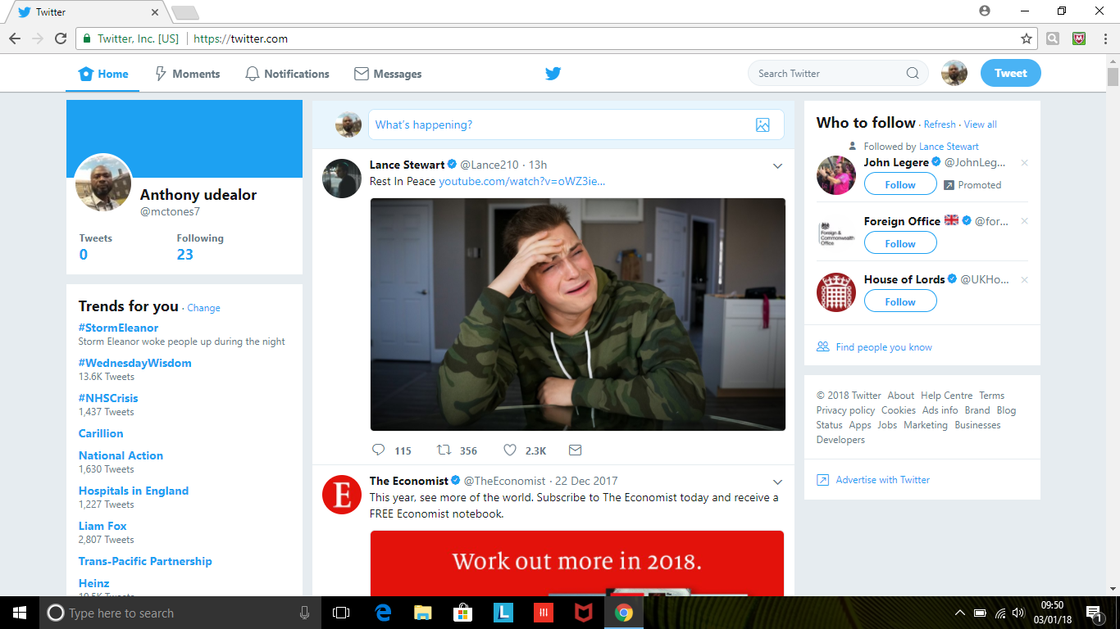
https://twitter.com/mctones7
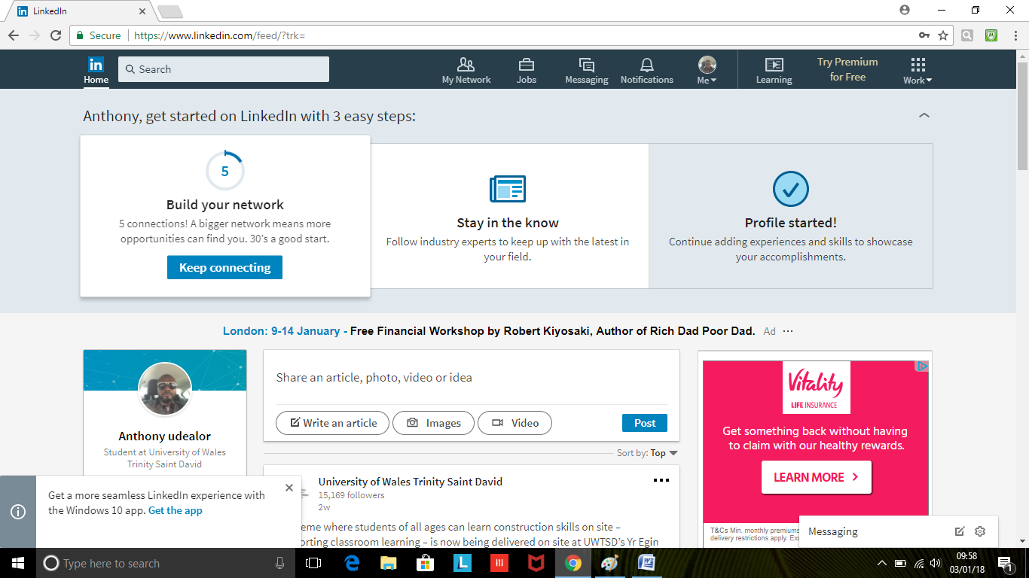

https://www.linkedin.com/in/anthony-udealor-783661154/
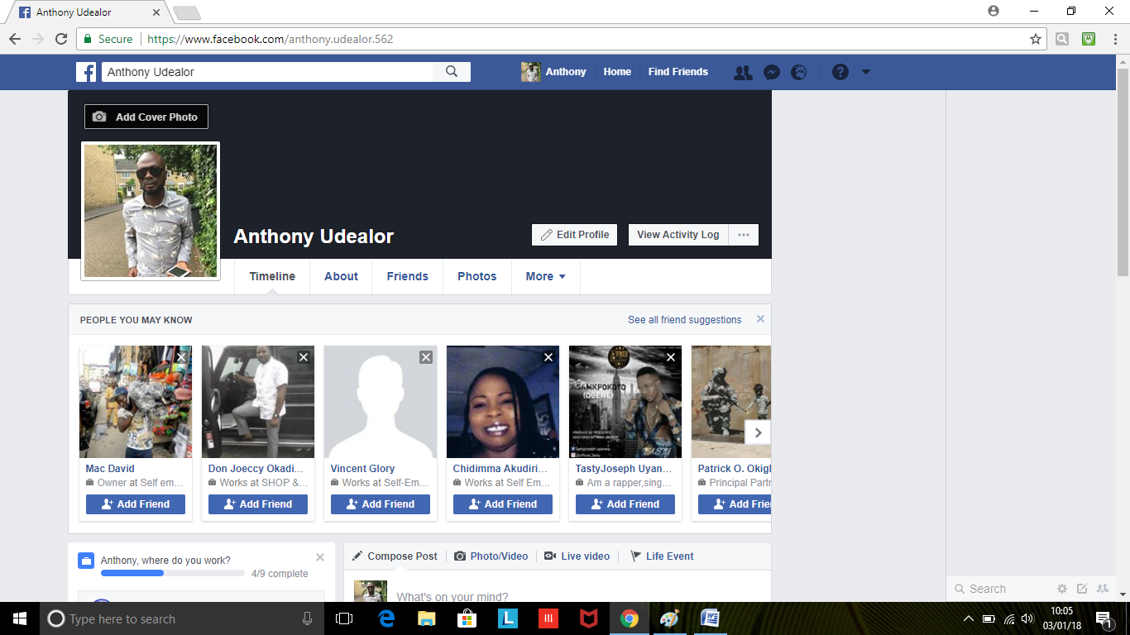
https://www.facebook.com/anthony.udealor.562

