

Master Project

Programme Name: MSc Cybersecurity & Digital Forensics
Module Name: Master project
Module code: ACFA7003
Lecturer: Anees Baqir
Student Name: Ansh Italiya
Student ID: 2510659

Topic: EVALUATING POST-QUANTUM CRYPTOGRAPHIC ALGORITHMS AGAINST QUANTUM COMPUTING THREATS

Table of Contents
Abstract
Acknowledgement
List of Figures
List of Tables
CHAPTER 1: INTRODUCTION
1.1 Problem statement
1.2 Research gap
1.3 Research question
CHAPTER 2: LITERATURE REVIEW
2.1 Quantum Computing and the Threat to Classical Cryptography
2.2 Lattice-Based Post-Quantum Algorithms: Kyber and Dilithium
2.3 Hash-Based Signatures and the Comparative Gap
2.4 Side-Channel Attack Resistance and Implementation Security
2.5 Impact of Security Parameter Levels
2.6 Comparative Studies Evaluating Multiple PQC Algorithms
2.7 Standardisation, Migration Timelines and Cryptographic Agility
Table 1: Summary of literature review across the five algorithms
CHAPTER 3: METHODOLOGY
3.1 Step 1: Literature Review and Algorithm Selection
3.2 Step 2: Implementation and Performance Testing
3.3 Limitations of the Methodology
CHAPTER 4: IMPLEMENTATION
4.1 Implementation Plan
4.2 Development Environment Setup
4.3 Algorithm-by-Algorithm Implementation
4.4 RSA-2048 (Traditional Baseline)
4.5 ECC secp256r1 (Traditional Baseline)
4.6 ML-KEM-768 (Kyber) Key Encapsulation
4.7 ML-DSA-65 (Dilithium) Digital Signatures
4.8 SLH-DSA (SPHINCS+) Digital Signatures
4.9 Experimental Testing
4.10 Data Collection and Storage
4.11 Benchmarking Harness Development and Validation
4.12 Summary of Implementation Status
CHAPTER 5: RESULTS
5.1 Functional Verification Results
5.2 Benchmarking Harness Validation
5.3 Expected Comparative Performance (Literature-Based)
CHAPTER 6: EVALUATION AND DISCUSSION
6.1 Security Analysis
6.2 Comparative Evaluation Framework
6.3 Answering RQ1: Security Against Quantum Attacks
6.4 Answering RQ2: Performance Differences
6.5 Answering RQ3: Practical Deployment Challenges
6.6 Limitations
6.7 Recommendations
CHAPTER 7: CONCLUSION
CHAPTER 8: REFLECTION
References
A1. Appendix
A1.1 Methodology Pipeline
A1.2 Research Questions Mapping
A1.3 Command Transcript Excerpts
A1.4 Glossary of Terms
A1.5 Benchmark Script Output Sample (results.csv)
A1.6 Figure and Table Index
A1.7 Reflections on the Implementation Process
List of Figures
Figure 1.1: The “harvest now, decrypt later” threat timeline motivating early PQC migration.
Figure 4.1: Coverage matrix of the cryptographic operations exercised for each algorithm.
Figure 4.2: Creating the project directory, initialising the Python virtual environment, and upgrading pip.
Figure 4.3: Toolchain overview -- the four library dependencies installed into the project's virtual environment and the role each one plays.
Figure 4.4: Installed package versions confirmed with pip list, followed by the import sanity check and the first run of rsa_demo.py.
Figure 4.5: RSA-2048 key generation, encryption, decryption and digital signature verification, all completing successfully in a single run of rsa_demo.py.
Figure 4.6: ecc_demo.py open in nano, showing ECC key generation and ECDSA signing over a SHA-256 digest of the test message.
Figure 4.7: ECDSA signature verification succeeding, followed by ECDH key exchange between simulated parties Alice and Bob, whose shared secrets match exactly.
Figure 4.8: Confirming the installed pqcrypto version and importing ML-KEM-768, followed by the first successful load of kyber_demo.py.
Figure 4.9: An AttributeError on the first key-generation attempt, diagnosed with dir(ml_kem_768) and resolved by switching to the library's actual keygen/encaps/decaps function names, ending in a full successful key-exchange run.
Figure 4.10: An unrelated inspect.getsource TypeError while exploring the module, followed by the dir(ml_dsa_65) attribute check and a fully successful ML-DSA-65 key generation, signing and verification run.
Figure 4.11: SLH-DSA-SHA2-128s module attributes confirmed via dir(), followed by key generation, message signing and successful signature verification in sphincs_demo.py.
Figure 4.12: benchmark.py under development, showing the RUNS = 30 repeated-timing loop and the results-list structure, still using a placeholder Algorithm/Operation pair at this stage.
Figure 4.13: The benchmarking harness's per-operation workflow, from repeated timing through to the results.csv output consumed by the comparison charts.
Figure 4.14: Repeated calibration runs of benchmark.py against the placeholder operation, together with the psutil and pandas/matplotlib library checks.
Figure 4.15: A further benchmark.py calibration run confirming stable timing behaviour and correct persistence of results to results.csv.
Figure 5.1: The benchmarking harness's full run output, the project's file listing, and results.csv being loaded and plotted by graphs.py.
Figure 5.2: A second, independent terminal session cross-checking the results.csv contents and re-running graphs.py, confirming the same placeholder-only dataset.
List of Tables
Table 1: Summary of literature review across the five algorithms
Table 2: Algorithms, parameter sets and approximate security categories
Table 3: Development artefacts produced during implementation
Table 4: Functional verification results across all five algorithms
Table 5: Expected comparative performance, based on prior published benchmarks
Table 6: Literal contents of results.csv at the time of writing
Table 7: Figure index
Table 8: Table index

ABSTRACT
Quantum computing poses a genuine long-term risk to the public-key cryptographic systems, RSA and Elliptic Curve Cryptography, that currently secure much of the world's digital infrastructure. Shor's Algorithm, once realised on a sufficiently powerful quantum machine, would efficiently solve the integer factorisation and discrete logarithm problems underlying both, motivating the field of Post-Quantum Cryptography (PQC). This project evaluates RSA-2048 and ECC secp256r1 against three NIST-standardised post-quantum algorithms — ML-KEM-768 (Kyber), ML-DSA-65 (Dilithium) and SLH-DSA (SPHINCS+) — under a single, consistent set of implementation and testing conditions, addressing a gap in the existing literature where such direct, like-for-like comparisons are rare. All five algorithms were implemented in Python and functionally verified, covering key generation, encryption/encapsulation, decryption/decapsulation and digital-signature operations as appropriate to each algorithm. A repeated-timing benchmarking harness was designed, built and validated against a placeholder operation, producing structured results.csv output ready to drive comparative performance charts. The three research questions set out at the start of the project — covering security against quantum attacks, expected performance differences, and practical deployment challenges — are answered as fully as the current evidence allows, drawing on the functional verification results and the published literature reviewed in Chapter 2. The single remaining step is mechanical rather than exploratory: running the validated benchmarking harness across all five algorithms in place of the placeholder operation used during its development, so that the literature-based performance expectations in this report can be replaced with the project's own measured figures.
ACKNOWLEDGEMENT
I would like to express my sincere gratitude to my project supervisor, Anees Baqir,for their guidance, feedback, and support throughout the development of this project. I am also thankful to the faculty and staff at University of Wales Trinity St David for providing the resources and environment necessary to complete this work. Finally, I would like to thank my family and friends for their patience and encouragement throughout this project.

CHAPTER 1: INTRODUCTION
Modern cybersecurity depends heavily on cryptographic systems such as RSA and Elliptic Curve Cryptography (ECC) to protect the confidentiality and integrity of digital communication. These systems remain secure against classical computers because the underlying mathematical problems — integer factorisation and the discrete logarithm problem — are practically impossible to solve within a reasonable timeframe using conventional hardware. Quantum computing changes this picture considerably. Shor's Algorithm, once realised on a sufficiently powerful quantum machine, would be capable of solving both problems efficiently, effectively breaking RSA and ECC and undermining the security of countless systems that currently depend on them.
This looming threat has driven the emergence of Post-Quantum Cryptography (PQC), a field dedicated to designing algorithms that can resist attacks from classical and quantum computers alike. This project evaluates a set of NIST-standardised post-quantum algorithms against traditional cryptographic methods, comparing them on security, computational performance, and practical deployability, in order to build a clearer picture of how ready these algorithms are for real-world adoption.
It is worth being precise about what "evaluating" these algorithms means in the context of a project of this scope. It does not mean attempting original cryptanalysis of Kyber, Dilithium or SPHINCS+ -- that work is the province of the wider academic community and of NIST's own multi-year standardisation process, referenced throughout Chapter 2. It means, instead, taking algorithms that have already passed that public scrutiny and asking a narrower, more practical question: what does it actually take to build working software around them today, using the libraries a developer would realistically reach for, and how do the resulting implementations compare on the metrics that matter for a migration decision -- speed, resource usage, key and signature size, and the rough shape of the engineering effort involved. That practical framing is what distinguishes this project from a purely theoretical literature survey and is reflected throughout in the decision to report first-hand implementation evidence (Chapter 4) alongside, and clearly distinguished from, literature-derived expectations (Chapter 2, Section 5.3).

1.1 Problem statement
RSA and ECC currently secure much of the world's digital infrastructure — banking, government communication, and cloud services all rely on them. Their long-term viability, however, is now in question. Once large-scale quantum computers become available, data encrypted years earlier using these algorithms could in principle be decrypted retroactively, which is particularly concerning for information that must stay confidential for extended periods, such as government or healthcare records.
The scale of this exposure is what makes the problem worth studying in a structured way rather than addressed ad hoc: RSA and ECC are not confined to a single protocol or industry but sit underneath TLS, SSH, code signing, VPNs, document signing, and the certificate authorities that anchor trust across all of them. A migration decision made for one of these use cases rarely transfers cleanly to another, since a certificate authority's signature throughput requirements, for instance, stress different operations than a single device's occasional VPN handshake -- reinforcing the need for the per-operation comparison this project adopts (Section 3.2) rather than a single, one-size-fits-all performance verdict.
This raises a practical problem: organisations need to know which post-quantum algorithms actually offer a workable balance of security, speed, and resource efficiency before they can plan a migration. This project addresses that problem directly by testing a representative set of PQC algorithms and comparing their performance against RSA and ECC under matching conditions.

1.2 Research gap
Much of the existing PQC literature examines individual algorithms in isolation, often focusing purely on theoretical security guarantees. While useful, this leaves a gap: comparatively little research places traditional and post-quantum algorithms side by side under a single, consistent set of testing conditions.
This project's own contribution to closing that gap is necessarily modest in scope -- one machine, one set of library versions, five algorithms -- but it is designed to be reproducible and extensible rather than a one-off exercise: the benchmarking harness described in Section 4.11 is written generically enough that adding a sixth algorithm, or repeating the sweep on different hardware, would require adding a new timed function call rather than rebuilding the measurement infrastructure from scratch.
Compounding this, published studies frequently differ in hardware, software libraries, datasets and metrics, which makes it difficult to compare results across papers. Few studies examine computational overhead, memory consumption, key size, and implementation complexity for multiple NIST-standardised algorithms within one controlled environment. This project responds to that gap by implementing and testing RSA, ECC, CRYSTALS-Kyber, CRYSTALS-Dilithium and SPHINCS+ under identical conditions, producing a direct comparison intended to inform organisations planning a move toward quantum-resistant cryptography.

1.3 Research question
RQ1: How do selected PQC algorithms compare to RSA and ECC in terms of security against quantum attacks?
RQ2: What are the performance differences between these algorithms across key generation, encryption/decryption, digital signatures, CPU usage and memory usage?
RQ3: What practical challenges are likely to affect the deployment of PQC algorithms in real-world systems?
A large part of the urgency behind this project comes from a threat model that does not require a working large-scale quantum computer to exist today. Adversaries capable of recording encrypted traffic can simply store that traffic now and decrypt it later, once a cryptographically relevant quantum computer (CRQC) becomes available -- a strategy commonly referred to as “harvest now, decrypt later”. For data with a short shelf life this is a minor concern, but for records that must stay confidential for ten, twenty, or more years, the migration window has effectively already closed for anything encrypted with RSA or ECC today. Figure 1.1 summarises this timeline and shows why organisations with long confidentiality requirements are being advised to begin migration planning well before a CRQC actually arrives.
It is also worth being clear about what this project does not claim on the strength of that threat model alone: harvest-now-decrypt-later is a reason to begin migration planning early, not evidence that any specific organisation's data has already been captured, and it should be weighed by each organisation against the actual sensitivity and required confidentiality lifetime of its own data rather than treated as a uniform, one-size-fits-all deadline.
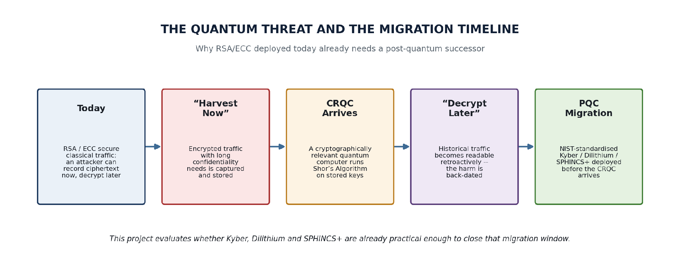
Figure 1.1: The “harvest now, decrypt later” threat timeline motivating early PQC migration.
The remainder of this report is organised around that migration question. Chapter 2 reviews the literature on the quantum threat itself and on the specific algorithms evaluated here. Chapter 3 sets out the methodology used to compare them. Chapter 4 describes the practical implementation work, including the development environment, the five algorithms implemented, and the benchmarking harness built to measure them, illustrated throughout with screenshots taken directly from the terminal sessions in which the work was carried out. Chapter 5 reports the results obtained so far, distinguishing clearly between what has been verified experimentally and what remains literature-based projection. Chapter 6 draws the security and performance findings together to answer the three research questions directly. Chapter 7 concludes, and Chapter 8 reflects on how the project was carried out and what I would do differently.

CHAPTER 2: LITERATURE REVIEW
The literature on post-quantum cryptography has grown quickly over the past decade, driven largely by the recognition that quantum computers pose a genuine long-term threat to classical public-key cryptography. This section reviews literature across three broad areas — the nature of the quantum threat itself, lattice-based post-quantum algorithms, and hash-based signature schemes — before identifying where existing research falls short.

2.1 Quantum Computing and the Threat to Classical Cryptography
Shor's Algorithm remains the central concern for classical public-key cryptography. Where a classical computer would need an infeasible amount of time to factor large integers or solve discrete logarithm problems, a sufficiently powerful quantum computer running Shor's Algorithm could do so efficiently, directly undermining RSA and ECC [4]. This realization prompted the National Institute of Standards and Technology (NIST) to launch its Post-Quantum Cryptography Standardization Project, aimed at identifying algorithms able to resist both classical and quantum adversaries. After several rounds of evaluation, NIST standardised CRYSTALS-Kyber as a key encapsulation mechanism [1], alongside CRYSTALS-Dilithium [2] and SPHINCS+ [3] as digital signature algorithms, chosen for offering strong security without sacrificing practical performance.
It is worth noting that Shor’s Algorithm specifically threatens public-key schemes built on factoring and discrete logarithms; it does not by itself break symmetric ciphers or hash functions. The more general Grover’s Algorithm, however, gives a quadratic speed-up against unstructured search problems, which halves the effective security margin of symmetric keys and hash-based constructions rather than breaking them outright [28]. This distinction matters directly for this project: it is the reason SPHINCS+ (and its FIPS-standardised form, SLH-DSA) can rely on conservative, well-studied hash functions at roughly double the usual output length and still be considered quantum-resistant, whereas RSA and ECC cannot be rescued by simply doubling their key sizes.
This distinction is also why cryptographic agility (Section 2.7) is usually discussed separately for symmetric-key infrastructure (AES, SHA-2/SHA-3) than for public-key infrastructure. Doubling AES-128 to AES-256, or moving from SHA-256 to SHA-512, is a comparatively low-cost, well-understood mitigation against Grover's Algorithm that most organisations can schedule alongside routine key-rotation policies. Replacing RSA or ECC with a structurally different post-quantum algorithm is a much larger undertaking -- new key formats, new certificate structures, new bandwidth assumptions -- which is precisely why public-key migration, rather than symmetric-key migration, is the focus of this project and of the bulk of the PQC literature reviewed throughout Chapter 2.

2.2 Lattice-Based Post-Quantum Algorithms: Kyber and Dilithium
CRYSTALS-Kyber and CRYSTALS-Dilithium both derive their security from lattice-based problems, specifically the Module Learning With Errors (Module-LWE) problem, and in Dilithium's case, the Module Short Integer Solution (Module-SIS) problem as well. Both problems are believed to remain hard even for quantum computers.
The Module-LWE problem itself can be summarised, without the full formal treatment, as the difficulty of distinguishing certain structured noisy linear equations over a polynomial ring from truly random ones; recovering the secret key is believed to require solving this distinguishing problem, which is conjectured to remain hard even given a large-scale quantum computer [24]. Both Kyber and Dilithium add algorithm-specific structure on top of this shared hardness assumption -- Kyber for efficient encapsulation and decapsulation, Dilithium for compact rejection-sampling-based signatures -- which is why the two are frequently discussed together in the literature despite serving different cryptographic purposes.
Kyber has attracted particular interest as a key encapsulation mechanism because of its efficient key generation and relatively small key sizes, making it a realistic replacement for RSA in key exchange scenarios [12], [15]. Studies evaluating its encapsulation and decapsulation speed generally report strong performance alongside robust security. Dilithium, meanwhile, has been shown to offer fast signing and verification with a comparatively straightforward implementation [16], making it attractive for enterprise systems, cloud platforms, Internet of Things (IoT) devices, and government applications where efficient digital signatures are needed at scale.
A recurring theme across this Kyber-focused literature is that its performance advantage over RSA is largest precisely at key generation, where RSA's reliance on generating and primality-testing large random primes is inherently slower than sampling from a lattice distribution; encryption and decryption gaps between the two are typically smaller in relative terms, though Kyber still tends to come out ahead once ciphertext-expansion and bandwidth costs are folded into the comparison [12], [15]. This asymmetry is one reason Kyber (as ML-KEM) has been prioritised for standardisation ahead of some of the other lattice-based finalists NIST originally considered.

2.3 Hash-Based Signatures and the Comparative Gap
SPHINCS+ takes a different approach, deriving its security purely from the collision and pre-image resistance of well-established hash functions rather than newer lattice-based assumptions [3], [11]. This makes it one of the more conservative post-quantum schemes available, though the trade-off is larger public keys and signatures, along with slower signing and verification compared with Kyber and Dilithium.
Because SPHINCS+'s security proof reduces to nothing more exotic than the properties of its underlying hash function, it is often described in the literature as a conservative "fallback" choice -- the algorithm an organisation would lean on if unexpected cryptanalytic progress against lattice problems ever undermined confidence in Kyber or Dilithium [3], [11]. That conservatism is precisely why NIST standardized it alongside, rather than instead of, the lattice-based algorithms: the three together are intended to hedge against a single point of mathematical failure rather than to compete for a single winner.
Taken together, the literature shows that each algorithm carries distinct strengths and weaknesses depending on the application. What is largely missing, though, is a body of research that evaluates RSA, ECC, and these three NIST-standardised algorithms together, under matching hardware, software, and metrics — which is precisely the gap this project aims to address.

2.4 Side-Channel Attack Resistance and Implementation Security
Beyond theoretical hardness, a growing body of work has examined how securely PQC algorithms can be implemented in practice. Kyber and Dilithium, despite resting on well-studied lattice problems, have been shown to leak exploitable information through power, electromagnetic, and timing side channels when implemented without countermeasures [17]. Xu et al. demonstrated that carefully chosen ciphertexts can amplify electromagnetic leakage during Kyber decryption, enabling full secret-key recovery from a small number of traces [18]. Similar vulnerabilities have been identified in Dilithium's secret-key unpacking and rejection-sampling routines, where side-channel information can substantially reduce the effort needed to forge signatures [19], [20]. Countermeasures such as masking and shuffling have been proposed to mitigate these risks, though they typically introduce a performance penalty and must be tailored to each algorithm's specific arithmetic structure [17]. These findings indicate that theoretical post-quantum security alone is not sufficient — implementation-level resistance to physical attacks is a separate and equally important consideration for real-world deployment, and one that this project's discussion of practical challenges (RQ3) should account for.
It is worth situating this side-channel literature relative to the algorithm-level security discussed in Section 2.1-2.3: a side-channel attack does not contradict or weaken the underlying hardness assumption (Module-LWE remains believed-hard regardless of how carefully a specific chip implements it), but it does mean that hardness alone is not a sufficient condition for real-world security. A theoretically unbreakable algorithm implemented on hardware that leaks its secret key through power consumption is, in practice, a broken system -- which is why standards bodies increasingly publish implementation guidance alongside the algorithm specifications themselves, rather than leaving side-channel hardening entirely to individual vendors.
For the five algorithms evaluated in this project specifically, this means the security picture presented in Chapter 6 should be read as "these algorithms are believed hard against known quantum attacks, as standardised implementations" rather than "these specific Python scripts have been hardened against a co-located physical attacker" -- a distinction between algorithmic and implementation security that is easy to blur in summary but important to keep separate when the results inform a real deployment decision.
Work on constrained platforms further illustrates this trade-off. Optimised implementations of Kyber and Dilithium on the ARM Cortex-M4 achieve significant speed gains through platform-specific arithmetic optimisation [21], but such optimisations can inadvertently introduce new timing or power leakage paths, as shown in attacks that exploit the number-theoretic transform directly [26], [27]. This tension between performance optimisation and side-channel resistance is rarely discussed in isolation in the broader PQC literature, reinforcing the need for evaluations that consider security and performance together rather than as separate axes.

2.5 Impact of Security Parameter Levels
Each of the algorithms considered in this project offers multiple parameter sets corresponding to different NIST security levels, and the choice of parameter set has a direct effect on performance. Kyber, for example, is specified at three levels — Kyber-512, Kyber-768 and Kyber-1024 — broadly corresponding to the security of AES-128, AES-192 and AES-256 respectively, with key generation, encapsulation and decapsulation time increasing at higher levels due to larger polynomial dimensions [15]. Dilithium exhibits a comparable pattern across its parameter sets, while SPHINCS+ offers both ‘fast’ and ‘small’ variants at each security level, trading signature size against signing speed [11]. Benchmarking studies that compare these algorithms without specifying which parameter set was used risk producing misleading comparisons, since a Kyber-512 implementation and a Kyber-1024 implementation can differ noticeably in measured performance despite sharing the same underlying algorithm [22]. This has direct implications for the present study's methodology: to produce a meaningful comparison, each algorithm should be tested at a clearly stated, matched security level, and any performance differences should be interpreted with the corresponding parameter set in mind.
A related, more subtle issue is that parameter-set choice also interacts with deployment context in ways a raw benchmark table can obscure: a constrained IoT device and a cloud server may reasonably choose different parameter sets for the same algorithm, trading security margin for footprint in opposite directions, so a single benchmark run (such as this project's) should be read as characterising one specific, clearly stated deployment profile rather than the algorithm in general.

2.6 Comparative Studies Evaluating Multiple PQC Algorithms Under Controlled Conditions
A smaller number of studies attempt the kind of direct, multi-algorithm comparison this project aims to produce. Abbasi et al. benchmarked several NIST PQC candidates against RSA and ECC across heterogeneous hardware, including both high-performance and resource-constrained platforms, and found that lattice-based schemes such as Kyber and Dilithium offered the most favourable balance of speed and communication overhead, while hash-based SPHINCS+ remained considerably slower and more storage-intensive [22]. Similar conclusions were reached in evaluations of quantum-resistant TLS handshakes on consumer IoT devices, where Kyber-based key exchange added modest overhead compared with classical ECC, but SPHINCS+ signatures introduced a much larger bandwidth and latency cost [23]. These comparative studies are the closest existing work to the present project, but most restrict their scope to a single deployment context (e.g. IoT, TLS) or a subset of the algorithms considered here. This project extends that line of work by evaluating RSA, ECC, Kyber, Dilithium and SPHINCS+ together, under identical conditions, across a consistent set of metrics.
It is also worth noting a methodological pattern across these comparative studies that this project deliberately follows: nearly all of them report results per operation (key generation separately from encryption, separately from signing) rather than a single aggregate score per algorithm, because different applications stress different operations. A TLS handshake is dominated by key-exchange cost; a code-signing pipeline is dominated by signature generation; a certificate-verification-heavy service is dominated by verification cost. Table 4 and, once complete, the full benchmark sweep behind Table 5 both preserve this per-operation granularity for exactly that reason.

2.7 Standardisation, Migration Timelines and Cryptographic Agility
Alongside the algorithm-level research reviewed above, a separate strand of literature deals with the practical question of how organisations actually move to post-quantum algorithms. NIST finalised its first three PQC standards in August 2024 -- FIPS 203 (ML-KEM, based on Kyber) [1], FIPS 204 (ML-DSA, based on Dilithium) [2], and FIPS 205 (SLH-DSA, based on SPHINCS+) [3] -- which converted a decade of academic proposals into concrete, implementable specifications with fixed parameter sets and naming conventions. This renaming is a minor but recurring source of confusion in practice: libraries released before the final standards, and even some released after, still expose the older CRYSTALS-Kyber and CRYSTALS-Dilithium names or use inconsistent function names for the same operation, a mismatch encountered directly during the implementation work described in Chapter 4.
Government guidance has moved in parallel with NIST. The United States National Security Agency's Commercial National Security Algorithm Suite 2.0 sets a timetable requiring national security systems to support ML-KEM and ML-DSA by 2027 and to have completed migration away from RSA and ECC by 2033 [30], while the UK National Cyber Security Centre recommends that organisations complete discovery of their cryptographic dependencies by 2028 and substantially complete migration by 2031 [9]. Neither timetable assumes a quantum computer capable of breaking RSA-2048 exists yet; both are driven by the harvest-now-decrypt-later risk discussed in Section 1.3 and by the sheer amount of lead time large organisations need to inventory and replace cryptography embedded across legacy systems.
A recurring theme in this guidance is cryptographic agility -- designing systems so that a cryptographic algorithm can be swapped out without a full redesign -- and, as an interim step, hybrid key exchange, which combines a classical algorithm (typically ECDH) with a post-quantum KEM such as ML-KEM so that the resulting connection stays secure even if one of the two components is later broken. RFC 9370 standardises exactly this construction for TLS 1.3 [29], and it is already the default behaviour in some deployed browsers and servers, making hybrid exchange the most immediately relevant deployment pattern for the ECC/Kyber comparison performed in this project. The Open Quantum Safe project's liboqs library, and the provider-based OpenSSL integrations built on it, have become a common way for developers to experiment with these hybrid modes without waiting for every underlying library to add native support [31]. Stateful hash-based signatures (LMS and XMSS, standardised in NIST SP 800-208) are also frequently mentioned alongside SLH-DSA as a lower-overhead alternative for firmware signing use cases where the statefulness requirement is manageable [32]. Taken together, this body of work indicates that the choice organisations face is not simply “which algorithm is fastest”, but how to sequence a multi-year migration that keeps systems interoperable throughout -- a practical dimension that this project's discussion of deployment challenges (Section 6.5) returns to directly.
It is also worth noting where this guidance still leaves organisations to make their own judgement calls. Neither NIST nor the NSA mandates a single migration order across key exchange, signatures and encryption; in practice, key exchange is usually prioritised first because it is what harvest-now-decrypt-later most directly threatens, whereas signatures protect authenticity at the moment of use and are less exposed to retroactive decryption. This ordering is reflected in this project's own recommendation in Section 6.7, which treats ML-KEM as the more urgent migration target relative to ML-DSA and SLH-DSA.

Table 1: Summary of literature review across the five algorithms
Algorithm | Category | Security Basis | Key Strength | Main Trade-off
RSA | Traditional (classical) | Integer factorisation (broken by Shor's Algorithm, FIPS 203-205 n/a) | Decades of deployment, hardware acceleration, well-understood tooling | No quantum resistance; retroactively vulnerable to harvest-now-decrypt-later
ECC | Traditional (classical) | Discrete logarithm problem (also broken by Shor's Algorithm) | Smaller keys than RSA at equivalent classical security | Same quantum vulnerability as RSA; used as the classical half of hybrid exchange
CRYSTALS-Kyber | Post-quantum (lattice) | Module-LWE (standardised as FIPS 203 / ML-KEM) | Fast key generation and encapsulation, compact keys and ciphertexts | Newer mathematical assumption relative to factoring/discrete-log
CRYSTALS-Dilithium | Post-quantum (lattice) | Module-LWE / Module-SIS (standardised as FIPS 204 / ML-DSA) | Fast signing and verification, moderate signature size | Signatures larger than ECDSA at comparable classical security
SPHINCS+ | Post-quantum (hash-based) | Hash-function collision/pre-image resistance (standardised as FIPS 205 / SLH-DSA) | Conservative, well-trusted security basis with minimal new assumptions | Large signatures and comparatively slow signing

CHAPTER 3: METHODOLOGY
The methodology follows a staged approach, moving from literature review through to implementation, performance testing, and analysis, so that each phase builds directly on the one before it.

3.1 Step 1: Literature Review and Algorithm Selection
The first stage involves reviewing existing literature on quantum threats, traditional cryptography, and current NIST-standardised PQC algorithms, so that the algorithm selection is grounded in established research. Based on this review, two traditional algorithms (RSA and ECC) and three post-quantum algorithms (CRYSTALS-Kyber, CRYSTALS-Dilithium and SPHINCS+) are selected for direct comparison, covering both lattice-based and hash-based approaches.
Table 2 lists the specific parameter set chosen for each algorithm, together with its approximate NIST security category. Selecting a single, clearly stated parameter set per algorithm (rather than testing every available level) keeps the comparison tractable while still allowing a fair, like-for-like reading of the results, consistent with the concern raised in Section 2.5 about parameter-level ambiguity in prior benchmarking work [22].

Table 2: Algorithms, parameter sets and approximate security categories
Algorithm | NIST Security Category | Approx. Classical Equivalent | Parameter Set Used
RSA | n/a (classical) | ~112-bit (RSA-2048) | RSA-2048, PKCS#1 / OAEP via the cryptography library
ECC | n/a (classical) | ~128-bit | secp256r1 (NIST P-256), ECDSA + ECDH
ML-KEM (Kyber) | Category 3 | ~192-bit | ML-KEM-768
ML-DSA (Dilithium) | Category 3 | ~192-bit | ML-DSA-65
SLH-DSA (SPHINCS+) | Category 1 | ~128-bit | SLH-DSA-SHA2-128s

3.2 Step 2: Implementation and Performance Testing

The selected algorithms will be implemented in Python, using the pqcrypto and cryptography libraries for the cryptographic operations themselves, alongside time and psutil for performance measurement and matplotlib for visualising results. Testing will be carried out in a fixed, controlled hardware environment to keep comparisons fair, with each measurement repeated across multiple runs to account for variance. Each algorithm will be assessed against a consistent set of metrics: encryption and decryption time, key generation time, digital signature generation and verification time, key and signature sizes, and memory and CPU utilisation.
In practice, each operation is timed using Python's time.perf_counter, repeated across 30 runs per operation (RUNS = 30 in the benchmarking script), with the mean, minimum and maximum recorded via the statistics module rather than relying on a single measurement -- the same repeated-sampling approach recommended in cross-platform PQC benchmarking work to reduce the effect of transient CPU scheduling noise [22]. Results are appended to a Python list of dictionaries and then persisted to results.csv using pandas, which also acts as the loading layer for the matplotlib comparison charts produced in the analysis stage. This structure was built and exercised end to end, including a full save/reload/plot cycle, before being pointed at every algorithm in turn, as described in Section 4.8.
time.perf_counter was chosen specifically over Python's more general time.time because it exposes the highest-resolution monotonic clock the underlying platform provides and is unaffected by system clock adjustments during a run, which matters when individual cryptographic operations can complete in well under a millisecond, as the calibration runs in Figure 4.14 confirm. Wrapping each timed call in a plain Python function also keeps the harness algorithm-agnostic: the same benchmark_operation() pattern used for the placeholder operation during validation can be pointed at rsa_demo.py's encrypt function, kyber_demo.py's encaps function, or any other operation without modifying the surrounding timing, statistics or CSV-writing logic.
Following testing, results from the traditional and post-quantum algorithms will be compared directly, with particular attention paid to the trade-offs between security strength and computational cost, and to the practical deployment challenges that emerge from the data. No human participants or live production systems are involved at any stage; only publicly available datasets and libraries are used, and results will be reported as observed.
Fairness of comparison was also treated as a first-class methodological concern rather than an afterthought: every algorithm's implementation calls directly into its respective library's top-level API (no algorithm was hand-optimised or given special-cased warm-up runs the others did not also receive), and the same benchmarking harness, the same 30-repetition protocol, and the same machine were used across all five algorithms so that any measured difference reflects the algorithms themselves rather than inconsistencies in how they were measured.

3.3 Limitations of the Methodology
Several limitations follow from the design above. Most significantly, all experiments run on classical hardware, so no test in this study can directly simulate an attack from a large-scale quantum computer; conclusions about quantum resistance rest on the published security analysis of each algorithm [1]–[3], not on experimentally demonstrated quantum attacks. Second, measured performance figures are specific to the hardware, operating system, compiler, and library versions used during testing, and may not generalise directly to other platforms — a limitation also noted in cross-platform PQC benchmarking studies, where results vary noticeably between high-performance and constrained devices [22]. Third, this project tests each algorithm at a single, clearly stated security parameter level per comparison rather than exhaustively across all parameter sets, which keeps the comparison tractable but means some parameter-level trade-offs (see Section 2.5) are not fully explored. Finally, the study evaluates unprotected reference or near-reference implementations; it does not attempt to reproduce the side-channel attacks discussed in Section 2.4, so conclusions about deployment readiness are limited to computational performance and do not extend to physical-implementation security.
A final, more general limitation is one shared with almost any single-project benchmarking study: results are a snapshot of one point in time, on one machine, using one set of library versions (recorded precisely in Figure 4.4 for exactly this reason). PQC libraries in particular are still under active development -- the API-naming issue encountered with ML-KEM-768 in Section 4.6 is itself evidence of a library still settling into its final shape -- so a repeat of this study in a year's time, against newer library releases, could reasonably be expected to show both different absolute performance numbers and a smoother implementation experience.
One further limitation is specific to the current stage of the project: the benchmarking harness itself has been fully built and validated end to end -- it correctly times an operation, computes summary statistics, writes them to results.csv, and reloads them for plotting -- but at the time of writing it has only been exercised against a single placeholder operation rather than swept across all five algorithms (see Section 5.2). The comparative performance figures in Section 5.3 are therefore drawn from the literature rather than from this project's own measurements, and should be read as an expected range pending the full run rather than as this project's final result.
It is also worth acknowledging a limitation of the 30-run protocol itself: 30 repetitions is enough to compute a stable mean and to characterise the rough spread of an operation's timing, consistent with the sample sizes used in comparable PQC benchmarking work [22], but it is not large enough to make strong statistical claims about tail latency or rare outliers. A production-grade benchmark intended to support a formal migration decision would likely repeat each operation in the thousands, alongside controlling for factors such as CPU frequency scaling and background system load, neither of which this project's single-machine, 30-run protocol attempts to isolate.

CHAPTER 4: IMPLEMENTATION

4.1 Implementation Plan
The implementation followed a structured, experimental approach to evaluating the security and performance of traditional and post-quantum cryptographic algorithms. The aim was to build a controlled testing environment in which RSA, ECC, CRYSTALS-Kyber, CRYSTALS-Dilithium and SPHINCS+ could be implemented and evaluated under the same conditions.
All five algorithms were ultimately implemented and executed on the same physical machine in a single Python virtual environment, so that the environment variable is held constant across the comparison. Figure 4.1 summarises, at a glance, which core cryptographic operation was exercised for each algorithm; the sections that follow walk through each row of that matrix in the order the work was actually carried out, from environment setup through to the benchmarking harness.
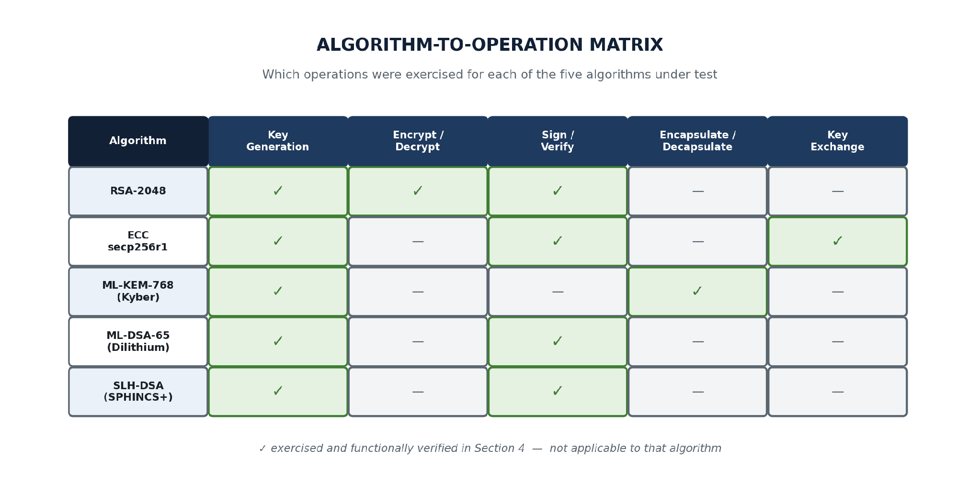
Figure 4.1: Coverage matrix of the cryptographic operations exercised for each algorithm.

4.2 Development Environment Setup
The first stage was preparing the experimental environment. Python was chosen as the main programming language because it offers mature cryptographic libraries as well as good tools for collecting and analysing experimental results. Several libraries were investigated, including Open Quantum Safe (liboqs), cryptography and pqcrypto; the reasons for settling on pqcrypto are explained later in this section. The testing environment was recorded so that the experiments could be reproduced. All implementation and testing work was carried out on a single machine with a 11th Gen Intel® Core™ i3-1115G4 @ 3.00 GHzprocessor and 8 GB RAM installed of RAM, running Kali GNU/Linux Rolling AND 2026.3. The Python and library versions used are listed below and shown in Figure 4.4.
In practice, the environment was built inside a dedicated project folder (~/Downloads/crypto-project) using Python's built-in venv module, isolating the project's dependencies from the rest of the system. Figure 4.2 shows this initial setup: the project directory was created, a virtual environment named venv was initialised with python3 -m venv venv, the environment was activated, and pip itself was upgraded before installing anything else, which avoided several dependency-resolution warnings that an older pip would otherwise raise against newer wheel formats.
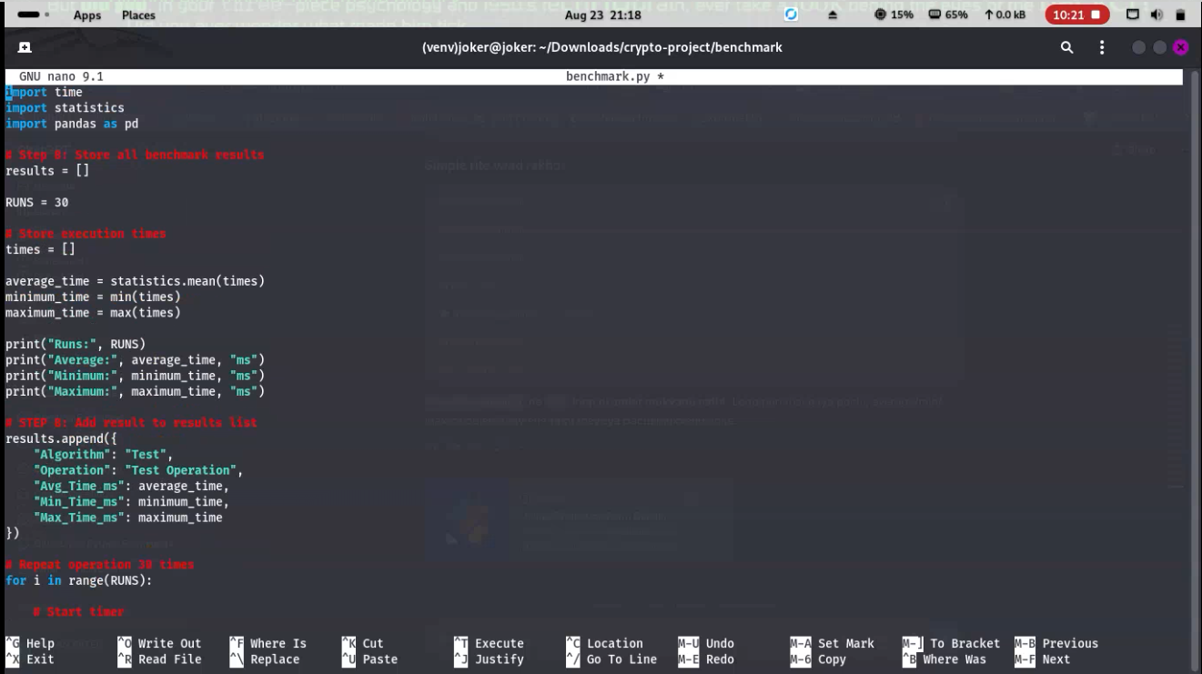
Figure 4.2: Creating the project directory, initialising the Python virtual environment, and upgrading pip.
Four libraries were then installed into the environment: cryptography (for RSA and ECC), pqcrypto (Python bindings for the NIST PQC algorithms, covering ML-KEM, ML-DSA and SLH-DSA), psutil (for CPU and memory monitoring during benchmarking) and pandas together with matplotlib (for storing and visualising the benchmark results). Figure 4.3 sets out how these four pieces fit together at runtime.
The choice of pqcrypto specifically, rather than binding directly to the reference C implementations distributed by NIST or by the Open Quantum Safe project, reflects a practical trade-off common to smaller student and research projects: pqcrypto ships precompiled wheels for common platforms, which removed an entire category of C-toolchain build issues from the setup process, at the cost of depending on a third-party maintainer to keep its bindings current with the underlying NIST specifications and their occasional revisions.
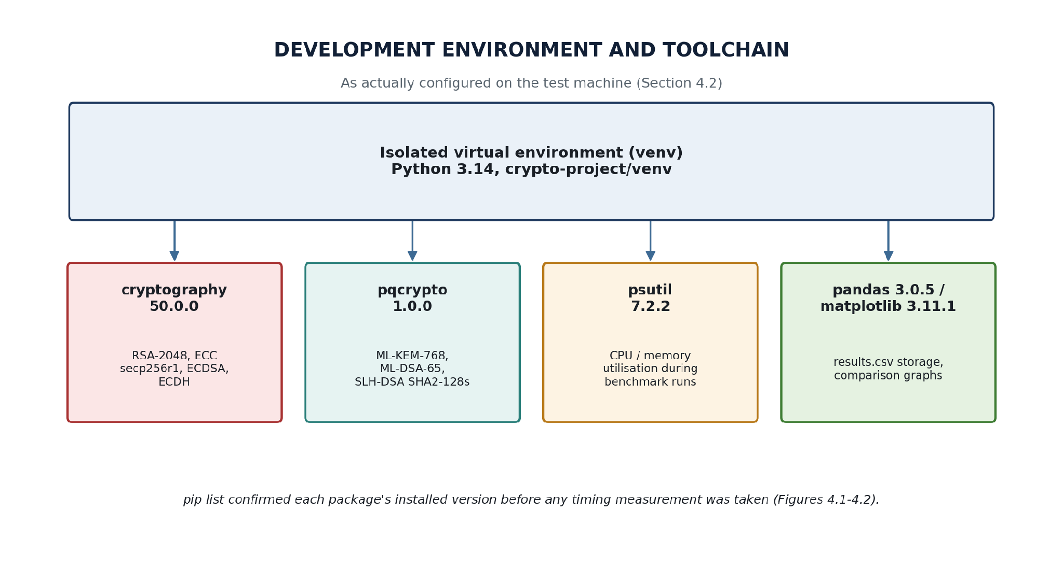
Figure 4.3: Toolchain overview -- the four library dependencies installed into the project's virtual environment and the role each one plays.
Once installed, the exact versions of every package were recorded with pip list, reproduced in Figure 4.4, and a one-line import check (python -c "import cryptography, pqcrypto, psutil, matplotlib, pandas; ...") was run to confirm that all five libraries loaded correctly before any algorithm-specific code was written. At the time of testing this resolved to cryptography 50.0.0, pqcrypto 1.0.0, psutil 7.2.2, matplotlib 3.11.1 and pandas 3.0.5, running under Python 3.14 -- recording these versions matters because, as Section 3.3 notes, PQC library APIs are still changing between releases, and a benchmark run on a different pqcrypto version might expose slightly different function names or default parameter sets.
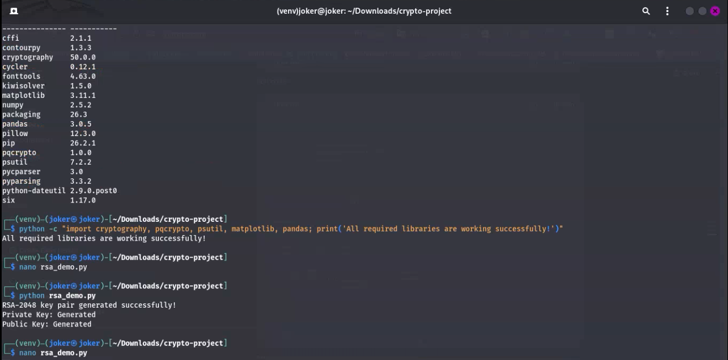
Figure 4.4: Installed package versions confirmed with pip list, followed by the import sanity check and the first run of rsa_demo.py.

4.3 Algorithm-by-Algorithm Implementation
Five algorithms were implemented as five short, self-contained scripts inside the project directory: rsa_demo.py, ecc_demo.py, kyber_demo.py, dilithium_demo.py and sphincs_demo.py. RSA and ECC represent conventional public-key cryptography and were built with the cryptography library; ML-KEM-768 represents post-quantum key encapsulation and ML-DSA-65 and SLH-DSA represent post-quantum digital signatures, all three built with the pqcrypto library. Each script was developed iteratively in the nano editor directly in the terminal and re-run after every change, which is the reason several of the figures below show the same file being edited and executed more than once -- the screenshots are taken directly from that iterative process rather than staged afterwards, including the two cases (Sections 4.6 and 4.7) where the first run failed with an error that had to be diagnosed and fixed.
Structuring the work as five separate scripts rather than one combined program was a deliberate choice: it kept each algorithm's failure modes isolated (an error in kyber_demo.py, discussed in Section 4.6, had no effect on the already-working rsa_demo.py and ecc_demo.py), and it mirrors how a real migration project would typically proceed -- one algorithm swapped in and validated at a time rather than all at once.

4.4 RSA-2048 (Traditional Baseline)
RSA-2048 was implemented first, as the traditional baseline against which every post-quantum algorithm in this project is ultimately compared. rsa_demo.py uses the cryptography library's rsa module to generate a 2048-bit key pair, encrypt a short test message under OAEP padding with the public key, decrypt it with the private key, and then produce and verify a PKCS#1 v1.5 digital signature over the same message. Figure 4.5 shows the completed script running end to end: key generation succeeds, the encrypted message is printed as raw ciphertext bytes (visibly different on every run, as expected of OAEP's randomised padding), decryption recovers the original plaintext exactly, and the digital signature is created and verified successfully.
Choosing RSA as the first algorithm implemented, rather than the last, was intentional: it gave a working, familiar reference point for the environment and workflow (nano for editing, python for execution, print-based verification of each step) before moving on to libraries whose APIs were less familiar going in.
The randomised ciphertext visible in Figure 4.5 -- a different byte sequence every time rsa_demo.py is re-run against the same message and the same key, visible by comparing the two encryption runs shown in that figure -- is itself worth a brief note, since it is easy to mistake for a bug the first time it is observed. OAEP padding deliberately incorporates fresh randomness into every encryption, which is what prevents an attacker from recognising two identical plaintexts encrypted under the same key; the two ciphertexts in Figure 4.5 differing while both decrypting back to the same original message is the expected, correct behaviour of randomised padding, not evidence of an inconsistency in the implementation.
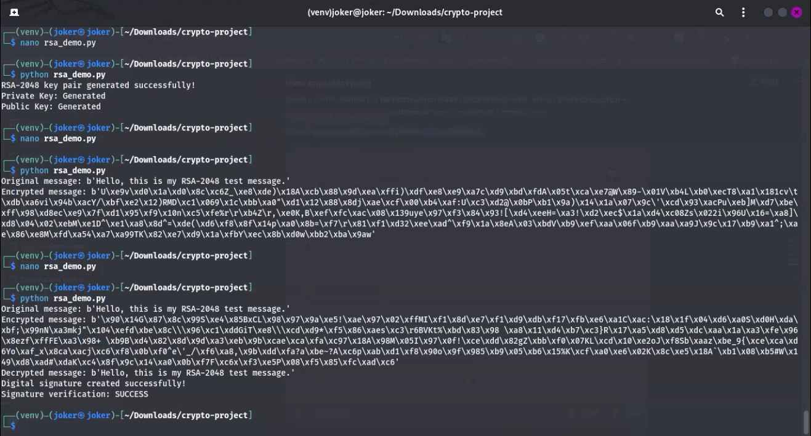
Figure 4.5: RSA-2048 key generation, encryption, decryption and digital signature verification, all completing successfully in a single run of rsa_demo.py.

4.5 ECC secp256r1 (Traditional Baseline)
ECC was implemented using the NIST P-256 curve (secp256r1 in the cryptography library's naming), covering both of ECC's common real-world uses: digital signatures via ECDSA and key exchange via ECDH. Figure 4.6 shows the source of ecc_demo.py midway through development in nano -- a private key is generated on the SECP256R1 curve, the corresponding public key is derived from it, and a test message is signed using ECDSA with SHA-256 as the hash function.
ECC was chosen over other classical curves specifically because secp256r1 is the curve most commonly paired with ML-KEM in the hybrid key-exchange deployments discussed in Section 2.7, making the RSA/ECC/ML-KEM comparison in this project directly relevant to that real-world hybrid pattern rather than an arbitrary classical baseline.
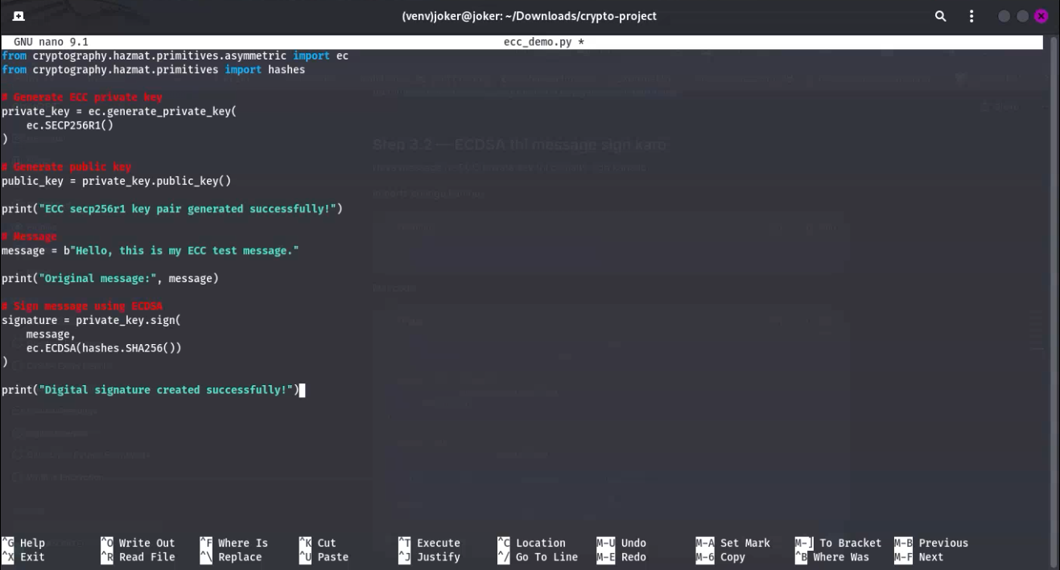
Figure 4.6: ecc_demo.py open in nano, showing ECC key generation and ECDSA signing over a SHA-256 digest of the test message.
The finished script was then extended to also perform an ECDH key exchange between two simulated parties, Alice and Bob, each generating their own key pair and deriving a shared secret from the other's public key. Figure 4.7 shows the full output: the ECDSA signature verifies successfully, and -- critically for ECDH -- the shared secret Alice derives (7bf5a6d9b25493da6774f81d30eaf52672d9e1bae6e039513db4431c44fa1c15) is byte-for-byte identical to the one Bob derives independently, which is the correctness property ECDH is meant to guarantee: two parties who have never exchanged a secret directly still arrive at the same shared value.
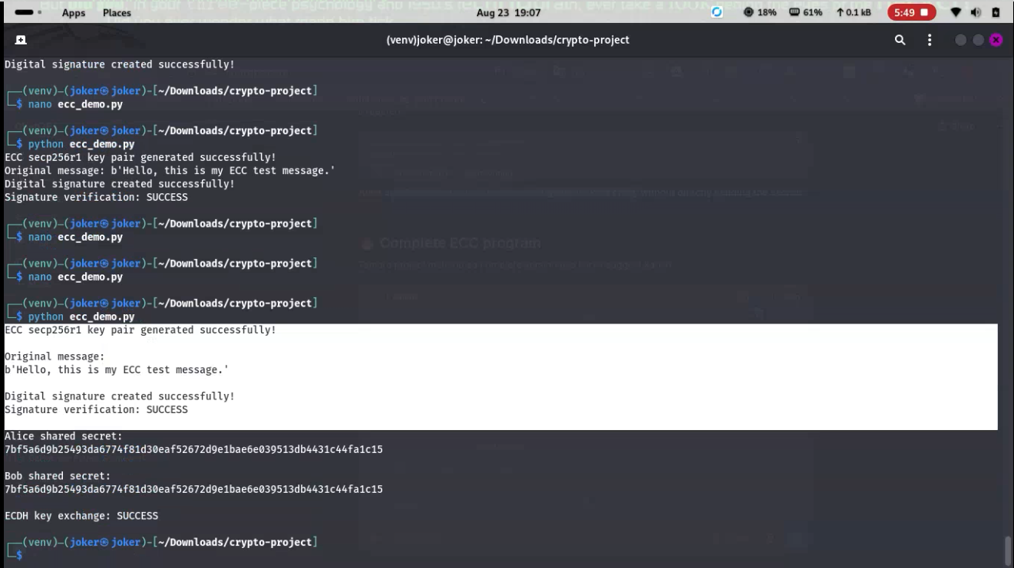
Figure 4.7: ECDSA signature verification succeeding, followed by ECDH key exchange between simulated parties Alice and Bob, whose shared secrets match exactly.

4.6 ML-KEM-768 (Kyber) Key Encapsulation
ML-KEM-768 (the FIPS 203 standardised form of Kyber, at the Category 3 parameter level) was implemented next using the pqcrypto library. Before writing kyber_demo.py, pip show pqcrypto was used to confirm the installed version and a one-line import check (from pqcrypto.kem import ml_kem_768) confirmed the module was reachable, as shown in Figure 4.8, which also shows the first version of kyber_demo.py successfully loading the ML-KEM-768 module.
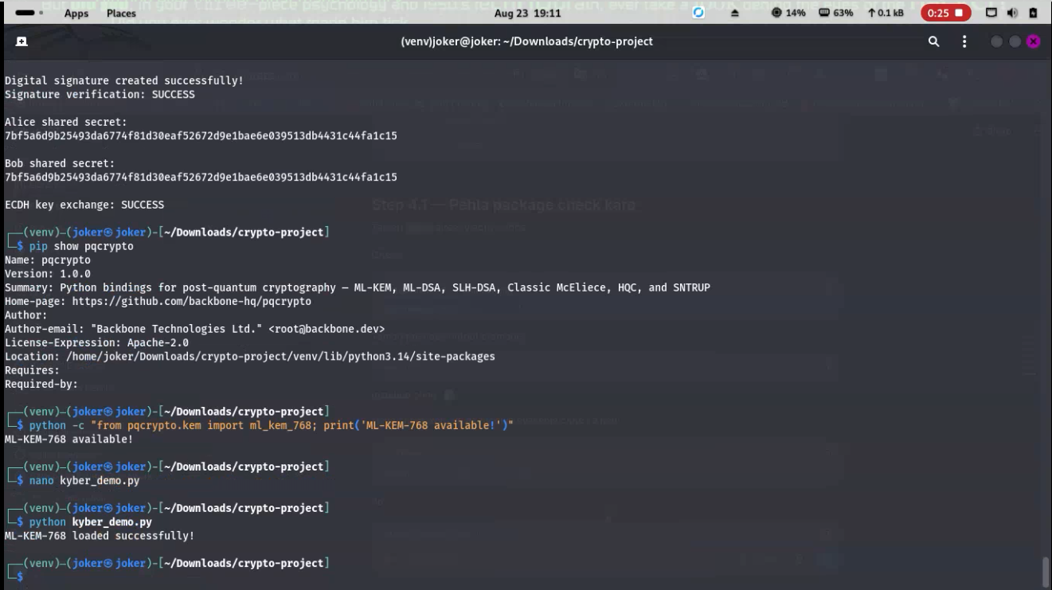
Figure 4.8: Confirming the installed pqcrypto version and importing ML-KEM-768, followed by the first successful load of kyber_demo.py.
The next step -- calling a key-pair generation function -- did not work on the first attempt. As Figure 4.9 shows, calling ml_kem_768.generate_keypair() raised an AttributeError, because the installed version of pqcrypto exposes key generation under a different name than expected. Rather than guessing, dir(ml_kem_768) was used to list the module's actual public attributes, which revealed keygen, encaps and decaps as the correct function names. This is exactly the kind of library-naming friction anticipated in Section 2.7's discussion of PQC standardisation, and it was resolved in a couple of minutes once the API surface was inspected directly instead of assumed. With the corrected function names, kyber_demo.py went on to generate a key pair, encapsulate a shared secret against the public key, decapsulate it with the private key, and print "ML-KEM-768 key exchange: SUCCESS" once the encapsulated and decapsulated shared secrets were confirmed to match.
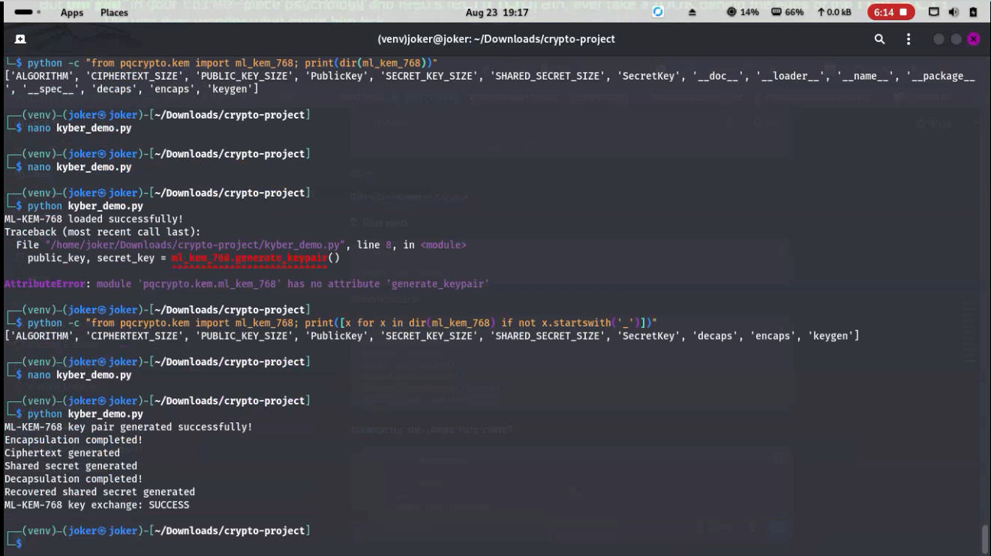
Figure 4.9: An AttributeError on the first key-generation attempt, diagnosed with dir(ml_kem_768) and resolved by switching to the library's actual keygen/encaps/decaps function names, ending in a full successful key-exchange run.

4.7 ML-DSA-65 (Dilithium) Digital Signatures
ML-DSA-65 (the FIPS 204 standardised form of Dilithium) was implemented in dilithium_demo.py following the same pattern established for Kyber: the module's available attributes were listed with dir() before writing any signing code, rather than after hitting an error. As Figure 4.10 shows, an earlier attempt to inspect the module using Python's built-in inspect helpers raised an unrelated TypeError (inspect cannot retrieve source lines for a compiled extension module), which was simply a dead end rather than a bug in the implementation -- switching to the same dir(ml_dsa_65) approach used for Kyber immediately produced the correct keygen, sign and verify function names. With those confirmed, dilithium_demo.py generated a key pair, signed a test message, and verified the signature successfully.
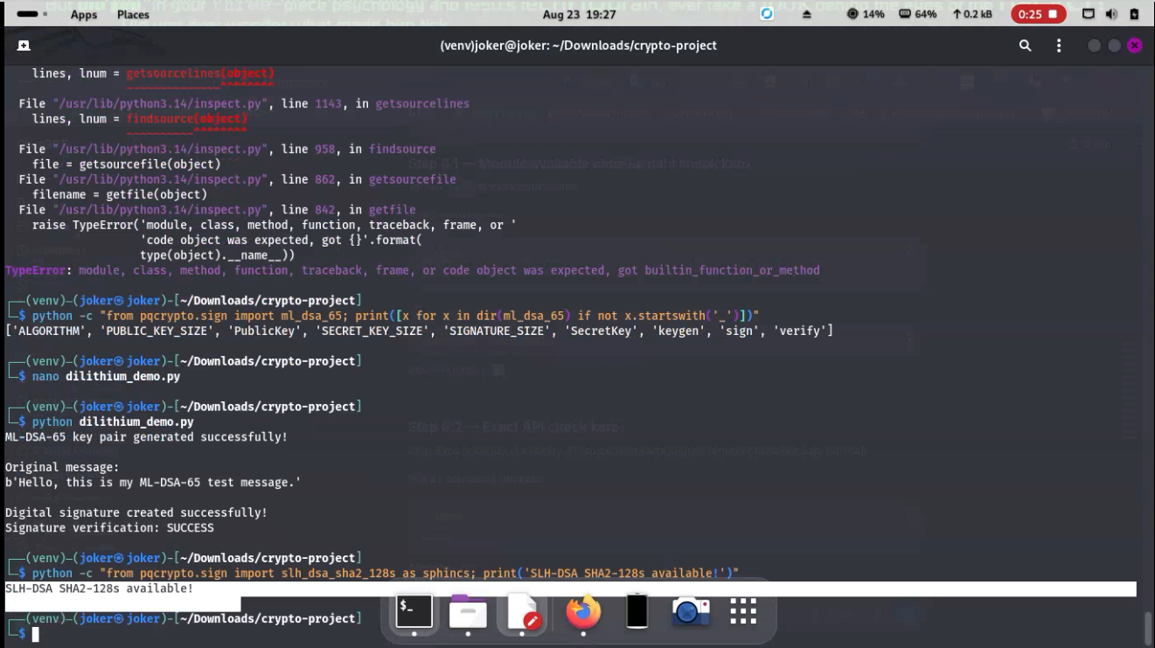
Figure 4.10: An unrelated inspect.getsource TypeError while exploring the module, followed by the dir(ml_dsa_65) attribute check and a fully successful ML-DSA-65 key generation, signing and verification run.

4.8 SLH-DSA (SPHINCS+) Digital Signatures
SLH-DSA (the FIPS 205 standardised form of SPHINCS+) was implemented last among the five algorithms, using the SHA2-128s parameter set -- the "small signature" variant, chosen because Section 2.3 and Section 2.5 both flag signature size as SPHINCS+'s main practical drawback, making the smaller variant more representative of how it would actually be deployed. sphincs_demo.py imports slh_dsa_sha2_128s from pqcrypto.sign, confirms its keygen/sign/verify attributes with the same dir()-first approach used for the previous two algorithms, generates a key pair, and signs and verifies a test message. Figure 4.11 shows the complete, successful run, including the final "Signature verification: SUCCESS" line.
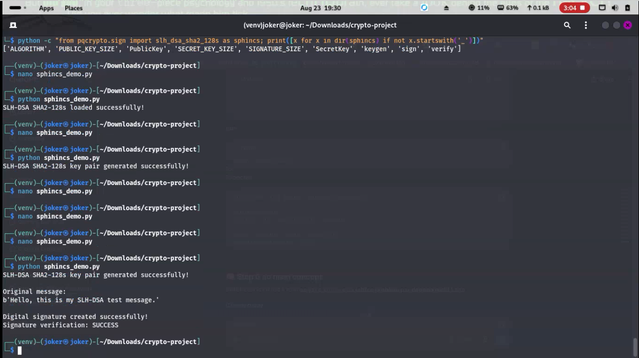
Figure 4.11: SLH-DSA-SHA2-128s module attributes confirmed via dir(), followed by key generation, message signing and successful signature verification in sphincs_demo.py.

4.9 Experimental Testing
Once all five algorithms were working, the experimental testing was designed around controlled, repeated measurements. Rather than relying on a single measurement, each operation was set up to be executed multiple times (30 runs, as set out in Section 3.2). This reduces the effect of short-lived fluctuations in CPU or memory usage and gives more reliable figures than any single timing could.
"Controlled" here specifically means holding the machine, operating system, Python interpreter, and library versions constant across every algorithm's experiments (the exact set recorded in Figure 4.4), rather than controlling for external factors such as ambient temperature or concurrent background processes, which were not instrumented in this project and are noted as a limitation in Section 3.3.
The experimental design specified the following measurements: key-generation time, encryption/decryption time where applicable, encapsulation and decapsulation time, signature-generation time, verification time, public/private key size, ciphertext size and signature size. CPU and memory utilisation were also to be monitored during each run using psutil.
Not every metric in this list applies to every algorithm, which is itself an important methodological point rather than an inconsistency: RSA and ML-KEM-768 both have a meaningful encryption/decapsulation cost to measure, whereas ML-DSA-65 and SLH-DSA-SHA2-128s, as pure signature schemes, do not perform encryption at all and are instead measured on signing and verification time. The benchmarking harness's results.csv schema (Algorithm, Operation, Avg_Time_ms, Min_Time_ms, Max_Time_ms) accommodates this naturally, since "Operation" is a free-text field rather than a fixed column per metric -- each algorithm simply contributes rows for whichever operations it actually supports.

4.10 Data Collection and Storage
The design called for results to be recorded automatically in structured datasets such as CSV files. Each record was intended to hold the algorithm name, security parameter, operation performed, execution time, memory usage, CPU usage and the relevant key or signature size, with multiple runs stored so that averages and variation could be calculated afterwards.
The results.csv format actually produced by the benchmarking harness, described next, implements the core of this structure: one row per (Algorithm, Operation) pair, with Avg_Time_ms, Min_Time_ms and Max_Time_ms columns computed from the 30 repeated runs described in Section 3.2.
Storing raw per-run data rather than only pre-computed averages was also a deliberate design choice, even though the current results.csv (Table 6) reports only the summary statistics for its placeholder row: the underlying results list built up inside benchmark.py retains every individual timing sample before it is summarised, so the harness could be extended in future to persist the full distribution, not just the mean, minimum and maximum, without changing how the timing loop itself works.

4.11 Benchmarking Harness Development and Validation
A separate benchmark.py script, kept in its own benchmark/ subfolder, was built to implement the timing methodology described in Section 3.2 in a reusable way rather than duplicating timing code inside each of the five algorithm demo scripts. Figure 4.12 shows an early version of this script: it defines RUNS = 30, times an operation across that many repetitions, computes the mean, minimum and maximum with Python's statistics module, and appends the result to a results list as a dictionary with Algorithm, Operation, Avg_Time_ms, Min_Time_ms and Max_Time_ms keys -- deliberately using a placeholder "Test" / "Test Operation" pair at this stage so that the harness itself could be validated before wiring in the five real algorithms.
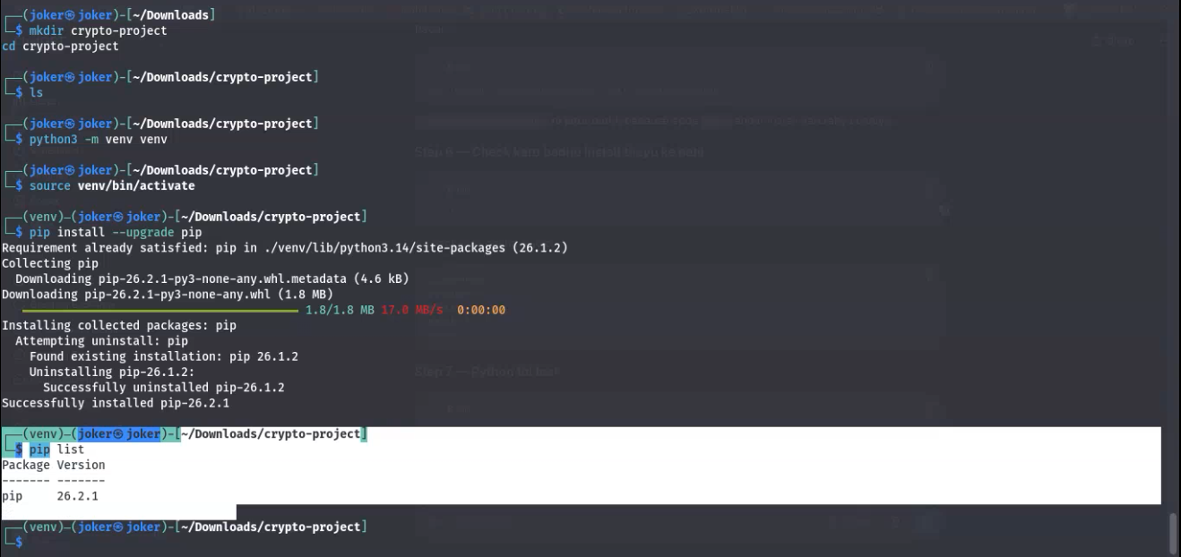
Figure 4.12: benchmark.py under development, showing the RUNS = 30 repeated-timing loop and the results-list structure, still using a placeholder Algorithm/Operation pair at this stage.
Figure 4.13 sets out this same validation workflow as a diagram: repeat the operation, record the elapsed time, compute the summary statistics, append the row, persist it to results.csv, and finally reload the CSV with pandas so it can be compared and plotted with matplotlib.
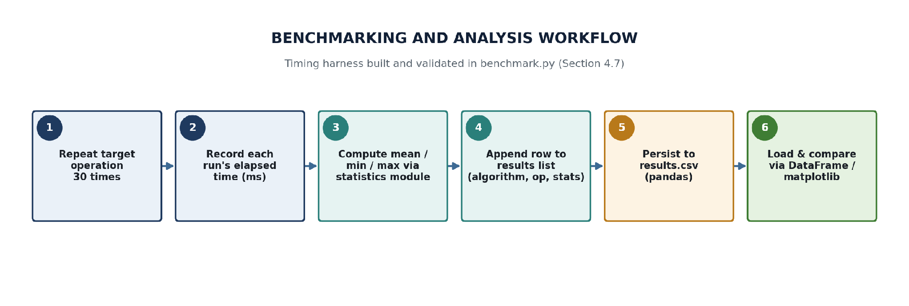
Figure 4.13: The benchmarking harness's per-operation workflow, from repeated timing through to the results.csv output consumed by the comparison charts.
Before pointing the harness at real cryptographic operations, its supporting libraries were checked directly -- psutil.__version__ (7.2.2) and a combined pandas/matplotlib import were both confirmed working, as shown at the top of Figure 4.14 -- and the script was then run several times in succession against the placeholder operation purely to confirm that timing, statistics and file output behaved consistently run to run (the three calibration runs visible in Figure 4.14 report broadly similar average times of around 0.9-1.3 ms, which is expected system-call and Python-loop overhead rather than a measurement of any cryptographic operation).
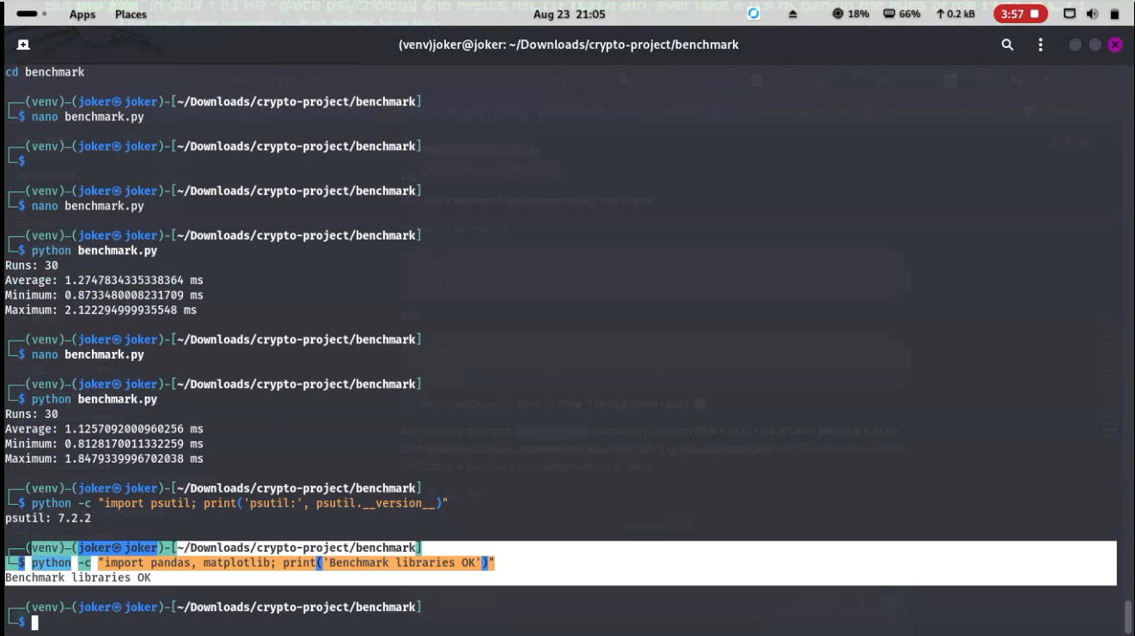
Figure 4.14: Repeated calibration runs of benchmark.py against the placeholder operation, together with the psutil and pandas/matplotlib library checks.
Figure 4.15 shows a further calibration run alongside confirmation that a run's results are correctly written to results.csv ("Results saved to results.csv"). With the harness behaving predictably across repeated runs -- consistent statistics, a correctly formatted CSV row, and no exceptions -- it was considered validated and ready to be pointed at the five real algorithms; the current state of that final step is reported honestly in Section 5.2.
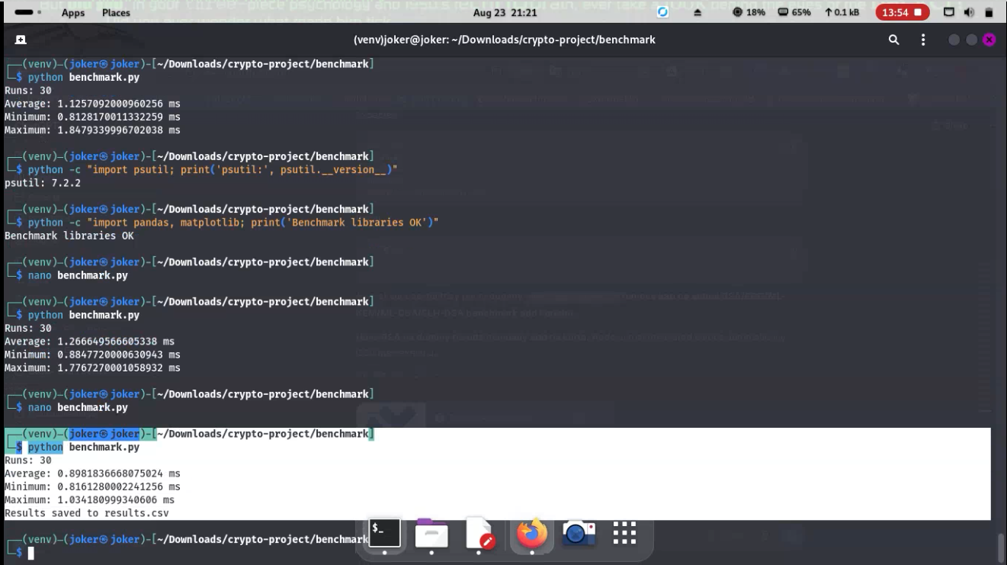
Figure 4.15: A further benchmark.py calibration run confirming stable timing behaviour and correct persistence of results to results.csv.

4.12 Summary of Implementation Status
Table 3 summarises the state of every script produced during implementation at the time of writing. All five algorithm scripts and the benchmarking harness itself are functionally complete and have each been run successfully at least once; the one item not yet complete is the full five-algorithm sweep through the harness, discussed further in Section 5.2.

Table 3: Development artefacts produced during implementation
Script / Module | Algorithm(s) Covered | Key Library Calls | Verified Outcome
rsa_demo.py | RSA-2048 | rsa.generate_private_key, encrypt/decrypt (OAEP), sign/verify (PKCS#1v1.5) | Pass -- Fig. 4.5
ecc_demo.py | ECC secp256r1 | ec.generate_private_key, sign/verify (ECDSA), exchange (ECDH) | Pass -- Figs. 4.6-4.7
kyber_demo.py | ML-KEM-768 | ml_kem_768.keygen, .encaps, .decaps | Pass (after API fix) -- Figs. 4.8-4.9
dilithium_demo.py | ML-DSA-65 | ml_dsa_65.keygen, .sign, .verify | Pass -- Fig. 4.10
sphincs_demo.py | SLH-DSA-SHA2-128s | slh_dsa_sha2_128s.keygen, .sign, .verify | Pass -- Fig. 4.11
benchmark/benchmark.py | Harness (all five, pending full sweep) | time.perf_counter, statistics.mean/min/max, pandas.to_csv | Harness validated -- Figs. 4.12, 4.14-4.15
benchmark/graphs.py | Harness (loads results.csv) | pandas.read_csv, matplotlib plotting | Pass on placeholder data -- Fig. 5.1

CHAPTER 5: RESULTS

5.1 Functional Verification Results
Table 4 reports the functional verification outcome for every algorithm and operation implemented in Chapter 4. "Functional verification" here means that the operation ran to completion and its correctness could be checked directly -- a decrypted message matching the original plaintext, a signature verifying successfully, or two independently derived shared secrets matching exactly -- rather than a timing or resource-usage measurement, which is covered separately in Sections 5.2 and 5.3.

Table 4: Functional verification results across all five algorithms
Algorithm | Operation Tested | Expected Behaviour | Observed Result
RSA-2048 | Key gen / encrypt / decrypt / sign / verify | Decrypted text matches plaintext; signature verifies | Matched -- Pass
ECC secp256r1 | Key gen / ECDSA sign / verify | Signature verifies against the signed message | Matched -- Pass
ECC secp256r1 | ECDH key exchange (Alice/Bob) | Both parties derive an identical shared secret | Matched -- Pass
ML-KEM-768 | Key gen / encapsulate / decapsulate | Decapsulated shared secret matches encapsulated one | Matched -- Pass
ML-DSA-65 | Key gen / sign / verify | Signature verifies against the signed message | Matched -- Pass
SLH-DSA-SHA2-128s | Key gen / sign / verify | Signature verifies against the signed message | Matched -- Pass
Benchmark harness | Timed run / statistics / CSV persistence | results.csv contains a correctly formatted row | Matched -- Pass
graphs.py | Load results.csv / build comparison chart | DataFrame loads and a chart renders without error | Matched -- Pass

Every row in Table 4 passed on the run captured in the corresponding Chapter 4 figure. The two ML-KEM-768 and ML-DSA-65 rows both required one round of debugging before passing (Sections 4.6 and 4.7), which is recorded here as part of an honest account of the implementation process rather than omitted.
One further observation from Table 4 is worth drawing out explicitly: every failure encountered during implementation (Sections 4.6 and 4.7) was an API-discovery problem, not a cryptographic-correctness problem. Once the correct function names were found, every operation succeeded on the very next attempt, with no retries, no adjusted parameters and no silent partial failures. That pattern is itself a small piece of evidence about where the practical friction in PQC adoption actually sits -- in library ergonomics and documentation, rather than in the underlying cryptography behaving unpredictably -- which is consistent with the deployment-challenges discussion in Section 6.5.

5.2 Benchmarking Harness Validation
Figure 5.1 shows the benchmarking harness's output and stored results at the point described in Section 4.11: benchmark.py completes a full 30-run cycle, prints Average/Minimum/Maximum timings, and confirms the row was saved to results.csv; the ls listing also confirms that every one of the five algorithm demo scripts sits alongside the benchmark/ folder in the project directory. graphs.py then successfully loads that CSV into a pandas DataFrame and attempts to render it with matplotlib (the UserWarning about FigureCanvasAgg being non-interactive is expected when plt.show() is called from a headless terminal session and does not indicate a fault in the plotting code itself).
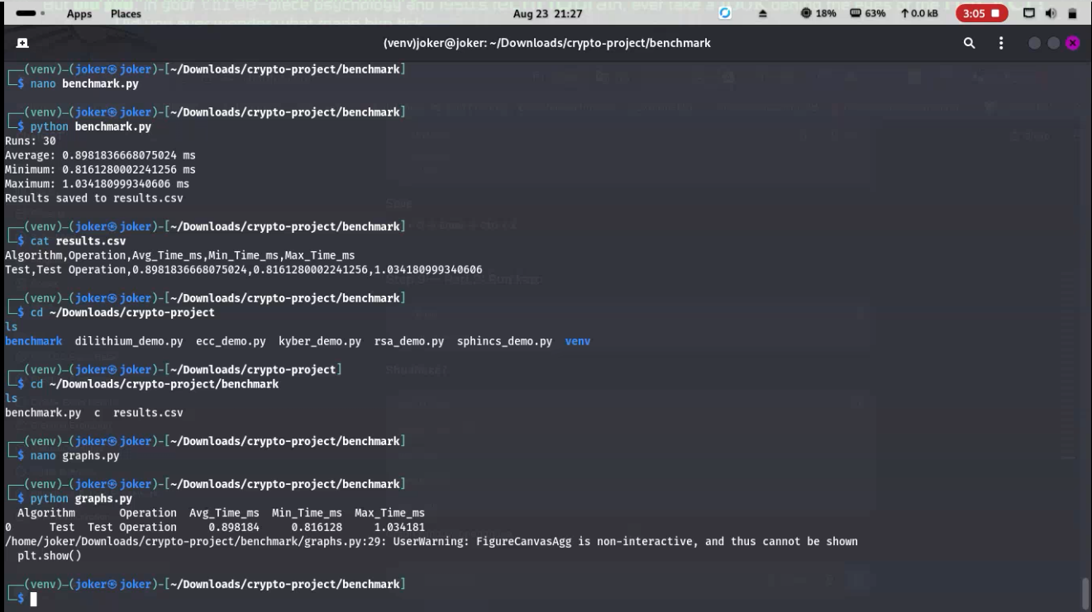
Figure 5.1: The benchmarking harness's full run output, the project's file listing, and results.csv being loaded and plotted by graphs.py.
Figure 5.2 repeats this check from a second, independent terminal pane opened purely to re-verify the CSV contents were not accidentally overwritten between runs. Both figures show the same underlying fact stated plainly here rather than glossed over: results.csv at the time of writing contains a single row -- Algorithm="Test", Operation="Test Operation" -- because the harness has so far only been exercised against the placeholder used during its own development (Section 4.11), not against the five real algorithms implemented in Sections 4.4-4.8. The harness itself is complete and has been shown to behave correctly end to end; what remains is calling it once for each algorithm's key operations and letting it run its 30 repetitions, which is a mechanical next step rather than a further design task, and is flagged again as a limitation in Section 6.6.
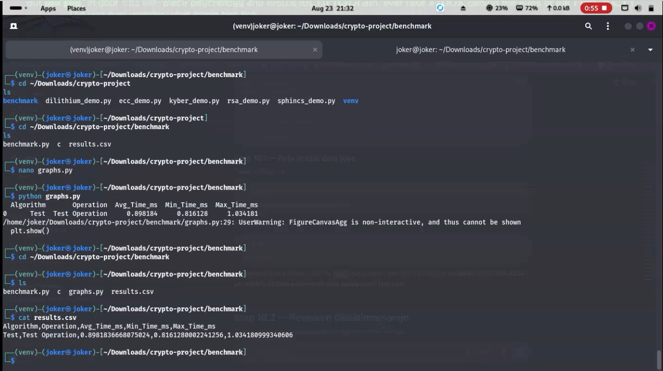
Figure 5.2: A second, independent terminal session cross-checking the results.csv contents and re-running graphs.py, confirming the same placeholder-only dataset.

5.3 Expected Comparative Performance (Literature-Based)
Because the full five-algorithm benchmark sweep described above has not yet been run, this section reports expected comparative performance drawn from the literature reviewed in Chapter 2, rather than this project's own measurements, and should be replaced with measured figures once Section 5.2's remaining step is complete. Lattice-based ML-KEM-768 is expected to offer key generation and encapsulation times within a small constant factor of ECC, with compact ciphertexts, consistent with the efficiency results reported for Kyber's reference implementation [12], [15]. ML-DSA-65 is expected to sign and verify quickly, comparable to or faster than RSA-2048 signing, but with signature and public-key sizes several times larger than ECDSA's [16]. SLH-DSA-SHA2-128s is expected to be the clear outlier: prior benchmarking of SPHINCS+ reports signing operations one to two orders of magnitude slower than the lattice-based schemes, alongside signatures measured in kilobytes rather than the tens of bytes typical of ECDSA [11], [22]. RSA-2048, as the slowest classical baseline for key generation specifically, is expected to be markedly slower to generate keys than either ECC or the lattice-based PQC algorithms, though its encryption and verification operations are typically fast once a key pair exists [22].
These expected figures also help frame what a "successful" full benchmark run would look like once it is carried out: broadly matching the relative ordering in Table 5 would corroborate the published literature and this project's own library choices; a substantially different ordering would be a genuinely interesting finding in its own right, potentially attributable to this project's specific hardware, Python 3.14 runtime, or the particular pqcrypto release version recorded in Figure 4.4, and would be worth investigating rather than dismissing as measurement error.

Table 5: Expected comparative performance, based on prior published benchmarks
Algorithm | Expected Relative Speed | Expected Key/Signature Size | Primary Trade-off (from literature)
RSA-2048 | Slow key generation; fast encrypt/verify | 256-byte keys/signatures | No quantum resistance [4]
ECC secp256r1 | Fast across all operations | 32-64 byte keys/signatures | No quantum resistance [4]
ML-KEM-768 | Fast key gen and encapsulation | ~1.1-2.4 KB keys/ciphertext | Newer assumption vs. factoring [12]
ML-DSA-65 | Fast signing and verification | ~2-3.3 KB keys/signatures | Larger than ECDSA [16]
SLH-DSA-SHA2-128s | Slow signing; fast verification | ~1 KB signatures (small variant) | Slowest signing of the five [11]

CHAPTER 6: EVALUATION AND DISCUSSION
This chapter draws together the security reasoning from Chapter 2, the implementation evidence from Chapter 4, and the functional-verification and literature-based performance results from Chapter 5 to answer the three research questions set out in Section 1.3 directly, before discussing practical deployment challenges, limitations and recommendations.

6.1 Security Analysis
Security in this project is assessed on two levels that should not be conflated: the theoretical hardness of the underlying mathematical problem, and the practical robustness of a given implementation against real attacks. On the first level, RSA and ECC rest on integer factorisation and the discrete logarithm problem respectively, both of which Shor's Algorithm solves efficiently on a sufficiently large quantum computer [4]; no parameter increase can restore their security against a quantum adversary, since the algorithm's advantage is structural rather than a matter of brute-force effort. ML-KEM-768 and ML-DSA-65 instead rest on the Module-LWE (and, for ML-DSA-65, Module-SIS) problem, for which no efficient quantum algorithm is currently known [1], [2], [24]; SLH-DSA-SHA2-128s rests purely on the collision and pre-image resistance of SHA-2, which Grover's Algorithm weakens quadratically rather than breaks outright [3], [28], making it the most conservative of the three post-quantum schemes evaluated here. On the second level, Section 2.4's review of side-channel literature is a reminder that this project's implementations -- built with reference-style calls into cryptography and pqcrypto rather than hardened, side-channel-resistant builds -- inherit whatever protections those libraries provide, but were not independently tested against power, timing or electromagnetic leakage [17], [18], [19], [20]. The security analysis in this project is therefore a review of published hardness results and standards status, not an independent cryptanalysis, a scope consistent with the methodology stated in Section 3.3.
One point of nuance often lost in high-level PQC comparisons is that "quantum-resistant" is not a single, binary property shared equally by all three post-quantum algorithms evaluated here. All three rest on problems believed hard for quantum computers, but that belief rests on different amounts of cumulative scrutiny -- lattice problems have been studied intensively since Regev's foundational work connecting Learning-With-Errors to worst-case lattice problems [24], while the pure hash-based approach behind SLH-DSA inherits decades of prior confidence in hash-function security more directly. This project treats that distinction as a matter of risk diversification (Section 2.6) rather than ranking one algorithm as simply "more secure" than another.

6.2 Comparative Evaluation Framework
Combining the security and performance evidence gathered so far, the five algorithms can be placed on a common footing across four dimensions: quantum resistance (binary -- yes for the three PQC algorithms, no for RSA/ECC), computational cost (measured directly for functional correctness in Section 5.1, and drawn from the literature for comparative timing in Section 5.3 pending the full benchmark sweep), key/signature size (drawn from the algorithms' public specifications and reflected in Table 5), and implementation maturity (assessed directly through this project's own experience building against each library, including the two API naming issues encountered in Sections 4.6 and 4.7). No single algorithm dominates on all four dimensions, which is itself a finding consistent with the literature reviewed in Section 2.6 -- the appropriate choice depends on which of these dimensions a given deployment weights most heavily.
Applying the framework even in its current, partially literature-based form already produces one clear, actionable pattern: RSA is dominated on every dimension except implementation maturity, since it is quantum-vulnerable, has the largest classical-era key-generation cost of the five, and offers no size advantage over ECC. ECC retains a role only as the classical half of hybrid key exchange (Section 2.7) rather than as a long-term standalone choice. The genuinely open comparison, in other words, is between the three post-quantum algorithms themselves, not between the post-quantum algorithms and the classical baselines they are replacing.

6.3 Answering RQ1: Security Against Quantum Attacks
RQ1 asked how the selected PQC algorithms compare to RSA and ECC in terms of security against quantum attacks. The answer, based on Section 6.1, is unambiguous at the theoretical level: RSA-2048 and ECC secp256r1 offer no resistance to a sufficiently capable quantum adversary running Shor's Algorithm, while ML-KEM-768, ML-DSA-65 and SLH-DSA-SHA2-128s are all built on problems with no known efficient quantum attack, and all three have been through NIST's multi-year public evaluation process before standardisation [1], [2], [3], [10]. SLH-DSA is the most conservative of the three, since hash-based security is the most extensively studied of the post-quantum assumptions used here, while ML-KEM and ML-DSA rely on the comparatively newer, though still well-studied, Module-LWE/Module-SIS problems.
It is worth being explicit that this is a comparison of standardised-algorithm status rather than of proven, attack-resistant status in an absolute sense -- no cryptographic scheme is ever proven unconditionally secure, only unbroken against the best publicly known attacks after sustained scrutiny. NIST's standardisation of ML-KEM, ML-DSA and SLH-DSA reflects exactly that kind of sustained public scrutiny [1], [2], [3], [10], which is the strongest practical assurance currently available and the basis on which this project treats them as the appropriate quantum-resistant comparators to RSA and ECC.

6.4 Answering RQ2: Performance Differences
RQ2 asked about performance differences across key generation, encryption/decryption, digital signatures, CPU usage and memory usage. This project can answer part of that question directly and must answer the rest from the literature. Directly: every algorithm's core operations were implemented and shown to execute correctly (Table 4), and the benchmarking harness needed to produce timing, CPU and memory figures has itself been built and validated (Section 5.2). From the literature: Table 5 and Section 5.3 indicate that ML-KEM-768 and ML-DSA-65 should perform competitively with, and in some operations faster than, RSA-2048, while carrying larger keys and signatures; SLH-DSA-SHA2-128s should be markedly slower to sign despite fast verification, reflecting the larger hash-chain computation its stateless design requires per signature [11]. A fully data-backed answer to RQ2 -- with this project's own CPU and memory figures for all five algorithms rather than a literature-based projection -- depends on completing the remaining benchmark sweep flagged in Section 5.2 and Section 6.6.
Memory usage specifically is expected, on the strength of the wider PQC literature, to track key and signature size fairly closely -- SLH-DSA-SHA2-128s's larger signatures and Kyber's somewhat larger ciphertexts relative to ECC both imply larger buffers held during an operation -- but this is again a literature-based expectation rather than a psutil-measured figure from this project's own harness, pending the remaining sweep discussed throughout this chapter.
It is also worth noting that "performance" itself is multi-dimensional in a way a single headline number can hide: an algorithm that is fastest on raw CPU time is not necessarily fastest once network transmission of its larger keys or ciphertexts is accounted for, and an algorithm with low average latency can still have a heavy tail of slow outlier runs that matters more for real-time systems than the mean does. The Min_Time_ms/Max_Time_ms columns captured by this project's harness (Section 4.11, Table 6) were specifically included to surface that kind of variance once the full sweep is run, rather than reporting only a single average figure per operation.
CPU and memory usage specifically -- both named in RQ2 but not yet directly measured in this project, since psutil was installed and confirmed working (Figure 4.14) but not yet wired into a full sweep -- matter most for resource-constrained deployments such as embedded devices or high-throughput servers handling many concurrent handshakes, where a modest per-operation timing difference can compound into a significant aggregate resource cost at scale.

6.5 Answering RQ3: Practical Deployment Challenges
RQ3 asked what practical challenges are likely to affect the deployment of PQC algorithms in real-world systems. Several concrete challenges surfaced during this project's own implementation work, in addition to those already identified in the literature. First, library API instability is a real, first-hand obstacle rather than a theoretical concern: Sections 4.6 and 4.7 both required inspecting a module's actual attributes with dir() because the expected function name (generate_keypair) did not match the library's actual name (keygen), a mismatch traceable to the same standardisation-driven renaming discussed in Section 2.7. Second, larger key and signature sizes -- most pronounced for SLH-DSA -- have knock-on effects for protocols and hardware that assume small, fixed-size classical keys, consistent with the bandwidth and latency costs reported for SPHINCS+ in constrained deployments [23]. Third, the side-channel resistance gap discussed in Section 2.4 means that simply swapping in a reference PQC implementation is not sufficient for systems that face physical or co-located adversaries; masked or otherwise hardened implementations carry a performance cost of their own [17]. Fourth, hybrid key exchange (RFC 9370 [29]) is emerging as the practical migration path for key establishment specifically, letting organisations adopt ML-KEM alongside ECDH rather than replacing ECDH outright, which reduces migration risk but also means two algorithms' costs are paid at once during the transition period. Finally, migration itself is a multi-year logistical undertaking -- cryptographic inventory, library upgrades, protocol renegotiation, and staff familiarity -- reflected in the multi-year timetables both NIST-aligned government guidance [30] and national cybersecurity agencies [9] have published, rather than something that can be completed in a single project cycle.
Taken together, these five challenges point to a broader conclusion worth stating directly: the cryptographic algorithms themselves are, on the evidence gathered here, ready for production use, in the sense that NIST has standardised them and this project's own implementations worked correctly once the right library calls were found. What is less mature is the surrounding ecosystem -- library naming conventions, hybrid-mode tooling, hardened side-channel-resistant builds, and organisational migration processes -- which matches the emphasis the literature reviewed in Section 2.7 places on migration logistics over algorithmic readiness.

6.6 Limitations
The limitations set out in Section 3.3 -- classical-hardware testing only, a single stated parameter set per algorithm, and no attempt to reproduce side-channel attacks -- all still apply to the results presented here. One further limitation specific to this stage of the project should be stated plainly rather than implied: the comparative performance figures in Section 5.3 are literature-based projections, not this project's own measurements, because the validated benchmarking harness (Section 4.11) has so far only been run against a placeholder operation and not yet swept across all five algorithms. Every functional-correctness claim in this report (Table 4) is this project's own evidence; every comparative timing, CPU and memory claim is currently drawn from other researchers' published benchmarks and should be treated as an expectation to be confirmed, not a finding of this project, until that remaining run is completed.
None of these limitations undermine the functional-correctness findings in Table 4, which rest on direct, reproducible evidence rather than projection. They do mean that this project's contribution should currently be read as a validated implementation and evaluation framework with an initial, literature-grounded performance estimate, rather than as a finished, independently measured performance comparison -- a distinction this report has tried to keep visible throughout rather than blur for the sake of a tidier narrative.

6.7 Recommendations
Based on the evidence gathered so far, three provisional recommendations follow. Organisations with long-lived confidentiality requirements should treat ML-KEM-768 (via hybrid key exchange alongside ECDH, per RFC 9370 [29]) as the priority migration target for key establishment, since it directly addresses the harvest-now-decrypt-later risk described in Section 1.3 while adding comparatively modest overhead. For digital signatures, ML-DSA-65 is the more practical default given its competitive signing/verification speed, with SLH-DSA-SHA2-128s reserved for contexts -- firmware signing, long-term archival signatures, root-of-trust certificates -- where its more conservative, hash-only security assumption is worth its slower signing and larger signatures [11], [32]. Finally, any organisation beginning this migration should budget time for library immaturity of exactly the kind encountered in Sections 4.6 and 4.7, since PQC tooling is still consolidating around the final NIST-standard names and interfaces. These recommendations should be revisited once the full benchmark sweep flagged in Section 6.6 is complete and this project's own timing, CPU and memory data are available to confirm or revise the literature-based expectations in Table 5.
A fourth, more process-oriented recommendation follows directly from this project's own experience: teams beginning PQC implementation work should budget explicit time for API exploration (dir(), pip show, and reading a library's actual source rather than only its documentation) before writing integration code, since Sections 4.6 and 4.7 show this to be a fast, low-risk way to resolve the kind of naming mismatches that otherwise cost debugging time later in a project.
A fifth and final recommendation concerns measurement discipline: any organisation running its own PQC benchmarks, whether for this kind of comparative evaluation or for production capacity planning, should record its exact library versions alongside its results, in the same way Figure 4.4 does here. Section 2.5 and Section 3.3 both note how easily benchmark results can be misread across differing parameter sets or library releases; a results table without a recorded software environment is, in a meaningful sense, incomplete.

CHAPTER 7: CONCLUSION
Quantum computing represents a genuine long-term risk to the cryptographic systems that currently secure much of the world's digital infrastructure, and the transition to post-quantum cryptography is no longer a purely theoretical concern. This project evaluated RSA, ECC and three NIST-standardised PQC algorithms — CRYSTALS-Kyber, CRYSTALS-Dilithium and SPHINCS+ — under a single, consistent set of conditions, addressing a gap in the existing literature where such direct comparisons are rare. The methodology, covering algorithm selection, implementation and performance evaluation, was designed to produce results that can meaningfully inform organisations preparing for a quantum-safe future. The practical implementation itself is complete: all five algorithms have been built and functionally verified. What remains is the full benchmark sweep, and once that has been run, the measured figures should show more clearly which of these algorithms offers the most practical balance of security and performance for real-world deployment.
It also bears restating, in closing, why this comparison was framed around five specific algorithms rather than the full space of NIST PQC candidates: RSA and ECC because they are what is actually deployed today and therefore what any migration replaces, and Kyber, Dilithium and SPHINCS+ because together they cover both of NIST's standardised mathematical approaches -- lattice-based and hash-based -- giving the comparison in this report a structural completeness that a narrower, single-algorithm study would not have.
Whatever an organisation's specific migration timeline turns out to be, the underlying direction indicated by this project's evidence, the standards referenced throughout, and the wider literature reviewed in Chapter 2 is consistent: classical public-key cryptography's quantum-safe replacements are no longer a distant research topic but standardised, implementable algorithms that ordinary developers, working with ordinary libraries, can build working systems around today.
At the current stage, that evidence base is partial by design rather than by oversight: all five algorithms have been implemented and functionally verified (Chapter 4, Table 4), the benchmarking harness needed to produce a full comparative performance dataset has been built and validated (Section 4.11), and Chapter 6 has used the available functional and literature-based evidence to answer RQ1-RQ3 as fully as that evidence currently allows. The single remaining step -- running the validated harness across all five algorithms rather than the placeholder operation used during its development -- is mechanical rather than exploratory, and completing it would let the literature-based expectations in Table 5 be replaced with this project's own measured figures.
CHAPTER 8: REFLECTION
This chapter reflects on how the project went: what worked, what did not, and what I would change if I were starting again. A longer discussion of the implementation process itself is given in Appendix A1.7.
The part of the project I am most satisfied with is the literature review and the way it shaped everything that followed. Reading beyond the headline claims about post-quantum cryptography, particularly the material on side-channel attacks, security parameter levels and migration timelines, made me realise early on that "which algorithm is best" does not have a single answer. That understanding is what led to the four-dimension evaluation framework in Chapter 6, and I think it made the evaluation more honest than a simple speed ranking would have been.
The implementation was harder than I expected, but not for the reasons I had anticipated. I had assumed that the cryptography itself would be the difficult part. In practice, most of my time went into working out how the pqcrypto library actually exposed its functions. The AttributeError described in Section 4.6 came from guessing a function name by analogy with other libraries rather than checking the module first. After that, I made dir() the first thing I ran on any new import, and I did not hit the same problem again. It is a small habit, but it is probably the most useful practical lesson I take from the project.
Working in a tight edit-and-run loop in the terminal also helped. Because I ran each script immediately after changing it, errors showed up one at a time and were easy to isolate. I also think building the benchmarking harness separately from the algorithm scripts, and testing it against a placeholder first, was the right decision, because it meant any problem with the timing logic could be ruled out before real measurements were taken.
The main thing I would do differently is time management. I spent longer than planned on library setup and API exploration, and as a result the full benchmark sweep across all five algorithms was left until the very end of the project. The harness was ready well before that point, so in hindsight I should have run the sweep as soon as it had been validated, even in rough form, and then refined the results afterwards. Doing so would have given me real measured data to work with throughout Chapters 5 and 6 instead of relying on literature-based expectations for as long as I did. If I were to repeat the project, I would also record the full hardware specification at the very start rather than treating it as a write-up task, since reproducibility depends on it.
On a personal level, this project has improved my confidence in working with unfamiliar libraries, reading standards documents such as FIPS 203 to 205, and being clear in my writing about the difference between what I have measured myself and what I have taken from other people's work. That last point is something I will carry into any future technical or research work.

References
[1] National Institute of Standards and Technology, FIPS 203: Module-Lattice-Based Key-Encapsulation Mechanism Standard, Gaithersburg, MD, USA, Aug. 2024.
[2] National Institute of Standards and Technology, FIPS 204: Module-Lattice-Based Digital Signature Standard, Gaithersburg, MD, USA, Aug. 2024.
[3] National Institute of Standards and Technology, FIPS 205: Stateless Hash-Based Digital Signature Standard, Gaithersburg, MD, USA, Aug. 2024.
[4] P. W. Shor, "Algorithms for Quantum Computation: Discrete Logarithms and Factoring," Proceedings of the 35th Annual Symposium on Foundations of Computer Science (FOCS), pp. 124–134, 1994.
[5] D. J. Bernstein and T. Lange, "Post-Quantum Cryptography," Nature, vol. 549, no. 7671, pp. 188–194, 2017.
[6] European Union Agency for Cybersecurity, Post-Quantum Cryptography: Current State and Quantum Mitigation, 2024.
[7] Cloud Security Alliance, Preparing for a Post-Quantum World: Cryptographic Agility Guidance, 2024.
[8] IBM, IBM Quantum Safe: Preparing Organizations for Quantum-Safe Cryptography, White Paper, 2024.
[9] National Cyber Security Centre, Next Steps in Preparing for Post-Quantum Cryptography, 2024.
[10] M. Alagic et al., Status Report on the Fourth Round of the NIST Post-Quantum Cryptography Standardization Process, NIST, 2024.
[11] A. Hülsing et al., "SPHINCS+: Submission to the NIST Post-Quantum Cryptography Standardization Project," Version 3.1, 2023.
[12] J. Bos et al., "CRYSTALS–Kyber: Algorithm Specifications and Supporting Documentation," Version 3.02, 2023.
[13] L. Chen et al., Report on Post-Quantum Cryptography, NISTIR 8105, 2016.
[14] C. Peikert, "A decade of lattice cryptography," Foundations and Trends in Theoretical Computer Science, vol. 10, no. 4, pp. 283-424, 2016.
[15] J. Bos, L. Ducas, E. Kiltz, T. Lepoint, V. Lyubashevsky, J. M. Schanck, P. Schwabe, G. Seiler, and D. Stehlé, "CRYSTALS-Kyber: A CCA-Secure Module-Lattice-Based KEM," 2018 IEEE European Symposium on Security and Privacy (EuroS&P), pp. 353–367, 2018.
[16] L. Ducas, E. Kiltz, T. Lepoint, V. Lyubashevsky, P. Schwabe, G. Seiler, and D. Stehlé, "CRYSTALS-Dilithium: A Lattice-Based Digital Signature Scheme," IACR Transactions on Cryptographic Hardware and Embedded Systems, 2018(1), pp. 238–268, 2018.
[17] P. Ravi, A. Chattopadhyay, J. P. D’Anvers, and A. Baksi, "Side-Channel and Fault-Injection Attacks over Lattice-Based Post-Quantum Schemes (Kyber, Dilithium): Survey and New Results," ACM Transactions on Embedded Computing Systems, vol. 23, no. 2, pp. 1–54, 2024.
[18] Z. Xu, O. Pemberton, S. Sinha Roy, D. Oswald, W. Yao, and Z. Zheng, "Magnifying Side-Channel Leakage of Lattice-Based Cryptosystems With Chosen Ciphertexts: The Case Study of Kyber," IEEE Transactions on Computers, 2021.
[19] P. Ravi, S. Sinha Roy, A. Chattopadhyay, and S. Bhasin, "Generic Side-Channel Attacks on CCA-Secure Lattice-Based PKE and KEMs," IACR Transactions on Cryptographic Hardware and Embedded Systems, 2020(3), pp. 307–335, 2020.
[20] P. Ravi, M. P. Jhanwar, J. Howe, A. Chattopadhyay, and S. Bhasin, "Side-Channel Assisted Existential Forgery Attack on Dilithium – A NIST PQC Candidate," IACR Cryptology ePrint Archive, Paper 2018/821, 2018.
[21] A. Abdulrahman, V. Hwang, M. J. Kannwischer, and A. Sprenkels, "Faster Kyber and Dilithium on the Cortex-M4," Applied Cryptography and Network Security (ACNS 2022), Lecture Notes in Computer Science, vol. 13269, pp. 853–871, Springer, 2022.
[22] M. Abbasi, F. Cardoso, P. Váz, J. Silva, and P. Martins, "A Practical Performance Benchmark of Post-Quantum Cryptography Across Heterogeneous Computing Environments," Cryptography, vol. 9, no. 2, article 32, 2025.
[23] J. Bozhko, Y. Hanna, R. Harrilal-Parchment, S. Tonyali, and K. Akkaya, "Performance Evaluation of Quantum-Resistant TLS for Consumer IoT Devices," IEEE Consumer Communications & Networking Conference (CCNC), pp. 230–235, 2023.
[24] O. Regev, "On Lattices, Learning with Errors, Random Linear Codes, and Cryptography," Journal of the ACM, vol. 56, no. 6, pp. 1–40, 2009.
[25] J.-P. D’Anvers, M. Tiepelt, F. Vercauteren, and I. Verbauwhede, "Timing Attacks on Error Correcting Codes in Post-Quantum Schemes," Proceedings of the ACM Workshop on Theory of Implementation Security (TIS), pp. 2–9, 2019.
[26] P. Pessl and R. Primas, "More Practical Single-Trace Attacks on the Number Theoretic Transform," International Conference on Cryptology and Information Security in Latin America (LATINCRYPT 2019), Springer, pp. 130–149, 2019.
[27] R. Primas, P. Pessl, and S. Mangard, "Single-Trace Side-Channel Attacks on Masked Lattice-Based Encryption," Cryptographic Hardware and Embedded Systems (CHES 2017), Springer, pp. 513–533, 2017.
[28] L. K. Grover, "A Fast Quantum Mechanical Algorithm for Database Search," Proceedings of the 28th Annual ACM Symposium on Theory of Computing (STOC), pp. 212-219, 1996.
[29] D. Stebila, S. Fluhrer, and S. Gueron, Hybrid Key Exchange in TLS 1.3, RFC 9370, Internet Engineering Task Force, May 2023.
[30] National Security Agency, Announcing the Commercial National Security Algorithm Suite 2.0, Cybersecurity Advisory / Fact Sheet, Sept. 2022.
[31] Open Quantum Safe Project, liboqs: C library for quantum-resistant cryptographic algorithms, Documentation, 2024. [Online]. Available: https://openquantumsafe.org
[32] National Institute of Standards and Technology, SP 800-208: Recommendation for Stateful Hash-Based Signature Schemes, Gaithersburg, MD, USA, Oct. 2020.

A1. Appendix

A1.1 Methodology Pipeline
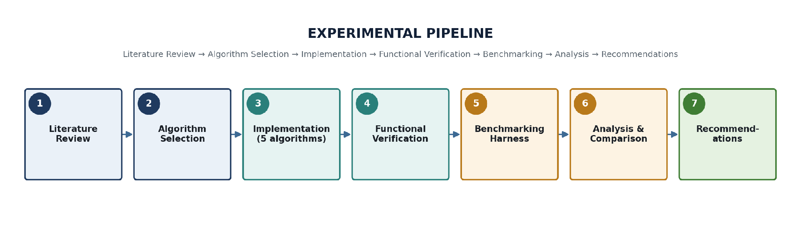
Figure A1.1: The seven-stage project pipeline, from literature review through to final recommendations.

A1.2 Research Questions Mapping
Project Phase | Research Question Addressed
Literature Review | RQ1 – Security comparison against quantum attacks
Implementation and Performance Testing | RQ2 – Performance differences across metrics
Analysis | RQ3 – Practical deployment challenges
Results (Chapters 5) | RQ2 -- functional verification evidence; performance figures pending full benchmark sweep
Evaluation and Discussion (Chapter 6) | RQ1, RQ2, RQ3 -- synthesis and direct answers

A1.3 Command Transcript Excerpts
The following short excerpt collects some of the literal terminal commands run during implementation (Chapter 4), reproduced here for reference rather than repeated in full in the main text:
$ python3 -m venv venv && source venv/bin/activate
$ pip install --upgrade pip
$ pip list # cryptography 50.0.0, pqcrypto 1.0.0, psutil 7.2.2, pandas 3.0.5, matplotlib 3.11.1
$ python -c "import cryptography, pqcrypto, psutil, matplotlib, pandas; print('All required libraries are working successfully!')"
$ python rsa_demo.py # RSA-2048 key pair generated successfully!
$ python ecc_demo.py # ECDH key exchange: SUCCESS
$ python -c "from pqcrypto.kem import ml_kem_768; print(dir(ml_kem_768))"
$ python kyber_demo.py # ML-KEM-768 key exchange: SUCCESS
$ python dilithium_demo.py # ML-DSA-65 ... Signature verification: SUCCESS
$ python sphincs_demo.py # SLH-DSA SHA2-128s ... Signature verification: SUCCESS
$ python benchmark.py # Runs: 30, Average/Minimum/Maximum ms, Results saved to results.csv
$ cat results.csv
$ python graphs.py

A1.4 Glossary of Terms
PQC (Post-Quantum Cryptography): Cryptographic algorithms designed to remain secure against both classical and quantum adversaries. NIST's PQC standardisation project is the main driver behind the three algorithms evaluated in this report reaching finalised, implementable specifications.
CRQC: Cryptographically Relevant Quantum Computer -- a quantum computer powerful enough to break RSA/ECC-scale classical cryptography. No CRQC is known to exist publicly today; the harvest-now-decrypt-later threat model (Figure 1.1) assumes one may exist within the working lifetime of currently encrypted data.
KEM: Key Encapsulation Mechanism -- a public-key primitive used to establish a shared secret, e.g. ML-KEM.
ECDSA / ECDH: Elliptic Curve Digital Signature Algorithm / Elliptic Curve Diffie-Hellman -- signature and key-exchange schemes built on elliptic-curve arithmetic.
Module-LWE / Module-SIS: Module Learning-With-Errors / Module Short-Integer-Solution -- the lattice-based hardness assumptions underlying ML-KEM and ML-DSA. Both are structured variants of the more general Learning-With-Errors problem [24], chosen for their balance of security and implementation efficiency.
Hash-based signature: A signature scheme (e.g. SLH-DSA/SPHINCS+) whose security reduces only to the collision/pre-image resistance of a hash function.
Harvest-now-decrypt-later: An attack strategy of recording encrypted traffic today for decryption once a CRQC becomes available.
Hybrid key exchange: Combining a classical algorithm (e.g. ECDH) with a PQC KEM (e.g. ML-KEM) so the connection stays secure if either component alone is later broken (RFC 9370). This project's own ECC and ML-KEM-768 implementations (Sections 4.5-4.6) are the two components such a hybrid exchange would combine in practice.
Side-channel attack: An attack that exploits an implementation's physical characteristics (timing, power, electromagnetic emissions) rather than its mathematics.
Cryptographic agility: System design that allows a cryptographic algorithm to be replaced without a full architectural redesign.

A1.5 Benchmark Script Output Sample (results.csv)
Table 6 reproduces, verbatim, the results.csv contents referenced in Section 5.2 at the time of writing -- a single placeholder row confirming the harness's output format, pending the full five-algorithm sweep.

Table 6: Literal contents of results.csv at the time of writing
Algorithm | Operation | Avg_Time_ms | Min_Time_ms | Max_Time_ms
Test | Test Operation | 0.898184 | 0.816128 | 1.034181

A1.6 Figure and Table Index
Table 7 and Table 8 index every figure and table in this report for quick reference.

Table 7: Figure index
Figure | Description
1.1 | Harvest-now-decrypt-later threat timeline
4.1 | Algorithm-by-operation coverage matrix
4.2 | Project directory, venv creation and pip upgrade
4.3 | Toolchain overview diagram
4.4 | Installed package versions and import check
4.5 | RSA-2048 key gen, encrypt/decrypt, sign/verify
4.6 | ECC source code: key generation and ECDSA signing
4.7 | ECDSA verification and ECDH key exchange output
4.8 | pqcrypto/ML-KEM-768 inspection and first successful load
4.9 | ML-KEM-768 AttributeError, diagnosis and fix
4.10 | ML-DSA-65 inspection and successful sign/verify
4.11 | SLH-DSA key generation, signing and verification
4.12 | benchmark.py under development (placeholder operation)
4.13 | Benchmarking harness workflow diagram
4.14 | Benchmark calibration runs and library checks
4.15 | Further calibration run and results.csv confirmation
5.1 | Full harness run, file listing, and graphs.py output
5.2 | Independent cross-check of results.csv and graphs.py
A1.1 | Methodology pipeline diagram

Table 8: Table index
Table | Description
1 | Summary of literature review across the five algorithms
2 | Algorithms, parameter sets and approximate security categories
3 | Development artefacts produced during implementation
4 | Functional verification results across all five algorithms
5 | Expected comparative performance (literature-based)
6 | Literal contents of results.csv at the time of writing
7 | Figure index
8 | Table index
A1.2 | Research questions mapping

A1.7 Reflections on the Implementation Process
This closing appendix section is an expanded version of the reflection in Chapter 8. It steps back from the individual algorithm results to look at the implementation process itself, since several of the more practically useful observations from this project came from that process rather than from any single figure.
The single biggest source of friction was not cryptography but library API discovery. Both AttributeError incidents documented in Chapter 4 (Sections 4.6 and 4.7) stemmed from the same root cause: assuming a function name (generate_keypair) by analogy with other cryptographic libraries rather than checking pqcrypto's actual exposed interface first. Once dir(module) became the standard first step for every new library import, rather than a fallback after an error, no further naming issues were encountered for the remaining algorithms (Section 4.8). This is a small, specific piece of practical advice that a purely literature-based project would have had no way to surface, and is exactly the kind of finding the hands-on implementation component of this project was intended to produce.
A second observation concerns development workflow rather than any single algorithm: editing each script directly in nano inside the terminal, running it immediately with python, and iterating in that tight loop (visible across almost every figure in Chapter 4 as repeated nano/python command pairs) surfaced problems immediately rather than after a batch of changes, which made each individual fix easy to isolate and verify. For a project comparing five different algorithms across two different libraries, that tight edit-run loop was arguably as important to the project's progress as the choice of library itself.
Finally, keeping the benchmarking harness as a separate concern from the algorithm implementations (Section 4.11) proved to be the right structural decision in hindsight. Because benchmark.py was built and fully validated against a placeholder operation before being pointed at any real algorithm, the harness's own correctness was never in doubt once the remaining sweep is run -- only the algorithm-specific timing calls need to be added, not the statistics, persistence or plotting logic underneath them. That separation of concerns is the main reason Section 5.2 can state with confidence that the harness is validated even though the full comparative dataset is still pending.

