Module Name: Managing Enterprise
Module Code: BMSW4011
Student: Jade Bevan
Student Number: 2511714
Lecturer: Mel Squire
Submission Deadline: 19th June 2026
Word count:1074

Contents
AI Acknowledgement 3
Company Name and Concept 4
My Story 4
Mission Statement 5
Business Aims 5
Business Objectives 5
Legal Identity 5
Marketing and PR Plan 6
Pricing Strategy 8
Market Research 9
USP 10
Physical Location 10
Human Resource Strategy 10
Finance and Costs 11
Cash Flow Forecast 11
SWOT Analysis 12
References 12
Appendices 14

AI Acknowledgement

I confirm that I have not presented any AI generated text as my own work. I can confirm I have copies of my drafts, notes, and other resources, which I may be asked to provide in evidence.

Company Name and Concept
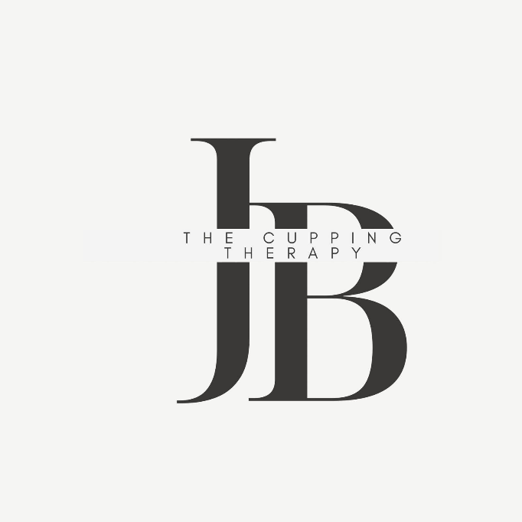
The Cupping Therapy
The Cupping Therapy is a mobile and home-based business in cardiff specialising in cupping therapy treatments aimed to help and support physical recovery, relaxation, blood flow, reduce muscle tension and overall wellbeing. The business aims to provide high quality, professional, and affordable cupping therapy for all customers, within the local community, especially for individuals interested in alternative medicine, sports recovery, and holistic health treatments.
Cupping therapy is an ancient form of alternative therapy that involves placing suction cups on the skin to improve blood circulation, ease blood flow and muscle tenson, it helps reduce inflammation and toxins and helps with healing (Sina and Bokhari, 2023)
Cupping has gained popularity worldwide, especially within sports therapy and wellness industries after high-profile athletes promoted its benefits such as during the 2016 Olympic Games (Shmerling, 2024)
The business will operate as a mobile and home-based service, allowing some customers to receive treatments with the comfort of their own home.

My Story
The Cupping Therapy was developed from a personal interest in holistic health and alternative therapies. Cupping therapy has always had a strong cultural and religious significance within many communities and has become very popular due to growing awareness of natural health treatments (Institute of Clinically Applied Holistic Therapy, 2025).
The business was created to provide a trusted, professional, and affordable cupping therapy service within the local area. Now, there are very limited qualified cupping therapists locally, therefore creating a big opportunity to attract business from those who are health conscious and who practice cupping for religious and cultural reasons.

Mission Statement
Cupping Therapy aims to offer alternative ancient forms of therapy to improve health and wellbeing.

Business Aims
The aim of The Cupping Therapy is to build a trusted and reliable wellness brand that delivers high-quality cupping therapy services while prioritising customer care and affordable pricing.

Business Objectives
- To gain at least 30 regular clients within the first 12 months of trading.
- To promote the business consistently through social media
- To maintain all professional qualifications, hygiene standards, and health and safety regulations.
- To achieve customer satisfaction ratings above 90%
- To earn back all start-up costs and break even within the first year of trading.

Legal Identity
The Cupping Therapy will operate as a sole trader business(Gove.UK “no date”). This means I will own and run the business myself and be fully responsible for all business decisions, finances and daily operations. I chose this type of trading because it is simple to s
et up and suitable for a small start-up business with low running costs (DNS Accountants, no date).
As a sole trader I will keep all profits made after tax and have full control over the business (Milton, 2025). It also allows flexibility when managing appointments and customer services. However, one disadvantage is that I will be personally responsible for any debts or financial losses within the business (UK Government, 2026)

Marketing and PR Plan
The target market for The Cupping Therapy is individuals aged 18 and over who are interested in health, fitness, sports recovery, alternative therapy treatments. The service is aimed at individuals who are generally in good health and do not have serious medical conditions that may affect treatment. The business is also targeted towards the Muslim community due to cupping therapy having religious and cultural importance. However, the business is open to everyone regardless of religion or background.
This business will use social media platforms such as Instagram, TikTok (TikTok, 2016) and Facebook(Meta, 2021). to promote the business widely. Some short videos will be uploaded to show behind the scenes content, customer testimonials and plenty of educational information about the benefits of cupping therapy and what it involves
A booking system which is called the Booksy app, will allow all customers to view available appointments immediately, prices and good reviews online instantly without having to wait. Promotional offers will be used for first-time customers to encourage repeat bookings and help build customer loyalty.
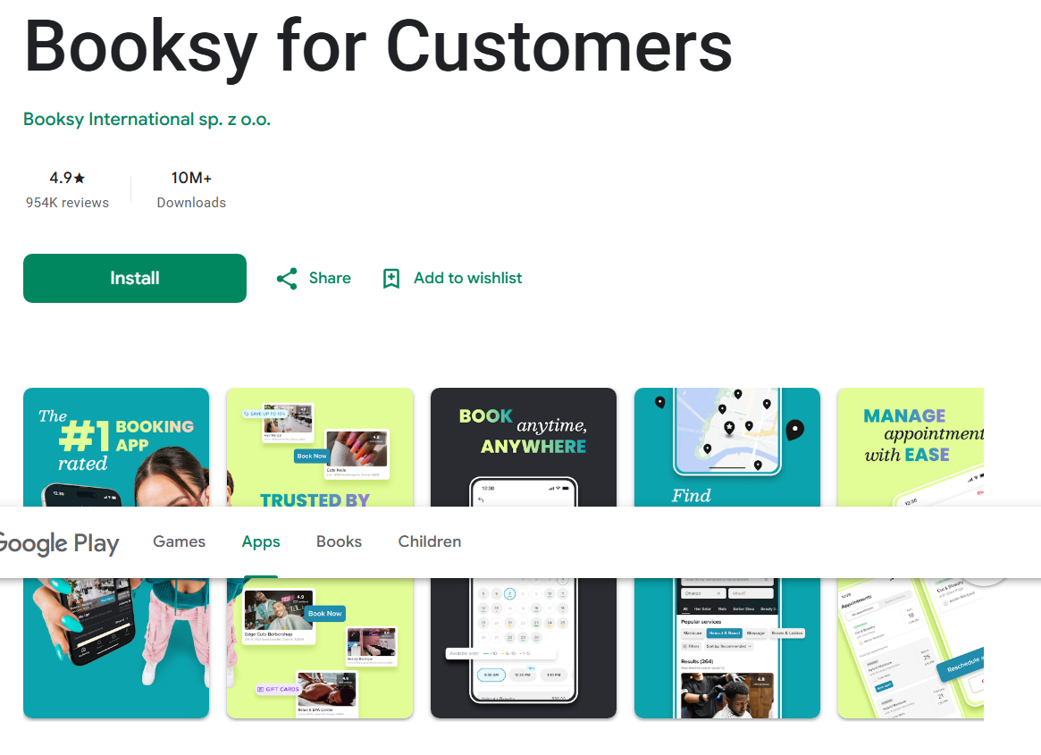
Flyers and business cards will also be placed within local gyms, barber shops and community centres to gain new customers were possible. However, word of mouth and customer recommendations will also be dependent upon.
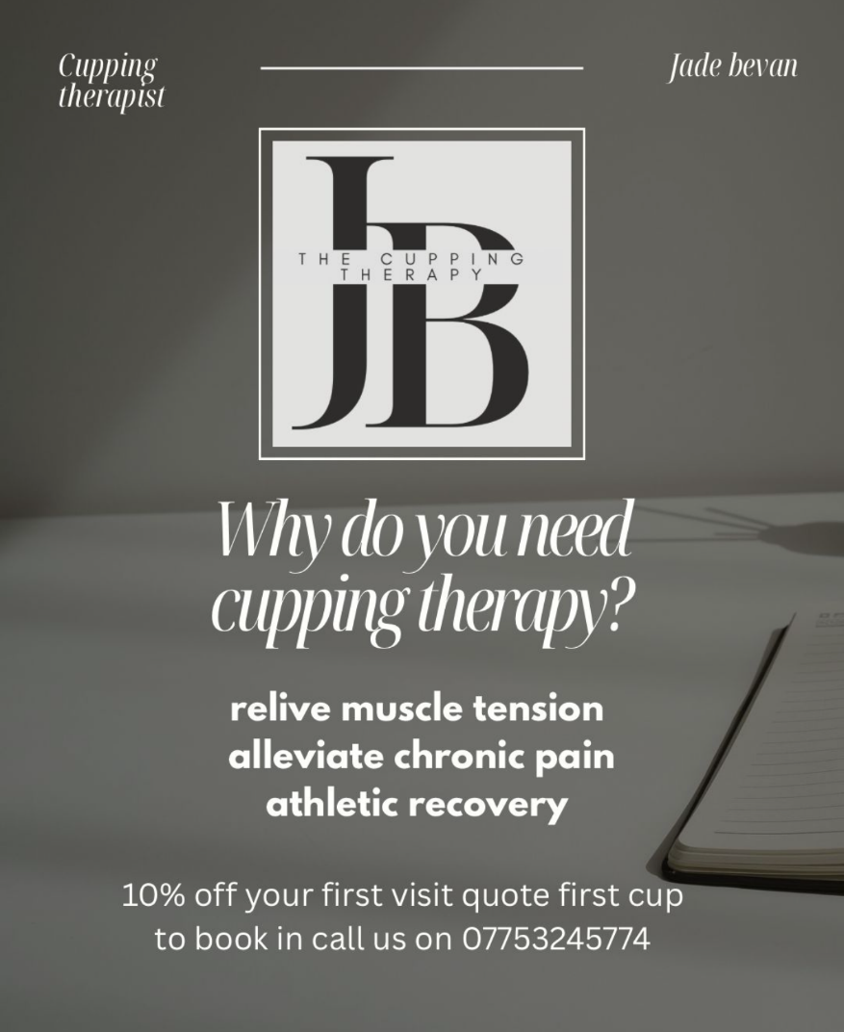

Pricing Strategy
The pricing strategy used for The Cupping Therapy will be penetration pricing. The services will initially be priced slightly lower than competitors within the local area to attract customers and build a good client base.
Research into competitors showed that cupping therapy services in the local area range between £50–£85 per session, with additional costs for home service (Corbin Chiropractic, 2026; The Recovery Room Cardiff, 2026)
Therefore, the business will offer competitive pricing while still maintaining professional quality services.
Services provided:
- Mobile home visit – 60 minutes – £70
- Additional charges for diet plan
- Additional travel charge of £1.50 per mile outside the 5-mile radius

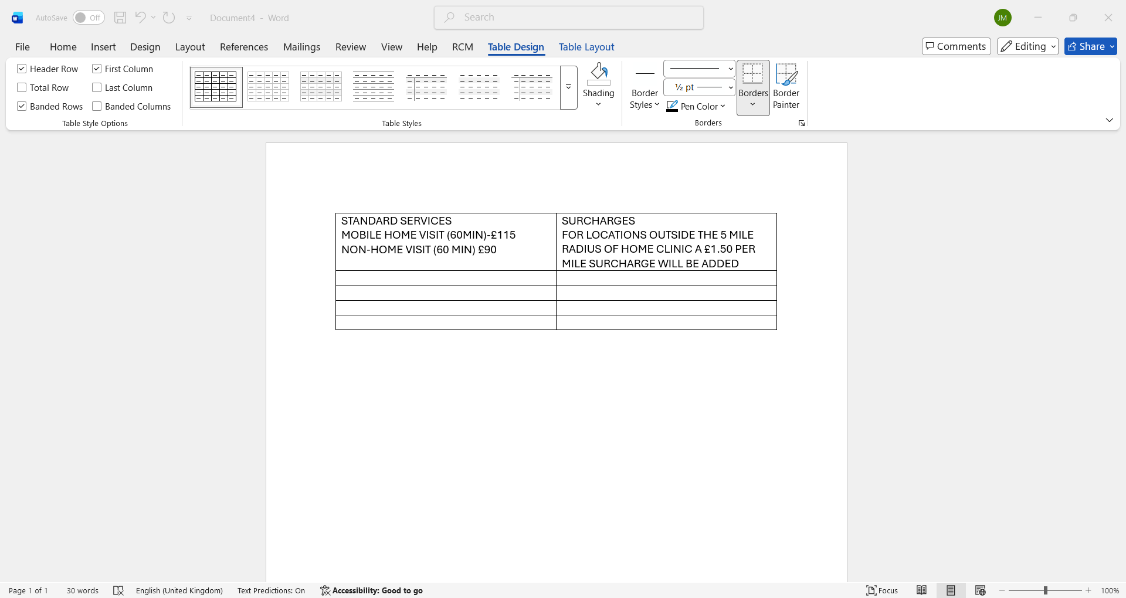

Market Research
Age range of potential customers interested in cupping therapy.

Cupping therapy has become more well known in recent years, partly due to its use by famous athletes and celebrities (Nash, 2026). For example, former Olympic swimmer Michael Phelps at the 2016 Rio Olympics had circular marks left by cupping therapy visible during competitions. This attracted significant media attention and increased public interest in the therapy. Following the event, Google Trends reported a large rise in online searches related to cupping therap#y (Lyons, 2016)

USP
Services are inclusive to everyone
Specializing in services that are different to competitors

Physical Location
The cupping therapy will be a home-based business offering therapy services from the comfort of the client’s own home.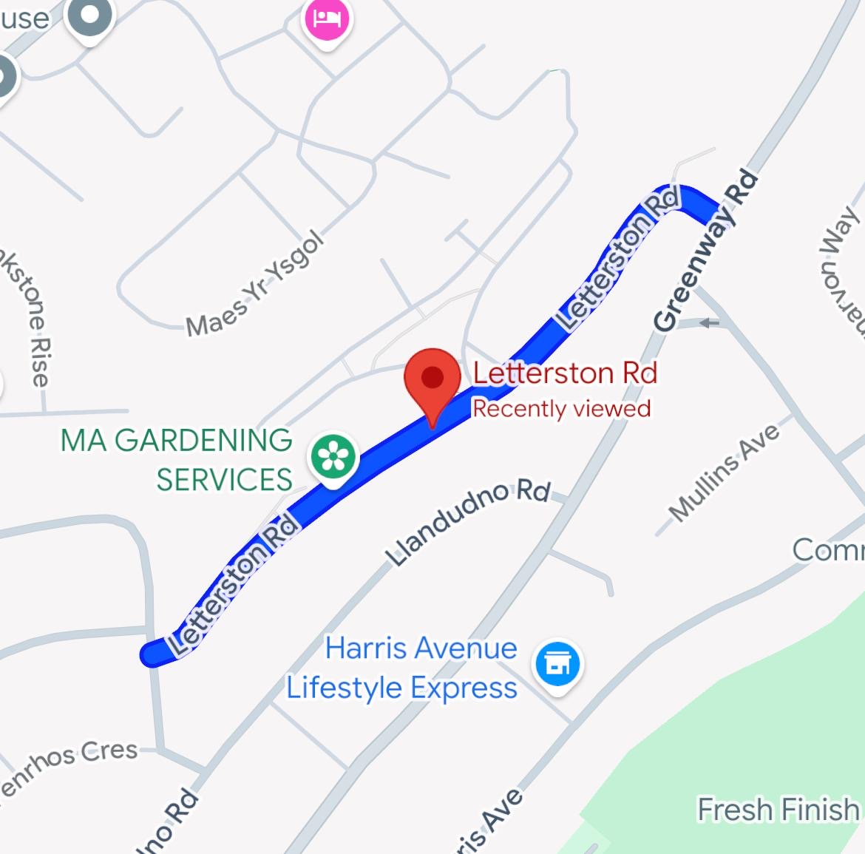
(See Appendix 1)

Human Resource Strategy
As The Cupping Therapy is operating as a sole trader business, I will be the only employee working within the company during the early stages. I will be responsible for appointments, customer service, marketing, finances and treatments.
To run the business professionally, I will ensure all qualifications and certificates are kept up to date, particularly regarding hygiene, health and safety and cupping therapy training.
If the business expands in the future, additional therapists or administrative staff may be recruited to help manage customer demand and business growth.

Finance and Costs
Breaking down the start-up cost helps with a realistic look at what the business needs to open.
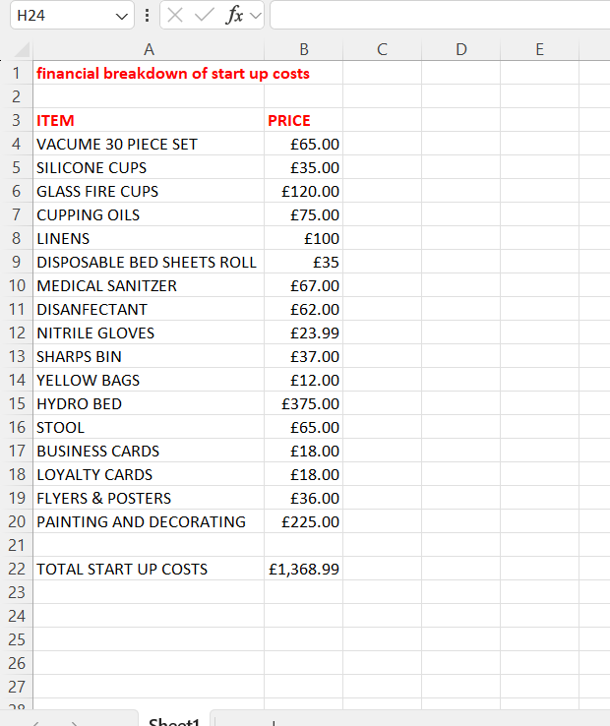
(Boogard, 2025). Explains how you can make spread sheets within excel.

Cash Flow Forecast
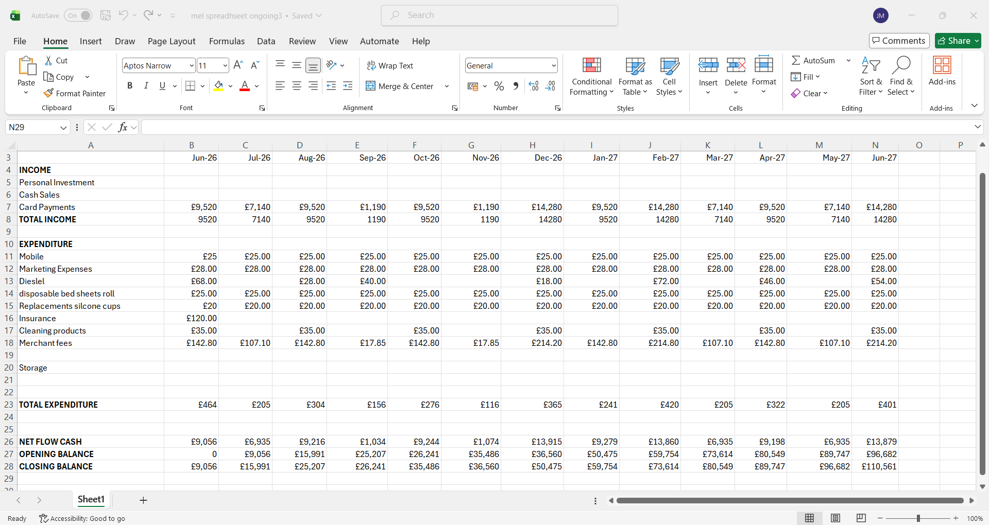

SWOT Analysis
Using the swot analysis helps to understand the areas of the business for the strengths, weaknesses, opportunities and threats. Phadermrod, “Et al” (2019).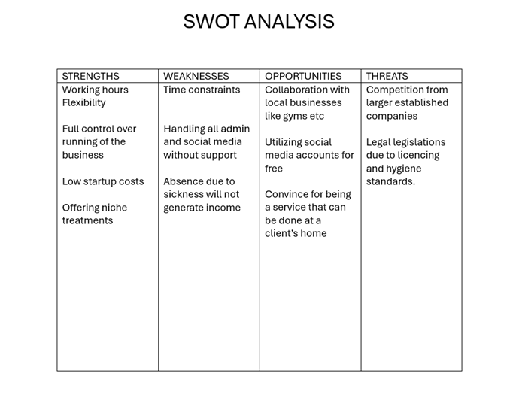
references
Boogard, K. (2025) 21 cool things you can make with excel other than spreadsheets. Available at: 21 Important Uses of Excel in Business | GoSkills
Corbin Chiropractic (2026). Corbin Chiropractic Cardiff Clinic. Available at: https://www.corbinchiropractic.co.uk/cuppingcardiff (Accessed: 13 June 2026)
DNA Accountant (no date) Sole Trader Advantages & Disadvantages. Available at: Sole Trader Advantages and Disadvantages | dns accountants (Accessed: 11 June 2026)
Gov,UK (“no date”). Available at: Become a sole trader: Register as a sole trader - GOV.UK Accessed 19 June 2026
Institute of Clinically Applied Holistic Therapy (2025). Origins of Cupping Therapy – Exploring the Ancient Art of Hijama Cupping: Benefits, Techniques, and Practices. Available at: Origins of Cupping Therapy - Exploring the Ancient Art of Hijama Cupping: Benefits, Techniques, and Practices (Accessed: 6 June 2026)
Lyons, K. (2016) ‘Interest in cupping therapy spikes after Michael Phelps gold win’, The Guardian, 8th August. Available at: https://www.theguardian.com/sport/2016/aug/08/cupping-therapy-interest-spikes-michael-phelps-rio-olympics (Accessed: 4 June 2026)
Milton, N. (2025). The Advantage and Disadvantages of Being a Sole Trader. Available at: https://www.bcu.ac.uk/business/blog/the-advantage-and-disadvantages-of-being-a-sole-trader (Accessed: 10 June 2026)
Meta (2021). Facebook. Available at: Facebook(accessed:19 June 2026).
Nash, L. (2026) Cupping Therapy: From Celebrities to Athletes, Why It's Gaining Popularity. Available at: Cupping Therapy: From Celebrities to Athletes, Why It's Gaining Popularity — Holistic Hummingbird (Accessed: 4 June 2026)

Shmerling, R.H. (2016). What exactly is cupping? Available at: https://www.health.harvard.edu/blog/what-exactly-is-cupping-201609301170 (Accessed: 6 June 2026)
Sina, R.E. and Bokhari, A.A. (2023) Cupping Therapy. Available at: https://www.ncbi.nlm.nih.gov/books/NBK538253/ (Accessed: 6 June 2026)
The Recovery Room Cardiff. (2026) About: The Recovery Room Cardiff - Sports Therapy, Rehabilitation & Recovery. Available at: https://recoveryroomcardiff.co.uk/ (Accessed: 13 June 2026)
UK Government (2026) What a sole trader is. Available at: Become a sole trader: What a sole trader is - GOV.UK (Accessed: 10 June 2026)
Phadermrod, B., Crowder, R., & Wills, G. B. (2019). Importance- performance Analysis based SWOT analysis. International journal of information management, 44, 194-203. Available at: Importance-Performance Analysis based SWOT analysis - ScienceDirect (Accessed: on 19 June).
Tiktok (2016). Available at: TikTok - Make Your Day Aceesed on: 19 june 2026.

Appendices
Appendix 1

Location

Part 2: Reflection

Throughout the lectures and while completing my business plan assessment, I have developed different new entrepreneurial skills and strengthened some existing ones. One of the most valuable skills I have learned is how to use Excel effectively. Before this module, I had very limited experience using Excel for business planning purposes. However, I now understand how to create and manage a cash flow forecast, calculate income and expenditure, and monitor opening and closing balances over a 12-month period. Learning how to organise financial information and automate calculations has helped me understand the financial side of running a business and the importance of budgeting and forecasting.
I have also gained a better understanding of how to create and what to include in a basic business plan, such as market research, setting out aims and objectives, and understanding the different types of legal identity of a business. I also developed my market research skills, and I now understand that to make a business feasible and maintainable, I need to look for what is already out there, identify customer needs and competitors.
I also learned how to create marketing materials, such as a leaflet and through research found a booking system for customer – the Booksy App, which seems straightforward and easy to use.
Personally, I would invest in my own business idea because market research showed that there is a gap in the local market for mobile cupping therapy services. There are very few cupping therapy services in my area, which creates an opportunity to attract customers.
Cupping therapy offers a wide range of benefits, including pain relief, muscle recovery, improved circulation, and support for overall wellbeing. These benefits make it appealing to a wide range of customers, particularly athletes and sportspeople who are looking for ways to improve recovery and performance and people from the Muslim community, where cupping is widely practised. I believe that positive customer experiences and word-of-mouth recommendations could help the business grow and attract additional clients over time.
Another reason I would invest in this business is the flexibility of the service. I plan to a mobile service where I travel to customers. This provides convenience and allows clients to receive treatment in the comfort of their own homes. I believe this flexibility gives the business a competitive advantage and increases its appeal to potential customers.
I already have extensive experience in sales and promotion from my previous work in sales and call centres. This experience helped me understand the importance of communication, customer service, and attracting potential clients.
Overall, I would be willing to invest in this business because I am passionate about the service, believe there is demand within the local market, and feel confident that the knowledge and skills I have gained during this module have prepared me to successfully plan and manage the business.

