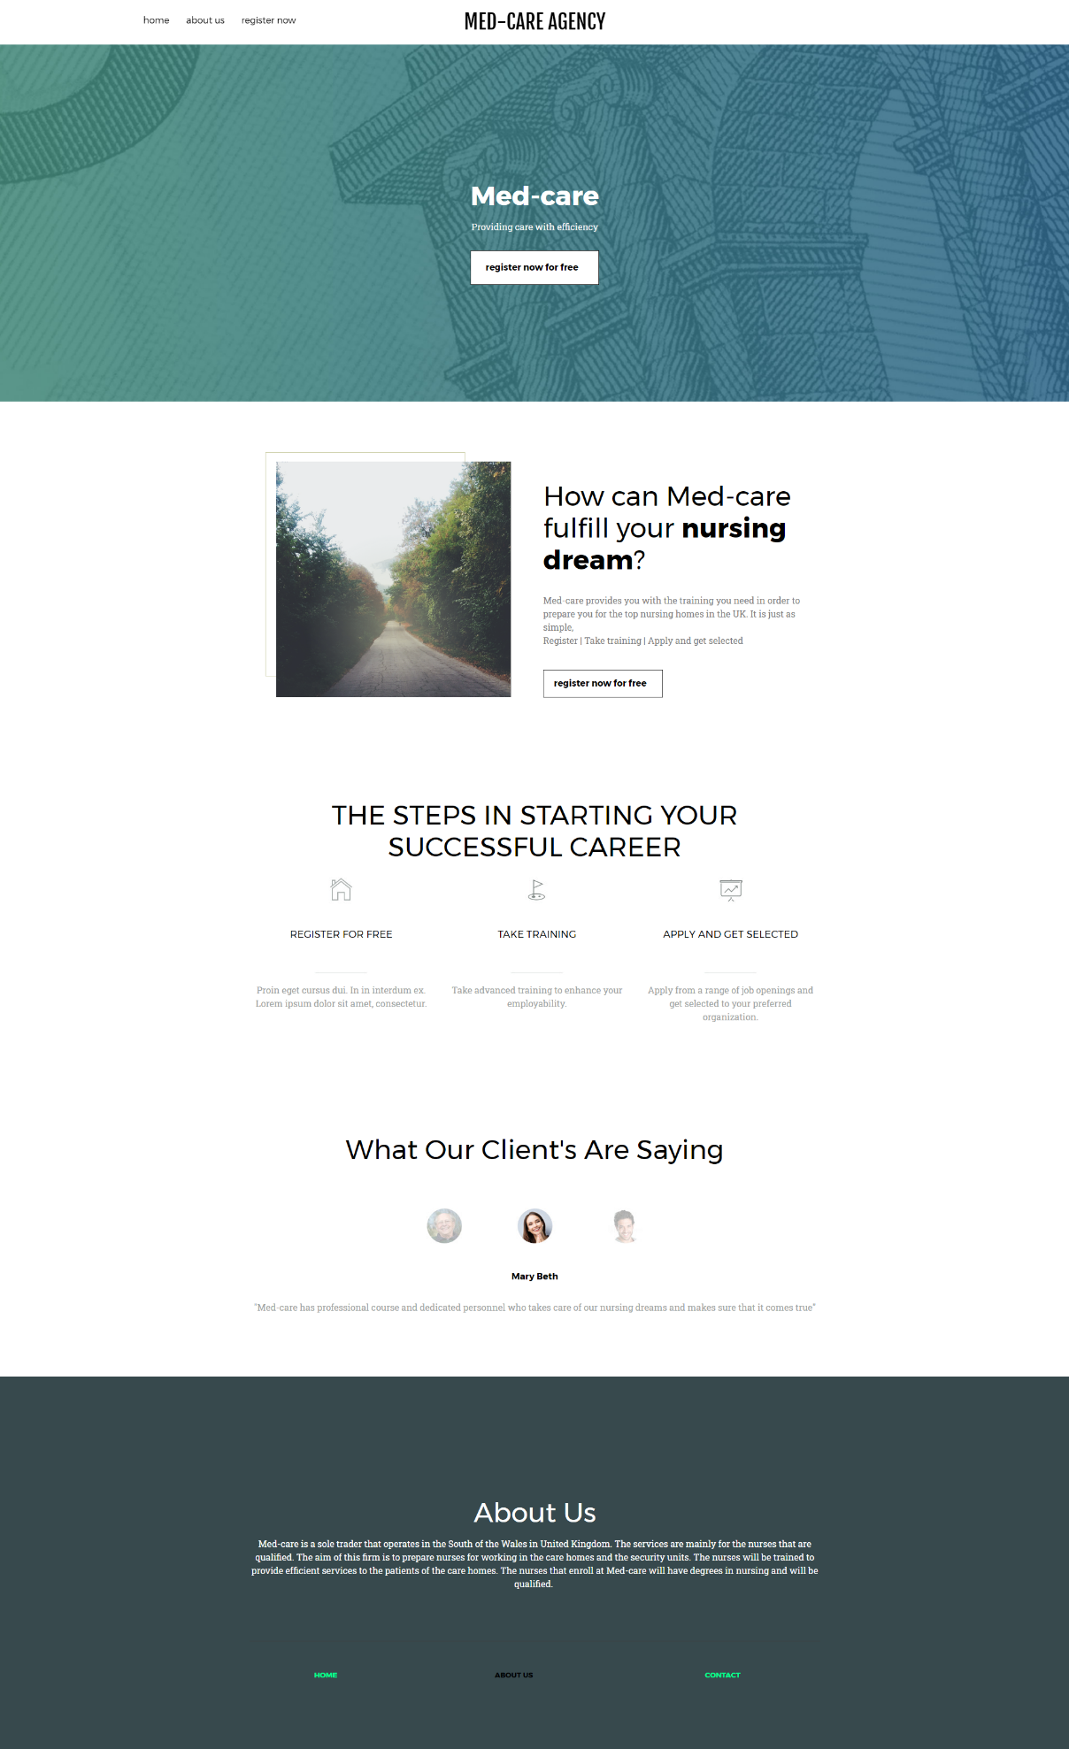

Website Weebly login details: 1908799DS@gmail.com
Password: diana3438

Considering the fact 70% of the respondents in my primary research believe that the nurses are not properly trained, the Med-care agency will be providing training facilities to the nurses in order to develop their skills further. The homepage of the website is divided into five sections, apart from the header and footer which includes the main body, the way Med-care helps the nurses, steps in the registration process, testimonial, and simple about us section.
The main body focuses on providing call-to-action, the mission statement, and the name of the organization in order to increase the awareness level.
The next section provides details on how Med-care can help the nurses in order to enhance their skills and abilities so that they can be recruited by the top nursing homes in the UK.
The next section outlines the steps in the process of the nurses to reach their dreams. Since the visual appeal is most important, excessive texts have not been used in this case so that the applicants do not get distracted in the website (Faisal, 2016).
It is apparent from the primary research that positive feedbacks are important from 80% of the respondents. Feedback systems increase trust among customers. As a result, the next section provides testimonials from the real customers so that others can see what level of services they have been able to gather from Med-care.
Finally, the about us section provides a brief description of the business and its features at the bottom of the website. Through this, the customers get an idea regarding what our business is about and what they can expect from the level of services that we offer.
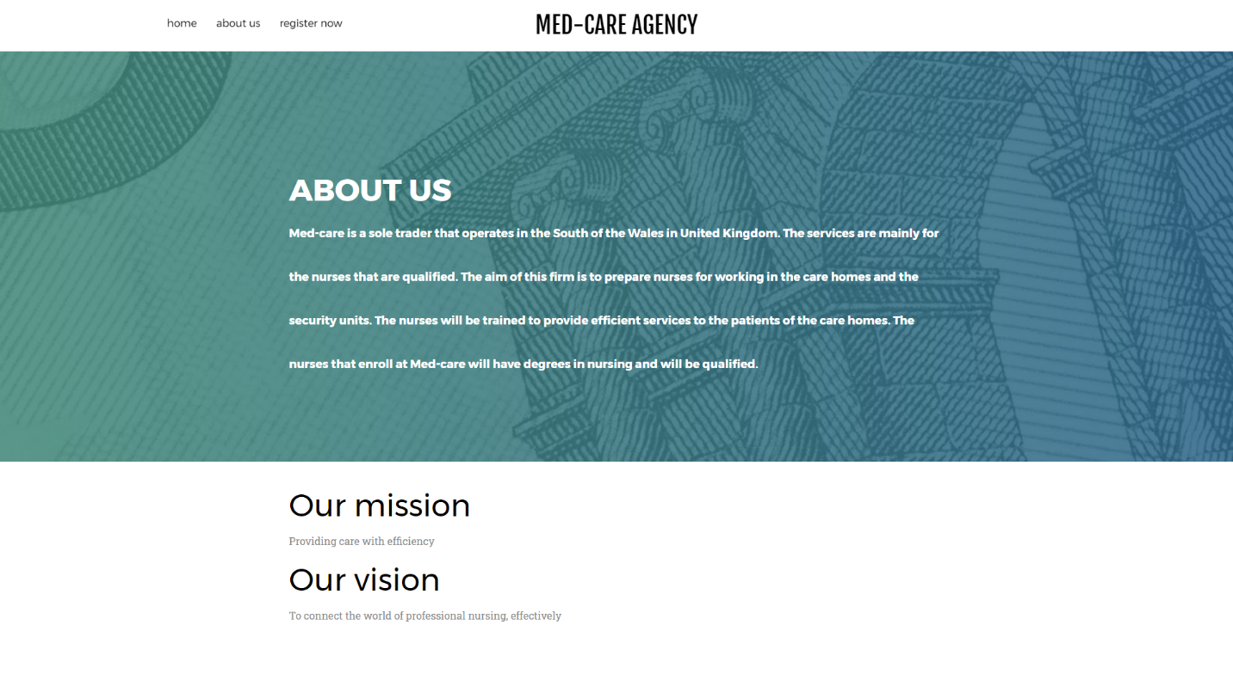
The about us page on the website is kept simple and related to the homepage so that the customers can relate the brand and the brand messages are consistent. The about us section also includes the mission and vision statement of the organization. This not only provides guidelines for the employees but also for the customers regarding what are values are, how we operate, and what type of impact we are willing to have on the society at large.
Where the mission statement defines the type of business an organization is currently operating, the vision statement defines how the organization will have a positive impact on the society in the future (Sanchez, 2017). Through the mission and vision statement communicated above for the customers, I have outlined what they can expect and how we are going to have an impact on society at large through our operations.

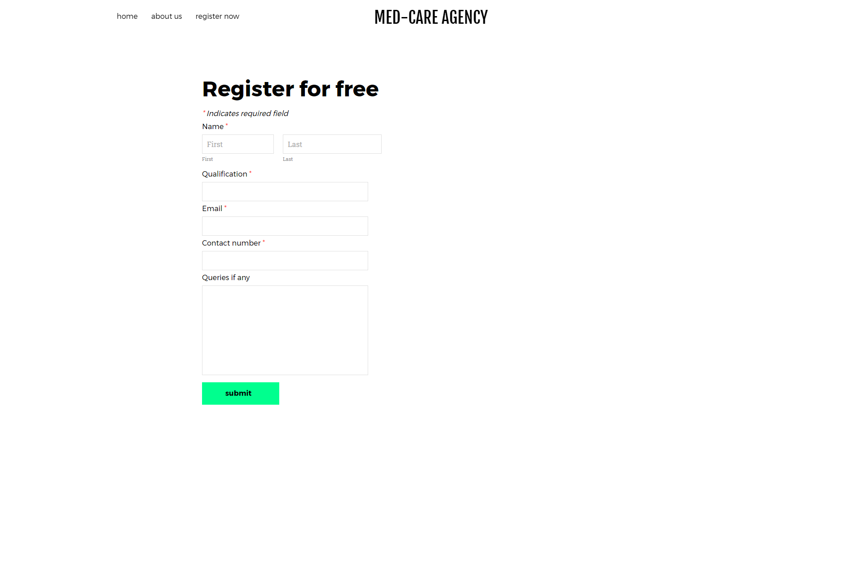
The final page is about registration. Since the key purpose of the website is to get nurses registered to the website, the buttons are included in every section on the website so that the visitors are encouraged to register. In the registration bar, contact details and qualifications are sought in order to contact later and train the nurses in order to get them ready for the job that is offered by the top-level nursing institutions in the UK.

Reference
Faisal, A., 2016. Marketing Strategies in Online/Digital Marketing. Account and Financial Management Journal,.
Sanchez, P., 2017. Refocusing Website Marketing. Health Marketing Quarterly, 20(1), pp.37-50.

