FUTURE DEVELOPMENTS IN THE FIELD OF MARKETING: A CASE STUDY ON STARBUCKS

Module: Managing Marketing Change
Module Code: BMMB7026
Student Name: MARSOOK KOTTADAN
Student ID: 2220272
Executive Summary
Identification of contemporary marketing strategies for executing future development in the competitive market is the fundamental goal of this report. In this regard, Starbucks and its marketing strategies are critically illustrated in this report to identify the current marketing changes. In this report, the critical assessment of the marketing activity of Starbucks is evaluated by following theoretical frameworks and several marketing models. On the other hand, the current change initiative and its benefits is rectified. Customer behaviour regarding the company is identified and a competitive scenario is also executed to understand the future possibilities for the marketing growth of Starbucks. Hence through this analysis, the current marketing strategies and the limitations are highlighted by following essential recommendations for future marketing growth.

Contents
Introduction 4
Task 1: Provide a critical evaluation of your chosen organization’s marketing activity 4
1.1. The concept and importance of marketing: invested resources in marketing 4
1.2. The macro and micro marketing environment that influence marketing strategy 6
1.3. Change management strategies 10
1.4. Target market for the organisation 12
1.5. Key channels of communication used for marketing 18
1.6. Measuring success of Starbucks 19
Task 2: Conclusion 23
Task 3: Recommendations 24
Reference 25

Introduction
The fundamental aim of these reports is to identify the marketing strategy for a specific organization to understand its competitiveness and the initiative for future development. Regarding this Starbucks is a selected company and the effective resources which are invested for marketing are evaluated in this report. The macro and micro business environment by following theoretical assessment is also included in this analysis to understand the contemporary marketing strategy of Starbucks. Change management strategies and the target market-based factors are also evaluated with a comparative assessment of the fundamental competitor of the organization. Finally, the matrix-based assessment is also included to understand its drawbacks and the strong points that are identified. The essential recommendations are also suggested in this report for Starbucks for future improvement of its marketing strategy.

Figure 1: Starbucks logo
(Source: Starbucks 2023)

Task 1: Provide a critical evaluation of your chosen organization’s marketing activity

1.1. The concept and importance of marketing: invested resources in marketing
The resources in marketing contribute an essential role in managing the operation management to achieve long-term revenue and profitability. Regarding days the significance of marketing for Starbucks is enhanced by the basic resource which is associated with the quality of coffee. The collaboration with local pharma for the authentic resource of coffee beans is the primary resource of Starbucks that helps to create a most embracing experience. The partners of Starbucks like the employees and the investors maintain the local culture which signifies the organization's marketing value for attracting the target market in the local level. Major investment is associated with the business partner of Starbucks such as the landlord, suppliers, the corporate authorities, and the authorities of food service (Sakunasingha et al. 2023). Regarding this, the support centre of the landlord invests in electronic fund transfer (EFT) to encourage the payment system that increases the networking of Starbucks. Besides that the suppliers of Starbucks successfully maintained the resource supply by 40 years enhancing the customer experience. Regarding this, the effective code of conduct and the security standard of the supply chain are maintained by Starbucks which helps to manage the diversification (Wicaksana et al. 2022). There are 250000 partners of Starbucks that provide a 401K program as a basic resource and invested one billion dollars for developing the industry benefits (Starbucks 2023). Additionally, in 2022 4.3 million bonus payment is also invested by the business partner of Starbucks from Africa, the Middle East, and Europe that provide hybrid work facilities and support programs for developing mobility (Starbucks 2023). As a result, Starbucks enhanced the period by $15 per hour and expanded they are partnership above 21 International markets (Starbucks 2023).
McKinsey 7-S Model
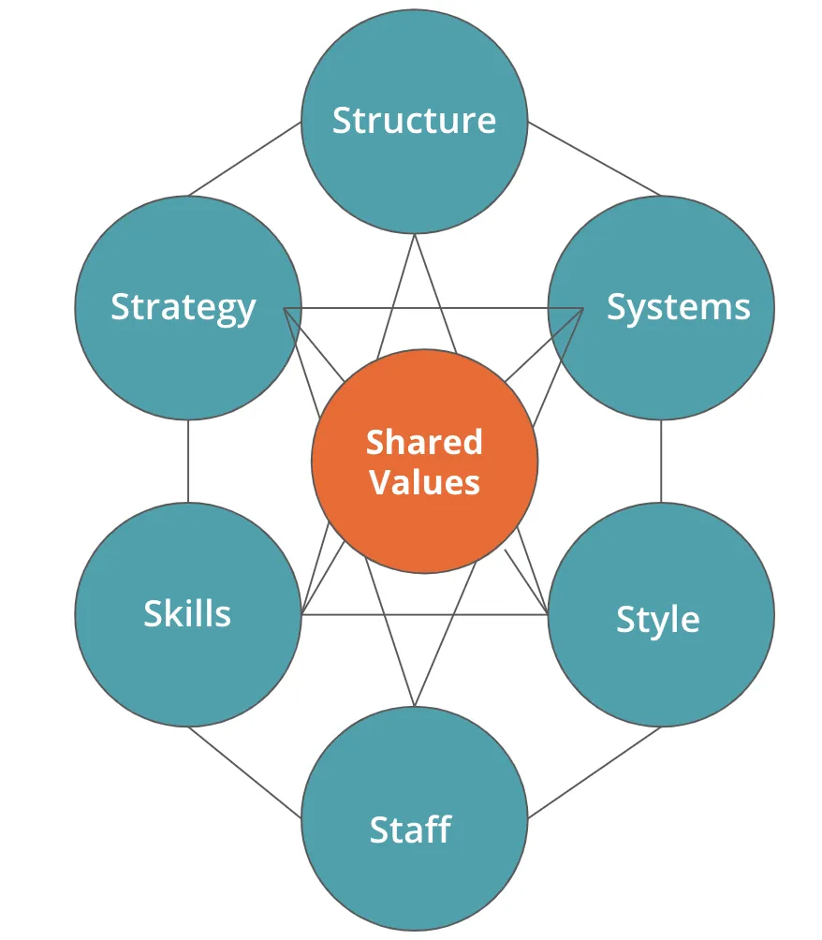
Figure 2: McKinsey 7-S Model
(Source: Corporatefinanceinstitute 2024)
The above figure represents the McKinney 7-S model that focuses on the shared value of an organization which is associated with the company's structure, system style, staff, skills, and strategy (Sumbane et al. 2023). This critical assessment of the model can identify the essential resources that support Starbucks in managing its marketing activity by the essential resources.
Starbucks follows a product-based company structure and there is a hierarchical order that manages the coordination with the employees for developing and distributing the resources. On the other hand, Charbagh follows the regulation of beverage retailing organizations that provide high-quality coffee and beverages. Starbucks also follows the system of a chain-based business model that manages the revenue and sales to ensure finance-based resources (Berg et al. 2021). Starbucks's business style is associated with collaborating with the landlord to achieve royalty. Additionally focusing on the cultural essence of coffee is another style of Starbucks for utilizing the resources to connect with the target market at the local level. In the context of staff, there are more than 402000 employees present in Starbucks all over the world who are the fundamental human resources of the company that provides quality service to the target market. The skill to operate all the machines and automated services enhances the digitalization service of Starbucks and increases customer service. Starbucks adopts the strategy of merchandise for selling high-quality coffee to consumers (Abuabara et al. 2019). Developing an international-level coffee chain is a fundamental strategy of Starbucks that increases the number of operated stores in the company. As a result within a short time, Starbucks enhanced its social impact by connecting with business partners.

1.2. The macro and micro marketing environment that influence marketing strategy
Micro marketing environment
SWOT analysis

Figure 3: SWOT analysis
(Source: Cottgroup 2022)
Strengths
The fundamental strength of Starbucks is comprehensiveness which enhanced 58% employee turnover in 2023. In 2023 Starbucks achieved 29462.3-million-dollar revenue which is utilized for operation management and service quality to enhance the target market and Business expansion (Starbucks 2023b).
Weakness
The fundamental weakness of Starbucks is the excessive market competition which reduced more than 70% profitability from the previous year and failed to manage the effective product distributions. Therefore, the target market complaints regarding the structure in process and operation management of Starbucks.
Opportunities
Effective collaboration with business partners is the basic source of opportunity for Starbucks to enhance its financial achievement. The strategic training program for employees 10 development is another opportunity for Starbucks and the company invested 1 billion dollars on it to rejuvenate the market reputation (Starbucks 2023b).
Threats
Increasing the organization's expenses is a threat to Starbucks which fail to manage resource utilization. As a result in 2023 1823.4-million-dollar operating loss is recorded for Starbucks (Starbucks 2023b). Besides that, the high price of the product increases the obligations from the customer site which is another serious threat to the organization.
Macro marketing environment
PESTLE analysis
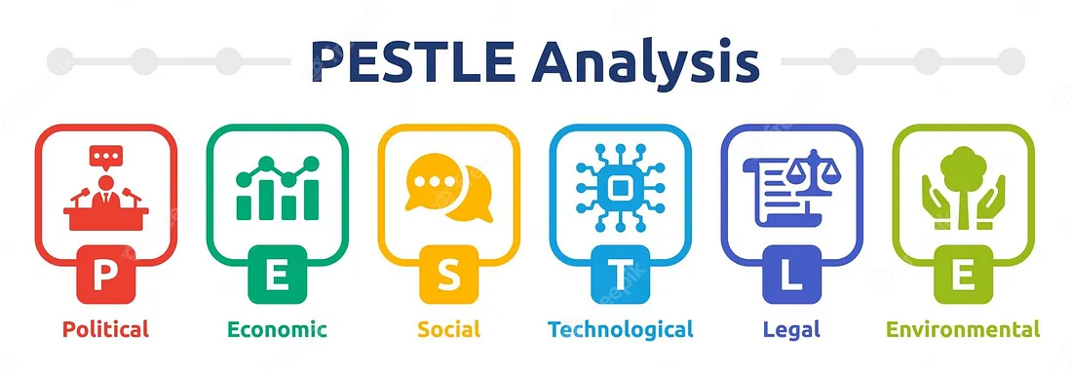
Figure 4: PESTLE analysis
(Source: Mukherjee 2023)
Political | Starbucks is a United States-based company and it focuses on the tax policies to achieve good revenue (Rooney et al. 2020). Regarding this in the United States due to the existence of the 2 political right index and -0.04 political index, the political stability executes, and the direct investment enhance the chance for Business expansion in several countries for Starbucks (Theglobaleconomy 2024). | High
Economical | In the context of the economy, the United States is the largest economic nation as the GDP growth is 2.90% and 3.27% low inflation it supports official collaboration with multinational enterprises (Theglobaleconomy 2024). As a result, Starbucks enhanced its revenue by 26569.6 million dollars in the context of product segmentation with 100% profitability (Starbucks 2023b). | High
Social | In the United States society is associated with modernization and more than 300 million population and 83.08% urban population prefer diversification and inclusiveness (Theglobaleconomy 2024). Hence its wide range of product services of Starbucks has successfully achieved product appreciation from the huge customer background of the nation (Isbandi and Handayani, 2020). | Moderate
Technological | The USA executes 9.07% of technological exports and 61.08-unit high innovation index supports technological upgradation (Theglobaleconomy 2024). In contacts of technology, Starbucks implements the smart machinery and artificial intelligence in every store for faster service execution. As a result, 92% engagement of society by effective technology enhancement is recorded in 2023 (Starbucks 2023c). | Moderate
Environmental | In the USA 13.03 metric tons Co2 is emitted and 11.16% of alternative energy is used for environmental stability in USA (Theglobaleconomy 2024). Starbucks reduced greenhouse emissions by 50% to support the climate and also reduced the use of water by 50% (Starbucks 2023c). The company focused on executing sustainable development goals in 2030 to support the environment and increase its marketing reputation (Starbucks 2023c). | Low
Legal | 5.38% effective polity rate in USA maintains the legal stability and the 1.37-unit Law index sustain legal structure (Theglobaleconomy 2024). Starbucks implemented the “Security Exchange Act” and the “Inflation Reduction Act” in 2022 manage the marketing security and regulation that helps to reform the organization's stability (Starbucks 2023). | Moderate
Table 1: PESTLE analysis
(Source: Self-Developed)

1.3. Change management strategies
The fundamental change management strategy of Starbucks is available at the highest rate of investment from the business partners to enhance resource utilization. On the other hand execution of transformational leadership is another strategy of Starbucks that increases the dignity and trust of the organization (Ibrahim et al. 2023). Restructure in the existing program executes effective commitment to the target community and that ensures business transparency at the international level. In 2022 Starbucks developed the initiative to increase the global level reputation that helps to manage community demand and loyalty. Adopting several resilient programs to increase the service of coffee is another creativity-based change of Starbucks that enhances the organization's quality. On the other hand, Starbucks implemented a “Starbucks college achievement plan (SCAP)” in 2022 that helps to associate 23000 partners and 2150 young generations increasing the unity and business agile team (Starbucks 2023b). Currently, Starbucks also focuses on healthcare-inclusiveness which is a positive change for developing the individual consumer's wellness in every location.
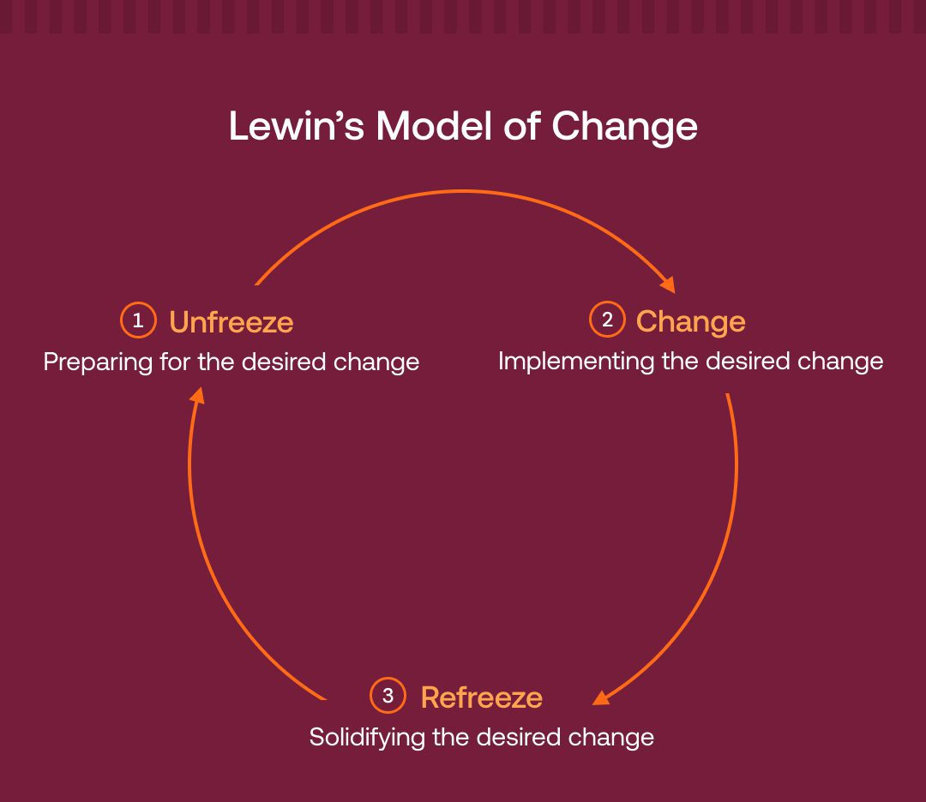
Figure 5: Change management model of Lewin
(Source: Whatfix 2024)
The above figure represents a change management model of Lewin associated with three fundamental stages. Initially unfreezing of the existing situation takes place. Regarding these Starbucks initially looked after the challenges of operational management that was emerging as a continuous threat to profitability (Cone, and Unni, 2020). After that, the company focuses on restructuring in and reinforcing the management by collaborating with stakeholders and business partners. In the second stage of this change management model executing of positive change by adopting several action plans and financial investment occurs (Musungwini and Mondo, 2019). Regarding this, Starbucks adopted the Starbucks college achievement plan in 2022 for connecting with the target youth. Finally, referee the situation is the third stage of the change management model that manifests the positive change and successful implementation of the newly established operation. As a result, Starbucks adopted the inflation deduction action in 2022 which helps to reduce the excessive market expenses.
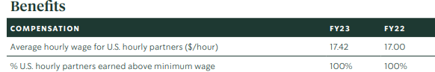
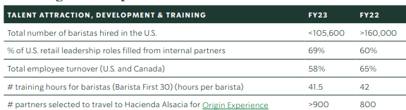
Figure 6: Impact of the change in Starbucks
(Source: Starbucks 2023c)
The above figure represents that due to the positive change in Starbucks, the hourly wage increases to 17.42 per hour, and 100% minimization of the wages of partners arises as a benefit in Starbucks. Additionally, the hiring process increases and the leadership roles are also optimized by 69% as an outcome of The change management that ensures a 58% positive turnover of the employees (Starbucks 2023c).

1.4. Target market for the organisation
Starbucks is highly famous for its coffee and variety of beverages which are highly demanded by the modern generation, especially in the urban area (Xiang et al. 2023). Quality coffee and authentic flavour hitting the target market satisfaction helps to generate a worldwide target market for Starbucks. As a result, Starbucks achieved 24.6 billion dollars in revenue in 2021 (Start 2022). Mostly the most urbanized and educated population are highly attracted to the products of Starbucks. In most of the cases 20 to 60-year-old population is highly attracted to the coffee of Starbucks which helps them to relax from the daily work pressure and refreshments (Start 2022).

 | Isebella Jones
Age: 26
Address: Washington
Occupation: Marketing Manager
Monthly income: 10,000 $
Status: Single
“Bing a marketing handling the work pressure is a daily life story, therefore I prefer to have coffee from Starbucks to become refresh and that enhance my strength of working.”
PERSONALITY TRAITS  - Leadership  - Explorative | GOALS  - Hard-working  - Traveling  - Dealing the clients
PREFERRED BRANDS  - Starbucks  - McDonald's  - KFC | FRUSTRATIONS  - Work pressure  - Increasing expenses
Table 2: Consumer Persona
(Source: Self-developed)
The above consumer person represents that the young customer of Starbucks highly prefers coffee to release hard stress from daily life. Additionally, the monthly income represents the affordability of Starbucks which is another fact of attracting the target market.
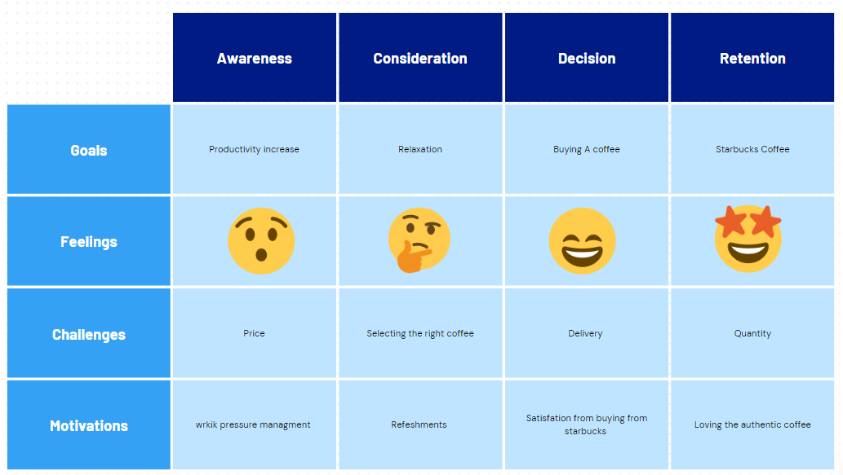
Figure 7: customer journey map
(Source: Self-developed)
The above customer journey map represents that the strategy to buy a coffee is associated with the necessary increase in productivity and relaxation level. Through having the coffee from Starbucks, the customer represents their satisfaction of refreshment that helps to manage their daily work pressure. Product authentication is also effective however the price is not sometimes suited for every consumer.
Segmentation, targeting, differentiation, and positioning
Segmentation
The segmentation of the market for Starbucks is associated with several categories such as demographics, behaviour, and psychographics. The demographic segmentation of the target customers is associated with the age group of 20 to 60 years old (Start. 2022). Additionally, the middle-income group to the high-income group is another demographic characteristic of the segmented market. In most cases, the customers of Starbucks are single, working, newly married, or belong to the young generation and upper class. The geographic segmentation for Starbucks is associated with the developed and urban region (Chibba, and Luiz, 2021). Above 3000 locations in America, Europe, the Middle East, Africa, China, Asia, and other continents are highly preferred by the product of Starbucks (Chuan 2019). The psychographic segmentation is associated with increasing the awareness and productivity by the coffee of Starbucks mostly preferred by customers. The behaviour segmentation of Starbucks products is associated with the rapid pickup of coffee in Suburban areas. The young generation mostly order from online from the mobile which is a contemporary trend of behaviour for Starbucks.
Targeting
The target market of Starbucks is associated with an increasing rate of sales in recent years. Due to the huge market demand for coffee, the sales of beverages of Starbucks increased by above 18 billion dollars. As a result, global networking optimized and that will result in above 5 billion dollars in profit in 2021. In most of the cases, Starbuck fundamentals target the highest investor-based organizations associated with above 90000 earnings. Starbucks mostly targets busy urban areas therefore it opens stores near gyms, shopping malls, children's centres, and others (You and Zhang, 2022). Technology investment and association of artificial intelligence and Wi-Fi facilities are also established in the Starbucks stores to attract and target consumers. The health consciousness is also activated in Starbucks and for that maintenance of freshness is also added to the beverage menu (Park 2019).
Positioning
In the context of Market positioning Starbucks adopts a strategy for international expansion and a unique Identity of the coffee stores is established to enhance its brand reputation. Maintenance of authentication of labour and the Aroma of coffee is another strategy for maintaining the brand positioning of Starbucks (Manolica et al. 2020). Quality as well as consistency also attract a strong market position. The continuous change of menu and arrangement of at comfortable and cozy atmosphere in the coffee shop ensure customer satisfaction which helps to position the brand for a long time. Targeting and satisfying the premium customers by providing extra gifts is a fundamental strategy of Starbucks.
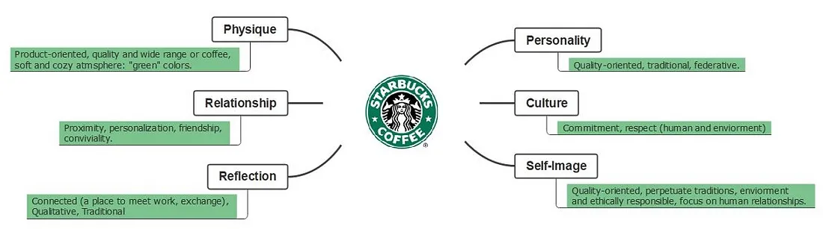
Figure 8: strategies to maintain the Market positioning of Starbucks
(Source: Srikanth 2023)
The above figure represents that the product-oriented marketing initiative and developing the relationship with customers enhance the personality of the brand. Focusing and individual culture by committing to the local population also enhances its reliability. Developing a self-image by providing a traditional and comfortable environment to the customers also helps to maintain the brand position (Otterbring et al. 2021).
Differentiation
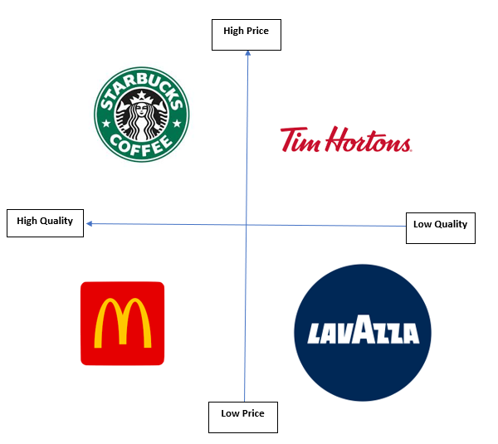
Figure 9: Positioning map
(Source: Self-developed)
The above figure represents the positioning map of Starbucks. As per the figure, Starbucks product belongs to the high price and high-quality segment. On the other hand, McDonald's is the primary competitor of Starbucks that ensure high-quality products in comparatively low prices. Tim Horton and Lavazza are the least competitors of Starbucks that fail to offer effective quality beverages as compared to Starbucks. On the other hand, Tim Horton also offers high price-based products (Bryan, and Barber, 2021). Therefore it can be stated that Starbucks' highest competitor is McDonald's and after that, the second competitor is Tim Hortons. On the other hand, it can be stated that Starbucks needs to focus on its pricing structure to increase its affordability as compared to its competitors.
The marketing mix
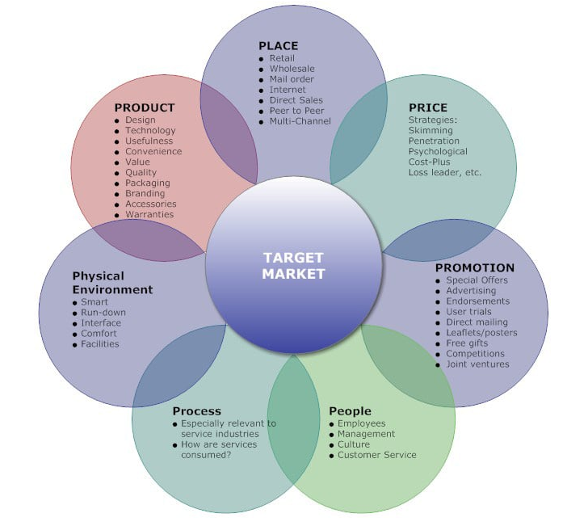
Figure 10: 7p marketing mix
(Source: Sramkowski 2021)
The above figure represents the 7p marketing mix model which is associated with product, place, price, promotion, people, process, and physical environment (Ho et al. 2022).
Product: Regarding this, the fundamental product of Starbucks is the coffee. Intercity coffee attracts a huge market.
Place: Starbucks is associated with more than 40 places all over the world. There are more than 38000 locations in the world that is acquired by the company successfully (Statista 2023).
Price: The price of the product is sometimes high however Starbucks focuses on affordability.
Promotion: Promoting the product of Starbucks by online marketing and social media collaboration is implemented. As a result, Starbucks achieve 25 million website visit n 2024 (Similarweb 2024).
People: More than 300 million population is associated with Starbucks in the context of employees and customers (Theglobaleconomy 2024).
Process: On the other hand, the effective product-based process and smart initiative for managing the business help to target the consumers (Suyanto, and Dewi, 2023).
Physical evidence: Starbucks achieved 29462.3 million dollars in revenue and 58% positive employee turnover in the competitive market which justified the growth of the marketing strategy of the company (Starbucks 2023b).

1.5. Key channels of communication used for marketing
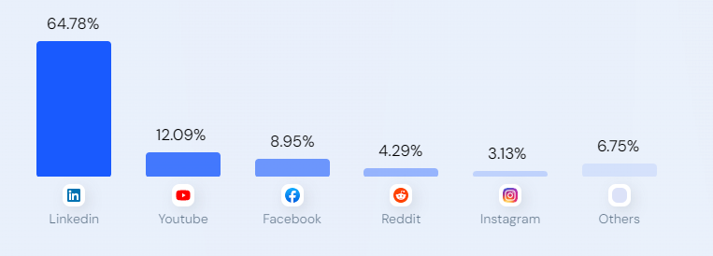
Figure 11: Communication media for marketing in Starbucks
(Source: Similarweb 2024)
The above graph shows that Starbucks avail the social media like LinkedIn, YouTube, and Facebook highly to communicate with the target market. Starbucks uses the accessibility of LinkedIn by 64.78% and Starbucks uses YouTube by 12.09% to enhance consumer networking (Similarweb 2024). On the other hand in Instagram Starbucks ensures 3.13% of channelling and in other social media platforms 6.75% of networking is established by Starbucks. Therefore Starbucks mostly avail the social media for networking to enhance the target market community (Similarweb 2024). As a result, Starbucks ensure 25.4 million online page visit frequency by assuring rank 7 in the international level. Therefore it can be stated that for enhancing the website traffic Starbucks uses specific media and social media challenges to enhance the interaction with the consumers. Social media collaboration to enhance the band reputation in the target market is another reason for selecting the social media marketing which enhances 50% of marketing growth (Similarweb 2024).

1.6. Measuring success of Starbucks
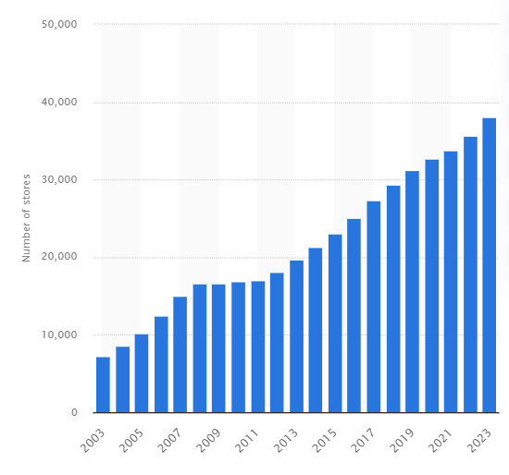
Figure 12: increase of Starbucks location
(Source: Statista 2024)
The above graph shows that from 2003 to 2023 there are 38038 stores that have increased in the international level. On the other hand within the last 20 years, the huge growth of the market represents the high growth matrix. As a result, Starbucks achieved 932.1 billion dollars in revenue in 2023 that justifies is growth measurement (Statista 2024).
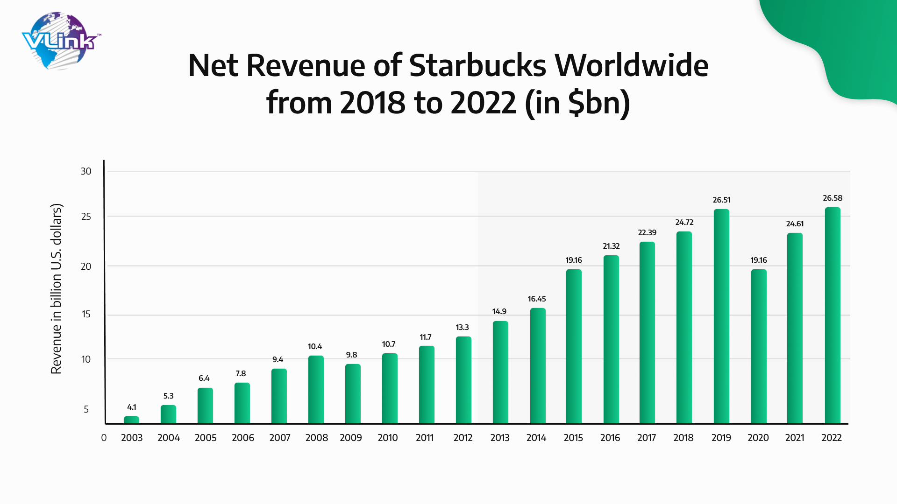
Figure 13: Growth of revenue of Starbucks
(Source: Gardner 2023)
The above figure represents that from the year 2003 to 2022 a continuous both of revenue is achieved by Starbucks. In 2003 4.3 billion in revenue was achieved and in 20226.58-billion-dollar revenue was achieved by Starbucks which also justifies the measurement growth (Gardner 2023). Research shows that the modern generation prefers Starbucks by 24% and the older generation also prefers 40% of this company's service which is the fundamental reason behind this rapid growth and long-term profitability (Gardner 2023). Almost 8.5 million population regularly use Starbucks to order several beverages including coffee which justify the positive customer experience and the strategy to increase the target market engagement (Gardner 2023).
Effectiveness of Marketing Strategy
VRIO analysis
Actions | Valuable | Rare | Inimitable | Organization
Pricing strategy | Yes | Yes | No | Yes
Product Quality | Yes | Yes | Yes | Yes
Customer engagement strategy | Yes | No | No | Yes
Promotional strategy | Yes | Yes | Yes | Yes
Table 3: VRIO analysis
(Source: Self-developed)
The above table represents the VRIO analysis where the valuable, rare, inimitable, and organization factors are measured. The four basic actions are analysed of Starbucks based on its valuability, prayer, and inimitable aspects that impact on organization quality. The first action is the pricing strategy and after that, the product quality is measured. The customer engagement and promotional strategies are also analysed in this table to understand the competitiveness of the company.
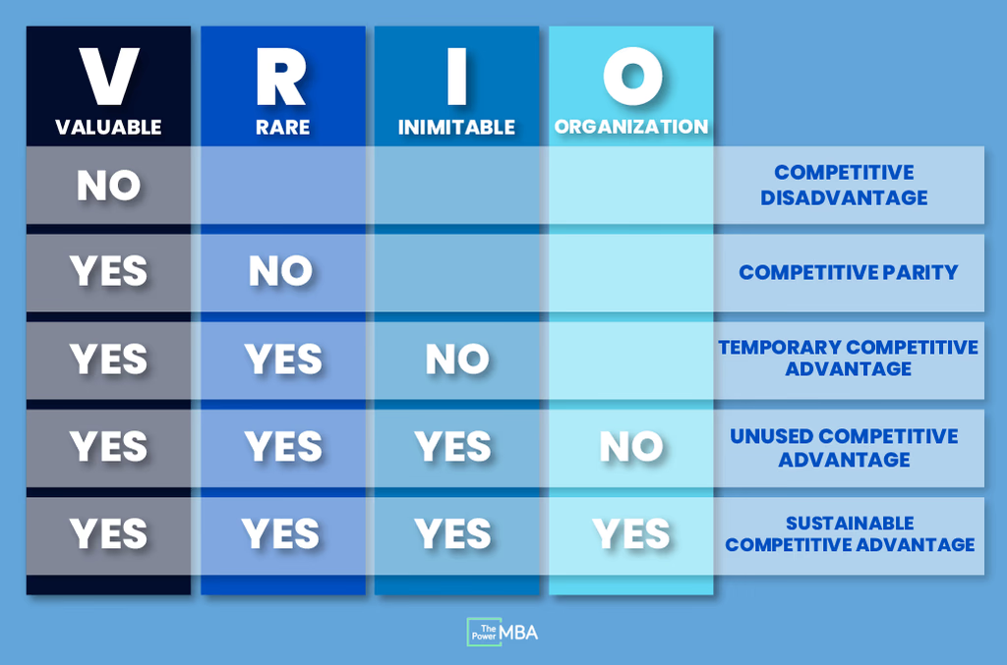
Figure 14: VRIO categories
(Source: Raca 2021)
The above figure represents the different categories of VRIO analysis. Previous VRIO analysis table the pricing strategy is valuable rare and organised but it is not inimitable. Therefore as per the category list it is belongs to a temporary competitive advantage which means Starbucks needs to focus on its pricing strategy to enhance its uniqueness in the competitive market. The product quality is highly valuable, rare inimitable and organized. Therefore product quality belongs to the sustainable competitive advantage that ensures a balanced marketing initiative of Starbucks that successfully achieves continuous revenue from the target market (Chibba, and Luiz, 2021). On the other hand, the customer engagement strategy is only valuable and organized. However, this engagement strategy is not rare therefore it is parity competitive which needs to be refocused by the organization to enhance the optimum marketing reputation as compared to its competitors. Additionally, the social media channel initiative to enhance the customer engagement also need to be re-focused for Starbucks to enhance its unique characteristics for a long time. Finally, the promotional strategy also belongs to sustainable competitive advantage as it is effective in all the categories of VRIO analysis (Pacevičiūtė and Razbadauskaitė, 2023). As a result, Starbucks has successfully enhanced is marketing expansion by over 300 million population (Starbucks 2023). Hence it can be stated that the marketing strategy of Starbucks is effective in the context of product quality maintenance and promotional strategy. Additionally, the pricing strategy and customer engagement initiative need to be re devil up to ensure optimum effectiveness.

Task 2: Conclusion
Based on the above discussion it can be concluded that Starbucks is an international organization and it focuses on target market expansion and continues revenue generation. However, due to the extreme market competition, Starbucks is suffering from several operating laws in the contemporary year. Besides that, the increasing expenses also result in an insignificant customer engagement initiative and which impacts on the pricing strategy. However, Starbucks focuses on affordability but sometimes the price of the beverages is extremely high for the young generation. Even after these consequences Starbucks successfully enhanced its promotional strategy and increased its product quality and authentication in several international locations. As a result, a huge target market appreciation is resulted in Starbucks within the last 10 years. The continuous revenue growth and increase of locations in several countries evidence the popularity and strong Market positioning as compared to its competitors. Therefore, it can be dated that Starbucks needs to focus on its resource utilisation to reduce internal and external expenses so that it can lead in the market competitiveness by availing the highest marketing strategy.

Task 3: Recommendations
Development of a digital marketing initiative
The optimum utilization of digital marketing needs to be executed by Starbucks to enhance customer engagement more rapidly. The strategy to increase digital marketing is to enhance the social media posts and activity on Facebook and Instagram (Balli 2023). Additionally for targeting premium customer posting on social media by an official tag also can increase the strategy of digital marketing to enhance the target market engagement more effectively. The strategy also can develop the target market's trust and also can enhance the social reputation.
Availing renewable energy to reduce marketing expenses
The used energy for operating the mechanism of the individual Starbucks store needs to be utilized from renewable energy sources to reduce marketing expenses (Laur, and Berntzen, 2023). Self-dependency for developing renewable energy is the basic strategy to reduce the extra cost for declining the scope of operating loss. Besides that for developing the sustainability concerns to attract the target market, this recommendation is effective as well.
Optimizing the dependency on artificial intelligence to reduce the human capital resource
Optimum use of artificial intelligence can reduce the extra cost of employees in the Starbucks store which is another strategy to reduce the internal expenses and the probability of operating costs which are the major consequences of the organization (Yathiraju et al. 2023). The automated and machine learning-based services by AI in Starbucks stores can increase the market engagement with target customers as a symbol of attraction and modernization. Hence AI can increase the profitability in long term by developing the market reputation and marketing strategy.

Reference
Abuabara, L., Paucar-Caceres, A. and Burrowes-Cromwell, T. (2019) ‘Consumers’ values and behaviour in the Brazilian coffee-in-capsules market: promoting circular economy’, International Journal of Production Research, 57(23), pp. 7269–7288. doi:10.1080/00207543.2019.1629664.
Balli, A. (2023) ‘The Effect of Consumers’ Competence in Using Digital Marketing Tools on Digital Product Perceptions’, Journal of Yaşar University / Yaşar Üniversitesi E-Dergisi, 18(72), pp. 495–525. doi:10.19168/jyasar.1279870.
Berg, J.B. et al. (2021) ‘Reconfiguring the construction value chain: analysing key sources of friction in the business model archetypes of AEC companies in strategic partnerships’, Construction Management & Economics, 39(6), pp. 533–548. doi:10.1080/01446193.2021.1925134.
Bryan, C. and Barber, P.G. (2021) ‘Parsing the mobilities of capital and labour: The case of Tim Hortons and internationally mobile Filipino workers’, International Migration, 59(2), pp. 72–88. doi:10.1111/imig.12826.
Chibba, M. and Luiz, J.M. (2021) ‘The Convergence of Business and Economics Principles: The Case of Starbucks’, World Economics, 22(3), pp. 141–156. Available at: https://research.ebsco.com/linkprocessor/plink?id=efc9d883-d978-35eb-b772-0dcc0e76ad42 (Accessed: 7 July 2024).
Chuang Hui-Jung (2019) ‘Starbucks in the World’, Holistica, 10(3), pp. 99–110. doi:10.2478/hjbpa-2019-0031.
Cone, C. and Unni, E. (2020) ‘Achieving consensus using a modified Delphi Technique embedded in Lewin’s change management model designed to improve faculty satisfaction in a pharmacy school’, Research in social & administrative pharmacy : RSAP, 16(12), pp. 1711–1717. doi:10.1016/j.sapharm.2020.02.007.
Corporatefinanceinstitute. (2024). McKinsey 7S Model. Available at:https://corporatefinanceinstitute.com/resources/management/mckinsey-7s-model/ (accessed on: 7 July 2024)
Cottgroup. (2022).What is SWOT Analysis? How is SWOT Analysis Performed? Available at: https://www.cottgroup.com/en/blog/work-life/item/what-is-swot-analysis-how-is-swot-analysis-performed(accessed on: 7 July 2024)
Gardner, T. (2023).How Popular Brands Like Starbucks Have Increased Sales Through Mobile App Development. Available at: https://www.vlinkinfo.com/blog/how-popular-brands-like-starbucks-have-increased-sales/(accessed on: 7 July 2024)
Ho, C.-I., Liu, Y. and Chen, M.-C. (2022) ‘Factors Influencing Watching and Purchase Intentions on Live Streaming Platforms: From a 7Ps Marketing Mix Perspective’, Information (2078-2489), 13(5), p. 239. doi:10.3390/info13050239.
Ibrahim, N. et al. (2023) ‘Relationship Between Transformational Leadership and Employees’ Creativity with Psychological Empowerment as Mediator’, South East Asian Journal of Management, 17(2), pp. 1–25. doi:10.21002/seam.v17i2.1321.
Isbandi Isbandi and Nurma Dhona Handayani (2020) ‘Illocutionary act between barista and customers in Starbucks coffee shop at Changi airport’, Journal of Research on English and Language Learning, 1(2). doi:10.33474/j-reall.v1i2.6923.
Laur, I. and Berntzen, L. (2023) ‘Opposing forces of business model innovation in the renewable energy sector: Alternative patterns and strategies’, The International Journal of Entrepreneurship and Innovation [Preprint]. doi:10.1177/14657503231194727.
Manolica, A. et al. (2020) ‘Cultural Profile of a Brand: Starbucks Case’, Transformations in Business & Economics, 19(2B), pp. 767–782. Available at: https://research.ebsco.com/linkprocessor/plink?id=c61a0bc1-2885-39c9-ba5a-9a4c3712fcf1 (Accessed: 7 July 2024).
Mukherjee, A. (2023). PESTLE Analysis. Available at: https://medium.com/@anirbanmukherjee1311/pestle-analysis-c6b822164d4(accessed on: 7 July 2024)
Musungwini, S. and Mondo, L. (2019) ‘Developing a Change Management Model for Managing Information Systems Initiated Organisational Change: A Case of the Banking Sector in Zimbabwe’, Journal of Systems Integration (1804-2724), 10(1), pp. 49–61. doi:10.20470/jsi.v10i1.362.
Otterbring, T., Wu, F. and Kristensson, P. (2021) ‘Too close for comfort? The impact of salesperson‐customer proximity on consumers’ purchase behavior’, Psychology & Marketing, 38(9), pp. 1576–1590. doi:10.1002/mar.21519.
Pacevičiūtė, A. and Razbadauskaitė-Venskė, I. (2023) ‘The Role of Green Marketing I N Creating a Sustainable Competitive Advantage’, Regional Formation & Development Studies, 40(2), pp. 89–98. doi:10.15181/rfds.v40i2.2533.
Park, J. et al. (2019) ‘Coffee intake, health-related quality of life, and associated factors of overactive bladder in older Korean women living in rural South Korea’, Journal of Women & Aging, 31(5), pp. 367–380. doi:10.1080/08952841.2018.1444950.
Raca, C. (2021). VRIO Analysis: The Four-Question Framework in Competitive Advantage. Available at: https://global.thepower.education/blog/vrio-analysis(accessed on: 7 July 2024)
Rooney, P. et al. (2020) ‘The Impact of Five Different Tax Policy Changes on Household Giving in the United States’, Nonprofit Policy Forum, 11(4), pp. 1–18. doi:10.1515/npf-2020-0040.
Sakunasingha, B., Ishido, H. and Liang, L. (2023) ‘Exploring Finance-Driven Factors Influencing M&A Type of Foreign Direct Investment : A Firm-Level Investigation of the Thai Business Landscape’, Journal of Southeast Asian Economies, 40(3), pp. 387–400. Available at: https://research.ebsco.com/linkprocessor/plink?id=fe8df9d6-5edf-3d13-ae8a-d75eb564ff85 (Accessed: 7 July 2024).
Similarweb. (2024). Strucbucks. Available at: https://www.similarweb.com/website/starbucks.com/#overview(accessed on: 7 July 2024)
Sramkowski, L. (2021). From 4Ps to 7Ps: Towards an Integrated Marketing Mix. Available at: https://www.exportplanning.com/en/magazine/article/2021/03/03/from-4ps-to-7ps-towards-an-integrated-marketing-mix/(accessed on: 7 July 2024)
Srikanth, B. (2023). Starbucks: Segmentation, Targetting, and Positioning. Available at: https://medium.com/@r.b.srikanth/starbucks-market-segmentation-target-and-positioning-stp-65c714be9176(accessed on: 7 July 2024)
Starbucks. (2023). ENVIRONMENTAL & SOCIAL IMPACT report. Available at: https://stories.starbucks.com/uploads/2023/06/Starbucks-2022-Global-Environmental-and-Social-Impact-Report.pdf(accessed on: 7 July 2024)
Starbucks. (2023b). Starbucks Fiscal 2023 Annual Report. Available at:https://www.annualreports.com/HostedData/AnnualReports/PDF/NASDAQ_SBUX_2023.pdf (accessed on: 7 July 2024)
Starbucks. (2023c). Impact report 2023. Available at:https://content-prod-live.cert.starbucks.com/binary/v2/asset/137-88758.pdf (accessed on: 7 July 2024)
Start. (2022). Who is Starbucks’ Target Market? Customer Characteristics & Marketing Strategy Analysis. Available at: https://www.start.io/blog/starbucks-target-market-customer-characteristics-marketing-strategy/(accessed on: 7 July 2024)
Statista. (2024). Total Starbucks locations globally 2003-2023. Available at: https://www.statista.com/statistics/266465/number-of-starbucks-stores-worldwide/(accessed on: 7 July 2024)
Sumbane, G.O. et al. (2023) ‘The McKinsey’s 7-S Model Framework for Assessment of Challenges Faced by Teachers of Children with Autism Spectrum Disorders in the Limpopo Province, South Africa’, South African Journal of Childhood Education, 13(1). Available at: https://research.ebsco.com/linkprocessor/plink?id=7e975a2d-73bc-3cf1-8e36-d4e023f7334a (Accessed: 7 July 2024).
Suyanto, A.M.A. and Dewi, D.G. (2023) ‘Marketing Mix on Purchase Intention and Its Impact on the Decision to Purchase Somethinc Products’, International Journal of Professional Business Review (JPBReview), 8(10), pp. 1–21. doi:10.26668/businessreview/2023.v8i10.3779.
Theglobaleconomy. (2024). USA Available at: https://www.theglobaleconomy.com/USA/(accessed on: 7 July 2024)
Whatfix. (2024). Lewin’s 3-Stage Model of Change Theory: Overview. Available at: https://whatfix.com/blog/lewins-change-model/(accessed on: 7 July 2024)
Wicaksana, A. et al. (2022) ‘A decade of progress in supply chain risk management: risk typology, emerging topics, and research collaborators’, International Journal of Production Research, 60(24), pp. 7155–7177. doi:10.1080/00207543.2022.2077672.
Xiang, Y., Chang, D. and Feng, X. (2023) ‘Leveraging Urban Big Data for Informed Business Location Decisions: A Case Study of Starbucks in Tianhe District, Guangzhou City’, 2023 IEEE International Conference on Industrial Engineering and Engineering Management (IEEM), Industrial Engineering and Engineering Management (IEEM), 2023 IEEE International Conference on, pp. 1012–1016. doi:10.1109/IEEM58616.2023.10406983.
Y. You and J. Zhang (2022) ‘Analysis of New Retail Location Based on Gis Spatial Analysis—Take Starbucks and Luckin Coffee for Example’, The International Archives of the Photogrammetry, Remote Sensing and Spatial Information Sciences, XLVIII-3-W2-2022, pp. 79–84. doi:10.5194/isprs-archives-XLVIII-3-W2-2022-79-2022.
Yathiraju, N. et al. (2023) ‘Research and Innovation to Market Development: Artificial Intelligence in Business’, 2023 Eighth International Conference on Science Technology Engineering and Mathematics (ICONSTEM), Science Technology Engineering and Mathematics (ICONSTEM), 2023 Eighth International Conference on, pp. 1–6. doi:10.1109/ICONSTEM56934.2023.10142715.

