Module: Material Science and Building Services

Module code: ACBA4006

Lecturer: Allan Nantel

Internal Verifier: Dr. K.Ranasinghe

Assignment Title: Construction Materials

Hand Out Date: 26/01/2021

Submission deadline: 02/03/2021
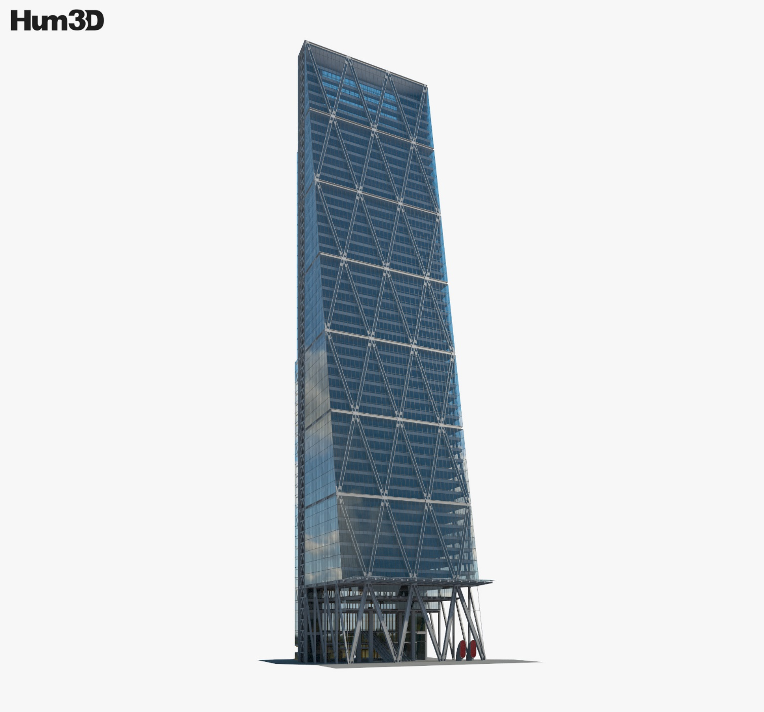
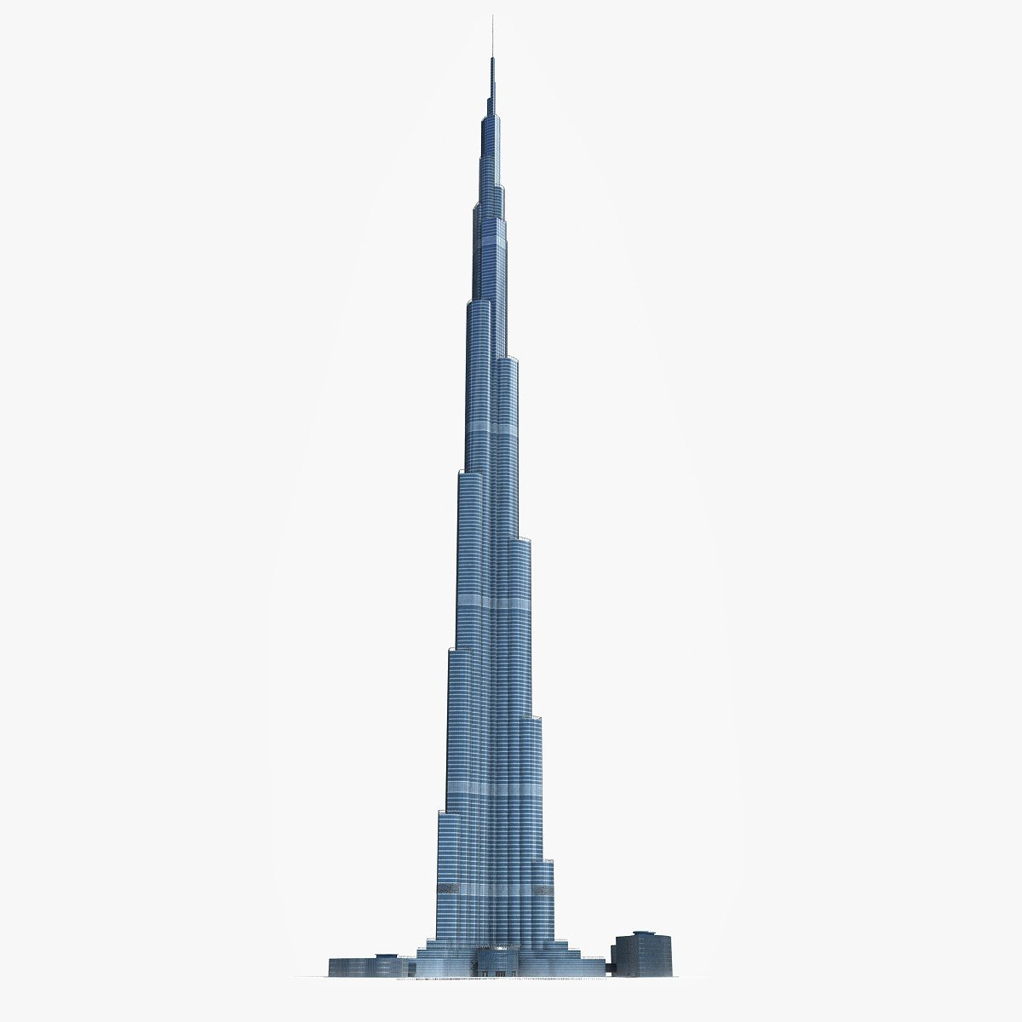
3dhorse (n.y) Burj Khalifa Dubai Tower 3D Model. Available at: https://www.3dhorse.com/products/burj-khalifa-dubai-tower-3d-model (Accessed: 12 February 2021).

Hum3D (n.y) Leadenhall Building 3D Model. Available at: https://hum3d.com/3d-models/leadenhall-building/ (Accessed: 12 February 2021).

Table Of Contents

Introduction 03

Findings 03

2.1 BURJ KHALIFA - CONCRETE FRAME, DESIGN & CONSTRUCTION 03

2.2 BURJ KHALIFA - SOCIAL & ENVIROMENTAL IMPACT 04

2.3 Leadenhall Building - Steel FRAME, DESIGN & CONSTRUCTION 05

2.4 Leadenhall Building - SOCIAL & ENVIROMENTAL IMPACT 07

2.5 Steel vs Concrete 07

2.6 STEEL VS CONCRETE - DURABILITY AND CLIMATIC RESISTANCE 07

2.7 Steel vs Concrete - Enviromental Impact of materials 08

2.8 Steel vs Concrete - Ease of assembley 09

2.9 Steel vs Concrete - Ease of adaption & Shape 09

2.10 Steel vs Concrete - A comparison 10

References 11

Introduction
This aim of this report is to research, contrast and compare two habitable buildings, one concrete frame and one steel frame. It will report on the building design and construction process along with its social & environmental impact. Finally, the report will discuss different aspects of steel and concrete frame design and its adaptability during the buildings lifetime.

Findings

Burj Khalifa - Concrete Frame

Design & Construction

travelinstinct (n.y.) Hymenocallis. Available at: https://travelinstinct.blogspot.com/2010/01/burj-khalifa-jewel-in-dubais-crown.html (Accessed: 18 February 2021).

Construction Cost - $ 1,500,000.000
Construction programme - 2004 to 2009
Height - 828 m
(thetowerinfo, n.d.)

The iconic top down design of the Burj Khalifa is inspired by the shape of a Hymenocallis, a desert Lilly that lives locally in Dubai (thetowerinfo, n.d.). The true purpose of the shape however is designed to resist the effects of the wind. Its irregular shape causes a number of smaller wind created ‘vortices’ that pull the building in a number of different directions all at once as opposed to fewer large vortices that would cause failure in a building of this scale if it were shaped like a regular rectangular skyscraper. (Richards Hammonds Big, 2000). Supporting the irregular design of the tallest structure in the world in the desert sands with no solid bedrock was a challenge faced early on by the construction team. The solution was to drill 194 piles to a depth of 50 meters each, these piles were then filled with a concrete polymer mix that supports the building with friction alone in the loose wet calcium silicate rock beneath the sands. On top of these piles the superstructure is built from reinforced concrete formwork, the whole structure contains 30,000 tons of steel rebar which gives the concrete increased tensile strength. When pouring concrete for the 150th floor it took 40 minutes to pump the concrete in hoses from the base (Big, Bigger, Biggest, 2008). This concrete frame is then clad with glass specifically designed to reflect a particular spectrum of light and keep the building cool while still utilising natural light, in total there are 26,000 panels that cover the exterior (guinnessworldrecords, n.d.).

Burj Khalifa - Social & enviromental Impact
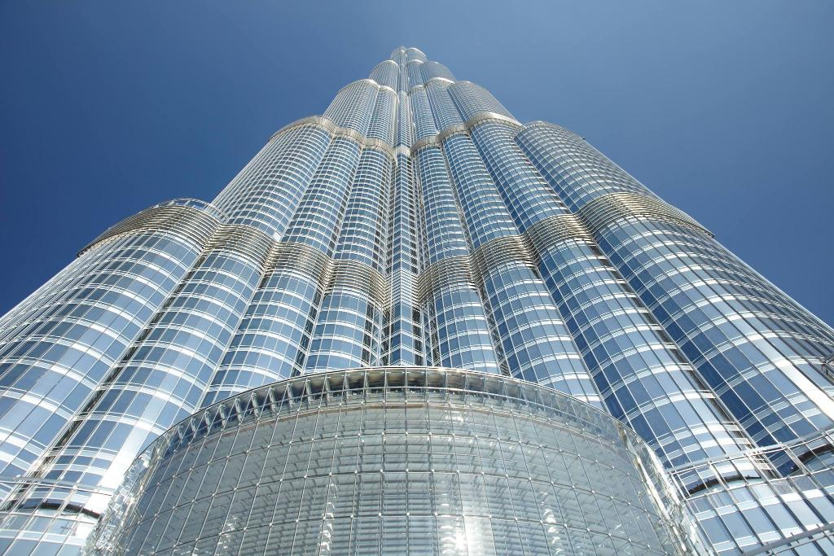
During construction of the Burj Khalifa 330,000 tons of concrete and 55,000 tons of steel rebar, stainless steel, glass and silicone are used (Structures Insider, 2020). The environmental impact of this quantity of materials is significant; all materials were manufactured off site and transported in with much of the workforce being brought in from outside the country. Specialist engineers and fitters were brought in from around the world with 300 cladding specialists being brought in from china just to work on the glass fitting (Burj Khalifa, n.d.). The large carbon footprint incurred by transporting not just materials but also the workforce is not a sustainable form of construction.
indigobluglassco (n.y) Glass panels used in Burj Khalifa. Available at: https://indigobluglassco.blogspot.com/2018/07/glass-panel-used-in-burj-khalifa.html (Accessed: 20 February 2021).

Leadenhall Building - Steel Frame

Design & Construction

Construction Cost - £ 340,000.000
Construction programme - 2011 to 2014
Height - 224.5 m
(Rogers Stirk Harbour + Partners, n.d.)

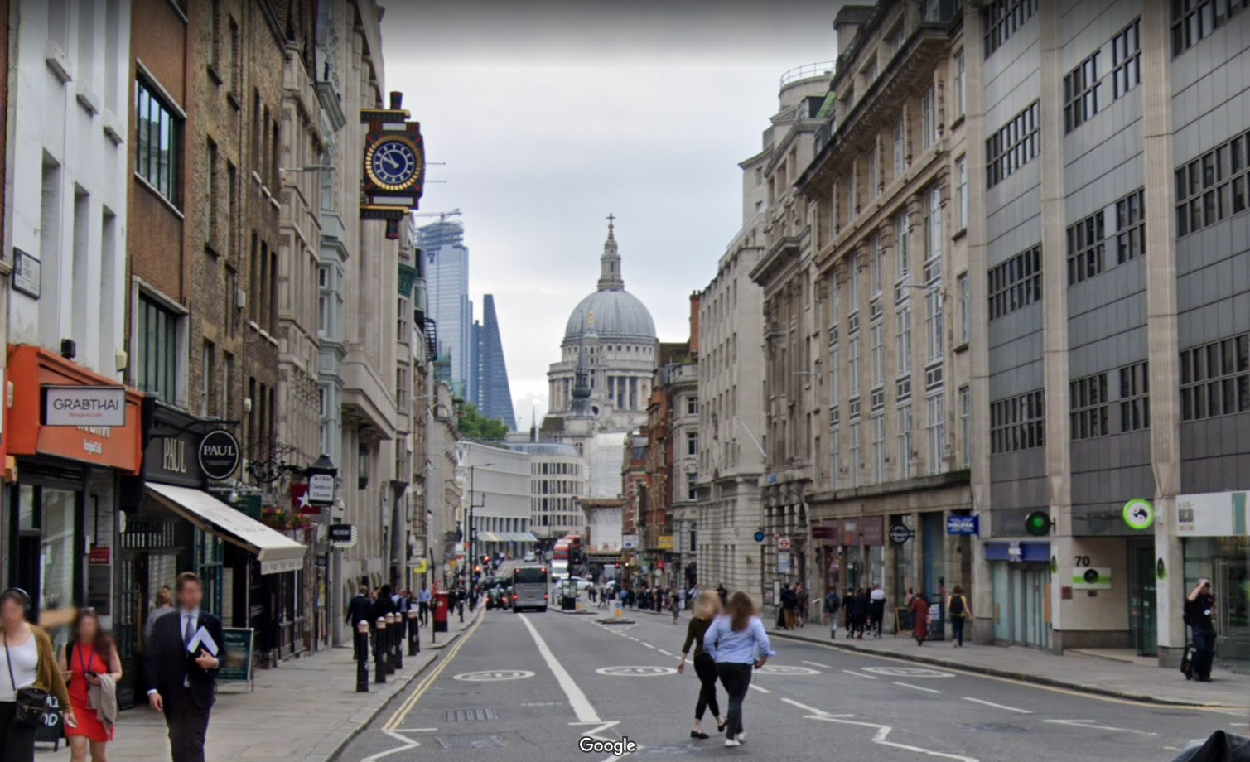
The ‘cheese grater’ shape of the Leadenhall building was solely based around appeasing London’s planning authority, London is building more high-rise buildings every year and the iconic shapes of older buildings are becoming hidden or obscured by new developments. St Pauls Cathedral is one of these older iconic buildings and has one of the most recognisable shapes on the London skyline (designbuild-network, n.d.). Various architectural designs were proposed by Rogers Stirk Harbour + Partners for the project but the Chief planner for London; Peter Wynne-Rees, and his team decided that the wedge shape was most suited as it would not interrupt or distract from the view of St Pauls on the iconic view looking east on Fleet Street (Building the future, 2014).
Googlemaps (2019) 88 Bolt Ct. Available at: https://www.google.com/maps/@51.514268,-0.1077459,3a,22.6y,95.96h,94.94t/data=!3m6!1e1!3m4!1sVTqHGwseAspT1e7XDz4QKw!2e0!7i16384!8i8192 (Accessed: 12 February 2021).
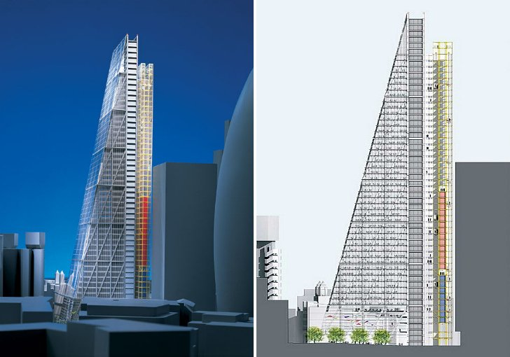
The developers British Land and Oxford Properties wanted to maximise rentable space within the structure as they didn’t have as much room as in a traditional rectangular shaped skyscraper and also to minimise construction time so they could start to reclaim money on their investment faster. To satisfy this brief the architects and contractors invented new techniques and methods of design and construction. To maximise rentable space a steel frame exoskeleton was designed, this frame meant that they didn’t lose space to the central concrete core that most skyscrapers have (Building the future, 2014). The building was also designed so that the ‘north core’ (shown in the right of the image) would contain all the lifts, washrooms and mechanical systems (Steel Construction, n.d.). This design while maximising the available space comes with an issue all a-symmetrical buildings have; the weight distribution isn’t balanced. During construction the building was regularly monitored and was tipping on average 2mm every 5-6 weeks towards the north, to compensate for this the steel frame was built with ‘nodes’ and steel shims (spacers) that could be removed as the building settled to keep it vertical. The location for the building also posed its own challenge, working space was limited as the building footprint had only a 10ft perimeter. Couple this with the project being in the center of London meant that very little could be stored on site and delivery’s has to be scheduled at night time so as not to disrupt the traffic. To overcome these hurdles and to speed up assembly, the building was created from as many prefabricated modular elements as possible. The building was modelled in 3D software that integrated the structure and its mechanical and electrical services, from which prefabricated sections were created of-site for delivered as required. The sections of the north tower that contained the services were created as modular ‘tables’ that arrived with all mechanical and electrical work already fitted. The prefabricated modular approach allowed deliveries of components to be programmed to arrive exactly when they were to be fitted, negating the need for storage. The project and its form of construction may set a precedent for building high rise in cities of the future (Building the future, 2014).
Inhabitat (n.d.) Leadenhall Building. Available at: https://inhabitat.com/work-set-to-resume-on-londons-energy-efficient-cheese-grater-building/leadenhall-building-12/ (Accessed: 12 February 2021).

Leadenhall Building - Social & enviromental Impact
Large construction projects such as this one usually provide a boost to the local economy and employment but because of the off-site prefabrication of most of the components the local area didn’t benefit as much as would be expected. The contracts were spread thought the United Kingdom, key elements included steel fabrication in Ireland and electrical and mechanical service fitting in Wolverhampton. Distributing the contracts further afield does ensure the spreading the social benefits outside the immediate area of the construction but may cause more harm to the environment in the process. Comparing a faster construction whilst creating less waste with no offcuts against & increased transport costs can be difficult and while there will always be a detrimental affect to the environment a balance between the two will need to be struck (designbuild-network, n.d.).

Steel vs Concrete
While there have been significant improvements in using timber for high rise projects, currently there are only two feasible materials for structures such as the Burj Kalifa or the Leadenhall building. Each material has particular attributes and qualities that make it more suited in certain situations, steel is known for its shear strength and speed of construction while concrete for its superior compressive strength and its mouldable form (Gupta, 2017).

Steel vs Concrete - durability and climatic resistance
Durability and resistance to climatic challenges should be assessed on a case-by-case basis and by looking at what particular environmental conditions the material will have to withstand will help us make informed choices as to the most appropriate material. For example, coastal locations having to endure the corrosive effects of salt and desert locations will have to cope with large swings of temperature. During the design stage we must choose the most appropriate material for the design but also for the environment. Steel has high shear strength and can be fabricated into most shapes in a factory, its also durable and hard wearing as long as it is protected for the environment. Protecting steel from the environment involves creating an outer layer that will act a barrier to moisture; this can be another less reactive form of metal such as zinc in the galvanizing process or a paint such as red oxide. Exposed steel may also be covered over with a cladding system but quite often even then the steel is treated giving it multiple layers of protection (SteelConstruction.info, n.d.).
Concrete if correctly specified can be left exposed even in coastal environments, much of its durability comes from being correctly proportioned, it will require the correct mix & ratio of cement, water, additives and aggregate that have been designed for purpose (The Aberdeen Group, 1962).

Steel vs Concrete - Enviromental Impact of materials
C0₂ produced including raw material extraction, processing and transportation etc.
Material | Embodied Energy (MJ/kg) | Produced CO2 (kg CO2/ kg)
Cement (typical) | 4.60 | 0.83
Concrete | 0.95 | 0.13
Steel  Hammond G.P. and Jones C.I. (2008) Inventory of carbon and energy (ICE). Available at: http://www.organicexplorer.co.nz/site/organicexplore/files/ICE%20Version%201.6a.pdf (Accessed: 28 February 2021). | 35.0 | 2.80
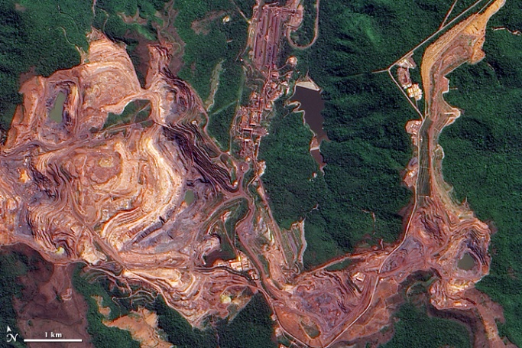
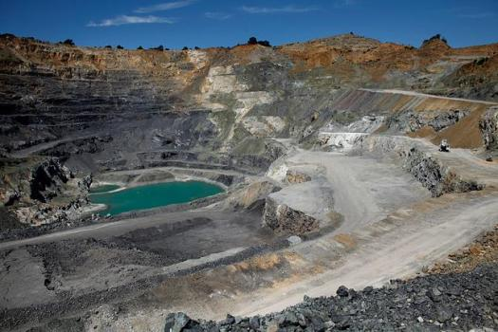
Neither steel or concrete could be classed as true environmentally friendly materials, both require large scale gathering of raw materials in a highly damaging process. Mining, quarrying and refining need to be done before the raw components such as iron ore or limestone can even start the manufacturing process for steel or concrete. Both Iron ore and limestone are quarried which leave huge scars in the landscape. The manufacture of steel and concrete are similar in the process, they both require additional materials, high temperatures (that take large amounts of energy to create) and they both produce a mass quantity of bi-products (Think Wood, n.d.). The quantity of C0₂ produced during the manufacturing process of steel is far greater than that of concrete, this is mainly due to the extremes of temperature required for the various stages of the process such as the creation of pig iron and then the more refined manufacture of steel products.
Jesse Allen (2009) Carajás Mine. Available at: https://earthobservatory.nasa.gov/images/39581/carajas-mine-brazil (Accessed: 20 February 2021).

Dai Sugano (n.d) Lehigh Southwest Cement’s quarry. Available at: https://www.mercurynews.com/2015/04/28/cupertino-cement-quarry-to-pay-7-5-million-to-settle-water-pollution-violations/ (Accessed: 20 February 2021).

A key difference in the environmental impact of these materials can be seen in their recyclability. Concrete can be reused in many cases, it can be crushed down and used as hardcore and fill but the cement cannot be separated and reused. Steel however can be recycled and reused to make other steel products. Changes can be made in both processes to lessen its environmental damage but there will always be a detrimental impact in the creation of both.

Steel vs Concrete - Ease of assembley
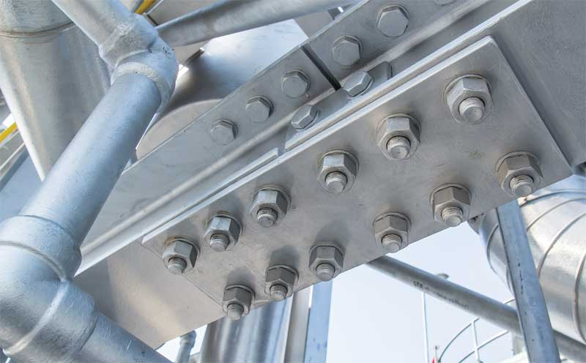
Erecting steel vs concrete structures differs significantly in both method and duration. Concrete structures can come preformed in precast sections but commonly they will be delivered as a wet product and poured into formwork before being left to cure on site. This process can be time consuming as in a high rise structure each floor much be left to cure before progress can continue to the next layer. In projects where precast concrete sections are used then they will commonly require a steel frame to support them, the precast floor slabs in the Leadenhall building are a good example if this (designbuild-network, n.d.). Steel comes manufactured to a design so when it is delivered to site it can be bolted together making the assembly of buildings a much faster process. If there are issues with the precast steel sections it is very difficult if not impossible for any adjustments to be made on-site and new steel will need to be manufactured causing delays.
Construction Canada (2019) Bigstock Joint Of Steel Structure. Available at: https://www.constructioncanada.net/assignment-of-design-to-constructors-continuing-the-discussion/bigstock-joint-of-steel-structure-with-225662422/ (Accessed: 20 February 2021).

Steel vs Concrete - Ease of adaption & Shape
Adapting existing buildings is trend that is becoming more popular and is usually accounted for during the design stage. If a building can be designed so that in the future it can be adapted instead of being rebuilt it will significantly benefit the client. For example if an office building is designed so that it could be adapted into apartments at minimal cost it will give future options for a client. The sections of concrete frame structures can be hard to adapt, formwork and structural components are reinforced with an interior framework of steel rebar. The quantity, size and pattern of this rebar is designed around the final shape of the concrete component. Adapting the concrete without changing and recasting around this internal structure isn’t recommended unless it has been designed to do so. (Namita, 2017)
Steel in comparison is much easier to adapt, while the frame would still be designed much in the same way as concrete the steel members are easier to extend by bolting on additional members where required.

Steel vs Concrete - a comparison
 | Steel | Concrete | Comment
Climatic resistance | Poor unless treated | Good | Concrete, if specified correctly is far more climatically resistant but if steel is treated correctly by using a galvanising or coating process it can be just as suitable
Durability | Good | Good | While both have their strengths in different areas of the construction they are both durable products.
Speed of assembly | Fast | Slow | Steel is far quicker to erect as there is no drying or curing time.
Off-site construction | Yes | Optional | Steel frame structures can be prefabricated off site while this is an option for concrete frame however it will depend on the shape of the frames as some may need to be cast in situ.
Ease of assembly | Specialist fitters | Less specialist | Erecting a steel frame construction is usually done by a specialist team that work using harnesses to work safely from height.
Ease of adaption | Modular | Difficult | Adding and adapting a steel frame construction is far easier than concrete frame.
Waste/offcuts | None | Waste | Precast steel elements will mean there is no waste while concrete frame will always have an amount of waste.
Environmental damage caused during extraction of raw materials | Significant | Significant | Both materials require large scale mining operations that damage the landscape.
C02 Produced during manufacture (kg CO2/ kg) | 2.8 | 0.13 | Concrete produces less carbon dioxide in the manufacturing process.
Recyclability | Readily recyclable | Poor recyclability | While concrete can be reused it cannot truly be recycled.

Even in concrete frame structures we must remember that a large quantity of steel rods and rebar will be required inside the frame, because of this we cannot not directly use the C0₂ comparison to declare concrete less environmentally harmful than steel. Steel is shown to produce far more C0₂ during its manufacture process but its ability to be reused, adapted and its speed and ease of construction make it a better building material for the future.

References
Big, Bigger, Biggest. 2008. [Film] Directed by Robert Hartel. United Kingdom: Windfall Films.
Building the future. 2014. [Film] Directed by Matt Jackson. USA: PBS.
Burj Khalifa, n.d. Structural Elements. [Online]
Available at: https://www.burjkhalifa.ae/en/the-tower/structures/
[Accessed 18 02 2021].
designbuild-network, n.d. The Leadenhall Building, London. [Online]
Available at: https://www.designbuild-network.com/projects/the-leadenhall-building-london-uk/
[Accessed 12 February 2021].
guinnessworldrecords, n.d. Burj Khalifa: The tallest building in the world. [Online]
Available at: https://www.guinnessworldrecords.com/records/hall-of-fame/burj-khalifa-tallest-building-in-the-world
[Accessed 18 02 2021].
Gupta, A., 2017. Steel Structures Vs Concrete Structures. [Online]
Available at: https://civildigital.com/steel-structures-vs-concrete-structures-complete-comparison-of-steel-concrete/
[Accessed 18 02 2021].
Namita, 2017. Practical Steps in Design of Concrete Buildings. [Online]
Available at: https://civildigital.com/practical-steps-in-design-of-concrete-buildings/
[Accessed 15 02 2021].
Richards Hammonds Big. 2000. [Film] Directed by Matthew Wortman. United States of America: Discovery Channel.
Rogers Stirk Harbour + Partners, n.d. The Leadenhall Building. [Online]
Available at: https://www.rsh-p.com/projects/the-leadenhall-building/
[Accessed 15 02 2021].
Steel Construction, n.d. The Leadenhall Building, London. [Online]
Available at: https://www.steelconstruction.info/The_Leadenhall_Building,_London
[Accessed 13 02 2021].
SteelConstruction.info, n.d. Corrosion protection. [Online]
Available at: https://www.steelconstruction.info/Corrosion_protection
[Accessed 18 02 2021].
Structures Insider, 2020. 137,500 elephants 🐘 were used for the construction of Burj Khalif. [Online]
Available at: https://www.structuresinsider.com/post/137-500-elephants-were-used-for-the-construction-of-burj-khalifa
[Accessed 18 02 2021].
The Aberdeen Group, 1962. CONCRETE IN MARINE ENVIRONMENTS. [Online]
Available at: https://www.concreteconstruction.net/how-to/materials/concrete-in-marine-environments_o
[Accessed 18 02 2021].
thetowerinfo, n.d. Burj Khalifa Facts and Information. [Online]
Available at: https://thetowerinfo.com/buildings-list/burj-khalifa/
[Accessed 18 02 2021].
Think Wood, n.d. How It’s Made and the Environmental Impacts: A Comparison of Wood, Steel and Concrete. [Online]
Available at: https://www.thinkwood.com/blog/made-environmental-impacts-comparison-wood-steel-concrete
[Accessed 15 02 2021].

