Reflective Journal

I have always been a teacher and the last twenty years have been spent teaching Foundation Phase at the same school in a small town in Pembrokeshire, that nestles on the River Cleddau. During these twenty years it has transitioned from an infant school to a primary school on two bases and ten years ago a new school was built where we were united on one site. It is a large school with just over 300 pupils from a variety of backgrounds and over the years we have seen a steady increase in eFSM children.
To say it has been an unsettled few years in education would be an understatement. As we gingerly emerge from the pandemic, I have noticed a number of differences in the children in my Reception class. As we know prior to covid, children were moving less than in previous generations. Young children lead increasingly sedentary lifestyles due to a number of factors and ‘watching TV, travelling by car, bus or train or being strapped into a buggy for long periods are not good for a child’s health and development.’ (www.nhs.uk)
One of the most evident changes was the children’s interaction and concentration. Many had difficulties coming back to the whole class setting, finding it hard to share, interact in a meaningful way (there have been more arguments and disagreements) and to sustain concentration – sitting on the carpet is a challenge for many. Out of a class of 33 children, a quarter have significant challenges (behaviour, speech and language). A change of approach was needed and having had previous SKIP experience, I realised more active learning was necessary – “movement plays an equally important role in the growth, development and education of all children.” (M Davies 2003 p1) Enrolment on this course came at a perfect time!
My first session was an opportunity to assess what stage of development the children were at. Starting the warmup with the ‘Mr Men’ game it became immediately apparent that the children had issues with spatial awareness and their fundamental movement skills were indeed lacking. As I modelled the different ways of travelling around the hall, the children ‘clumped’ around me, illustrating an inability to make use of the hall space. This was rectified by using spots around the hall and, in following sessions, encouraging the children to move around the spots, creating pathways. Their existing movement vocabulary was fairly good, but their execution of these movements was poor. They had a tendency to rush, as if everything was a race - they were able to model a low/ high movement and they had an understanding of the basic ways of travelling (running, jumping, walking) but these movements often turned into a run. They were at the early stages of galloping and hopping, many exhibiting the ‘wounded soldier’ and the leg held forward when hopping. As illustrated in the ‘proficiency barrier’ model, it is essential young children become proficient in these fundamental movement skills if they are to partake successfully in further sports and games. (Seedfeldt 1980)
Consequent warm up activities (Mr Men and Splat the Spot) worked on developing these skills, using the spots to further develop their spatial awareness and I continued to model proficient actions. As the weeks progressed, the children grew in confidence - we were able to incorporate speed and direction with these movements and create curved and zigzag pathways. I kept in mind that at this early stage “young children are best helped to appreciate directions by references to the body” (M Davies 2003 p20) and used lots of modelling and words to support – they found travelling backwards a little unnerving initially as early-stage development focuses on moving forward. Leading with their back, moving sideways using arms as indicators helped here. By the fifth session the children were able to respond appropriately to the instructions with less modelling from myself and control their movements to create their own pathways.
The first catching session was again an opportunity to assess their starting stage. We began sitting on the floor rolling the ball to partners – what were their tracking skills like? In this session I introduced ‘hands ready’ and that five successful ‘catches’ meant they could challenge themselves further by moving back. I was pleased to see the enthusiasm from all and that nearly all were able to track the ball successfully over a short distance. However, some issues became evident. I noted that those who struggled to send and receive were quite excitable and in their eagerness were just batting the ball back to their partner. This then resulted in the ball rolling out of reach. I modelled the ‘hands ready’ with ‘grippy fingers’ outstretched ready to receive and then sending back with a push. A further point that needed addressing was with the children who successfully received 5 times often found it difficult to move back a sensible distance and some went so far apart they struggled to roll the ball the distance with control. This was rectified in further sessions by initially putting the spots out ready to mark appropriate yet challenging distance. As the weeks progressed the children then showed an awareness of a ‘sensible’ level of challenge independently.
The children were able to progress to high kneeling and incorporate movement to catch the ball when rolled, showing an improvement in tracking skills and it was great to see them increasingly supporting each other by using the prompts ‘hands ready’ and later when, throwing to partner, using their ‘x zone arms’ to help with aim when sending. To keep the children enthusiastic and progressing according to their needs, I used the ‘Constraints Theory’ – I changed the task appropriately, offering opportunities to use different sized and textured balls, vary distance and also changed the environment – using the hall or the outdoor MUGA and the layout of the equipment within those spaces.
(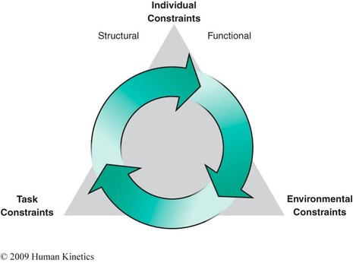Newell 1986)
All children were able to progress to stand and catch a large ball over a short distance, with all able to exhibit a stage 2/3 catch, hugging or scooping and a quarter of the children hand catching with growing proficiency. They were given opportunities to choose smaller balls and beanbags to catch but I noted (as did the children themselves) that they were having a lot less success and they took themselves back to the larger balls to practice further. This reflected the positive/ negative spiral of engagement theory (Stodden et al), my Reception children have such positive attitudes towards their own abilities, they are keen to keep trying and respond well to praise and encouragement. It is vital this enthusiasm and positivity is nurtured as they grow so they can develop greater competence and a lifelong love of movement. As their fundamental movement skills journey continues, they will not only extend to catch smaller balls with greater reliability and also move from a stationary to a moving position but for now, the development of enthusiasm and perseverance is key!
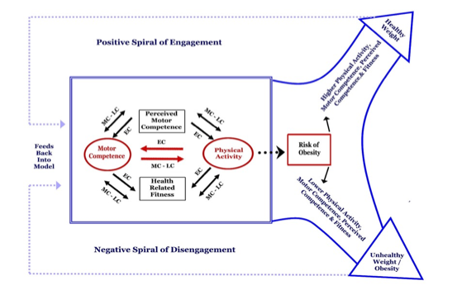
With the SKIP activities now an embedded weekly activity, the children were excited for each session and keen to partake. I was already seeing improvements in concentration, with the majority of children increasingly able to stay on task, and the need to work with a partner was definitely helping to develop the quality of their interaction with each other. The introduction of throwing gardens was well received, and the children relished the opportunities to throw as far as they could with pompoms and bean bags. Initial opportunities to throw showed the majority were ‘choppers’ from a stationary position. (Gallahue, Ozman and Goodway 2011) A small group of children told me they practised throwing at the local after school cricket club and illustrated to the others a lean back and a step forward before releasing the bean bag which was wonderful to see. They also developed their underarm throw through aiming games, initially hoops on the floor and then progressing to knocking over cones. As the weeks progressed, most children were able to exhibit a contralateral step with consistency and a well developing hand-eye co-ordination, with half aiming specifically at a chosen hoop/ cone.
In reflection, what have I gained from using SKIP in my setting? As stated at the beginning of this essay, my main concern was the quality of concentration and social interaction within my class. Have I seen any changes?
To begin, I think a change has happened in my approach – I have started to look for opportunities to develop their movement through all areas of learning, from how we move around the school; in maths and literacy sessions, and during our ‘Fab Fridays’ in the outdoors – I am now more aware that childhood movement skills are essential to not only their physical development but also their social, cognitive and psychological development (Diamond A). I fully intend to continue to develop this further in the new school year and incorporate Fundamental Movement Skills as an area of high importance in our daily activities, planned and incidental.
Regarding the children’s development, I have seen an improvement during the focused SKIP sessions in the following...
- Increased concentration – the majority are able stay on task and persevere on a set activity for increasing amounts of time.
- Improved interaction – by working with partners or small groups I have seen improvements in turn taking and the use of supportive and encouraging language.
- Self-challenge – many can adapt activities to incorporate challenge appropriate to their own level – it was wonderful to see them moving further away, aiming specifically for targets, changing their equipment and identifying when they were unsuccessful and needing to take a step back to practice further.
- An increased movement vocabulary – through our warm-ups and obstacle course gardens, most children have developed their movement vocabulary and have started to understand the importance of refining these movements rather than rushing. It was great to see some incorporating different ways of travelling into a throwing activity (without my suggestion!), hopping or jumping to retrieve their bean bag rather than just walking or running, a sign to me that these movements are becoming embedded.
Outside of the focused activities, I have started to notice the following...
- Improved sitting on the carpet for some, leading to greater engagement and listening.
- Increased confidence when engaging in outdoor activities – I have seen previously nervous children climbing and rolling down big hills, climbing trees, balancing on logs and stones and increased stability on the trim trail. There is more risk taking and I have also seen more hanging upside down or dangling from ropes or branches, bringing the work of Jean Ayres to my mind and reaffirming how the development of the vestibular system is so essential in these very early childhood stages. If these children are to develop their spatial awareness and understand how their bodies relate to other objects, they need lots of opportunities to engage in these types of play.
- Creating their own SKIP style activities! – it has been wonderful to see children using logs, planks and other loose parts to create their own stepping-stones/ obstacle courses and engaging in games such as piggy in the middle, skittles, tin can alley and target games to name a few.
As this SKIP course draws to an end, for me it marks the beginning of a new way of thinking about the development of the children I will teach in the years to come.
“Whether for sport, dance or everyday tasks, we value our ability to move and interact with our environment throughout our entire lives.” (Haywood and Getchell Ch1 p4) and as an early year’s educator, my role is vital in encouraging and enabling the development of these fundamental movement skills at the very beginning of these lives. With the confidence of my newly acquired knowledge and understanding, I will not rush to put pencils in hands but instead we will climb, balance, roll and, of course, skip our way to developing the gross and fine motor skills that are essential in creating confident, healthy and most importantly, happy individuals.

Reference list (reading on the moodle page)

Ayres, A. J., & Robbins, J. (2005). Sensory integration and the child: Understanding hidden sensory challenges. Western Psychological Services.
Davies, M. (2003). Movement and dance in early childhood. Sage.
Gallahue, D., Ozmun, J. and Goodway, J. (2012). Understanding motor development: Infants, children, adolescents, adults. 7th ed. New York: McGraw Hill Higher Education.
Haywood, K. M., & Getchell, N. (2019). Life span motor development. Human kinetics.
Seefeldt, V. (1980). Developmental motor patterns: Implications for elementary school physical education. Psychology of motor behavior and sport, 36(6), 314-323.
Stodden, D. F., Goodway, J. D., Langendorfer, S. J., Roberton, M. A., Rudisill, M. E., Garcia, C., & Garcia, L. E. (2008). A developmental perspective on the role of motor skill competence in physical activity: An emergent relationship. Quest, 60(2), 290-306.
Diamond, A. (2000). Close Interrelation of Motor Development and Cognitive Development and of the Cerebellum and Prefrontal Cortex. Child Dev

