Contents
Introduction to the school and context 4
A review of the relevant literature on your chosen topic; 4
Topic pack 6
An analysis of your microteach 6
Evaluation of, and suggestions for the revision of the approaches and materials 8
Appendix 1 - Powerpoint 10
Appendix 2 Lesson plan 13
Appendix 3 Pupil work sheet 14
Bibliography 15

Introduction to the school and context
The school where this micro-teach session is to take place is a comprehensive school serving a mixture of rural and small urban conurbations and is situated on the West Wales coast. The school has a roll of just under a 1000 pupils of which around 100 are within a sixth form. The school is currently in special measures and before this, it had been in an Eystn category for the past 6 years. The school underwent a TLR restructure and moved to a model more in line with the new curriculum for the start of the 2018-19 academic year, however, due to several factors including the size of some of the AoLE areas some anomalies exist when compared to the Curriculum 2022 model. Within the school structure, the science sits as a separate subject and Design Technology aligned to the Expressive Arts AoLE. Within the school, a Head of Department for Science was appointed and started in the post in January 2019, since starting the post he has restructured the teaching at KS3 putting in topics that cover a half term. Each topic is split into lessons consisting of a range of theory lessons based on shared PowerPoints and practical sessions on the subject and then concluded with an end of unit test. The end of unit test is marked in line with the school’s close the gap system and followed by a Stop, Think Action and Reflection task (Star) task. In the Star task pupils review a section of work where they performed poorly in the test. Within Key Stage 3 pupils are taught in ability bands with the top 60% of pupils split into classes of between 32-35 pupils and the lower 40% split into two teaching groups. The school re-instated A-level science subjects for the start of the 2019-20 academic year.

A review of the relevant literature on your chosen topic;
Following the poor performance by Welsh pupils compared to other OEDC countries in the 2009 PIZA testing Wales started looking at school development and the way schools work (Welsh Government, 2017) leading to reforms in the areas of Teacher Training (FURLONG, 2015), ALN provision (Welsh Goverment, 2018) and Curriculum reform (Donaldson, 2015) (Welsh Goverment, 2019). The basis for the new curriculum was built around successful futures. Following on from the publication of the Successful Futures document the draft Curriculum 2022 was released for consultation and after feedback from this document (Griffiths., 2019)the new curriculum was developed.
The new curriculum has been designed to help pupils develop forming the four purposes of the curriculum (Welsh Government, 2020). If lessons are going to be successful in supporting pupils to develop they will need to be designed to help pupils develop against the four purposes.
Within his Successful Futures document, Donaldson highlights a range of pedagogical strategies that can be used in the teaching of the curriculum. However, Donaldson (2015) makes it clear in his work that there is not a defined way to deliver lessons going further by explaining that making decisions about teaching and learning are context-driven and should be decided by teachers. To ensure that this micro-teach is successful it will be necessary to consider the 12 principals which can be applied to have the most impact on pupil progression within the lesson. Within the 12 identified principles (Donaldson, 2015) reference is made to using a blend of approaches including direct teaching. Within the document reference is also made to both building on previous knowledge and assessment for learning principals. Both of these are areas that link to diagnosing misconceptions in previous learning. Through robust use of assessment for learning principals and building on the sound knowledge from the topic taught it is thought to be necessary to include a form of assessment for learning as a diagnostic tool within the micro-teach lesson. The last of the pedagogical principals that are considered is the use of collaboration to improve learning this could be developed by looking at ways to include peer work within the micro-teach lessons. It is also important that within the micro-teach session, as in all lessons, pupils are given the opportunities to develop their metacognition. This links back to one of the 12 principals identified within the document. As well as being supported by the work of others who have looked at what makes learning successful, including the Educational Endowment Foundation, all note that this allows pupils to take more control over what they are learning. If pupils can develop their metacognition skills they will be able to better think strategically about a process which will help them learn, such as plan, do, evaluate to achieve a goal or the method by which they learn best (Stringer., n.d.)
In the micro-teach session, it is important to have an effective assessment for learning (AFL) tools that allow the progress of pupils to be measured and improved. According to Ausubel (1968), one of the most important factors in enabling learning is what the learner already knows. This gives importance to either knowing the level of knowledge that the pupils currently have on the topic before the lesson, or, building in a method to test what they know and the misconceptions they may already have before building and consolidating their knowledge. When undertaking this micro-teach the teacher must know about the pupils in the lesson and their needs (Black, 2004) this would include any common misconceptions that the pupils may have already learned or could learn during the session so they can be addressed.
Within the micro-teach, it is important to differentiate the task so that all pupils can access the work while being challenged by it and make progress in the lesson. The differentiation of the teaching needs to be fundamental in planning the lesson and not added on (O'Brien, 2001) so will need to be thought of throughout the planning process. To successfully differentiate the lesson it is important to be able to anticipate the learning needs and misconceptions of the pupils: create opportunities for group working if they naturally arise in the lessons which are backed up by clear objectives. (Hill, 2018) Ways in which the micro-teach could be differentiated could include using flexible learning paces within the Micro teach with pupils who work faster given extension tasks to avoid rushing pupils who work at a slower rate, this means that pupils who work at a slower pace don’t feel rushed and can still complete their best quality work. Using progressive tasks within the micro-teach lesson and separating the content into ability banded tasks; allowing pupils to choose or setting pupils certain tasks has the drawback of increasing lesson planning time and highlighting weaker pupils to their peers. Therefore, the use of verbal support in the lesson to aid pupil progress to help enable all pupils to make progress in line with their ability during the lesson is essential. Differentiation could also include the varying of outcomes for pupils ensuring that pupils can have more than one outcome for the class within the work undertaken; however, steps need to be taken to prevent lower ability pupils underperforming if this strategy is applied. (Promethean, 2017). Tools to allow this differentiated approach to take place could include the Frayer model, a graphic organizer which will help pupils to build their vocabulary (Teacher Tool Kit, n.d.) and link correctly to the topics that can become common misconceptions, the pro forma can be varied to include partially pre-filling the sheet to vary the learning pace.
Pupils develop ideas about the world around them that can be different from the scientific concepts that are accepted. These misconceptions must be identified and within Schemes of Work and action is taken to help address the misconception (The National Strategies | Secondary, 2008). To move pupils from the misconception to the accepted scientific concept several methods can be deployed. One of these is the use of Concept cartoons, concept mapping or annotated drawings. These methods give pupils the chance to discuss and consider alternative views and ideas either working in a small group or a class. This task can be extended by asking pupils to explain why they do not agree with some of the views on the concept cartoon, or, setting up a debate with different pupils taking different roles from the concept cartoon. These activities can be backed up by using TRUE? False? Unsure?, either as a sheet or a card-sorting task to both check their knowledge and create opportunities for peer working and discussion (The National Strategies | Secondary, 2008). Concept cartoons are a method of introducing interest and student engagement using a range of characters to express different views on a topic. (Fitzsimons, 2018)
If pupils are to make progress in the lesson and avoid their progress and learning being impaired by the misconceptions, it is important to make sure the pupils use the correct language and that this is modelled through the micro-teach lesson. If pupils misuse language, the lesson needs to be a place where this is corrected. This will allow pupils to become confident in the use of scientific specific vocabulary and be able to understand the concepts being taught. (Harden, 2019)
To help reinforce what the pupils are learning and help them understand the difference between the two concepts of melting and dissolving in the lesson, videos of practical sessions will be shown. The use of different methods helps pupils understand scientific concepts (Green, 2019), if pupils understand the two concepts they are likely to be able to address the misconception. If the lesson was a full lesson pupils could undertake the practical tasks themselves, however, this is limited by time in the micro-teach.
In the micro-teach it is important that the practical tasks or videos clips of practical tasks are backed up with the concept of melting and dissolving, many teachers explain the concepts using models to explain what is happening within scientific concepts (Royal Society of Chemistry, n.d.). In the micro-teach, the concept will be modelled based on a video of a practical and then asking pupils to discuss what is happening to the particles within the beakers. A pupil will then model their idea drawing in the particles on the whiteboard to be discussed by the class. Pupils will be shown the correct model on the board to facilitate discussion around why it is correct. The difference between the model of dissolving and melting should help pupils distinguish between the two concepts and help deal with any misconceptions. This will be linked to a class question focussed on the mass when dissolving sugar into tea to show the conservation of the mass. (Taber, 2002)This will also act as an AfL tool to identify pupils or groups of pupils who have not understood the concept.

Topic pack
PowerPoint Appendix 1 (screen shots)
Lesson plan Appendix 2
Pupils work sheets Appendix 3

An analysis of your microteach
The micro teach was delivered via a Microsoft Teams platform which changed the dynamic of delivering the lesson. However, it ran technically well with the PowerPoint, YouTube clips and video clips all playing and sharing well over Teams. Working and delivering lessons remotely is a skill where I am developing my practice and this is something that has become focused during the school closure period. The lesson was split into several chunks to allow pupils to make progress and gave numerous opportunities for AfL to take place. The starter section of the lesson had two YouTube clips and provided an opportunity for pupils to self-assess if they knew the difference between the two concepts showing their views using Yes, No, Don’t Know cards. This would have allowed the teacher to start to assess the level of misconception or knowledge gaps. Learning objectives and outcomes were then shared; this allows pupils to know what they were learning about, these were designed in a way that they did not answer the key question of the lesson. An alternative approach at this point could have been to ask the pupils to try and work out the learning intention of the lesson and explain their thinking at the end of the lesson. Pupils were shown a key question which would be referred back to through the lesson to help split the concepts that create the misconception that melting and dissolving are the same process. The key question used was “Are melting and dissolving the same thing”. The next phase in the lesson used a concept cartoon to address the conservation of mass when dissolving; this was introduced by carrying out the practical task on the concept cartoon and showing pupils a video of the experiment and asking them to discuss their views on the cartoon. In the micro-teach this was a quick task as no time was allowed for discussion, however, if this lesson was to be replicated in school this task would take longer and would provide the pupils with the opportunity to discuss in a group before feeding back to the whole class. This will provide an assessment point for the teacher to check the learning and to diagnose if the misconceptions exist within the pupils knowledge. For pupils to apply the knowledge they have learned and to further embed this knowledge pupils will, as a class, complete a question on the dissolving of sugar into a cup of tea, this will be done in a “no hands up” style. Pupils then refined and organized their learning using a Frayer model. Pupils would have completed this task independently feeding back the answers to the class, in the micro-teach session this was shown and explained, however, if replicated in a classroom this could have been completed by the pupils. Once the pupils had fed back and constructed a class answer pupils would have been given opportunities to improve the work using a green pen to ensure they have a correct answer in the Frayer model for them to refer back to. This task would have been differentiated by allowing some pupils the opportunity to complete the examples section on the grid using a card sort exercise. The final section of the lesson on the dissolving was focused on the particles and designed to visibly show the conservation of mass. This section aimed to have pupils draw out their ideas on a whiteboard and then show and explain the concept on the board to allow them to correct the work. Group working should create the opportunity for all pupils to complete a definition.
At the end of the dissolving part of the lesson, there was a return to the main focus question to allow pupils to reflect. All pupils should now be able to describe dissolving and this created an opportunity for them to make links with melting.
The next phase of the lesson will focus on the other part of the misconception, the melting point of view. This part of the lesson was designed to further help pupils distinguish between melting and dissolving by allowing pupils to gain the knowledge of the melting part. This part of the lesson was designed to be briefer due to the limited time available in a micro-teach but would have been an area that could have been expanded in a real lesson. The first section of this work was to show the pupils a video clip of ice starting to melt in a cup, this made clear the starting mass of the ice was 5g and posed a question to the pupils predicting the mass of the water from the melted ice. This would create a discussion point for the pupils regarding what might happen to the ice. While pupils are discussing this the teacher would walk around and questions could be used to both assess the learning in a formative way and differentiate the learning.
Pupils will then move onto the second chunk of the melting learning completing a second Frayer model. This time with the key concept of melting, this should allow the pupils to further distance the two concepts and the use of examples and non-examples to check the learning. If salt is added to water is this an example or non-example of melting? The lesson will then move into the final chunk of the lesson on the melting concept, this will focus on the particles in melting. The first part of the task is for pupils to add the mass of the water this will be done in a no-hands up manor. Pupils will be asked to use their prior knowledge to describe the particle arrangement of the solid ice and what they think will happen when it turns to water. This task will allow pupils to discuss the difference in the particles between melting and dissolving making clear the difference in the concepts and the similarities regarding the conservation of mass.
The plenary task in the lesson was designed to make pupils think about their learning and arrange it hierarchically to select the top 5 tips or hints they would give another group completing the same task. This activity would promote group discussion to select the important facts and reject other less important information. To aid pupils on the last slide there was a copy of the learning objective and the starter YouTube clips. Some groups would be asked to feedback to the class on the top 5 tips they had chosen and explained why they had decided on them.

Evaluation of, and suggestions for the revision of the approaches and materials
When evaluating this task it is limited to the micro-teach taking place on Microsoft Teams. After teaching in a class environment it may be necessary to re-evaluate and make further changes. This is an area where the work could be expanded.
The starter task provided an opportunity for pupils to see both concepts at the start of the lesson. However, this could be more effective if pupils engaged in watching a practical task; this could be set up as a demonstration and projected onto the whiteboard for pupils to watch due to the size this would allow it to be upscaled. The beaker for melting could be warmed to speed up the melting to keep the task brief. The use of cards for formative assessment is effective and quick this could be developed into a Kahoot quiz so pupils anonymously completed questions on their phones to give a class picture of the level of misconception. However, the effectiveness of this revision depends on the level of mobile phone access for pupils in the class and could draw out the start of the lesson which may negatively impact on the amount of teaching time available.
The learning objective and outcome provide an effective scaffold for pupils to achieve in a differentiated manner through the lesson. In this lesson, it is effective to share the learning intention near the start of the lesson. If the style of the lesson was to be changed and pupils were to investigate what happened to the mass of 200g of tea when 10g of sugar is added, or, what is the mass of 5g of ice when it turns to water the learning intention could be shared at a later point in the lesson.
The video clip of the tea with the sugar added would help pupils visualize what is happening in the concept cartoon and provides a solid base for them to discuss the views in the concept cartoon. The discussion of the cartoon provides pupils with a group to work with to agree with a unanimous view. In the micro-teach this was an area that was not differentiated, however, all pupils are in a similar ability set and the use of groups should support all pupils to take part in this task.
The use of the of questions following this task is an area that could be expanded with some different levels of questions, or the use of correct and incorrect examples of dissolving; with pupils selecting which are correct/incorrect and explaining why they have come the that view
The Frayer model provided the pupils the opportunities to organize their knowledge on paper. However, this is a time-effective way for pupils to produce this work and an area of weakness may centre on the pupils have not used this method before so it may need to be embedded into lessons.
Particle models create the opportunity for pupils to understand the microscopic concept. This was not effective in the micro-teach as all parts of the model appeared at the same time this would need to be refined so pupils could see it in a stage by stage approach to make it more interactive and create further AfL opportunities.

The plenary is an area where the lesson could be developed. The task completed could be used as a homework task with pupils making use of applications such as Flip Board to record and upload themselves discussing the 5 most important tips and give an explanation why they are the most important 5 points.
This would create time to carry out a more effective plenary task such as getting pupils to categorize common processes into melt and dissolve. Pupils could then feedback explaining why they think the process in melting or dissolving.

Conclusion
In conclusion, this micro teach was designed to address the common misconception that the process of melting and dissolving is the same thing which I feel it did. It created a clear opportunity for pupils to learn about the two concepts independently while still comparing the two processes via the key question. The micro teach was designed with a range of activities to chunk the lesson down and enable pupils to learn about the two concepts separately; and, in the evaluation, possible ways of improving the end of the lesson to give pupils the opportunities to apply the concepts and distinguish between them are discussed. Throughout the lesson, there are a range of techniques from the 12 principals utilized and space created for AfL and strategies to differentiate the lesson to help pupils deal understand why misconception that melting and dissolving are the same process is incorrect and the concept theory to show that this is the case back up with video clips to show the experiments to prove this. This should allow pupils to understand the difference in the concepts and better understand other areas of the curriculum based on solid knowledge.

Appendix 1 - Powerpoint
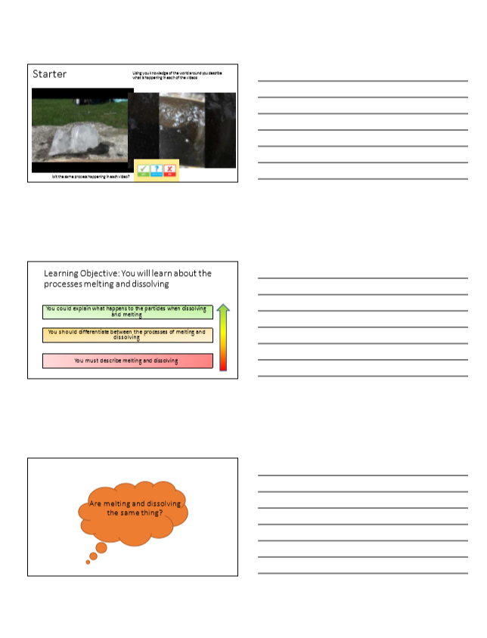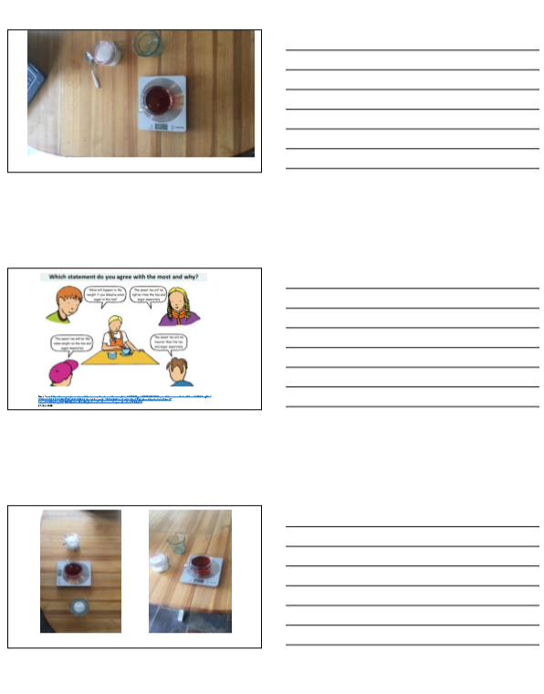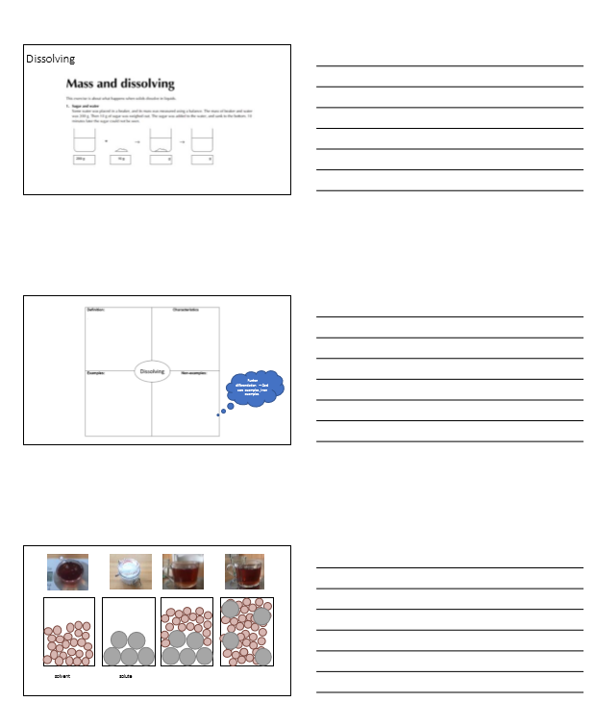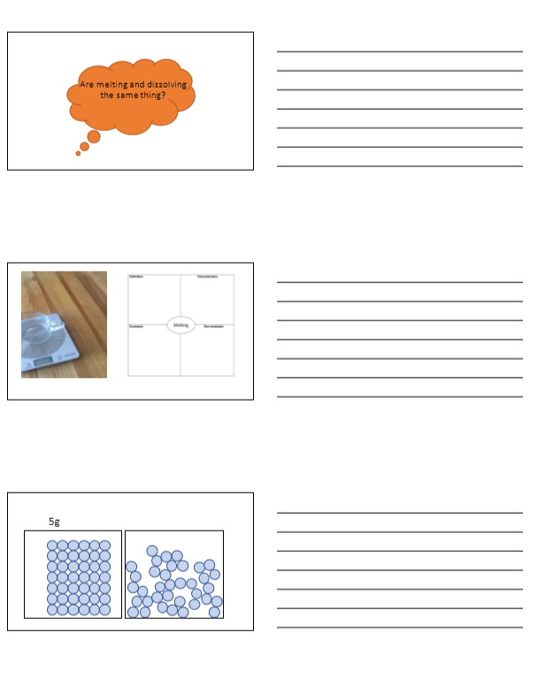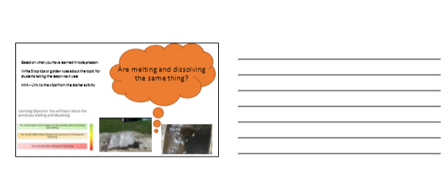

Appendix 2 Lesson plan
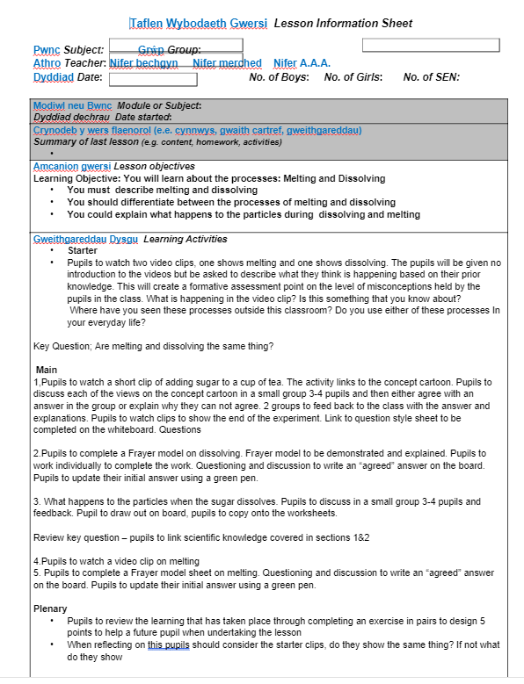

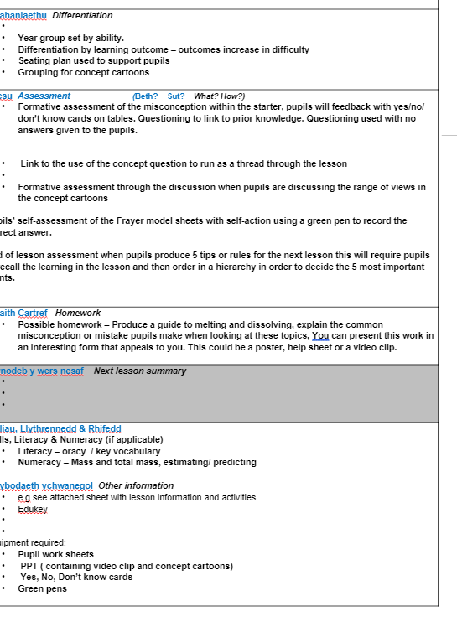

Appendix 3 Pupil work sheet
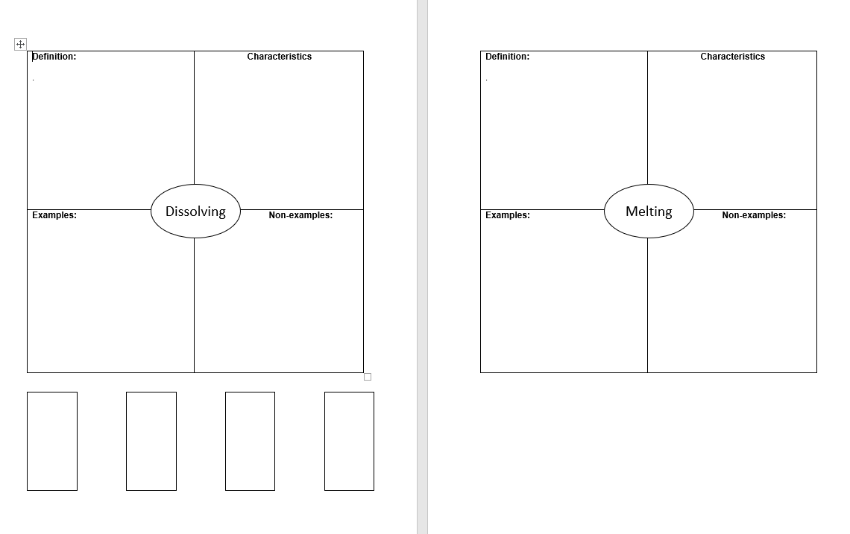

Bibliography
Ausubel, D., 1968. Educational psychology: A cognitive view. New York: Holt, Rinehart & Winston.
Black, P. H. C. L. C. M. B. a. W. D., 2004. Working inside the black box: Assessment for learning in the classroom.. s.l.:Phi delta kappan.
Donaldson, G., 2015. Successful futures, s.l.: s.n.
Fitzsimons, F., 2018. Academic Literacy and Language. [Online]
Available at: https://academicliteracy.wordpress.com/2018/01/09/how-concept-cartoons-can-stimulate-and-engage-learners-in-classroom-discussions/
[Accessed 21 04 2020].
FURLONG, J., 2015. Teaching tomorrow’s teachers, s.l.: UNIVERSITY OF OXFORD.
Green, J., 2019. Royal society of chemistry Different approaches build understanding. [Online]
Available at: https://edu.rsc.org/feature/different-approaches-build-understanding/3010710.article
[Accessed 28 04 2020].
Griffiths., L. O. D. P. T. J. A. B. C. M. S. U. L. K. E., 2019. Curriculum for Wales 2022 Feedback Analysis, s.l.: s.n.
Harden, H., 2019. Royal society of chemistry - education in chemistry. [Online]
Available at: https://edu.rsc.org/ideas/avoid-the-pitfalls-of-language/3010601.article?adredir=1
[Accessed 28 04 2020].
Hill, M., 2018. Teacher Tool Kit. [Online]
Available at: https://www.teachertoolkit.co.uk/2018/03/05/what-is-differentiation/
[Accessed 21 04 2020].
O'Brien, T. G. D., 2001. Differentiation in teaching and learning. s.l.:A&C Black.
Promethean, 2017. Differentiation in the classroom — 7 methods of differentiation. [Online]
Available at: https://resourced.prometheanworld.com/differentiation-classroom-7-methods-differentiation/
[Accessed 21 04 2020].
Royal society of Chemistry , n.d. Chemical misconceptions II - Mass and dissolving. [Online]
Available at: https://edu.rsc.org/resources/mass-and-dissolving/1084.article
[Accessed 28 04 2020].
Stringer., A. Q. D. M. E., n.d. METACOGNITION AND SELF-REGULATED LEARNING, s.l.: EEF.
Taber, K., 2002. Chemical Misconceptions: Prevention, diagnosis and cure: Classroom resources, Volume 2. In: s.l.:s.n., pp. 17-18.
Teacher Tool Kit, n.d. Frayer Model. [Online]
Available at: http://www.theteachertoolkit.com/index.php/tool/frayer-model
[Accessed 21 04 21].
The National Strategies | Secondary, 2008. Understanding misconceptions – teacher guidance, s.l.: s.n.
Welsh Goverment , 2019. Draft Curriculum for Wales 2022 , Cardiff: s.n.
Welsh Goverment, 2018. ADDITIONAL LEARNING NEEDS AND EDUCATION TRIBUNAL (WALES) ACT Explanatory Memorandum Incorporating the Regulatory Impact Assessment and Explanatory Notes , s.l.: s.n.
Welsh Government, 2017. Education in Wales: Our national mission , s.l.: s.n.
Welsh Government, 2020. Developing a vision for curriculum design. [Online]
Available at: https://hwb.gov.wales/curriculum-for-wales/designing-your-curriculum/developing-a-vision-for-curriculum-design/#curriculum-design-and-the-four-purposes
[Accessed 20 04 2020].

