
- Student Name: MAHIPALSINH RANVIRSINH GOHIL
- Student ID: 2510635
- Module Name: HUMAN CAPITAL MANAGEMENT
- Module Code: LCMB7023
- Lecturer’s Name: DR. GLADIUS DAVID KULOTHUNGAN
- Work Count: 3222
- Term 1
Executive Summary
It examines how technical, demographic, and geopolitical factors are changing global and national labour markets and HRM and IHRM initiatives. AI, automation, and digital platforms create and eliminate jobs. HR executives must focus up-skilling, data-driven workforce planning, and ethical AI in recruitment and learning platforms to change. Multigenerational, inclusive, flexible management is needed for migrants, elderly populations, and workforce diversity. Geopolitical tensions, protectionism, and global health crises have disrupted talent mobility and supply chains, prompting HR professionals to strengthen crisis management, compliance, and remote-work standards.
The report covers data visualisation, digital adaptability, communication, cross-cultural leadership, and personal professional progress.

Table of Contents
Introduction 3
1.0 Question 1: Technology & Labour Markets 4
1.1 Cause-and-effect relationship between technology and HR strategy 4
1.1.1 The Reshaping of Labour Markets 4
1.1.2 Implications for HRM/IHRM Strategies 5
2.0 Question 2: Demographic & Geopolitical Factors 7
2.1 Key macro-environmental factors and analysing the specific challenges they pose for HR 7
2.1.1 Key Demographic Factors 7
2.1.2 Key Geopolitical Factors 8
2.1.3 Challenges for HR Professionals 9
3.0 Question 3: Skills Gaps & Strategic HRM 10
3.1 Strategic solutions driven by HRM 10
3.1.1 Understanding the Causes 10
3.1.2 Strategic HRM Approaches 10
3.1.3 Sector-Specific Examples 11
4.0 Question 4: Reflective Report on Capabilities 13
4.1 Self-assessment and a proactive plan for development 13
4.1.1 Introduction 13
4.1.2 Self-Assessment 13
4.1.3 Development Plan 16
Conclusion 18
References 19
Appendix 21

Introduction
Context of the Report
This study analyses how technology, demographics, and geopolitics affect global employment markets. An evidence-based analysis of how these dynamics affect HRM and IHRM strategies helps manage workforce transformation and reflect on personal preparation for global success.
Global forces on labour markets and HRM
International trade, migration, and globalisation have transformed workforce mobility and variety. In integrated labour markets, talent surpluses offset shortages. Thus, HRM must adopt global cultural integration frameworks, international labour norms, and remote, multicultural team management.
Technological forces on labour markets and HRM
AI, automation, and digital platforms alter work. Automation replaces routine occupations, requiring digital, analytical, and creative skills. In technology-driven workplaces, HRM and IHRM strategies emphasise digital transformation, continuous learning, and data-driven talent management to keep workers agile.

1.0 Question 1: Technology & Labour Markets

1.1 Cause-and-effect relationship between technology and HR strategy

1.1.1 The Reshaping of Labour Markets
Automation & AI: Job replacement and creation are accelerated by automation and AI. By 2030, 92 million job losses and 78 million gains, resulting in a net increase but substantial disruption. At high risk of automation are around 19 million jobs—12.6% of current jobs—according to a US research (World Economic Forum, 2025
The Gig Economy & Digital Platforms: Jobs are shifting due to digital platforms and gig economy. Digital labour platforms are changing millions of occupations, from ride-hailing and delivery to freelance digital labour, according to the ILO/WEF. It is estimated that the global gig economy at $556.7 billion in 2024 and $2.1 trillion by 2033.
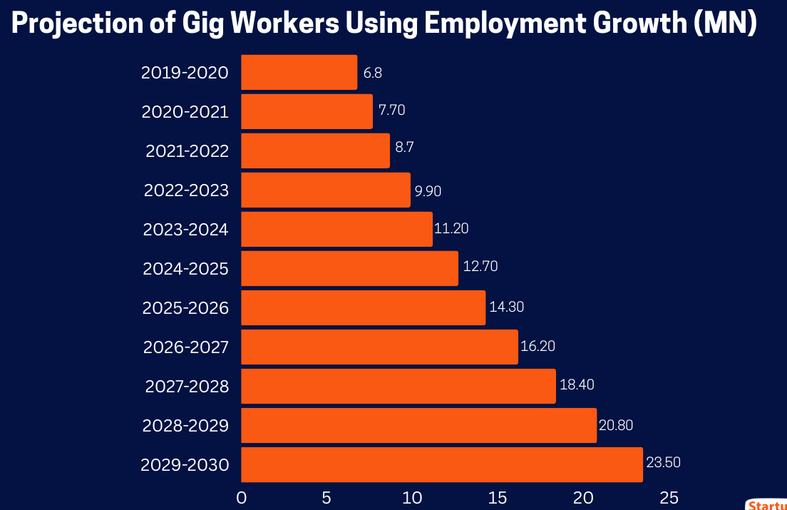
Fig 1: Projection of Gig Workers
Source: (Jadhav and Bajj, 2025)
Skills Churn: Skills half-life accelerating, STEM and digital literacy demand growing. Technology shortens skills. 39% of core work skills will change by 2030. Tech skills, analytical thinking, resilience, creativity, and lifelong learning are valued by employers. HRM must now provide ongoing L&D with technologies that monitor skill obsolescence, forecast future skill needs, and give micro-learning, digital credentials, and fast upskilling (Brynjolfsson and McAfee, 2014)

1.1.2 Implications for HRM/IHRM Strategies
Talent Acquisition
By 2025, 87% of organisations will use AI-driven recruitment, saving 67% of hiring executives time. AI-powered solutions cut costs 30% and hire 50% faster. HR and IHRM must bring flexibility, learning agility, and digital readiness to talent acquisition frameworks beyond sourcing faster.
Learning & Development (L&D)
Video-based micro-learning modules were used in 85% of 2025 training programs. We expect the $312.7 million digital badges and micro-credential sector to rise after 2025. AI helps learning systems adapt to user needs (CIPD, 2024). Create HRM/IHRM learning ecosystems for fast skill renewal, personalised content, and global dissemination..
Strategic HR Planning
Strategic HR planning must integrate full-time, part-time, gig, freelance, and remote global talent. HR must predict position changes when and how as automation and AI shorten skill lifecycles. Reports predict generative AI may reach 37% of workers in 2–5 years. We need skill-flow mapping, workforce composition change scenario modelling, and gig/contract talent model integration with internal workforce pipelines.
HRM Specifics
Remote and digital-platform-enabled workers need global hire, onboarding, engagement, performance, and mobility policies from IHRM. GDPR concerns worldwide employee data processing, but gig-work laws vary by jurisdiction (classification, rights, and rewards). IHRM must ensure global employment laws, cross-border compliance, and gig-worker pool fairness on digital platforms. HR strategy must address global remote workforce management, local-law compliance, digital-platform governance, and cross-cultural team management (SHRM, 2025).
2.0 Question 2: Demographic & Geopolitical Factors

2.1 Key macro-environmental factors and analysing the specific challenges they pose for HR

2.1.1 Key Demographic Factors
Ageing Populations
Many advanced economies are under demographic pressure as population’s age and working-age cohorts shrink. The OECD predicts its member states' old-age dependence ratio (65+ people to working-age population) to climb from 31% in 2023 to 52% in 2060. It is stated that Europe's working-age population has declined since 2014, resulting in fewer new entrants and older workers staying active.
Changing Migration Pattern
Immigration helps labour markets overcome population decline and skills gaps. The 2025 OECD International Migration Outlook shows that migration flows remained high in 2024 and 2025 and that immigrant employment rates in many OECD countries are at historic highs (Dowling et al., 2017). To quickly fill shortages, international recruiting involves immigration constraints, credential recognition, cultural integration, migrant talent retention, and national origin justice and equity.
Increasing Workforce Diversity
As global and mobile labour markets grow, worker diversity increases in nationality, age, gender, culture, employment type, and arrangement. Diverse teams can innovate, but they need advanced HRM practises for inclusion, communication, and cross-cultural collaboration. Ageing workforces, migration, and gig work require HR policies that promote multi-cultural teams, flexible work, language and cultural training, and inclusive leadership.

2.1.2 Key Geopolitical Factors
Trade Wars & Protectionism
US-China tech disputes and EU carbon border policies impact supply chains. World Trade Organisation anticipates global commercial trade will rise 2.6% in 2025, below pre-pandemic levels, due to protectionist measures. The below graph illustrates Asia will lead global merchandise trade volume increase through 2026, with North America and Europe contributing marginally (PwC, 2025).
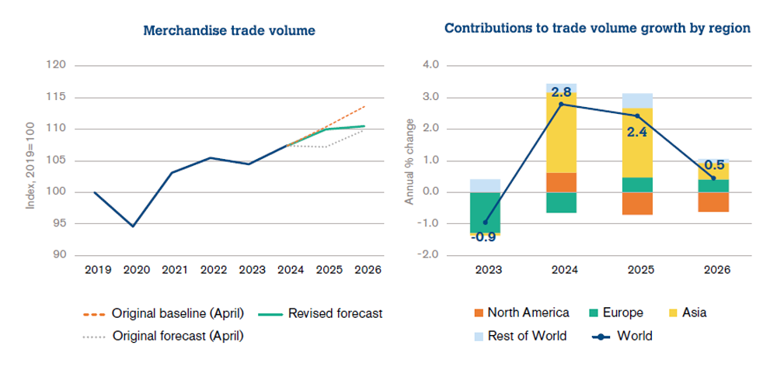
Fig 2: Trade Volume of the company
Source: (World Trade Organisation, 2025)
Political Instability & Sanctions
Multinationals face Russia sanctions, Middle East tensions, and African instability. Compliance and safety considerations make expatriate operations more expensive and dangerous. HR practitioners must manage complex cross-border payroll, tax, and employment-law limits while strengthening duty-of-care frameworks, crisis communication, and flexible assignment models.
Pandemics & Global Health Crises
COVID-19 has standardised remote and hybrid work in businesses. Nearly 30% of workers will work remotely by 2025, estimates ILO. HR must maintain virtual collaboration, health-and-safety, and business-continuity plans during transition. In addition to managing remote teams and digital well-being, IHRM must follow national health and data-privacy laws.

2.1.3 Challenges for HR Professionals
Challenges for HR Professionals | Analysis
Talent Mobility | Global mobility is constrained by evolving visa policies and post-Brexit, U.S., and EU immigration reforms. HR must manage complex cross-border work permits and hybrid work compliance to enable seamless international assignments.
Risk Management | The increasing political tension and natural catastrophes require more robust crisis-management strategies. The HR should make sure the expatriates are safe by implementing duty-of-care systems, travel risk management, and emergency measures.
Compliance | With over 190 national labour systems, maintaining legal compliance is challenging. HR must align global policies with local employment laws, taxation, data privacy (GDPR), and working-time regulations.
Cultural Integration | Diverse global teams require inclusive leadership and cross-cultural training. HR must promote collaboration and communication among dispersed, multicultural workforces to prevent misunderstanding and enhance engagement (PwC India, 2025).
Table 1: Challenges

3.0 Question 3: Skills Gaps & Strategic HRM

3.1 Strategic solutions driven by HRM

3.1.1 Understanding the Causes
Rapid technology advancement, education–industry misalignment, and insufficient workforce development spend sustain global skills gaps. Even though 44% of workers' critical skills will change by 2030, only 50% have sufficient reskilling possibilities. Automation and digitalisation have surpassed schooling, leaving many graduates unprepared for STEM, AI, and data analytics jobs. Global corporate training costs climbed 3% in 2024, behind technology (Cappelli, 2009). The global corporate training market expanded 6.4% from 2023 to 2033, reaching USD 713.5 billion.
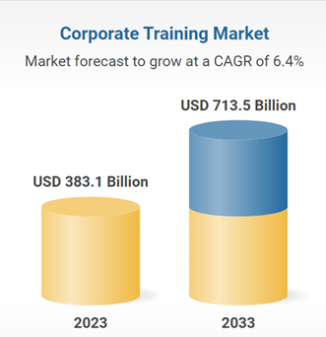
Fig 3: Corporate Training Market
Source: (Research and Markets, 2024)

3.1.2 Strategic HRM Approaches
Strategic HRM Approach | Analysis
Build (Internal Development) | Organisations are prioritising in-house upskilling to close capability gaps. It is noteed that 48% of companies enhanced internal talent development systems, while here is a 24% rise in corporate apprenticeship enrolments worldwide. This approach strengthens loyalty and culture but demands sustained investment.
Buy (Strategic Recruitment) | External hiring remains vital for high-demand roles. 63% of firms rely on external recruitment for digital and AI positions amid a global tech skills shortage exceeding 85 million workers. It enables speed but raises acquisition costs and retention risks.
Borrow (External Talent) | The global freelance and gig workforce surpassed 520 million people in 2024, valued at over US $550 billion (ManpowerGroup Insights, 2025). Borrowing specialists offers flexibility and cost efficiency, yet poses challenges in knowledge retention and quality control for HR.
Bind (Retention) | Retention is critical in tight labour markets, 26% of employees plan to switch jobs within a year. HR responses include mentorship, career-path mapping and learning cultures to reduce turnover and safeguard institutional knowledge (ManpowerGroup, 2025).
Table 2: Approaches

3.1.3 Sector-Specific Examples
Tech: A 4.3 million-person technology industry digital and AI talent shortfall is expected by 2030. IBM and Microsoft "build" talents using internal coding bootcamps and AI academies. Programs retrain workers in data analytics, cybersecurity, and automation. Companies can “borrow” freelance AI professionals and developers on global digital marketplaces for project continuity and innovation.
Healthcare: Worldwide, WHO (2025) predicts a 10 million nurse-midwife shortage by 2030. Thus, hospitals and health systems in wealthier nations like the UK, Canada, and Germany are increasing “buy” tactics through large-scale Asian and African recruiting. Overreliance on overseas recruitment poses ethical and retention issues. Healthcare organisations use “bind” methods including wage rises, job development, and well-being programs to retain staff..
Hospitality: Post-pandemic hospitality rebound has intensified skilled labour competition. Expect 14 million more jobs by 2026 to meet demand. Marriott and Hilton internal management schools teach leadership, service, and sustainability. Employers use social media, recruiting fairs, and tourism school alliances to attract young workers..

4.0 Question 4: Reflective Report on Capabilities

4.1 Self-assessment and a proactive plan for development

4.1.1 Introduction
Leading in today's interconnected corporate environment requires global and flexible MBAs. Cross-border companies need professionals that can handle cultural diversity, technology, and market changes. It isfound that companies value adaptability, analytical thinking, and cross-cultural teamwork. MBAs can manage international teams, use digital technologies, and innovate in difficult conditions with these talents.

4.1.2 Self-Assessment
Technology
Description: In my MBA, I relied on the collaboration tool of MS Teams, data analysis tools of Excel and SPSS, and research synthesis tools of ChatGPT. These tools play a very important role in group and academic management.
Feelings: I was initially overwhelmed by the number of digital platforms, but with the frequency of use, I have gained confidence in becoming more accepting and adopting new technology.
Evaluation: This skill in utilizing various digital tools enabled me to become more productive and data-oriented in my thinking, but I also became aware that I use more fundamental analytical capabilities.
Analysis: The HR practitioners in the contemporary world need to be techno savvy as the evidence based decision making demands data. Lack of Power BI and Tableau knowledge prevents the visualisation of insights.
Conclusion: I have a good attitude towards digital systems, but it is paramount to develop competencies in data-visualisation.
Action Plan: By a middle of 2025, I will accomplish increased Power BI and Tableau training to enhance my data-interpretation and HR analytics capacity.
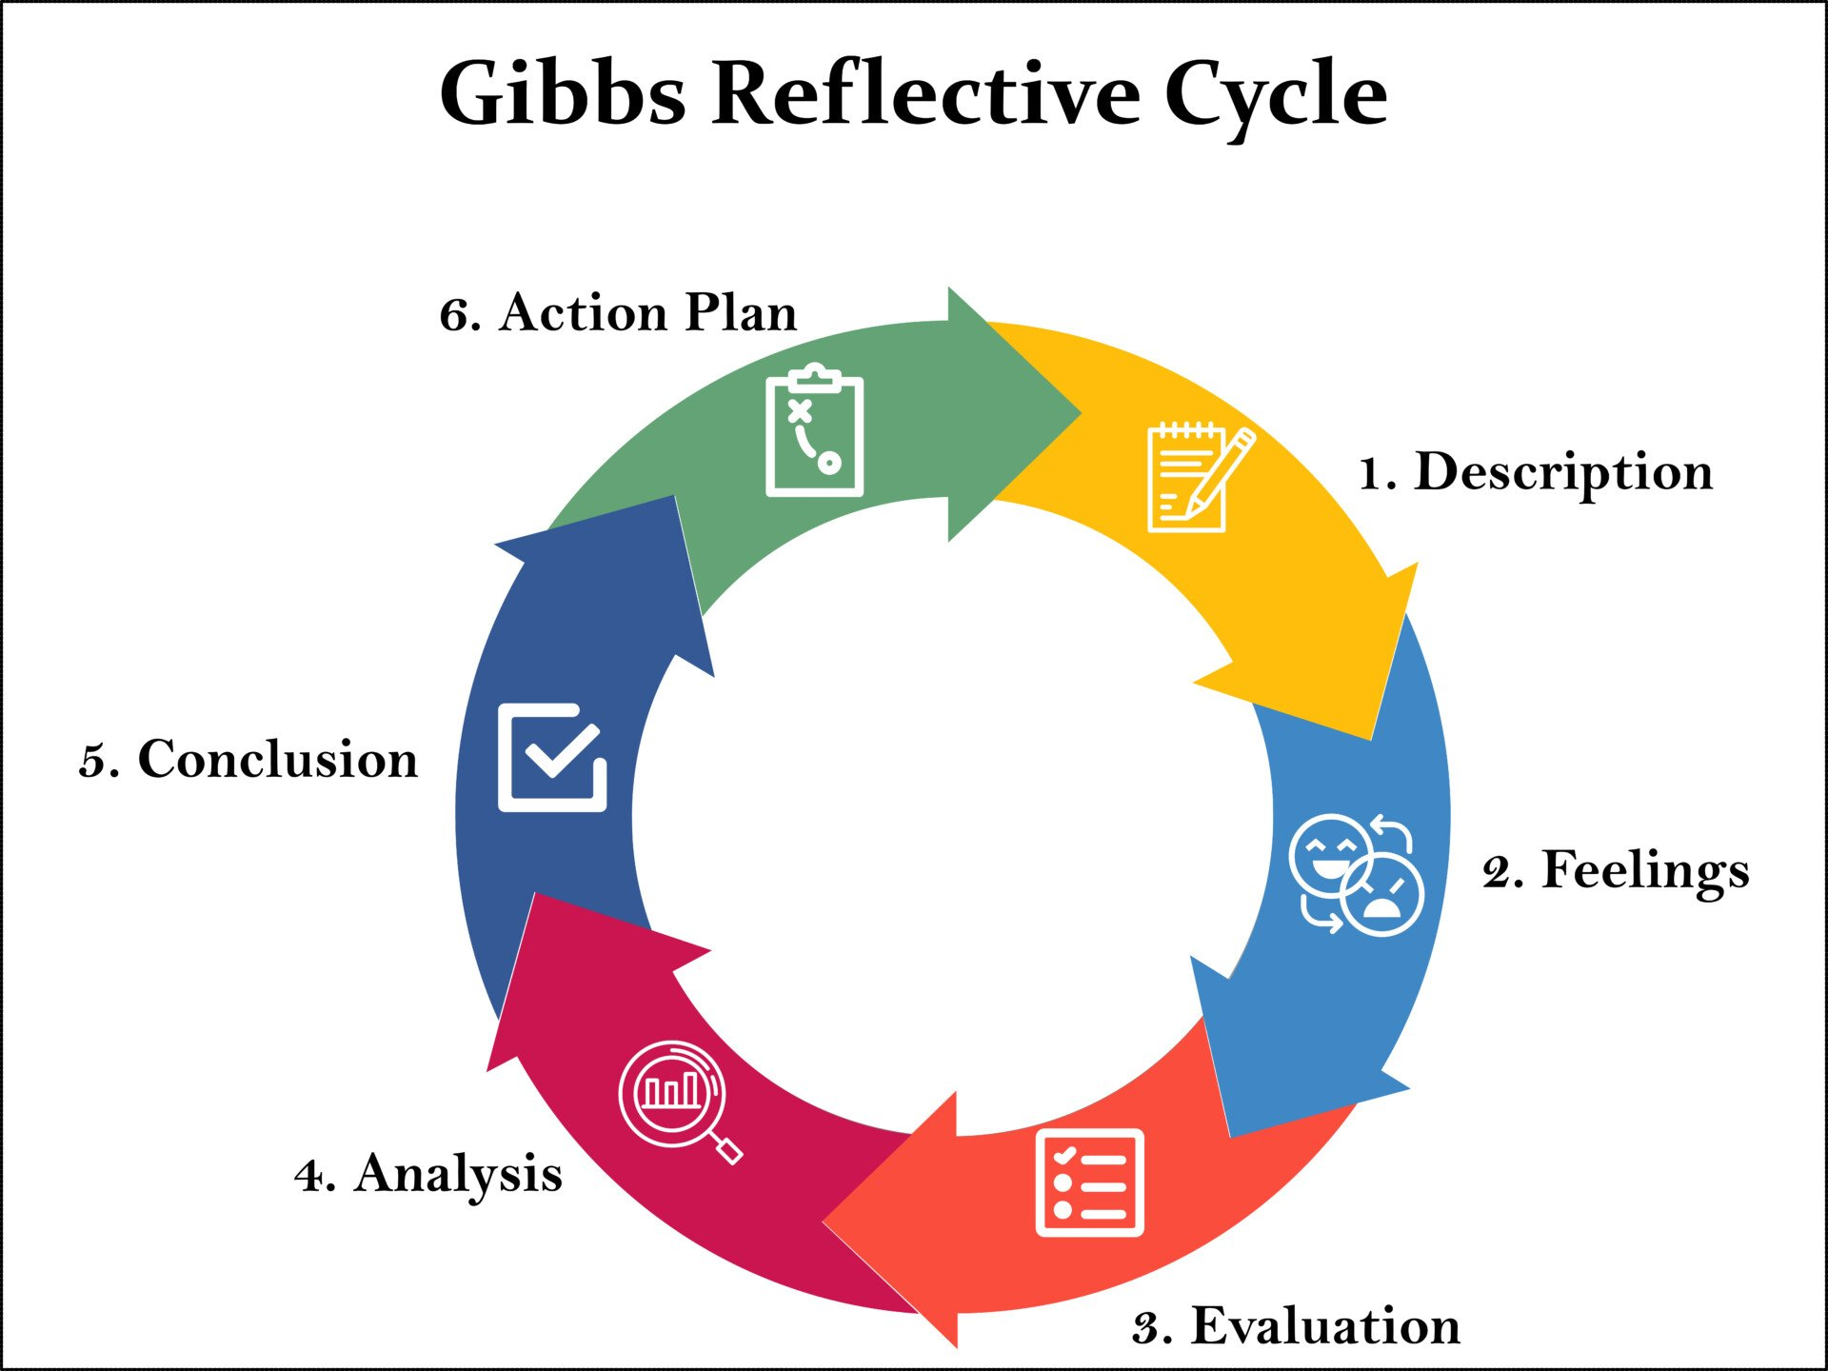
Fig 4: Gibbs Reflective Cycle
Source: (Simply Psychology, 2025)
Communication
Description: My presentations and written reports in the MBA were very well reviewed on clarity and logic.
Feelings: I was confident in formal communication and less so in informal and on-the-fly speaking cases.
Evaluation: The communication was effective in written and planned form, however, there were cases when I was not fluent and confident in impromptu multicultural group discussion.
Analysis: Global communication also entails agility, cultural sensitivity and real-time confidence. Little practice in the outside world retarded my progress.
Conclusion: I am a good communicator in formal situations but need to learn how to be spontaneous and verbally assertive.
Action Plan: In the coming six months, I will attend professional-networking events and discussion forums to gain experiences in oratory and improvement in intercultural communication.
Teamwork
Description: I organized deadlines, delegated work and also solved conflicts in team projects.
Feelings: Time zone virtual relationships were challenging, yet I enjoyed job working and promoting teamwork.
Evaluation: The cooperation and the accountability had made the teams successful, but at times the virtual coordination slowed down the communication.
Analysis: The collaboration and transparency can be improved with the help of agile practices and digital project-management technologies.
Conclusion: I am a good team player in the field who requires improvement in virtual and international environments.
Action Plan: To enhance the management skills in operating a virtual team in a different location.
Leadership
Description: I volunteered a lot to summarise the results and lead discussions when we were doing our operations-management assignment.
Feelings: I was inspired by the fact that I was able to lead, but felt reluctant to be authoritative in times of high pressure.
Evaluation: My leadership style of participations facilitated teamwork, but lack of decision-making impeded key actions (Gibbs, 1988).
Analysis: On high stakes projects, a leader has to strike a balance between cooperation and aggressiveness.
Conclusion: My leadership approach encourages interaction and requires greater confidence and tactical determination.
Action Plan: By the year 2025, I will be committed to a Leading Global Teams certification and also mentor with an experienced project leader to enhance my cross-cultural leadership competency.
Self-Directed Learning
Description: I was reading over and above what was required in the MBA, and I was working with cases outside of the school, and I was handling numerous projects.
Feelings: I was reading over and above what was required in the MBA, and I was working with cases outside of the school, and I was handling numerous projects.
Evaluation: This self-discipline enhanced the depth of my analysis and research quality though I did not always have a progress monitoring mechanism.
Analysis: Professional development is dependent on lifelong learning and reflection. In the absence of quantifiable objectives, improvement will be hard to assess.
Conclusion: Professional development is dependent on lifelong learning and reflection. In the absence of quantifiable objectives, improvement will be hard to assess.
Action Plan: In order to advance above the MBA, I will begin with a quarterly personal development tracker, and obtain HR analytics and AI ethical micro-credentials.

4.1.3 Development Plan
Leveraging Strengths: I will benefit from self-directed learning and digital adaption in the changing workplace. I quickly master new technologies and join digitally savvy companies that use HR analytics and AI. These and my proactive learning attitude help me meet industry demands.
Addressing Weaknesses: I lack cross-cultural team leadership expertise and struggle to manage diverse perspectives. I will offer to manage the next multicultural team project during my MBA and request official team feedback on my leadership style. By June 2025.

Conclusion
According to global labour market dynamics, technology, demographics, and geopolitics impact HRM and IHRM. AI, automation, and digital platforms transform job structures, therefore HR must intervene in digital upskilling, flexible workforce planning, and ethical data management. Changing and ageing populations necessitate flexible, intergenerational workforce policies.

References
Brynjolfsson, E. and McAfee, A. (2014). The second machine age: Work, progress, and prosperity in a time of brilliant technologies. WW Norton & company.
Cappelli, P., (2009). Talent on demand–managing talent in an age of uncertainty. Strategic Direction, 25(3).
Chartered Institute of Personnel and Development (CIPD) (2024). ‘Analysis | Quantifying the impact of generative AI on HR’. Available at: https://www.cipd.org/en/views-and-insights/thought-leadership/insight/quantifying-impact-generative-ai/
Dowling, P. J., Festing, M., and Engle, A. D. (2017). International Human Resource Management. Cengage Learning.
Ernst & Young (EY) (2024) ‘EY Work Reimagined Survey 2024 – GenAI adoption at work’. News release, 8 November. Available at: https://www.ey.com/en_cy/newsroom/2024/11/news-release-ey-reimagined-survey-2024
Gibbs, G. (1988) Learning by Doing: A Guide to Teaching and Learning Methods. Oxford: Further Education Unit. Available at: https://my.cumbria.ac.uk/media/MyCumbria/Documents/ReflectiveCycleGibbs.pdf
Global Partnership for Education (2020) 21st Century Skills: What Potential Role for the Global Partnership for Education? A Landscape Review. Paris: GPE. Available at: https://www.globalpartnership.org/node/document/download?file=document%2Ffile%2F2020-01-GPE-21-century-skills-report.pdf
ManpowerGroup (2025). Talent Shortage Survey 2025: Global – Nearly 74% of employers say they’re struggling to find skilled talent. Available at: https://go.manpowergroup.com/talent-shortage.
ManpowerGroup Insights (2025). Global Talent Barometer June 2025 – shows skill confidence vs employer skill readiness gap. Available at: https://www.manpowergroup.com/en/insights/report/global-talent-barometer-june-2025-global-report.pdf
PricewaterhouseCoopers (PwC) (2025) Megatrends: Revisiting the Megatrends. Available at: https://www.pwc.com/gx/en/issues/megatrends.html
PricewaterhouseCoopers India (PwC India) (2025) Making the Case for Global Workforce Migration: A Strategic Blueprint to Harness India’s Demographic Dividend. Available at: https://www.pwc.in/assets/pdfs/making-the-case-for-global-workforce-migration.pdf
Society for Human Resource Management (SHRM) (2025). ‘The evolving role of AI in recruitment and retention’. Available at: https://www.shrm.org/labs/resources/the-evolving-role-of-ai-in-recruitment-and-retention
World Economic Forum (2025). The Future of Jobs Report 2025. Geneva: World Economic Forum. Available at: https://www.weforum.org/publications/the-future-of-jobs-report-2025/
Image Reference
Jadhav, S. and Bajj, A. (2025) ‘Industry trend analysis: The gig economy in 2025: Trends, opportunities, and challenges’, StartupTalky, 14 April. Available at: https://startuptalky.com/gig-economy-trends/
Research and Markets (2024) 2024 Corporate Training Research Report: Market Projected to Surpass $713 Billion by 2033. Available at: https://www.globenewswire.com/news-release/2024/11/07/2976800/28124/en/2024-Corporate-Training-Research-Report-Market-Projected-to-Surpass-713-Billion-by-2033.html
Simply Psychology (2025) ‘Gibbs Reflective Cycle’, Simply Psychology. Available at: https://www.simplypsychology.org/gibbs-reflective-cycle.html
World Trade Organization (2025) AI goods and front-loading lift world trade in 2025 but outlook dims for 2026, 7 October. Available at: https://www.wto.org/english/news_e/news25_e/stat_07oct25_e.htm

Appendix
SWOT Analysis
SWOT | Analysis
Strengths | I possess strong digital adaptability with proficiency in MS Teams, SPSS, Excel, and AI tools such as ChatGPT. My written and structured communication skills have been consistently praised in assessments. I demonstrate effective team coordination and conflict-resolution abilities and maintain a high level of self-discipline and motivation toward continuous learning.
Weaknesses | My background in the field of advanced data-visualisation software such as Power BI or Tableau is weak, and I feel anxious when forced to improvise a speech in front of strangers. Furthermore, I should become more assertive when I am leading high-stakes or culturally diverse teams to make sure that there is confidence in making decisions.
Opportunities | To enhance my analytical and leadership skills, I can take the certifications in the field of Leading Global Teams and HR analytics. Participating in cross-cultural and remote team management international virtual projects will enable me to gain experience, and attending professional HR events and networks would broaden my industry network.
Threats | Unless my skills are continuously kept up to date, rapid technological changes may outpace me. Increasing competition throughout the world in obtaining managerial jobs can complicate the career advancement, and excessive use of collaborative leadership will limit the power in the structured or hierarchical setting.

