Daniel Thomas (2003824)
BA Computer Games Design
User Experience Design
ACCA6034
User Experience (UX) Design Analysis

Initial Review 2
UX Design Principles 4
UX Analysis 5
Recommendations for Improvement 9
Conclusion 9
References 10
Bibliography 10

Initial Review
The product I’ve decided to review for this assignment is the Steam online website [1]. Steam is a program which allows you to buy and play video games, and while there are dedicated programs, apps, and even its own console for it, there’s also an online website where you can browse and buy games as well, essentially acting a browser version of the program or app. Upon opening the site, the first thing you’ll see is a large banner of a game, which you can click at to go to its store page. Aside from that, the background of the site consists of dark blue and black, just like the logo of the brand.
You can also see two drop-down menus, which act as a good way of navigation to other parts of the site, especially Categories and its wide selection of options. There’s also a search bar to make it even easier to get to a page of a game you know.
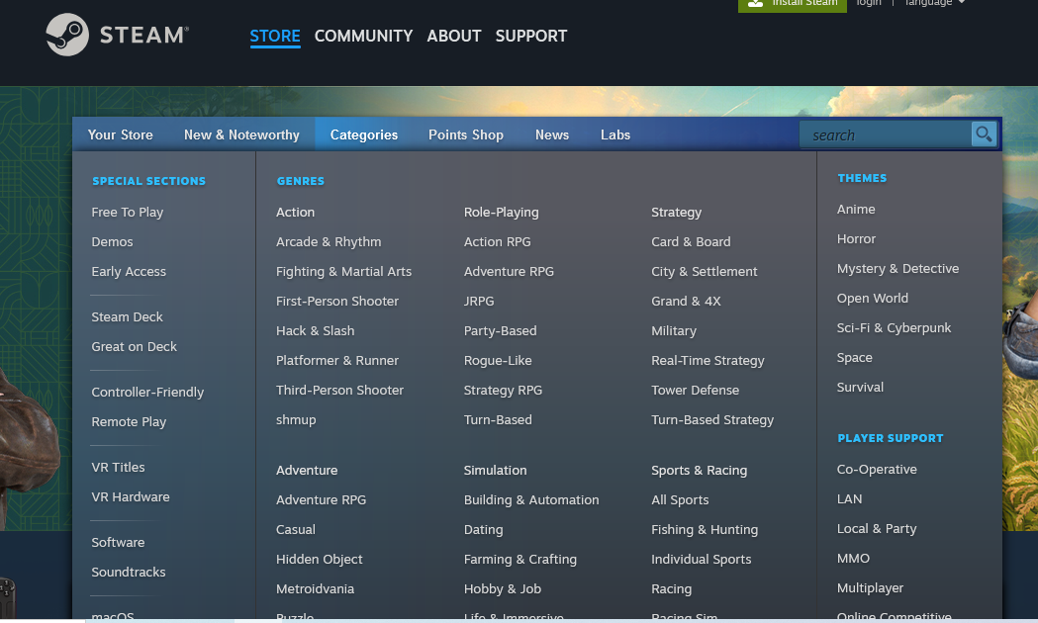
Scrolling down reveals more games, namely a set of 12 featured and recommended games, all with a group of images so you can see more of it. Below is another set of popular games, whether it be from a special offer or if it got updated recently. The side also has a lot of links, serving as another way to navigate from pages, which is good as the two drop down menus at the top don’t scroll down with the site.
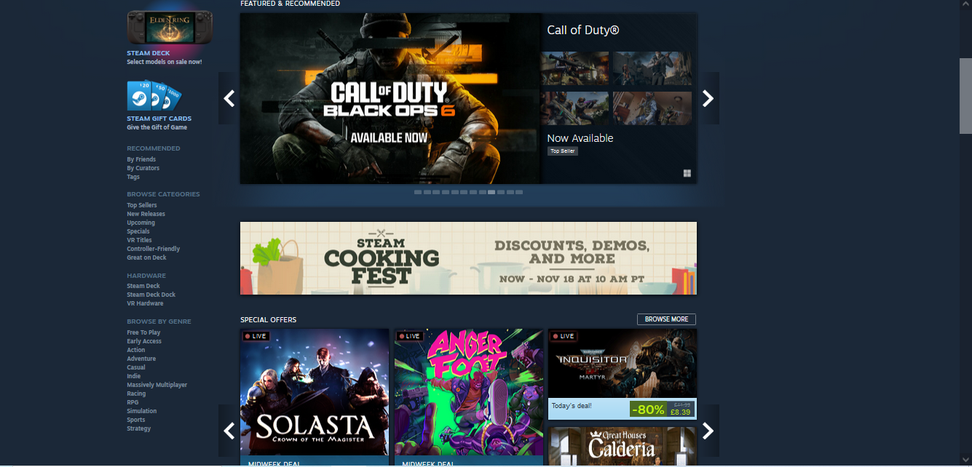
On a game’s page [2], the site gives you a lot of ways to find out more about it. The first thing which will catch your attention is the images of the game, which also include videos, often trailers made by the developers. The side of that also shows more information, such as the genre of the game, the developers, as well as any other way to find out about them and their game through other sites, and the reception. Scrolling down shows more written information about the game, as well as the specs required to run it, which is good as the viewer knows exactly what they need to be able to play it optimally. The bottom of the page also shows similar games, acting as a way to lead the viewer to new games. The online site has this pop-up prompting you to use the application instead, likely as it’s faster as it remembers your details as you sign in, but still allows you to view the page. Helping this is also the fact the “Install Steam” button can always be found on the top of the page too. It doesn’t let you minimize the pop-up however, and it’ll stay on the top of the page.
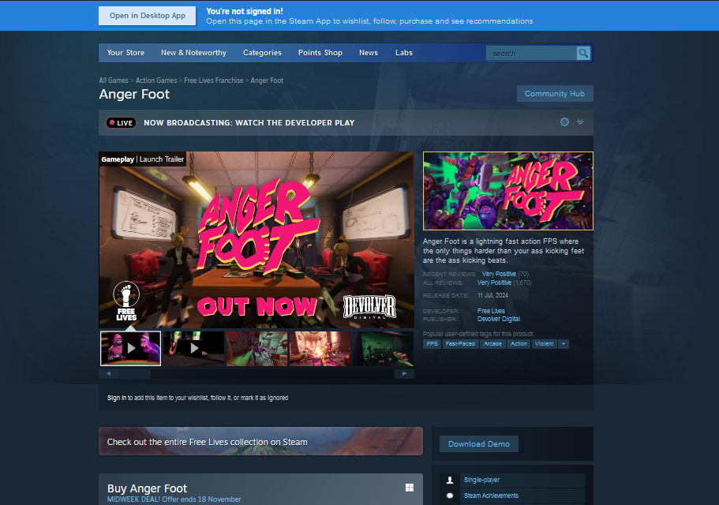

UX Design Principles
In UX design, there are many principles used or focused on to improve a user’s experience on the site. One of the most important of these is user-centered design, where the design tries to be as beneficial to the user’s needs as possible. This involves understanding the target audience of the userbase and considering the age, gender, demands and product expectations while making the design of the site and basing it around those factors. It’s a process more about designing a product to be understood by the users rather than being something they’re going to have to adapt to. [3]
Another principle which ties into this is usability. Not only should the site be easy for users to understand, but it should also work efficiently too, so that the user can do what they want without any frustration and in a way which doesn’t make them want to leave [4]. To make this work, the site has to be user tested by users who’ve never used the site before, as this makes it a good way to see how new users would see the site and you can adapt the site based on the most common reactions.
Similarly, accessibility means for the site to be accessible to all users, disabled ones included, as well as users using a different device. To make this fair, the design needs to account for principles such as audio accessibility, mobility considerations, different forms of input and contrast, so that there are still ways for the users to view the site. [5]
Consistency is an important part of UX design and is the idea that the site generally keeps the same type of layout for a number of pages. This is so that the user doesn’t have to adapt to the changes a page makes to the layout frequently. This is known as internal consistency and is something that needs to be accounted for elements like menus and typography. External consistency is based around the web industry as a whole, and is where a common element on many sites, such as a button or a search bar, should work as the user expects it to do on those sites, as “users should not have to wonder whether different words, situations, or actions mean the same thing” [6].
Another important principle of UX design is visual hierarchy, which is where elements, such as menus and icons are arranged by importance of their order, acting somewhat as a guide so that the user can understand them more easily. This can be altered by size, repetition, or the whitespace of an element [7].

UX Analysis
Going back to the Steam website, its navigation is well done as there are numerous ways to traverse to different parts of the sites, be it the drop-down menus at the top, the links at the side, or other image hyperlinks to game pages. The site’s information architecture is also good, as the site also labels what the game is being shown by, namely by offers, which the site makes it clear what it is along with image of the game by using bigger typography. Furthermore, hovering over the image of a game will most likely make another text box show up next to it, listing the genre of the game, as well as some reviews, meaning not only is this a good way to find information, but if you want to find out more you can just click on the image’s hyperlink to get to the game’s page.
The visual design of the site is quite dark, being a range of dark blue and black for the background. This is accompanied by a lighter blue or white colour for typography and pop ups, which makes them stand out over the darker background. These sort of colours are similar to other sites, such as Discord or YouTube’s, dark mode, where it chooses darker colours. However, unlike those sites, there is no option for a light mode with brighter colours. The layout of the site plays off this though, having a lot of images of games all the way down the middle, giving the site a variety of colour while still sticking to its purpose of showing off games. More recommended and featured games are usually given bigger images on the main page, and most of them are grouped together in a box-like format. On a game’s page, the media of it will likely be the first thing you see, as it’s big and right in the middle, prompting the user to look more into it. This is an example of visual hierarchy on the site. The page also allows you to switch through pictures as a gallery, being a way of not cluttering the page with lots of them.
The menus and buttons on the site work fairly conventionally, staying consistent with most other sites. The extended options of the drop-down menu take about a quarter second to show after hovering down the menu. The only problem I feel is that not every option on the initial top menus is a drop down, some just being regular links with no visual indication that they’re a bit different. All the elements that look like buttons on the site are links to another part of the site, including the “Install Steam” button at the top of the page. That link then takes you to a page with a bigger button saying “Install Steam”, which downloads the setup onto your device if you click it on desktop. The language button at the top also shows a drop down of languages, instantly refreshing the page and changing to the selected language when the option is picked.
A big downside of the site so far is that, at least without an account, the site isn’t very accessible. Not only is there not a lighter mode for being who do need it, but there’s also a lack of options to change the size of elements outside just changing it from the browser itself. Even if it’s less likely the site’s target audience, gamers in the 20s age range [8], would need help with this, it makes the site automatically not accessible to everyone it could be.
Now looking at the site on a mobile browser, it hides away some things to make up for the smaller screen capacity. It still has the same selection of games, and they show up pretty big, now needing you to swipe across them to see all of them. Switching from portrait to landscape just makes the site wider, and you’d still probably have to scroll the same amount. While there is a menu and a search bar at the top, another menu is tucked away by a drop down in the header, though this means it's accessible at all times since it stays at the top of the screen as you scroll down.

The store page is also pretty similar to its desktop counterpart, still having the media of the game and you having to scroll across to see more of it, though you’ll likely have to scroll down to see it compared to the desktop showing it front and centre, so the visual hierarchy is a bit worse despite how much room the pictures take once you scroll down to see them. The mobile site also gives you the option to download the app at the top of the page, taking you to whatever app store you have on your device when tapped.

Signing into the site with my preexisting account, the site adapts to the user, now having a selection of games on the home page based on games you’ve played before. This also carries over to the game pages, now giving a little highlight if the game’s recommended or not based on other games you previously played. This is very user-centered, and it encourages people who’ve used the program already to keep using it. I also noticed that even without an account, the site still kept track of what game page I visited.
The load times between both versions of the site are quite fast, which is good for usability as the user doesn’t have to wait too long to get to page to page.

Recommendations for Improvement
As I said before, the site’s biggest problem is its lack of accessibility options. There’s little to no customization to the elements on the site, even with an account. This is a problem for users with a disability which makes it difficult to see certain elements. For example, Discord, despite having darker colours on default, still has a mode with brighter colours, and light modes are generally a good option to have as they come with benefits such as enhancing readability and potentially causing less eye strain for some users [9]. A mode with lighter colours would make the site more accessible to people who have those problems.

Conclusion
In conclusion, there are many principles needed to make a site as best for the user as it can be. This includes layout, usability, accessibility, visual hierarchy and consistency, all being things which, when done right, can make the site a lot easier to use. While Steam is lacking in accessibility options, it still has a good layout, with tons of ways to navigate, and it shouldn't be a problem for the user to find what it’s looking for.

References
[1] Welcome to Steam, Steam (Online) Accessed: 10/10/2024, Available: https://store.steampowered.com/
[2] Anger Foot, Steam (Online) Accessed: 10/10/2024, Available: https://store.steampowered.com/app/1978590/Anger_Foot/
[3] “User-Centered Design: An Introduction”, Ekaterina Novoseltseva, Usability Geek (Online) Accessed: 20/10/2024, Available: https://usabilitygeek.com/user-centered-design-introduction/
[4] “Usability 101: Introduction to Usability”, Jakob Nielsen, Nielsen Norman Group, January 3 2012 (Online) Accessed: 20/10/2024, Available: https://www.nngroup.com/articles/usability-101-introduction-to-usability/
[5] “Accessibility in UX Design: Guidelines and Key Principles”, Ramotion, May 25, 2022 (Online) Accessed: 20/10/2024, Available: https://www.ramotion.com/blog/accessibility-in-ux-design/
[6] “Maintain Consistency and Adhere to Standards (Usability Heuristic #4)”, Rachel Krause, Nielsen Norman Group, January 10, 2021 (Online) Accessed: 20/10/2024, Available: https://www.nngroup.com/articles/consistency-and-standards/
[7] “Visual Hierarchy”, Interaction Design Foundation (Online) Accessed: 20/10/2024, Available: https://www.optimalworkshop.com/blog/information-architecture-vs-navigation-creating-a-seamless-user-experience

[8] “Steam User and Demographic Statistics (2022)”, Sidetrain (Online) Accessed: 09/11/2024, Available: https://sidetrain.com/guides/steam-user-demographic-statistics
[9] “Light Mode vs. Dark Mode: What is Better for UX?”, Mukul Sharma, SoluteLabs, 14 March, 2024 (Online) Accessed: 09/11/2024, Available: https://www.solutelabs.com/blog/light-vs-dark-mode

Bibliography
- “User-Centered Design: What It Is and How to Do It Right”, Jenny Romanchuk, Hubspot, April 18, 2022 (Online) Accessed: 20/10/2024, Available: https://blog.hubspot.com/website/user-centered-design
- 7 Essential UX Design Principles And How To Apply Them, Ramotion, Jun 1, 2021 (Online) Accessed: 20/10/2024, Available: https://www.ramotion.com/blog/ux-design-principles/
- Principle of Consistency and Standards in User Interface Design, Euphemia Wong, Interaction Design Foundation, 2021 (Online) Accessed: 20/10/2024, Available: https://www.interaction-design.org/literature/article/principle-of-consistency-and-standards-in-user-interface-design?srsltid=AfmBOooHVJv3X6jzYCl36GfwsuMJr7KC4haPBO8IwbUGI_p-0jHhOPMo
- “The Difference Between Information Architecture (IA) and Navigation”, Jen Cardello, Nielsen Norman Group, June 22, 2014 (Online) Accessed: 4/11/2024, Available: https://www.nngroup.com/articles/ia-vs-navigation/

