Ways of Perceiving
ADAD4010

The Precarious Teenager

Julia Lockheart
Ryan Moule
Scott L Smith
Gwen Beynon
Rob Jones
Martin Bush

Word count - 1467

This essay discusses the accoutrements of social media, researching the effects, along with its potential problems and darker forms. The exhibition is designed to show the negative effects of social media, including cyber bullying and internet addiction; focusing predominantly on the younger generation.
‘Prevalence rates of having bullied others or having been bullied at school for at least once in the last 2 months were 20.8% physically, 53.6% verbally, 51.4% socially, or 13.6% electronically. Boys were more involved in physical or verbal bullying, whereas girls were more involved in relational bullying. Boys were more likely to be cyber bullies, whereas girls were more likely to be cyber victims. African-American adolescents were involved in more bullying (physical, verbal, or cyber) but less victimization (verbal or relational). Higher parental support was associated with less involvement across all forms and classifications of bullying’ (Wang et al, 2009).
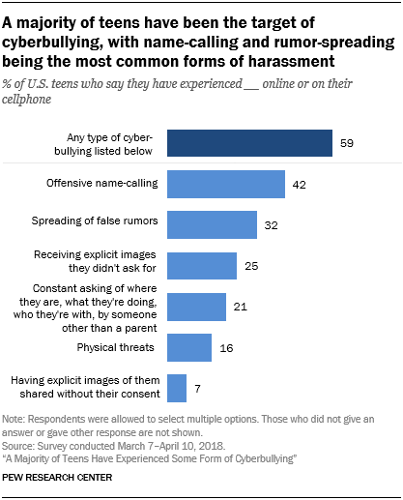
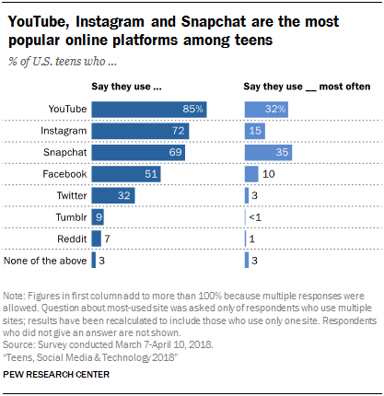
This paper was published 10 years ago. It is highly likely that these percentages have increased, due to more adolecents being given their own online devises. In 2018 Anderson & Jiang published an article stating that 95% of teenagers now have access to smart phones and 45% say they are online almost constantly.
Five pieces of art have been carefully selected for maximum impact. The joyless and precious nature of this curation will help people to recognise the truth about social media, within their own lives.
The imagined space chosen, is to maximise the impact of the exhibition. The viewer is introduced to a warm, well-lit, corridor. This will encourage the audience to feel calm and relaxed. This is where the first piece of the exhibition will be displayed. As they move onto the landing of the descending staircase, nothing seems untoward. As the viewer descends the spiral staircase, they are introduced to a few chosen negative comments. Comments that have been targeted at social media stars. Moving down the staircase, the atmosphere, starts to get colder, darker and more unsure. Going further into darkness. At the very bottom, they will be introduced to a dark, damp and very cold room, with an old-style computer at the end (possibly late 90s). The only way out of the room is by taking part in an online game. This interactive experience is designed to inflict maximum impact on the realisation of how dangerous the internet can be. Once the viewer has completed this, they can then leave. Having the audience being placed within this environment is one of the key points for the exhibition. The idea of the viewer starting off feeling calm and warm, lulling them into a false sense of security, similar to how some online predators work. Giving false hope, kindness and encouragement. As they eventually get to the bottom, they are witnessing some hard truths about social media addiction and cyber bullying. The exhibition will end in a dark, cold room to signify how cold and lonely it can be for the victims of these social media attacks. Feeling isolated and alone, too frightened to speak up.
The main point of the exhibition is to immerse the viewer and to utilise active learning. Giving them first hand experiences and allowing them to come to their own conclusions about these experiences (Petty 2014).

The first chosen piece is of entrepreneur and self-made billionaire Kylie Jenner. Well known for her online social media presences. Miss Jenner is heavily featured on Instagram, advertising her own make-up brand, Kylie Cosmetics. These simple photos attract millions of likes from other users across the globe. Many teenagers aspire to be like her, following her trends and journey. Kylie Jenner comes across as a good role model on line. She does not glorify many negative aspects of modern living, unlike some other social media stars who can take things too far all in the name of attention, e.g. dangerous selfies (Hewson 2016).



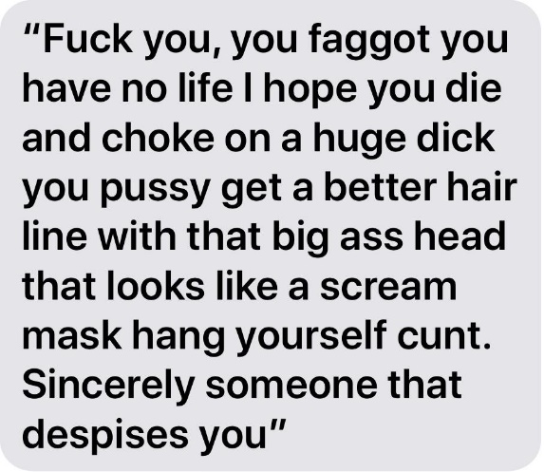
For the second piece in the Precarious Teenager exhibition, I have chosen negative comments targeted at social media stars, influencers and content creators. This is the sort of negativity they face every day. The price for being a public figure online. What I want to show is that these kinds of comments also get targeted at teenagers from all backgrounds. The unfortunate side of this is they are not used to this kind of; attention, social media bullying and negative attention. This will make victims feel very isolated and alone. They can start to feel depressed, some turn to self-harming, feeling body conscious, ugly and not good enough. It’s not just the victims of these comments that might be reading them during the exhibition. They may even be read by some, who have written similar comments about others themselves. Hopefully, helping them to see the other side of social media bullying and the effects it can have on their target.
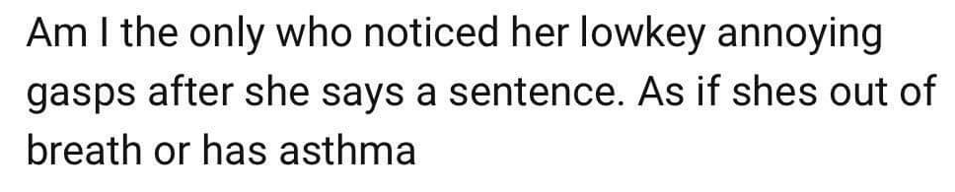
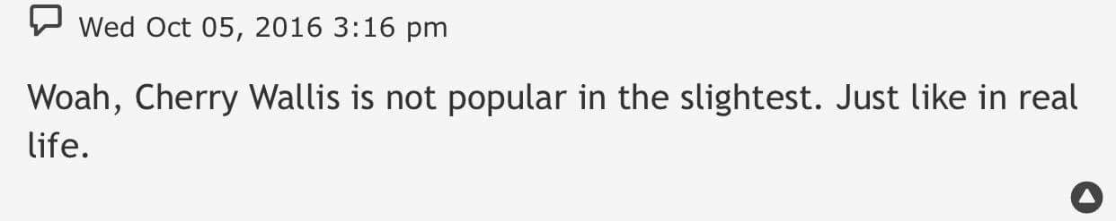
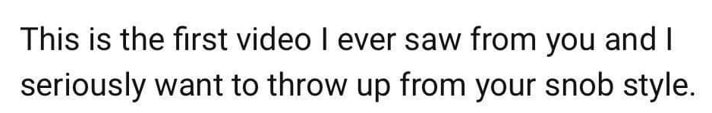
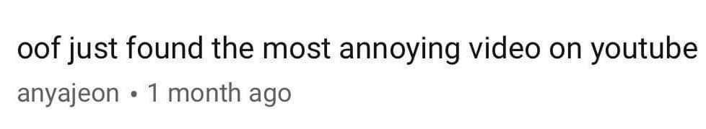

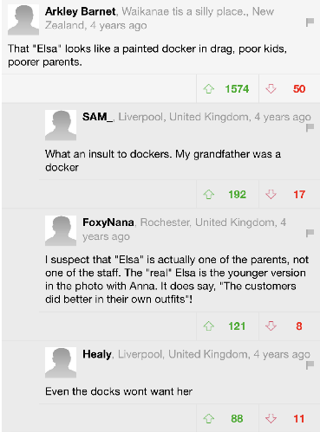

Here is an example of a good deed going punished. A charity worker, performing as a Disney character for children at a local event that turned sour quickly. This lady was part of an event that was later targeted by the press for its poor organisation and overcrowding. The article went viral and this innocent performer became the target. Here are a few examples of the sort of comments that were posted on this news site. The point of the event was missed, and the lady became the target for online trolls. These comments and picture have been chosen to show that you don’t have to be a huge name in the social media world, to become a target for online trolls.

The fourth piece is a short animated social media addiction video. This shows the hard truths of our social media addictions and how it has elevated to the worst possible outcomes. 13 seconds in to this short video, we see a character being attacked by a group of others, all while being filmed by on lookers. This represents an older social media trend, Happy Slapping. This was a craze created on school playgrounds. It involved an innocent pupil being hit across the head out of the blue by another pupil, all while being filmed. The video would be sent to other students for entertainment. This quickly went out of control, ending in some students being admitted to ICU for severe head injuries. In 1991, Tango introduced the nation to the now-infamous "Orange Man". The advert, featuring a bald assailant slapping the face of a Tango-drinker It was widely credited with sparking a wave of copycat attacks across the country. As folklore goes, many a school-child was left with perforated ear-drums as a result of being Tangoed too hard. The phenomenon is seen by many as a spiritual predecessor to happy-slapping. (Harrison 2018)
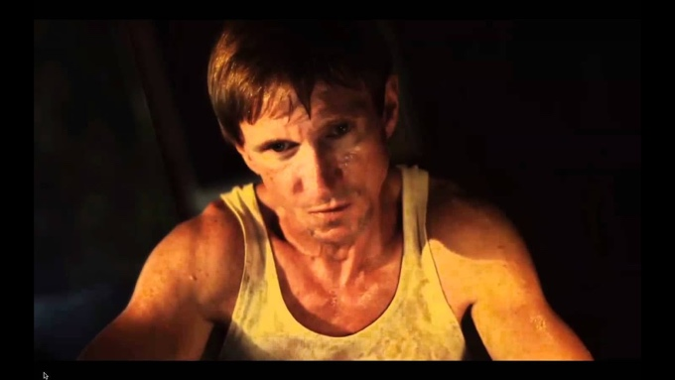
This video also shows the consequences of cyber bullying, with a young girl being filmed dancing at a club. When the video goes viral, she is mocked and humiliated by strangers. The sad truth at the end of this short video, is that these actions, of strangers, drives her to commit suicide. All because of being filmed in the name of entertainment. This is so true to life and a very sad fact within our society. If these sorts of short films were shown within schools, would this decrease the amount of cyber bullying that occurs? Would it make the bully rethink his or her next comment? Would it help the victim to see that they are not alone? This part of the story, within the video, only lasts 31 seconds but truly hits home. It’s so true to life when there are so many young girls who are the victims of social media bullying.

‘Take this lollypop, I dare you’, a short interactive online movie experience is the 5th and final piece within this exhibition. Specifically created for the Halloween festivities by Jason Zada in 2011. It shows the potential darker side of the web, accessed through the users own Facebook accounts. The video immerses the user into the darker side of the web, by being artificially stalked by an online villain. I have chosen this piece because it is a, seemingly, accurate portrayal of teenagers trusting complete strangers within social media. Teenagers tend to believe what they see on line, who they speak to and what people are telling them. All within the context of a text message or a comment. It may be beneficial to educate them on the dangers of social media, and to not take things at face value.

Once the experience is over, it is hoped that the viewers will reflect upon what they have seen, and use the results to educate themselves in their own lives. With victims gaining reassurances that they are not alone, and for the potential perpetrators to think twice before posting their next comment and the damage they could have caused.

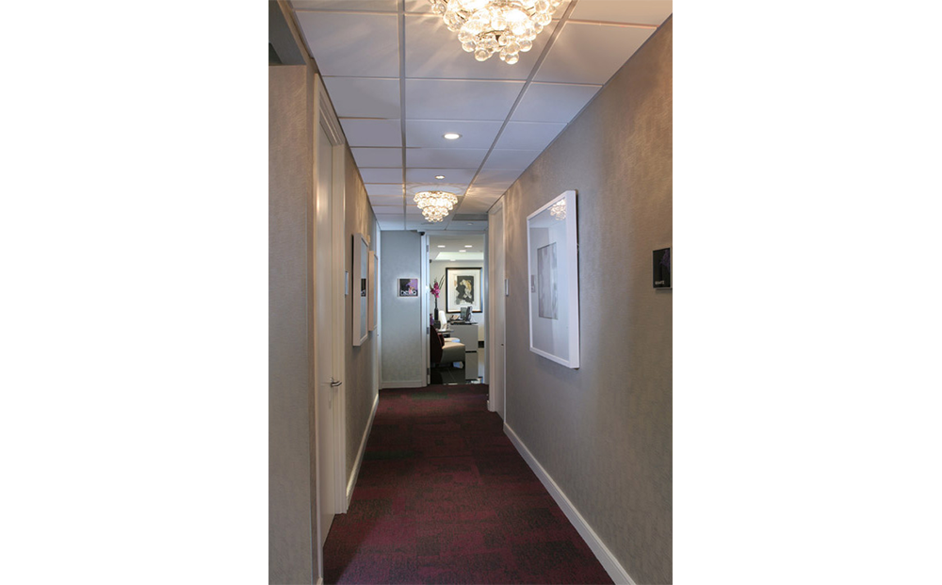




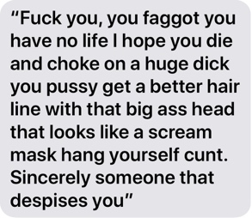





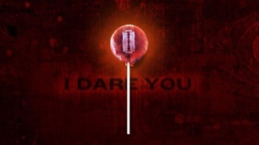
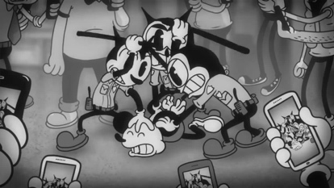
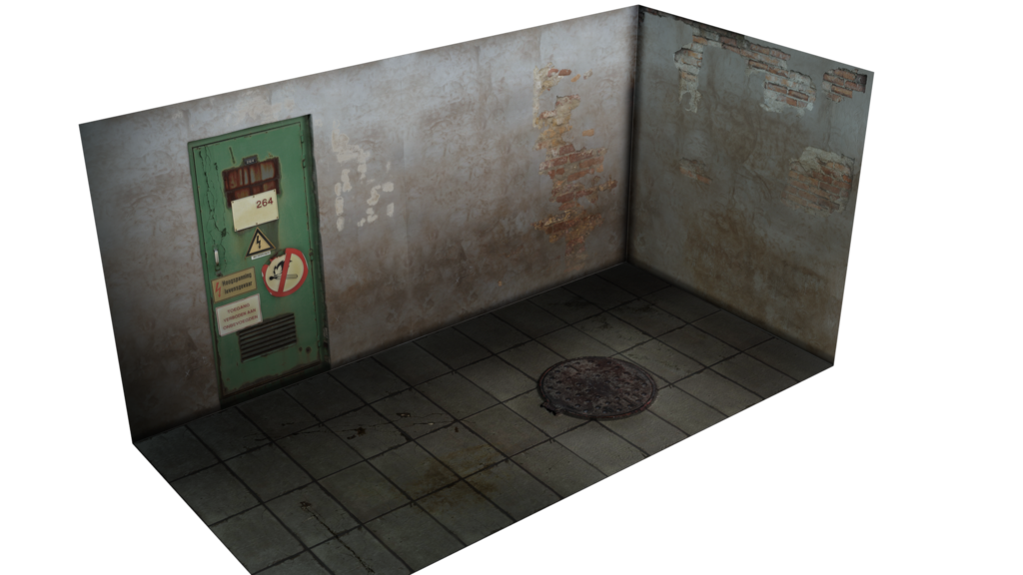

Image List
A Majority of Teens Have Experienced Some Form of Cyberbullying. Available at: https://www.pewinternet.org/2018/09/27/a-majority-of-teens-have-experienced-some-form-of-cyberbullying/ (Accessed: 26th April 2019)

Anderson,M. & Jiang, J. (2018) Teens, Social Media & Technology 2018. Available at: https://www.pewinternet.org/2018/05/31/teens-social-media-technology-2018/ (Accessed: 26th April 2019)
Targeted comments. Anonymous. (Accessed 17th April 2019)
Victoria Maclean Daily Mail. Available at: https://www.dailymail.co.uk/news/article-3097101/Not-super-Scores-parents-complain-park-s-rip-bank-holiday-superhero-fun-day-complaining-children-s-favourites-seen.html (Accessed on 11th April 2019)
Kylie Jenner Instagram picture. Available at: https://www.instagram.com/p/BluRShgcpm/?igshid=1vfo8hpwe6867 (Accessed on 11th April 2019)
Performing Else. Available at: https://www.dailymail.co.uk/news/article-3097101/Not-super-Scores-parents-complain-park-s-rip-bank-holiday-superhero-fun-day-complaining-children-s-favourites-seen.html (Accessed on 11th April 2019)
Technical Mix Masala (2017) Image. Available at: https://www.youtube.com/watch?v=QN11E74HIOE (Accessed on 09th April 2019)
Take this Lollypop I dare you still. Available at https://www.bing.com/images/search?view=detailV2&ccid=5jabieyn&id=42269CBC72837DB93DC10A0B79E677DE29113D77&thid=OIP.5jabieynb5mEEpe1ecQVXAHaEo&mediaurl=http%3a%2f%2fi.ytimg.com%2fvi%2f4obWARnZeAs%2fmaxresdefault.jpg&exph=900&expw=1440&q=take+this+lollypop&simid=608015923135712736&selectedIndex=22&ajaxhist=0 (Accessed on 10th April 2019)
Take this Lollypop second still. Available at: https://www.bing.com/images/search?view=detailV2&id=2F81F6B089B2F7BC706A6B8C5E8845B8F229061B&thid=OIP.73Dqzv0Ca2X1oKM6kgsSdAHaEZ&mediaurl=http%3A%2F%2Fb.vimeocdn.com%2Fts%2F287%2F634%2F287634284_1280.jpg&exph=760&expw=1280&q=take+this+lollypop&selectedindex=58&ajaxhist=0&vt=0&eim=1,2,6 (Accessed on 10th April 2019)
Nice corridor sources. Available at: http://bpiladesign.com/clientuploads/directory/portfolio_slider/luxury-dermatology-practice-desing-corridor-05-1.png (Accessed on 31st March 2019)
Spiral staircase image one. Available at: https://www.bing.com/images/search?view=detailV2&id=082EE99E8256E7FAE642A6E8B68758BE7970DD15&thid=OIP.LTeS8ntxCs_jekEcUP8ojAHaHa&mediaurl=http%3A%2F%2Fimg.roomeon.com%2Fimg%2Fobject%2Fspiral-staircase-stairs_236478cad1_xxl.png&exph=1000&expw=1000&q=spiral+stair+case+png&selectedindex=0&ajaxhist=0&vt=0&eim=1,2,6 (Accessed on 10th April 2019)
Spiral staircase image two. Available at: https://www.bing.com/images/search?view=detailV2&id=082EE99E8256E7FAE6422DDF95FD38FAE072EA7F&thid=OIP.qk8aaC3P21aQMm1xiVGZbQHaHa&mediaurl=http%3A%2F%2Fimg.roomeon.com%2Fimg%2Fobject%2Fspiral-staircase-stairs_88827ecf3e_xxl.png&exph=1000&expw=1000&q=spiral+stair+case+png&selectedindex=2&ajaxhist=0&vt=0&eim=1,2,6 (Accessed on 10th April 2019)
Dark corridor. Available at: https://img00.deviantart.net/1c81/i/2015/265/9/b/dark_and_grungy_hallway_by_johoben-d9aikic.png (Accessed on 31st March 2019)
Stair case 1. Available at: http://img.roomeon.com/img/object/spiral-staircase-stairs_236478cad1_xxl.png (Accessed on 31st March 2019)
Stair case 2. Available at: http://img.roomeon.com/img/object/spiral-staircase-stairs_88827ecf3e_xxl.png (Accessed on 31st March 2019)

Bibliography
Anderson,M. & Jiang, J. (2018) Teens, Social Media & Technology 2018. Available at: https://www.pewinternet.org/2018/05/31/teens-social-media-technology-2018/ (Accessed: 26th _{April 2019)}
Dreamhost (2011) Take this lollypop. Available at: https://www.dreamhost.com/blog/take-this-lollipop-i-dare-you/ Accessed on 31 March 2019
Elson Cabral (2011) Take this lollypop. Available at: https://www.youtube.com/watch?v=pbQm-nIMo_A Accessed on: 31st March 2019
Harrison, A. (2018) A Complete History of Happy-Slapping. Available at: https://www.vice.com/en_uk/article/437b9d/a-complete-history-of-happy-slapping (Accessed 24th April 2019).
https://tubularinsights.com/take-this-lollipop-personalized-video/ (Accessed on: 31 March 2019)
Jason Zada (2018). Take this lollypop official site. Available at: http://www.takethislollipop.com/ (Accessed on: 31st _{March 2019).}
Jeremy Scott (2011) Take This Lollipop, Interactive & Personalized Video Will Creep You Out. Available at
Parry,H. (2015) 'Stinking toilets, massive queues and £19 to see a shoddy Olaf': Parents' fury at 'rip-off' Frozen fun day which featured dodgy costumes... and not enough superheroes Available at: https://www.dailymail.co.uk/news/article-3097101/Not-super-Scores-parents-complain-park-s-rip-bank-holiday-superhero-fun-day-complaining-children-s-favouritesseen.html (Accessed: 24th _{of April 2019).}
Petty,G. (2014) Teaching Today (5th Ed.). Oxford Univeristy Press. London.
Technical Mix Masala (2017). Social Media Addiction short film 2017 Short Movie on Social Media Addiction 2017. Available at https://www.youtube.com/watch?v=QN11E74HIOE (Accessed on 09th _{April 2019).}

Wang. J, Iannotti.R.J., Nansel.T.R, ‘School Bullying Among Adolescents in the United States: Physical, Verbal, Relational, and Cyber’ Journal of Adolescent Health
Zych, I. Ortego-Ruiz, R. Del Rey, R. (2015). Scientific research on bullying and cyberbullying:Aggression and Violent Behaviour. 24. Pp. 188-198

