
Mananging enteprinse in the 21st century
BUSINESS PLAN


Business plan: Greek restaurant Hesperos
Course: Certificate in Higher Education Skills for the Workplace
Module: Managing Enterprise in the 21st Century
Module code: 4006
Student name / ID number:
Madalina Lupu (1911762)
Timurhan Gabriel Avci (1915405)
Andreea Elena (2016917)
George Cuzmin (2016154)
Dragos Zane (2022015)

Table of Contents
INTRODUCTION 2
BUSINESS and COMPANY OVERVIEW 3
PRODUCT and SERVICES 3
MARKET ANALYSIS 4
SWOT ANALYSIS 4
PESTEL ANALYSIS 6
TARGET MARKET 7
MARKETING PLAN 8
MANAGEMENT TEAM 8
FINANCIAL PLAN 9
REFERENCE: 11

INTRODUCTION

Starting a new business is a big step for anyone who wants to do it because it has a lot of impacts. If the business gets through to a strong start and starts to pay back, the investment, both in money and time, begins to pay off; but, if the firm fails, all is lost and may result in bankruptcy and obligations.
A business plan will help us turn a concept into a viable business. In order to plan how things will work, you will have to think about all aspects of the company. If all goes well, it will take a few weeks to finish. Some sections will be simpler than others.

The purpose of a business plan is to:
- Check if the business is viable
- Plan the stages of the business: sales, management, marketing, operations
- Conduct an economic analysis of the environment to identify threats
- Define the goals
- Create a financial report for the money needed and the return of the investment
- Present it to potential investors that might be willing to support financially

In this report, I will present the business plan for Hesperos restaurant, a new business that will be funded with the loan provided by the Lottery Company UK in the amount of £25,000. The business will belong to me and 4 colleagues of mine and I hope that this business plan will allow us to have access to the start-up funds.
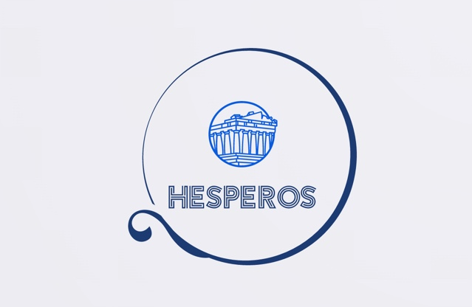

BUSINESS and COMPANY OVERVIEW

Name of the restaurant: HESPEROS
Location: BIRMINGHAM
Associates: Madalina Lupu, Timurhan Gabriel Avci, Cuzmin George, Andreea Elena, Dragos Zane
Start date: 21-09-2021

The restaurant’s goal is to take you Greece while enjoying a traditional Greek dish. The dishes will derive from the Mediterranean cuisine and will be created using organic ingredients. The restaurant will be a luxurious retreat from a busy day where the customers will be welcomed in a Mediterranean atmosphere to enjoy a delicious and healthy meal.

PRODUCT and SERVICES

Hesperos restaurant will provide a wide range of Greek dishes created with organic ingredients. The menu will include appetizers, salads, soups, sandwiches, main dishes and desserts and beside the food the restaurant will provide a wide range of beverages such as: coffee, tea, Greek beverages (ouzo), beer, wine, whiskey, soft drinks.

Few examples of the dishes that will be served are:
- Appetizers: spanakopita; Greek meze platter, Greek layer deep, Feta dip phyllo cups, Saganaki, Tzatziki, Greek fava, Courgette balls
- Salads: Greek salad, Fresh salad, Salad Skewers, etc
- Main dishes: Moussaka, Chicken with feta, Arni, Skepasti pork or chicken, Greek lamb pita with tzatziki sauce
- Desserts: Baclava, Pistachio with honey, Homemade Kataifi, Greek Samali, etc
The services provided by the restaurant will be in-doors, based on reservation with menu a ’la carte after 17:00 and between 12:00-14:00 the restaurant will offer lunch menus. The aim is to be able to offer as fast as possible also delivery services based on phone or on-line reservations.

MARKET ANALYSIS

As a new business, Hesperos restaurant, need to conduct some analysis to see if the market, or the environment is good to launch the business. The most common environment analysis are the SWOT analysis and the PESTLE analysis.

SWOT ANALYSIS

SWOT Analysis is an economic tool that will help a manager in assessing which areas of the business flourish, developing a future strategy, as well as identifying areas where the business is not functioning effectively and where the competition may exploit if no action is made. I'm going to analyse the SWOT analysis that was offered in the PowerPoint slides. Strengths, Weaknesses, Opportunities, and Threats are the four components of a SWOT analysis.
Strengths  New & refreshing  Greek Staff  Highly enthusiastic team  Experienced management team  Outstanding customer service | Opportunities  High exposure location  Loyal returning customers  Bringing a new taste of Greek food in Birmingham
Weaknesses  Competitors provide a lower selling  price.  Design with a high cost  Authenticity, not particularly Greek  Location often exposed by different  events that block the street | Threats  Competitors is in the area  Competitors provide a lower selling price.  Bad reviews  Quality of products  Slower growth due to the inability to rise funds

The strengths are:
- It is fresh and new, and the people are always looking for novelty
- It addresses a community of 150.000 Greek people living in Birmingham, the second largest city with a Greek community after London
- The staff will be Greek and therefore the restaurant will be announced among their relatives and friends.
- Experienced management team as we all have experience in field related to restaurant, customer service, acquisitions, etc.
- The enthusiasm of the team and of the staff will also be a strong point because all will be new, will need to create a good first impression and there is nothing in the world that compares with Greek hospitality.
- Being a central location, outdoor events might provide extra clients.

The weaknesses are:
- High costs for the setup of the restaurant because will be a luxury location.
- Lower prices at the other restaurants but the quality and the ingredients used are of a lower quality of the ones used by Hesperos.
- There are 17 Greek restaurants in Birmingham but only 5 of them are proper restaurants and these restaurants already have a history and a set of clienteles.
- Parking will be limited because the restaurant will be in a central area and the city centre is problematic for parking.
- The area might have closed or blocked by the cultural events organised in the centre.

The opportunities for Hesperos restaurant can be:
- The location being in the city centre
- The Greek community that can turn into regular clients
- Diversification of the services provided with delivery
- Online reservations
- Special events for restaurant reservation: weddings, birthday parties, marriage celebration, etc

The threats are basically the same as for a new business that is not an innovation:
- Competitors in the area regardless of if they are Greek or not because they might lower their selling prices to attract clients because they already have a profit to work with.
- Bad reviews because of bad service or bad products
- The cashflow in the beginning will be a big threat because it might hold the development of the business and the growing rate will be slower.

PESTEL ANALYSIS
As we are aware PESTLE analysis is a tool addressed to the macro-environment by analysing the Political, Economic, Social, Technological, Legal and Environmental factors. All these factors are highly important because they affect the future of any business.

POLITICAL factors are related to the action taken by the government. A stable government means a good economy. The restrictions in place due to determine the government to set the closing time to 23:00 which has a negative impact on the restaurant. Leaving UE is another factor that might have an impact on the restaurant because there will be new taxes for export products and the time for delivery will be increased by custom formalities.

ECONOMIC factors that might have an impact on the future of the restaurant can be related to the inflation rate (higher rate, higher costs, lower profit). The wages, the costs for living (rent, utilities, daily shopping) might also affect the sales because people will not afford to come and eat. The increase of the maintenance costs will also lead to smaller profit.

SOCIAL factors are determined by the people and there is a high demand in the past years for healthy food and our restaurant is using organic products, low-fat and gluten free so it is a plus towards our business.

TECHNOLOGICAL factors that can affect our restaurant are related to the equipment and the release of better and faster ones but also on the software that will allow the clients to order online and make bookings. Card payment and internet connection are essential for payments.

LEGAL factors related to the wellbeing of the restaurant are related to health and safety, food regulations and hygiene standard but also the labour laws.

ENVIORNMENTAL factors are very important, and clients are caring more and more about the environment so using recyclables items for delivery, using electric scooters or bicycles for deliver will be a plus towards our restaurant. On the other hand, the restaurant is will be using bio-degradable items for tables, cleaning because Going Green is also our motto.

TARGET MARKET

As a new business, Hesperos restaurant target market as follows:
- The breakfast time will offer sandwiches for the people to grab on their way to work and the target people are the regular customers and everybody that is passing by the restaurant.
- The lunch time will offer set menus that people will be able to eat on the run or take away, but the restaurant will not be opened to sit it. The target market is composed by those customers that are in the vicinity of the restaurants, clients that work in the companies in the nearby
- The dinner time, when the restaurant will be opened for public is targeting mostly the Greek community but also other people willing to try something exquisite. Another segment that is targeted by our restaurant are the clients that apricate a healthy meal: gluten free, organic and low fat but keeping the marvellous taste of the Greek cuisine.

MARKETING PLAN

Marketing refers to all the activities that are taken by the company to attract potential clients, to increase the cash flow and to promote the restaurant. Marketing means promotion, letting people about the restaurant and the restaurant’s marketing plan consists of:
- Advertising in the local newspaper
- Flyers distributed to the surrounding companies
- Adding a reservation link on Google search engine
- Visible sign from the street
- Delivery done by cars, scooters or bikes having the logo and the address of the restaurant
- Word of mouth from the loyal customers
- Sales promotions for breakfast (buy 1 sandwich and the second has 50% discount)
- Fidelity cars for the pub (buy 4 drinks and the 5th is free)
- Discounts to the loyal customers for special occasions.

MANAGEMENT TEAM
The management team will be composed of:
- Chief executive officer (CEO) - Mrs Madalina Iuliana Lupu will be in charge of significant company decisions and will serve as the principal point of contact for the board of directors.
- Chief operating officer (COO) - Timurhan Gabriel duty is to manage the business's day-to-day administrative and operational functions, reporting to the CEO.
- Chief Financial officer (CFO) - Andreea Elena Ion The function includes overseeing all financial transactions of the organization, tracking cash flow and financial planning, keeping track of the financial situation of the restaurant.
- Marketing officer (CMO) - George Cuzmin is responsible for sales, pricing, communication, publication promotion.
- Marketing officer (CMO) - Mr Dragos Zane oversees the restaurant's market strategy and fresh supplies.

FINANCIAL PLAN

This last part of the business plan is the most important because the figures must be as accurate as possible because based on the financial plan it might attract investors, receive loan, and prove that it is a successful to be business.

The financial plan includes:
- Start-up costs – costs related with rent, kitchen equipment, furniture, cutlery and other investments
- Cash flow projections – show the estimated amount of money that can me earned by the restaurant and the money that will be spent.
- Income statements – presents an accurate between expenses and revenues
- The balance sheet – contains all the assets of the restaurant. These assets can be: money, property, vehicle, inventory, etc. The balance sheet predicts the net worth of a business
- Break even analysis calculates the point when the restaurant starts to make profit and it is based on three elements: selling price, fixed costs, and variable costs
Another thing that must be included in the financial plan, but it is not mandatory are potential methods of financing the business and can be:
- Equity financing – the associates are putting money in the business
- Debt financing – contracting loans to cover the expenses of the restaurant.

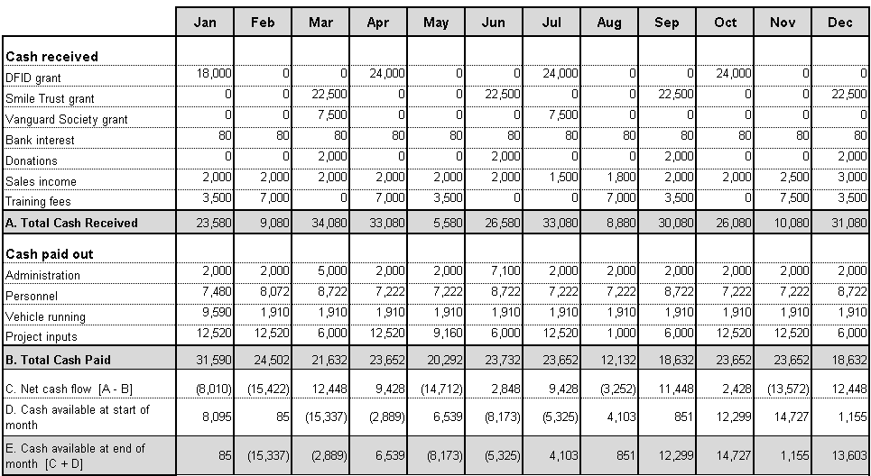
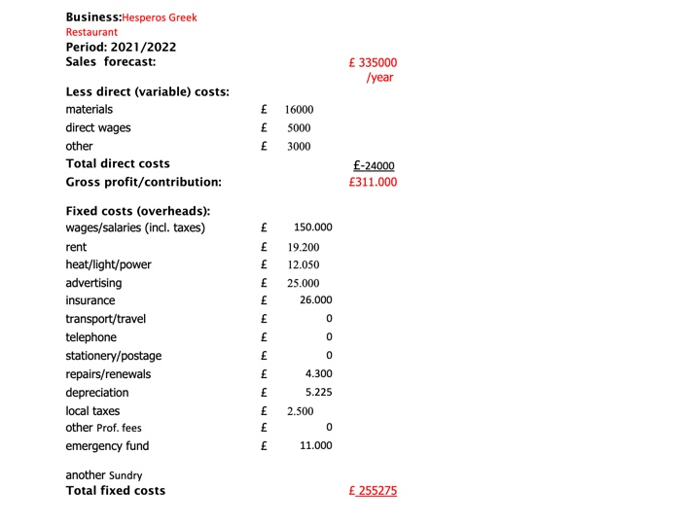

Hesperos Greek Restaurant cashflow forecast 2021

REFERENCE:
American Marketing Association (2021) Definition of Marketing. Available at: https://www.ama.org/the-definition-of-marketing-what-is-marketing/ (Accessed 21.11.2021)
Barclays (2021) Writing a business plan. Your guide to a successful business plan. Available at: https://www.barclays.co.uk/business-banking/business-insight/writing-a-business-plan/ (Accessed 21.11.2021)
Bright Flow (2021) What is financial Planning in a business plan. Available at: https://brightflow.ai/blog/financial-planning-in-business-plan-with-example/ (Accessed 21.11.2021)
Business Planning (2021) How to write a financial plan for your small business. Available at: https://articles.bplans.com/the-key-elements-of-the-financial-plan/ (Accessed 21.11.2021)
Cyberclick (2021) Marketing. Available at: https://www.cyberclick.net/marketing (Accessed 21.11.2021)
Investopidia (2021) Marketing Available at: https://www.investopedia.com/terms/m/marketing.asp (Accessed 21.11.2021)
MindTools (2021) SWOT Analysis. Understanding your business, informing your strategy. Available at: https://www.mindtools.com/pages/article/newTMC_05.htm (Accessed 21.11.2021)
Prince’s Trust (2021) Business plan. Available at: https://www.princes-trust.org.uk/help-for-young-people/tools-resources/business-tools/business-plans (Accessed 21.11.2021)
Startup Donut (2021) Essential guide to writing a business plan. Available at: https://www.startupdonut.co.uk/business-planning/write-a-business-plan/essential-guide-to-writing-a-business-plan (Accessed 21.11.2021)
Transfer GO (2021) Greeks living in the UK. Available at: https://www.transfergo.com/en/blog/greeks-in-the-uk/ (Accessed 21.11.2021

