

Name: NAVEEDA FATIMA

Student no :2406614

Module: Changemakers: Creativity and Value Creation

Module code: BMHP5014

Assignment Title: Component 1: Online Portfolio of Set Exercises

Table of Contents
- Introduction ........................................................................................3
- Task 1 – Concept Map……………………………………………………3
- Task 2 – Self-Reflection of Group Activity ......................................... 4
- Task 3 – Case Study: NHS at Home – Remote Monitoring to Reduce Hospital Admissions ...........................................................................6
- Task 4 – Research Task: Barriers to Mental Health Care….............. 7
- Task 6 – NHS Leadership Framework Analysis ................................ 8
- Task 7 – Self-Reflection Journal Entry .............................................. 9
- Conclusion ....................................................................................... 10
- References ...................................................................................... 11

Introduction
This assignment examines how creativity, value creation, and reflective practice drive improvements in health and social care (HSC). Through reflective activities, case studies, and research, it explores innovative approaches to addressing challenges such as workforce shortages, rising demand, and complex care needs. Emphasis is placed on collaborative practice, technology-enabled solutions, and evidence-based innovation to enhance patient outcomes and service quality.

Task 1 – Concept Map

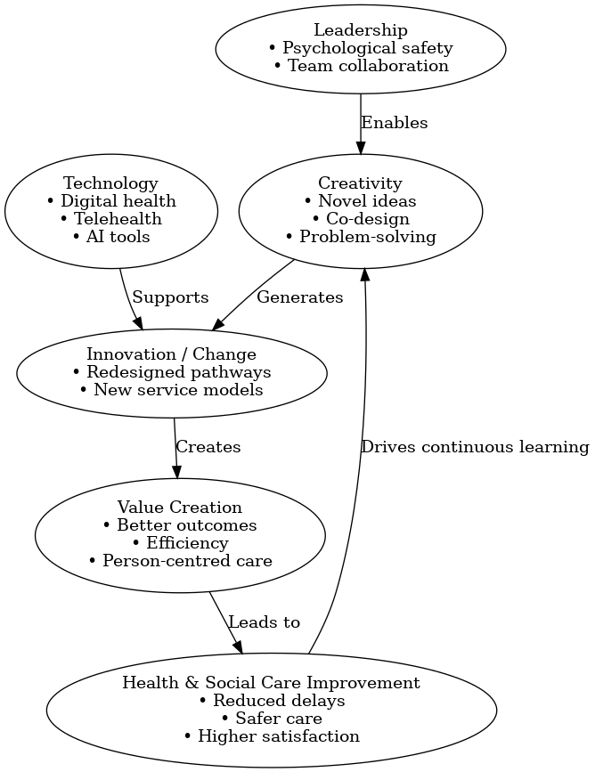
In health and social care (HSC), creativity, value creation, and service improvement are dynamically interrelated concepts that drive effective responses to complex system pressures such as workforce shortages, demographic change, and rising demand (Venkatesh et al., 2022). Creativity is understood as the ability to generate novel, useful ideas and approaches to persistent challenges in HSC this includes rethinking care pathways, co-designing services with users, and adapting practice in context (Anderson et al., 2021). Creativity does not operate in isolation it is shaped and enabled by leadership behaviors that foster psychological safety, interdisciplinary dialogue, and experimentation (Reeves et al., 2023).
Contemporary technology (e.g., digital records, telehealth, AI triage tools) amplifies creative ideas by making new solutions practicable at scale, thus forming a bridge between ideation and implementation (Greenhalgh et al., 2024). When creative ideas are operationalized supported by leadership and enabled by technology, they become innovations that deliver value. Value creation in HSC involves enhanced patient outcomes, improved efficiency, and more person-centred care without disproportionate resource use (Porter and Lee, 2019; applied in recent HSC research by Nilsson et al., 2022).
This value then translates into improvement in health and social care, seen in measurable performance gains such as shorter waiting times, reduced hospital readmissions, and higher service satisfaction. Importantly, improvement feeds back into creativity as organizational learning reinforces new ways of thinking and doing, creating a continuous improvement cycle.
Task 2 - Self-Reflection of Group Activity
Reflective Model Used: Rolfe et al. (2001)
The paperclip activity required our group to apply divergent thinking to generate multiple uses for a paperclip, followed by convergent thinking to evaluate and refine ideas. I have used the Rolfe et al. (2001) reflective model, which is structured around three core questions: What? So what? Now what? This model was chosen because it promotes concise, critical reflection and links experience directly to professional action, making it suitable for health and social care contexts where reflection must inform practice improvement.
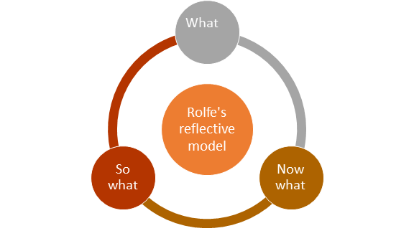
(Patel, 2022)
What?
During the divergent phase, I initially felt hesitant to suggest unconventional ideas. However, as the group maintained a non-judgmental environment, I became more confident in contributing creative suggestions. The convergent phase required analytical thinking to assess feasibility.
So what?
This activity highlighted the importance of separating idea generation from evaluation. Recent research demonstrates that structured reflective and experiential learning activities strengthen critical thinking and professional judgement among health students (Açıl and Keçeci, 2024). The exercise mirrored multidisciplinary team discussions in practice, where exploring multiple care options before decision-making improves problem-solving and reduces premature judgement.
Now what?
In future practice, I will apply divergent thinking when contributing to care planning or service improvement discussions, ensuring creative options are fully explored before convergent evaluation. I will also encourage psychological safety within teams to support collaborative creativity and reflective learning.

Task 3 – Case Study: NHS at Home – Remote Monitoring to Reduce Hospital Admissions

Introduction
The NHS at Home initiative using remote monitoring technology represents a transformative response to rising emergency department attendances and unplanned hospital admissions in the UK. Traditional care models often result in older people being transported to hospital for assessment and treatment, which can be disruptive and costly. NHS at Home, implemented in care homes and community settings, aims to keep patients safely in their place of residence by using digital tools to monitor health indicators and trigger appropriate clinical responses (Mason et al., 2024; Patel et al., 2024).

Creativity and Innovation
Creativity in this case lay in reimagining how routine health data could be captured and used to prevent unnecessary hospital admissions. Rather than relying on episodic clinician visits or reactive calls for assistance, the NHS at Home approach introduced real-time remote monitoring systems embedded into care workflows. Key elements included a digital smartphone app (Health Call) used by care staff to record vital signs such as temperature, heart rate, and clinical observations daily, and secure transmission of this information to NHS clinical teams (Mason et al., 2024).
This creative use of mobile health technology integrated established clinical measures (e.g., National Early Warning Score) with digital platforms, allowing early identification of health deterioration. The innovation extended beyond the technology itself to work process redesign: care home staff were trained to use the app and interpret preliminary signs of decline, which shifted parts of monitoring traditionally done in hospitals into the home setting. Such co-production of innovation with care staff aligns with contemporary research emphasizing frontline engagement for successful digital health implementation (Greenhalgh et al., 2024).
Remote monitoring also reduced reliance on physical travel and face-to-face clinical assessment, introducing a proactive rather than reactive care model. This reflects growing evidence that early detection and remote management supported by digital tools contribute to improved resource allocation and patient outcomes (Patel et al., 2024).

Impact – Value Creation
Evaluation of the NHS at Home remote monitoring program has demonstrated clear value creation. Studies show that use of the Health Call app in care homes was associated with an 11% reduction in emergency department attendances and a 25% drop in emergency hospital admissions, alongside shorter length of stay when admissions did occur (Mason et al., 2024). These improvements not only reduced pressure on acute services but also offered intangible benefits: care home staff reported increased confidence in managing deteriorating residents, and residents benefited from remaining in familiar environments. Cost analysis estimated savings of up to £113 per resident annually, reinforcing that remote monitoring can deliver both clinical and economic value in UK health systems.

Task 4 – Research Task: Barriers to Mental Health Care
Access to mental health care remains a significant challenge in health and social care, particularly for vulnerable populations. Despite rising prevalence of mental health disorders globally, substantial gaps exist between the need for care and actual service utilization. Two recent academic studies, a meta-analysis of unmet needs and a systematic review of service use barriers shed light on the multifaceted reasons for this problem.
Armoon et al. (2025) conducted a comprehensive meta-analysis examining unmet need and barriers to care among individuals with mental health issues, synthesizing data from over 200 studies. Their findings revealed that barriers are both structural and psychosocial, with motivational barriers (e.g., reluctance to seek help) present in 38 % of cases, structural barriers (e.g., lack of service availability) in 37 %, financial barriers in 31 %, and stigma-related barriers in 25 % (Armoon et al., 2025). The analysis highlighted that people with concurrent substance use disorders and those experiencing homelessness reported even higher levels of unmet need, emphasizing how intersecting vulnerabilities exacerbate access problems. Cost limited geographic coverage of services, and fragmented care pathways were identified as significant obstacles to accessing mental health support.
Complementing this, Gao et al. (2024) systematically reviewed predictors of mental health service use and identified socio-demographic and cultural contributions to access disparities. Their review found that high treatment costs, lack of transportation, and scarcity of mental health professionals were major structural impediments to service utilization (Gao et al., 2024). Additionally, attitudinal barriers such as stigma, cultural beliefs about mental illness, and fear of being labelled or discriminated against further reduced help-seeking. These findings align with broader literature that stigma and cultural perceptions meaningfully hinder engagement with mental health services, even where services are physically available.
Together, these studies illustrate that access issues are not caused by a single factor but by a combination of financial, structural, and social barriers, which disproportionately affect vulnerable groups. Improving access therefore requires policies that address service capacity, affordability, and cultural attitudes toward mental health care.
TASK 5 – PODCAST

Task 6 – NHS Leadership Framework Analysis

Summary of the NHS Leadership Framework
The NHS Leadership Framework outlines the core behaviors required to lead effectively within complex healthcare systems. It emphasizes that leadership is a shared responsibility across all professional levels rather than confined to senior management. The framework focuses on domains such as demonstrating personal qualities, working with others, managing and improving services, and setting direction. These domains integrate relational, strategic and operational competencies necessary for delivering high-quality, patient-centered care.
Recent evidence highlights that effective healthcare leadership must be adaptive, collaborative and innovative-oriented to respond to increasing system pressures (Thapa, Gyawali and Kalauni, 2026). Their systematic review of UK healthcare organizations identifies transformational and distributed leadership as key strategies for fostering innovation, improving service delivery and strengthening organizational performance. The framework’s emphasis on collaboration and continuous improvement aligns with research showing that leadership directly influences care quality, patient safety and workforce wellbeing (Ahmed et al., 2024). In the context of financial constraints, digital transformation and workforce shortages, the NHS Leadership Framework provides a structured behavioral guide to support innovation while maintaining safety and accountability. Overall, it promotes leadership as a relational and system-focused process essential for sustainable healthcare improvement.

Application of “Working with Others” to Encourage Creativity
The “Working with Others” domain focuses on collaboration, partnership and effective communication across multidisciplinary teams. A leader applying this component can encourage creativity by fostering psychological safety, enabling staff to share ideas without fear of criticism. Research indicates that collaborative and transformational leadership approaches significantly enhance innovation capacity within UK healthcare settings (Thapa, Gyawali and Kalauni, 2026).
For example, a service manager implementing remote patient monitoring could organize co-design workshops with nurses, healthcare assistants and IT staff. By valuing frontline perspectives and encouraging shared decision-making, the leader strengthens engagement and collective problem-solving. Ahmed et al. (2024) demonstrates that inclusive leadership behaviors are associated with improved patient safety and care quality. Therefore, by actively promoting open dialogue and shared accountability, NHS leaders can embed creativity into everyday practice, leading to more efficient, patient-centered and innovative service delivery.

Task 7 – Self-Reflection Journal Entry
This module significantly enhanced my understanding of how creativity and value creation function in health and social care (H&SC) practice. Initially, I perceived creativity as mainly about generating ideas; however, through reflective activities and engagement with research, I now recognize creativity as a dynamic process embedded in clinical reasoning, problem-solving, and team collaboration that directly contributes to value creation and quality improvement. Weekly exploration of reflective practice, especially in Week 9, reinforced that reflection is not merely a requirement but a critical professional habit that supports deeper learning, self-awareness, and adaptive practice (Bowers et al., 2025). Reflective practice helps to bridge the gap between theoretical knowledge and practical application by facilitating continuous evaluation of actions and outcomes.
Research shows that reflective practice enhances clinical competency, emotional resilience, and decision making in real healthcare settings (Bowers et al., 2025). This aligns with my personal experience: engaging in structured reflection enabled me to identify assumptions, recognise areas for improvement, and integrate creative approaches into real-world care scenarios.
Going forward, I will actively use reflective practice to inform my professional development, ensure value-driven care decisions, and foster creativity when addressing complex care challenges. I now see reflective practice as essential for delivering compassionate, effective, and innovative health and social care.
Conclusion
In conclusion, creativity and reflective practice are essential for improving HSC services. Examples such as NHS at Home illustrate how innovation, co-designed workflows, and technology can enhance care, efficiency, and patient experience. By fostering critical thinking, collaboration, and evidence-informed decision-making, HSC professionals can deliver sustainable, value-driven improvements that benefit patients, staff, and organizations alike.

REFERENCES
Açıl, A. and Keçeci, A. (2024) ‘Effect of a simulation game on nursing students’ reflective thinking skills: a mixed methods study’, BMC Nursing, 23, 704.
Ahmed, F., Zhao, F., Faraz, N.A. and Qin, Y. (2024) ‘How and when does inclusive leadership affect patient safety? Evidence from healthcare settings’, BMC Health Services Research, 24, 512.
Anderson, N., Potočnik, K. and Zhou, J. (2021) ‘Innovation and creativity in organizations: A state-of-the-science review’, Journal of Management, 47(3), pp. 1–37.
Armoon, B., Lesage, A., Mohammadi, R., Khoshnazar, Z., Rostami Varnosfaderani, M., Hosseini, A., Fotovvati, F., Mohammadjani, F., Beigzadeh, M. and Griffiths, M.D. (2025) ‘Perceived unmet need for care and barriers to care among individuals with mental health issues: a meta-analysis’, Administration and Policy in Mental Health and Mental Health Services Research, 52(4), pp. 653–686.
Bowers, M., Terry, D. and Irwin, P. (2025) ‘The impact of reflective practice on nursing students: a scoping review’, Nurse Education in Practice, 87, 104468.
Gao, Y., Burns, R., Leach, L., Chilver, M.R., and Butterworth, P. (2024) ‘Examining mental health services among people with mental disorders: a systematic review’, BMC Psychiatry, 24, 568.
Greenhalgh, T., Wherton, J., Papoutsi, C., Lynch, J., Hughes, G., A’Court, C. (2024) ‘Beyond Adoption: A New Framework for Theorizing and Evaluating Nonadoption, Abandonment, and Challenges to the Scale-Up, Spread, and Sustainability of Health and Care Technologies’, Journal of Medical Internet Research, 26, e35366.
Mason, S., et al. (2024) ‘Digital remote monitoring technology in care homes reduces emergency admissions’, Age and Ageing, published 13 February 2024.
Nilsson, K., Baathe, F. and Andersson, A. (2022) ‘Value-based healthcare as a strategy for healthcare improvement’, International Journal of Health Policy and Management, 11(4), pp. 1–10.
Patel, R. et al. (2024) ‘Remote vital sign monitoring in admission avoidance Hospital at Home: a systematic review’, Journal of the American Medical Directors Association, 25(8): 105080.
Reeves, S., McMillan, S., Flemington, A., et al. (2023) ‘Leadership for creative health care teams: A scoping review’, Social Science & Medicine, 315, 115500.
Thapa, R., Gyawali, S. and Kalauni, B. (2026) ‘Leadership strategies to foster innovation in healthcare organizations of the UK: a systematic review’, BMC Health Services Research, 26, 1432.
Venkatesh, V., Bala, H., Sykes, T. A. (2022) ‘Impacts of Digital Transformation on Health Care Delivery’, MIS Quarterly Executive, 21(2).

