The Application of Pop Art in the Field of Satire

-Research Report

Yue Yin

Table of Contents

Research Report 1
Introduction 3
Research purpose 3
Research background 3
Research significance 3
Practice 4
References to concepts 5
The gap between references and practice 9
Practice work 10
Discussion 16
Conclusion 18

Introduction

Research purpose
From the selection and use of popular elements in pop art and the creative form of pop art, this paper deeply explores the application of pop art in the field of satire.

Research background
As an art form that emerged in modern times, pop art is not widely used in the field of satire. The satire it shows is often regarded as a vague expression, which will weaken the satirical effect or lose its original satirical meaning as the social environment changes.
At the same time, since the creative form of pop art is the extraction and use of popular elements, its application in the field of satire is also regarded as vague, with both propaganda and satire, and this duality is controlled by the audience.
“...Thus, Pop Art’s critical function appeared as a problematic notion because the sociological commentary oscillated according to the viewer’s reading... ”
“...Pop Art’s double interpretation turned it into an art on the borders of legibility and legibility, integration and rejection, subversion and conformity, dissonance and propaganda...”
（American Pop Art and political engagement in the 1960s-Eliane Elmaleh）
In modern times, this prejudice against pop art is still intensifying.
At the same time, because pop art is regarded as an art form related to commercial culture, it is not used in satirical occasions most of the time, but has become an art form that is more inclined to promote a certain culture, group and commodity.

Research significance
Refute the view that pop art has two sides in the field of satire, find and explore a creative method to solidify the satirical meaning presented by pop art, make the satirical view presented by pop art clearer and more lasting, and will not let this satire become a propaganda of certain things and phenomena because of the audience's interpretation.
In order to complete this research, the subject of the research will start from practice, analyze the process of practice and the final display effect, determine the feasibility of solidifying the satirical meaning of pop art, and finally determine the means to apply pop art to the field of satire, which includes the selection and use of popular elements in pop art, and the thinking of the creation form of pop art.

Practice
The practice will start from the two directions of painting and collage. The choice of this practice form is inspired by the pop artist Richard Hamilton. In his representative work "Just what is it that makes today's homes so different, so appealing?", he selected a number of different popular images for collage and reassembled them into a brand new picture, giving these popular things a new image, that is, showing the family scenes depicted by the consumer society at that time.
Using Visual Culture to Put a Contemporary “Fizz” on the Study of Pop Art this article summarizes it as "using the most advanced social images of the 1950s at that time in the form of collage to judge consumer society, which is essentially using the images of visual culture to criticize the values and beliefs of the viewer".
Hamilton's works are considered to be the use of visual images, and people believe that he expresses a criticism of the viewer's beliefs and values.
This view is similar to the previous criticism of the ambiguity of pop art in the field of satire, but compared with Hamilton's works, other works have not been able to carry out their satire better.
This also makes Hamilton's works unlike other pop art works, whose satirical meaning becomes vague and wavering with the changes of the times. His works still retain the criticism of the consumerist society at that time.
Therefore, imitating Hamilton's creative method and completing the satire of current social phenomena have become the focus of this practice.
The first thing to establish is the object of practice. In the selection of the object of practice, follow two key points.
The first is popularity, which is one of the characteristics of pop art. The essence of pop art is the extraction and use of popular elements. At the same time, pop art is also a response to its own social environment. Therefore, the object of this practice is not intended to be separated from the current era for selection.
Secondly, controversy. The purpose of this study is to oppose the ambiguity and duality of pop art in terms of satire. Therefore, social phenomena with negative or positive meanings are not enough to complete the exploration of this study. Controversial social phenomena can help us better determine whether the satire conveyed by pop art is influenced and shaken by the audience's values and beliefs.
Therefore, the object of this practice is established as the most popular AI concept at present, but the practice itself does not want to show the advantages and disadvantages of AI. The advantages and disadvantages of AI are more like an objective existence, and people's attitudes towards AI and the different emotions they show are the different subjective images of the viewers of the practice.
And this different emotion displayed towards AI is the object that this practice wants to show and satirize.
From the initial vague understanding of AI to accepting various propaganda on multimedia and the Internet, almost everyone has a basic understanding of AI.
But this understanding is also affected by external factors. In addition to the different propaganda received, people's attitudes towards the emergence of AI are also different according to their class, social environment, and cultural level. From crazy resistance to embracing a new future, this difference is huge, and it can even be said that they are in two extreme mentalities, which is more in line with our research goals in practice.
From the results of practice, we can determine whether the same picture will have different perceptions or affect the irony of the work due to different mentalities.

References to concepts
References：American Pop Art and political engagement in the 1960s
Key theory: The reason why Pop Art does not seem to be firm in its position in political participation comes from the way Pop Art is created.
This article mainly describes the problems of Pop Artists in political participation. It believes that the critical function of Pop Art is very problematic because of its creative concept, because sociological comments will be unstable due to different interpretations of different audiences, so the elements of the works presented by Pop Artists will also be ambiguous in imagery.
The main problem with this comes from the way Pop Art is created. Pop Art always highlights and reflects a certain popular element, rather than giving it a certain meaning.“...Should art function as a prism that would pick up elements of social reality, refract them and bend them before sending them out again? The Pop artist chose the mirror analogy instead of the prism analogy as his strategy was to adopt a chameleon like attitude. By having the environment give their works various connotations, he defied the spectator’s judgement. Then should not the role of the latter be to question the meaning that the artists’ works and declaration refuse to give him...”
Research Method: List the posters designed by pop artists for political participation, and analyze the different interpretations that posters bring to the audience at different time points.
Research Results: The reason why pop art is ambiguous in political participation is clarified, and it is determined to be the use of popular elements by pop art. It is believed that the display of popular elements by pop art does not give meaning to the popular elements themselves.
Different from the traditional and conventional cognition of pop art, this document believes that the use of popular elements by pop art is precisely the problem when it is created.
Insufficient: This document lists the posters created by pop art during political participation, and lists the different images it brings to people at different time points, but does not carefully analyze whether the popular elements used in each poster have the meaning of political participation, that is, it does not consider whether these popular elements clearly express the political attitude of pop artists at the time of creation.
In other words, this document does not clarify whether the individual, unprocessed elements really have the image of expressing the attitude of political participation, so it directly regards the problems of these posters themselves as the problems of pop art, and at the same time regards the creation method of these posters as the creation method of pop art as a whole.。
References: Research on the Application of Pop Art in Modern Architectural Form Design
Key theory: This paper mainly discusses the way in which pop art gives viewers a sensory experience. At the same time, it does not regard pop art as a simple extraction of popular elements. This paper believes that the characteristics of pop art are "commercialization", "popularization" and "dramatization".
Research method: A large number of buildings that contain pop art design concepts were analyzed.
Research results: It clarified the sense of absurdity represented by pop art, and regarded this sense of absurdity as a manifestation of the "dramatization" of pop art. It deeply explored the source of this sense of absurdity, and used strong color contrast, overlap, exaggeration, deformation, collage and other techniques to transform popular elements, rather than simply presenting popular elements.
Insufficient: This paper limits the research to architectural design, and does not reflect the artistic characteristics of this pop art in other fields.
References: The Influence and Significance of Contemporary Art Thought on Modernist Design
Key theory: Pop art does not pursue particularly harmonious matching, nor is it a copy and paste of popular elements in the traditional sense, but another form of conveying "popularity", which is a re-deconstruction of popular elements by pop art.
Research method: Analyze the application of pop art in clothing design and interior design, and explore the reasons why pop art brings people a sense of fashion.
Research results: The design characteristics of pop art are clarified, with a large number of popular elements, and the expression method is not simply to collage and combine popular elements, but to summarize it as widely absorbing popular elements, multiple tiled compositions (unique composition methods) and strong color contrast.
At the same time, this document also focuses on the combination of pop art and modernization, and believes that pop art should break tradition when creating, and pursue its own unique understanding and contemporary people's emotions.
Shortcomings: This document does not make a detailed analysis of the way popular elements are handled, that is, it does not make a detailed analysis of how designers deconstruct and reorganize popular elements when designing, nor does it compare the images represented by popular elements before and after the reorganization. It only briefly explains the characteristics of the design.
References：Using Visual Culture to Put a Contemporary "Fizz" on the Study of Pop Art
Key Theory: Pop Art is defined as an exploration of visual culture that emerged with the development of society. It is believed that Pop Art provides an opportunity to continue to explore consumerism and its impact on society in a larger context, that is, today's global culture.
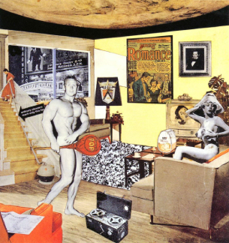
Figure 1.Just what is it that makes today's homes so different, so appealing?
Research Methods: Hamilton's works were briefly analyzed, and Hamilton's creative methods were summarized and summarized. Combined with the development of Pop Art, Pop Art was combined with visual culture.
Research Results: Pop Art is defined as an exploration of visual culture that emerged with the development of society. Pop Art provides an opportunity to continue to explore consumerism and its impact on society in a larger context, that is, today's global culture.
Deficiencies: The relationship between Hamilton's use of popular elements and visual culture is not clearly defined.
References: Pop Surrealism: The Rise of Underground Art
Core theory: The application of cartoon images in pop art, also known as vulgar art, has an interesting side in modern applications, but the main disadvantage is that these art forms are prone to difficulties in complex decorative arrangements, and they are difficult to integrate into modern environments and buildings in a harmonious way. The advantage is that the application of cartoon images is rich in subject matter, which can easily make up for the distracting and invasive characteristics of cartoon images.
Research method: Take the actual cartoon images as the analysis object.
Research results: Although cartoon images can contain enough images, they still require viewers to have advanced observation skills.
Disadvantages: This document has sufficient examples of cartoon images, but lacks detailed analysis.

The gap between references and practice
The references mostly discuss the characteristics and creative concepts of pop art, and lack a detailed analysis of pop art works. Most of the literature does not explore how a pop art work deforms or utilizes the popular elements it displays.
This includes Hamilton's works and the emerging genre of pop surrealism with cartoon images as the main body.
However, what this practice wants to accomplish is to explore the changes in the imagery represented by the deformation and utilization of popular elements.
It is worth referring to that it can be determined from the literature that pop art is not simply a means of creation based on copying and pasting. Its use of popular elements is the source of the absurdity of pop art.
At the same time, the literature also makes a simple summary of this way of using popular elements, using color contrast, overlap, exaggeration, deformation and collage.
Coupled with the ideas provided by Hamilton's works and the advantages of cartoon images in expressing popular elements, this practice has a basic theoretical framework.
First of all, the way of creation, the creation method of this practice will be mainly collage and painting.
On the one hand, collage is a continuation of Hamilton's work style, and on the other hand, it also takes into account the cartoon background as the main body and carrier of the picture.
As a popular element of the collage part, the responsibility is to show the main body of the image, that is, the central theme of the whole picture. In this regard, there is no intention to make changes such as deformation. The reason for this design is not only to make the image of the picture more intuitive, but also to make up for the shortcomings of painting and no longer test the viewer's observation skills.
The use of painting to carry collage elements takes into account that painting can make up for the "mirror analogy" that collage brings to the viewer, and eliminate the defect that collage elements in traditional pop art do not have imagery.
At the same time, using painting and collage to complete pop art works is also to increase the "drama" and absurdity of the work itself, which is to strengthen the imagery contained in pop art works and the author's own emotions.
Practical work

Practice work description
The theme of this practice is to show people's emotions when facing AI in the form of pop art. The creative form is still mainly painting, combined with collage as an auxiliary to increase the absurdity of the picture and amplify the emotions of people that the picture wants to express.
The whole theme is completed in three paintings.
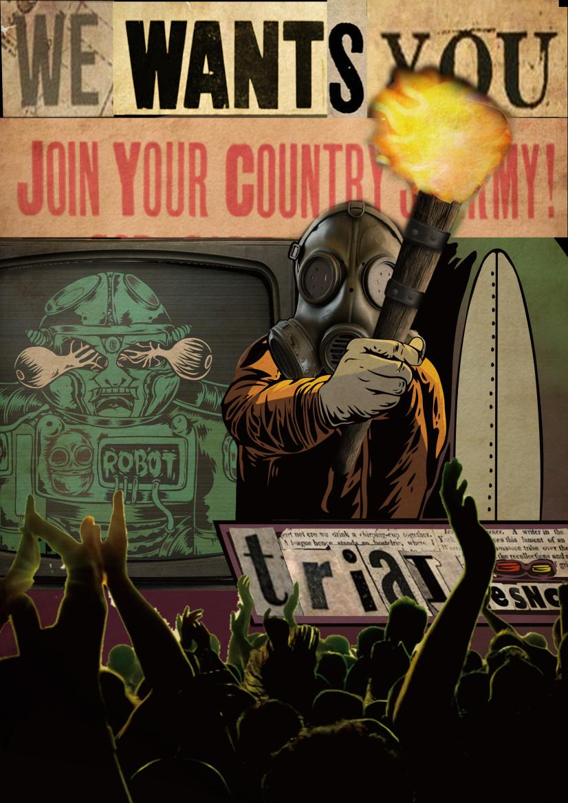
Figure 2.Trial
The name of the first painting is Trial. It shows the panic and rejection of people when facing AI. The main elements of the picture are recruitment posters, torches and masks of characters, and blind robots that appear as AI images.
The slogans on the recruitment posters are mostly collages of texts on recruitment posters during World War I and World War II. What is wanted to express here is a fanatical atmosphere.
The mask on the face of the main character and the torch in his hand are derived from the common costumes of extreme groups in reality. Both of them have symbolized the persecution of certain minority groups.
The persecuted in the picture is obviously the AI symbol with the image of an old cartoon robot. The limbs and head made of metal are similar to humans, but the robot's eyes are blinded by the tentacles behind it. What I want to express here is that at this stage, AI actually does not have the same thinking ability as in science fiction works, and its behavior is obviously not controlled by itself. Despite this, it is still the target of people's crusade.
This painting attempts to express people's extreme rejection of AI. Taking AI driving in reality as an example, a large number of people believe that AI has replaced their jobs, so they regard the emergence of AI as a replacement for humans.
In fact, the capital groups and companies that control AI behind the scenes are obviously the ones who really want to eliminate labor costs. Therefore, this painting also wants the audience to think about another question: Is our emotional catharsis against AI in the wrong place from the beginning? Do the hostility and extreme emotions that fill our hearts also obscure our vision like a gas mask?
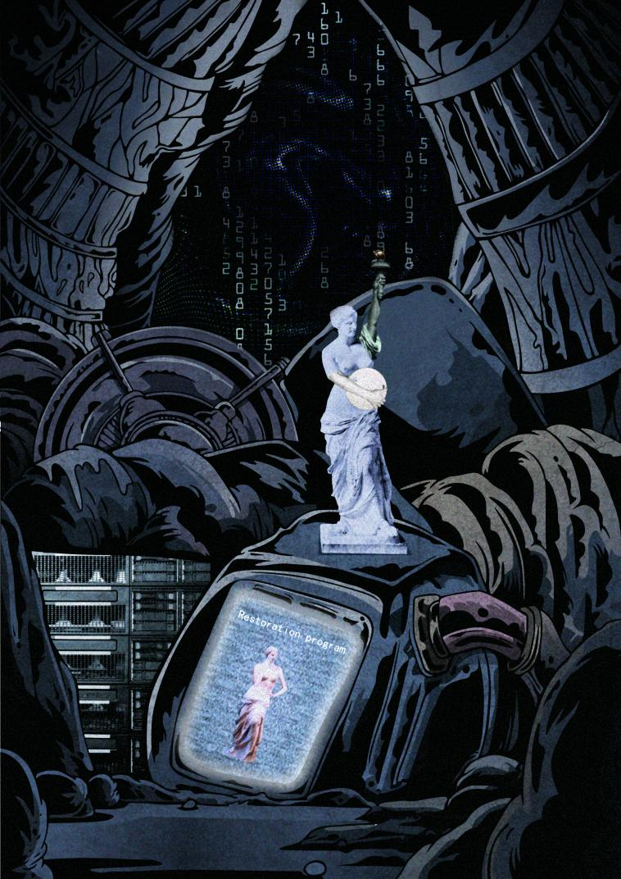
Figure 3.Unfinished, Venus
The name of the second painting is Unfinished, Venus. It shows the actual processing power of AI at this stage. In fact, AI's deep learning at this stage has not been separated from human creativity. It is better to say that it is combining and utilizing human creations than learning. Therefore, this painting is set to allow AI to repair the broken-armed Venus alone.
The main body of the picture is completed by collage, using the armless Venus, the arm of the Statue of Liberty and the arm of the discus thrower.
Venus is recognized by the world as a work showing the beauty of the female body. No matter from which angle, she has the golden ratio. Because of this, Venus's lost arms appear more mysterious. And many people who try to repair the broken arms eventually complete works that are not as beautiful as Venus when she was broken.
The Statue of Liberty is a gift from the French people to the Americans. The raised arms and torch have important representative significance. The torch itself represents progress. Combined with the crown of the Statue of Liberty, it represents freedom illuminating the world.
The discus thrower, a work by the Greek artist Myron, has a strong sense of dynamics and shows the most expressive moment when Hercules throws the discus. In contrast to the armless Venus, the discus thrower reflects the perfect male body shape.
Combining these three completely unrelated things together is an exaggeration of the flaws of AI at this stage, but this is not the subject that the practical work wants to satirize.
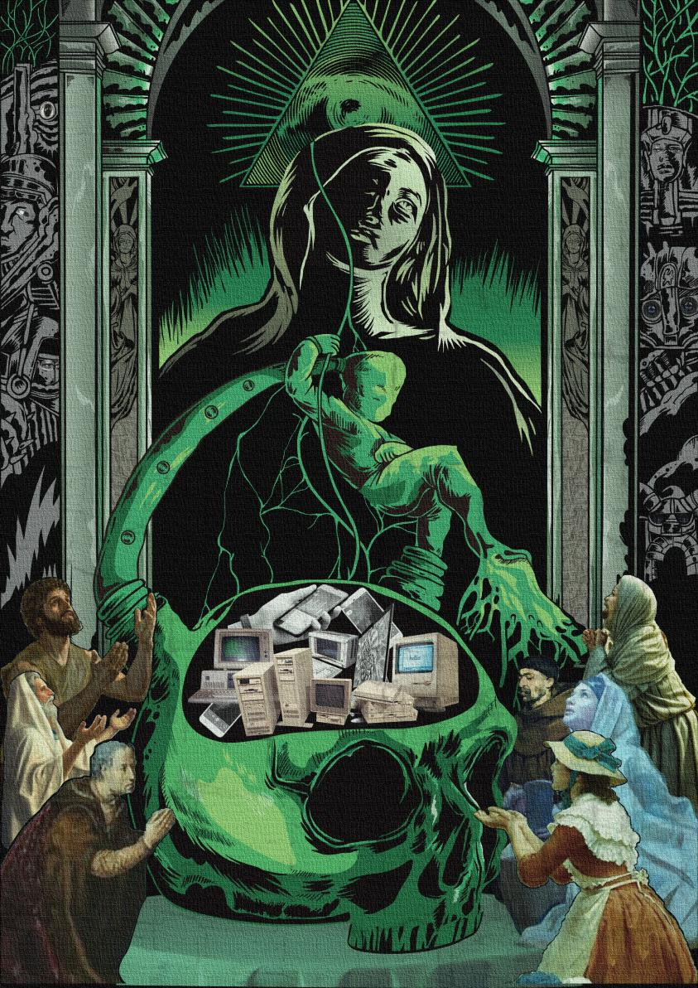
Figure 4.Fear, cult + AI
The third painting is called Fear, cult + AI. The main body of the painting consists of a baby, the Virgin Mary, a skull and the All-Seeing Eye.
The All-Seeing Eye is an important symbol on U.S. banknotes. Its original meaning is "He approves [our] undertakings". In the whole painting, it not only represents that the emergence of AI is an inevitable trend of history, but also represents the promotion of AI by capital. For AI, the capital group is the real creator.
The Virgin Mary is the traditional image of the Virgin Mary. She is placed in front of the All-Seeing Eye and behind the baby. According to the traditional religious painting composition, Mary's arms should be around the baby, but here Mary's arms are restrained behind the door frame.
The baby in this painting is also different from the traditional baby image. It has stronger limbs and is connected to the huge skull through pipes. Obviously, its growth no longer requires exercise and nutrition, and it represents the current AI.
The skull, a huge skull connected to the baby, means that the baby is born from it, and also means that the baby draws nutrition from it. It represents the sum of human wisdom. At the same time, human knowledge is also the learning goal of AI, through the various computers and network devices collaged in the skull. A living human brain is not used here, but the cognition of AI by those extreme worshipers of AI is considered. Some fanatical people believe that AI will be a new species that replaces humans, or that AI will eventually eliminate humans. This emotion is like AI is the Son of God descended from heaven.
In the process of practice, these three paintings are also designed as a series or a whole. First of all, the order of the three paintings. According to the order of the three paintings, these three paintings can be regarded as a complete and closed story, from people's fear and disgust of AI, to AI showing its working ability, and finally people's fanatical worship and the coming of the Son of God.
This is also the reason why these three paintings are displayed as videos, which are combined into a story.
Considering that the purpose of practice is to satirize people's extreme emotions, the order of the composition of this story is not unchangeable. First, AI comes as the Son of God, then AI shows its working ability, and finally those unemployed people begin to gather and oppose the birth of AI. This is also a complete story.
The purpose of displaying in this way is not to focus on depicting extreme emotions in one aspect, nor to make judgments on extreme emotions dominated by stories. This follows Richard Hamilton's creative method, using images of visual culture to criticize the values and beliefs of the viewer.
The practice process does not consider whether the viewer will eventually identify with the extreme emotions in the picture. This is because the content of the picture uses exaggerated means to amplify people's emotions and thoughts under extreme emotions, and then depicts them, making them more extreme and difficult for people to accept.
The goal of this practice is to enable people to think from a more rational and objective perspective.

Discussion
First of all, the creative form adopted in this practice is a combination of painting and collage.
This is because the imagery contained in the pop art works themselves is not clear enough. Therefore, in the early stage of practice, the coordination between painting and collage was not considered, or in other words, in the early stage of practice, the incoordination between painting and collage was the main pursuit in creation.
This is due to the practice's desire to maximize the "absurdity" of pop art. Because of this, the color conflict between a large number of paintings and collage parts makes the subject that the collage part wants to show unclear, and the sense of separation between the painting and collage parts makes the subject of the picture that was initially intended to be further clarified by collage become blurred.
At the same time, this sense of separation not only intensifies the sense of surreality, but also increases the visual impact of the two at the same time, which makes the primary and secondary of the picture unclear, adding a layer of messiness to the whole picture.
But it is precisely this sense of disorder that proves the assumption before the practice began. Popular elements do have satirical images, and the conflict of the picture is enough to make it appear. Like pop art works created with cartoon images, a large number of popular elements piled up will distract people, and the painting itself is also aggressive.
The combination of painting and collage further amplifies this defect.
In fact, this dilemma forces people to re-examine Hamilton's works. Hamilton's works simply use collage to complete the display of satire and surrealism.
In addition to Hamilton's choice of popular elements, Hamilton also takes into account the perspective and layout of the overall picture.
Hamilton even chose a planet as the roof in the picture, but this did not affect the coordination of the picture, or the element that exists as a roof only occupies the space that the roof should have.
Considering the combination of painting and collage, perhaps the two elements of painting and collage should occupy their own division of labor from the beginning, rather than fully exerting their imagination.
Back to this study, the purpose of this study is to explore the application of pop art in the field of satire, and the essence is to explore whether pop art has a stable way to diverge the creator's thoughts and imagery, rather than letting it change at any time.
This practice has fully demonstrated the potential of pop art in the field of satire. First of all, whether pop art can clearly express the creator's thoughts, which has been confirmed in the practice of painting and collage. Not only that, the sense of separation between the two also represents that pop art has the ability to deeply highlight certain popular elements. Its characteristics and creative forms are not the reason for weakening the imagery of the picture.
Similarly, there is the way in which pop art expresses images. The way in which pop art expresses images often stays in a single creative environment. It is rarely combined by two different creative methods. If you want to occupy a major position in the field of satire, this mutual combination is obviously one of the means that can be considered.
In addition to deepening the image, the mutual combination of creative forms can also make up for their respective shortcomings. The combination of collage and painting can allow collage to eliminate the problem of scattered elements of the picture caused by single painting creation, and painting itself can also make up for the limitations of collage in imagination.
This is also the case with the practice process this time. Pop art’s extraction and highlighting of popular things has a strong expressiveness in highlighting a certain image. Coupled with the use of the sense of separation between painting and collage, the communication of this image becomes more vivid.
In actual application, it can be determined that the combination of painting and collage can indeed deepen or clarify the satirical intention that Pop art wants to express. At the same time, this design method can also make the application of Pop art more diverse. The sense of surrealism formed by the sense of separation between painting and collage can highlight the importance of popular things at the visual level.
But at the same time, the practice process also made me notice the difficulty of controlling this image expression. Too vivid collage objects will take away the main position of the entire picture and the ideas that the picture wants to convey, while over-emphasizing the balance of the picture will reduce the strength of the main image.
At the design level, this practice and research reminded me of more combinations of painting and collage. For example, clothing design with a sense of hierarchy can use the combination of painting and collage to allow designers to better express their ideas and the trendy elements they want to express at the level of clothing design. Similarly, designers can also make the wearer of the clothing one of the elements of collage, and the clothing itself is where the designer can use his painting ability.
At the level of satire, pop art is no longer limited to expressing itself with cartoon images. Although pop surrealism is now the mainstream of the use of satirical images, combined with the theory of pop surrealism, cartoon images are actually used at the level of satire. The main reason is that it can better deform and distort popular elements to form a satirical effect, and adding collage effects is undoubtedly a supplement to the use of pop art at the level of satire.

Conclusion
This practice and research mainly explored the application of pop art, deepened the satirical imagery through pop art, and clarified the feasibility of combining painting and collage at the satirical level.
This feasibility is based on the sense of separation produced by the combination of painting and collage. The sense of surrealism brought by this sense of separation has the effect of aggravating the image of popular elements and the author's expression intention.
The purpose of this study is to find this means of deepening the expression intention, that is, to find a method that can solidify the satirical imagery of pop art.
Through practice, the creative form of this method has been further explored, but the effect of practice has not met expectations. What is meant here is not that there is a problem with the direction of practice, but that after clarifying the form of expression, the balance between painting and collage has not been done well. The overly strong contrast causes the intention of the whole picture to be replaced by the highlighted popular things. This is a new problem arising from this practice.
At the same time, this practice also made me realize another problem, that is, the distribution of elements in the picture should not be too much. Unlike simple painting, the accumulation of too many elements and the sense of separation after combining with collage will make the whole picture feel messy, which is not easy to appear in simple painting. Therefore, if you want to successfully use the creative method of combining painting and collage, you still need to explore and study for a period of time, which is also the direction I plan to think and explore in the future. In this regard, Richard Hamilton's work is still the first choice. He has a very good control of coordination. He can collage a large number of elements into one picture without appearing messy. In the creative form of combining painting and collage, his work is obviously a good reference direction. The first is the control of the colors between various popular elements, which is obviously the focus of improving coordination. The second is the selection of popular elements. Hamilton's selection of popular elements not only considers the meaning represented by each element, but also takes into account the overall perspective. In my opinion, this is also an area that I should improve in the future.
Reference
[1] Manli Gan (May,31，2023) The Influence and Significance of Contemporary Art Thought on Modernist Design
[2] Bohan Wang, Su Liu, Fei Zheng and Meiling Zhong (2020) Research on the Application of Pop Art in Modern Architectural Form Design
[3] Pamela G. Taylor & Christine Ballengee-Morris (2015)Using Visual Culture to Put a Contemporary “Fizz” on the Study of Pop Art
[4] Qing Shen,WeiLiang Wang (2024) An aesthetic investigation of modern landscape design in light of postmodernism: pop doctrine
[5] Yoon Kim' and Youn Hee Lee (April 30, 2004)A Study on Sportslook Design Applying Pop Art -Centering around Graffiti Works of Keith Haring -
[6] Anmar Abbas Fadel ,Prof. Dr. Saleh Ahmed Al-Fahdawi (2023) AESTHETICS OF THE GROTESQUE IN POSTMODERN ART (POP ART)
[7]Eliane Elmaleh (2024) American Pop Art and political engagement in the 1960s
[8] Ligia Lesko The Art of Graffiti as Inner-City Communication and as a means of Public Literacy
[9]Timmins F, McCabe C（May，10，2005）How to conduct an effective literature search
[10]Jan vom Brocke，Alexander Simons，Kai Riemer，Bjoern Niehaves ，Ralf Plattfaut（2015）Standing on the Shoulders of Giants: Challenges and Recommendations of Liter ature Search in Information Systems Recommendations of Literature Search in Information Systems Resear Research
[11]Kirsten Anderson (Ed) Pop Surrealism: The Rise of Underground Art

