Postgraduate/Distance Learning
Assignment coversheet & feedback form

THIS SHEET MUST BE THE FIRST PAGE OF THE ASSIGNMENT YOU ARE SUBMITTING (DO NOT SEND AS A SEPARATE FILE)

For completion by the student:
Student Name: Lee Ying Ching (Berna)

Student University Email: 2126627@student.uwtsd.ac.uk
Module code: HPCA7015  Module title: Foundations in Cultural Astronomy and Astrology | Student ID number:  2126627 |  |  | Educational support needs:  No
Assignment title: Essay based on a Sky Journal
To Think is To Walk Among Clouds

Assignment due date: 1st December 2022
This assignment is for the 1st 2nd 3rd x 4th 5th 6th module of the degree
I confirm that this is my original work and that I have adhered to the University policy on plagiarism.
Signed ……………Lee Ying Ching………………………………………………
Email submission:if you are submitting this form via email, please tick this box □
(as a substitute for your signature) to confirm that you agree to the above declaration.
Assignment Mark
1st Marker’s Provisional mark
2nd Marker’s/Moderator’s provisional mark
External Examiner’s mark (if relevant)
Final Mark

NB. All marks are provisional until confirmed by the Final Examination Board.

For completion by Marker 1 :
Comments:

Marker’s signature: |  |  | Date:
For completion by Marker 2/Moderator:

Comments:

Marker’s Signature: |  | Date:
External Examiner’s comments (if relevant)

External Examiner’s Signature: |  | Date:
Introduction
"To think is to walk among clouds” suggested by Alexandra Harris in Weatherland: Writers and Artists under English Skies. Harris explored the English attitude shifts through examining the representations in literature. In this paper, clouds in the sky are used as literature to study the Chinese skies in the form of a sky journal. Daytime clouds of Hong Kong were studied for 30 days from 11th October to 11th November 2022. The sky was observed at the same location every day for 10 minutes at 4pm, recorded with photographs, writings and drawings. The point of observation was the phenomenon of the clouds against the landscape of the Lion Rock Mountain, the symbol of the spirit of Hong Kong. The orientation of the observation was on a small hill in Tai Wai, facing the northern slope of the Lion Rock Mountain.
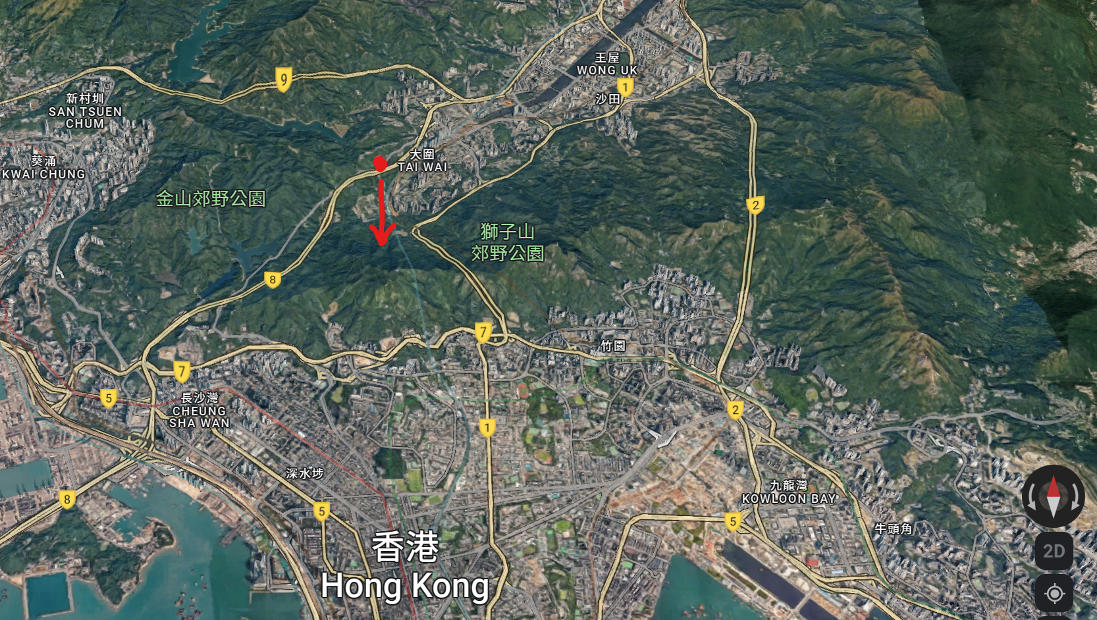
Explores the notion suggested by Harris, this paper investigates the phenomenon of clouds from sensations to inspirations, from historical to the cultural interpretation. Identifying the characteristics and the cultural meaning of clouds through the change of time. For the city and the people, Hong Kong has been through a spectrum of cultural acculturation and hegemony. From a colony under British rule to the recent decades of challenges reconciling with the new Chinese culture. The city’s culture continues to evolve along with history in the midst of changes. As different perceptions of the sky and cosmologies across history and civilizations enable us to glimpse into the different views of the world. The paper takes a cultural and historical “walk” among the clouds through the arts, divination and boundless imagination.

Cloud as “Xiang 象”
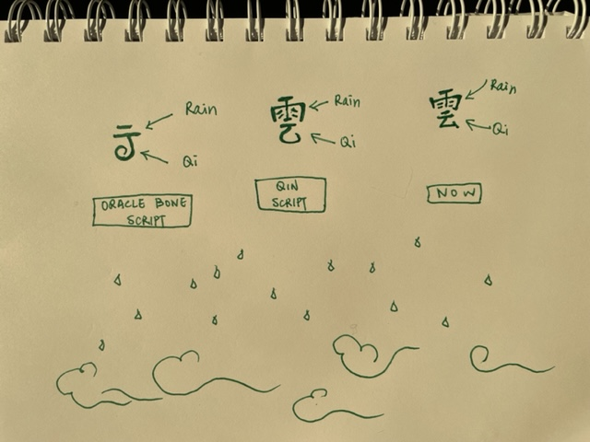
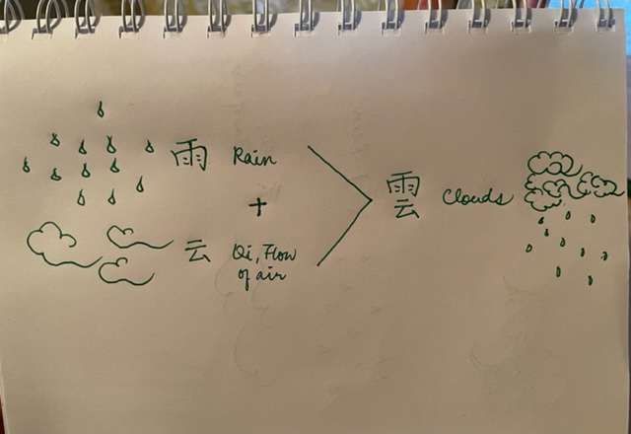
The composition of the Chinese character “cloud” 雲 came to mind as I ponder on the formation of the phenomenon while feeling the high humidity in the air. The character cloud can be found in the oldest form of Chinese character system, the “Xiang”-shaped characters 象形文字 found in the Oracle bone scripts in Shang Dynasty (1600-1046 BCE). Xiang 象 meaning phenomenon, the Xiang-shaped character of “cloud” figuratively described the phenomenon in the form of drawing. Xiang-shaped “cloud” consists of two horizontal lines on the upper portion and a symbol of a J-shaped current pointed through to the top from underneath. It continued to evolve through the Qin Dynasty (221-206 BCE), a clear identification of the two parts phenomena, water, and air, was found in the composition. The upper portion signifying rain 雨 and the lower portion signifying the flow of air 云 or Qi 氣. Qi resembles a flow of energy in the cosmos that permeates in every aspect in life, from metaphysical form of energy to natural phenomena of air, to a physical breath, all are considered to be Qi. Cloud as the “Qi in the sky” was seen as a representation of water in the sky in interaction with air, it is a form of nourishment for the Earth. As a result of the constant changing forms of the clouds, indicating the interactions between the celestial and the terrestrial through Qi.

Cloud in Stories
Cloud is a word and as a phenomenon sparked artistic imagination, through history it has also become an emblem for the divine. “Culture is an ‘historically transmitted pattern of meanings embodied in symbols, a system of inherited conceptions expressed in symbolic form” From nature to culture, when experiencing clouds against the blue sky, it always inspired me to think of the different shapes of the “cloud rides” that are designed for the deities. From traditional Chinese paintings to contemporary dramas and animations, they offer space for boundless imagination. The shape of the puffy cumulus clouds reminded me of the epic Journey to the West, Xiyouji 西游記. the story features the legendary Sun Wukong 孫悟空, commonly known as the Monkey King, and his teacher Monk Xuanzang 唐玄奘. As a fallen deity, Wukong was given the sacred mission to safeguard Xuanzang’s Buddhist Pilgrimage from China to India in the Tang Dynasty. Wukong, as a half deity and half monkey, he could only call on his ride, the Flipping Cloud 跟斗雲, in service for Xuanzang’s goodwill for humanity. The contrast fascinates me that Wukong could ride on the Flipping Cloud through time and space in a blink of an eye, while Xuanzang as a human could only ride on a horse or on his feet walking on Earth. Wukong appeared to be fearless but spiritually weak, while Xuanzang appeared to be helpless physically and spiritually strong. The juxtaposition of the roles and capabilities inspired philosophical questions on mortality and spirituality, as well as cultural and historical questions on the role of religion and the hierarchy of the society.

Cloud as Qi
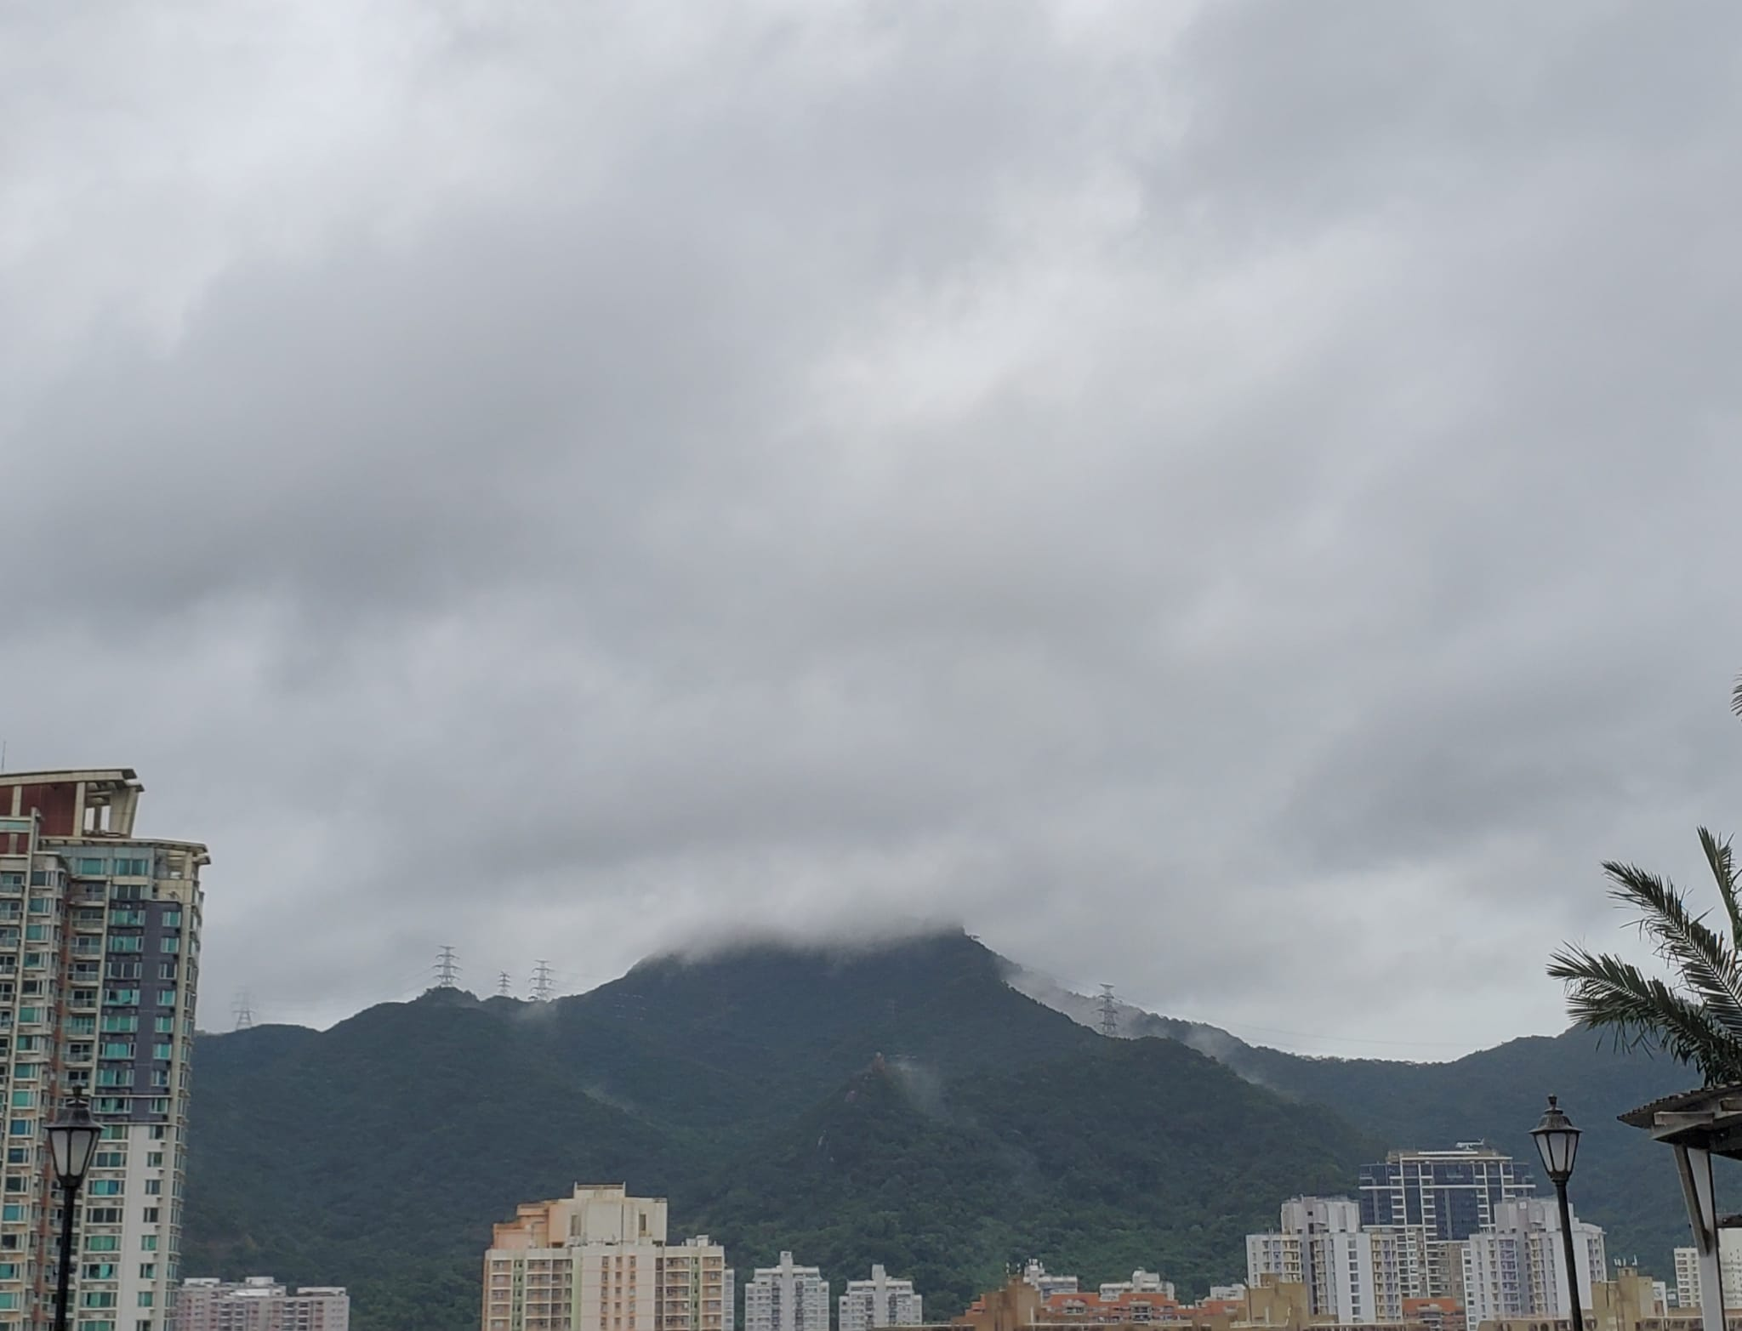
The Chinese cosmology sees the whole universe as an organic whole that all parts interact with each other with the influence of “Qi 氣”. Clouds as “Qi in the sky” is considered to be a cosmic parallelism in reflecting the happenings in the Earthly realm. On the 2nd of November 2022, a level 8 typhoon occurred on an unusual autumn day. Strong wind howling, the summit of the Lion Rock submerged into the dark thick clouds. Rain drizzled sporadically accompanied by heavy thunder that gradually brought torrential rain over the next few days. The tropical cyclone coincided with the Global Financial Leaders’ Investment Summit, as well as forcing the US$4 trillion Hong Kong stock market to close early on the day. This summit, themed “navigating beyond uncertainty”, was the first top level international financial summit hosted by the People’s Republic of China and the Hong Kong SAR government since the lockdown in 2019. In the midst of the implementation of the National Security Law and the Covid-19 restrictions, the government intended to reinstate their stand and announce ways to revive the image of Hong Kong as an international financial hub. On the day of the event, the uncertainty of weather did hinder travel plans of some of the global invitees, while some also declined to not risk the backlash from the civil society in support of human rights. The extreme weather conditions added force to the already low attendance rate, leading to only half of the invitees showing up at the summit.
From 1st November to 7th November 2022, the darkened sky and thick heavy clouds carried through and days after the end of the summit. Two common Chinese idioms came to mind regarding the phenomenon. The first one being “Black clouds covering the top'' 烏雲蓋頂, it describes the witnessing of a devastating event or an observation of an unfortunate person. While the other one is quite opposite, describing a person who is capable to “command the wind and the clouds'' 叱吒風雲, an impactful and powerful figure who is actively using Qi to negotiate with nature. As a historically agricultural society, observing and describing the natural phenomena and cycles were an important part of life. Although time has changed, and there are more factories and skyscrapers than farmlands, the natural phenomenon still lives in the day to day language to describe abstract concepts with natural phenomenon.

Cloud in Divination
Through Chinese history, clouds as a phenomenon of Qi inspired not only stories, but also became a favorite emblem for kingship through the years. From the decor of the Forbidden City to the 2008 Beijing Olympics design themes. Clouds were associated with the divine and Kingship. And thus, the movement of this Qi in the sky is considered to be revealing messages from the divine. Inspired by the typhoon 8 during the financial summit, the extreme weather from 1st to 3rd November also brought my curiosity to the cosmic parallelism of the natural cycles with what was happening in the city. From the I Ching Book of Divination (Zhouyi 周易), hexagram Tun 屯 stood out with the interactions of cloud and thunder 雲雷聚. It was explained in Xiang Zhuan that the phenomenon is seen as a dichotomy of nourishment and punishment in the context of a political dimension.
《屯》之卦象是為雲雷聚，雲行於上，雷動於下。
《象傳》 以雨比恩澤，以雷比刑。謂君子觀此卦象和卦名，則善於兼用恩澤與刑罰，以經緯國家。
“Cloud walks above, thunder moves below” - I Ching
“Rain as nourishment, thunder as punishment. The noble person who watches the Xiang and the name of the hexagram, displays good judgement on nourishment and punishment, carries out proper statesmanship” – Xiang Zhuan
The theory of the correlation among heavenly signs and natural phenomena on Earth are central for the livelihood of the people as well as the State since archaic times. The religious-political vision of the Universe echoes through all of Chinese history to some of the present-day Chinese societies. I Ching was designed to empower the Zhou State (1046-256 BCE) to communicate with the will of the divine, while it has also become the core foundation of Chinese philosophical discourse in the Warring State Period (203-221 BCE). From the referencing in I Ching, it is interesting to see the relevance in contemporary times that offers insights regarding current events.

Cloud and Weather
As much as we observe from the divination, it always helps when cross referencing the actual observation in nature. According to the 2022 Chinese lunisolar calendar, Tung Sing 通勝, the one-month observation from 13th October to 15th November of 2022 spanned across two Solar Terms (Jie Qi 節氣). The two Solar Terms happened were the Frost Falls (Shuangjiang 霜降) and the Beginning of Winter (Lidong 立冬). They landed on the 23rd October and the 7th November respectively. During Frost Falls, the Sun was blasting an immense heat of 32 degrees Celsius and there were hardly any clouds in the sky. As for the Beginning of Winter, a rainstorm occurred and stirred up heavy dark clouds with high humidity. Far from the feeling of winter, the contrast of the description of the Solar Terms and the actual experience raised some questions about how relevant they are to our contemporary lives and how they came about through history. The land of China spreads across the cold north to the tropical south, climate varies spanning the vast regions. As a result, the design of the lunisolar calendar was oriented from the archaic China capital as the other regions adjusted and followed. Hong Kong as a city located in the south of China was far from the center, with the maritime climate closer to the equator, it is only natural to show less distinct seasonal changes overall. However, the slightest changes of the natural cycles can still be sensed with observations. With most of the archaic states situated on the south bank of the Yellow River around the center of the land, the orientation reflects in the calendar as well as from the name of China, the “Central Kingdom”. In the ancient times, to standardize calendars, rituals, knowledge, and language were some of the ways used to reinforce control through culture oriented from the center. From the “burning of the books” in the Qin dynasty to appropriating history in the Han dynasty. Various degrees from cultural acculturation to cultural hegemony occurred. The legitimacy of the throne was enhanced by mirroring the sky as well as centralizing power in culture. Regardless of the changes, from the Mandate of Heaven to the construction of calendars, the foundational unit for calculating the interaction of time and space remained unchanged with the sexagenary cycle (Gan-zhi system 干支) through previous dynasties. Contemporary Chinese cosmology evolved from the study of the universe as an orderly system to a form of culture that brewed from nature. Today, the sexagenary system is still practiced among some Chinese societies, yet it is no longer an official perspective of the State. Some of the actively celebrated Solar Terms are the “Spring Begins”, as the first day of the New Year and the “Moon festival” as a day of family reunion in the mid 8th month of the year. Cosmology continues to refashion itself as a set of unconscious codes, perhaps it is the shift of livelihood from agricultural to urban, perhaps people no longer live for sowing and harvesting. This shift of culture raised the question towards Eagleton’s claim: does culture really "comes naturally, bred in the bone rather than conceived by the brain”? or is it constantly changing and re-interpreting.

Conclusion
Through the study of clouds in the Chinese skies, cosmic parallelism is found in reference to Chinese culture and history. Reading the sky as text has been an intricate part of life from the State to the economy echoed through Chinese dynasties. With changes in recent history and culture, perhaps it is the lack of physical and mental space to think in the day sky. Perhaps it’s the distraction of the city lights and glamor in the night sky. The culture of reading the sky and the natural cycles seems to be diminished through the years. Amid changes, the Chinese skies continue to provide insights through language, arts, literature and divination. As Clive Ruggles argues “Society’s views of and beliefs about the celestial sphere are inextricably linked to the realm of politics, economics, religion, and ideology”. The observations brought my awareness closer to nature, closer to where culture started to cultivate. Bringing back the attunement ecologically between celestial and the terrestrials as we continue to make cultural meanings to our worlds that would in turn impact the environment and vice versa.

Bibliography

Eagleton, Terry, The Idea of Culture (Oxford, Blackwell, 2000)

Fields, Lanny B., ‘THE CH’IN DYNASTY: LEGALISM AND CONFUCIANISM’, Journal of Asian History, 1989, 26

Geertz, Clifford, Religion as a Cultural System, in: Banton, Micheal P. (ed.): Anthropological approaches to the study of religion (Tavistock and New York: Frederick A. Praeger Press, 1966)

Harris, Alexandra, Weatherland: Writers & Artists under English Skies (London: Thames & Hudson, 2015)

Hong Kong May Raise Storm Warning During Finance Summit’, Bloomberg.Com, 2 November 2022 <https://www.bloomberg.com/news/articles/2022-11-02/hong-kong-considers-raising-storm-warning-during-finance-summit>

Hon, Tze-Ki, ‘Chinese Philosophy of Change (Yijing)’, in The Stanford Encyclopedia of Philosophy, ed. by Edward N. Zalta, Summer 2019 (Metaphysics Research Lab, Stanford University, 2019) <https://plato.stanford.edu/archives/sum2019/entries/chinese-change/>

Louis, François, ‘The Genesis of an Icon: The “Taiji” Diagram’s Early History’, Harvard Journal of Asiatic Studies, 63.1 (2003), 145 (p. 151)

Pankenier, David W. , ‘The Cosmic Center in Early China and Its Archaic Resonances’, Proceedings of the International Astronomical Union, 7.S278 (2011)

Pankenier, David W. , ‘Astronomical Dates in Shang and Western Zhou’, Early China, 7 (1981), 2–37

Ruggles, Clive and Saunders, Nicholas J., The Study of Cultural Astronomy, ed. Astronomies and Cultures (University of Colorado Press, 1993)

Yu, Anthony C , ‘The Formation of Fiction in the “Journey to the West”’, Asia Major, Third, 21.Star Gazing, Firephasing, and Healing in China: Essays in Honor of Nathan Sivin (2008), 15–44

Alexandra Harris, Weatherland: Writers & Artists under English Skies (London: Thames & Hudson, 2015), p. 245.
François Louis, ‘The Genesis of an Icon: The “Taiji” Diagram’s Early History’, Harvard Journal of Asiatic Studies, 63.1 (2003), 145 (p. 151) <https://doi.org/10.2307/25066694>.
Clifford Geertz, Religion as a Cultural System, in: Banton, Micheal P. (ed.): Anthropological approaches to the study of religion (Tavistock and New York: Frederick A. Praeger Press, 1966), p. 3.
Anthony C Yu, ‘The Formation of Fiction in the “Journey to the West”’, Asia Major, Third, 21. Star Gazing, Firephasing, and Healing in China: Essays in Honor of Nathan Sivin (2008), 15–44 (p. 15-16).
Tze-Ki Hon, ‘Chinese Philosophy of Change (Yijing)’, in The Stanford Encyclopedia of Philosophy, ed. by Edward N. Zalta, Summer 2019 (Metaphysics Research Lab, Stanford University, 2019) <https://plato.stanford.edu/archives/sum2019/entries/chinese-change/> [accessed 20 November 2022].
‘Hong Kong May Raise Storm Warning During Finance Summit’, Bloomberg.Com, 2 November 2022 <https://www.bloomberg.com/news/articles/2022-11-02/hong-kong-considers-raising-storm-warning-during-finance-summit> [accessed 25 November 2022].
Louis, p. 145.
Lanny B. Fields, ‘THE CH’IN DYNASTY: LEGALISM AND CONFUCIANISM’, Journal of Asian History, 1989, 26 (p. 3).
David W. Pankenier, ‘The Cosmic Center in Early China and Its Archaic Resonances’, Proceedings of the International Astronomical Union, 7.S278 (2011), 298–307 <https://doi.org/10.1017/S1743921311012737>.
David W. Pankenier, ‘Astronomical Dates in Shang and Western Zhou’, Early China, 7 (1981), 2–37 (p. 3) <https://doi.org/10.1017/S0362502800005599>.
Nakayama, p. 448.
Terry Eagleton, The Idea of Culture (Oxford, Blackwell, 2000), p. 31.
Clive Ruggles and Nicholas J. Saunders, The Study of Cultural Astronomy, ed. Astronomies and Cultures (University of Colorado Press, 1993), p. 1.

