
Student Name: | Leonie Nsimba
Student Number: | 1708020
Module No: | BMSK5005
Module Title: | Professional Career Development
Lecturer Name: | Mary March
Skills for the Workplace
Module Assignment Submission
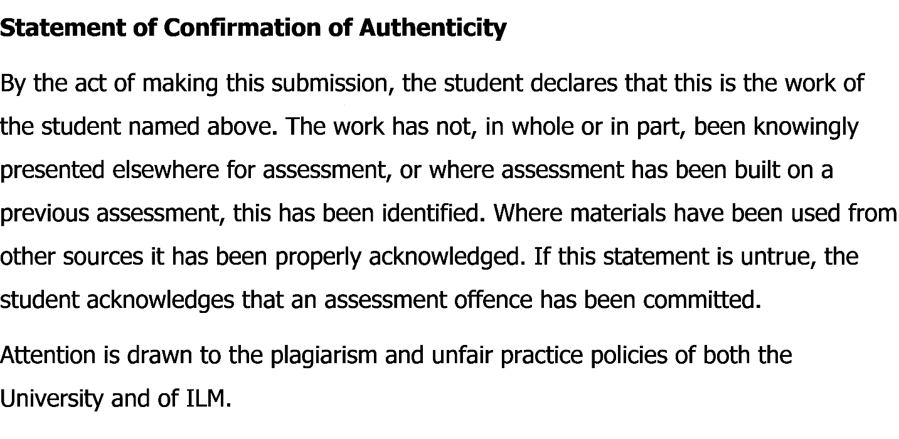
Contents
Introduction 2
Self-evaluation 3
Research and learning style 3
Reflect on my learning style 7
Expectations of the Employment 8
Career Roles and Suitability 12
Long and Short-Term Vision 13
SWOT analysis 13
Belbin Test 15
Johari window 16
Personal Development Plan 17
Importance of personal development plan 17
Personal Development Plan 18
Good Practice in the workplace 19
Conclusion 20
Reference 21
Appendix 1 22
Honey and Mumford: Learning Styles Questionnaire 22
Appendix 2 25
VAK Learning Styles Self-Assessment Questionnaire 25

Introduction

The market demand for a professional person is higher and everyone wants to increase their development skill through hard work. Profession means what a person does in his life as an income source, its important for a human to survive. Finding the best job is the most essential thing for a person that increase the chances of making life in higher standard (Cottrell, 2011). In the field of competition for getting the best job, there is always a demand for best hard working person with a better qualification in personal or professional life. A skilled person always gets the best opportunity and they are always demanded in the market. To find out their skill, there is always taken the different examination before recruiting for the job. The market always needs the best people who can increase the overall profit margin of the organization. That’s why it’s important to increase professional abilities in the job sector. This report is about the professional career development of myself, on this journey I will discuss all the potential part of my career and my future planning. Becoming a businessman is the dream of my life and for this, I need to get the proper experience of working in the different job sector. Practical experience increases the chances of becoming a successful businessman (Morgan, 2016). I will include a different part of the professional field that helps a person to boost up the chances of getting the desired job. To become successful in the professional field, it's important to make all the preparation from the very beginning of the career. As a silly mistake can make a big loss that is run for whole life.

Self-evaluation

I am currently working as a manager in a café for the last two years. As I am planning for becoming self-employed and open my own café, I need practical experiences of working in this field. That’s why I am working here to learn different important parts of the cafe business. Daily I am learning different aspects of the cafe business and increasing my overall experience. Different activities of managing people through proper motivation, making them skilled in giving the best is an important task as well.
There are different types of people who are currently working in the cafe and it's really challenging to work with them. I have to cooperate with them and motivate them for doing the best in the job. This type of work will help me in the future to increase my managing capability for my own business. Dealing with different people is a great skill that boosts up the overall ability to work.
My strength is I can manage different type of people and can convince them easily, this skill is essential for becoming successful in any profession. I can analyze the factor that can influence consumers buying, which is important in the cafe business. I can communicate with people easily that help me to work as a team. Teamwork helps to increase overall working structure and complete all the work before the lead time. The cafe business is all about creating the best food that is important to gain customers attention and overall selling. I have the ability to make different types of campaign that are helpful to beat other competitors in the market.

Research and learning style

Learning means the acquisition of knowledge or skills through different study, practical experience, or being taught by a person (Stegman, 2015). From the very beginning of our life, we learn about different parts of life to survive. There is no limitation of learning and one can learn as many as he wants to learn. Learning is a unique collection of individuals and preference that affect a person overall perceives, gathering and processing of information. It is apparent to many of those who have considered learning, even only in passing, that we learn in different ways from each other and we often choose to use what has become known as a preferred learning style. The mode of learning in which to think, process information and demonstrate learning. A person preferred means how the person is acquiring knowledge and skills. Habits of a person, strategies to adapt or formulate the rules, behavior with other person reflects on the learning of an individual.
There are different varieties of learning style that follows by different types of people. it's important to find out appropriate learning style that boosts up the chances of success. Learning environment must need to be flexible to accommodate different learning style or an individual. Good learner always develops different new strategies that help to adopt a variety of environments. Each person adopts an approach to learn different thing that the person feels comfortable and do leave on which the person doesn’t feel comfortable (Maund, 2017). Here are different types of learning style:
- Kolb (1984)
- Honey and Mumford (1986)
- Neuro-linguistic programming (VAK)
- Dantec
Honey and Mumford: Honey and Mumford identified four learning styles or preference, they are activist, theorist, pragmatist, and reflector. These learning styles are preferred by individuals by their nature and they recommend maximizing persons own learning that learner might understand their learning style, seek out opportunities to learn using the style.
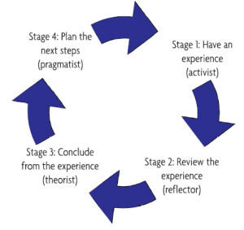
Figure: Honey and Mumford learning style (McMillan, 2006)
To understand one’s particular learning style, Honey and Mumford have prepared a learning style questionnaire that helps to know about someone far better position. I have included the file in the appendix session. Here is the below point that Honey and Mumford have to find out in their learning style:
- To fit with different learning style or opportunities that helps to learn the best is becoming smart, this helps a learner to learn different thing easily. It just not only saves time but also saves keeping learning on a timed basis. Its equipped with different learning hits with lots of information that makes a person learn through enjoying it.
- Through becoming all-around learner, it helps to increase the opportunity to learn a range of different experience. It can be formal, informal, planned and spontaneous as well that increase the opportunities for learning through benefit.
- It increases overall learning skill and the process through how a person learns, opens the overall process to self-security and improvement. Learning the best way to learn something is the most important capability of an individual that provides the path to everything else that a person wants to develop himself (Weyers, 2006).

Neuro-linguistic programming (VAK): Neuro-linguistic programming or VAK provides three types of preferred learning style they are Visual, Auditory, and Kinaesthetic. The questionnaires are added to the appendix to get the idea. Here is the below description of this style:
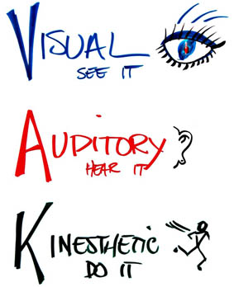
Figure: Neuro-linguistic programming (VAK) learning style
- Visual learning style means seen something or observed on some preference it can be pictures, diagrams, demonstrations, displays, handouts, films, flip-chart or many others. These learning styles are based on showing the this or looking at the preference that is the best match in reading or instructing through watching a person or individual. These people are always work based on watching something and direction or instructions that are written (Pritchards, 2008).
- A person with Auditory learning style means having the preference for transferring on information through listening or spoken with someone or something, hearing sounds or noises. These people always want to use the phrase show me, talk to me, tell me are able to perform some task after listening over the instructions as an expert. They are happy being spoken the instructions over the telephone or even can remember all the things they hear.
- Kinaesthetic learning style means having the preference for a physical experience like feeling, touching, holding, doing something, and practical working experience. They use some phrases like let me try on, tell me about your feeling and they can perform the best through experimenting or try as much time it takes.

Reflect on my learning style
 | Visual | Auditory | Kinesthetic | Other | Reflections
Leadership | Analysing diagram, overall view, pictures, and graphs. | Talking with employees, get an overall idea of how they work. | Physically experimenting, doing something and feeling. |  | I observe other people while leading. I always take with other people before judging them
Ethics | Films on overall culture, picture. | Talking with people, showing their overall preference. | Working practically on the ethics or different people. | Cognitive? | To follow the ethics, I prefer talking to people and got all the basic ideas.
Team Building | It requires observations on display, handout and watching someone | Talking with all members, listen to them | Working practically with all members, doing something with them |  | I think I can make a team bonding by analyzing all of their capabilities and organizing their tasks through proper distribution.
Conflict Resolver |  | Talk with employees, listening to their experience | Practical working experience with different people, feel their work |  | To remove conflict from working its important to talk with them and find out their problems then make a solution.
Numerical Skills |  |  | Doing lots of examples |  | I think the only way for me to get better is to practice. I will find myself some free examples and practice twice a week for the next 6 weeks. It will help me to feel more confident in this area in the future.
Time Management |  |  | Make time to do something through working practically |  | It's important to work in a practical timed way following proper timed instruction. I am able to work on the timed basis that helps to solve time issues.
Communication | Analysing diagram, overall view, pictures, and graphs. | Talking with employees to communicate on regular basis. make a solution to different problems through communication. |  |  | I am able to communicate with a different level of people through managing them. Communicate helps to work on the different tough situation and handle all the people in the professional field.
Motivator |  | Transforming different information into the practical field through hearing different sounds and instructions. |  |  | It's important to motivate people in the professional field. I am able to motivate different people easily and make them inspired to do the best.
Negotiator | Look at a different picture, analyze all the charts or displays. | Follow all the instructions properly |  |  | I can navigate on something through the proper following of the maps and other equipment’s to make the path of working.
Written Skills |  |  | Working practically increase written experience. |  | I have the ability to write on something by visualizing the working structure and make all the necessary things that are related to writing.

Expectations of the Employment

Employment means hiring employees for the workplace by the employer. There is a huge process of employment that starts with hiring the right person in the right place at right time. Recruitment and selection process is should be cost efficient that will follow all the process properly (Van, 2010).
It must be effective with enough suitable candidates and effective employees are selected for the workplace that will ensure the identification of the people they are mostly fitted for the job and the organization.
Ensuring the fair policy is a must because it’s important to make the most important decision through finding the merit people who are eligible for the organization.
Acts for Employee recruitment: There are two most important laws are applied from the employee legislation these are The Equality Act 2010 and The Rehabilitation of Offenders Act 1974. Equality act follows bellow things:
- Age
- Disability
- Gender reassignment
- Marriage and civil partnership
- Pregnancy and maternity
- Race
- Religion and belief
- Sex
- Sexual orientation
Recruitment policy: To follow proper recruitment policy, there are few things that must need to follow carefully. Proper equality of opportunity for employees. Monitor all the equal opportunities of the employees with maintaining the diversity of recruitment (Becker, 2010). Proper authorization of recruitment is important for the recruitment process. It's important to provide a job description that will include what a person needs to do in the workplace and what are the necessary activities that the person must need to perform. Provide advertisement in different media regarding the job vacancies with the job description. After getting a response from the candidates, there needs to shortlist employees and call them for interviews. After the interviews, final candidates are selected for the organization based on their qualification. Different types of tests are taken to make evaluate a person’s quality, numeracy, personality and ability to work for the post. Their mist needs to follow or find out their records through reference list that are given on the CV, find out any complaints are formed for the candidates or not. While it is obviously important to get a person’s CV looking good, do homework and perform well at interview, the fact that most hiring managers ultimately go with their gut shows how a lot of our nervous energy about the application process may be misplaced. A person is specified based on a seven or five-point plan that reflects a person overall qualification and classification.
Employment Act: There is a common law for the customer and judicial precedent than different statutes. Common law is all about the rule that is made by the judge that people have a duty to read contracts (Britt, 2003). Common law is the contract that is made of employment between employer and employee.
Here are the important acts that are related to the employment law:
- Health & Safety at Work etc. Act 1974
- Trade Union and Labor Relations (Consolidation) Act 1992
- Employment Tribunals Act 1996
- Employment Rights Act 1996
- Equality Act 2010
- Employment Act 2002
- Enterprise and Regulatory Reform Act 2013.
- Public Interest Disclosure Act 1998
- Data Protection Act 1998
- National Minimum Wage Act 1998
- Human Rights Act 1998
- Employment Relations Act 2004
- Working Time Regulations 1998,
- Transfer of Undertakings (Protection of Employment) Regulations 2006
- Parental Leave (EU Directive) Regulations 2013.

Contract and Written Statement: A contract is a legally binding agreement that makes the offer for the employee who will work for the organization. it also called the acceptance of working for the organization that is considered to follow all the rules and regulations of the organization. a contract must need to be a written statement that summaries all the contract of the employment. Below contents are written on the statement:
- Names of employer and employee
- Date employment began
- Whether employment with another company counts towards this employment
- Salary and how paid
- Hours and overtime provisions
- Holiday entitlement and pay
- Sick pay and reporting arrangements
- Pension schemes
- Notice – both sides
- If not permanent, how long
- Location of work
- Any collective agreements that affect employee
- Discipline/grievance procedures
- If expected to work outside the UK for more than a month, how long and currency of pay

Employee Obligations: There are some rules and regulations that an employee must need to follow carefully, otherwise it will create job dismissal for the employee. These rules and regulations are very common and most of the organization are following the same rules with some added features that are related to the organization. Here are the obligations:
- Not to take bribes
- Not to put a hand in till
- Not to make a secret profit
- To reveal the misconduct of employees
- Not to disclose trade secrets
- Not to solicit customers before employment ends
Employee Rights: There are some rights of an employee that must need to follow accordingly. Different unions and social organizations are formed to maintain the proper rights are given to employees or not. If any organization is failed to give the proper right, it makes a problem for the employer and legal actions are taken as well. here are the employee common employee rights at work:
- Maternity pay
- Protection from discrimination
- Wage protection insolvency
- Redundancy payments
- Unfair dismissal after two years’ service
- Notice rights
- Sick pay

Career Roles and Suitability
To build up better career, it's important to care about it and hard work from the very beginning. A career is a sequence of positions that is occupied by a person during the course of a lifetime. That means it’s the sense of work that goes one’s lifetime and evaluated what the person does in his whole life (Conger, 2003). Below points are must need to keep in mind for career development:
- Planning of the career
- How do individuals choose careers?
- The career cycles
- Changing ideas about careers
- Current issues in careers
Proper planning in a career is important to make the most use of it. Career planning helps to act based on the planning. First, there need to identify the individual goals what the person wants to become. As I want to become a businessman, so I have planned the process how I will make sure to do these things. Then there need to find out my personal characteristics and determine how I will achieve these goals by collecting more information. After that, I will take steps to achieve the goal through mentor and personal development activities. Finally, I will reassess the goal to make progress it properly.
A person’s career choice is formed based on certain things that are related with the success of life. it can be based on the overall life goals, what the person wants to do. It can be a social background, or family factors as well. A career can be chosen by a person’s personal interest, abilities, self-identity, and personality factors as well (Fulmer, 2003).

Long and Short-Term Vision
At the beginning of my career, I will work on the different business organization in multinational companies and cafe business. From there I will learn how to manage different people and work cooperatively with a different person. It will increase my overall skill development to make something better and find out the problem that arises while working. This is a short time plan and will help to stay on my aim to reach the goal. After getting overall experience, I will start my own business and try to make something different that will help me to shine in my career which is my long-term vision.

SWOT analysis
SWOT Analysis

Strengths | Weaknesses
What are you good at?  I am able to communicate with different type of people easily and can motivate or inspire them to work in any tough situation. I am able to handle different type of people and they believe in myself that I can lead them to achieve anything. I have technical advantages that can make any solution shortly and I believe that it helps me a lot to increase my overall working task easily. | What do you need to improve?  I need to improve my anger management, I have short temper that makes my trouble to work with different or new people. I need to work on this issue to make people easy to handle.
What special resources do you have (e.g. qualifications, experience, contacts etc.)?  I can interact with new people that are helpful to making any business decision. My qualification background is also bright and can compete with the different type of people. I have contact with different types of people in the society and they will come to help me with any tough situation. | In what areas do you have fewer resources than other people? (e.g. qualifications, experiences, contacts etc.)  I have less experience with some scientifical issues and less communication with these people. I need to gather more experience on these to use this in my career for solving different issues.

Opportunities | Threats
What opportunities are available to you?  As I can motivate and handle people easily, it gives me lots of opportunities to handle any tough situation. I have enough knowledge on new innovation and technologies that are important for business and professional development as well. I can communicate and satisfy a customer with their needs and it’s a big opportunity to beat other competitors. | What threats could damage your ambitions or career prospects?  Competitors are always looking for new opportunities and its threat for my personal skill as well. I need to increase my ability and less down my mental stress. There are some people who copy my projects and planning, also the demand of my job is also getting higher that’s why its great threat to shine in this career.
How can you turn your strengths into opportunities?  As I can communicate with different people and interact with them to make the best decision, it’s a great opportunity for me to handle different type of people. I can also impress customer by satisfying and its another opportunity to increase overall selling. | What threats arise because of the personal areas of weakness you have identified?  As I have short temper problem, it’s a threat and personal weakness as well to manage new people. This weakness makes tough situation to handle different things.

Belbin Test
A team’s overall performance depends on the overall responsibilities of the team members. when all the team member works and fulfills their responsibilities, it makes the team successful automatically. Belbin Test is all about team roles and how a team works cooperatively that are designed to achieve on something (Vijayaraghavan, 2003).
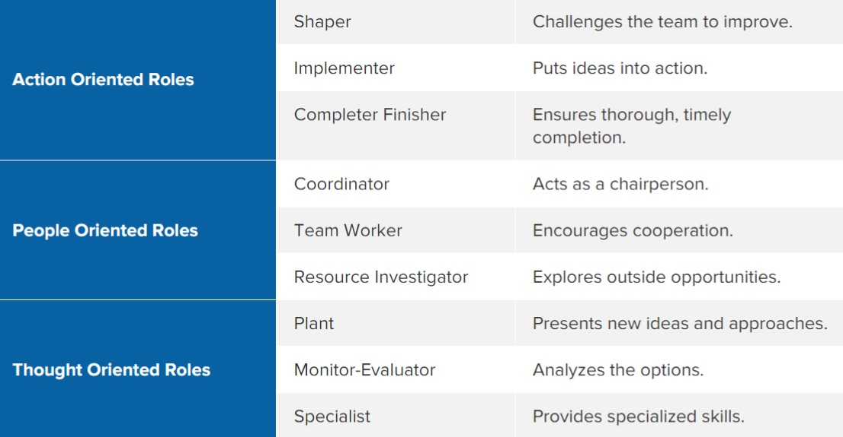

Johari window

It’s the technique that helps people better in understanding their relationship or bonding with other people. This tool helps to find out soft skill that is related to a person through cooperation, intergroup development and interpersonal development (Griffin, 2003). There are two factors that are works with Johari Window, one is what I know about myself and another is what other people know about myself.
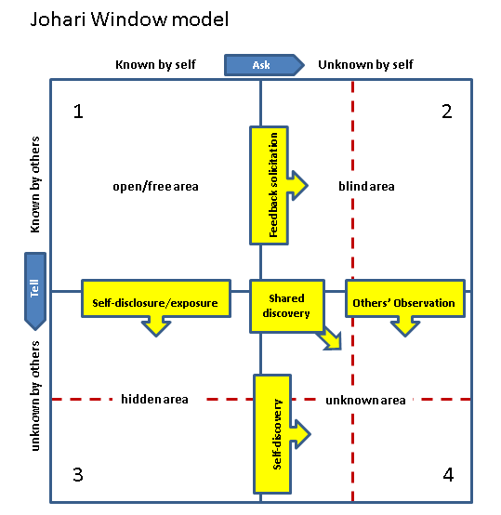
Figure: Johari window (Griffin, 2003)
This model is formed with four areas that are related to anything that a person knows about himself that is shared with an open area. A person can increase trust by sharing or disclosing information to others and learn and disclose the information as well. There is another part that a person doesn’t know is the blind area and it needs to collect feedback from another person. It formed with positive and negative information from other people. Another part is a hidden area that is a person is aware of but don’t want to share with another person. Final remaining part is an unknown area that anyone doesn’t know about a person even a person also doesn’t know about this. By working with different people and taking information all the four parts are filled to find out personal information of a person.

Personal Development Plan

Personal development plans are the process of making different plans based on creating awareness, values, reflection on something, setting up a goal for planning that is important for personal development through career, education, and personal improvement in whole life (Hewlett, 2002). It makes overall planning what a person wants to do in his life or what are the works need to be done to achieve career goal through developing it. The personal development plan is setting up aims and objectives that a person wants to achieve in his life that the person will do through making a shot and long-term planning (Becker, 2010).
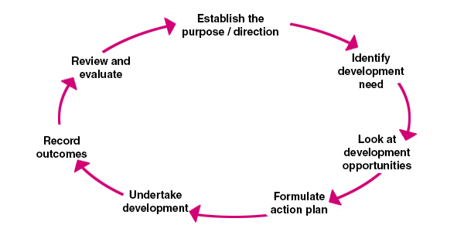
Figure: Personal Development Plan (Becker, 2010)

Importance of personal development plan

There is the huge importance of creating a personal development plan that is related to a person’s overall success. The personal development plan must need a SMART objective that will help to achieve.
Self-Awareness: It makes self-awareness of a person that helps to evaluate the value through proper information. To achieve something, there must need to evaluate a person first, who the person is and what are the capabilities that a person has. Personal development plan makes self-awareness first to compete with others.
Proper Direction: Personal development plan directs a person to reach the goal. Before doing anything, there must need to make the proper direction in life. there are different tough decisions that need to be made by a person to achieve the goal and mistakes are also done. But learning from mistakes is the important part of life. When directions are set up, no one can stop to reach the goal of life.
Focusing: Personal development plan makes the proper focus on something that is important for a person to achieve or fulfill something. It makes a person to look forward that are related to the plan as per the deadlines and take all the necessary things that are related to the priorities.

Skills that are required
Currently, I am working as a manager in Cafe for the last two years. As I am planning for becoming a businessman and open my own cafe, I need practical experiences of working in this field. That’s why I am working here to learn different important parts of the cafe business. Daily I am learning different aspects of the cafe business and increasing my overall experience.
I need to complete my studies properly to reach on my goal and will help to gather my professional skill and employability skill. In terms of professional skill different activities of managing people through proper motivation, making them skilled in giving the best is an important task as well.

Personal Development Plan

NAME: | Leonie Nsimba | Student ID | 1708020
COVERING THE PERIOD FROM: | 01/09/2019 | TO: 01/12/2022

What do I want/need to learn?  I need to learn different things that are related to business development. | What will I do to achieve this?  To achieve this, I am currently working in a cafe and I will, later on, join in a big cafe or hotel where I will be able to learn different things. | What resources or support will I need?  I need to study different materials that are related to my career. | What will my success criteria be?  My overall academic result, professional achievement are success criteria. | Target dates for review and completion  My target date for review is the end of 2022.

Good Practice in the workplace

It’s important to make good relationship with all the people in the workplace, I really enjoy to work in the cafe business as it’s my dream and I love to work cooperatively with different types of people. Competition is becoming high on day by day and different types of new strategies are influencing overall marketing strategies (Kiger, 2001). I am learning new techniques on a regular basis that definitely will help me in the future. I can communicate with different type of people easily and these help me a lot to increase my overall good practice and manage other people.

Conclusion

To sum up the report, it can be said that the importance of career development is must for any person. It not only just increases the performance but also helps to keep aware what are the things that a person needs to do. Different people follow different learning style and its obvious to find out the appropriate learning style that is matched with a person’s life or interest level. From this report, I have evaluated different learning style that is related to myself and what are the things that I need to develop as per my self-evaluation. A person’s success is relying on focusing on his career and personal development. That’s why it's important to look after on the career from the very beginning of life and make the necessary planning to achieve to the goal of life.

Reference

Britt, J. (2003). It's time to get serious about succession planning. HR Magazine, pp. 12-13.
Conger, J.A., & Fulmer, R. M. (2003). Developing your leadership pipeline. Harvard Business Review, pp. 76-84.
Cottrell, S. (2011) Critical thinking skills: Developing effective analysis and argument (Palgrave study skills). 2nd edn. Basingstoke: Palgrave Macmillan.
Griffin, N. S. (2003) Personalize your management development. Harvard Business Review, pp. 113-119.
Hewlett, S. A. (2002). Executive women and the myth of having it all. Harvard Business Review, pp. 66-73.
Kiger, P. J. (2001). Good Practices in the Workplace. Workforce, pp. 54-56.
Morgan, P. (2016). The Business Student’s Guide to Study and Employability. Sage Publications.
Maund, A. Schriek, M. and Tinkler, P. (2017). Certificate in Higher Education: Skills for the Workplace Student Yearbook. Sage Publications.
McMillan, K. and Weyers, J. (2006) The smarter student: Skills and strategies for success at university, London: Prentice Hall.
Pritchards, A. M. (2008) Studying and Learning at University: Vital Skills for Success in your Degree. London: Sage Publications.
Stegman, J. (2015). The Importance of Managerial Communication. The Bulletin of the Association for Business Communication, 51(3), pp.25-26.
Van Emden, J. & Becker, L. (2010) Presentation Skills for Students (2nd edition). Palgrave Macmillan
Vijayaraghavan, V. (2003). Career and Personal Planning. Harvard Business Review, pp. 96-102.

Appendix 1

Honey and Mumford: Learning Styles Questionnaire
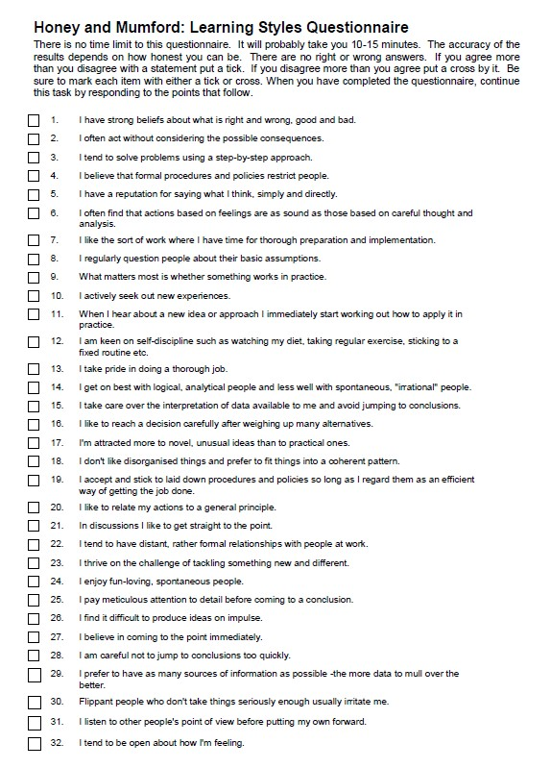
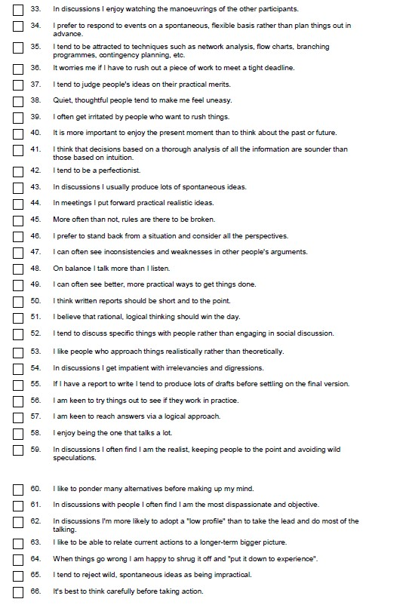
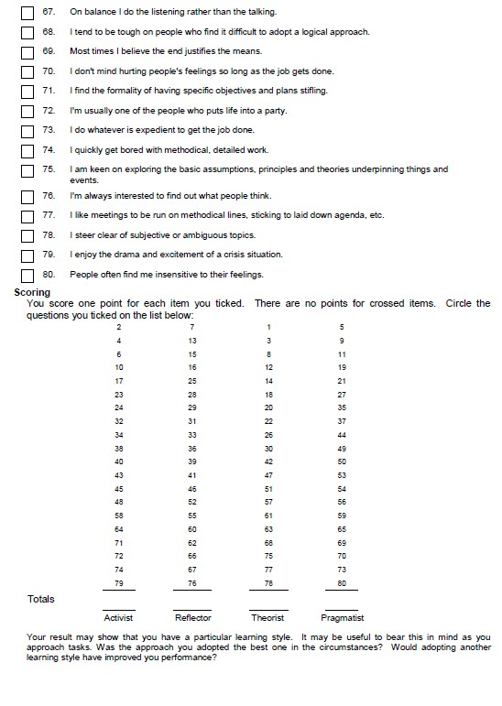

Appendix 2

VAK Learning Styles Self-Assessment Questionnaire


