An analysis of the current situation
In the NHS

Habibur Rahman Lecturer: Marie Pitson
Student ID 0452010
Executive Summary

The executive summary is based on problem-solving and decision making of NHS regarding their challenges. This report covers the current situation of NHS, which is facing different kind of problem and impact of their stakeholders. The main problems of NHS are aging population, rising cost and lifestyle. It is also explained about why and how the NHS facing this kind of problems. Analysis this kind of problem the candidate uses the PESTLE, Fishbone theories and SWOT analysis. Where PESTLE shows external factor, which cannot control such as Political, Economic, Social, Technology, Legal and Environment. Fishbone shows internal factor which help to find out the cause of problem and help to make a decision about problem. SWOT analysis, which helps to identify the Strength, Weakness, possible opportunities and threats of NHS.

Contents
Introduction 4
The concept of problem solving in NHS……………………………………………………………………………………5-6
Staticial Analysis of NHS…………………………………………………………………………………………………………7-9
Stakeholders Analysis…………………………………………………………………………………………………………10-11
Impact of business factor in NHS………………………………………………………………………………………..11-14
Fishbone Analysis ………………………………………………………………………………………………………………..15-16
SWOT Analysis…………………………………………………………………………………………………………………….16-17
Conclusion and Recommendation……………………………………………………………………………………..18-21
References………………………………………………………………………………………………………………………….22-24

Introduction

NHS is a public service. It stands for National Health Service. It was launched on 5th July 1948 by the Health Secretary, Aneurin Bevan at park Hospital in Manchester (Known today as Trafford General Hospital). (NHS70, 2018). It was based on 3 core principles, that it meets the needs of everyone, that it be free at the point of delivery and that it be based on clinical need, not ability to pay (NHS choices, 2018).

These are the principles but in current situation NHS struggling and facing with different kinds of problems. Such as obesity, ageing population, changes of lifestyle, lack of doctors and nurses, over pay for agency staffs, financial crisis, alcoholic, smoking, privatization, political condition, emergency and accident department as well as development in medicine and technology. So, the report explains the how National Health Service implements their strategies and decisions to solve problems and challenges.

Among these problems the major problems are Ageing, Finance and changes of lifestyle.

In this section, the current situation of NHS has been discussed along with the impact of this on their stakeholder's activities. The candidate is using PESTLE Analysis, Fishbone, Stakeholders Analysis and SWOT analysis model and theories to measure of this kind of problems. All these kinds of problems are some of them internal and some of them external. Today, NHS has been facing the biggest challenge in its existence. The report has detailed information about the NHS challenges and solutions to solve these problems. Besides that, the pressures on this health organization are more significant than they have been ever.

The concept of problem solving in NHS

Decision making and problem-solving are two significant requirements for business. The problem-solving process includes decision making. The leaders and managers of National Health Service are involved in decision-making process. The only strategy to get rid of the problems as mentioned above is to bring a change in the decision making or problem-solving process. The management may change the leader, or the leader may change the way of work and meet the recent demands of UK’s citizens. According to Scott(2008), scientific work is the most significant one hand art for improvement and development. At first, theoretical approaches should be made and after that practical activities should be performed based on the theoretical approaches. For example, the NHS can introduce Electronic Aspirin or ATI Neuro-stimulator in the hospital for treating patients who are suffering from migraines, cluster headaches, excruciating head as well as facial pain. The figure of the device is given below:
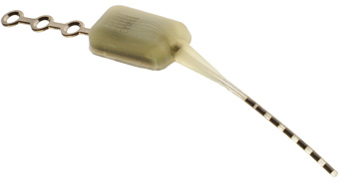
Figure 1: ATI Neuro-Stimulator
Apart from these, NHS needs to create objectives, and the purposes should be:
- To establish the facts and root of the issue regarding the Brexit case.
- To define, document as well as identify a problem.
- To identify, define as well as document an opportunity.

- To assist problem-solving and problem analysis by the team members of NHS.
- To simplify and enhance management reporting.
- To make regular meetings in a more organized, focused and productive way.
- To measure the effectiveness of the solution to the particular problem as well as the amount of improvement.
- To support the creation of procedures and standards.
- To simplify dissemination, transfer of knowledge/technology, communication by providing a common language for presentation and analysis.

Statistical Analysis of NHS
The report explains the how National Health Service implements their strategies and decisions to solve business problems and challenges. In this section, the current situation of NHS has been discussed along with the impact of this on their stakeholder's activities. Today, NHS has been facing the biggest challenge in its existence. The report has detailed information about the NHS challenges and solutions to solve these problems. Besides that, the pressures on this health organization are more significant than they have been ever. Some of the obstacles are aging population, lifestyle factors, the change in public health awareness, rising cost, emergency and accident departments as well as developments in medicine and technology. The case for the National Health Service is direct. Besides, it completes an excellent job for singular patients, offering brilliant watch over a consistently growing scope of conditions. It diminishes infirmity for families, mainly from time to time of financial susceptibility and separation, since access to mind isn't devoted to patient’s wage or patient’s activity.
According to Barros and Braun (2016), NHS is one of the world's most practical health institutes, and it straightforwardly adds to the accomplishment of the British economy. The particular healthcare organization has stood all time beside the needed patients, but research says that one of the most dynamic debates of England has been seen over the Brexit and NHS was the center stage.
Impact of Brexit on NHS: The information was taken from an article “Brexit will destroy the NHS by step by step – this is how”. In this article, it has been said that Brexit will destroy this healthcare organization step by step. The pharmaceutical companies of the United Kingdom are now having to sidetrack money on improving and developing the treatment by spending this money on research. These companies decide to invest money in new medical instruments (Ben Bradshaw, 2018).
The change in public health awareness: The primary job of National Health Service was to tackle the disease. Now, people are expecting much from this healthcare company. UK’s citizens are demanding advice on healthcare management along with social and mental health. Lin (2015) stated that maternity services, contraception, vaccination campaigns as well as efficient processing of medication and appointments are on the demand list of British citizens.

Lifestyle factors: Three lifestyle factors work in the UK, and they are high-class, mid-class and labor-class. NHS has always been helpful to the mid-class and labor-class citizens. Today’s lifestyle is putting a negative impact on people’s health. According to Merchant and Wilson (2010), a poor diet with an increase in alcohol consumption can lead a severe threat to the general health of UK's population.

Rising Costs: According to the financial reports of FDI, the economic and manufacturing costs of different products and services are being increased due to varying types of political pressures on healthcare systems. Mahmoud (2010) stated that due to high population, the costing price of medicines and other treatment equipment has increased the costing price which is not affordable by poor and illiterate people of the United Kingdom. Therefore, NHS hass to invest a lot of amount on technology without any future support.

Developments in technology and medicine: Attractive news among most of this miserable situation is there has never been a better time than go up against a refresh. Considerable movements in medication and surgery, near to IT and mechanical developments infer that there is an abundance of musings and efficiencies that could be realized to pass on our NHS up to introduce day standards to address the issues of each one of us in the Twenty-first Century. Hunter, Tiley and Sang (2005) stated that utilizing these new strategies inside an extensive refurbishment the National Health Service could proceed to be supporting human health and care along with an inspiring model of good working practice for a significant time allotment to come.
According to Dale (2015), during the last seven decades of the life of NHS, the development in funding department of NHS has intimately experienced the ups and downs of more great financial cycles. After the recession of 2008 in the UK, the economic picture has again become more challenging.
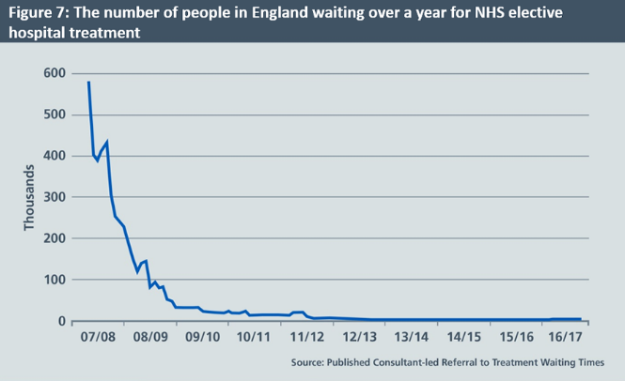
Figure 3: Statistics showing the decline rate of NHS’s patients

Stakeholder Analysis

Stakeholder A person, group or organization that has interest or concern in an organization. Stakeholders can have affected by the organization’s action and policies. Some example of stakeholders are community, government, staff, management, patients and suppliers [online 2018]. All stakeholders have different power and interest. Stakeholders can be divided into three categories there are internal, external and connected. In the NHS the internal stakeholders are Employee, Government and management an external are who in interest on an organization such as customer, community and council. Connected are who has economic relation with organization such as supplier and shareholders.

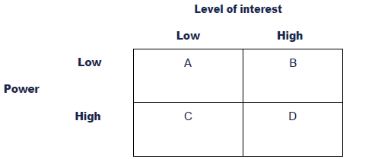

Figure: Mendelow’s Matrix

Mendlow’s Matrix is comprising of four sections. Box A represents the minimum effort required for understanding the lack of stakeholder interest. Box B represent the theme of continuous information. Box C represents the factors required for maintaining the stakeholder. Stakeholder satisfaction is the main key topics in this analysis. The stakeholders of NHS have to keep satisfied. Box D represents the driver of stakeholder motivation. In other UK’s healthcare firms, all level people are encouraged as well as empowered to make decisions informed by accurate information. Therefore, the involvement of every member from NHS is necessary to solve issues about business extinction [Kaplan Financial, 2018]. With the help of the Mendelow’s matrix, NHS can identify, mention the stakeholder and pay attention to manage them.

Impact of business factors on NHS

The patients had to wait over a year for NHS elective hospital treatment because of no place for extra patients. Recently, the hospital's five-year view set out three alternative scenarios for least possible funding amounts in the year 2020. NHS funding has fared better than other public services, but the problem lies in their present infrastructure as compared to other public healthcare services (NHS managers rate quality of NHS leadership as poor, 2013). N

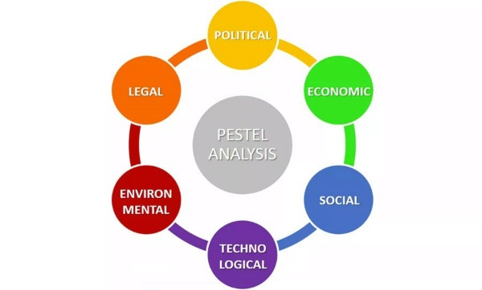
Figure 4: A PESTLE analysis framework
The above figure represents a diagram of PESTLE analysis. The analyst dismembers the NHS through these four points and differentiations the result and its opponents which in the end help them to overcome on the escape provisos in a minute and gives the NHS a distinct edge over its adversaries. It is reasonable to depict every region for purposes of enthusiasm to see what parts affect the relationship under the umbrella of political, environmental, social and technological subjects. By contrast of this industrial segments are to organize the productivity within a comparable industry.

Political: Political factors consists of governmental rules and regulations and other valid legal issues prevalent in the country, which intentionally or accidentally, formally or calmly an organization need to complete to work with their full point of confinement (Moro Visconti, 2014). Appraisal approach, environmental controls, employment laws, trade customers and taxes, strong political quality and legitimateness condition in the country generally goes under the authority of the politics.

Economical: The factors like budgetary advancement, interest, exchange and refund rates in the country are orchestrated under the economic field. One of the primary requirement of NHS is funding to meet the demands of the rising population of the United Kingdom, and that's why they have set a target to develop within 2020 (Sarra, 2005). The company needs to make investments in the training of present employees who are unaware of the new technologies and medicines.

Social: The second-rate class is the social factor which includes the social and measurement parts of the external microenvironment. Some social factors are health insight, age appointments, prosperity stress and people advancement rate. The heath of people is deteriorating day by day due to unbalanced working hours, weak relationships, increase in consumption of fried foods without performing the daily workout (NHS England issues naloxone warning, 2014).

Technological: NHS should introduce defibrillators, anesthesia machines and patient monitors for better treatment of UK’s citizens. Anesthesia machines are proposed to give an exact and predictable supply of remedial gases passed on to the patient at an ensured weight and stream to keep up actual anesthesia process. Besides that, these propelled machines consolidate a suction unit, ventilator and patient-watching contraptions for keeping up palatable anesthesia levels. Defibrillators are ordinarily used to treat hazardous conditions, for instance, ventricular fibrillation, tachycardia and cardiovascular arrhythmias (Parmar and Aniq, 2014). By passing on an accommodating estimation of the electrical embodiment, the defibrillator closes the arrhythmia and restores a typical state of mind to the heart. The LCD screen is a standard piece of remedial equipment that empowers pros to see pictures of surgical methodologies ahead of time at high assurance with the objective that the master has a unique point of view of the system.

Environmental: The healthcare organization should involve themselves in organizing a healthcare campaign where travelers and passerby will be provided a free checkup of any body parts. Consequently, the campaign will attract media which will go viral on the internet. This promotion will increase the growth of the organization. Moreover, waste and disposals of the hospital should be neutralized by scientific methods without creating any pollution.

Legal: NHS should safeguard the legal rights of people to make their own healthcare decisions. The safeguarding of these constitutional rights needs planning and thinking (NHS issues call to action over community pharmacy’s place in primary care, 2013). The conduction of personal affairs, making wishers and making them sure are respected but it may impact the people who are mentally or physically injured. Therefore, during unknown treatment person should be allowed to meet the patient until and unless the person provides pieces of evidence.

Fish Bone analysis

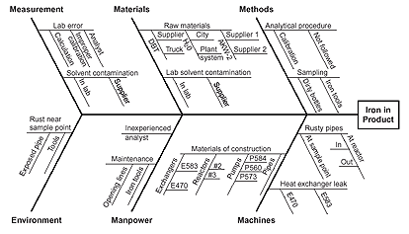
Source: http://asq.org/img/laq/cause-analysis-tools-fishbo.gif

The fishbone diagram, or the conditions and final products diagram is a fundamental practical presentation that demonstrates all the possible purposes behind an issue in business. It is also implied as Ishikawa diagram. Here is a fishbone diagram representation demonstrating the purposes behind low bit of the general business from five perspectives like customer, advertisement, workforce, contender and sales channel. The fishbone diagram gets the companies like NHS among the potential causes and results appeared in the diagram. Organized keenly, the relationship can be grasped at first. To help perceive the fundamental drivers from each one of the considerations delivered, NHS should consider a multi-voting framework, for instance, having every partner recognize the best three primary drivers. NHS should demand that every associate put three tally stamps or tinted sticky spots on the fishbone adjacent to what they acknowledge are the fundamental drivers that could possibly be tended to.

Impact of Fishbone Analysis on healthcare

“A fishbone diagram helps team members visually diagram a problem or condition's root causes, allowing them to truly diagnose the problem rather than focusing on symptoms” It allows team members to separate a problem's content from its history and allows for team consensus around the problem and its causes. Brainstorm possible problem causes and attach each to the appropriate rib. Besides that, medical team might find it helpful to place ideas on category ribs as they are generated, or to brainstorm an entire list of ideas and then place them on ribs all at once.

SWOT Analysis
The SWOT analysis looks at the internal and external factors that have an impact on the organization. The internal factors are Strength and weakness. The external factors are opportunities and threats. It is an important tool of any business or organization because it’s helping to focus on the strength and minimize on threats just like any other organization, in NHS also has strength, weakness, threats and opportunities. Here is the NHS SWOT analysis.

Strength: NHS is one of the most popular organization in Europe which has experienced doctors and nurses to treat patients. The system of NHS can be implemented relatively quickly.

Weakness: There are abundance of information regarding new health diseases among the doctors and nurses and the government meddling is very concerning rules.

Opportunities: The supply chain of NHS is under developed and this healthcare organization want to reduce costs. Therefore, it is an opportunity for NHS to get help from the government.

Threats: The only threat to NHS that the managers do not try to innovate and do not want any change in the workplace.
Distributer managers of NHS should commandingly move their associations. Besides, it incorporates understanding the isolated supply chains that must progress, and to support their change.

Effect

Conclusion

Initially, the issue should be defined to ensure that NHS is dealing with the real problem, not its symptoms. In simple word, the root of the cause needs to be identified. If the problem of NHS is simple, then the solution is usually apparent, and the company does not need to follow the objectives made for the company (Buheji, 2017). It means that the problem is complicated. It is very significant for National Health Service to understand the complexity of the problem. Here, the complication is that the company is facing a sign of extinction. Therefore, a problem-solving framework and PESTLE analysis have been to avoid destruction. The main advantage of PESTLE analysis is that it can remove the competitive and political threats and can bring an improvement in the technology.

Recommendation

The recommendation is based on the extent of the solutions provided above. Apart from electronic aspirin, National Health Service should introduce diagnostic tools and EKG machines. There are other ways that NHS could have handled the problems they faced. One of the most significant jobs of NHS was to identify the capability of organization's employees as well as seek to find a balance between meeting the expectations of upper management and the requirements of the employees. Moreover, the healthcare company should also understand the organizational culture as well as the culture of the UK’s healthcare industry (Misselbrook, 2013).
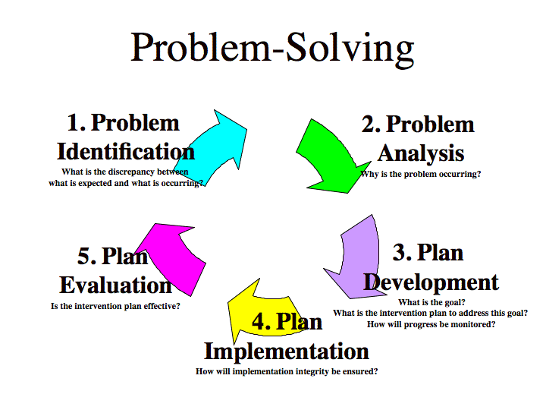
Figure 2: A problem solving framework
The above figure represents a problem-solving framework. This framework is divided into five parts such as problem identification, problem analysis, plan development, plan implementation as well as plan evaluation. It is a breakdown process to problem-solving and decision-making process. The five steps are described below:

Problem identification: It is the first stage where NHS can identify the problem. For example, NHS had identified difficulties like employee turnover, need for up gradation of medical equipment and development of organizational infrastructure (Kwisthout, 2012). A business is incomplete with problems and NHS can clearly identify the need for the growth of business by identifying the current problems. Besides that, the organization can identify the need of their patients and provide medicines and its equipment according to the health requirements.

Problem analysis: This is the second stage where NHS needs to analyze the problems. A problem analysis is a set of analytic tasks which is meant to enhance the designers’ understanding of unbalanced circumstances (Reading, 2013). Moreover, a problem analysis is required for the sake of designing a change to the circumstances that would have better balance.

Plan development: It is the third stage of a decision making and problem-solving process. The plan of NHS should include efficient use of political support and medical resources. Moreover, this public company must make a plan to establish the objectives. Team building plays a significant role in a plan development process. Planning helps in promoting a spirit of cooperation and team building.

Plan implementation: It is the fourth stage of a decision making and problem-solving process. The plan implementation helps to bring a positive change which can help the management body to solve critical issues. Moreover, NHS will accomplish their objectives of developing organizational infrastructure by implementing their plans (Franker and James, 2016).

Plan evaluation: It is the last stage where all plans are implemented practically. A proper plan evaluation will helps the whole NHS to recognize how they could improve what they are achieving and take actions to build on successes as well as avoid repeating old problems (Jabot, Turgeon and Carbonnel, 2011). On the other hand, this evaluation process will help the company to meet today’s demands of patients for their treatment.

References

Barros, P. and Braun, G. (2016). Upcoding in a National Health Service: the evidence from Portugal. Health Economics, 26(5), pp.600-618.
Bradshaw,B.(2018), ‘ Brexit will destroy the NHS step by step – this is how’ [ online]. Available: tps://www.independent.co.uk/voices/brexit-nhs-destroy-how-healthcare-donald-trump-eu-withdrawal-bill-funding-crisis-money-budget-a8194751.html [2018, Febrabury ,5].
Buheji, M. (2017). Understanding Problem Solving in Inspiration Labs. American Journal of Industrial and Business Management, 07(06), pp.771-784.
Businessdictionary.com(2018),’Stakeholder’[online].
Available: http://www.businessdictionary.com/definition/stakeholder.html[ 2018, July 19].
Gardashova, L. (2017). RDM Based Approach To Solving Decision Making Problem Under Uncertain Environment. International Journal of Innovative Research in Computer Science & Technology, 5(2), pp.247-252.
Hunter, C., Tiley, L. and Sang, H. (2005). Developments in transgenic technology: applications for medicine. Trends in Molecular Medicine, 11(6), pp.293-298.
Kaplan.co.uk.(2018),‘Mendelow’sMatrix’[Online].Available: http://kfknowledgebank.kaplan.co.uk/KFKB/Wiki%20Pages/Mendelow%27s%20matrix.aspx, [ 2018, July 19].
Lin, S. (2015). Raising Public Awareness: The Role of the Household Sector in Mitigating Climate Change. International Journal of Environmental Research and Public Health, 12(12), pp.13162-13178.
Mahmoud, A. (2010). FDI, Local Financial Markets, Employment and Poverty Alleviation. SSRN Electronic Journal.
Majeed, A. (2017). Brexit will put further pressure on the NHS. BMJ, p.j1380.
Merchant, R. and Wilson, A. (2010). Mental health chaplaincy in the NHS: current challenges and future practice. Mental Health, Religion & Culture, 13(6), pp.595-604.
NHS reports reveal rising costs and variations in access. (2010). British Dental Journal, 209(5), pp.201-201.
Scott, J. (2008). Visual representations in problem solving and decision-making. International Journal of Management and Decision Making, 9(3), p.266.
Calinici, T. and Drugan, T. (2015). Using e-learning for developing new skills for administrative staff. MedEdPublish.
Dale, I. (2015). The NHS. New York: Elliott & Thompson.
Franker, K. and James, D. (2016). The Course Development Plan: Macro-Level Decisions and Micro-Level Processes. New Directions for Higher Education, 2016(173), pp.43-53.
Jabot, F., Turgeon, J. and Carbonnel, L. (2011). The evaluation of the PACA regional public health plan: Reconciling the managerial, scientific and democratic finalities. Evaluation and Program Planning, 34(3), pp.196-205.
Kwisthout, J. (2012). Relevancy in Problem Solving: A Computational Framework. The Journal of Problem Solving, 5(1).
Langenau, E., Zhang, X., Roberts, W., Dechamplain, A. and Boulet, J. (2012). Clinical skills assessment of procedural and advanced communication skills: performance expectations of residency program directors. Medical Education Online, 17(1), p.18812.
Misselbrook, D. (2013). Does The Future Have an NHS?: NHS SOS: How The NHS Was Betrayed -- And How We Can Save It. British Journal of General Practice, 64(618), pp.40-40.
Moro Visconti, R. (2014). PPP versus Traditional Healthcare Procurement in Italy: Assessing Value for Money with PESTLE and SWOT Analysis. SSRN Electronic Journal.
Moss, E. (2010). Basic keyboarding for the medical office assistant. Australia: Delmar Learning.
NHS England issues naloxone warning. (2014). The Pharmaceutical Journal.
NHS issues call to action over community pharmacy’s place in primary care. (2013). The Pharmaceutical Journal.

