
MSc PUBLIC HEALTH AND SOCIAL CARE INPRACTICE

POPULATION HEALTH AND DIGITAL HEALTH PROMOTION

MODULE CODE -LCHS7007
COMPONENT 1- BLOG 1 AND 2, POSTER
LECTURER- Dr DIOLA BIJHOUT

STUDENT NAME- AISWARIYA SASI
STUDENT ID -2246673

TABLE OF CONTENTS

BLOG 1 IMPACT OF TELEMEDICINE AND TELEHEALTH TECHNOLOGY IN OBESITY ISSUES AND ITS CONCERN FOR PUBLIC HEALTH 3
Telemedicine and Telehealth Technology 4
Advantages of Telemedicine use for obesity intervention 5
Disadvantages of Telemedicine use for obesity intervention 5
BLOG 2AI-driven smartwatch and Cardiovascular disease (CDVs) 6
AI-driven smartwatch and Cardiovascular disease (CDVs) 6
NEW Technology for health promotion against CDVs 7
Advantages and limitations of AI-Based Hart Health Trackers 8
References BLOG 1 9
References blog 2…………………………………………………………………………………………………………………………….10
Telemedicine for health promotion against obesity POSTER……………………………………………………………………………………………………………………………………………11

BLOG 1

IMPACT OF TELEMEDICINE AND TELEHEALTH TECHNOLOGY IN OBESITY ISSUES AND ITS CONCERN FOR PUBLIC HEALTH

Presently, obesity and overweight issues become critical healthcare problems, nearly 1 billion people have suffered from obesity issues including 39 million children.
WHO estimates that this number has been increasing daily, and it is expected that nearly 167 million adults will become less healthy due to obesity issues by 2025 (Who. int, 2022).
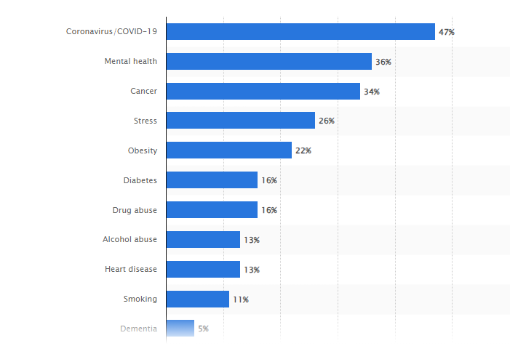
Figure 1: Leading health problem globally and the contribution of obesity to it
(Statista.com, 2023)
From Figure 1, it has been evaluated that globally obesity contributed 22% as a public health problem.
Obesity issues affect the human body including the heart, liver, and kidneys and it leads to different “noncommunicable diseases” (NCDs) like Type 2 diabetes.

Telemedicine and Telehealth Technology
Telemedicine or telehealth use can be used as suitable digital technology to promote awareness about obesity. As observed by Kahan et al. (2022) telemedicine is effective for obesity care treatment, and boosts awareness among suffering patients. Telehealth helps provide guidance to obesity-suffering patients, by connecting medical professionals through mobile.
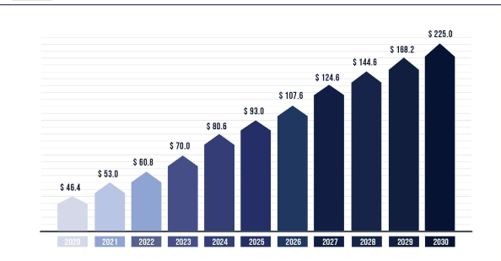
Figure 2: Telemedicine market size insights
(Source: Precedenceresearch.com, 2023)
In addition, by using telehealth patients do not need to visit a doctor every time, doctors can guide patients and give intervention strategies over mobile. Telehealth use has increased since 2020, and nearly 60% of healthcare organisations are using this telemedicine to treat patients globally.
According to López et al. (2022), telehealth use is helpful in boosting awareness of obesity and healthy living among customers and recommended patient interventions.

Advantages of Telemedicine use for obesity intervention

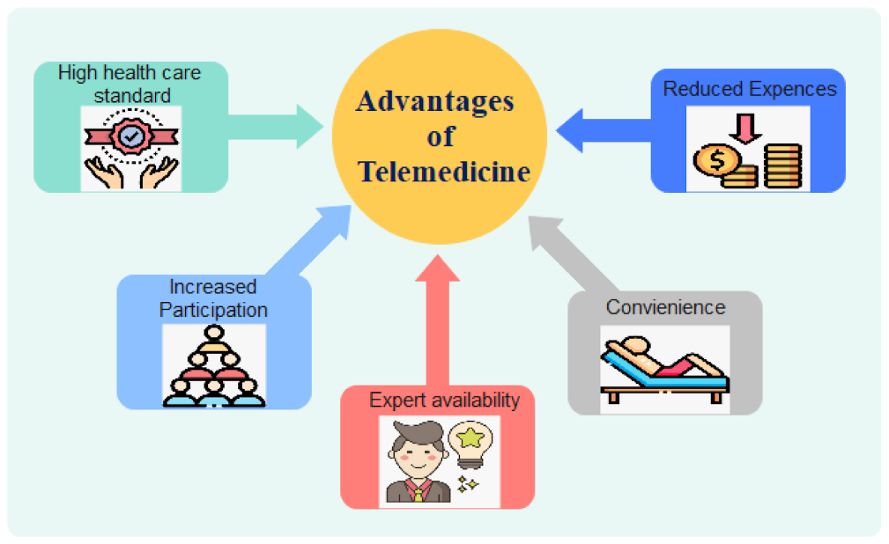
Figure 3: Advantages of telehealth
(Source: Alenoghena et al. 2023)
- The use of telehealth for treating obesity breaks the barrier of treatments, as this technology helps patients to understand interventions required to reduce weight and to anticipate obesity issues, from professional doctors (Partners.livi.co.uk, 2023).

- The telemedicine concept boosts the ideas of individualised care, which is essential for obese patients.

Disadvantages of Telemedicine use for obesity intervention

- However, telemedicine is limited because of its lower opportunity for physical checkups of obese patients, which makes this technology limited to only primary care (Hinchliffe et al. 2022).
- Further, technological difficulties also hampered the promotion of obesity intervention through telemedicine.
THIS SHORTFALL CAN BE OVERCOME BY
- developing high infrastructure for improving telemedicine
- digital literacy can be another option to improve obesity treatments.

BLOG 2

AI-driven smartwatch and Cardiovascular disease (CDVs)
What is CVD??
CVDs can be illustrated as a group of diseases of the heart, coronary artery, and blood vessels. Vaduganathan et al. (2022) mentioned CVDs as a present as well as future problems of the earth.

Cardiovascular disease has become the most common reason for death worldwide, and the number of people suffering from this disease has increased.
Cardiovascular diseases (CVDs) are the most critical diseases from which global people suffer continuously, only for these diseases, approximately 17.9 million people die each year (Who. int, 2023).
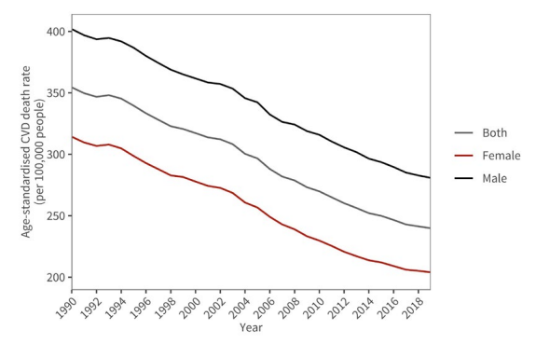
Figure 1: Death rate of Males and females by CDVs
(Source: World-heart-federation.org, 2023)
Further, to bring intervention on CVD it is done by increasing awareness about self-care and by identifying parameters for keeping the heart healthy.

NEW Technology for health promotion against CDVs
AI-DRIVEN SMARTWATCH
It senses the heart condition of patients and suggests possible measures to prevent heart attacks.
This new AI-based smartwatch helps patients to prevent heart attack situations, by continuously monitoring heart condition and enabling suggestions.

- This smartwatch provides medicinal help, by sending a message to doctors if the condition of the heart becomes out of control through precautionary measures.
- Besides, this AI-based Smart watch will facilitate voice commands to the patients and guide them for doing the bedded physical exercise to be fit and make the heart healthy.
As opined by Joshi et al. (2022) AI-technology can be an effective tool for taking cardio health and tracking its conditions.

Advantages and limitations of AI-Based Hart Health Trackers

- ADVANTAGES

The key advantages of AI-based smartwatch healthcare promotion will be to
- Guide patients to keep safe from heart failure
- Give them the opportunity to always be fit.

- LIMITATIONS
- However, in very critical physical situations this smartwatch fails to provide suggestions, rather than only sending emergency alerts to doctors.
- Another possible disadvantage of this AI-based smartwatch will be it needs technology for a person to be habdel.
However, these shortcomings of usability can be reduced by guiding parents before use.

References
BLOG 1
- Alenoghena, C.O., Ohize, H.O., Adejo, A.O., Onumanyi, A.J., Ohio In, E.E., Balarabe, A.I., Okoh, S.A., Kolo, E. and Aleoghena, B., 2023. Telemedicine: a survey of telecommunication technologies, developments, and challenges. Journal of Sensor and Actuator Networks, 12(2), p.20. https://www.mdpi.com/2224-2708/12/2/20
- Hinchliffe, N., Capehorn, M.S., Bewick, M. and Feenie, J., 2022. The potential role of digital health in obesity care. Advances in Therapy, 39(10), pp.4397-4412.https://www.ncbi.nlm.nih.gov/pmc/articles/PMC9362065/Kahan, S., Look, M. and Fitch, A., 2022. The benefit of telemedicine in obesity care. Obesity, 30(3), pp.577-586. https://pubmed.ncbi.nlm.nih.gov/35195367/
- López, A., Escobar, M.F., Urbano, A., Alarcón, J., Libreros-Peña, L., Martinez-Ruiz, D.M. and Casas, L.Á., 2022. Experience with Obese Patients Followed via Telemedicine in a Latin American Tertiary Care Medical Center. International Journal of Environmental Research and Public Health, 19(19), p.12406. https://pubmed.ncbi.nlm.nih.gov/36231703/
- Partners.livi.co.uk, (2023), Obesity care and the promise of digital health, https://partners.livi.co.uk/hubfs/Obesity%20care%20and%20the%20promise%20of%20digital%20health.pdf [Accessed on: 9/11/2023]
- Precedenceresearch.com, (2023), Telemedicine Market-Global Industry Analysis, Size, Share, Growth, Trends, Regional Outlook, and Forecast 2022 - 2030, Available at: https://www.precedenceresearch.com/telemedicine-market [Accessed on: 12/11/2023]
- Statista.com, (2023), Percentage of adults worldwide who stated select issues were the biggest health problems facing people in their country in 2022, Available at: https://www.statista.com/statistics/917148/leading-health-problems-worldwide/ [Accessed on: 12/11/2023]
- Who.int, (2022), World Obesity Day 2022 – Accelerating action to stop obesity, Available at: https://www.who.int/news/item/04-03-2022-world-obesity-day-2022-accelerating-action-to-stop-obesity#:~:text=More%20than%201%20billion%20people,they%20are%20overweight%20or%20obese. [Accessed on: 9/11/2023]

BLOG 2
- Joshi, R.C., Khan, J.S., Pathak, V.K. and Dutta, M.K., 2022. AI-CardioCare: Artificial Intelligence Based Device for Cardiac Health Monitoring. IEEE Transactions on Human-MachineSystems, 52(6),pp.1292-1302. https://ieeexplore.ieee.org/abstract/document/9915528
- Unblast.com, (2023), Free Heart Rate Monitor Watch Illustration (Ai), Available at: https://unblast.com/free-heart-rate-monitor-watch-illustration-ai/ [Accessed on: 12/11/2023]
- Vaduganathan, M., Mensah, G.A., Turco, J.V., Fuster, V. and Roth, G.A., 2022. The global burden of cardiovascular diseases and risk: a compass for future health. Journal of the AmericanCollegeofCardiology, 80(25),pp.2361-2371. https://pubmed.ncbi.nlm.nih.gov/36368511/
- Who.int, (2023), Cardiovascular diseases, Available at: https://www.who.int/health-topics/cardiovascular-diseases#tab=tab_1 [Accessed on: 9/11/2023]
- World-heart-federation.org, (2023), World-Heart-Report-2023, Available at: https://world-heart-federation.org/wp-content/uploads/World-Heart-Report-2023.pdf [Accessed on: 12/11/2023]

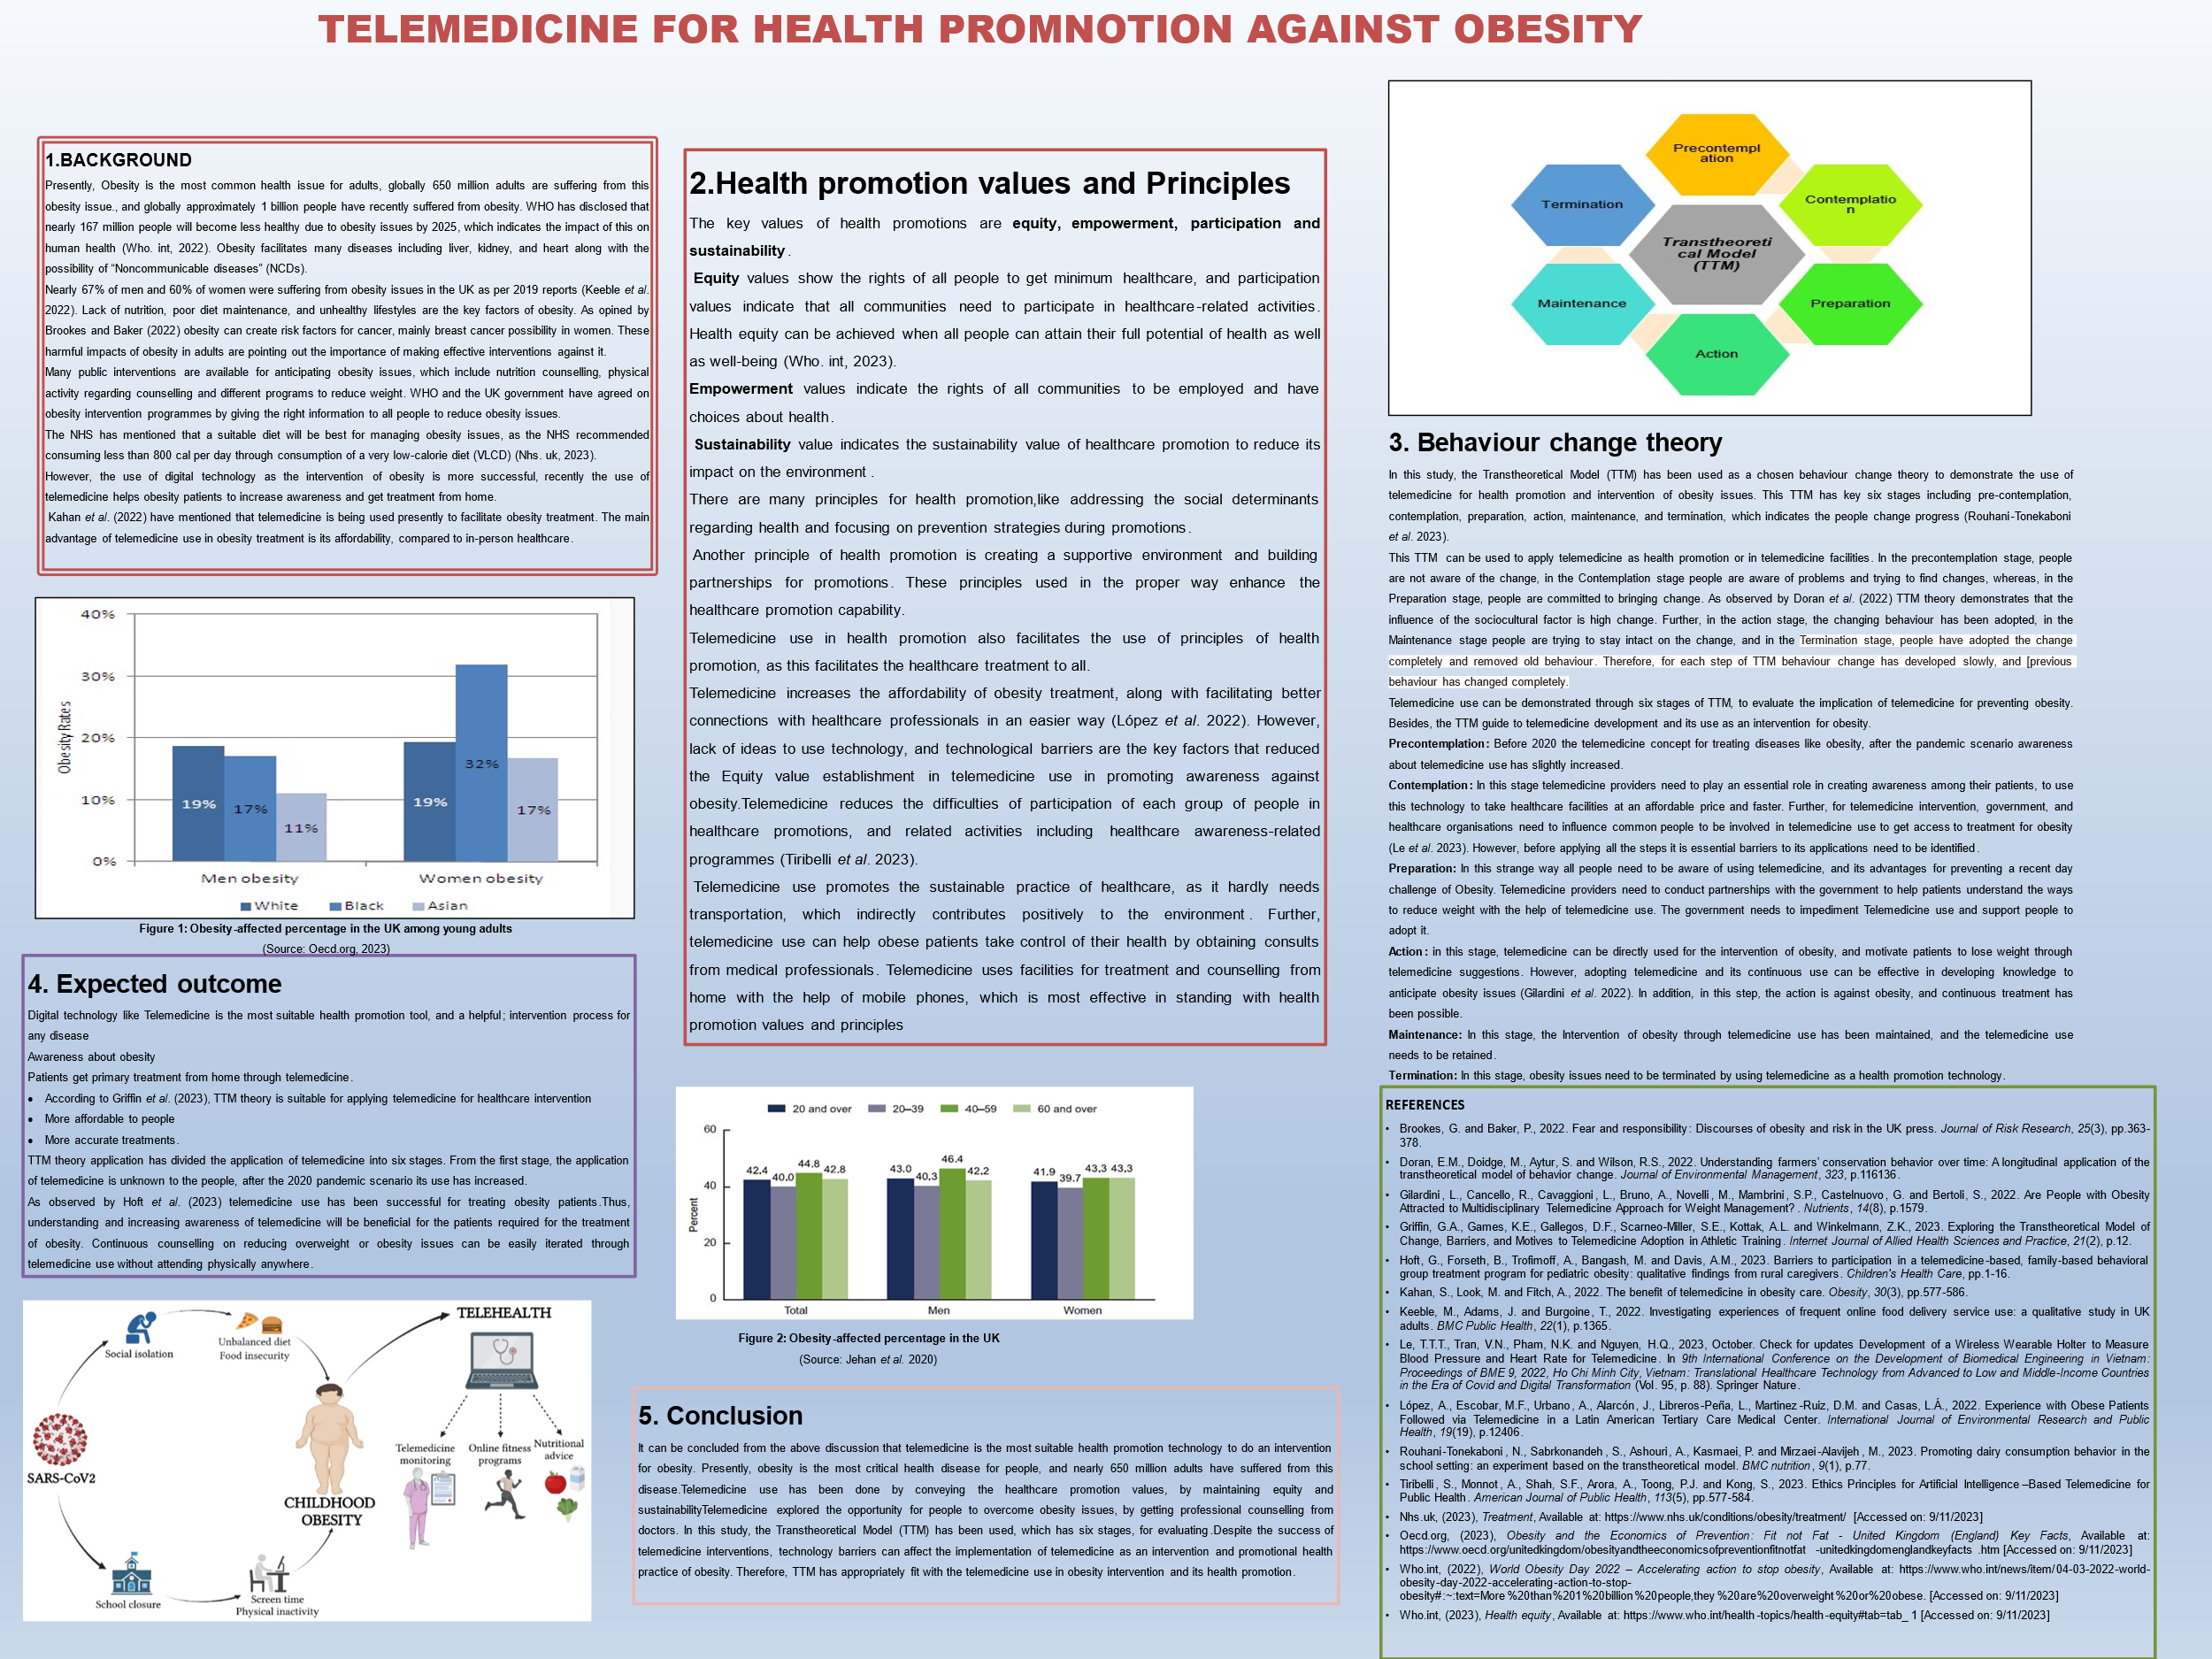

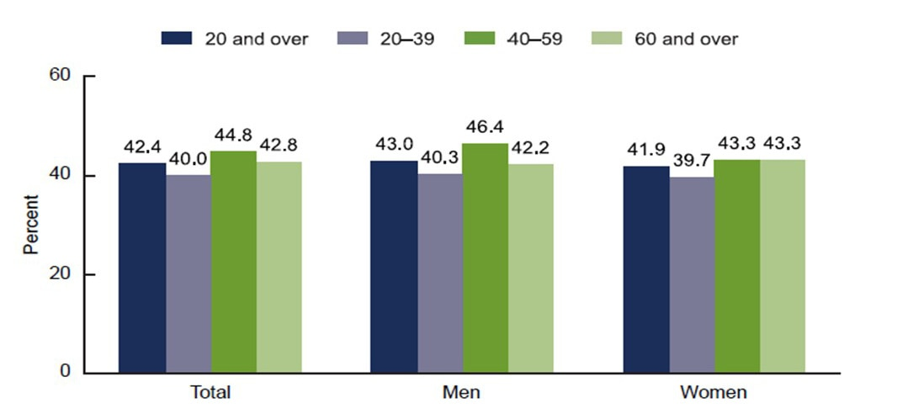
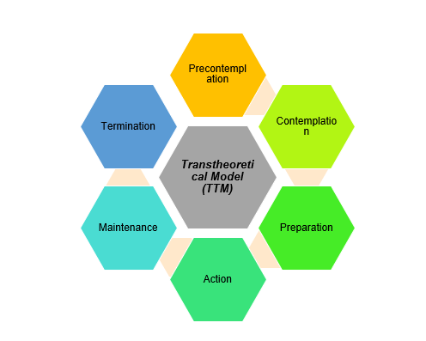
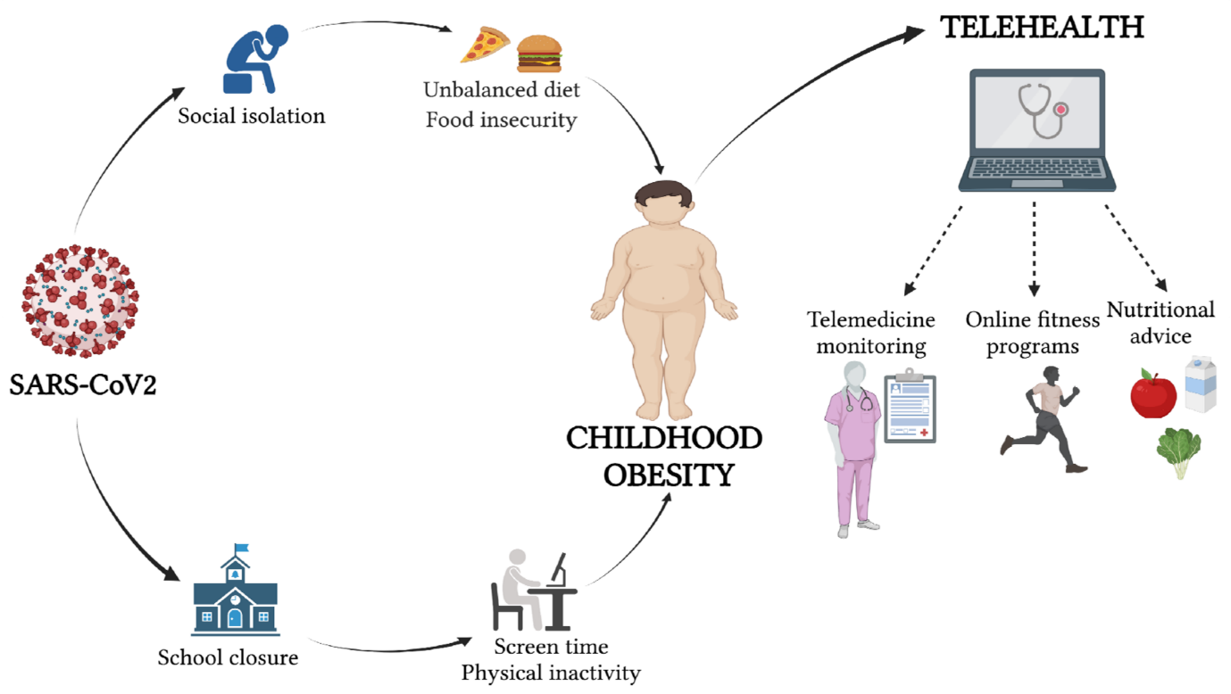
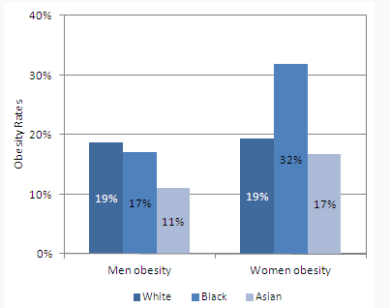
1.BACKGROUND
Presently, Obesity is the most common health issue for adults, globally 650 million adults are suffering from this obesity issue., and globally approximately 1 billion people have recently suffered from obesity. WHO has disclosed that nearly 167 million people will become less healthy due to obesity issues by 2025, which indicates the impact of this on human health (Who. int, 2022). Obesity facilitates many diseases including liver, kidney, and heart along with the possibility of “Noncommunicable diseases” (NCDs).
Nearly 67% of men and 60% of women were suffering from obesity issues in the UK as per 2019 reports (Keeble et al. 2022). Lack of nutrition, poor diet maintenance, and unhealthy lifestyles are the key factors of obesity. As opined by Brookes and Baker (2022) obesity can create risk factors for cancer, mainly breast cancer possibility in women. These harmful impacts of obesity in adults are pointing out the importance of making effective interventions against it.
Many public interventions are available for anticipating obesity issues, which include nutrition counselling, physical activity regarding counselling and different programs to reduce weight. WHO and the UK government have agreed on obesity intervention programmes by giving the right information to all people to reduce obesity issues.
The NHS has mentioned that a suitable diet will be best for managing obesity issues, as the NHS recommended consuming less than 800 cal per day through consumption of a very low-calorie diet (VLCD) (Nhs. uk, 2023).
However, the use of digital technology as the intervention of obesity is more successful, recently the use of telemedicine helps obesity patients to increase awareness and get treatment from home.
Kahan et al. (2022) have mentioned that telemedicine is being used presently to facilitate obesity treatment. The main advantage of telemedicine use in obesity treatment is its affordability, compared to in-person healthcare.
2.Health promotion values and Principles
The key values of health promotions are equity, empowerment, participation and sustainability.
Equity values show the rights of all people to get minimum healthcare, and participation values indicate that all communities need to participate in healthcare-related activities. Health equity can be achieved when all people can attain their full potential of health as well as well-being (Who. int, 2023).
Empowerment values indicate the rights of all communities to be employed and have choices about health.
Sustainability value indicates the sustainability value of healthcare promotion to reduce its impact on the environment.
There are many principles for health promotion,like addressing the social determinants regarding health and focusing on prevention strategies during promotions.
Another principle of health promotion is creating a supportive environment and building partnerships for promotions. These principles used in the proper way enhance the healthcare promotion capability.
Telemedicine use in health promotion also facilitates the use of principles of health promotion, as this facilitates the healthcare treatment to all.
Telemedicine increases the affordability of obesity treatment, along with facilitating better connections with healthcare professionals in an easier way (López et al. 2022). However, lack of ideas to use technology, and technological barriers are the key factors that reduced the Equity value establishment in telemedicine use in promoting awareness against obesity.Telemedicine reduces the difficulties of participation of each group of people in healthcare promotions, and related activities including healthcare awareness-related programmes (Tiribelli et al. 2023).
Telemedicine use promotes the sustainable practice of healthcare, as it hardly needs transportation, which indirectly contributes positively to the environment. Further, telemedicine use can help obese patients take control of their health by obtaining consults from medical professionals. Telemedicine uses facilities for treatment and counselling from home with the help of mobile phones, which is most effective in standing with health promotion values and principles
3. Behaviour change theory
In this study, the Transtheoretical Model (TTM) has been used as a chosen behaviour change theory to demonstrate the use of telemedicine for health promotion and intervention of obesity issues. This TTM has key six stages including pre-contemplation, contemplation, preparation, action, maintenance, and termination, which indicates the people change progress (Rouhani-Tonekaboni et al. 2023).
This TTM can be used to apply telemedicine as health promotion or in telemedicine facilities. In the precontemplation stage, people are not aware of the change, in the Contemplation stage people are aware of problems and trying to find changes, whereas, in the Preparation stage, people are committed to bringing change. As observed by Doran et al. (2022) TTM theory demonstrates that the influence of the sociocultural factor is high change. Further, in the action stage, the changing behaviour has been adopted, in the Maintenance stage people are trying to stay intact on the change, and in the Termination stage, people have adopted the change completely and removed old behaviour. Therefore, for each step of TTM behaviour change has developed slowly, and [previous behaviour has changed completely.
Telemedicine use can be demonstrated through six stages of TTM, to evaluate the implication of telemedicine for preventing obesity. Besides, the TTM guide to telemedicine development and its use as an intervention for obesity.
Precontemplation: Before 2020 the telemedicine concept for treating diseases like obesity, after the pandemic scenario awareness about telemedicine use has slightly increased.
Contemplation: In this stage telemedicine providers need to play an essential role in creating awareness among their patients, to use this technology to take healthcare facilities at an affordable price and faster. Further, for telemedicine intervention, government, and healthcare organisations need to influence common people to be involved in telemedicine use to get access to treatment for obesity (Le et al. 2023). However, before applying all the steps it is essential barriers to its applications need to be identified.
Preparation: In this strange way all people need to be aware of using telemedicine, and its advantages for preventing a recent day challenge of Obesity. Telemedicine providers need to conduct partnerships with the government to help patients understand the ways to reduce weight with the help of telemedicine use. The government needs to impediment Telemedicine use and support people to adopt it.
Action: in this stage, telemedicine can be directly used for the intervention of obesity, and motivate patients to lose weight through telemedicine suggestions. However, adopting telemedicine and its continuous use can be effective in developing knowledge to anticipate obesity issues (Gilardini et al. 2022). In addition, in this step, the action is against obesity, and continuous treatment has been possible.
Maintenance: In this stage, the Intervention of obesity through telemedicine use has been maintained, and the telemedicine use needs to be retained.
Termination: In this stage, obesity issues need to be terminated by using telemedicine as a health promotion technology.
REFERENCES
- Brookes, G. and Baker, P., 2022. Fear and responsibility: Discourses of obesity and risk in the UK press. Journal of Risk Research, 25(3), pp.363-378.
- Doran, E.M., Doidge, M., Aytur, S. and Wilson, R.S., 2022. Understanding farmers’ conservation behavior over time: A longitudinal application of the transtheoretical model of behavior change. Journal of Environmental Management, 323, p.116136.
- Gilardini, L., Cancello, R., Cavaggioni, L., Bruno, A., Novelli, M., Mambrini, S.P., Castelnuovo, G. and Bertoli, S., 2022. Are People with Obesity Attracted to Multidisciplinary Telemedicine Approach for Weight Management?. Nutrients, 14(8), p.1579.
- Griffin, G.A., Games, K.E., Gallegos, D.F., Scarneo-Miller, S.E., Kottak, A.L. and Winkelmann, Z.K., 2023. Exploring the Transtheoretical Model of Change, Barriers, and Motives to Telemedicine Adoption in Athletic Training. Internet Journal of Allied Health Sciences and Practice, 21(2), p.12.
- Hoft, G., Forseth, B., Trofimoff, A., Bangash, M. and Davis, A.M., 2023. Barriers to participation in a telemedicine-based, family-based behavioral group treatment program for pediatric obesity: qualitative findings from rural caregivers. Children's Health Care, pp.1-16.
- Kahan, S., Look, M. and Fitch, A., 2022. The benefit of telemedicine in obesity care. Obesity, 30(3), pp.577-586.
- Keeble, M., Adams, J. and Burgoine, T., 2022. Investigating experiences of frequent online food delivery service use: a qualitative study in UK adults. BMC Public Health, 22(1), p.1365.
- Le, T.T.T., Tran, V.N., Pham, N.K. and Nguyen, H.Q., 2023, October. Check for updates Development of a Wireless Wearable Holter to Measure Blood Pressure and Heart Rate for Telemedicine. In 9th International Conference on the Development of Biomedical Engineering in Vietnam: Proceedings of BME 9, 2022, Ho Chi Minh City, Vietnam: Translational Healthcare Technology from Advanced to Low and Middle-Income Countries in the Era of Covid and Digital Transformation (Vol. 95, p. 88). Springer Nature.
- López, A., Escobar, M.F., Urbano, A., Alarcón, J., Libreros-Peña, L., Martinez-Ruiz, D.M. and Casas, L.Á., 2022. Experience with Obese Patients Followed via Telemedicine in a Latin American Tertiary Care Medical Center. International Journal of Environmental Research and Public Health, 19(19), p.12406.
- Rouhani-Tonekaboni, N., Sabrkonandeh, S., Ashouri, A., Kasmaei, P. and Mirzaei-Alavijeh, M., 2023. Promoting dairy consumption behavior in the school setting: an experiment based on the transtheoretical model. BMC nutrition, 9(1), p.77.
- Tiribelli, S., Monnot, A., Shah, S.F., Arora, A., Toong, P.J. and Kong, S., 2023. Ethics Principles for Artificial Intelligence–Based Telemedicine for Public Health. American Journal of Public Health, 113(5), pp.577-584.
- Nhs.uk, (2023), Treatment, Available at: https://www.nhs.uk/conditions/obesity/treatment/ [Accessed on: 9/11/2023]
- Oecd.org, (2023), Obesity and the Economics of Prevention: Fit not Fat - United Kingdom (England) Key Facts, Available at: https://www.oecd.org/unitedkingdom/obesityandtheeconomicsofpreventionfitnotfat-unitedkingdomenglandkeyfacts.htm [Accessed on: 9/11/2023]
- Who.int, (2022), World Obesity Day 2022 – Accelerating action to stop obesity, Available at: https://www.who.int/news/item/04-03-2022-world-obesity-day-2022-accelerating-action-to-stop-obesity#:~:text=More%20than%201%20billion%20people,they%20are%20overweight%20or%20obese. [Accessed on: 9/11/2023]
- Who.int, (2023), Health equity, Available at: https://www.who.int/health-topics/health-equity#tab=tab_1 [Accessed on: 9/11/2023]
4. Expected outcome
Digital technology like Telemedicine is the most suitable health promotion tool, and a helpful; intervention process for any disease
Awareness about obesity
Patients get primary treatment from home through telemedicine.
- According to Griffin et al. (2023), TTM theory is suitable for applying telemedicine for healthcare intervention
- More affordable to people
- More accurate treatments.
TTM theory application has divided the application of telemedicine into six stages. From the first stage, the application of telemedicine is unknown to the people, after the 2020 pandemic scenario its use has increased.
As observed by Hoft et al. (2023) telemedicine use has been successful for treating obesity patients.Thus, understanding and increasing awareness of telemedicine will be beneficial for the patients required for the treatment of obesity. Continuous counselling on reducing overweight or obesity issues can be easily iterated through telemedicine use without attending physically anywhere.
5. Conclusion
It can be concluded from the above discussion that telemedicine is the most suitable health promotion technology to do an intervention for obesity. Presently, obesity is the most critical health disease for people, and nearly 650 million adults have suffered from this disease.Telemedicine use has been done by conveying the healthcare promotion values, by maintaining equity and sustainabilityTelemedicine explored the opportunity for people to overcome obesity issues, by getting professional counselling from doctors. In this study, the Transtheoretical Model (TTM) has been used, which has six stages, for evaluating.Despite the success of telemedicine interventions, technology barriers can affect the implementation of telemedicine as an intervention and promotional health practice of obesity. Therefore, TTM has appropriately fit with the telemedicine use in obesity intervention and its health promotion.

TELEMEDICINE FOR HEALTH PROMOTION AGAINST OBESITY

Figure 1: Obesity-affected percentage in the UK among young adults
(Source: Oecd.org, 2023)
Figure 2: Obesity-affected percentage in the UK
(Source: Jehan et al. 2020)

