A case study focusing on:
The analysis of a steel frame building

Created For:
A. Nantel

Created By:
Ieuan Vokes

Completed on:
06/12/2022

Word Count:
2,435

Table of Contents
- Summary of works - Page 3
- Terms of reference – Page 3/4
- Procedures – Page 4
- Findings – Page 4/5/6/7
- Conclusion – Page 7/8
- References – Page 9
- Appendix – Page 10/11/12/13

1.0 Summary of works
I am creating this case study so that I can analyse a steel frame building that I have chosen through my own research. To be able to complete this I will look to research already complete. When looking to research the building of choice, I will look to focus on original design planning, construction method and potential impact in consideration of social and environmental sustainability, at the site of the build.

2.0 Terms of Reference
2.1 Identify the likelihood of the durability and climate resistance given the environment that the building is exposed to on site.

Due to this being located within Merthyr Tydfil on a north facing mountain, the buildings are going to be susceptible to the colder elements of weather such as wind and rain. The steel within the building is going to be much more likely to be affected by erosion from water, due to the age and condition of these buildings. As these buildings were only constructed as a temporary measure the facades on the properties were never designed to last if they have. Reviewing this information gathered allows me to get an understanding of the durability of the building. The refurbishment works for these buildings were completed in 2015. This means that the temporary buildings lasted 65 years with only needing minimal works completed to them.
2.2 Show the materials original production process, and any impacts that this process would have on the social and ecological environment, referencing all resources used in the material’s manufacture, and any harmful by products produced.
During this period, the type of steel that was used on the buildings was 60X60 RSA. A lot of the steel was recycled from the war. The original design works of this building were completed by BISF (British Iron and Steel federation). The BISF were responsible for mostly all the steel frame buildings that were created during this time. Between 1945 and 1950 there were 33,000+ BISF homes built throughout the United Kingdom. Using steel can have a large impact on the environment from the emission that it gives off when being created. This emission can have a large effect on the environment. [Structherm.com, 2019]

2.3 Research the frames ease of assembly, its positive aspects with regards to building services provision and the potential ease of its adaptation to different building shape and use, when compared to a concrete frame.

The assembly of the steel frames used are shown below within the appendix. (7.3)

The image shows how the steel frames are installed during its original building. Within the image it also allows you to see the exact materials that were sued for the creation of the building.

2.4 Investigate The frames properties in wind loading, and how this is potentially remedied in the frame’s design.
As the building I am looking It is only a two-story house. This means that Wind
loading was not taken into consideration within the design of the building. This is
because the wind would not be strong enough at such a low level to influence the
buildings’ structure. However, the wind loading would have been taking into a slight
consideration since the Valleys can have an extreme level of weather and the
designer would have made sure to note this when the original construction process
was taking place.

2.5 This assignment is due to be completed by the 7th of December

3.0 Procedures

In this section I will look to identify the different styles of research that I will use to complete my case study.

3.1 The main way that I will look to complete my research will be done through the internet, I will mainly look to use case studies for the build that I chose to look at. I will look to make sure that I use reliable websites to make sure my research is as accurate as possible. I will also look to use case studies that I have already created as a part of the company that I work for. These case studies will have a large amount of information that can be used.

3.2 I will also look to use the knowledge and information that I have gained by listening and working within my lectures. Using this information will allow me to have a good basic understanding before I begin to investigate the research.

4.0 Findings

4.1
For this case study, I have decided to look at sets of houses that were made of a
steel frame structure in Merthyr Tydfil (A town in Wales). BISF properties which are
steel frame properties constructed as temporary housing after World War II. The
properties were located throughout Merthyr and Merthyr Vale and were
constructed in the 1950’s. Some of the properties had not received any
improvement work since initial construction. These properties were firstly created as
temporary living for people after the 2nd world war. However, the structures then
became permanent as more and more people moved to live within the Welsh valleys
due to the large wealth of the coal and steel industries during this period.
The steel frame building that I am specifically looking at is 37 Glazier Road. This
building has since been refurbished to give the building the ability to last for a
minimum of an extra 30 years. The company that completed these works are Joyner
Cymru. They are a specialist contractor company that specialise in external
refurbishments of housing. (This is the company that I work for)

4.2
Throughout the building, it was found that the main error of its durability came from
water damages. The water damage caused several problems to the steel frames. The
main damage was that over the many years of the building the steel frame began to
erode and if not treated could cause problems with the stability of the structure. IF
the erosion wasn’t treated it could mean that the building could no longer be classed as a safe place to live. This was because the erosion that took place in some properties
was so severe the steel had a high likelihood of collapsing the building. (Appendix
7.3) In the photos that are shown below. The erosion happened due to water
entering the building through the steel top half of the facade becoming rusty or
overtime people fixing things to the façade and not sealing them. The water entering
the cavity would run down to the bottom of the steels. Within the cavity there was a
glass fibre which was the insulation used this would get wet. This then causes
erosion to occur and means that the erosion will rise. Due to the erosion that took
place over such a long period of time it meant that the structure was significantly
affected.

As the company (Joyner Cymru) was hired by Merthyr Valley homes to restore these
buildings when they looked at the steel frames and saw the level of damage to the
property was significant to the frames over the years due to the erosion, some
property was worse than others. To be able to fix this problem and restore the
buildings Joyner Cymru needed to cut out “Any steel legs which are showing signs of
erosion was replaced. Some of the properties were showing extensive amounts of
erosion with up to 80% of the steels being replaced.” (Case study Completed by
Joyner PA Cymru,2015) This quote from the case study just shows how damaged this
property was. As Joyner’s worked over a mass of 65 properties with the same
problem, they saw this in multiple properties. To solve the problem of water coming
in Joyner’s replaced the exterior facade of the building with structural grade WBP boarding, then they installed a rock wall insulation system onto the properties and a
dashed finish.

Since the properties have been finished there has been a substantial improvement in
appearance of the building. Not just that but there has also been a dramatic change
for the better in the building’s thermal performance. This is shown through the fact
that tenants within the building are saving a large amount of money of fuel and
energy bills with some saving upwards of £15 a week.

From the information that I have shown above it allows you to see the difference
that have been created for the refurbishments complete and how vital they needed
to be completed. This is shown drastically when its states the level of erosion that
has taken place on the steel.
4.3

The BISF type have buildings have been constructed throughout the UK. According to
reports created by Curtin’s Consulting LTD. The process used for the construction
was the lightweight frame of the two-storey semi-detached house was designed for
rapid construction and consists of vertical channels (76mm x 38mm) at 1.067m
centres in the front and back walls which carry horizontal angles (100mm x 76mm) at
first floor level.
These in turn carry steel floor joists that are given intermediary support by steel
columns concealed within the internal partitions. The external wall is of two
sections. The ground floor wall consists of a cement render on ribbed metal lath that
was in turn fixed to the vertical channels. The upper section of walling was
constructed of steel corrugated sheeting panels fixed to rails that were bolted to the
vertical channels. This steel sheeting panel can suffer from erosion resulting in loss of
section and the steel lath to the lower panels can corrode, leading to spalling of the
render face. (Report completed by Curtin’s Consulting LTD) These were the
materials that were used to construct this building. This report that was created
would have given Joyner’s all the information that they needed before starting to
complete any type of work on the building. Using this report Joyner’s would have the
ability to understand how to start the works. Not just that this could be used as a
way of looking at the creation of the risk assessments and method statements that
you would legally need to be on site before any works could begin to start.
4.4
When any type of steel is created it leaves its mark on the environment. By this I
mean that to be able to make steel there are a few components involved that cause
problems for the environment. The first problem that occurs when making steel Is
the fact that all greenhouse gas emissions that are associated with the making of
steel come from the carbon dioxide that is released (CO2). These are all related to
the exertion of energy from the steel. CO2 is one of the leading factors within the world of climate change and by steel realising all of this into the atmosphere
contributes towards climate change. (Greenspec.com,2022)

Another problem that occurs is the production of coke. Coke is one of the most
damaging sources from steel production. “Air emissions such as coke oven gas,
naphthalene, ammonium compounds, crude light oil, sulphur and coke dust are
released from coke ovens”. (Greenspec.com,2022) These substances that are
released from the coke ovens are very dangerous once they are in the air. And play a
large role in the emissions that are in the air making the quality or air a lot worse.

Another way that the creation of steel effects the environment is through water
emissions. Water emissions come from the water that is used to cool down the coke
after it has finished baking. This water then becomes contaminated with coke
breezes and other compounds. This can cause a great amount of water to become
contaminated. However, mostly all the contaminants can be removed from the
water with filtration. (Greenspec.com,2022)

By looking at all these different ways that steel can affect the environment it allows
me to see the dangers that can occur from using steel in our buildings as this mean
that more and more steel needs to be built to create buildings. Luckily, now it is a lot
less likely to see steel being used for newer builds as it is not as cost effective.

4.5
The steel frames that were used in the original build were assembled as shown
within the appendix (7.2). From the image that is shown within the appendix it
allows me to see how the steel frames were assembled within the building. The steel
frame building appears to have been assembled in stages. Firstly, the foundation was
created then they would lay services and then put down the floor slab for the
building. Once this was completed and there was a base created, the builders would
then look to erect the steel sanctions and bolt the legs to the concrete base and bolt
and weld to ensure the steel frame connected.
Another image showing the different ways in which the steel was assembled and showing what it looks like within the wall can be found inside of the Appendix (7.4)

5.0 Conclusion
To conclude on the findings I have completed, I have found that the building was
created just after the second world war for affordable housing. These houses used
steel frame as it was a material that was very easily found and manufactured during
this time. The company who created these houses is BISF (The British iron and steel federation). As a result of being steel frame houses over time they suffered from a
large amount of erosion due to the amount of water that was able to break through
the exterior of the house. The house itself suffered massively from this with up to
80% of the steel becoming eroded which makes it a dangerous living condition until
it was restored by Joyner PA Cymru. When they refurbished the building by taking
away the erosion and replacing it with new steel.

The making of steel for a building such as this can have a rather dangerous effect on
the environment through: Climate Change, Air emission and water emission. These
effects that steel have can give me an indication of why steel frames are no longer as
common to be used in the building of a house. However, it is more common to still
see this within bigger buildings such as a Skyscraper.

When it comes to the assembly of these buildings, The way that are assembled can
be found within the appendix as shown within the image.

A common problem that can occur with large buildings that are made from steel is
wind loading. This is where the steel can bend due to the amount of pressure caused
by the wind. However, Within the house that I have been studying this is not
something that would cause as much of a problem because the wind will not be able
to have a damaging effect on the building.

6.0 References
Harry Harrison, Stephen Mullin, Barry Reeves and Alan Stevens (2012) Identifying non-traditional houses in the UK1918 – 75. Available at: Non-traditional houses - digital edition.pdf

Structherm (2019) Non-traditional Profile- BISF refurbishments. Available at:
https://www.structherm.co.uk/non-traditional-profile-bisf-refurbishment/ (Accessed 04 December 2022)

Joyner PA Cymru (2015) Merthyr Tydfil BISF properties cases study. Available at:
file:///C:/Users/Ieuan/OneDrive/Desktop/School/University%20Year%201/Material%20science%20and%20building%20services/Case%20Study,%20Steel%20Frame/Merthyr%20Tydfil%20BISF%20and%20MTCBC%20Case%20Study%20combined%20on.pdf
Case study supplied by Joyner group Cymru

Greenspec (2022) Steel production and environmental impacts. Available at:
https://www.greenspec.co.uk/building-design/steel-products-and-environmental-impact/#:~:text=Steel%20production%20has%20a%20number,from%20coking%20and%20iron%2Dmaking. (Accessed 06 December 2022)

7.0 Appendix

7.1 37 Glazier Road, Steel frame Building

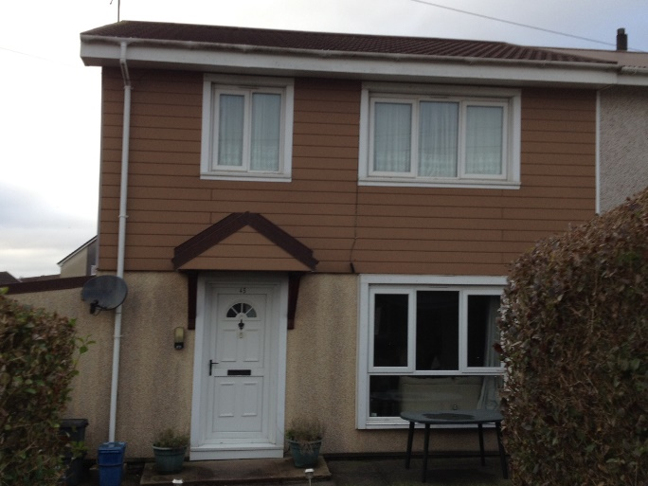

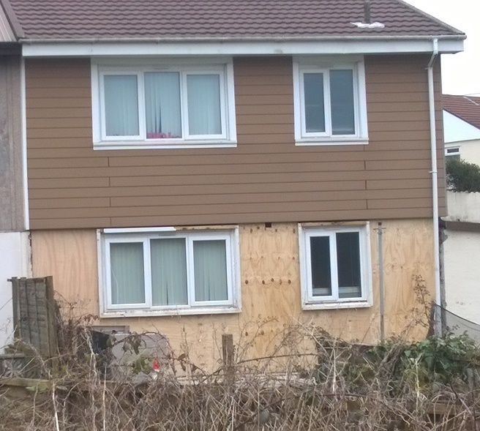

7.2
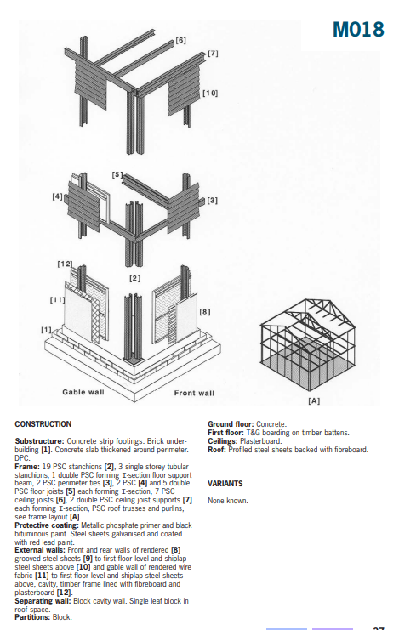

This is the assembly of the steel frame building and the materials used within the frame and the building.

7.3

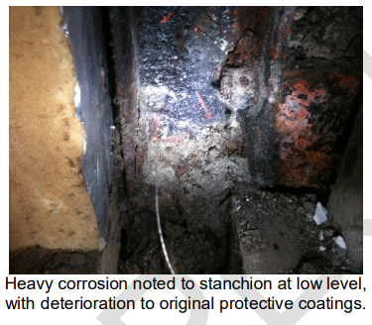

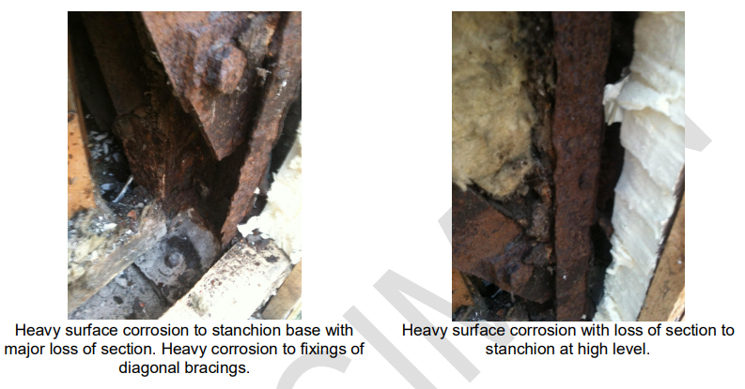
Images taken from pdf of original case study that took place. (Curtin’s Consulting LTD)

7.4



