Ayesha Begum
1810150
The Impact of Loneliness and Social Isolation on the Elderly Population of the UK
BMHP6009
Joanne Davies

Introduction
There are many definitions of ‘elderly’ but the one chosen for this assignment is that an elderly person is an individual over the age of 65. The ageing population is rapidly increasing in the UK as the number of people aged 60 plus is predicted to rise from 14.9 million in 2014 to 18.5 million in 2025 (NHS, no date). Among the ageing population loneliness and social isolation is prevalent and there is a clear difference between them. Social isolation is when a person is lacking social contact and engagement, whether that be communicating with family or going out with friends. Loneliness means that a person is not satisfied with the quality of care of their personal relationships and an elderly individual may have a feeling of distress from being alone (Alspach, 2013).

There are many issues that have arisen for the ageing population in the UK. A report from Age UK highlights issues elderly people have faced. Around 1.7 million pensioners are currently living under the poverty line, half of these individuals are Bangladeshi and Pakistani. Furthermore, a quarter of these individuals live in inadequate housing. This hugely impacts physical and mental health (Age UK, 2013). Loneliness is a big issue among the ageing population as this category is a vulnerable group. Around 2 million individuals in the UK over the age of 75 live on their own and have limited contact with their family and friends. This is a stressor for social isolation. These issues cause an elderly person to become weaker, physically and mentally, which may lead them to lose their job or leave the workplace which can lead to more loneliness. This can impact mental health and causes disorders like depression (NHS, 2018). There has seen to be an increase in loneliness and social isolation in the over 50s category. Statistics show that by 2025-2026 over 2 million people will be experiencing loneliness and social isolation. This is an upsurge as in 2016 and 2017 there was 1.4 million people suffering from loneliness. This is a 49% rise in 10 years (Age UK, 2018). There is evidence suggesting that elderly individuals move into care homes due to social isolation and loneliness. However, for some of the ageing population moving into a care home will make them feel less lonely. Elderly people have an inclined risk of illnesses and cognitive impairment, which may rise the necessity of an individual moving into a care home (Hanratty et al. 2018). The graph below shows the cost of treatment for a 90-year-old in comparison to a 30-year-old. Treating an older individual costs, a significant lot more for NHS and with the rising numbers in the elderly population this will cost the NHS a significantly higher amount of money (Triggle and Butcher, 2020).

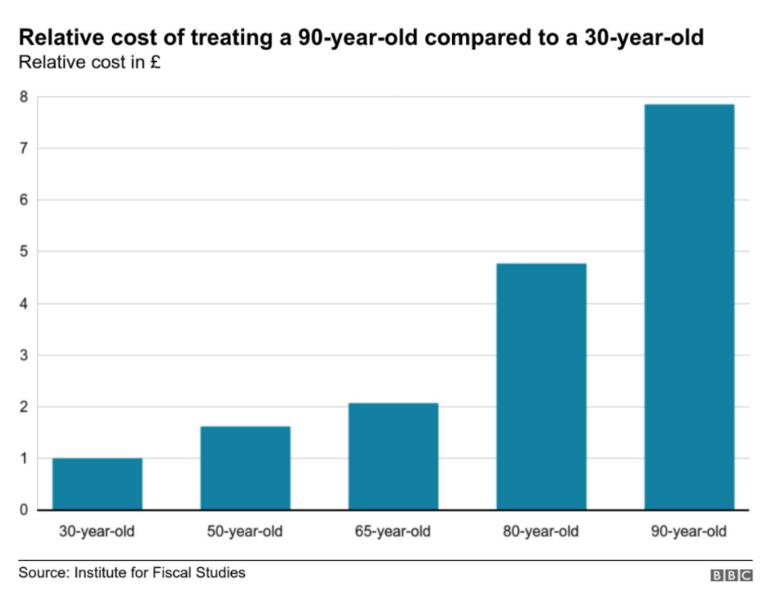

Another issue with the ageing population on the rise is ageist attitudes. There can be stereotypes associated with the elderly individuals which can lead to discrimination. Ageist attitudes can cause negative stigma around older people. Elderly people’s rights can be violated by the unethical treatments. This causes significant damage to an elderly person’s health and wellbeing. Other stereotypes associated with the elderly population is that they can be a burden and dependant on their family and society. This can increase negative ageist attitudes. Older individuals are known to be fragile which can make them an easy target for discrimination (WHO, 2018). Another issue in the elderly is disengagement. This is called the disengagement theory. This is when elderly individuals disassociate with society or society disengages from them. This is common among older people as they tend to be prone to loneliness and therefore become less social. As the aging population is increasing it is becoming difficult to access care. An Age UK study finds that in the last 12 months, around 700,000 appeals for care and support have been made by elderly people and yet have resulted in them not receiving care provisions. This is equivalent to 2,000 claims from older people being unsuccessful each day (Age UK, 2020).

The ageing population in the UK is rapidly increasing. According to the Office for National Statistics (ONS), it is projected that by 2050 one in every four individuals will be 65 years and over. This is a rise as in 2018 the figure was one in five people (ONS, 2019).
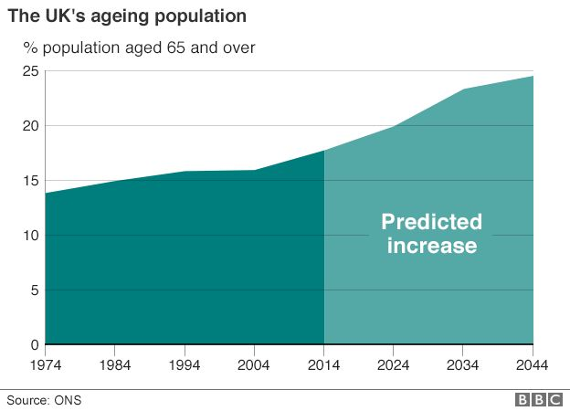
(Triggle,2017)

This graph shows the increase in the UK’s aged population. In 1974, the percentage of the population aged 65 and over was lower than 15%. This means that the life expectancy was lower. Over the years that figure rose and is continuing to rise. It is estimated that in 2044 the percentage of the population aged 65 and over will be around 25%. This figure shows that elderly people will live longer than in previous years. The Office for National Statistics has estimated a rise from 18.2% to 20.7% in the ageing population between mid-2018 and mid-2028.

The graphs below show the percentage of the population aged 65 and over in Birmingham in 2018, 2021, 2028 and 2038. In 2018, the graph shows that the aged population was 13%. Presently, in 2021 there was a 1% increase in the elderly population. This increase is very small but still the population of individuals aged 65 and over is slowly rising. A further ten years on in the future in 2028, it is estimated that 14% of the population will be 65 years old and over. This shows the 10% increase as in 2018 it was 13%. In 2038 the estimated elderly population is said to be even higher at 15.6%. These statistics show how the aging population will continue to increase (ONS, 2018)
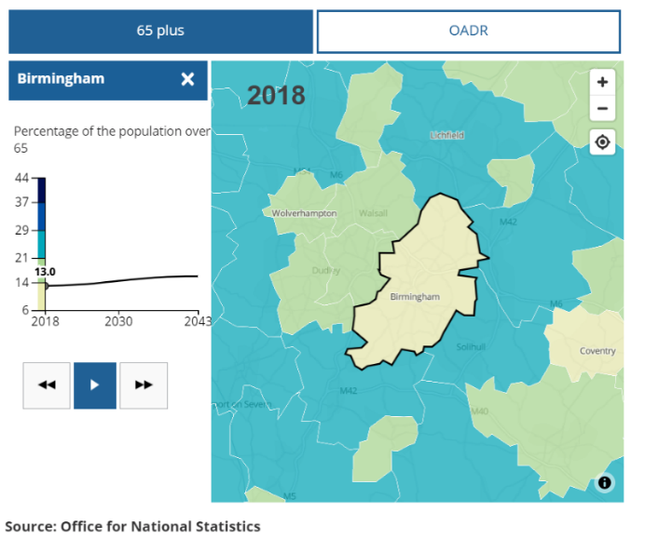
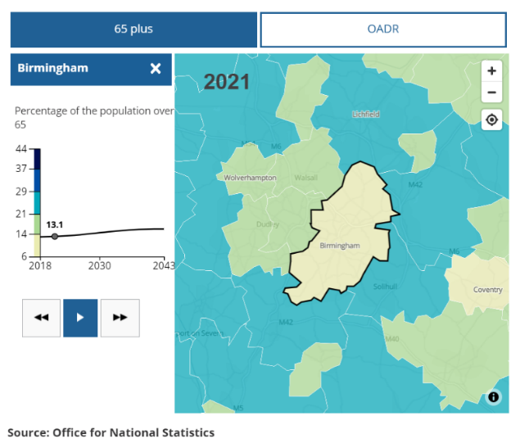

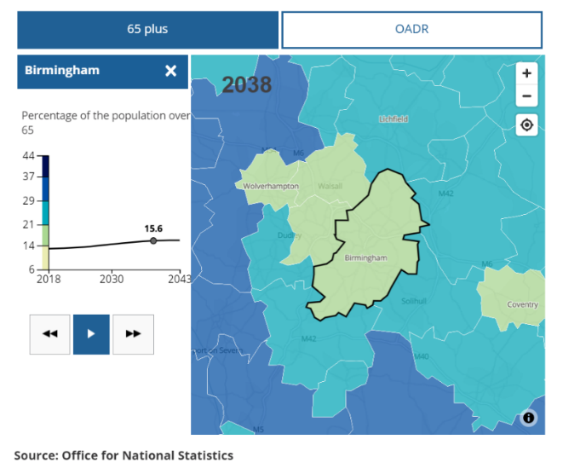
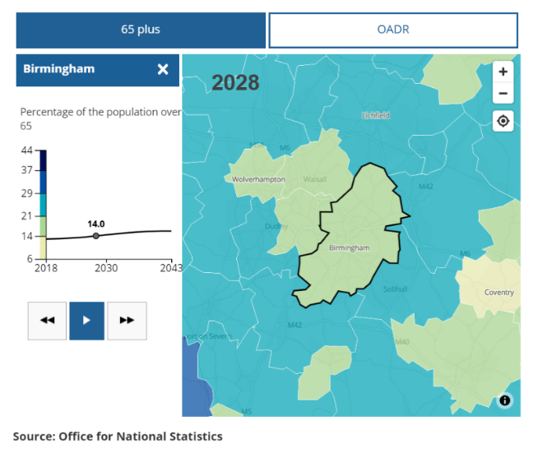

The World Health Organisation (WHO) say the population of individuals aged over 60 will increase from 2015 to 2050 from 12% to 22%. Research also shows that the number of elderly individuals aged 60 years and over will be a significant lot higher than children who are younger than 5. The pace the ageing population is increasing is quickly. As population increases it also means that the life expectancy is also simultaneously increasing. It is projected that by 2050 the world’s population aged 60 plus will be 2 billion, which is an upsurge from 900 million in 2015 (WHO, 2018; Spijker, 2013).
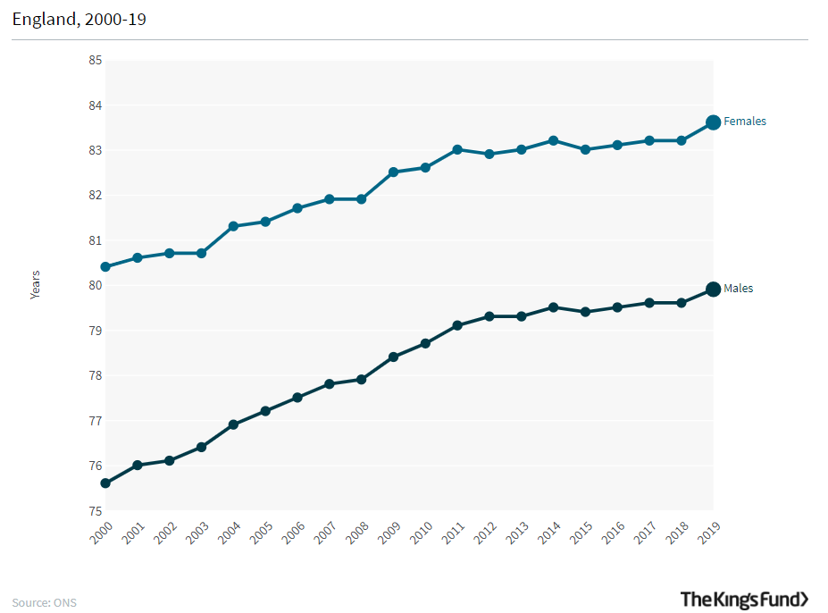

This graph shows the life expectancy at birth between 2000-2019. It shows the increase in life expectancy as the years go by. The life expectancy is higher for females due to biological differences but nonetheless the life expectancy will continue to rise (Raleigh, 2020).

As the elderly population is increasing a way to cope with it is to increase the retirement age. However, the effect of a higher retirement age will not be felt equally among elderly working people. Those with private savings may be able to retire early. But those with low pay occupations are more probable to have to keep working. The effect of extended working life will be felt more by manual workers who will find it difficult to continue working. In November 2018, the state pension age for men and women was 65. This number is progressively rising and has changed to people’s date of birth. It is estimated that by 2028 the pension age will be 67. However, this can change due to factors such as life expectancy (Age UK, 2021). As elderly people are working longer for their pension, it will take a toll on their health and physically it will be challenging. An aspect in determining the impact of an ageing population is upcoming rates of economic development. The western economies have encountered periods of secular stagnation, this is the fall growth rates. This deterioration in economic growth will rise the pressure on public finances from an elderly population. Strong economic development, increases tax revenues which makes it less challenging to fund pension. An effect of the increasing ageing population is that there has been a stagnant wage and a fall in the incomes of young people. This places pressure on redistribution of income from the young to retired (Pettinger, 2019).

In the ageing population loneliness and social isolation is prevalent. There is a difference between social isolation and loneliness. Social isolation is when a person is lacking social contact, whether that be communicating with family or socialising with friends. Loneliness means that a person is withdrawing and separating from family and friends. This causes the elderly a feeling of distress from being alone (Alspach, 2013). A lack of these things causes elderly people to feel down and unmotivated (Golden et al. 2009). Loneliness is one of the main causes for other risks in life such as declined well-being, low mortality, poor health and mental illnesses like depression. Research shows that these health risks have as much effect as other issues such as obesity and smoking. Social isolation can be caused due to the decline is social resources such as money and status, economic resources, deaths of loved ones and mobility (Courtin and Knapp, 2017). In the UK loneliness is common, over 1.4 million elderly individuals are feeling lonely and isolated. According to Age UK if this crisis isn’t delt with appropriately over 2 million people ages 50 and over will be isolated (Age UK, 2018). In different areas of the UK the risk of social isolation and loneliness is different.

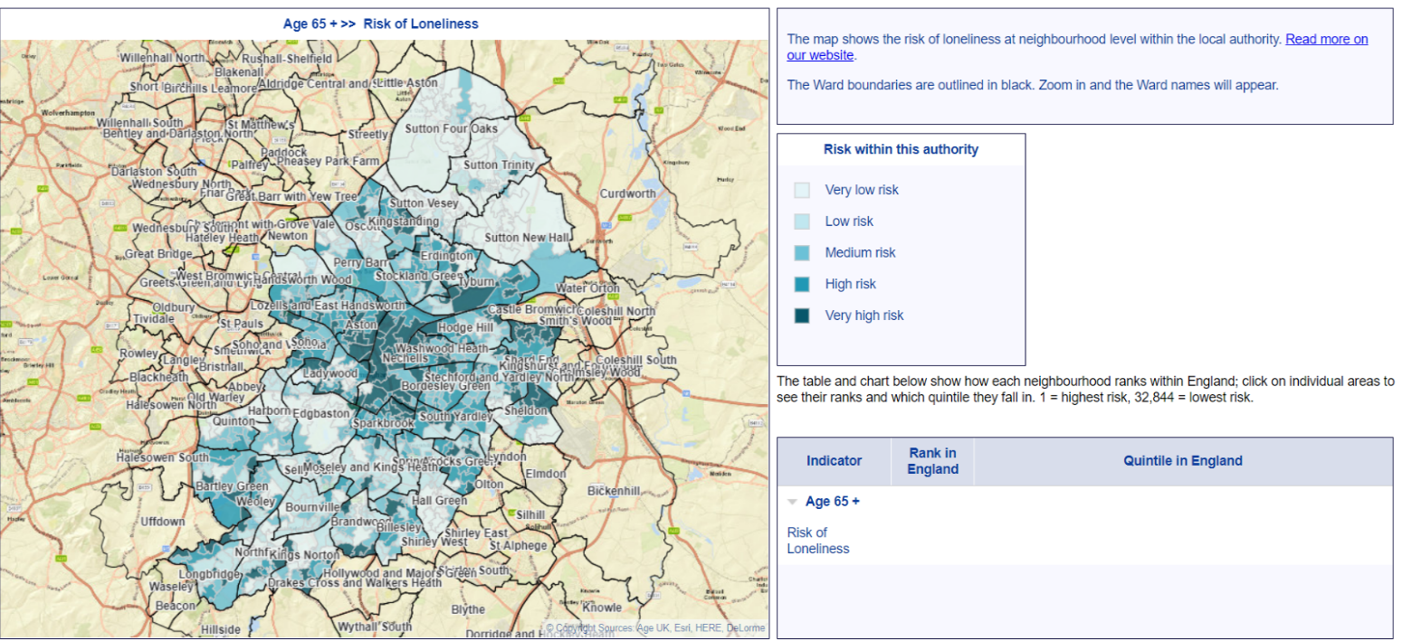
(Age UK, 2016)

For example, this is the risk map of loneliness and social isolation in Birmingham. This map shows that in the centre of Birmingham the risk of loneliness is higher than the outskirts. A factor that can affect social isolation is the geographical background of the area. Living in an area with low socio-economic background can be a risk factor for loneliness. It has been found that elderly individuals residing in deprived areas may be more prone to loneliness with the risk of other health issues compared to an elderly individual living in a non-deprived neighbourhood (Algren et al. 2020). Loneliness can be a risk factor for other diseases. Elderly individuals are prone to social isolation as they are more likely to live alone and have chronic illnesses. Research shows that social isolation poses an increased predisposition of premature death. Also, loneliness can be associated with a 50% risk of developing dementia. Mental illnesses such as depression may be common among the elderly who are isolated (CDC, 2020; DiPietro, 2020). Social isolation can affect the well-being of elderly people, this can cause harmful health issues. Research shows that being lonely can have effects on blood pressure. This risk can lead to premature death (SCIE, 2012). As a result of loneliness individuals can disengage from society. This is known as the disengagement theory. Social isolation causes elderly people to be alone for majority of their day this can cause mental health issues such depression. It is estimated that 15% of adults aged 60 and over suffer from a mental illness (WHO, 2017).

Loneliness is common in the UK. Currently 400,000 individuals live in residential homes. In this figure one in six are over the age on 85 (Hanratty et al. 2018). These elderlies are vulnerable especially if they have health conditions. Care homes can be a challenging environment to socialise. This can be a reason why an elderly person can feel lonely in the care home (Rabiee et al. 2021). A study was conducted on 5,115 participants to observe the prevalence of loneliness in the care home setting. Results showed that the frequency of moderate loneliness was 61% and severe loneliness was 35% (Gardiner et al. 2020). The impact of loneliness can be very harmful. Loneliness disturbs sleep patterns which takes a toll mentally and physically. Research shows that social isolation is one of the biggest challenges among the elderly in the 21st century, it increases the risk of death by 29%. Dementia is a common illness for those living in care homes. In the population who are aged 65 and over suffering from dementia, 61% live in their own home and 39% live in care homes. 80% of individuals living in care homes suffer with dementia and or have memory problems. Dementia sufferers have an increased risk of loneliness (SCIE, 2020; Alzheimer's Society, 2018). The COVID-19 pandemic has caused social isolation to rise drastically. In March 2020, care home doors had to close in order to keep infection rates low. This affected the elderly individuals as their family were not allowed to visit (O'Connor, (2020). The pandemic caused care home plans to be cancelled such as group activities. Elderly people in care homes mainly spend their day in their room alone as mixing with other residents risked passing on the virus. This played a part in increasing loneliness and social isolation in care homes (Simard and Volicer, 2020). Loneliness had taken a negative toll on elderly people in care homes as for most their only source of social contact were day trips and seeing their family (Armitage and Nellums, 2020). In a care home setting elderly people can be victims of abuse. These individuals are vulnerable as they can suffer from multiple chronic disease that cause them to have limitations physically and psychologically. Abusers see this as an opportunity to take advantage of the elderly. When abuse occurs in care homes the individual who is abused may be unable to report it due to fear of being neglected and or retaliation from the abuser (Hawes, 2003). Institutional abuse is frequent occurrence of poor care of individuals. This can be through malpractice which cause the individual physical and mental pain (SCIE, 2018). The number of abuses towards elderly individuals are increased in facilities such as care homes. Two in three staff report that they have committed abuse in the past year. Care homes are meant to be places for elderly people to be safe and cared for. However, some elderly has to go through the trauma of being abused (WHO, 2020).

To combat the crisis of loneliness the government has to put strategies and policies in place. In 2018, the prime minister started the government’s first strategy to aid the challenge. The 2018 loneliness strategy will allow GPs in England to refer their patients who are experiencing isolation to community activity facilities in 2023. This practice is called social prescribing. Patients will be referred to facilities which will aid to improve their well-being instead of being prescribed medication. The NHS will also be funded so they can carry out activities such as art classes and walking groups and other activities for elderly individuals (GOV UK, 2018). The Care Act 2014 aids in reducing loneliness in the elderly population. Action on social isolation is compulsory under the wellbeing principle. The act is in place so that authorities can encourage wellbeing when carrying out any of their care services in respect of an individual. Given the well-evidenced effects on mental and physical health loneliness can have, action on loneliness ought to form a crucial part of this act. Poor well-being and loneliness go together therefore The Care Act is there to help the crisis (Campaign to end loneliness, 2015).
Another policy that was put in place and was the Care Standards Act 2000. This act places a strong, independent governing system for care outside the NHS via the creation of the National Care Standards Commission. This Commission guarantees that all residential homes for elderly people meet the appropriate national minimum standards. This also encourages improving the welfare and quality of life for the elderly. No Secrets offers guidance for all public services on the advancement of policies to protect defenceless adults from abuse. Better Care Higher Standards (BCHS) is a national charter which requires local BCHS charters to put out standards of services agreed across the NHS and social care sectors (DH, 2001). The Equality Act 2010 also protects individuals from being discriminated against their age. There are different types of age discrimination such as direct discrimination, indirect discrimination, harassment and victimisation (Equality and Human Rights, 2020). This act protects elderly people from being judged because of their age and prevents ageism. It can also protect the way the elderly population are portrayed in the media which also affects the public’s attitude towards the elderly (Age UK, 2017).

Provisions are in place for older people which support those suffering from loneliness. Age UK offer exercise classes for the elderly so they can spend their time and socialise with other people. The classes they offer are: dance classes which aid brain and memory functions, yoga which help strengthen muscle, seated exercise which is suitable for people who are not mobile, walking clubs and walking football which improves general fitness. These prevent elderly people suffering from social isolation (Age UK, 2020). Age UK also set up day centres. These centres provide elderly individuals an opportunity to socialise with others and receive support. The activities in these day centres are quizzes, day trips and arts and crafts. Referrals to day centres can be made my family members, GP’s or an elderly person can refer themselves. An assessment will have to be carried out beforehand. This assessment will aid in understanding the individual’s necessities (Age UK, 2020). This also prevents elderly people detaching from society. The Disengagement theory outlines the development of detachment from social life that people experience as they age. Disengagement is a common, in which the elderly not only disengages from the society, and in turn the society disengages from them. The individual will develop self-preoccupation and decrease emotional ties with others and have a reduction of interest in social events (Larkin, 2009; Diggs,2008). The theory states that, over time, elderly withdraw from the social roles that were dominant to their life in adulthood (Crossman, 2019). These provisional services help elderly people stop from disengaging and give them an opportunity to socialise.

Recommendation
An improvement for the care of elderly is that integrated care can be incorporated into healthcare systems. Integrated care is a trend in healthcare which allow more organisational arrangements focusing on coordinated forms of care provision (Ham and Curry, 2011). As people age their health requirements are expected to become more complex. However, existing health systems are damaged and lack organisation. This makes it problematic to successfully address needs. The WHO Integrated Care for Older People (ICOPE) package proposes approaches that supports shareholders in health and social care sector to understand and implement a person-centred and coordinated model of care. By providing evidence-based tools and guidance precise to every level of care, ICOPE helps health systems support the elderly population (WHO, 2021).

Conclusion
To sum up the points that have been stated, the elderly population is increasing and will continue to do so. Loneliness and social isolation are a big issue among the ageing population as this category is a vulnerable group, this has serious effects to a person’s health. The ageing population in the UK is increasing. According to the Office for National Statistics (ONS), it is projected by 2050 one in every four individuals will be 65 years and over (ONS, 2019). This report also highlighted the impacts of loneliness. In a care home setting elderly people can be victims of abuse. These individuals are vulnerable as they can suffer from multiple chronic diseases that cause them to have limitations physically and psychologically. Abusers see this as an opportunity to take advantage of the elderly. When abuse occurs in care homes the individual who is abused may be unable to report it due to fear of being neglected and or retaliation from the abuser (Hawes, 2003).

References

Age UK (2013) Challenges of an Ageing Population - Age UK report. Available at: https://www.ageuk.org.uk/latest-press/archive/vision-and-imagination-critical-to-meet-challenges-of-ageing-population/ (Accessed: 12th March 2021).

Age UK (2016) Risk of Loneliness in England in 2019. Available at: http://data.ageuk.org.uk/loneliness-maps/england-2016/birmingham/ (Accessed: 15th March 2021).

Age UK (2017) Ageism. Available at: https://www.ageuk.org.uk/information-advice/work-learning/discrimination-rights/ageism/#:~:text=Ageism%2C%20also%20called%20age%20discrimination,impact%20on%20the%20public's%20attitudes (Accessed: 28th March 2021).

Age UK (2018) All the Lonely People. Available at: https://www.ageuk.org.uk/globalassets/age-uk/documents/reports-and-publications/reports-and-briefings/loneliness/loneliness-report_final_2409.pdf (Accessed: 12th March 2021).

Age UK (2020) Day Centres. Available at: https://www.ageuk.org.uk/services/in-your-area/day-centres/ (Accessed: 25th March 2021).

Age UK (2020) Exercise and physical activity classes. Available at: https://www.ageuk.org.uk/services/in-your-area/exercise/ (Accessed: 25th March 2021).

Age UK (2020) 2,000 older people’s requests for care turned down every day. Available at: https://www.ageuk.org.uk/latest-press/articles/2020/02/2000-older-peoples-requests-for-care-turned-down-every-day/ (Accessed: 27th March 2021).

Age UK (2021) Changes to State Pension age. Available at: https://www.ageuk.org.uk/information-advice/money-legal/pensions/state-pension/changes-to-state-pension-age/ (Accessed: 27th March 2021).

Algren, E, Ekholm, O, Nielsen, L, Ersbøll, K, Bak, K and Andersen, T. (2020) ‘Social isolation, loneliness, socioeconomic status, and health-risk behaviour in deprived neighbourhoods in Denmark: A cross-sectional study’, SSM-population health, 10, pp.100546. DOI: 10.1016/j.ssmph.2020.100546.

Alspach, J. (2013) ‘Loneliness and Social Isolation: Risk Factors Long Overdue for Surveillance’, Crit Care Nurse, 33 (6), pp.8–13. DOI: 10.4037/ccn2013377.

Alzheimer's Society (2018) Tackling loneliness in people living with dementia. Available at: https://www.alzheimers.org.uk/blog/tackling-loneliness-people-living-dementia (Accessed: 17th March 2021).

Armitage, R and Nellums, B. (2020) ‘COVID-19 and the consequences of isolating the elderly’, The Lancet Public Health, 5(5), pp.256. DOI: 10.1016/S2468-2667(20)30061-X.

Barbara, H, Daniel, S, Danni, M, Nicole, V and Fiona, M. (2018) ‘Loneliness as a risk factor for care home admission in the English Longitudinal Study of Ageing’, Age and Ageing, 47 (6), pp.896–900. DOI: 10.1093/ageing/afy095.

Campaign to end loneliness. (2015) The Care Act 2014 and Loneliness. Available at: https://campaigntoendloneliness.org/guidance/wp-content/uploads/2015/06/The-Care-Act-2014-and-Loneliness.pdf (Accessed: 20th March 2021).

Centres for Disease Control and Prevention (2020) Loneliness and Social Isolation Linked to Serious Health Conditions. Available at: https://www.cdc.gov/aging/publications/features/lonely-older-adults.html (Accessed: 16th March 2021).

Courtin, E and Knapp, M. (2017) ‘Social isolation, loneliness and health in old age: a scoping review’, Health & social care in the community, 25(3), pp.799-812. DOI: 10.1111/hsc.12311.

Crossman, A. (2019) Disengagement Theory. Available at: https://www.thoughtco.com/disengagement-theory-3026258 (Accessed: 25th March 2021).

Department of Health (2001) Modern Standards and Service Models. Available at: https://assets.publishing.service.gov.uk/government/uploads/system/uploads/attachment_data/file/198033/National_Service_Framework_for_Older_People.pdf (Accessed: 25th March 2021).

Diggs, J. (2008) ‘Activity theory of aging’, Encyclopaedia of aging and public health, pp.79-81. DOI: 10.1007/978-0-387-33754-8_9.

DiPietro, L, Al-Ansari, S, Biddle, J, Borodulin, K, Bull, C, Buman, P, Cardon, G, Carty, C, Chaput, P, Chastin, S and Chou, R. (2020) ‘Advancing the global physical activity agenda: recommendations for future research by the 2020 WHO physical activity and sedentary behavior guidelines development group’, International Journal of Behavioral Nutrition and Physical Activity, 17(1), pp.1-11. DOI: 10.1186/s12966-020-01042-2.

Equality and Human Rights. (2020) Age discrimination. Available at: https://www.equalityhumanrights.com/en/advice-and-guidance/age-discrimination#:~:text=lawful%2C%20explained%20below.-,What%20the%20Equality%20Act%20says%20about%20age%20discrimination,known%20as%20dis (Accessed: 28th March 2021).

Gardiner, C, Laud, P, Heaton, T and Gott, M. (2020)’ What is the prevalence of loneliness amongst older people living in residential and nursing care homes? A systematic review and meta-analysis’, Age and ageing, 49(5), pp.748-757. DOI: 10.1093/ageing/afaa049.

Golden, J, Conroy, M, Bruce, I, Denihan, A, Greene, E, Kirby, M and Lawlor, A. (2009) ‘Loneliness, social support networks, mood and wellbeing in community‐dwelling elderly’, International Journal of Geriatric Psychiatry: A journal of the psychiatry of late life and allied sciences, 24(7), pp.694-700. DOI: 10.1002/gps.2181.

GOV UK (2018) PM launches Government’s first loneliness strategy. Available at: https://www.gov.uk/government/news/pm-launches-governments-first-loneliness-strategy (Accessed: 17th March 2021).

Ham, C and Curry, N. (2011) Integrated care. Available at: https://www.kingsfund.org.uk/sites/default/files/field/field_publication_file/integrated-care-summary-chris-ham-sep11.pdf (Accessed: 28th March 2021).

Hanratty, B, Stow, D, Collingridge, D, Valtorta, K and Matthews, F. (2018) ‘Loneliness as a risk factor for care home admission in the English Longitudinal Study of Ageing’, Age and ageing, 47(6), pp.896-900. DOI: 10.1093/ageing/afy095.

Hawes, C. (2003) Elder mistreatment: Abuse, neglect, and exploitation in an aging America. United States: National Academies Press.

Hemmati, G, Dehshiri, G, Shojaie, S and Hakimi, E. (2008) ‘Health and loneliness status of the elderly living in nursing homes versus those living with their families’, Iranian Journal of Ageing, 3(2), pp.557-564.

Larkin, M. (2009) Vulnerable Groups in Health and Social Care. London: Sage Publications Ltd.

NHS (no date) Improving care for older people. Available at: https://www.england.nhs.uk/ourwork/clinical-policy/older-people/improving-care-for-older-people/ (Accessed: 12th March 2021).

NHS (2018) Loneliness in older people. Available at: https://www.nhs.uk/mental-health/feelings-symptoms-behaviours/feelings-and-symptoms/loneliness-in-older-people/ (Accessed: 12th March 2021).

O'Connor, M. (2020) Coronavirus and care homes: The pensioners suffering through isolation. Available: https://www.bbc.co.uk/news/uk-54436334 (Accessed: 17th March 2021).

Office for National Statistics (2018) Subnational population projections for England: 2018-based. Available at: https://www.ons.gov.uk/peoplepopulationandcommunity/populationandmigration/populationprojections/bulletins/subnationalpopulationprojectionsforengland/2018based (Accessed: 13th March 2021).

Office for National Statistics (2019) Overview of the UK population: August 2019. Available at:https://www.ons.gov.uk/peoplepopulationandcommunity/populationandmigration/populationestimates/articles/overviewoftheukpopulation/august2019 (Accessed: 13th March 2021).

Pettinger, T. (2019) The impact of an ageing population on the economy. Available at: https://www.economicshelp.org/blog/8950/society/impact-ageing-population-economy/#:~:text=Economic%20growth.,-A%20big%20factor&text=This%20decline%20in%20economic%20growth,real%20incomes%20of%20young% (Accessed: 27th March 2021).

Rabiee, P, Mann, R, Birks, Y and Wilberforce, M. (2021) ‘The experience of loneliness and living with sight loss in English care homes’, Journal of Aging Studies, 57, pp.100913. DOI: 10.1016/j.jaging.2021.100913.

Raleigh, V. (2020) What is happening to life expectancy in the UK. Available at: https://www.kingsfund.org.uk/publications/whats-happening-life-expectancy-uk#:~:text=By%202019%20life%20expectancy%20in,)%20(see%20Figure%202) (Accessed: 15th March 2021).

SCIE (2018) Types and Indicators of Abuse Available at: https://www.scie.org.uk/safeguarding/adults/introduction/types-and-indicators-of-abuse (Accessed: 28th March 2021).

Simard, J and Volicer, L. (2020) ‘Loneliness and isolation in long-term care and the COVID-19 pandemic’, Journal of the American Medical Directors Association, 21(7), pp.966-967. DOI: 10.1016/j.jamda.2020.05.006.

Social Care Institute for Excellence (2012) At a glance 60: Preventing loneliness and social isolation among older people. Available at: https://www.scie.org.uk/publications/ataglance/ataglance60.asp#references (Accessed 16th March 2021).

Social Care Institute for Excellence (2020) Dementia: At a glance. Available at: https://www.scie.org.uk/dementia/about/ (Accessed: 17th March 2021).

Spijker, J and MacInnes, J. (2013) ‘Population ageing: the timebomb that isn’t?’, BMJ: British Medical Journal, 347(7933), pp.20–22. DOI: 10.1136/bmj.f6598.

Triggle, N. (2017) 10 charts that show why the NHS is in trouble. Available at: https://www.bbc.co.uk/news/health-38887694 (Accessed: 13th March 2021).

Triggle, N and Butcher, B. (2020) 11 charts on the problems facing the NHS. Available at: https://www.bbc.co.uk/news/health-50290033 (Accessed: 13th March 2021).

World Health Organization (2017) Mental health of older adults. Available at: https://www.who.int/news-room/fact-sheets/detail/mental-health-of-older-adults (Accessed: 28th March 2021).

World Health Organization (2018) Ageing and health. Available at: https://www.who.int/news-room/fact-sheets/detail/ageing-and-health (Accessed: 15th March 2021).
World Health Organization (2020) Elder abuse. Available at: https://www.who.int/news-room/fact-sheets/detail/elder-abuse (Accessed: 28th March 2021).

World Health Organization (2021) Integrated Care for Older People. Available at: https://www.who.int/ageing/health-systems/icope/en/ (Accessed: 28th March 2021).

