Denika Brooks
P123714
Module Code - M6X02149

A critical analysis of the relationship between teacher subject knowledge and effective learning and teaching in the primary school.

Introduction.
Throughout this assignment my aim is to deliver an understanding of the literature, between teacher subject knowledge and effective learning. Using this information to help critically analysing my own teaching experiences, reflecting on what I have learnt about the importance of good subject knowledge to develop and improve my own teaching. To demonstrate the application of theory in my own practice, I will incorporate theoretical frameworks such as the knowledge quartet (Figure 1). I will be evidencing and reflecting on my own practice during Professional Teaching Experience (PTE) which took place in a small, urban, Community School in a village in South Wales. The school currently contains 128 pupils from the ages of three to 11. I was placed in Key Stage2, Year 3, with a class number of 22 children (14 girls and 8 boys) with a wide range of skills and abilities (see Appendix 1 for class register). Specific needs and special educational needs included; behavioural, emotional and social difficulties (BESD), speech, language and communication needs (SLCN), English as an additional language (EAL) and dyslexia. All ethical matters have been considered, for purpose I have chosen to ethical reference from BERA Guidelines (2018), and shall be referring to pupils by number to maintain constant anonymity, confidentiality, and respect throughout.
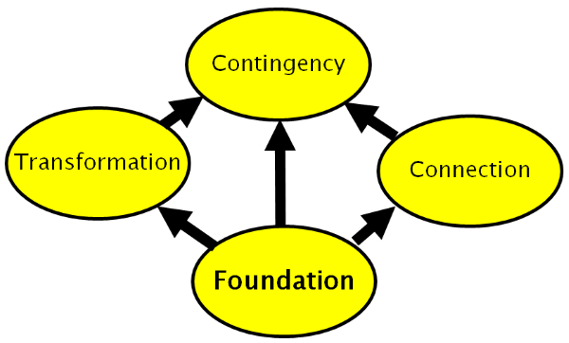
Figure1. The Knowledge Quartet.

Literature Review.
Effective teaching is required to create a positive learning experience for all students, there are a number of factors required to succeed in this. Factors included are; creating effective learning process for students, assisting in the development of independent learning. To plan relevant lessons, main activates suited to the ability and to provide understandable feedback to ensure engagement and progression in the class (Goe, Bell, and Little, 2008).
Teachers are required to have relevant subject knowledge in the subject and area which they are teaching so that they prepared to answer any questions about the subject or surrounding area, the subject matter knowledge. Having subject knowledge is essential however; the quality of teaching is just as significant; this is the pedagogical knowledge (Schulman, 1987). It is also essential to build professional, positive relationships with students, improving the student and teacher bond. This can help teachers reflect on the weaknesses and strengths of their students (Florian, Rouse, and Black-Hawkins, 2016).
Various data from studies and reports has been analysed to improve the education systems, especially in Wales. According to these reports, related to improving primary schools in Wales, procedures and practices are to be implemented to improve and support to develop teaching and quality in schools (Florian, Rouse, and Black-Hawkins, 2016). Primary education is crucial in the foundation years and key stage 2 as students are developing character and personal development, importance should be given to this.
According to Donaldson (2015), based on international reviews, there is research that covers a wide range of analysis and evidences. These analyses are drawn by effective researches, collection of relevant data and documentations. Countries included within this process were Australia, Canada, France, Scotland and Sweden. Their curriculums were compared and studied against UK based curriculums. The research was centred on monitoring the performance of individual students by the use of logistical practices and exercise based studies (Florian, Rouse, and Black-Hawkins, 2016). Throughout the research, it was founded that for successful learning in primary school students to occur, the development of interpersonal skills, self-confidence, and competencies should be developed in the students (Coe, Aloisi, Higgins, and Major, 2014).
The Welsh education system is found to be independent to other educational policies in the United Kingdom. It has its own system to focus on and improve the developing skills in children (Donaldson, 2015). During the foundation phase in children’s educational career, parents also play an important role to support teachers and to motivate and encourage their children’s’ learning. A main objective is to reinforce effective teaching through strong school governance and teacher’s performances. Learning systems in primary schools in Wales are assisted in different ways, through governments, documents, reports etc. These include external and internal evaluations and data recording. These evaluations are made part of improvement plans with linking it with parents and government.
According to Power et al, (2009), interviews and reviews were performed over Wales and data was collected. These researches developed reports regarding general audits obtained from different educational institutes present in Wales. The reports analysed problems faced and how they were overcome during studies. With these studies, local authorities running in Wales were found playing important roles in analysing and evaluating according to government policies but they have encountered problems due to the Welsh assembly. These institutes have to face challenging conditions due to low capacities, school sizes and transport issues. A significant less number of students are enrolled in Wales as compared to other areas in England, (Power et al, 2009).
According to Morrison, (1989), in response to the government, the education system is improving in Wales especially in Primary Schools. The Department of Education and Science (DES) has developed basic requirements for primary school teachers and constructed effective teacher training courses to improve primary education. These training courses include and focus on; learning the psychology of children, engaging them in different educational based activities to improve their educational and interpersonal skills, motivating them to ask questions and to participate in different curricular and extracurricular activities. These analytical tools are explained to teachers and devised to improve student and teacher relationships resulting in improvement in students grades, behaviours and can assist in students’ personal development. Primary education has improved providing effective context for learning and development of children, (Jones, and Whitehouse, 2017). Improvisations are made in the curriculum through various reforms in developing interpersonal and academic skills in students to ease the way of learning in Wales. Therefore, to achieve this, the Welsh government has introduced practices to improve the National Curriculum, Literacy and Numeracy Framework (LNF) in primary schools.

The relationship between students and teachers is very important. It eases communication gaps between student and teacher (Florian, Rouse, and Black-Hawkins, 2016). Teachers’ knowledge of a subject is also crucial because it can change the way of teaching the subject area and knowledge to the students. Another main factor contributing to the effectiveness of one’s teaching is to be able to maintain and control classroom behaviours and management. (Coe, Aloisi, Higgins, and Major, 2014).
Planning, instruction methods, the environment of the class and professional skills of teacher, combine to formulate effective teaching environment and enhance teacher-student relation, (Hinchey, 2010). Teachers are found using various management and coping methods when they are lacking in knowledge regarding a particular topic and subject which can sometimes affect the students learning. In order to avoid these scenarios ever occurring, the UK government has developed several, differentiated methods and evaluation programs for teacher training. These include ITT, initial teacher training (Huckstep, Thwaites, and Rowland, 2003).
The improvement in teaching can be obtained through evaluation methods, which is an effective way to gain feedback. This also includes the introduction of new ideas, plans to improve the education system in Primary Schools (Pring et al., 2012). Additionally, self-evaluation is seen to be very effective to improve teachers’ motivations to improve their teaching skills, subject knowledge and achieve their goals. Various inspections, such as ESTYN inspection and Reports, are performed in Primary Schools across Wales to analyse techniques used and compare them to effective methods. This is generated and implemented to find results for the overall effectiveness of schools in Wales. The teaching framework is found to be standard and a research-based system can improve overall teaching techniques (McPhee, 2009).

Analysis and evaluation of my subject knowledge for primary teaching.
I will be drawing on my professional teaching experiences, referencing to essential theoretical frameworks when evaluating, reflecting and assessing my own practice. I will be mainly focusing on two frameworks; the knowledge quartet (T. Rowland, P. Huckstep and A. Thwaites, 2003) and Schulman’s categories of teacher knowledge (L. Shulman, 1987). The knowledge quartet (T. Rowland, P. Huckstep and A. Thwaites, 2003) includes four categories being; Foundation, Transformation; Connection and Contingency. These two frameworks have a similar view and identify, through pedagogical content knowledge, that subject knowledge is more than what you know about a subject. However, the primary focus is on how you are able to bring together ideas that students can understand through your teaching. I will be discussing and reflecting on how my subject knowledge has progressed and how I bonded the relationship of the subject knowledge with effective teaching and learning.

Foundation.
The topic chosen for the duration of the term was ‘The Celts’. This topic was incorporated into numerous lessons and all subjects particularly, English, History, Design and Technology. Initially, I believed that I was confident with this topic and had substantial foundation subject knowledge, however when planning lessons I found that my subject knowledge needed significant improvement. The lesson plan that I chose to reflect on was the subject History (Donaldson, 2015) with the learning objective being; ‘To explore historical artefacts’ (See Appendix 2 for lesson plan). Success criteria included; to understand what a primary source is, to think about what an artefact can tell us about the Iron Age and to understand how the past is represented through artefacts (See Appendix 3).
During break time, before the lesson, I felt extremely nervous, believing that the research I had done prior to the lesson was not substantial enough. I realised that I did not fully know and understand the subject content needed to teach and challenge the student. In this situation, I panicked as I was not prepared and realised that having relevant subject knowledge was crucial. This strongly suggested that content knowledge is very important and is required in the teaching and learning of a subject (Rowland et al., 2009; Ball, Lubienski & Mewborn, 2001).
To help overcome this scenario I researched and found relative information about the Iron Aged Artefacts that the pupils were to discuss in the lesson (See Appendix 4). This included; the relevant Celtic name, what it was used for, how it was used, who would use it and what materials it was made from. This helped me to relax and feel more confident before the input. Having this support tool gave me all the basis content knowledge that I needed to know for the lesson to be a positive learning experience for the students. However, I was still anxious that a pupil may ask a question about one of the Artefacts and not know the answer. Luckily this did not occur during the lesson, however, made me more aware for the future.
To refrain this from happening in future lessons I identified that researching the topic and subject before planning lessons is essential; ensuring that I understand the content knowledge and what is expected of me is important. I now make sure that I have researched every aspect of the subject and understand the context of what is to be taught with the appropriate terminology.

Transformation.
The next lesson I am going to reflect on, relevant to the transformation unit, is Mathematics (Donaldson, 2015) Lesson 7, with the learning objective; Multiplying 2 digit numbers (See Appendix 5). I believe this was a positive experience for me as I was able to analyse my teaching and strategies, defining what aspects succeeded and what needed improving. This was the first lesson where students would be learning the concept of multiplying 2 digits numbers, therefore I had to ensure that the input was clear and precise for pupils to follow and understand the steps and theory.
I had planned for pupils to use Dienes 10 as a supporting visual device; students were using the equipment correctly and resourcefully. However, as I was observing the tables working out the model questions from the IWB I realised that Numicon could be as an alternative support. I immediately handed a Numicon box to each table and found it interesting to see the students also engaging with Numicon to support their learning. I gathered valuable information observing the students and found that lower and lower/middle ability students were using the numicon and the higher/middle and higher ability pupils were using Dienes 10 for support. This brought my attention that it is important to provide students with a range of relevant materials for support as student are all individuals learning in different ways at a range of levels and abilities. In future lessons, I will ensure that I have planned for and aided pupils with a range of materials and support relevant to the lessons being taught. This definitely highlighted the importance of pedagogical knowledge.
Still focusing on transformation in the knowledge quartet (T. Rowland, P. Huckstep and A. Thwaites, 2003), I experienced a negative experience which linked into this area. It occurred in the subject of Science (Donaldson, 2015) Lesson 2, Learning objective; Comparing animal life cycles (See Appendix 6 for lesson plan). I introduced the concept of comparing to the class, modelled a comparison table on the IWB and explained what they would be carrying out for the main activity. I realised at the start of the main activity that I had not demonstrated the ‘comparisons between animal life cycles table’ in a way in which all student could understand. This was brought to my attention as all students on ‘crocodile’ table all had their hands up as they were still unsure on how to compare. This was my own fault as I should have evaluated the different abilities of the class and catered for all in my introduction and not just the differentiation of worksheets.
To overcome this problem and to support students in gaining and understanding I spent a short period of time with the table. I modelled comparisons between the groups appearances first as it was easier to spot the similarities and differences. Then, I encouraged group discussion about the comparisons between a duck and a frog. I then told them to discuss their ideas and work as a team to collect answers. In the future, I will used this as a way forward to always be aware that students work at different stages and it is crucial to be able to model, demonstrate and explain in different ways so that all students can understand and gain knowledge (Shulman, 1986).

Connection.
Connection is the next area in the knowledge quartet and focuses on the coherence of planning and teaching, also being able to build on students’ prior learning and make connections with their future learning (T. Rowland, P. Huckstep and A. Thwaites, 2003). The subject I will be reflecting on are; History and Art (Donaldson, 2015), (See Appendices 7 and 8 for both lesson plans). These two lessons were combined and taught with a cross-curricular approach involving curricula from both educational subjects. The History lessons included students learning about Iron Age clothing, how it was made and what is was made from. The main activity was to choose and draw a Celtic person with the correct Celtic clothing and label the items. As a starter to the lesson, I devised a mind map on the IWB of pupils’ ideas of Celtic clothing. This helped me to build on students’ prior learning when in a workshop lesson at St Fagans National Museum of History. The class were shown different items of clothing, able to experience them at hand, and were shown the machinery to make the clothing. Pupils remembered the information from this experience when answering questions, all were very eager.
Throughout the lesson I informed pupils to concentrate on their designs, as it was linking into next lesson, where they were going to make and model their own Celtic clothing. This cross-curricular link would make connections to their future learning from the history to art lesson. The focus curriculum coverages throughout were; ‘To experiment with and examine the methods used by other artists, craft workers and designers from different periods and cultures (The National Curriculum in Wales, 2013).

Contingency.
Contingency is the final area in the knowledge quartet (T. Rowland, P. Huckstep and A. Thwaites, 2003). This category concerns events and behaviours that occur in classrooms and are virtually impossible to plan for, ensuring the teachers initiative and intuition. In my own practice, the subject I will reflect on is English (Donaldson, 2015) lesson 3 (See Appendix 8 for lesson plan). The learning objective was; to write a draft estate agent article. There were a range of abilities and educational needs in the class, which made me ‘think on my feet’ throughout. As it was an English session, I knew from experience with the class that the lower ability students did not favour this subject as they found it difficult. This enabled to me to plan in advance to reduce the chances of any unwanted behaviours concerning the lesson. Therefore, I decided for the main activity, that I would include a focus group into the session, with the 4 pupils who I now would excel with the aid of my support. Together we discussed the features of a roundhouse, as I knew pupils were confident with the area, boosting their self-esteem. We started to fill in the worksheet together, collaborating on ideas. By the end of the activity pupils were all working independently and had completed all the work set without any hesitation or occurring problems. This was a positive experience for me as I was able to think ahead and devise a plan to respond to students’ questions and difficulties.

Conclusion.
The knowledge quartet and Schulman’s, knowledge and teaching, identifies the fact that subject knowledge is more than what you know about the subject but how you are able to bring together ideas where children can understand and how you are able to react to children when you are teaching. Throughout this study, I have come to realise that yes, to be able to teach an area of learning, it is crucial to have good subject matter knowledge understanding the area being taught. However, it is also essential to have pedagogical knowledge to be able to deliver explanations and demonstrations in various ways, ensuring all students understand and gain knowledge experience.
I believe in my own teaching that I am demonstrating and progressing my own subject and pedagogical knowledge to create pedagogical content knowledge. Through reflection on my own practice I have been able to understand specifically where I have successfully understood pedagogical content knowledge. However, I still need to maintain and improve my understanding of what is being taught, to able to model, demonstrate or explain so that students can understand and be able to respond to students ideas and questions with confidence (T. Rowland, P. Huckstep and A. Thwaites, 2003).

References
Coe, R., Aloisi, C., Higgins, S. and Major, L.E., 2014. What makes great teaching? Review of the underpinning research.
Ball, D. L., Lubienski, S. & Mewborn, D. (2001). Research on teaching mathematics: The unsolved problem of teachers’ mathematics knowledge. In V. Richardson (Ed.), Handbook of research on teaching. New York: Macmillan.
Ball, D. L. & Bass, H. (2003). Toward a practice-based theory of mathematical knowledge for teaching. In E. Simmt & B. Davis (Eds.), Proceedings of the 2002 Annual Meeting of the Canadian Mathematics Education Study Group. Edmonton: CMESG/GCEDM.
British Educational Research Association (BERA) (2011) Ethical guidelines for educational.
Davies, S. and Salisbury, J., 2009. Building educational research capacity through inter-institutional collaboration: An evaluation of the first year of the Welsh Education Research Network (WERN). The Welsh Journal of Education.
Department for Education (2013) The National Curriculum in Wales: Key Stages 2 framework document. Available at: http://learning.gov.wales/resources/browse-all/art-and-design-in-the-national-curriculum-for-wales/?lang=en (Accessed: 30 December 2018).
Donaldson, G., 2015. Successful futures: independent review of curriculum and assessment arrangements in Wales: February 2015.
Estyn.gov.wales (2014), Her Majesty’s Inspectorate for Education and Training in Wales (June 2014): Estyn Report.
Florian, L., Rouse, M. and Black-Hawkins, K., 2016. Achievement and inclusion in schools.
London; Routledge.
Goe, L., Bell, C. and Little, O., 2008. Approaches to Evaluating Teacher Effectiveness: A Research Synthesis. National Comprehensive Centre for Teacher Quality.
Hinchey, P.H., 2010. Getting Teacher Assessment Right: What Policymakers Can Learn from Research. National Education Policy Centre.
Huckstep, P., Thwaites, A. and Rowland, T., 2003. Primary teachers' mathematics content knowledge: What does it look like in the classroom?
Jones, M. and Whitehouse, S., 2017. Primary humanities: a perspective from Wales.
McPhee, A.D., 2009. Problem-based learning in initial teacher education: taking the agenda forward. The Journal of Educational Enquiry.
Morrison, K., 1989. Training teachers for primary schools: the question of the subject study. Journal of Education for Teaching.
Power, S., Lewis, J.T., Taylor, C., Connolly, M., Thomas, G. and Wyn Jones, S., 2009. Local authorities and education research in Wales. The final report of LINK-Wales: the learning in Wales network.
Pring, R., Hayward, G., Johnson, J., Hodgson, A., Keep, E., Spears, K., Oancea, A., Rees, G. and Wilde, S., 2012. Education for All: the future of education and training for 14-19 year-olds. London; Routledge.
Robert Coe, Cesare Aloisi, Steve Higgins and Lee Elliot Major - What makes great teaching?
Rowland, T., Turner, F., Thwaites, A., & Huckstep, P. (2009). Developing primary mathematics teaching: Reflecting on practice with the Knowledge Quartet. London: Sage.
Shulman, L. (1986) ‘Those who understand, knowledge growth in teaching’. Educational Researcher.
Shulman, L. S. (1987) ‘Knowledge and teaching: Foundations of the new reform.’ Harvard Educational Review.
Wales. National Assembly, 2001. The Learning Country: A Paving Document; a Comprehensive Education and Lifelong Learning Programme to 2010 in Wales. Crown copyright.

Child Number | Ability | Additional
Child 1 | Middle Ability
Child 2 | Higher Ability
Child 3 | Middle Ability
Child 4 | Higher Ability | EAL  More able and talented
Child 5 | Middle Ability | Reader
Child 6 | Lower Ability | SLCN
Child 7 | Lower Ability | BSDE
Child 8 | Higher Ability
Child 9 | Middle Ability
Child 10 | Middle Ability
Child 11 | Higher Ability | EAL
Child 12 | Middle Ability
Child 13 | Middle Ability | EAL, Reader
Child 14 | Lower Ability | Target Child
Child 15 | Middle Ability | SLCN
Child 16 | Higher Ability | Target Child  More able and talented
Child 17 | Middle Ability | EAL
Child 18 | Middle Ability
Child 19 | Lower Ability | Dyslexia
Child 20 | Higher Ability
Child 21 | Middle Ability
Child 22 | Higher Ability
Appendix 1.
Appendix 2.
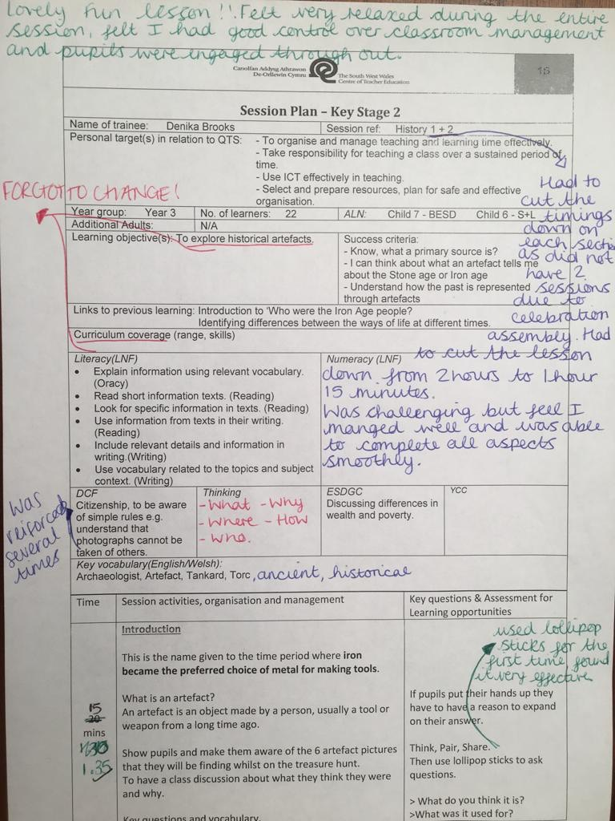
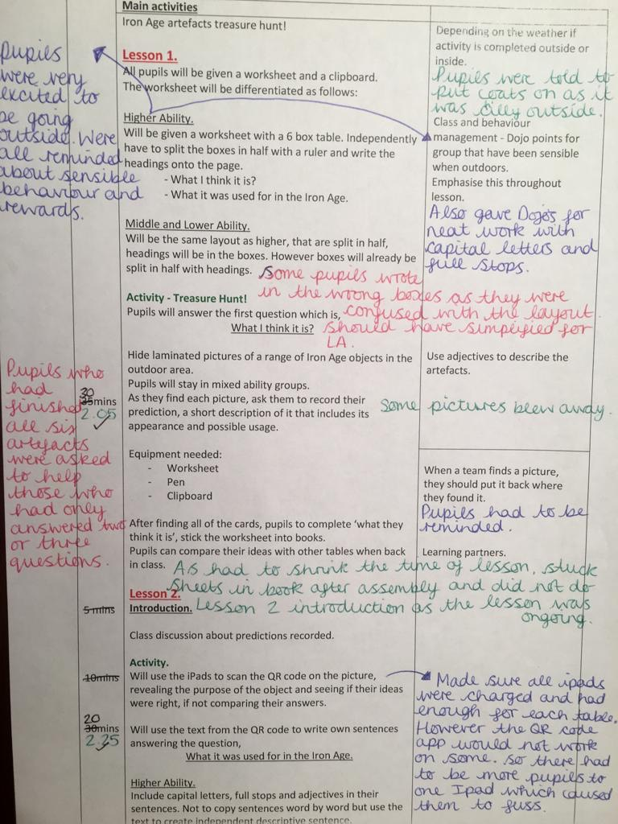

Appendix 3.
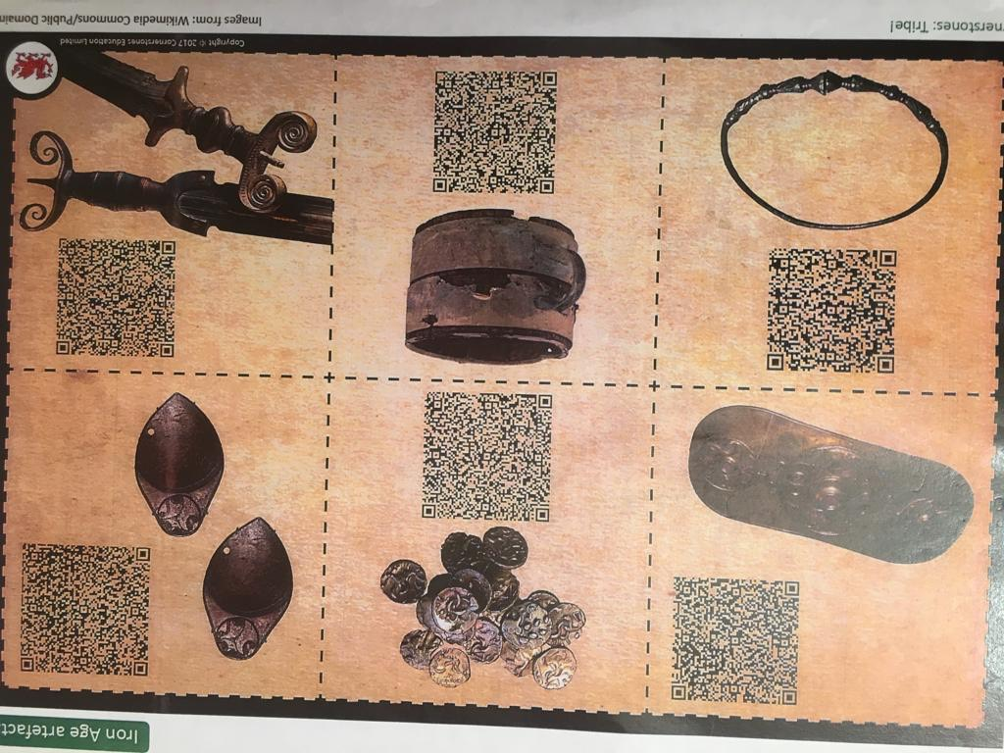
Appendix 4. 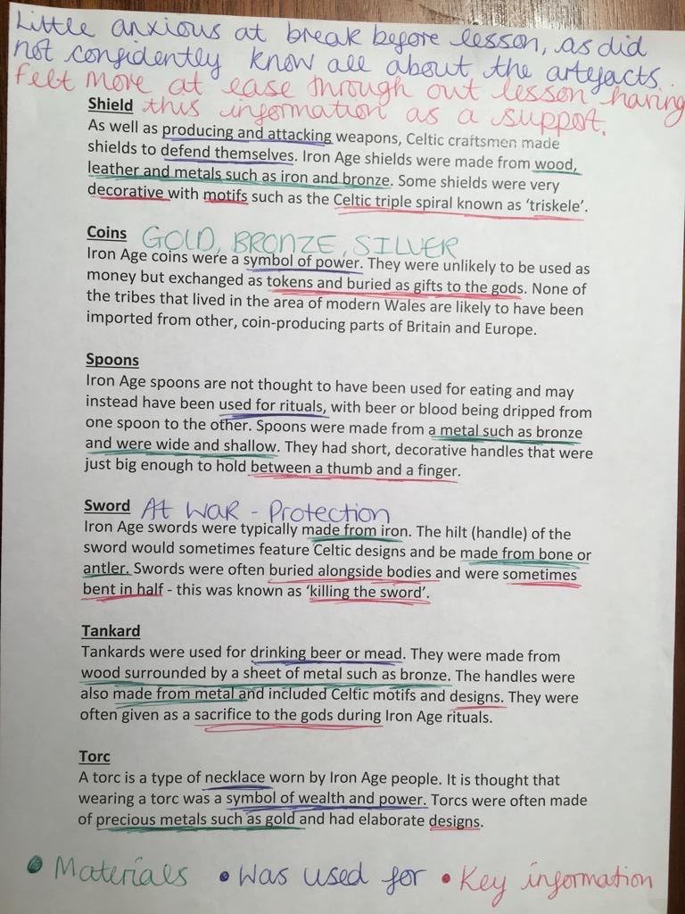

Appendix 5.
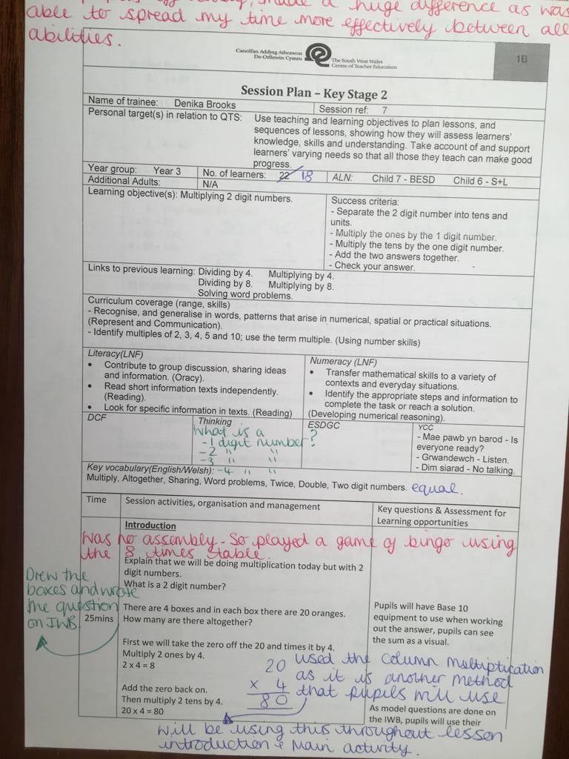

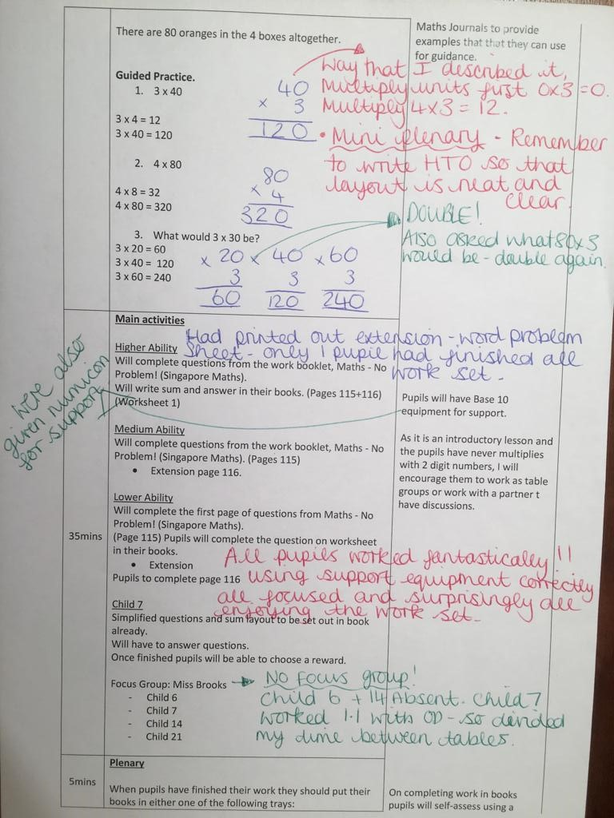
Appendix 6
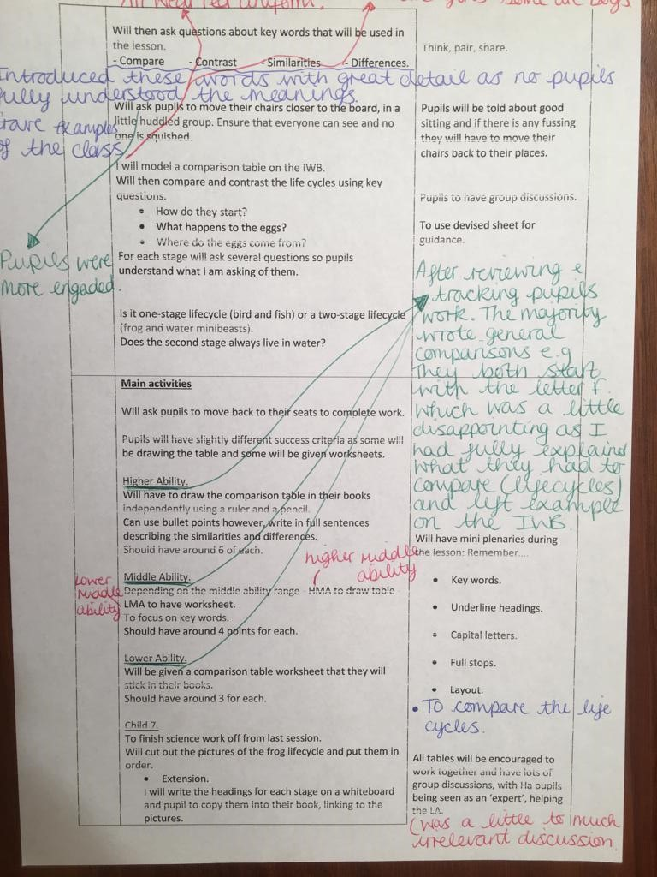
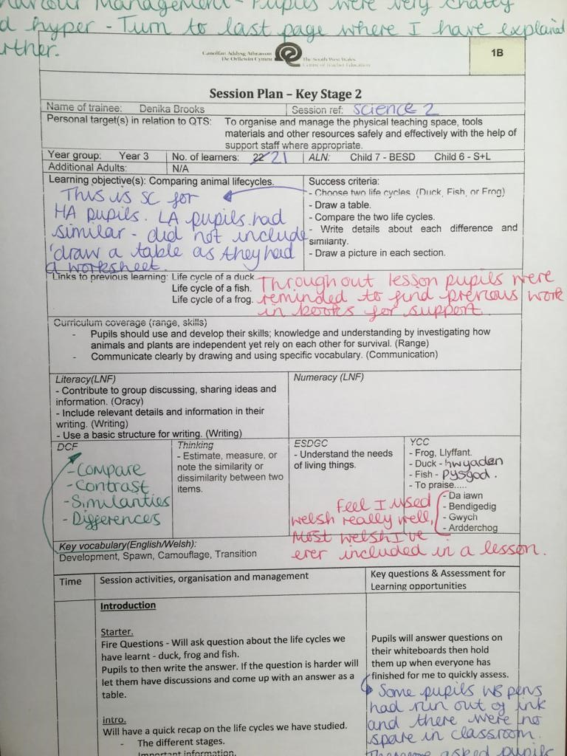

Appendix 7.
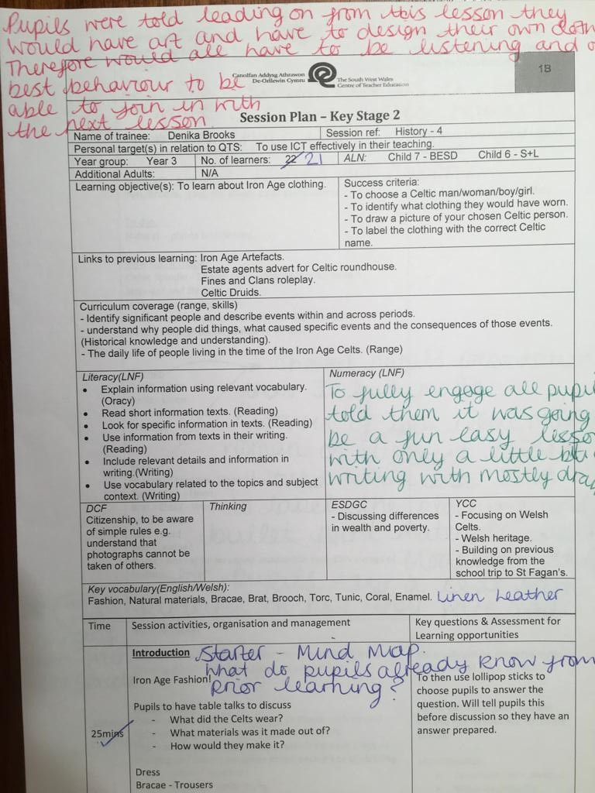
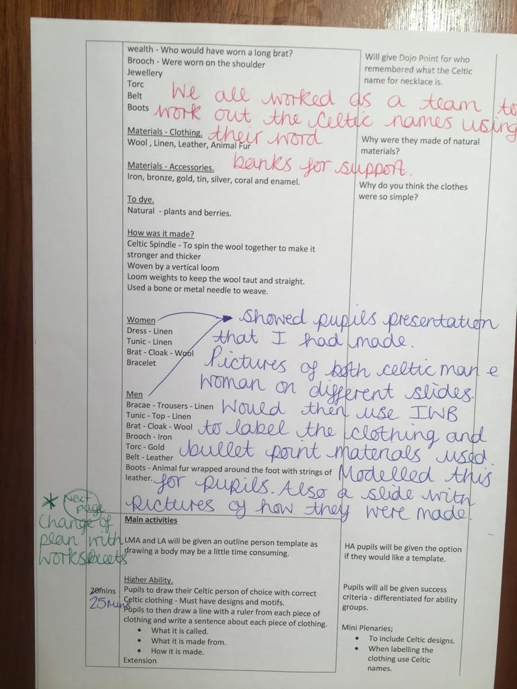
Appendix 8. 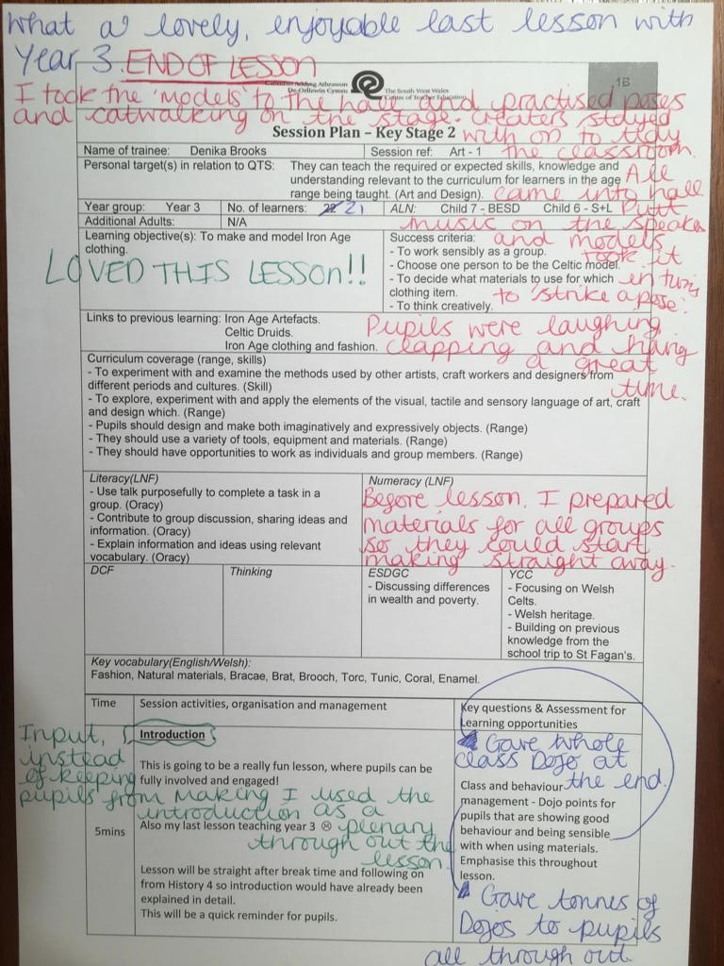

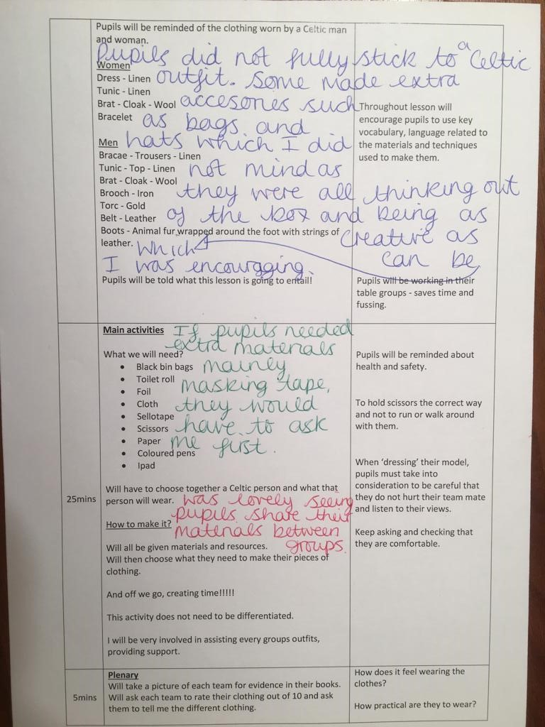
Appendix 9


