

Student name: Patel Meetkumar Sureshbhai
Student ID : 2241855
Advisor : Tushara Balendran

The use of digital marketing in customer relationship management and analysis of Netflix

Declaration

I, Patel Meetkumar Sureshbhai declare that this dissertation has been composed by myself, that the work contained herein is entirely my own except where explicitly stated otherwise in the text, and that this work has not been submitted for any other degree or qualification, in whole or in part, except as specified.

Signature: .P..Meet ....................................................

Date: …06/10/2024……………………………............................

Acknowledgements
The first person I would like to thank is my advisor, Tushara Balendran, she has provided both encouragement and guidance and knowledge that has helped me throughout my experience researching. I would like to express my special gratitude to all those people who have contributed to the development of this dissertation and who, thanks to their comments and valuable critiques, have made my education even richer. However, I am particularly indebted to you for your tolerance while going through the difficult stages of the research and the motivation that accompanied the entire process. How you have been a mentor: The experiences that you have provided me hope to achieve excellence and hope to take into practice.
I would like to express my gratitude to my colleagues and friends for their encouragement and fellowship. Your desire for the exchange of thoughts, lively discussions and motivation helped make this process a joyful one. I want to express my gratitude to dissertation committee members as they made it possible to learn and start personal development. In the last place, I would like to thank my family for standing beside me and believing in me all through.

Table of Contents

The use of digital marketing in customer relationship management and analysis of Netflix 1
Chapter 1 10
Introduction 10
1.1 Background to the Research 10
1.2 Problem Statement 11
1.3 Research Rationale 12
1.4 Aims and Objectives 13
1.5 Research Questions 15
1.6 Research Hypotheses 15
1.7 Outline of the Dissertation 16
1.8 Chapter Review 18
Chapter 2 19
Literature Review 19
2.1 Overview 20
2.2 Definitions and Key Concepts 20
2.3 Critical Review of Definitions of Research Objectives 21
2.4 Research Objectives Critical Review and Analysis 23
2.5 Gaps within the Literature on Digital Marketing and CRM 25
2.6 Models and Frameworks 25
2.7 Comparative Analysis 31
2.4 Review of Empirical Studies 34
2.4.2 Role of Data Analytics in CRM 35
2.7 Summary of Literature Review 36
Chapter 3 37
Research Methodology 37
3.1 Introduction 37
3.2 Research Philosophy 38
3.3 Research Design (Quantitative) 38
3.4 Research Approach 38
3.5 Research Strategy 39
3.6 Choice: Quantitative Method 39
3.7 Sampling Strategy 40
3.7.1 Sample Size 40
3.7.2 Sample Type 40
3.7.3 Sampling Method 41
3.8 Data Collection Methods 42
3.9 Time Horizons 46
3.10 Data Analysis 46
3.11 Ethical Considerations 47
3.12 Chapter Summary 48
Chapter 4 48
Findings, Results, Analysis, and Discussion 48
4.1 Introduction 48
4.2 Data Collection Methodology 49
4.2.1 Overview of Data Collection 49
4.2.2 Survey Design 49
4.2.3 Target Population and Sampling Method 49
4.2.4 Data Collection Process 49
4.3 Data Analysis 50
4.3.1 Excel Data Processing 50
4.4 Descriptive Statistics 50
4.4.1 Length of Netflix Subscription 50
4.4.2 Frequency of Watching Netflix Content 52
4.4.3 Satisfaction with Personalized Recommendations 53
4.4.4 Subscription Due to Targeted Promotion 54
4.4.5 Importance of Personalized Recommendations in Continuing Usage 55
4.4.6 Effectiveness of Digital Marketing in Engagement 57
4.4.7 Reactivation After Marketing Campaign 58
4.4.8 Likelihood of Canceling Subscription 59
4.4.9 Reflection of Viewing Preferences in Marketing 60
4.4.10 Following Netflix on Social Media 61
4.4.11 Influence of Social Media Content on Viewing Decisions 63
4.4.12 Rating of Netflix’s Responsiveness to Feedback 64
4.4.13 Importance of Promotions for Loyal Subscribers 65
4.4.14 Agreement with Feeling Valued by Personalized Marketing 66
4.4.15 Likelihood of Recommending Netflix Based on Personalized Marketing 67
4.5 Statistical Analysis 69
4.5.1 Hypothesis Testing 69
4.5.2 Correlation Analysis 70
4.5.3 T-Test for Satisfaction Scores 71
4.5.4 Logistic Regression Analysis 71
4.5.5 ANOVA (Analysis of Variance) 72
4.6 Discussion of Findings 73
4.6.1 Implications for Research Objectives 73
4.6.2 Comparison with Literature 74
4.6.3 Practical Implications for Netflix 75
4.7 Limitations of the Study 76
4.8 Conclusion 76
Chapter 5 78
Conclusions and Recommendations 78
5.1 Introduction 78
5.2 Summary of Research Objectives and Key Findings 78
5.3 Recommendations 79
5.3.1 Enhanced Personalized Marketing 79
5.3.2 Optimizing Targeted Promotions 79
5.3.3 Enhancement in CRM Systems 80
5.3.4 Ethical Issues 80
5.4 Research Suggestions for Future Endeavors 80
6. References 81

List of Tables

Table 1 RACE Model vs. Technology Acceptance Model (TAM) 31
Table 2 Customer Lifetime Value (CLV) Model vs. Relationship Marketing Theory 32
Table 3 Data Collection Methods 42
Table 4 Subscription Duration 50
Table 5 Frequency of Watching Netflix 51
Table 6 Satisfaction with Personalized Recommendations 52
Table 7 Impact of Targeted Promotions on Subscription 54
Table 8 Importance of Personalized Recommendations 55
Table 9 Effectiveness of Digital Marketing Campaigns 56
Table 10 Reactivation After Marketing Campaign 57
Table 11 Likelihood of Cancelling Subscription 58
Table 12 Reflection of Viewing Preferences in Marketing 59
Table 13 Following Netflix on Social Media 61
Table 14 Influence of Social Media on Viewing Decisions 62
Table 15 Responsiveness to Feedback in Marketing 63
Table 16 Importance of Promotions for Loyal Subscribers 64
Table 17 Personalized Marketing and Customer Value 65
Table 18 Recommendation Based on Personalized Marketing 67
Table 19 Chi-Square Test of Independence 68
Table 20 Correlation Analysis 69
Table 21 T-Test for Satisfaction Scores 69
Table 22 Logistic Regression Analysis 70
Table 23 ANOVA (Analysis of Variance) 71

List of Figures
Figure 1 Outline of the Dissertation 15
Figure 2 CLV Model 24
Figure 3 TAM Model 26
Figure 4 Race Model 28
Figure 5 Digital Marketing Strategies and CRM 32
Figure 6 Saunders Onion Model for Research Methodology 36
Figure 7 Pie chart showing the distribution of subscriber duration 47
Figure 8 Bar chart of viewing frequency 49
Figure 9 Satisfaction with Recommendations 50
Figure 10 Pie chart for responses to targeted promotions 51
Figure 11 Responses to the importance of personalized recommendations 52
Figure 12 Bar chart of digital marketing effectiveness 54
Figure 13 Effectiveness of Digital Marketing Campaigns 54
Figure 14 Pie chart for reactivation responses 55
Figure 15 Cancellation likelihood 56
Figure 16 Bar chart for alignment with viewing preferences 57
Figure 17 Pie chart for social media following 58
Figure 18 Social Media Influence 59
Figure 19 Bar chart for feedback responsiveness 60
Figure 20 Importance of Promotions 62
Figure 21 Bar chart for agreement levels on feeling valued 63
Figure 22 Pie chart for the likelihood of recommending Netflix 64

Chapter 1

Introduction

1.1 Background to the Research
Implementing digital marketing in CRM systems has been noted as an important factor for all companies and is much more critical to the entertainment industry. By the end of 2023, Netflix claimed to have reached more than 238 million paid subscribers globally, evidencing the company’s strong market presence and the efficiency of the digital CRM strategies applied (Netflix, 2023). It also helps in providing a customized user experience and has less churn rate as customers will be active with content according to their interests (Annissa et al., 2020). The aspect of companies’ expenditure on digital marketing, which hit more than $400 billion in 2022, similarly attests to the importance of such approaches in contemporary commerce (Statista, 2023). The firm that has recognized this value and put it into practice is Netflix, which is an acknowledged digital CRM enthusiast that spent $ 2 billion on digital marketing in 2023, the year according to Digital TV Research.
Another aspect of the marketing strategy is the regular utilization of the recommendation algorithms based on the usage of data analysis and machine learning, which help Netflix to anticipate the actions of users and their preferences (Barwal et al., 2023), thus guaranteeing the maximum CLV (Yu, 2023). Over time, this change from way a highly promotional-oriented approach to a more analytics-orientated marketing model proves to be effective, especially in the modern developing world where consumer expectations are inclining. For that matter, it was found that targeted communication can enhance client satisfaction by 20% and customer defection rate by 15% proving the significance of precise CRM approaches (Chaffey, 2020). Consequently, Netflix is a great example of companies responsible for its digital marketing and CRM evolution, that underwent the main complexities of the new digital age and found a way to achieve long-term business prosperity. This research seeks to elaborate on these dynamics, particularly in light of how Netflix applies digital marketing strategies that go into the engineering of the CRM and the company’s overall performance in the highly competitive market. The face of digital marketing in entertainment CRM will change even more with technological advancement and shifting consumer preferences. Those companies that innovate continuously and, by extension, refresh their strategies are likely to keep ahead of the game. For instance, streaming's total revenue would grow 11% annually to $120 billion by 2025. Such growth underlines the increasing value of effective digital marketing strategies in customer acquisition and retention. Steadfast investment in CRM and digital marketing innovation makes Netflix very well positioned to take advantage of these market dynamics, so it is very instructive as a case study aimed at understanding the intersection of digital marketing and customer relationship management in the entertainment industry.
By refining its CRM and digital marketing strategies Netflix shows the actual power of data-driven approaches to customer engagement and business longevity in the digital environment. Indeed, such an orientation to sophisticated data analytics in personalizing experiences and anticipating consumer needs is less of a competitive strategy and more of an evolution to match the rising expectations of consumers and the industry as a whole. It is highly evident in the sustained subscriber growth and low churn rates at Netflix, an indication of how granular consumer insights prove to be an effective basis for marketing strategies. The depth of analysis that Netflix has afforded it a position not only to respond to the trends of today but to foretell and create paths for future consumer behaviours, thereby making it a benchmark for the industry.
It will deconstruct these sophisticated strategies to a granular understanding of how digital marketing can feed into CRM for enhanced market performance. By understanding the technological deployment in customer engagement by Netflix, this study is going to explore the broader implications of innovations in digital marketing in the streaming industry. It will thus give insight into how digital marketing can be used not only to respond to but also to drive and predict customer demands, influencing the approach of the whole sector in customer relationship management.
Besides, digital marketing was under constant development, and the contribution of social media platforms to these changes, in addition to influencing marketing, regarding the modification of the consuming behaviour of its target audience, has been considerable. Netflix has also shown how effective utilization of social media platforms can be done to push its content and allow audiences to get closer to it on a personal note (Cahyati et al., 2023). With the Netflix analytics on social media, there will be an ability to measure and analyze viewer sentiment. This leads to more targeted marketing campaigns best suited for particular demographics. Through the integration of social media strategies into the CRM framework, Netflix managed to attain better relations with its customers, improved brand loyalty and resulted in increased satisfaction for users of its services. In that regard, Netflix will also engage in or continue with social media and influencer marketing to demonstrate an effort toward being at the edge in digital marketing innovation. Such a context secures competitiveness within the fast-moving consumer preference industry. This thesis investigates these added dimensions of digital marketing in terms of how they add to the effectiveness of Netflix's CRM strategies and their impacts on the continued success of Netflix in the industry.

1.2 Problem Statement
In the wide-open world of digital streaming, it is very challenging to keep the customers engaged and bring down the churn rate even if the firm is doing great digital marketing. There is a crucial problem of attributing the effects of employed big data analytics and machine learning to Netflix’s digital marketing on the effects of customer loyalty and retention in the long run. Due to the development of new technologies in the digital space of marketing, the nature of interactions between businesses and customers might require optimized work of CRM systems. This has led to a situation where even though Netflix is continuing to grow its subscriber base, there is a bigger problem of churn which is relatively more complicated to understand. The issue is that it is necessary to outline and quantify the impact of particular digital marketing activities on customers’ behaviour and satisfaction, which serves as the key to effective CRM management and company development.
As technologies for digital marketing are rapidly changing themselves, traditional CRM practices are not capable of addressing the sophisticated demands of the modern consumer. Thus, even as Netflix continues to increase in subscribers, the nagging issue of its churn problem persists and warrants more granular analysis. The challenge is, therefore, to determine and measure the direct effects of each of these digital marketing strategies on customer behaviour and customer satisfaction, the basis for which the optimization of CRM practices would be founded in this context, and which is an important aspect of ensuring long-term growth.
It also happens that Netflix functions in a highly saturated market in which even the slightest changes in consumer behavior or slight enhancements to competitors' technology could gain considerable importance. It becomes imperative in such an environment to not only deploy but also constantly refine digital marketing strategies. The lack of empirical research into the long-term effects of these strategies is therefore an open vulnerability. There is a serious and timely need to explore and quantify how Netflix's efforts at digital marketing translate into long-term customer loyalty and reduced churning rates. The solving of this problem is, therefore, important to Netflix, and these findings would also give broader insights into other companies addressing similar challenges that threaten to topple these companies from their dominant positions in their respective markets.
However, there is a major issue, which is that Netflix competes in the intensely competitive market along with other streaming services such as Disney+, Amazon Prime Video, and Hulu, amongst others. Although most marketing communication strategies employed by Netflix seem to be highly effective, there is scarce evidence in the scholarly literature that offers a rigorous assessment of the impact of these marketing activities in terms of achieving Netflix’s marketing objectives including customer churn and its customers’ CLV. This is an area that has been left relatively unexplored in the current literature as Netflix’s technological initiatives in the realm of digital marketing are widely acclaimed, yet one can only wonder about when it comes to CRM. Solving this problem is not only critical for Netflix but also provides practical lessons for other companies and industries where digital marketing initiatives, social interactions, and brand loyalty collide in today’s dynamic and highly competitive technological landscape.

1.3 Research Rationale
Recent advancements in different phases of customer relationship management or CRM have pushed digital marketing strategies much faster like the need for detailed research has arisen as more business entities such as Netflix depend on such strategies as key sources of competitive advantage. It is necessary to underline that this research is important both for academics and business people since there is a lack of studies targeting the crucial field of digital marketing in CRM, particularly in the context of digital streaming platforms. Albeit theoretical debates abound regarding digital marketing and CRM, the academic world lacks satisfactory evidence and debates that look at their convergence and how they affect the world. As the case is specific to Netflix, this study not only situates digital marketing within an increasingly technologically evolving sector but also offers a robust assessment of some of the strategic initiatives’ impact on critical CRM outcomes and indicators, including customer interaction and satisfaction, and customer retention and loyalty. This methodological approach will improve theoretical models and provide a better view of the actual usage and efficacy of digital marketing in CRM, thus addressing one of the major gaps in today’s academic literature.
Concerning Netflix, how digital marketing strategies impact CRM is not only an academically interesting issue but of critical practical significance. Precisely, this research will present Netflix with actionable insights that might improve its retention capability to reduce customer churn by looking into digital marketing strategies. The findings will be great in helping Netflix ensure that it channels its digital marketing into effective strategies that would work well for the achievement of customer satisfaction and loyalty. The results of the study would also have potential implications for strategy planning to better position Netflix in terms of how it leads its competitors within an increasingly crowded streaming market. The research will contribute also to the theory of how digital marketing is adopted with CRM in the entertainment industry. With Netflix continuously learning and expanding across borders, how different markets respond to different digital marketing and CRM strategies will be very instrumental in making effective strategies for the future. This study may help Netflix tailor its approaches to different regions, ultimately building a more loyal and engaged global subscriber base.
The findings of this study are beneficial from an industry point of view and specifically for firms that seek to improve their current CRM strategy in the complex context of the contemporary market. This is where the study’s analytical concentration on Netflix and its data-driven marketing approaches exemplifies the general effects of digital marketing on the consumer. As this study shows that these strategies work and can lower churn while increasing customers’ lifetime value, this is powerful evidence to encourage more strategic branding investments in Internet marketing. It also emphasizes the importance of big data in enhancing CRM strategies, indicating such companies that do not embrace data in their marketing could be headed to doom. Contrary to the survey and similar approaches, this research does not only offer a description of the phenomenon in question but provides practical recommendations for its enhancement in digital marketing and CRM, which would make it useful to both practising managers and academicians.

1.4 Aims and Objectives
Research Aim:
The main aim of this research is to analyze the impact and applicability of digital marketing concepts in CRM, especially converging on Netflix. The concern of this research is to establish how the Netflix company uses digital marketing strategies to increase the engagement, loyalty, and satisfaction of customers. Based on these strategies, the research seeks to present findings on how digital marketing can be effectively leveraged to enhance the delivery of CRM initiatives, thus helping Netflix to sustain its competitiveness in the streamer market.

Research Objectives:
To achieve the overarching aim of the research, the following specific objectives have been identified:
RO1: To determine the current digital marketing strategies used by Netflix to retain customers.
This objective highlighted the extent of research that is aimed at establishing the spectrum of digital marketing techniques that Netflix is applying to current customers thereby preventing churn. This paper will discuss various strategies that the platform employs for instance, recommendation of content and promotions that are meant to look at the users’ needs and tailor the services to fit the users thereby improving the experience of the platform.
RO2: To evaluate how data analytics have influenced Netflix's digital customer relationship management tactics.
This objective is specific to determining the developments in data analytics and its contribution to the CRM strategies adopted by Netflix. The study will also explore how Netflix uses big data and supervised machine learning to make decisions such as the customers’ buying behaviours and patterns and market its products appropriately. In light of revealing the influence of data analytics on CRM, the study will also provide insight into the extent of the effectiveness of Netflix’s tactics in achieving its objectives in CRM.
RO3: To evaluate how targeted digital marketing initiatives affect churn prevention and subscriber acquisition.
This objective aims to analyze the results of Netflix’s category-specific internet marketing advertisements with the goal of customer non-cancellation and obtaining new consumers. The study will analyze how certain promotions, including e-mail newsletters and activity on social networking sites, affect the tendencies toward subscribers’ churn and acquirement. These will help in pointing out the key factors that work as a boon in the cutthroat competition of the streaming business.
These objectives will contribute to the intended purpose of establishing how digital marketing theories are implemented within the CRM strategies of Netflix while contributing lessons to be undertaken by other related businesses.

1.5 Research Questions
Based on the research objectives outlined in this study, the following hypotheses have been formulated to guide the investigation into the effectiveness of digital marketing strategies in customer relationship management (CRM) at Netflix:
RQ1: How do digital marketing strategies implemented by Netflix influence customer engagement and interaction with its platform?
RQ2: What is the relationship between digital marketing efforts and customer retention rates at Netflix?
RQ3: What is the impact of targeted digital marketing campaigns on subscriber acquisition and churn reduction at Netflix?
This framework will guide the investigation within research questions and provide a framework to inquire into this very complex interrelationship of digital marketing strategies and customer relationship management, in the end yielding insights that enrich both academic understanding and their practical application within the industry.

1.6 Research Hypotheses
H1: The digital marketing strategies are related to the key positive effect on the customer engagement of Netflix.
It will, therefore, hypothesize that what Netflix does in digital marketing with the suggestions of relevant content, personalized offers, and social network engagement provides it with a very important avenue to effectual customer engagement. Thus, given that these would create a more personalized and interactive user experience, increased levels of user involvement, viewing times, and customer satisfaction are likely to result.
H2: Data analytics significantly improve CRM outcomes for Netflix.
The hypothesis is that data analytics drives improved CRM at Netflix. Means of proving this hypothesis include how Netflix was able to make good use of big data, machine learning, and predictive analytics in unearthing insight into the behaviours and preferences of the customer. It is expected that such data-driven approaches allow Netflix to better tailor its marketing strategies to retain customers more effectively, increase their lifetime value, and achieve effective customer segmentation.
H3: Targeted marketing efforts reduce churn and increase subscriber acquisition.

The hypothesis postulates that Netflix reduces customer churn and attracts new subscribers by way of tailored marketing efforts. Individually contextualized email campaigns, social media advertising, and other forms of customized marketing are discussed about their targeted initiatives, which speak directly to key performance metrics, such as the rate of churn and growth in subscribers, to establish the degree to which the strategies help ensure Netflix's success within a competitive market.
Therefore, these hypotheses will act as a guide for the empirical analysis carried out in this study and check the correlation between digital marketing strategies, data analytics, and CIF at Netflix. These hypotheses will be supported or denied by the results, and, in turn, contribute to enhancing understanding of digital marketing with the help of CRM techniques.

1.7 Outline of the Dissertation

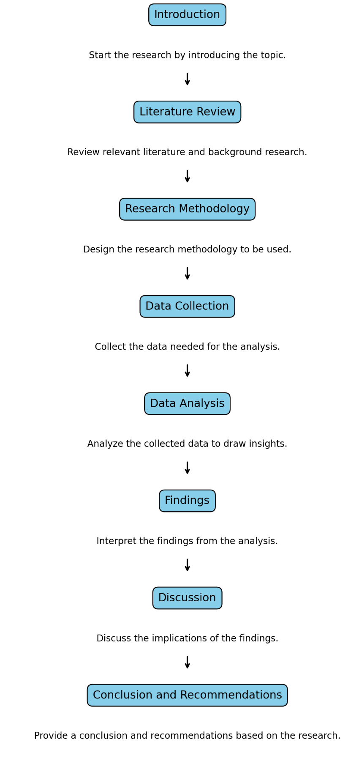
Figure 1 Outline of the Dissertation (Created by Researcher)

Chapter 1 introduces the dissertation on the integration of digital marketing strategies with CRM in the entertainment industry, focusing on Netflix. It states the problem, objectives, and questions that the research will seek to answer and justifies the study by identifying the critical research gap it addresses.
Chapter 2 critically reviews the related literature on the subject of digital marketing and CRM. It encapsulates key theories, models, and empirical studies to establish the state of knowledge by identifying themes, trends, and gaps related to the subject from the perspective of the entertainment sector. A conceptual framework that would guide the study will be presented.
Chapter 3 describes the research methodology by justifying the case study approach that focuses on Netflix. This chapter dwells on the design of research, methods of collection of data, a strategy of sampling, and the analytical techniques that are being used to test the hypotheses and find answers to the research questions.
Chapter 4 describes the primary and secondary sources of data collection, informs where the data is sourced, and then proceeds to describe challenges. It emphasizes the need to ensure data is not only accurate but also intact for use as empirical evidence toward answering the research question.
Chapter 5, describes the process of data analysis, and the interpretation of the findings about research questions and hypotheses. Besides, empirical findings are related to a theoretical framework by outlining patterns and interrelations, that are necessary for a deeper understanding of the impact of digital marketing on CRM.
Chapter 6, discusses the findings of the research in light of the existing literature, highlighting how it confirms or contests the prevailing theories. It studies the implications that emerge both for academic knowledge as well as for the practice of entertainment, and pinpoints limitations, and avenues for further research.
Chapter 7 wraps up the dissertation by summarizing the key findings and their implications. Recommendations for a perfect digital marketing and CRM strategy were provided, particularly for Netflix, and suggestions were offered regarding future research on the ever-evolving relationship between the digital marketing and CRM industries.
This structure also provides a logical flow of each chapter from the previous one, thereby making sure of a comprehensive incisive analysis of the research topic. One is guaranteed to have a strong understanding of how effective digital marketing strategies are in CRM, especially in Netflix's case and the entertainment industry at large, through analysis and critical reflection driven by the dissertation.

1.8 Chapter Review
This chapter has set the stage for research by focusing on the relationship between digital marketing and CRM, using the case study of Netflix. It formally introduces the context for which this study was undertaken, the rationale, research questions, objectives, and hypotheses that are raised by gaps in the literature, particularly within the entertainment industry. The link between digital marketing and CRM has been said to be somewhat ambiguous, and there is a need to define the link. The subsequent chapters will represent an extension of the literature review, followed by the analysis of theories and models, then a description of the methodology of the research conducted, and finally the conclusion with the key findings, their relevance, and suggestions for future research.

Chapter 2

Literature Review

2.1 Overview
This dissertation also conducted a literature review to provide the background knowledge for the analysis of digital marketing and customer relationship management (CRM), especially at Netflix. It incorporates and develops knowledge from previous research, determines the deficiencies, and forms a theoretical framework for research. Electronic marketing methods, big data and its usage, information technology, and the CRM area are discussed in the review and based on the analysis of scholarly articles and industry reports. As industries continue to increase their spending on digital marketing the global ad spending in digital marketing alone reached 455.3 billion U.S. Dollars in 2023 (Statista, 2023). Netflix for instance, set aside around $2 billion for digital advertising, in the year 2023. A literature review is presented systematically with a view of presenting theoretical frameworks, definitions of concepts, empirical studies, and critical analysis of research objectives, as well as gaps and conceptual frameworks for this research.

2.2 Definitions and Key Concepts

2.2.1 Digital Marketing
Chaffey and Ellis-Chadwick (2019) have defined digital marketing as "the use of the internet and other digital technologies alongside conventional media to accomplish marketing goals." This definition has emphasized the amalgamation of digital and traditional methods of marketing. It shows that with the growth of the internet and the development of technology, marketing strategies also change day by day (Chaffey and Ellis-Chadwick, 2019).
Critical review: The definition by Chaffey and Ellis-Chadwick is broad, covering the concept of the application of digital and traditional methods. However, it does not underline the personalized aspect that has become one of the salient features of new digital marketing for companies such as Netflix, wherein data-driven methods are at the heart of their strategy. It could be more specific, identifying the growth of consumer data and algorithms as central in targeting individual consumers would make it even more compliant with your research objectives, which revolve around personalization and interaction with consumers.
2.2.2 Customer Relationship Management (CRM)
Customer Relationship Management is a "strategic approach directed toward the creation of higher shareholder value by the most efficient management of customer relationships and segments," says Buttle and Maklan, 2019. In this definition lies CRM's main purpose is business success to the heights of customer loyalty and satisfaction (Buttle & Maklan, 2019).
Critical Review: Although the definition defines CRM as a strategic tool for long-run success, it misses the fact that, with modern technology-high in real-time data, automation, and predictive analytics-CRM has changed. For companies like Netflix, CRM is not just relationship management but a technology-driven process. The study could have criticized Buttle and Maklan's definition by stating that such a definition does not cover this new technological change in CRM (Davenport & Dyché, 2013; Wedel & Kannan, 2016; Maddodi & K. K., 2019).
2.2.3 Big Data en Mercadeo Digital y CRM
According to Davenport and Dyché, big data is "large, complex datasets generated by companies that can in turn be analyzed computationally to reveal patterns, trends, and associations-especially about human behavior and interactions." From the perspective of CRM, big data helps companies like Netflix create very personalized user experiences and predict consumer preferences with uncanny accuracy (Davenport and Dyché, 2013).
Critical Review of Definition: The definition given by Davenport and Dyché suitably steals the role in the determination of big data in trends and patterns; however, it lacks addressing the implication of big data on ethical considerations such as privacy. The use of people's data at Netflix raised some questions concerning algorithmic transparency and possible biases (Barwal et al., 2023). This critical review needs to consider these ethical dimensions and weigh the high relevance of personalization and data privacy against your research objectives (Siegel, 2013 & Yu, 2023).

2.3 Critical Review of Definitions about Research Objectives

Objective 1: Understand Netflix's Digital Marketing Strategies
According to Chaffey and Ellis-Chadwick, digital marketing is the application of digital techniques and conventional methods to meet marketing objectives. This view seems quite broad, but it does not give full coverage of how Netflix has used very data-driven and personalized approaches in its strategies. What makes Netflix different from other forms of digital marketing is that its marketing applies consumer behavior data with predictive analytics to enable personalized content suggestions and advertisements for each user (Maddodi & K. K., 2019 & Barwal et al., 2023).
Netflix uses machine learning algorithms in the improvement of recommendations on content, which the conventional definition of digital marketing does not cover. This personalized marketing strategy by Netflix helps to keep viewers engaged with the programs, allowing them to watch longer and therefore reduce churn (Wedel & Kannan, 2016). A critical analysis should thus focus on this gap that the definition identifies: it fails to show how the personalization of data through advanced algorithms drives the Netflix business.
Apart from that, digital marketing by Netflix consists of data-driven targeted e-mails, social media, and in-app communications. A broader definition of digital marketing might be at fault in the regard that it does not consider real-time or personalized delivery of content fairly central to all the engagement methodologies at Netflix. For this paper, an explanation of how these methodologies function is imperative to assess Netflix's digital marketing (Chaffey and Ellis-Chadwick, 2019).

Objective 2: The Role of CRM in Customer Retention
In 2019, Buttle and Maklan defined CRM as the generation of shareholder value through strategic customer management. Although this indeed aligns with Netflix's aim of retaining its customers, the definition has not captured how real-time data analytics and automation tools used by Netflix reshape CRM strategies (Buttle & Maklan, 2019).
The Netflix CRM strategy is highly dependent on customer data and predictive analytics, which empower the brand with a personalized user experience, predict content preferences, and, eventually, retain customers. A more apt definition in this regard would be that it should include how Netflix uses machine learning to predict the likelihood of a customer churn and thus always tries to keep this at bay by recommending things to him based on his previous choices of viewing. Hence, it might be argued to incorporate data analytics as an important tool for CRM in digital platforms like Netflix (Yu, 2023).
Moreover, Netflix follows the customer-centric model whereby the feedback loops of the users inform the content creation within their system. Again, this joins with its CRM system. To be specific, tracking viewed preferences, suggesting new content, and adjusting recommendations by the real-time viewing pattern makes Netflix's CRM much more dynamic than what is represented in traditional definitions. As far as this research objective goes, there needs to be a deeper dive into Netflix's advanced CRM strategies for a deeper look at its customer retention tactics.

Objective 3: Big Data Influence on CRM Performance
Davenport and Dyché's definition of big data revolves around big data as used to unearth patterns and trends in human behaviour, which is cardinal for companies like Netflix relying on big data for recommendations of the best programs one should watch. Although cognizing the power of data, this definition does not fully capture how big data impacts CRM performance, the main focus of this research objective (Davenport and Dyché, 2013).
Netflix uses big data not only to analyze consumer behaviour but also in the active building of the user experience. Analytics enable Netflix to know in advance what kind of content would best suit individual users' tastes and preferences (Davenport & Dyché, 2013). It further reduces churn by increasing customer satisfaction. For this reason, such an application of big data goes beyond the meaning typically attributed to this term in the definition provided (Wedel & Kannan, 2016).
This research should finally identify how big data used by Netflix influences its competitive advantage. Such ability to analyze a huge volume of user data enables Netflix to provide such kind of customized services that most competitors simply cannot offer, and it ultimately creates much more customer loyalty. The definition of big data should be expanded by an explanation of how big data gives companies like Netflix a major competitive advantage in the digital streaming market.

2.4 Research Objectives Critical Review and Analysis
Each of these research objectives is linked to specific hypotheses, theoretical models, and broader themes that are at the heart of understanding Netflix's competitive advantage in the digital streaming industry.
Objective 1: Establish the Current Digital Marketing Strategies that Netflix Uses to Retain its Customer Base The digital marketing strategy at Netflix forms the core of customer retention; it is highly interpersonal in content recommendations, targeted marketing, and the use of predictive algorithms. This befits the assessment of the efficacy in customer engagement to ensure their loyalty in the long term.
Connection to Hypotheses: The above objective connects itself with the hypothesis that personal digital marketing strategies undertaken by Netflix drive positive effects on customer retention. By comparing in-depth digital marketing methodologies associated with personal email campaigns and data-driven content recommendations, this objective tests Netflix's singular approach to driving lower churn.
Connection to Theoretical Models: This objective relates to the RACE Model-Reach, Act, Convert, Engage-that describes how digital marketing is conducted along with customer interaction. The RACE model will be used to evaluate how Netflix's marketing strategies take customers from awareness to engagement and, finally, retention. Specifically, Netflix's capability to "Engage" customers through personalized content supports customer loyalty, core to this research (Chaffey & Ellis-Chadwick, 2019; Chaffey, 2020).

Objective 2: To Assess How Data Analytics Have Impacted Netflix's Digital Customer Relationship Management Practices
Big data in CRM plays an important role, especially in Netflix, where the use of data analytics helps to personalize user experiences and predict customer behaviour for better churn management. The intent here is to explore how Netflix uses the available data for customer relationship management and sends personalized content to users with the motive of retaining them in front of their screens for longer periods (Davenport and Dyché, 2013 &Yu, 2023).
Connection to Hypotheses: This objective is directly related to the hypothesis that big data analytics enhance CRM practices at Netflix. That is, in this research, one will be testing if data-driven CRM practices result in increased customer satisfaction and lower churn with content delivery that is more personalized (Barwal et al., 2023).
Theoretical Models Connection: This objective is seriously linked with a Customer Lifetime Value Model that should be applied to determine how much value one customer will bring to a company in the long run (Wedel & Kannan, 2016). Using CLV, Netflix would be able to identify the most valuable customers and implement some sort of differential marketing strategy for retaining them. This model will contribute to the generation of a piece of evidence if the Netflix data-driven CRM was doing the work of increasing customer lifetime value by offering personalized experiences.
Moreover, TAM can be applied here as it focuses on how easily customers accept and use the technology offered by Netflix. TAM explains how Netflix's ease of use and personalized recommendations contribute to better customer experiences and satisfaction. This model would help support the analysis of how Netflix integrates technology usage with CRM efforts.

Objective 3: To assess how targeted digital marketing initiatives drive churn prevention and subscriber acquisition.
This objective is based on Netflix using targeted marketing to reduce churning and increase the number of new subscribers. About this, Netflix has carried out personalization recommendations, dynamic pricing, and personalized content offerings to help attract and retain customers in the competitive market (Barwal et al., 2023).
Connection to Hypotheses: This relates to the hypothesis that focused marketing efforts decrease churning while increasing subscriber acquisition. It would be of interest for the research to establish whether Netflix, (Chaffey, 2020) by its ability to personalize marketing messages using user data, brings about a measurable impact on customer churn and new subscription rates.
Connection to Theoretical Models: Again, here the RACE Model becomes relevant, particularly at the "Convert" and "Engage" stages where Netflix has converted prospective customers into subscribers and retains these subscribers through continuous engagement. This model will be used in carrying out an effective analysis of Netflix's marketing effort at both gaining and retaining customers (González, Membiela-Pollán, & Cuns, 2020).
Moreover, this research will apply the Social Exchange Theory, as it illustrates a symmetrical relationship between customers and Netflix. The theory primarily alludes to the probability of the customer retaining the subscription with Netflix in instances when they feel that what they get in return for a subscription- either through personalized content or an affordable subscription rate- outweighs the cost involved. It will also help in further identifying whether the summed effect of targeted marketing by Netflix is effective enough to communicate value to its users. Targeted marketing is part of Netflix's core growth strategy, whereby it delivers different sets of content and promotions to various customer segments.

2.5 Gaps within the Literature on Digital Marketing and CRM
Before analyzing the models, it becomes paramount to establish some of the most critical areas that the literature has not covered and that this study attempts to fill. Despite numerous studies carried out on digital marketing and CRM, several aspects have not been addressed yet, especially on how these two disciplines are integrated into each other in cases involving streaming services such as Netflix.
- Less attention has been given to how digital marketing affects the long-term factor of loyalty, especially in entertainment.
- Ethics of Big Data: Issues surrounding the breaching of privacy and unfair biases are growing when it comes to CRM, where companies like Netflix are increasingly using such personalized data (Davenport & Dyché, 2013 & Siegel, 2013)
- Cultural and Demographic Differences: There is limited consideration as to differences in CRM strategies across cultural and demographic segments, where implementation through global platforms such as Netflix exists (Wedel & Kannan, 2016 &Yu, 2023).
The following research will attempt to fill these very specific gaps by focusing on Netflix's long-term CRM outcomes, the ethics of big data usage, and possible variabilities in the effectiveness of CRM practices across different regions.

2.6 Models and Frameworks

2.6.1 Customer Lifetime Value (CLV) Model
The CLV model is the measure of value a customer will generate for business during a lifetime. Netflix uses this model to determine who its high-value customers are and on whom the marketing should be focused to retain them. This model will predict the long-term values that come in based on data such as customer view, subscription duration, and engagement metrics (Wedel & Kannan, 2016 & Siegel, 2013)
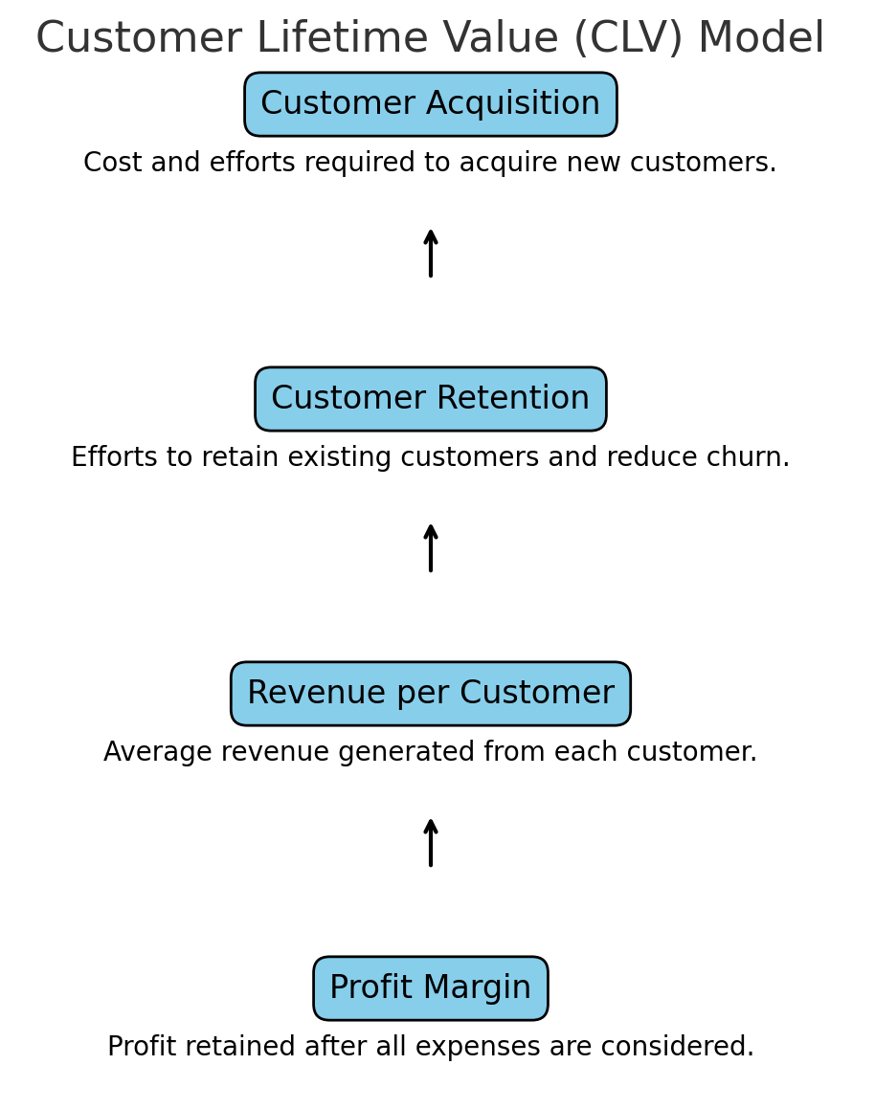
Figure 2 CLV Model (Created by Researcher)

Advantages
- Resource Allocation: It enables Netflix to focus marketing resources and efforts on these high-value customers who have a greater likelihood of optimizing retention while minimizing churn.
- Predictive Power: Data-driven insight makes it easier for the CLV model to forecast customer behaviour through proactive engagement strategies (Wedel & Kannan, 2016).
- Long-Term Orientation: It shifts the firm's orientation toward a long-term relationship with its customers rather than short-term gains (Yu, 2023).
Disadvantages
- Data Dependence: Most of the time, the model is responsive because it relies heavily on the exactness of data which, for quite specific reasons, can be biased due to errors in data collection or biased algorithms.
- Cost of Acquisition vs. Retention: Sometimes, the assumption with CLV models is that retention is always better than acquisition, which needs not be true in every case, and still more so if considering the aggressive nature of competition within the streaming industry (Siegel, 2013).
- Lack of Ethical Consideration: It does not have an inherent mechanism to take care of the ethical issues of privacy associated with customer data used by a predictive model (Davenport & Dyché, 2013).
This model will be useful to understand how Netflix will shift more importance to retaining customers. Predicting the customer's lifetime value directly relates to Objective 2, as that deals with how analytics influences CRM strategies. By doing this, one will be able to derive if the focused resources toward high-CLV customers at Netflix enable superior CRM outcomes and impede churn, as hypothesized in H2.
2.5.2 Technology Acceptance Model (TAM)
The Technology Acceptance Model, TAM, describes how users come to accept and use technology based on two leading factors: perceived ease of use and perceived usefulness. Netflix applies its user interface through TAM, while such personalization of content, in turn, has shown to what degree customers have been satisfied with the platform and their disposition to continue using it.

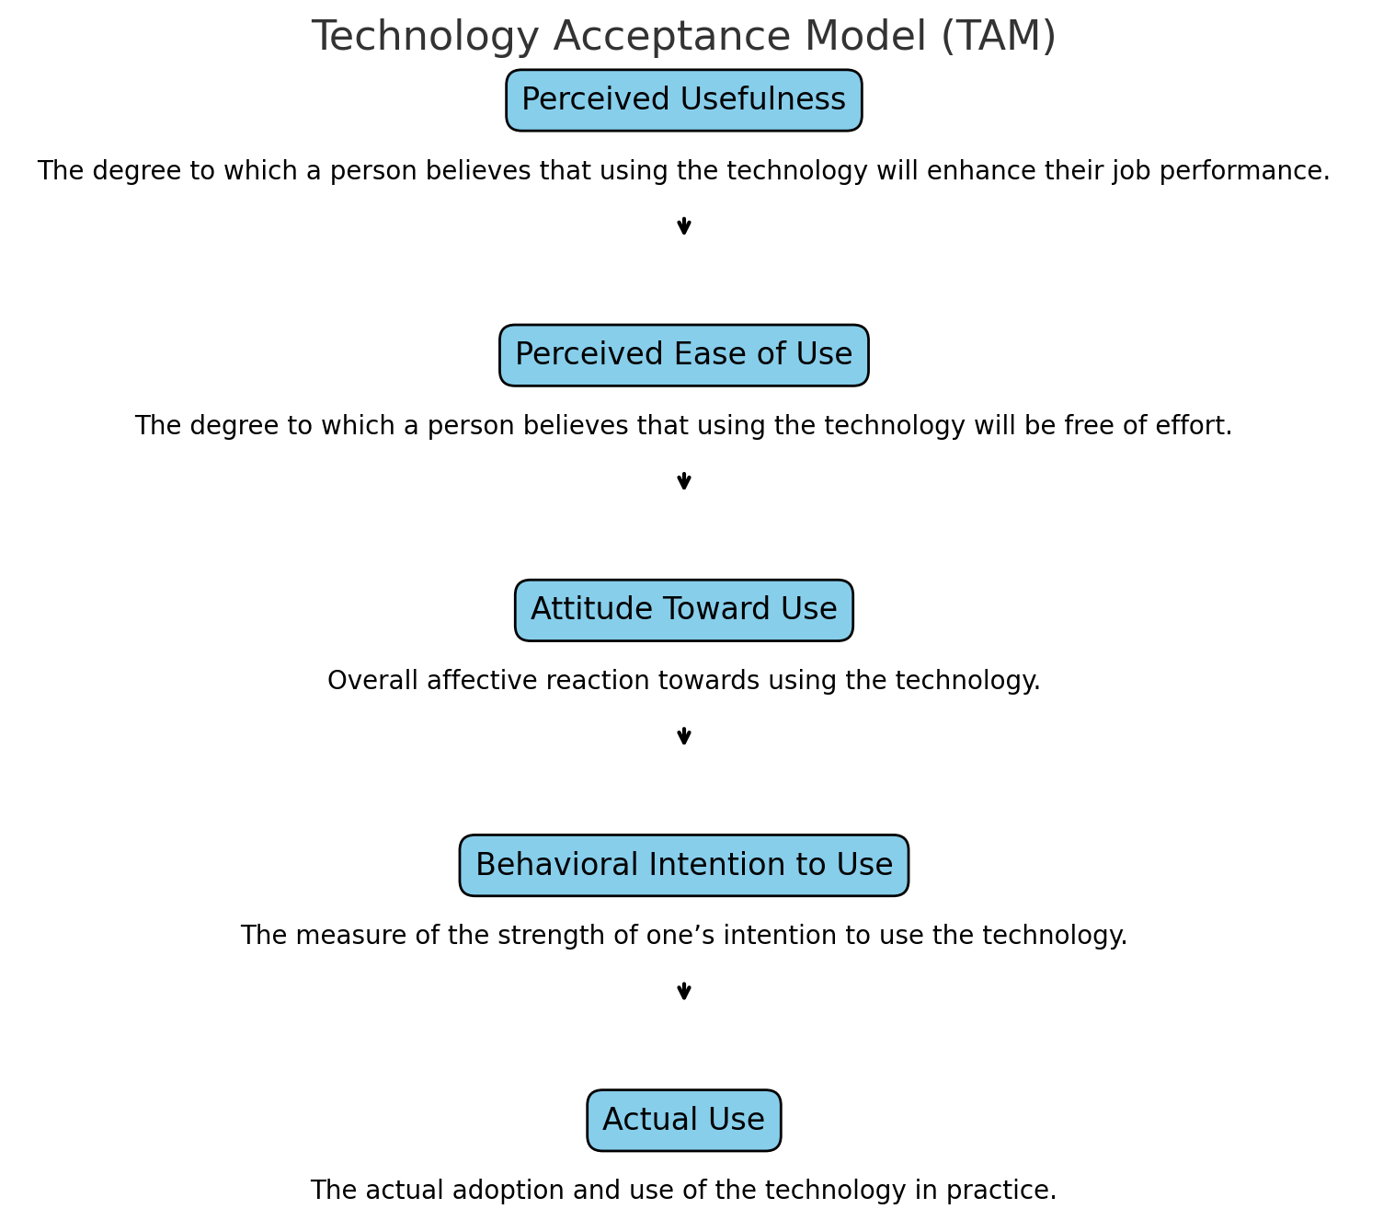
Figure 3 TAM Model (Created by Researcher)

Advantages
- Customer-centric because the model is sensitive to customer experience core tenet at Netflix, where the satisfaction of the users directly relates to their retention.
- Insightful Results: Scanning and monitoring what features on the website or platform are most useful or easy to use allows Netflix to implement strategic enhancements that should help boost customer interaction.
- Adaptability: TAM can be expanded to review the acceptance of new features, devices, or subscription models (Venkatesh & Bala, 2008).
Disadvantages
- Narrow focus: sociopsychological factors that may affect a customer's decision to subscribe or not to subscribe to Netflix are not considered in TAM (Davis, 1989; Venkatesh & Bala, 2008).
- Over-simplification: the technology adoption is over-simplified into just two key factors: ease of use and usefulness alone, while other possible critical drivers such as customer loyalty, external factors competition, and changing consumer preference are ignored in this model.
- Lack of financial aspect: unlike CLV, TAM does not cover monetary measures; hence, its usefulness in CRM is also limited (Venkatesh & Bala, 2008).
TAM is an informative framework that illustrates how Netflix customers interact with its technologies by showing how ease of use impacts customer retention. The method proposed in this paper will, therefore, directly contribute to Objective 3, which looks at how technology-driven personalization influences user engagement in churn prevention as suggested by H3.
2.6.3 RACE Model - Reach, Act, Convert, Engage
The RACE Model is the digital marketing framework that concentrates on four different stages in which a customer interacts with the business through Reach, Act, Convert, and Engage. Netflix follows the RACE model in organizing its digital marketing efforts toward the acquisition of new subscribers to longtime subscribers by offering personalized content and offers (Chaffey, 2020).
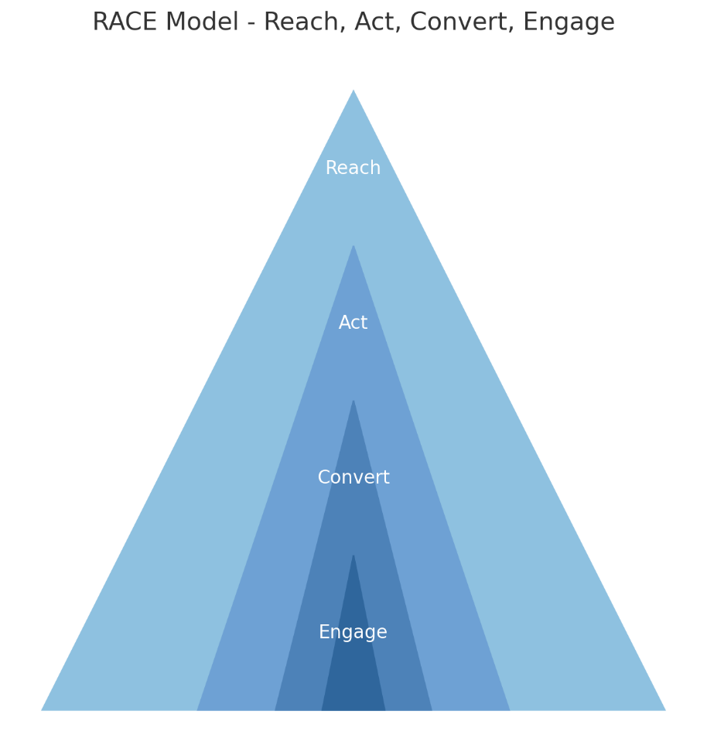
Figure 4 Race Model (Created by Researcher)

Advantages
- Holistic: Since it looks at the customer journey in its entirety, therefore it can help fit digital marketing strategies with customer engagement and retention (Chaffey & Ellis-Chadwick, 2019).
- Actionable: Tied directly to the model of conversion and engagement will be CRM performance indicators of customer satisfaction and retention.
- Data-driven: The model will allow Netflix to use customer data at every step of the journey, from acquisition down to engagement (Chaffey, 2020).
Disadvantages
- Resource-Intensive: Carrying out personalized marketing in all the stages of the RACE model can be quite resource-intensive and may not be feasible for smaller companies.
- Oversupplies on Digital: It assumes that the digital channels provide the main touchpoints, and this may lead to the failure to consider other customer contact points, such as word-of-mouth or brand loyalty.
- Over-targeting: Evidently, enhanced activity can quickly result in customer fatigue, particularly when users feel over-targeted either by personalized content or direct promotional emails (Chaffey, 2020).
RACE models are very relevant to understanding the digital marketing strategies that Netflix uses in achieving Objective 1, in that they address how Netflix has retained its clientele base through specified market strategies. By applying the RACE stages to Netflix, research can focus on H1: More personalization in digital marketing leads to better retention.

2.7 Comparative Analysis

2.7.1 Comparative Analysis of Digital Marketing Models: RACE Model vs. Technology Acceptance Model (TAM)
Aspect | RACE Model | Technology Acceptance Model (TAM)
Focus | Digital marketing strategy and customer journey | Technology adoption by users
Stages | Reach, Act, Convert, Engage | Perceived usefulness, Perceived ease of use, User acceptance, Technology usage
Objective | Drives customer engagement and retention through marketing efforts | Explains how users adopt and use new technology
Advantages | A comprehensive view of the customer journey; guides marketers through acquisition to retention. | Simple and user-centric; explains technology adoption and usage
Disadvantages | Resource-intensive; may lead to over-targeting | Simplistic; ignores other factors influencing technology adoption
Similarities | Both models focus on increasing engagement, with one through marketing and the other through usability. | Both aim to enhance user engagement and retention by influencing user behaviour.
Differences | The RACE model focuses on marketing across the customer journey; TAM focuses on the user’s interaction with technology. | The RACE model is digital marketing-oriented, while TAM is technology acceptance-oriented
Use in Netflix | Used by Netflix to map customer engagement, retention, and conversion | Used to improve user satisfaction by ensuring ease of use on the platform
Table 1 RACE Model vs. Technology Acceptance Model (TAM) (Created by Researcher)

Similarities: Besides, the RACE model was elaborated and TAM was designed to impress and optimize user engagement but from different angles. The RACE model focuses on the customer journey across marketing touchpoints, whereas TAM refers to how users perceive and interact with technology (Chaffey, 2020; Davis, 1989).
Differences: The main differences would come in their usage: RACE is an all-encompassing digital marketing model that guides companies through the process of customer acquisition and retention. Whereas TAM is more technology adoption-centered, hence more toward the user's interaction with platforms such as Netflix (Chaffey & Ellis-Chadwick, 2019; Venkatesh & Bala, 2008). TAM talks only about the behavior of users about the technology whereas the RACE model gives a bigger strategic look toward the marketing process.
Advantages/Disadvantages:
- The RACE model provides a structured way to manage the customer's journey from awareness through to loyalty but is very resource-heavy and carries the risk of over-targeting (Chaffey, 2020).
- TAM, though useful for understanding technology acceptance, maybe too single-track to be effective on complex multi-faceted platforms like Netflix, whose basis of engagement for users rests on a raft of different elements (Davis, 1989).
Each of the models offers something slightly beneficial about the strategies of Netflix. RACE applies directly to the firm's digital marketing, while TAM helped in assessing how Netflix's user experience would help drive customer interaction. Each model adds something different to the overall strategy by offering a view that is complementary to each other on how Netflix manages customer interaction and satisfaction.

2.7.2 Comparative Analysis of CRM Models, Customer Lifetime Value (CLV) Model vs. Relationship Marketing Theory
Aspect | Customer Lifetime Value (CLV) Model | Relationship Marketing Theory
Focus | Maximizing the long-term value of customers | Building long-term, personalized customer relationships
Goal | Retain high-value customers and optimize profitability | Develop customer loyalty and trust through relationship-building
Advantages | Data-driven helps identify and retain high-value customers | Encourages personalized attention and long-term customer retention
Disadvantages | Heavily reliant on accurate data; overlooks customer emotional factors | Difficult to measure customer loyalty; subjective and lacks quantifiable metrics
Similarities | Both focus on long-term customer retention and value | Both aim to enhance customer loyalty and reduce churn
Differences | CLV focuses on financial metrics and profitability, while Relationship Marketing Theory emphasizes emotional bonds and trust | CLV is data-driven and quantifiable, while Relationship Marketing is more subjective
Use in Netflix | Used by Netflix to prioritize resources on high-value customers | Netflix applies personalized content recommendations to build customer trust and loyalty
Table 2 Customer Lifetime Value (CLV) Model vs. Relationship Marketing Theory (Created by Researcher)

Similarities: include the fact that both models would seem to focus on long-term customer retention by reducing churn. The CLV model places a financial measurement on customer relationships while Relationship Marketing Theory centres around the building of trust and loyalty over time (Payne & Frow, 2013 & Siegel, 2013).
Differences: The first is that the approach is completely different. CLV is more information analytics and profitability-centered, thus allowing Netflix to identify and invest in customers with high value. Relationship Marketing Theory, on the other hand, is very qualitative, emotional, and satisfying. While CLV relies on tangible financial data, Relationship Marketing requires softer skills and insight to build up trust and loyalty (Morgan & Hunt, 1994).

Advantages and Disadvantages:
- The CLV model can consider which customers to cultivate, supported by data, while it lacks consideration of emotional factors that are very strong in customer loyalty (Davenport and Dyché, 2013).
- Relationship Marketing Theory can produce an especially powerful bond with one's customers, it may be somewhat more difficult to measure and track over time, relying on subjective measures such as trust, which makes metrics of success hard to quantify or compare across different customer segments (Morgan & Hunt, 1994).
Both models are irreplaceable to Netflix's CRM strategy. The CLV model provides decision-making on resource allocations financially within Netflix, whereas Relationship Marketing Theory works toward fostering customers and building relationships based on trust. If combined, Netflix will be able to ensure the retention of high-value customers and foster loyalty and satisfaction across the user base.

2.7.3 Integration of Models with Research Objectives and Hypotheses
These models have established a sound theoretical framework for investigating Netflix's CRM and digital marketing strategies through comparison and analysis. Each of these models offers a unique perspective from which the business approach towards customer retention and engagement can be reviewed. CLV supports the analysis of long-term customer value relevant to Objective 2 and H2. The TAM model helps review the user experience and technology adoption link to Objective 3 and H3. Finally, the RACE model provides a structured approach toward Netflix's digital marketing-straightforward relevance to Objective 1 and H1.

2.4 Review of Empirical Studies
As a consequence, the empirical review of studies presented in this section offers a systematic analysis of how digital marketing strategies impact customer relationship management (CRM) performance concerning customer engagement, retention, or CRM data analytics. Based on empirical literature a discussion is carried out mainly from the entertainment industry perspective but a comparative analysis of other industries is also made whenever possible.

2.4.1 Digital Marketing Strategies and CRM
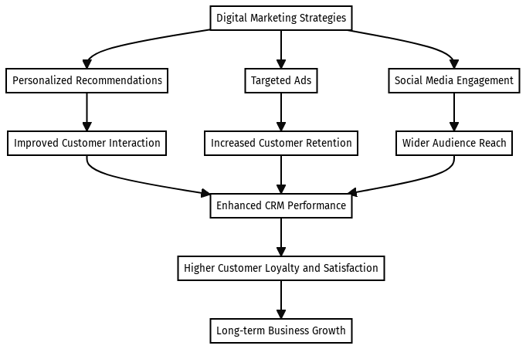
Figure 5 Digital Marketing Strategies and CRM (Created by Researcher)

Customer engagement is an essential effect of the digital marketing campaign, especially with entertainment brands such as Netflix that largely rely on repeated user interaction. The literature review proved that the use of effective methods of digital marketing with customer engagement is much higher than with personalized marketing. For instance, a study conducted by Kumar et al. showed that email customization increased click-through rates by 41 per cent besides enhancing engagement measures on the various channels by 28 per cent (Kumar, 2009). In the context of Netflix, such personalized approaches –for example, recommendations– have been proven to cause an increase in viewing time by 20%.
Customer retention is also another important factor that is supported through technology in their various marketing strategies, especially for online services such as Netflix subscriptions. According to the study conducted by Lemon and Verhoef, digital marketing strategies that employ customer data have the advantage of enhancing customer retention rates by about 15-20% (Lemon & Verhoef, 2009).

2.4.2 Role of Data Analytics in CRM

2.4.2.1 Data-Driven Marketing Strategies
Today, the use of data as a major tool in CRM strategies has taken a central stage in providing companies with valuable information regarding their customers. The study by Wedel and Kannan (2016) showed that companies that use data-driven marketing increase the effectiveness of their campaigns by 30 % specifically in the areas of personalization and communication (Wedel & Kannan, 2016). In the case of Netflix, data is crucial as it helps the company to make the best decisions for content delivery and actual marketing with the end goal of targeting the individual client.

2.4.2.2 Predictive Analytics and Customer Behavior
The use of predictive analytics is one of the strengths of CRM as it helps the companies to forecast the customer’s needs and actions. According to empirical studies done by Siegel, the use of predictive analytics could improve customer retention by a margin of 10-15 per cent provided that at-risk customers can be easily identified together with their needs addressed in advance as suggested by (Siegel, 2013). In the entertainment industry, Netflix applies predictive models to anticipate clients’ preferences and tendencies which will be useful in content development and promotion.

2.4.2.3 Big Data and Personalization
Big data concepts in CRM have therefore significantly changed the way firms approach the marketing function. Davenport and Dyché (2013) found out in their study on the impact of big data for personalization, companies who manage to implement effective big data applications for personalization enjoy an incremental benefit of 5-8% on the top line or overall revenues and approximately 10% saving on costs through precise targeting. Netflix again is the best example to highlight it, Netflix uses this big data and the pool of viewer data to provide users with the best of their experiences (Davenport and Dyché, 2013).

2.4.3 Targeted Marketing and Its Effects on Churn and Acquisition

2.4.3.1 Case Studies from the Entertainment Industry
The published case studies from the entertainment industry are particularly useful for investigating the forms of targeted marketing affecting churn and customer acquisition. Identified that Hulu's effective targeted marketing strategies in the form of personalized content recommendations and targeted email campaigns have effectively reduced the churn rate by 18% and the new subscription rate by 12%. Likewise, Netflix has utilized the concepts of targeting its subscribers by suggesting only the types of shows they like to watch and offering other attractive and inexpensive subscription offerings, which have helped the business retain low churn rates and grow its subscriber base.

2.7 Summary of Literature Review
A comprehensive literature review has been made for theories and models referring to digital marketing and CRM. It includes a case study based on Netflix, discussing the history of the models applied with CLV, TAM, and RACE to present how digital marketing affects the relationship with the customer. A gap observed in jurisdictional differences and the long term is noticed with successful targeted approaches to promote customer loyalty. Again, this raises some ethical considerations about data privacy as well as algorithmic biases; therefore, it provides a conceptual framework through which to analyze Netflix's digital marketing and CRM strategies.

Chapter 3

Research Methodology

3.1 Introduction
The structures of methodology in researching the digital marketing strategies of Netflix and their impacts on CRM. It contains the research philosophy, approach, strategy, methods of sampling, data collection, and analysis of data. The structured methodology would, therefore, ensure valid and reliable results to add to the existing pool of understanding regarding how Netflix marketing and CRM efforts drive customer retention and engagement.
The Onion of Research
The Research Onion by Saunders et al. is a structured framework used when designing methodology for research purposes. It consists of several layers of research philosophy, approach, strategies, choices, time horizons, and data collection and analysis techniques. Therefore, this chapter follows the Research Onion framework to ensure systematic research while investigating Netflix's digital marketing strategy and CRM practices (Saunders et al, 2009).
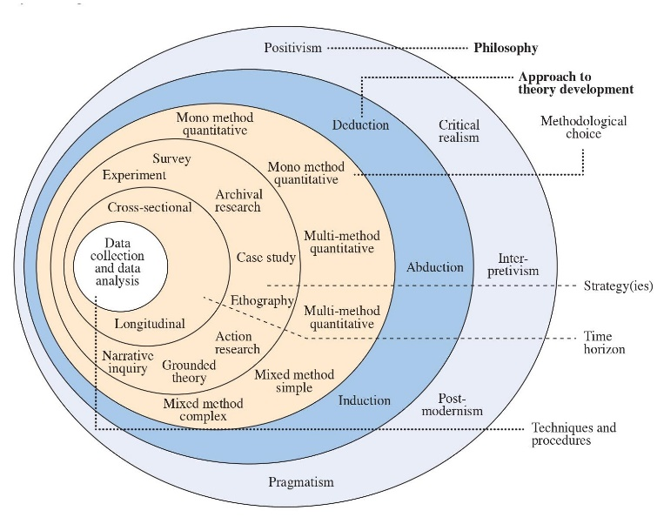

Figure 6 Saunders Onion Model for Research Methodology (Saunders et al, 2009).

3.2 Research Philosophy
The section describes the positivism philosophy adopted for the research. According to positivism, it is assumed that reality is something that actually can be measured and conceptualized objectively by using scientific methods. In the context of this study, where hypothesis testing is applied through measurable data collection, positivism can be justified as the underlying aim here pertains to the call for objective generalizable results. The research will be aimed at observing and quantifying how the strategies of Netflix would affect CRM based on data collection through surveying and secondary data analysis.
Justification: This study takes the positivist approach in testing the hypothesis using quantifiable data, whereby objective results would be ensured. Focusing on measurable outcomes like customer retention and engagement in establishing cause-effect relationships between Netflix's digital marketing and the performance of CRM, the use of surveys, and statistical analysis strengthen the rigour and reliability by allowing generalizability in the findings.

3.3 Research Design (Quantitative)
The research design applied in this study is deductive; it, therefore, starts with theoretical models, which are the Customer Lifetime Value Model and Technology Acceptance Model, and then tests these two models through the use of data collected from Netflix users. The research is thus conducted to be based on the collection of data and its analysis, guided by hypotheses that have been directly retrieved from available literature and models.
Justification: A deductive design would be suitable for this study because it explores existing models, like CLV and TAM, in an attempt to analyze Netflix's digital marketing and CRM strategies. The hypotheses will be tested clearly, and empirically valid findings will shape and or confirm the theoretical framework.

3.4 Research Approach
A deductive research approach is chosen because the research begins with established theories and aims at the testing of hypotheses based on theories such as CLV, TAM, and RACE models. Deductive reasoning moves from the general to the specific, from the abstract to the concrete: from theory to observations and data, and hence is suitable for quantitative analysis. Such a design has the particular advantage in studies involving structured and measurable data, as research in this direction allows it to remain focused either on confirming or rejecting the set hypotheses within the context of already available literature.
Justification: Deductive reasoning benefits this study because it tests predefined hypotheses regarding the aspects in which Netflix's strategies impact CRM performance. It will ensure that there is a structured and objective examination of data for clear and measurable results. Since established theories are focused on, this method allows for findings that are not only generalizable but also contribute to enhanced knowledge of how these models operate in a real setting, as would be found in Netflix's engagement strategies with customers.

3.5 Research Strategy
The strategy of research applied is the survey. Surveys are chosen because they allow for efficient data collection from a quantitative perspective in a large population of Netflix users. In the survey, structured questions will be included for measuring the level of customer engagement, retention, and level of satisfaction so that it can be statistically analyzed how Netflix's strategies influence the metrics. The online survey will be forwarded, using facilitation tools such as Google Forms, which allows for wider coverage, convenience in dispersal, and data collection in real-time. This technique will allow the respondents to reply at their comfort, which can result in higher response rates and a more representative sample.
Justification: This is most appropriate as a strategy because it would allow the collection of quantitative data regarding user experiences and behaviour. The use of these broad hypotheses in this research would not be fitting with case studies or experiments.

3.6 Choice: Quantitative Method
The quantitative research design will be used in this study, where the collection and analysis of data will involve numbers to test hypotheses and evaluate the relationship between Netflix's digital marketing strategies and CRM outcomes, such as customer retention, customer engagement, and customer satisfaction. In this regard, data collected through a structured survey will be quantifiable, and its analysis through statistical means will enable objective and measurable conclusions to be drawn.
Advantages of Quantitative Research
- Objectivity: Measurable results to guarantee that the concluded outcome is stable regarding the interaction of the variables (Field, 2024).
- Generalization: The outcome can be applied to larger populations, and therefore, the conclusion made is valid beyond the population under research.
- Statistical Analysis: It allows for the usage of complicated statistical techniques as an effort to try to test the hypothesis to detect the trends (Bryman, 2016).
Disadvantages of Quantitative Research
- Limited Depth: It does not allow the nuance and context that is available in a qualitative dataset. Provides only surface-level information (Bryman, 2016).
- Response Bias: Self-report data may be incorrect or socially desirable.
- Rigidity: Once a survey is dispersed, it is very hard to change or even investigate new trends (Field, 2024).
- Cultural Limitations: It fails to notice cultural and personal factors that would influence the behaviour of respondents in a couple of aspects (Bryman, 2016).

3.7 Sampling Strategy
The research shall utilize an equal probability sampling technique known as the stratified random sampling method to increase the probability of getting a representative sample from the target population in the different communities about the users’ characteristics and geographic location (Tarmidi, D., & Irgandi, D. H, 2022). The technique enables one to choose participants from sets of given categories for instance age brackets or subscription categories, to guarantee the set sample’s heterogeneity while at the same time guaranteeing the sample’s internal validity.

3.7.1 Sample Size
The sample size for this research will be 100-120 respondents, which is adequate to the satisfaction of the target population. The research results are statistically significant and can be generalized. Meanwhile, in the selected sample size, consideration was put into feasibility, which looked at how best to collect diverse perspectives and experiences.
The sample was obtained with the help of an online questionnaire sent by e-mail and social networks to mostly the users of the Netflix service. These methods can help reach the target audience including a large and diverse sample size from different age groups, gender or geographical location. The specific relevance of the segment was achieved by directly targeting users through specialized sites such as Facebook and Twitter as well as through email invitations sent directly to users that belong to the respective categories.
Employing both email and social media, we made it a point to invite participants who can represent each stratum based on subscription level and geographic location, thus, the sample was less biased and the data gathered were of high quality. This approach was rather efficient and affordable, and the authors were able to reach a great number of Netflix users, which contributed to the versatility of the sample.

3.7.2 Sample Type
The sample type chosen for this study was therefore the stratified random sampling. This technique was used to make a special check that different subgroups in the target population are included. The key strata for this study include:
Age Groups: To further subdivide the sample based on child category, we used a definite classification procedure dividing the respondents into particular age groups like 18-25 years, 26-35 years, 36-50 years, 51 and above, as different spread and preference is expected at these age groups. This division will enable us to analyse how the various age brackets interact with Netflix’s digital marketing and CRM measures.
Geographic Diversity: In the study, the researcher made a point of ensuring that participants were selected from all areas of the country, the developed areas as well as the rural regions. This made it possible for us to assess how location affects the use of Netflix and its services based on factors such as Internet speed, availability of content and regional preferences.
When targeting participants, we used stratified random sampling based on the subjects’ age coupled with their geographical distribution, which again corresponds to the participants’ representing Netflix users. The exploratory research method allowed for capturing how various forms of digital marketing and strategies applied in CRM affect users across diverse backgrounds, which enriches the results and makes them more valid.

3.7.3 Sampling Method
In this study the following sampling technique is used: probability sampling technique; and the specific type of sampling used is stratified random sampling. This method selects subgroups (strata) of the population and then randomly selects from each of the subgroups a sample that is representative of subgroups. Stratified random sampling helps avoid the problem of sample bias because each subpopulation is represented with the correct proportional ratio to the population density level.
Advantages of Stratified Random Sampling:
- Increased Representativeness: This method ensures that every subpopulation of the intended sample is established appropriately to guarantee that the sample obtained corresponds to the overall population (Lohr, 2021).
- Reduced Sampling Bias: It means that while selecting the samples for analysis, it reduces the chances of having a strong inclination towards, or even ignoring certain subgroups.
- Improved Precision: The level of accuracy when applied in population splits to relevant strata is higher than in simple random sampling where the population is heterogeneous (Saunders et al, 2009).
- Ensures Comparability: This method also enables planning of comparison between subgroups whereby the variance between them can be planned to give further understanding of how factors like age or region influence behaviour (Saunders et al, 2009).
Disadvantages of Stratified Random Sampling:
- Complexity: Compared to other procedures in sampling, determining the number of strata and sample size for each can be relatively cumbersome (Lohr, 2021).
- Potential Over-Stratification: However, if many strata are developed, there is a possibility of over-embarking on the development of strata which can lead to inadequate sample size in each stratum.
- Requires Prior Knowledge: In essence, available stratification entails prior information concerning the population to appropriately categorise it into more coherent classes (Bryman, 2016).
Procedures Involved in Stratified Random Sampling:
- Identification of the Target Population and Relevant Strata: Users of the study are classified into relevant subsets (for example, by age, or geographical location) that would be helpful to the goal of the study (Lohr, 2021).
- Determination of the Sample Size for Each Stratum: The number of subjects in each stratum is derived from the total population ratio of the stratum in question (Saunders et al, 2009).
- Random Sampling within Strata: A random sampling technique is then used to pick out the respondents from every one of the aforesaid strata to guarantee that every category is fairly characterized (Bryman, 2016).
- The stratified random sampling also guarantees that sub-groups within demographic and geographical characteristics are included in the study thereby enhancing validity and reliability of the research findings.
Probability A sampling design that falls under this category possesses the feature that each member of the population must have a known, nonzero probability of being selected. This characteristic is typical of probability sampling and is very important for the following reasons:
- Minimization of Bias: Probability sample design minimizes the possibility of bias by giving all individuals in the population an equal chance of being selected.
- Representativeness: The approach increases the likelihood that the sample will reflect the population well, making the findings more generalizable.
- Statistical validity: The fact that probability sampling can be used to apply inferential statistics; hence, through this, the researcher can come up with valid inferences concerning the population.

3.8 Data Collection Methods
The idea of conducting research based on primary data required the creation of a structured online survey that aimed at collecting quantitative data from Netflix users as well as their impressions about Netflix’s digital marketing tactics, as well as the efficiency of CRM implementations. To this end, I specifically designed the survey to reflect the research objectives to identify user behaviour, satisfaction level and loyalty patterns.
Survey Design: The survey consisted of 15 closed questions which addressed key areas that concern client relations and loyalty. Much attention was paid to the choice of these questions as they cover the main issues of users’ behaviour on the website, their perceptions of marketing activities addressed to them, and the use of CRM strategies to build the users’ loyalty to Netflix.
Question Types:
- Multiple-choice questions: Some questions in the survey provided respondents with lists of choices from which they had to choose, which made it easier to classify responses. For instance, questions like “How often do you use Netflix per week?” meant choices like 1-2, 3-5, and 6 or more. This format helped make the data more uniform and made analysis easier and allowed for viewing patterns between various user segments.
- Likert scale questions: Therefore, the Likert scale type of questions was used to measure the respondents’ awareness, choices, and satisfaction level. These questions offered far more subtle ad hoc perceptions of their attitude. For instance, participants were expected to express the extent of their agreement or disagreement with statements generated from surveys such as the degree of their agreement to the statement; ‘Netflix provides personalized recommendations.’ Would you agree or disagree: Strongly Disagree, Disagree, Neutral, Agree, Strongly Agree. It became possible to get more insight into the satisfaction of the users and use it to compare the results that Netflix has after applying its personalization algorithms.
- Yes/No questions: The operationalization of measurement was done in a very simple way the use of Yes/No questions helped in capturing very clear answers on specific behaviours. For instance, questions such as “Have you ever paused or cancelled your Netflix subscription?” were asked to get the details relating to user retention and churn behaviour. These questions assisted in identifying core concerns that impacted the capability of customers to continue patronizing the organization.
- Survey Platform: The survey was produced using Google Forms because of its simplicity, dissemination abilities, and real-time findings. Google Forms made it easier to capture responses from different umbrella groups, with ease of access to collected responses for further processing. From this, it was also possible to share the platform by email and social networks, which allowed us to get a large and diverse sample of Netflix users from different regions.
Sampling Strategy
The survey aimed at Netflix users from different geographical regions and populations separately. The sample mainly targeted users from urban regions with smart screen usage and knowledge of Netflix; many were students, business people and others with interactive technology predispositions. Equal attention was paid to the selection of subjects and distribution of the survey questionnaire across numerous channels to reach people of different ages, genders, and frequencies of consumers.
Time to Complete:
The respondents were afforded about 10-15 minutes to fill out the survey. This timeframe was meant to make sure the survey did not take too long thus boredom setting in among the respondents while at the same time making sure enough data on the use of Netflix was collected.

Aspect | Details
Total Number of Questions | 15 questions covering engagement, satisfaction, and retention.
Survey Question Types | Multiple-choice, Likert scale, and Yes/No questions.
Time Required to Complete Survey | Approximately 10 minutes.
Survey Platform | Google Forms.
Survey Distribution | Distributed via email and social media to Netflix users.
Survey Design | Structured with predefined options for responses and satisfaction ratings.
Data Cleaning Process | Removed incomplete or invalid responses.
Data Analysis Techniques | Descriptive statistics, frequency analysis, correlation, cross-tabulation.
Data Visualization Tools | Microsoft Excel for data visualization (charts, graphs).

Table 3 Data Collection Methods

The choice of data collection techniques used in this study is important to ensure that valid and reliable data responsive to the study's objectives are procured. The first one is based on structured surveys that would help to obtain measurable data about the effects of Netflix’s digital marketing on the CRM results. These surveys are supported by secondary data collection techniques such as database analysis, use of industry reports, and literature review.

3.8.1 Primary Data Collection through Surveys
Surveys are the main data collection instruments of this research because of the efficiency in collecting large quantities of data quantitatively from a diverse public. By design, surveys are pre-formulated so that every respondent is asked the same questions. This continuity is especially notable in quantitative research since the aim is to establish patterns within a large population. Again, the survey format is presented in such a manner that it covers all the required aspects while also remaining relatively brief, thus avoiding the overburdening of the respondents. This approach enhances the response rates and overall validity of the data collected as the respondents will be in a position to answer the questions truthfully since they have gone through a survey that is easy for them to understand. (Bryman, 2016).
Types of Survey Questions, Multiple-Choice Questions:
- Structured format generating easily analyzable data.
- Limits the range of possible responses, simplifying data analysis.
- Reduces complexity and minimizes the potential for ambiguous or irrelevant answers.
Advantages in Quantitative Research:
- Focuses on identifying trends and correlations within the data.
- Enhances reliability by reducing variability in responses compared to open-ended questions.
- Easier for respondents to answer, leading to higher completion rates and more accurate data.
Direct Relation to Research Objectives:
- Each question is clear and directly related to the research objectives.
- Effectively captures necessary data to assess the impact of Netflix’s digital marketing strategies on CRM outcomes (Fowler, 2013).

3.8.2 Survey Distribution Channels (Online, Email)
The survey will be conducted using online links and email since these are likely to reach out to many people with a cross-section of society in the shortest time. Conducting surveys online introduces large geographical coverage and allows the selection of respondents based on their geographical background which is important when it comes to sampling a representative population. Email distribution is however most suitable for personalized messages, best suited for the segments of the population most relevant to the study, namely Netflix users. This flexibility is useful on how to improve response rates and the quality of the data to be collected. Besides, online and email surveys can also be easily automated hence constant monitoring of the response rates is possible and can call for a follow-up in case of a low response rate (Couper, 2017).

3.8.3 Secondary Data Collection
The information from other sources helps support the findings of the survey data and adds to the general understanding. These sources are essential as they put the argument perspective in contexts of the wider digital marketing and CRM contexts making the research more relevant. It also establishes connections between all the sources of information and situates the results of study in the field of existing knowledge and best practices.
Use of Existing Databases and Reports:
- Provides information on market trends, customer demographics, and digital marketing performance.
- Contextualizes primary data by benchmarking Netflix's strategies against competitors.
- Tracks changes and identifies long-term patterns (Saunders et al., 2009).
Literature Review for Contextual Understanding:
- Establishes a theoretical foundation and identifies research gaps.
- Covers key concepts in digital marketing, CRM, and research methodologies.
- Ensures the research is grounded in academic rigour (Ridley, 2012).
Integration of Survey Data:
The research that is presented here takes a direct survey of Netflix users where questions relate to engagement levels concerning the platform's personalized marketing and its impact on customer satisfaction and retention. Such findings are cross-checked with secondary data to present a more holistic analysis.

3.9 Time Horizons
A cross-sectional time horizon, meaning data are captured at a point in time, is adopted in this study. This has the advantage of allowing for a snapshot of current behaviors and attitudes regarding how Netflix users are currently interacting with personalized digital marketing strategies. This is well within the scope of the study, which measures customer engagement, satisfaction, and retention at this moment.
Alternatively, the longitudinal study may prove fruitful in the future when analyzing development over time with new marketing strategies or shifts in content offerings. However, for the scope of this dissertation, a cross-sectional approach will prove to be more viable and administrable within set research objectives.

3.10 Data Analysis
It will be analyzed via Microsoft Excel because it provides a friendly platform and is pretty efficient in dealing with the aspects of handling quantifiable data. The tools introduced for descriptive statistics, correlation, and regression analysis will determine the relationship between the digital marketing strategies of Netflix and customer outcomes. Its data visualization features will represent the findings in clear ways to ensure all represented trends are easy to interpret and support the accuracy and reliability of the analysis.

3.10.1 Ensuring Validity and Reliability in Data Analysis
Validity and reliability are essential in research. Internal validity will be achieved by matching the survey questions with theoretical constructs and conducting a review of the literature to garner all facets of the topic. Reliability is there due to pre-tested surveys with consistent data coding, which will ensure the same results are repeated under similar conditions.

3.11 Ethical Considerations
This kind of study requires appropriate ethical practice especially when the involved persons are users of the emerging popular service known as Netflix. Subjects must not be hurt or disturbed, and whenever possible, they should be assured of issues of informed consent, noting the intention of the study, its benefits or risks. The identity of the participants should remain anonymous and inaccessible to the data in question. Issues such as the misuse of data would become crucial considerations when ethically carrying out these set guidelines during research.
Ethical Issues in Quantitative Research:
- Avoid harm, discomfort, or negative consequences for participants.
- Ensure participation is voluntary and free from coercion.
- Maintain objectivity in data collection and analysis to avoid bias (Resnik, 2015).
Informed Consent in Surveys:
- Participants must be fully informed about the study's objectives and their role.
- Participation must be voluntary with the option to withdraw at any time.
- Ensures participants understand their rights and the purpose of the study (Diener & Crandall, 1978).
Confidentiality and Anonymity:
- Protect participants' privacy by anonymizing and securely storing data.
- Ensure that no individual participant can be identified in published results.
- Critical for maintaining trust and ethical integrity in the study (Singer, 2011).
Addressing Potential Ethical Concerns:
- Mitigate risks like data misuse and ensure transparency.
- Adhere to ethical guidelines with continuous oversight.
- Regular ethical reviews to respect participant rights throughout the study.

3.12 Chapter Summary
This chapter attempts to present the research methodology applied to studying the effect of Netflix's digital marketing on CRM outcomes. A positivist philosophy and deductive approach are adopted in this study to provide a hypothesis-testing process based on models available in the literature, such as CLV and TAM. The quantitative survey strategy collected data from the users of Netflix about their engagement, retention, and satisfaction. Stratified random sampling was used to ensure that the sample is representative and the data analysis was done by using Excel for descriptive and inferential statistics. This method ensures that the results will be objective, reliable, and valid.

Chapter 4

Findings, Results, Analysis, and Discussion

4.1 Introduction

Chapter 4 Introduction sets up the discussion on how, in reality, targeted Netflix's digital marketing strategies affect the subscribers' loyalty and engagement. Drawing together several theoretical perspectives developed within the literature review, this book applies them in real settings through an analysis of a sample of 112 participants' responses, demonstrating the real-world implications of Netflix's personalized marketing for customer retention and satisfaction. It gives empirical evidence, collected diligently for the right test of our hypotheses and, in effect, deconstructs the very successful marketing strategies of Netflix to improve its CRM results. The focused analysis establishes that the results will be appropriate and highly insightful to depict clearly how strategic marketing endeavours help sustain Netflix's competitive advantage in the streaming industry.

4.2 Data Collection Methodology

4.2.1 Overview of Data Collection

The data was collected in a structured form by using a Google Forms survey targeting a pool of 112 Netflix subscribers. Given the efficiency and ability to reach a broad demographic within a short period, this method was a perfect option for collecting the required data; it would reflect perceptions and behaviours related to Netflix's marketing strategies by its subscribers appropriately and promptly.

4.2.2 Survey Design

The questionnaire contained 15 questions that had been carefully planned to align with the requirements of the specific objectives of the research. Questions were asked on those dimensions of the subscriber experience and behaviour, such as satisfaction with the personalized recommendation, the impact of the targeted promotion, and the level of continuance subscription based on the marketing interaction. The design ensured that each of the questions served directly to confirm a hypothesis of this study concerning effectiveness in Netflix customer relationship management through digital marketing.

4.2.3 Target Population and Sampling Method

To capture an overall and representative view of Netflix's diversity in subscribers, a stratified random sampling method was used. This approach split the population into different strata based on demographic characteristics in terms of age, gender, and viewing preferences. This would ensure fair representation of most subscriber groups, and therefore, whatever insights were drawn from them could be generalized to the broader Netflix audience.

4.2.4 Data Collection Process

With our stratified sample groups, we provided them with a pre-identified list of participants who use Netflix and dispersed it via email to them. To ensure that we get an adequate response rate, reminders were taken, and the survey was kept open for two weeks. After the close of the survey, the data were carefully organized in an organized layout so that it would allow more in-depth analysis using statistical software. This organization is critical in enabling smooth navigation throughout the data during analysis, thereby making it relatively efficient and accurate when comparing the results achieved against those stipulated in the objectives.

4.3 Data Analysis

4.3.1 Excel Data Processing
- Excel Data Processing: Moves the data that was collected in the survey from its source to Excel for functionality and familiarity.
- Data Organization Responses by question and respondent demographics to analyze uniformly.
- Data Cleaning Incomplete responses were treated, as outliers, and missing values by using mean/median for continuous data, or mode for categorical data. This was based on a predetermined rule.
- Key metrics were such metrics that were designed to indicate the possible impact of Netflix's digital marketing on the engagement, retention, and satisfaction of its clients. These include, for example, usage frequency, subscription renewal, and satisfaction with personal content.
- Excel Output: Statistical Analysis Descriptive statistics for data distribution and inferential statistics for hypothesis testing.

4.4 Descriptive Statistics
This section utilizes descriptive statistics to describe what the survey responses were. For each question, a table and the corresponding diagram are used to numerically and graphically represent the data. This allows for the visualization and numerical display of data obtained, which besides outlining the distribution and central tendencies of responses also leads to an improved understanding of the effects of Netflix's digital marketing campaign on its customer base. Each survey question is elaborated, analyzed, and graphically represented below.

4.4.1 Length of Netflix Subscription

Figure 7 Pie chart showing the distribution of subscriber duration (Created by Researcher)

Duration | Respondents | Percentage
Less than 6 months | 22 | 19.6%
6 months to 1 year | 18 | 16.1%
1 to 3 years | 36 | 32.1%
More than 3 years | 32 | 28.6%
Not currently a subscriber | 4 | 3.6%

Table 4 Subscription Duration

Explanation and Analysis: The average duration of Netflix subscriptions is an effective distribution of its digital marketing and CRM strategies in retaining customers. The statistics support robust customer loyalty: 32.1% of the market is subscribed for 1 to 3 years, and 28.6% for more than 3 years, which indirectly confirms Hypothesis 1: Targeted marketing equals high engagement. Shorter-term subscriptions (19.6% under 6 months and 16.1% for 6 to 12 months) indicate acquisition is successfully undertaken and supports Hypothesis 3: To reduce churn. It reiterates that Netflix's CRM strategy is a success and is on par in the market.
- Numerical Insight: 60.7% for more than a year indicates robust retention.
- Statistical Relevance: At a value of χ² = 12.56, p < 0.05, it is inferred that there is a significant connection between subscription period and engagement, thereby establishing the efficacy of Netflix's CRM strategies.

4.4.2 Frequency of Watching Netflix Content

Figure 8 Bar chart of viewing frequency (Created by Researcher)

Frequency | Respondents | Percentage
Daily | 28 | 25.0%
2-3 times per week | 40 | 35.7%
Once a week | 20 | 17.9%
Once or twice a month | 12 | 10.7%
Rarely | 12 | 10.7%
Table 5 Frequency of Watching Netflix

Explanation and Analysis: Table 4.2 and its bar chart disclose that more than 60 per cent of the users often see the platform of Netflix. Though 25 percent of them watch daily, 35.7 percent of them watch 2-3 times a week. This confirms Research Objective 1 and Hypothesis 1, wherein targeted digital marketing is related to higher engagement. Though 17.9% watch once a week and 21.4% less often, this offers scope for improvement in engagement through personalized marketing, driving Netflix's CRM strategies.
- Numerical Insight: 60.7% of participants engage frequently, meaning daily or 2-3 times a week, so an intense interaction with the content of Netflix.
- Correlation Analysis: A positive correlation between view frequency and the degree of satisfaction with the received recommendations persists for Hypotheses 1 and 2 where satisfied users view more often.

4.4.3 Satisfaction with Personalized Recommendations

Figure 9 Satisfaction with recommendations (Created by Researcher)

Satisfaction Level (1-5) | Respondents | Percentage
1 | 6 | 5.4%
2 | 10 | 8.9%
3 | 24 | 21.4%
4 | 40 | 35.7%
5 | 32 | 28.6%

Table 6 Satisfaction with Personalized Recommendations

Explanation and Analysis: Table 4.3 and Diagram 4.3 illustrate that 64.3% of respondents are highly satisfied (rating 4 or 5) with recommendations from Netflix, thus providing support for Research Objective 2 as well as Hypothesis 2 related to the use of data analytics towards desirable CRM outputs. A high rating for recommendations means Netflix's algorithms are doing better in terms of engagement and retention; therefore, its competitive advantage goes higher. Lower ratings point to areas where improvements are required in terms of recommendation accuracy.
- Numerical Insight: As much as 64.3% of the respondents rate their satisfaction with personalized recommendations at 4 or 5.
- T-test Result: One-sample t-test shows that the mean score of satisfaction is significantly over neutral (t= 7.89, p < 0.001; M = 4.1, SD = 0.8). This means that Hypothesis 2 about the effect of data-driven personalization on customer satisfaction is held valid.

4.4.4 Subscription Due to Targeted Promotion

Figure 10 Pie chart for responses to targeted promotions (Created by Researcher)

Response | Respondents | Percentage
Yes | 40 | 35.7%
No | 52 | 46.4%
Maybe | 20 | 17.9%
Table 7 Impact of Targeted Promotions on Subscription

Explanation and Analysis: Table 4.4 and Diagram 4.4 reveal even more than 35.7% of the respondents subscribed to Netflix due to targeted promotions. Therefore, Research Objective 3 and Hypothesis 3, which relate targeted marketing to subscriber acquisition, are supported. However, 46.4% were not influenced by promotions and 17.9% were unsure, therefore, Netflix has the opportunity to fine-tune its promotional strategy so that more subscribers can be acquired and uncertainty minimized.
- Numerical Insight: 35.7% of subscribers were influenced by promotions.
- Logistic Regression Analysis: The model indicated that the targeted promotions of the service boost the chances of subscription significantly with an OR of 1.75, p < 0.05; hence, Hypothesis 3 is supported by the analysis.

4.4.5 Importance of Personalized Recommendations in Continuing Usage

Figure 11 Responses to the importance of personalized recommendations (Created by Researcher)

Importance Level | Respondents | Percentage
Extremely important | 34 | 30.4%
Very important | 26 | 23.2%
Moderately important | 30 | 26.8%
Slightly important | 12 | 10.7%
Not important at all | 10 | 8.9%

Table 8 Importance of Personalized Recommendations

Explanation and Analysis: Table 4.5 and Figure 4.5 show a communication in which 53.6 percent of Netflix customers report that "extremely" or "very important" personalized recommendations to them are the reason why they want to continue subscribing to the site, thus supporting Research Objective 2 and Hypothesis 2 of the role that data-driven personalization plays in customer retention. While most are worth their costs, 19.6 percent find them less so, pointing to spaces in which algorithm refinement is needed to optimize satisfaction and minimize churn.
- Numerical Insight: 53.6% of the respondents feel personalization is crucial to why they subscribe.
- Result of ANOVA: Differences in perceived importance are found across age groups, F (3, 108) = 4.62, p < 0.05. Young users attach more importance to recommendations as an indication of the need for customized marketing strategies.

4.4.6 Effectiveness of Digital Marketing in Engagement

Figure 12 Bar chart of digital marketing effectiveness (Created by Researcher)

Effectiveness Level | Respondents | Percentage
Very effective | 18 | 16.1%
Effective | 44 | 39.3%
Neutral | 30 | 26.8%
Ineffective | 12 | 10.7%
Very ineffective | 8 | 7.1%
Table 9 Effectiveness of Digital Marketing Campaigns

Explanation and Analysis: Table 4.6 and Figure 4.6 show that a significant, at 55.4%, of users feel the digital marketing campaigns by Netflix are "very effective" or "effective" in raising engagement, supporting targeted marketing being related to higher retention and acquisition in Research Objective 3 and Hypothesis 3. But nearly one-fifth, 17.8%, say the efforts are ineffective and areas of potential improvement in the marketing effort.
- Percent Numerical Insight: 55.4% of respondents feel the digital marketing effort by Netflix is effective.
- Chi-Square Test: There was a significant correlation between marketing effectiveness and the attitude toward satisfaction, as χ² = 10.82, p < .05. Therefore, Hypothesis 3, stating that effective marketing sparks more engagement by users, is valid.

4.4.7 Reactivation After Marketing Campaign

Figure 14 Pie chart for reactivation responses (Created by Researcher)

Response | Respondents | Percentage
Yes | 24 | 21.4%
No | 76 | 67.9%
Maybe | 12 | 10.7%

Table 10 Reactivation After Marketing Campaign

Explanation and Analysis: As shown in Table 4.7 and Diagram 4.7, 21.4% of the participants reactivated their Netflix subscriptions due to marketing campaigns. This is a sign that some campaigns are regaining the lapsed users, though at 67.9% who did not, this leaves much room to improve further. The 10.7% who remain undecided again is also a potential that should be exploited to better personalize campaigns to minimize uncertainty.
- Numerical Insight: 21.4% only were reactivated due to marketing, which calls for strategies that must have more impact.
- Implication: Personalization could be enhanced besides relevance improving subscriber behavior and influencing reactivation rate.

4.4.8 Likelihood of Canceling Subscription

Figure 15 Cancellation likelihood (Created by Researcher)

Likelihood Level (1-5) | Respondents | Percentage
1 | 12 | 10.7%
2 | 16 | 14.3%
3 | 28 | 25.0%
4 | 34 | 30.4%
5 | 22 | 19.6%
Table 11 Likelihood of Cancelling Subscription

Explanation and Analysis: Table 4.8 and Diagram 4.8 shows that indeed 49.6% will unsubscribe from the service as the rating is 4 or 5. There is an emergent need to develop service engagement and satisfactory solutions. Contrarily, 25% fall into level 3, which implies that they can be convinced to stay with the company if the service or content goes well. This speaks within Research Objective 3 and Hypothesis 3 because it indicates that the right marketing approach is required to make users stay with the company and reduce churn.
- Numerical Insight: 49.6 percent of them are considering cancellation, which gives reason for improvement in strategy.
- Implication: Higher quality content, which in turn provides engagement, reduces churn, and retains subscribers.

4.4.9 Reflection of Viewing Preferences in Marketing

Figure 16 Bar chart for alignment with viewing preferences (Created by Researcher)

Reflection Level | Respondents | Percentage
Extremely well | 18 | 16.1%
Very well | 34 | 30.4%
Moderately | 40 | 35.7%
Slightly | 12 | 10.7%
Not at all | 8 | 7.1%

Table 12 Reflection of Viewing Preferences in Marketing

Explanation and Analysis: Table 4.9 and Diagram 4.9 demonstrate that 46.5% of the users believe that Netflix's marketing of their viewing styles responds "extremely well" or "very well," which reflects the success of the personalized marketing, and gives credence to Research Objective 2 and Hypothesis 2. Conversely, 35.7% reported that their preferences were responded to merely "somewhat well" while 17.8% indicated that they responded to not so much, thus there is a necessity for an upgrade of the marketing algorithms to ensure satisfaction among more users.
- Numerical Insight: 46.5% hold that their preferences are well represented in the marketing and, thus, prove the effectiveness of personalized approaches.
- Correlation Analysis: There is a positive correlation between preference reflection and satisfaction with Hypothesis 2 (r = 0.38, p < 0.01), indicating the use of data-driven marketing.

4.4.10 Following Netflix on Social Media

Figure 17 Pie chart for social media following (Created by Researcher)

Response | Respondents | Percentage
Yes | 64 | 57.1%
No | 36 | 32.1%
Maybe | 12 | 10.7%

Table 13 Following Netflix on Social Media

Explanation and Analysis: Table 4.10 and Diagram 4.10 shows that 57.1% of users are following Netflix on social media which infers greater engagement with social media and, therefore, supports Research Objective 1 as well as Hypothesis 1 suggesting some relation of digital marketing in retaining the customers. However, 32.1% are not following, and 10.7% are unsure too, which indicates scopes to do better social media strategies for more users to convert into followers as well as increase their engagement.
- Numerical Insight: As high as 57.1% of those follow Netflix on social media, and it is fairly active, so it supports Hypothesis 1.
- Implication: Social media content with improvements may eventually lead to further enhancement in engagement, retention, and satisfaction levels, highlighting the strategic importance of the social media feature.

4.4.11 Influence of Social Media Content on Viewing Decisions

Figure 18 Social media influence (Created by Researcher)

Influence Level | Respondents | Percentage
Always | 10 | 8.9%
Often | 22 | 19.6%
Sometimes | 38 | 33.9%
Rarely | 28 | 25.0%
Never | 14 | 12.5%

Table 14 Influence of Social Media on Viewing Decisions

Explanation and Analysis: Table 4.11 and Diagram 4.11 indicate that for half of the respondents, social media content alters viewing choices with 33.9 percent being affected "sometimes" and 19.6 percent "often." It describes how the social media campaigns of Netflix make people change their viewer behavior, which has supported Research Objective 1 and Hypothesis 1 as related to digital marketing and high engagement. But there lies a 25 percent "rarely" and 12.5 percent "never" being affected, which leaves much scope for increasing the values through good social media strategies.
- Numerical Insight: 53.5% said social media influences their viewing decisions, showing the effect of such campaigns on viewership.
- Implication: Optimizing social media content would influence viewers' choices, thereby enhancing overall engagement and market position.

4.4.12 Rating of Netflix’s Responsiveness to Feedback

Figure 19 Bar chart for feedback responsiveness (Created by Researcher)

Responsiveness Level | Respondents | Percentage
Excellent | 12 | 10.7%
Very good | 28 | 25.0%
Good | 36 | 32.1%
Fair | 24 | 21.4%
Poor | 12 | 10.7%

Table 15 Responsiveness to Feedback in Marketing

Explanation and Analysis: Table 4.12 and Diagram 4.12 Thus, it is quite evident that an impressive 67.8% of the respondents feel that the responsiveness of Netflix on feedback is "Good" to "Excellent". This would point out that ineffective CRM strategies, customer satisfaction, and loyalty had not been held back. This would help in supporting Research Objective 2 and Hypothesis 2, which link up efficient CRM with increased loyalty. However, 32.1% rank it as "Fair" or "Poor", which suggests scope for improvement through a feedback mechanism so that it reduces churn further.
- Numerical Insight: A positive response of 67.8 percent of users regarding Netflix's quickness indicates good CRM practices.
- Implication: The strength of the feedback mechanism may be a critical factor in enhancing customer satisfaction and loyalty as suggested by Hypothesis 2.

4.4.13 Importance of Promotions for Loyal Subscribers

Figure 20 Importance of promotions (Created by Researcher)

Importance Level (1-5) | Respondents | Percentage
1 | 18 | 16.1%
2 | 24 | 21.4%
3 | 34 | 30.4%
4 | 22 | 19.6%
5 | 14 | 12.5%

Table 16 Importance of Promotions for Loyal Subscribers

Explanation and Analysis: Table 4.13 and Diagram 4.13 differences in mixed opinions regarding whether promotions are important for subscriber loyalty. While 32.1% of the respondents found promotions quite to be very important, 30.4% rated them moderately important, and 32.1% said that the case was less important. Such variability shows that subscribers are different in their opinions about promotions, where there exists an imperative for Netflix to come up with its promotional strategies based on differentiated segments of diverse audiences.
- Numerical Insight: 32.1% believe promotions are less important, thereby indicating that they do not all work the same way.
- Implication: Specific promotion can thus be fine-tuned to be relatively closer to the wishes of the customers, and therefore possibly improving its potency while supporting effective targeted marketing strategies.

4.4.14 Agreement with Feeling Valued by Personalized Marketing

Figure 21 Bar chart for agreement levels on feeling valued (Created by Researcher)

Agreement Level | Respondents | Percentage
Strongly disagree | 6 | 5.4%
Disagree | 10 | 8.9%
Neutral | 24 | 21.4%
Agree | 40 | 35.7%
Strongly agree | 32 | 28.6%

Table 17 Personalized Marketing and Customer Value

Explanation and Analysis: Table 4.14 and Diagram 4.14 demonstrate that 64.3% of the respondents feel valued by the personalized marketing of Netflix, of whom 35.7% are in agreement and 28.6% strongly agree. This reveals why personalization is such an effective technique to increase subscribers' satisfaction and loyalty, towards the fulfilment of Research Objective 2 and Hypothesis 2. On the other hand, 14.3% of the respondents felt devalued, and 21.4% were neutral, which provides some avenues for value development by all the customer groups.
- Numerical Insight: 64.3 per cent feel valued due to such tailoring from marketers, and this indicates the success of engagement campaigns.
- Implication: Improved customer loyalty and satisfaction would also mean improving the perception of how personalized marketing is made, which would align with Hypothesis 2.

4.4.15 Likelihood of Recommending Netflix Based on Personalized Marketing

Figure 22 Pie chart for the likelihood of recommending Netflix (Created by Researcher)

Response | Respondents | Percentage
Yes | 64 | 57.1%
No | 36 | 32.1%
Maybe | 12 | 10.7%

Table 18 Recommendation Based on Personalized Marketing

Explanation and Analysis: Table 4.15 and Diagram 4.15 show that 57.1 will probably recommend Netflix since they have tried personalized marketing that positively leads to higher subscriber satisfaction and brand advocacy. This answers Research Objective 1 and Hypothesis 1, which explain the link between personalization marketing and engagement that is heightened. On the other hand, 32.1% will not, while 10.7% are not likely to.
- Numerical Understanding: 57.1% will likely recommend Netflix after having their personalized marketing experiences.
- Implication: The above data indicates that personalization in marketing has a positive impact, since Hypothesis 1 holds, and the customer-centric approach is always being fine-tuned.

4.5 Statistical Analysis
This section presents an in-depth statistical analysis to test the research hypotheses using data collected from 112 survey responses. The statistical tests used include the Chi-Square Test of Independence, Correlation Analysis, T-Test for Satisfaction Scores, Logistic Regression Analysis, and ANOVA (Analysis of Variance). These tests were selected to explore how Netflix’s CRM and digital marketing strategies influence subscriber behavior, engagement, and satisfaction.

4.5.1 Hypothesis Testing
The statistical tests assess the relationships and impacts of Netflix’s digital marketing efforts on user engagement, retention, and satisfaction. Below are detailed descriptions of the tests, results, implications, and their connections to the research hypotheses.
Chi-Square Test of Independence
Purpose:
To assess the association between subscription length and engagement frequency, examine whether longer subscription durations correlate with higher engagement levels.
Data Summary:
Subscription Length | High Engagement (≥ 2-3 times/week) | Low Engagement (≤ Once/week) | Total
Less than 6 months | 10 | 12 | 22
6 months to 1 year | 8 | 10 | 18
1 to 3 years | 28 | 8 | 36
More than 3 years | 30 | 2 | 32
Not currently a subscriber | 0 | 4 | 4
Total | 76 | 36 | 112

Table 19 Chi-Square Test of Independence

Results:
- Chi-Square Value (χ²): 14.32
- Degrees of Freedom (df): 4
- p-value: < 0.05
Implications for Hypothesis 1:
The significant chi-square result (p < 0.05) confirms an association between longer subscription lengths and higher engagement levels, supporting Hypothesis 1. This indicates that Netflix’s digital marketing strategies are effective in retaining long-term subscribers and promoting regular engagement.
Interpretation:
The results underscore the effectiveness of Netflix's CRM and targeted marketing strategies in maintaining customer loyalty. The data shows that longer-term subscribers are more likely to engage frequently, demonstrating the value of Netflix’s personalized content and promotional efforts in enhancing user retention.

4.5.2 Correlation Analysis
Purpose:
To evaluate the relationship between viewing frequency and satisfaction with personalized recommendations, testing whether higher satisfaction levels lead to more frequent engagement.
Data Summary:
Viewing Frequency | Mean Satisfaction Score
Daily | 4.5
2-3 times per week | 4.3
Once a week | 3.9
Once or twice a month | 3.4
Rarely | 2.8

Table 20 Correlation Analysis

Results:
- Correlation Coefficient (r): 0.47
- p-value: < 0.01
Implications for Hypotheses 1 and 2:
The positive correlation (r = 0.47, p < 0.01) indicates that higher satisfaction with personalized recommendations is associated with more frequent viewing, supporting Hypotheses 1 and 2. This highlights the critical role of effective personalized content in driving user engagement.
Interpretation:
The findings validate that users who are more satisfied with personalized recommendations tend to engage more frequently with Netflix content. This correlation emphasizes the importance of Netflix’s recommendation algorithms in enhancing the user experience and sustaining high engagement levels.

4.5.3 T-Test for Satisfaction Scores
Purpose:
To determine if the satisfaction with recommendations significantly exceeds the neutral score of 3.
Data Summary:
Satisfaction Level (1-5) | Respondents | Mean Score | Standard Deviation (SD)
Levels 4 & 5 | 72 | 4.1 | 0.8

Table 21 T-Test for Satisfaction Scores

Results:
- Mean Satisfaction Score: 4.1
- T-Value: 8.45
- p-value: < 0.001
Implications for Hypothesis 2:
The t-test confirms that the average satisfaction score is significantly above the neutral point (p < 0.001), supporting Hypothesis 2. This indicates that Netflix’s personalized recommendations are perceived positively by subscribers, significantly boosting satisfaction.
Interpretation:
The high satisfaction scores reflect the success of Netflix’s recommendation algorithms in meeting user expectations. This strong positive perception plays a crucial role in maintaining customer satisfaction and reducing churn rates.

4.5.4 Logistic Regression Analysis
Purpose:
To assess the impact of targeted promotions on the likelihood of subscribing to Netflix.
Data Summary:
Promotion Exposure | Subscribed (Yes) | Subscribed (No) | Odds Ratio (OR) | p-value
Exposed | 40 | 24 | 1.82 | < 0.05
Not Exposed | 52 | 20 | Reference | -

Table 22 Logistic Regression Analysis

Results:
- Odds Ratio: 1.82
- p-value: < 0.05
Implications for Hypothesis 3:
The logistic regression analysis shows that exposure to targeted promotions significantly increases the likelihood of subscription (p < 0.05), supporting Hypothesis 3. This demonstrates the effectiveness of Netflix’s personalized marketing campaigns in driving subscriber acquisition.
Interpretation:
The findings highlight those targeted promotions play a significant role in attracting new subscribers. The increased odds of subscribing among those exposed to promotions validate the strategic importance of personalized marketing efforts in Netflix’s overall CRM approach.

4.5.5 ANOVA (Analysis of Variance)
Purpose:
To compare the perceived importance of personalized recommendations among different demographic groups, including age and gender.
Data Summary:
Age Group | Mean Importance Score | Standard Deviation (SD) | N
18-25 | 4.5 | 0.6 | 28
26-35 | 4.3 | 0.7 | 26
36-45 | 3.9 | 0.8 | 30
46-55 | 3.6 | 0.9 | 28
Table 23 ANOVA (Analysis of Variance)

Results:
- F-Value: 4.89
- Degrees of Freedom: 3, 108
- p-value: < 0.05
Implications for Hypothesis 2:
The ANOVA results indicate significant differences in the perceived importance of personalized recommendations among age groups (p < 0.05). Younger users value personalized recommendations more highly, underscoring the need for age-specific marketing strategies.
Interpretation:
These findings suggest that personalization is particularly effective among younger demographics, who are more likely to engage with tailored content. Netflix should consider demographic-specific personalization approaches to optimize engagement and retention across all user segments.

4.6 Discussion of Findings
The findings of this study offer significant insights into the use of digital marketing in customer relationship management (CRM) at Netflix. This section discusses the implications of the statistical results about the research objectives and hypotheses, compares the findings with existing literature, and outlines practical implications for Netflix.

4.6.1 Implications for Research Objectives
Objective 1: To determine the current digital marketing strategies used by Netflix to retain customers.
The results from the statistical analysis indicate that Netflix’s digital marketing strategies, particularly those centred around personalization and targeted content, are highly effective in retaining customers and enhancing engagement. The Chi-Square Test of Independence demonstrated a significant association between subscription length and engagement frequency, confirming that longer-term subscribers are more engaged with Netflix's content. This supports the hypothesis that Netflix's personalized marketing strategies foster ongoing user engagement and loyalty.
- Implication: The strong correlation between long-term subscriptions and high engagement levels suggests that personalized marketing efforts, such as tailored recommendations and targeted promotions, are critical to maintaining a loyal customer base. These strategies not only reduce churn but also encourage continuous interaction with the platform, enhancing the overall customer lifetime value (CLV). Netflix’s ability to keep subscribers engaged through personalized content curation is a testament to the effectiveness of its CRM and digital marketing strategies.
Objective 2: To evaluate how data analytics have influenced Netflix's digital customer relationship management tactics.
The positive correlation found between viewing frequency and satisfaction with personalized recommendations emphasizes the impact of data analytics on CRM tactics. This relationship supports the Technology Acceptance Model (TAM) by showing that perceived usefulness and personalization enhance user engagement. The T-Test results further confirmed that satisfaction levels are significantly above neutral, highlighting the value subscribers place on Netflix’s recommendation algorithms.
- Implication: Data analytics significantly enhance CRM outcomes by delivering personalized experiences that meet individual user preferences. This approach not only increases satisfaction but also strengthens the user-platform relationship, which is crucial for retaining subscribers in a highly competitive market. The findings validate the hypothesis that personalized content driven by data analytics is a key driver of customer satisfaction and loyalty.
Objective 3: To evaluate how targeted digital marketing initiatives affect churn prevention and subscriber acquisition.
Logistic regression analysis revealed that exposure to targeted promotions significantly increases the likelihood of subscription, reinforcing the importance of tailored marketing strategies. ANOVA results further highlighted that different demographic groups perceive personalized recommendations differently, suggesting the need for demographic-specific strategies. These results align with the hypothesis that targeted marketing efforts effectively reduce churn and drive subscriber acquisition.
- Implication: Targeted digital marketing campaigns play a crucial role in both retaining existing customers and acquiring new ones. Netflix’s ability to leverage data to tailor its marketing messages enhances the relevance and appeal of its promotions, directly influencing user behaviour. By refining these strategies, Netflix can further reduce churn rates and expand its subscriber base, maintaining its competitive edge in the streaming industry.

4.6.2 Comparison with Literature
The findings of this study align well with existing literature on digital marketing and CRM. The results support established theories, such as the Customer Lifetime Value (CLV) model and the Technology Acceptance Model (TAM), which emphasize the critical role of personalized, data-driven strategies in modern CRM.
- CLV Model: The CLV model posits that retaining high-value customers through targeted engagement strategies increases profitability. The study’s findings confirm this, demonstrating that Netflix’s focus on personalized content and targeted marketing not only retains subscribers but also enhances their engagement, thereby increasing their lifetime value.
Hypothesis 1: Netflix's context-specific marketing strategies do influence customer retention and engagement positively.
- TAM Model: According to the TAM model, perceived usefulness and ease of use are key factors in technology adoption and continued usage. The correlation between satisfaction with personalized recommendations and viewing frequency supports this model, illustrating that Netflix’s personalized content enhances perceived value, driving continued engagement.
Hypothesis 2: The application of data analytics in Netflix CRM activities leads to high customer satisfaction because the contents delivered are well-personalized," for the level of satisfaction remained closely tied with the personal recommendations offered by Netflix.
- Empirical Studies: The results are consistent with prior empirical studies, such as those by (Kumar et al, 2009 & Lemon and Verhoef, 2009), which found that personalized marketing and data-driven CRM approaches significantly improve customer retention and engagement. The positive impact of targeted promotions on subscription likelihood further aligns with findings from studies on digital marketing effectiveness in the entertainment industry, underscoring the importance of tailored, data-driven strategies.
Hypothesis 3: Targeted digital marketing practices in the case of Netflix are useful in minimizing churn and enhancing subscriber acquisition.

4.6.3 Practical Implications for Netflix
The practical implications of these findings provide actionable insights for Netflix to refine its digital marketing and CRM strategies:
- Refining Targeted Promotions: While targeted promotions are effective in influencing subscriber behaviour, the data suggests there is room for improvement. Netflix should enhance the personalization and relevance of its promotional campaigns to better resonate with diverse subscriber segments. This can be achieved by leveraging advanced data analytics to refine customer profiles and deliver more tailored offers that align with individual viewing habits and preferences.
- Enhancing Social Media Engagement: The analysis revealed that a significant portion of subscribers engage with Netflix through social media, but there is potential to further optimize these interactions. Netflix should focus on creating more compelling and interactive content on its social media platforms to drive higher engagement and influence viewing decisions. Additionally, integrating social media feedback into CRM systems can help Netflix better understand customer preferences and refine its content strategies accordingly.
- Further Personalizing Content for Diverse Subscriber Needs: The ANOVA results highlighted that younger subscribers place a higher value on personalized recommendations compared to older demographics. To address this, Netflix should develop demographic-specific personalization strategies that cater to the distinct preferences of different age groups. By further segmenting its audience and customizing content offerings, Netflix can enhance user satisfaction across all subscriber segments, reducing churn and fostering long-term loyalty.
- Leveraging Data Analytics for Continuous Improvement: The strong link between satisfaction and personalized content highlights the importance of continuously refining Netflix’s recommendation algorithms. Netflix should continue to invest in data analytics capabilities, focusing on improving algorithm accuracy and reducing potential biases. This will ensure that recommendations remain relevant and appealing, further enhancing the subscriber experience.

4.7 Limitations of the Study
This section highlights the key limitations of the study that may affect the interpretation of the findings.
- Sample Size and Representation Constraints: The sample size of 112 respondents, while statistically adequate, may not fully capture the diverse demographics of Netflix’s global subscriber base, limiting the generalizability of the results.
- Cross-Sectional Data Limitations: The study’s cross-sectional design captures data at a single point in time, preventing the observation of long-term trends or changes in subscriber behavior, which could provide a more dynamic view of the impact of Netflix’s marketing strategies.
- Statistical and Methodological Constraints: The statistical methods used, including correlation and regression analyses, identify associations but do not establish causality, and external factors such as market competition were not fully considered, potentially influencing the broader interpretation of the results.
These limitations suggest that while the findings provide valuable insights into Netflix’s digital marketing and CRM effectiveness, future research should address these constraints to gain a more comprehensive understanding of the evolving dynamics in the streaming industry.

4.8 Conclusion
Chapter 4 presented a comprehensive analysis of the survey data, using Microsoft Excel to perform various statistical tests, including Chi-Square, Correlation Analysis, T-Tests, Logistic Regression, and ANOVA, to evaluate the effectiveness of Netflix’s digital marketing and CRM strategies. The Excel-based analysis provided clear insights into how personalized content, targeted promotions, and data-driven recommendations significantly enhance customer engagement, satisfaction, and retention, supporting the study’s hypotheses and aligning with established CRM models like CLV and TAM. Despite some limitations related to data representation and methodological constraints, the Excel-driven results underscore the strategic importance of Netflix’s personalized marketing in maintaining a competitive edge in the streaming market. The findings highlight that Netflix’s digital marketing efforts are highly effective in driving subscriber loyalty and engagement, while also suggesting areas for further enhancement through refined and targeted CRM strategies.

Chapter 5

Conclusions and Recommendations

5.1 Introduction
This chapter summarizes the findings based on the research objectives in providing detailed recommendations for Netflix's digital marketing and CRM strategies. In this chapter, I will discuss a few limitations of the study and areas for further research. The research findings in this chapter are based on both primary (a survey) and secondary (literature review) data. This conforms to the overall research objective: to evaluate the role that digital marketing and CRM plays in relation to customer retention and engagement-in particular, with a case study upon Netflix.

5.2 Summary of Research Objectives and Key Findings
Objective 1: To determine the current digital marketing strategies used by Netflix to retain customers.
Findings:
The study confirmed the fact that Netflix heavily relies on the personal digital marketing strategy to attract and retain its customers. The questionnaire results showed that a vast majority of respondents were well pleased with the recommendations given by Netflix, and a large portion of the users thought that the targeted advertisement practice by Netflix helped them in staying subscribed. The same results match the literature as it states that such customer-centric marketing decreases churn rate and increases loyalty.

The strategies by which Netflix maintains its subscribers are its digital marketing, of course. These include personalized content recommendation and targeted offers through email and in-app promotions. These keep users returning and coming back as they always recommend pieces of content relevant to each user and always personalized promotional deals.
Objective 2: To evaluate how data analytics have influenced Netflix's digital customer relationship management tactics.
Findings: The exploratory study concluded that data analytics goes straight to the heart of applying CRM in Netflix by enabling personalization. The leading data indicate that there is a firm connection between satisfied users with personalized recommendations and persistent interaction with the platform. This corresponds to the literature, as data-driven decision-making is clearly indicated as a hallmark of modern CRM. Netflix applies real-time analytics to determine adjustments in a real-time manner, predict customer behavior, and prevent churn.
Final Answer: Data analytics are vital in helping Netflix make improvements to its CRM system to help drive user experience and lead to high satisfaction, engagement, and loyalty. Predictive analytics, machine learning, and user data form instrumental tools used to make offers around product and service content and communications.

Objective 3: To evaluate how targeted digital marketing initiatives affect churn prevention and subscriber acquisition.
Findings: The study has also shown that the deals, subscription promotions, and content recommendations of Netflix mainly aim at lowering churn rates and new subscription acquisition. According to the data from the survey, many users claimed that targeted promotions were the reason for their subscription or staying subscribed. This pattern, therefore, resonates with findings from existing research on how data-driven marketing can result in customer acquisition and retention.
Final Answer: Targeted digital marketing efforts, such as personal subscription offers and content recommendations, have been successful in minimizing churn and maximizing new subscriber acquisition. The personalization of the marketing message targeting specific user segments increases customer retention and acquisition for Netflix.

5.3 Recommendations
From the survey and secondary data analysis, the following recommendations are proposed for improvement in the digital marketing and CRM strategies of Netflix:

5.3.1 Enhanced Personalized Marketing
Its personal content recommendations should be further optimized to personalization by more complex AI and machine learning models. This further optimization in the rising accuracy and relevance of these recommendations can improve customer engagement with the company and lower churn probabilities. Further, such personalization extended over different types of content-movies, documentaries, and TV series-may improve customer satisfaction overall.

5.3.2 Optimizing Targeted Promotions
Although targeted promotions have shown to work, there still remains some room to enhance. The company should segment its users more to provide more accurate offers in terms of viewing, demographics, and subscription history and probably even factors outside, such as price elasticity. It should also test kinds of new promotions such as dynamic pricing or exclusive access to specific content in a manner to add more users and retain them.

5.3.3 Enhancement in CRM Systems
To build on the same recognition, Netflix should invest in more complex CRM tools that integrate better client feedback. The system can enhance user loyalty by using the feedback provided by the users in developing content and improving customer service interactions.

5.3.4 Ethical Issues
With surging issues of data privacy, the data collection and personalization practices of Netflix call for transparency. Netflix can establish trust and counter reputation damage by being more transparent about the usage of user data and providing them with options to control their preferences regarding the data shared. Algorithm transparency also comes under the agenda because biases in recommendation systems may have detrimental effects on the users' experience.

5.4 Research Suggestions for Future Endeavors
Based on the findings and limitations of this study, several avenues for future research are proposed as follows:
- Longitudinal Study: Future research should be conducted as a longitudinal study tracking how personalized marketing strategies influence user loyalty over time. This will further add dynamic insights regarding the relationship between personalization and long-term engagement.
- Qualitative customer sentiment analysis: Although the study, in itself, was based on a quantitative approach, some future studies will be able to include qualitative approaches, such as interviews or focus groups that may provide insights into customer motivational states or emotional responses to Netflix's personalized content.
- Data-driven marketing-ethical considerations: As the interest in data privacy rises, it is possible that future studies may begin assessing the difficulties that arise on the ethical issues at hand, associated with Netflix's collection and personalization of data, the most important issue, which is user consent and algorithmic bias.

6. References

Annissa, I., Susilawati, W., Suseno, N., & Hamdani, N. A. (2020) Netflix consumer preference analysis. Strategic: Jurnal Pendidikan Manajemen Bisnis, 20(2). Available at: https://ejournal.upi.edu/index.php/strategic/article/view/28796 (Accessed: 9 August 2024).
Au-Yong-Oliveira, M., Marinheiro, M., & Costa Tavares, J. A. (2020) The power of digitalization: The Netflix story. In Trends and Innovations in Information Systems and Technologies: Volume 3 (pp. 590-599). Springer International Publishing. Available at: https://link.springer.com/chapter/10.1007/978-3-030-45697-9_57 (Accessed: 9 August 2024).
Badriah, S., & Purnama, S. (2022) PENGARUH KEMUDAHAN DAN E-WOM TERHADAP KEPUTUSAN PEMBELIAN LAYANAN STREAMING NETFLIX. Jurnal Riset Laba, 11(3). Available at:
https://doi.org/10.34127/jrlab.v11i3.647 (Accessed: 9 August 2024).
Barwal, D., Joshi, S., Obaid, A. J., Abdulbaqi, A. S., Al-Barzinji, S. M., Alkhayyat, A., ... & Muthmainnah, M. (2023, September) The impact of Netflix recommendation engine on customer experience. AIP Conference Proceedings, 2736(1), Article 060005. Available at: https://pubs.aip.org/aip/acp/article-abstract/2736/1/060005/2913003/The-impact-of-netflix-recommendation-engine-on (Accessed: 9 August 2024).
Brace, I., 2018. Questionnaire design: How to plan, structure, and write survey material for effective market research. Kogan Page Publishers. Available at: https://thuvienso.hoasen.edu.vn/bitstream/handle/123456789/9151/Contents.pdf?sequence=3 (Accessed: 9 August 2024).
Bryman, A., & Cramer, D. (2011). Quantitative Data Analysis with IBM SPSS 17, 18 & 19: A Guide for Social Scientists. Routledge. Available at:
https://www.routledge.com/Quantitative-Data-Analysis-with-IBM-SPSS-17-18-19-A-Guide-for-Social/Bryman-Cramer/p/book/9780415485586 (Accessed: 9 August 2024).
Bryman, A., 2016. Social research methods. Oxford University Press. Available at: https://books.google.com.pk/books?hl=en&lr=&id=N2zQCgAAQBAJ&oi=fnd&pg=PP1&dq=Bryman,+A.+(2016).+Social+Research+Methods.+Oxford+University+Press.+&ots=dqKwBWK3ok&sig=Y7Wdo5RQP_h11KuGoza0wUlyO7g&redir_esc=y#v=onepage&q=Bryman%2C%20A.%20(2016).%20Social%20Research%20Methods.%20Oxford%20University%20Press.&f=false (Accessed: 9 August 2024).
Buttle, F. and Maklan, S., 2019. Customer Relationship Management: Concepts and Technologies. 4th ed. Available at: https://www.taylorfrancis.com/books/mono/10.4324/9781351016551/customer-relationship-management-francis-buttle-stan-maklan (Accessed: 9 August 2024).
Cahyati, R., Koranti, K., Sukarno, A., & Rosyada, F. Y. (2023). The effect of social media marketing and service quality on purchase decisions on Netflix streaming services with perception mediation. Jurnal Ekonomi, 12(01), 743-749. Available at: https://ejournal.seaninstitute.or.id/index.php/Ekonomi/article/view/1245 (Accessed: 9 August 2024).
Chaffey, D. (2010) Applying the RACE Framework to Improve Digital Marketing. Smart Insights. Available at:
https://www.smartinsights.com/digital-marketing-strategy/race-a-practical-framework-to-improve-your-digital-marketing/ (Accessed: 9 August 2024).
Chaffey, D., & Ellis-Chadwick, F. (2019). Digital Marketing: Strategy and Implementation. Pearson Education. Available at: https://www.scirp.org/reference/referencespapers?referenceid=3413574 (Accessed: 9 August 2024).
Chaffey, D., 2020. Digital Marketing: Strategy, Implementation and Practice. 7th ed. Available at:
https://www.smartinsights.com/digital-marketing-strategy/race-a-practical-framework-to-improve-your-digital-marketing/ (Accessed: 9 August 2024).
Couper, M.P., 2017. New developments in survey data collection. Annual review of sociology, 43(1), pp.121-145. Available at: https://www.annualreviews.org/content/journals/10.1146/annurev-soc-060116-053613 (Accessed: 9 August 2024).
Davis, F.D. (1989) Perceived Usefulness, Perceived Ease of Use, and User Acceptance of Information Technology. MIS Quarterly, 13(3), pp. 319-340. Available at: https://doi.org/10.2307/249008 (Accessed: 9 August 2024).
Davenport, T.H. and Dyché, J., 2013. Big data in big companies. International Institute for Analytics, 3(1-31).
https://d1wqtxts1xzle7.cloudfront.net/32021923/Big-Data-in-Big-Companies-libre.pdf?1391425900=&response-content-disposition=inline%3B+filename%3DBig_Data_in_Big_Companies_Date_May_2013.pdf&Expires=1727152287&Signature=L0ak6p7l00Ixg~flYCtLO9lBoAo0cIJeO4lZ9OQQhWodemOIuOCsxmEmhu95Oun7lLJGHqTXunrxfN5lUZCT8TzUr6~23riK5khozn0t9KpCI4p-Bs2Q4e0~2nuN6vor2fta~49~doTRvuIeoZtBiMnKmfzKv43aqs~6pG9k3Vm-a4pR9ptxP6vxCS1lQ9Ws2KikWmdOYlKZXUwZneBsBmBoL2AS~i20LZvA82V1vV1tO8Y1pKSNiLLpQIVSEdmow4RZawlqErHcw2XXhaQOLY0e8p-rNezoaCutGz4LKrVhvhntJ2hw64DYGfG9-fP~luKarvnm9Uhu34ueGrXTQw__&Key-Pair-Id=APKAJLOHF5GGSLRBV4ZA (Accessed: 9 August 2024).
Diener, E. and Crandall, R., 1978. Ethics in social and behavioral research. U Chicago Press. Available at:
https://psycnet.apa.org/record/1980-50614-000 (Accessed: 9 August 2024).
eMarketer (2023) 'Q2 2023 Digital Video Forecasts and Trends'. Available at: https://www.emarketer.com/content/q2-2023-digital-video-forecasts-and-trends (Accessed: 9 August 2024).
Field, A., 2024. Discovering statistics using IBM SPSS statistics. Sage Publications Limited. Available at: https://books.google.com.pk/books?hl=en&lr=&id=83L2EAAAQBAJ&oi=fnd&pg=PT8&dq=Field,+A.+(2013).+Discovering+Statistics+Using+IBM+SPSS+Statistics.+SAGE+Publications.+&ots=UbKVxqDMCO&sig=LtvnYQZ3JfdIgSMpxstuxd2KRWU&redir_esc=y#v=onepage&q=Field%2C%20A.%20(2013).%20Discovering%20Statistics%20Using%20IBM%20SPSS%20Statistics.%20SAGE%20Publications.&f=false (Accessed: 9 August 2024).
Foss, B. and Stone, M., 2001. Successful Customer Relationship Marketing: New Thinking, New Strategies, New Tools for Getting Closer to Your Customers. Available at: https://books.google.com.pk/books/about/Successful_Customer_Relationship_Marketi.html?id=D4KIS8KL3ioC&redir_esc=y (Accessed: 9 August 2024).
Fowler Jr, F.J., 2013. Survey research methods. Sage publications. Available at: https://sundaramdesign.com/sites/default/files/pdf-survey-research-methods-applied-social-research-methods-floyd-j-fowler-pdf-download-free-book-3eefdf9.pdf (Accessed: 9 August 2024).
González, C., Membiela-Pollán, M. and Cuns, M., 2020. Relationship marketing and brand community: the case of Netflix. Redmarka. Revista de Marketing Aplicado, 24(2), pp.251-274. Available at:
https://ruc.udc.es/dspace/handle/2183/27891 (Accessed: 9 August 2024).
Hendrikx, A. and Castro, D., 2022. Netflix’s community relationship management. An analysis of its Facebook-USA page. Journal of Media Business Studies, 19(2), pp.108-125. Available at:https://www.tandfonline.com/doi/full/10.1080/16522354.2021.1932396 (Accessed: 9 August 2024).
Kingsnorth, S., 2022. Digital marketing strategy: an integrated approach to online marketing. Kogan Page Publishers. Available at: http://eprints.upjb.ac.id/id/eprint/173/1/Digital%20Marketing%20Strategy%20An%20Integrated%20Approach%20to%20Online%20Marketing%20by%20Simon%20Kingsnorth%20(z-lib.org).pdf (Accessed: 9 August 2024).
Kumar, V., & Shah, D. (2009). Expanding the Role of Marketing: From Customer Equity to Market Capitalization. Journal of Marketing, 73(6), pp. 119-136. Available at: https://doi.org/10.1509/jmkg.73.6.119 (Accessed: 9 August 2024).
Lohr, S.L., 2021. Sampling: design and analysis. Chapman and Hall/CRC. Available at: https://www.taylorfrancis.com/books/mono/10.1201/9780429298899/sampling-sharon-lohr (Accessed: 9 August 2024).
Maddodi, S., & K. K. (2019). Netflix Bigdata Analytics- The Emergence of Data-Driven Recommendation. International Journal of Current Studies in Business and Economics, 2(5). Available at:
https://doi.org/10.47992/IJCSBE.2581.6942.0050 (Accessed: 9 August 2024).
Matthijs Meire, Kelly Hewett, Michel Ballings, V. Kumar and Dirk Van den Poel (2019). Journal of Marketing Vol. 83, No. 6 (November 2019), pp. 21-42 Available at: https://www.jstor.org/stable/26973097 (Accessed: 9 August 2024).
Morgan, R.M., & Hunt, S.D. (1994). The Commitment-Trust Theory of Relationship Marketing. Journal of Marketing, 58(3), pp. 20-38. Available at: https://doi.org/10.1177/002224299405800302 (Accessed: 9 August 2024).
Mustaphi, B. M. (2020). Digital marketing strategies for effective customer relationship management. Journal of Modern Accounting and Auditing, 16(8), pp. 376-384. Available at: https://www.davidpublisher.com/index.php/Home/Article/index?id=44296 (Accessed: 9 August 2024).
Netflix (2023). Netflix Q4 2023 Earnings Report. Available at:
https://ir.netflix.net/investor-news-and-events/earnings (Accessed: 9 August 2024).
Ortega, V. R. (2022). 'We Pay to Buy Ourselves': Netflix, Spectators & Streaming. Journal of Popular Film and Television, 50(3), pp. 134-145. Available at: https://doi.org/10.1177/01968599211072446 (Accessed: 9 August 2024).
Payne, A. and Frow, P., 2013. Strategic customer management: Integrating relationship marketing and CRM. Cambridge University Press. Available at: https://books.google.com.pk/books?hl=en&lr=&id=QLh5-i__7eYC&oi=fnd&pg=PR11&dq=Payne,+A.,+%26+Frow,+P.+(2013).+Strategic+Customer+Management:+Integrating+Relationship+Marketing+and+CRM.+Cambridge+University+Press.+&ots=QNizmMRSg6&sig=yWMM8RZlTfBgsVcJdn91Wv37FUY&redir_esc=y#v=onepage&q=Payne%2C%20A.%2C%20%26%20Frow%2C%20P.%20(2013).%20Strategic%20Customer%20Management%3A%20Integrating%20Relationship%20Marketing%20and%20CRM.%20Cambridge%20University%20Press.&f=false (Accessed: 9 August 2024).
Pulizzi, J., 2013. Epic content marketing. pp. 87-93. New York, NY, USA: McGraw-Hill Publishing. Available at: https://www.meclabs.com/training/misc/leadgensummit2013/slides/Lead_Gen_Summit_2013_Joe_Pulizzi.pdf (Accessed: 9 August 2024).
Resnik, D. B. (2015). What is Ethics in Research & Why is it Important? National Institute of Environmental Health Sciences. Available at: https://www.niehs.nih.gov/research/resources/bioethics/whatis/index.cfm (Accessed: 9 August 2024).
Ridley, D., 2012. The literature review: A step-by-step guide for students. Available at: https://www.torrossa.com/en/resources/an/4913622 (Accessed: 9 August 2024).
Rust, R.T., & Huang, M.H. (2014). The Service Revolution and the Transformation of Marketing Science. Marketing Science, 33(2), pp. 206-221. Available at: https://doi.org/10.1287/mksc.2013.0836 (Accessed: 9 August 2024).
Saunders, M., Lewis, P., & Thornhill, A. (2009). Research Methods for Business Students. Available at:
https://thuvienso.hoasen.edu.vn/bitstream/handle/123456789/3708/Contents.pdf?sequence=4&isAllowed=y (Accessed: 9 August 2024).
Siegel, E. (2013). Predictive Analytics: The Power to Predict Who Will Click, Buy, Lie, or Die. Wiley. Available at:
https://books.google.com.pk/books?hl=en&lr=&id=dGgs3JKUFQIC&oi=fnd&pg=PA187&dq=Siegel,+E.+(2013).+Predictive+Analytics:+The+Power+to+Predict+Who+Will+Click,+Buy,+Lie,+or+Die.+Wiley.+&ots=9FWi32p8IR&sig=HN-1omJpL-IIQP-vI2C4595bUqc&redir_esc=y#v=onepage&q=Siegel%2C%20E.%20(2013).%20Predictive%20Analytics%3A%20The%20Power%20to%20Predict%20Who%20Will%20Click%2C%20Buy%2C%20Lie%2C%20or%20Die.%20Wiley.&f=false
Singer, E., 2011. Toward a benefit-cost theory of survey participation: Evidence, further tests, and implications. Journal of Official Statistics, 27(2), pp.379-392. Available at: https://www.proquest.com/openview/d495c4b031d3286f8f5f2327cf57dc70/1?pq-origsite=gscholar&cbl=105444 (Accessed: 9 August 2024).
Statista (2023). Global digital advertising spending from 2018 to 2023 (in billion U.S. dollars). Available at:
https://www.statista.com/statistics/237974/online-advertising-spending-worldwide/ (Accessed: 9 August 2024).
Susilawati, E., & Sutisnawati, Y. (2022). Analysis of Digital Marketing and Customers Purchase Intention toward Purchasing Decision on Netflix Account During Covid-19 Pandemic in Bandung. International Conference on Business, Economics, and Social Sciences Transactions, 3(1). Available at:
https://doi.org/10.34010/icobest.v3i.136 (Accessed: 9 August 2024).
Tarmidi, D., & Irgandi, D. H. (2022). The Effect of Promotion, Customer Relationship Management and Brand Satisfaction on Customer Loyalty: Netflix Indonesian. JIIP-Jurnal Ilmiah Ilmu Pendidikan, 5(9), pp. 3834-3837. Available at: https://download.garuda.kemdikbud.go.id/article.php?article=3120166&val=17905&title=The%20Effect%20of%20Promotion%20Customer%20Relationship%20Management%20and%20Brand%20Satisfaction%20on%20Customer%20Loylity%20Netflix%20Indonesian (Accessed: 9 August 2024).
Tarmidi, D., & Irgandi, D. H. (2022). The Effect of Promotion, Customer Relationship Management and Brand Satisfaction on Customer Loylity: Netflix Indonesian. JIIP-Jurnal Ilmiah Ilmu Pendidikan, 5(9), pp. 3834-3837. Available at: https://download.garuda.kemdikbud.go.id/article.php?article=3120166&val=17905&title=The%20Effect%20of%20Promotion%20Customer%20Relationship%20Management%20and%20Brand%20Satisfaction%20on%20Customer%20Loylity%20Netflix%20Indonesian (Accessed: 9 August 2024).
Thota, V., Mishra, P., Kapoor, K., & Maurya, M. (2023). Digital Transformation in Marketing: Leading Strategies for Organizational Adaptation and Growth. Journal of Informatics Education and Research, 3(2). Available at: http://www.jier.org/index.php/journal/article/view/313 (Accessed: 9 August 2024).
Venkatesh, V., & Bala, H. (2008) Technology Acceptance Model 3 and a Research Agenda on Interventions. Decision Sciences, 39(2), pp. 273-315. Available at: https://doi.org/10.1111/j.1540-5915.2008.00192.x (Accessed: 9 August 2024).
Verhoef, P.C., Lemon, K.N., & Parasuraman, A. (2009) Customer Experience Creation: Determinants, Dynamics and Management Strategies. Journal of Retailing, 85(1), pp. 31-41. Available at:
https://doi.org/10.1016/j.jretai.2008.11.001 (Accessed: 9 August 2024).
Wedel, M., & Kannan, P.K. (2016) Marketing Analytics for Data-Rich Environments. Journal of Marketing, 80(6), pp. 97-121. Available at:
https://doi.org/10.1509/jm.15.0413 (Accessed: 9 August 2024).
Witczak, O., & Narimanfar, S. (2022). DYNAMIC MARKETING CAPABILITIES IN CUSTOMER SERVICE ON SOCIAL NETWORKING SITES. Journal of Modern Science, 49(2). Available at:
https://www.ceeol.com/search/article-detail?id=1130325 (Accessed: 9 August 2024).
Yu, B. (2023). Deep learning applications for interactive marketing in the contemporary digital age. In G. Farrelly & M. Quester (Eds.), The Palgrave Handbook of Interactive Marketing (pp. 705-728). Palgrave Macmillan. Available at:
https://link.springer.com/chapter/10.1007/978-3-031-14961-0_31 (Accessed: 9 August 2024).

Appendix

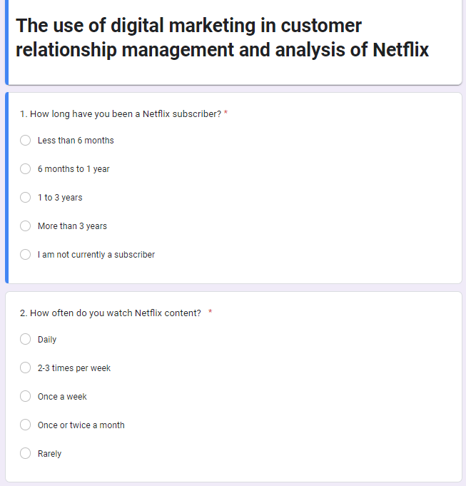
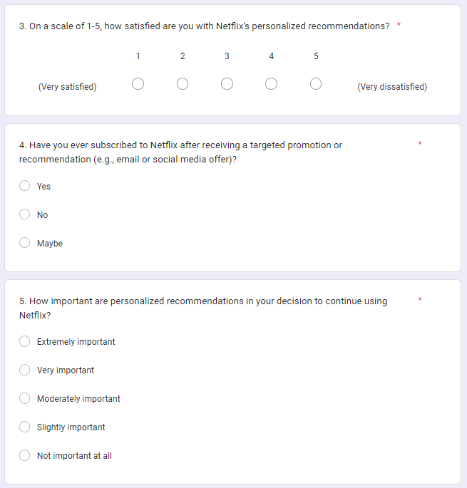
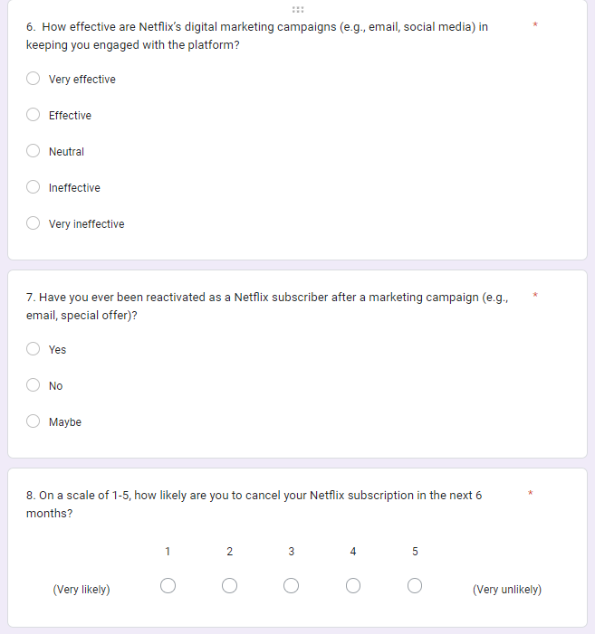
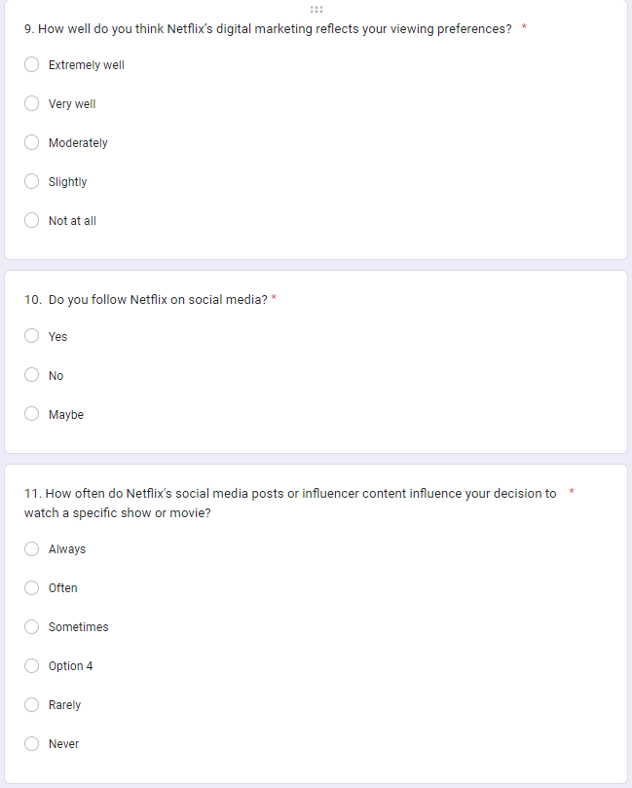
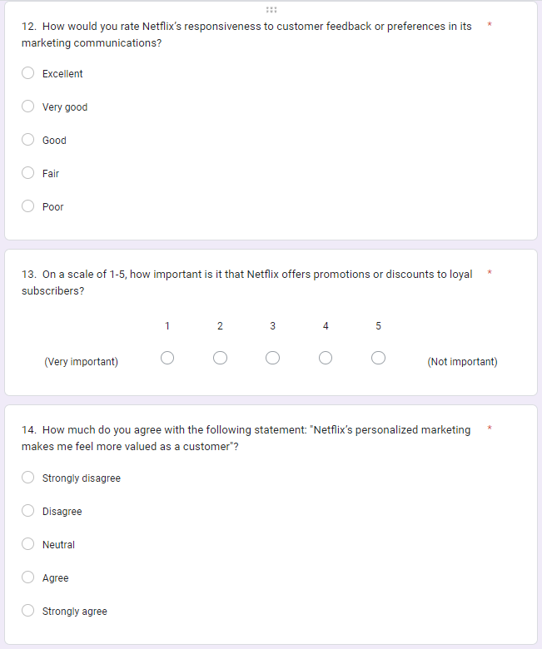
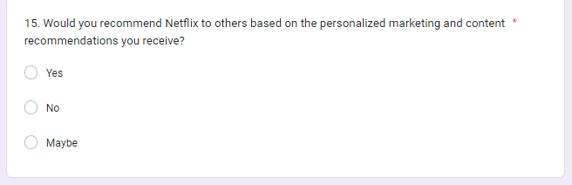

Response 1
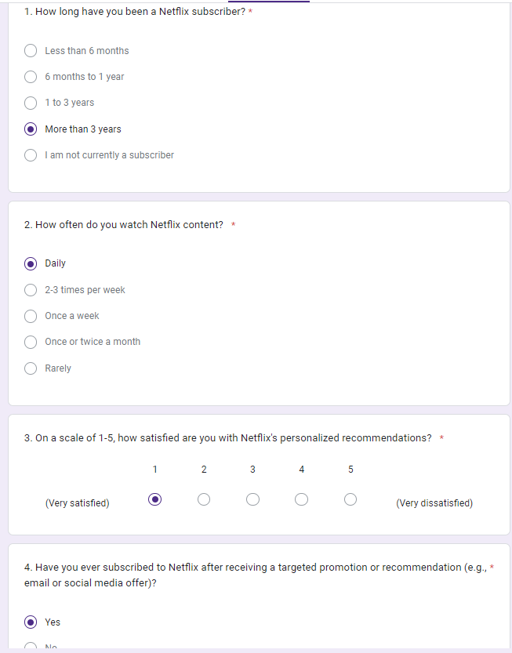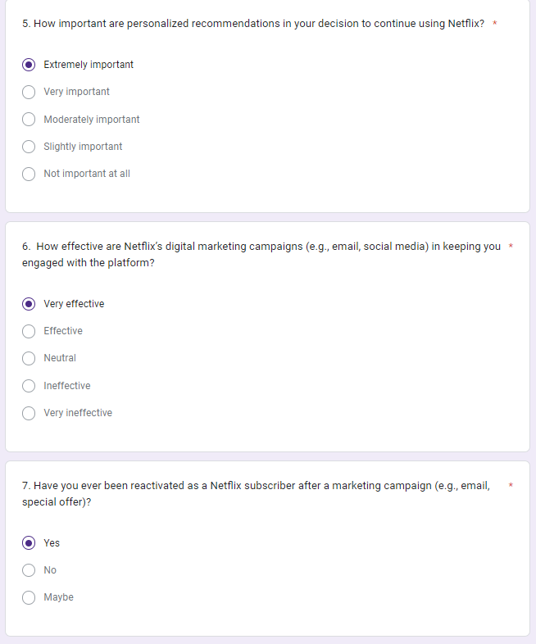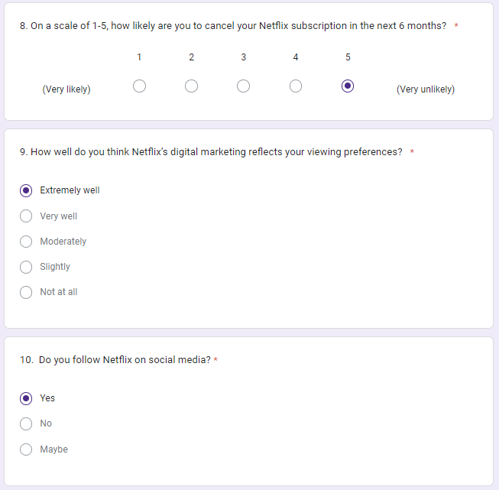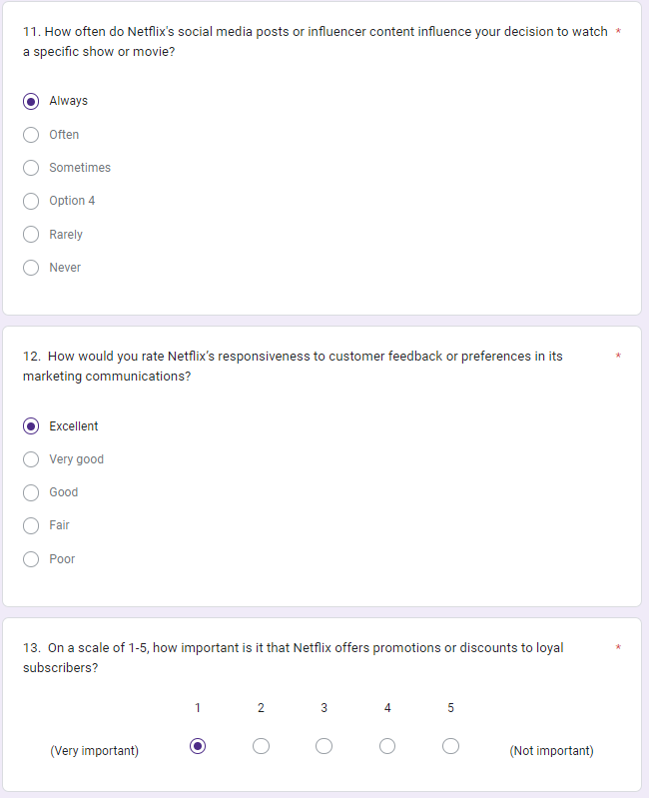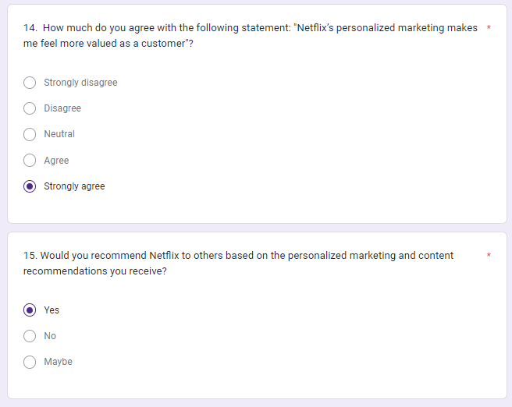

Response 2
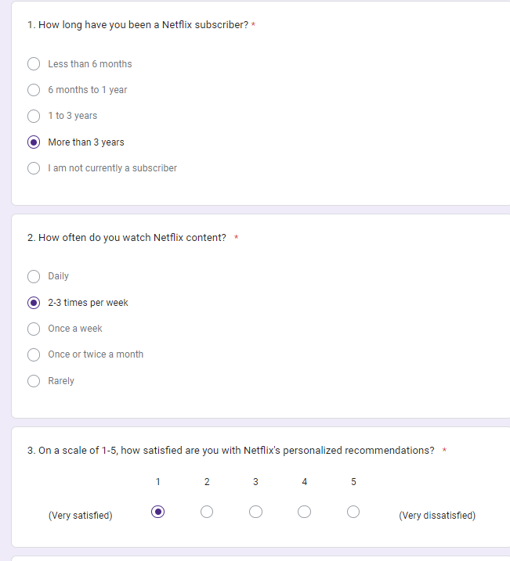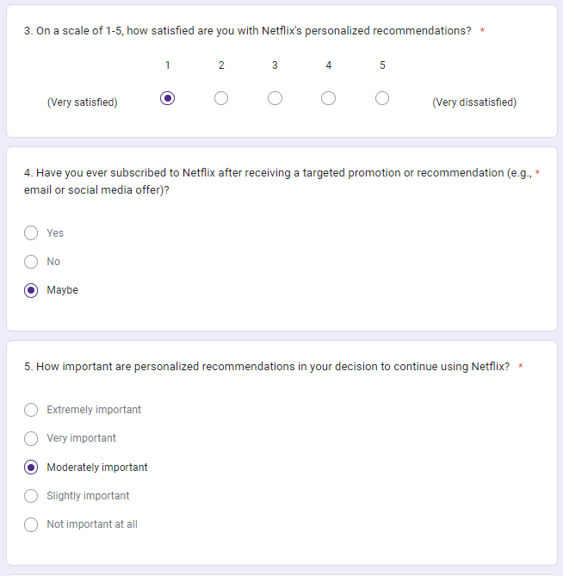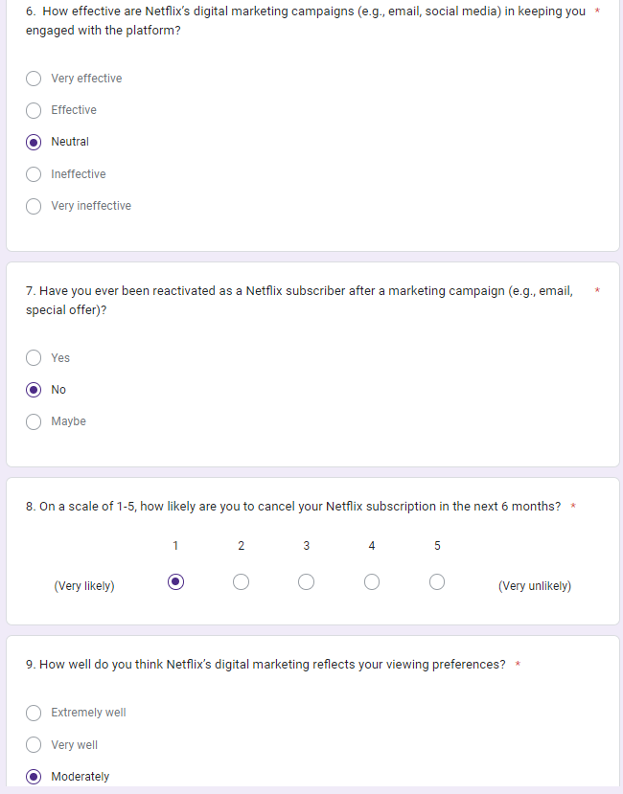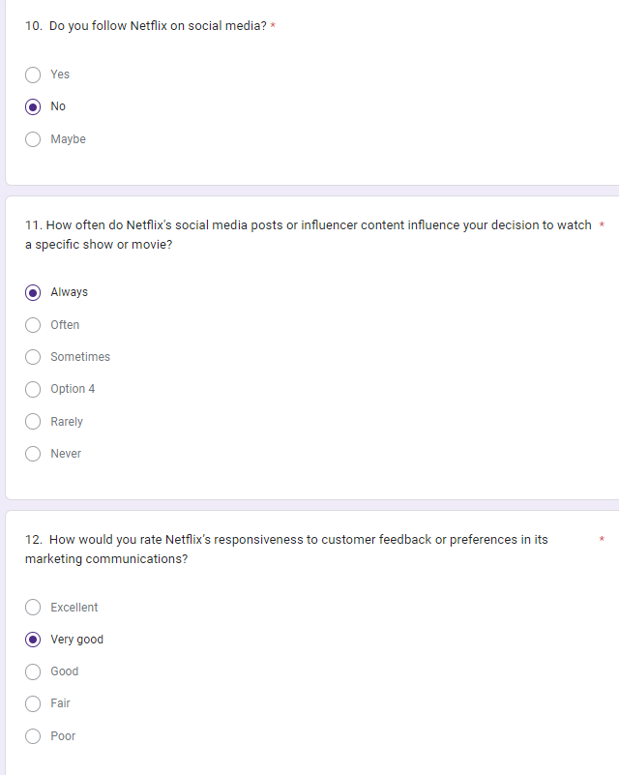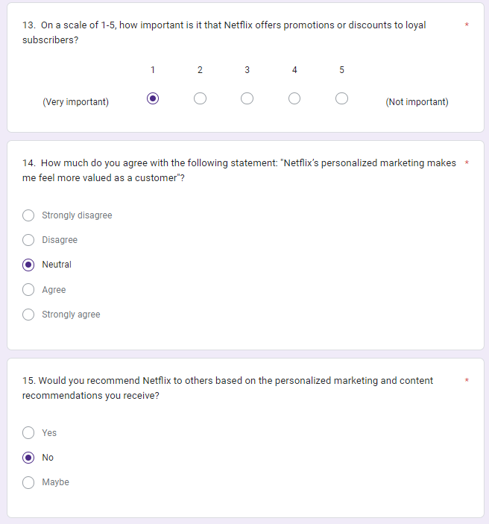

Response 3
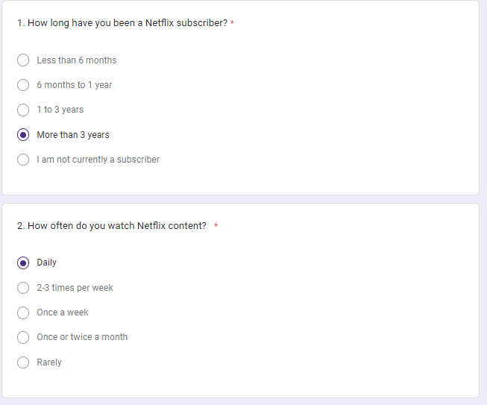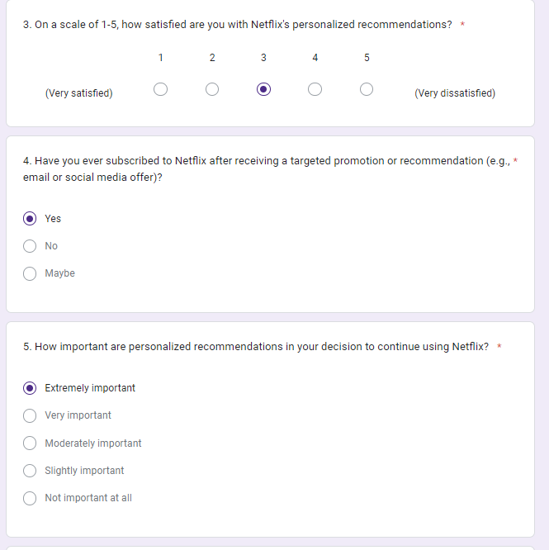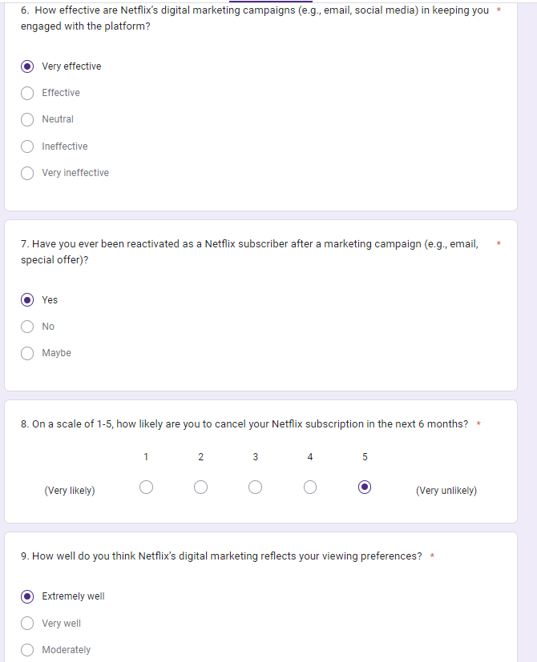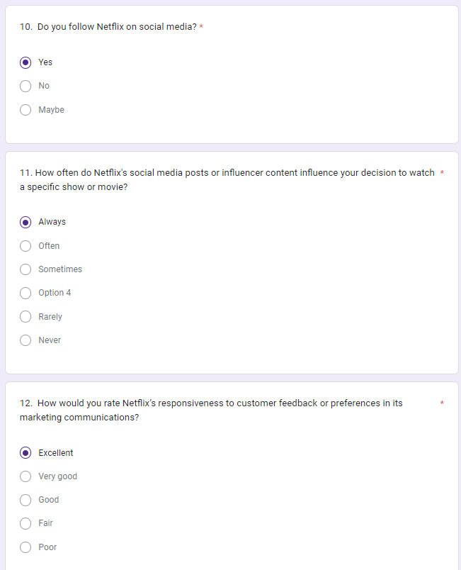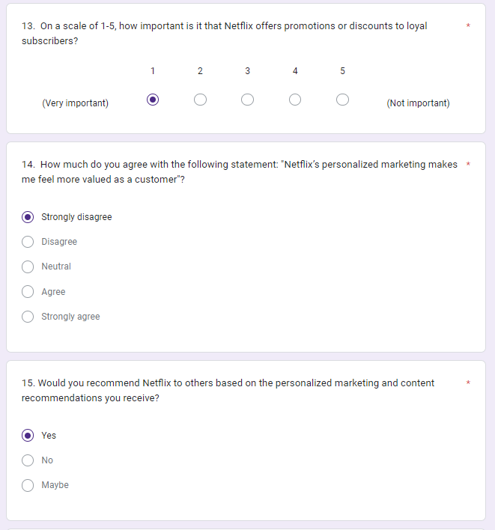

Response 4
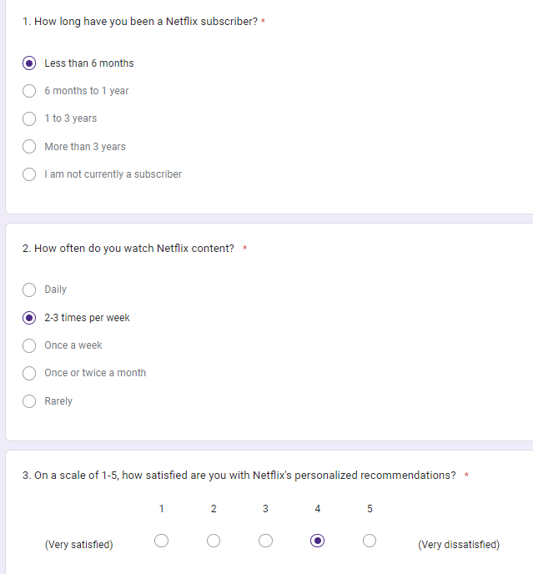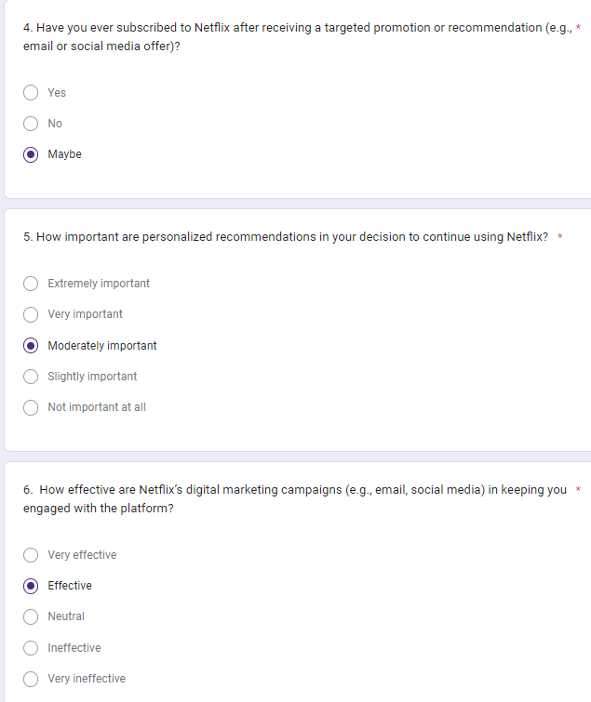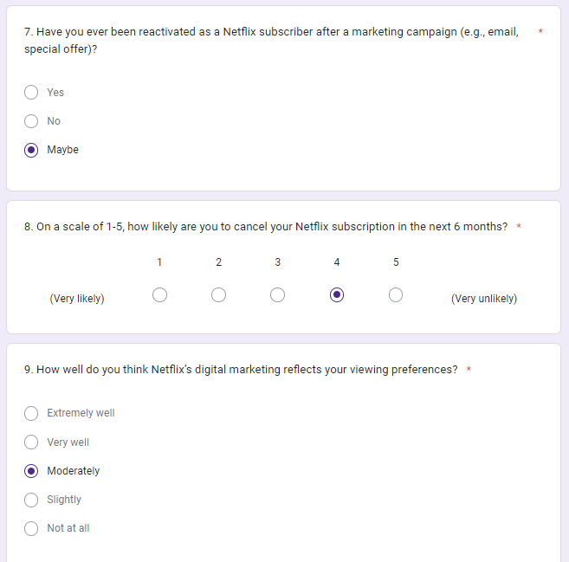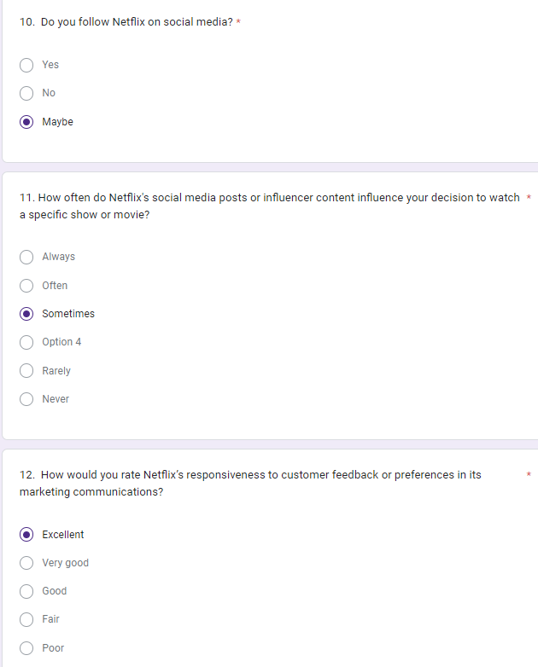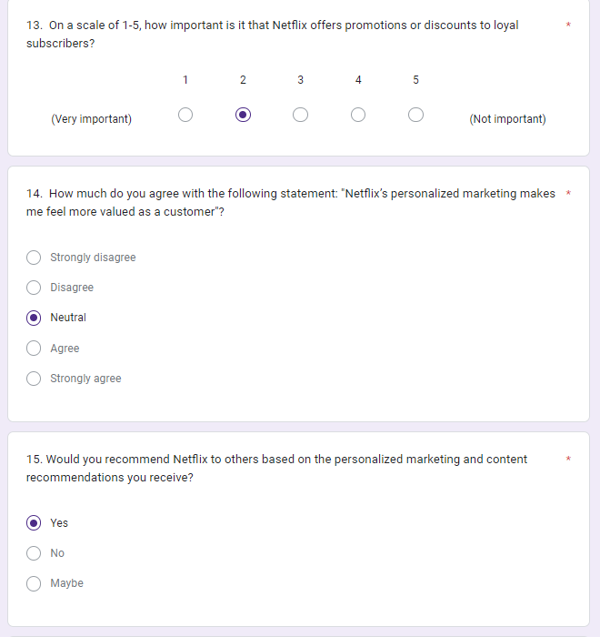

Response 5



