BA Leadership and Management
Module: Developing Workplace Critical Thinking

Module code: BMSW5101_BIRM

Reflective report
Kamil Lenczowski
Student number: 2120445

Lecturer:
Zahra Mohammadnazari

Table of Contents
Introduction 3
Era Model 4
Experience 5
Deductive reasoning 5
Inductive reasoning 5
Reflection 6
Action 7
Recap of the journey 8
References 14
Appendix 15

Introduction

As a second-year student studying leadership and management at the University of Wales Trinity Saint David, I recently finished a ten-week course called Developing Workplace Critical Thinking in Birmingham. This course helped me learn important critical thinking skills, understand different management ideas, and know how to handle conflicts at work. In this reflective essay, I will talk about my experiences and what I learned during the course, focusing on the challenges I faced and the knowledge and skills that I gained. In this essay, I will use the ERA model to help me think about the Developing Workplace Critical Thinking program. The ERA model is a useful way to think about our experiences, what we learn from them, and how we can use this learning in the future. I will use this model to look at my experiences during the Developing Workplace Critical Thinking program in detail. By focusing on the three main parts of the model - Experience, Reflection, and Action. Additionally, to be more clear about what I would like to say, I have added one additional part to the and to clarify the concepts. This will help me understand how much progress I made during the course and find areas where I need to improve. In the next sections of this essay, I will explain what happened during the course, think about the lessons I learned, and come up with a plan to use this knowledge in the future. By using the ERA model in this reflective essay, I hope to show how the Developing Workplace Critical Thinking program has helped me become a better leader and learn how to adapt to today's work environment.

Era Model

The ERA model is a way of reflecting on experiences and learning from them. ERA stands for Experience, Reflection and Action. Firstly, Experience involves describing what happened. Secondly, Reflection involves thinking about what you felt and thought during the experience. Finally, Action involves planning what to do next time based on what you have learned. Using the ERA model will help me to organise my thoughts and reflections so that I can learn from my experiences better. The ERA model is a framework commonly used in reflective practice to help individuals learn from their experiences. As a student, I can use the ERA model to reflect on my academic and personal experiences and learn from them in a structured and organised way. By following the three stages of the ERA model, I can describe the experience, reflect on my thoughts and feelings, and plan actions to improve my future practice based on what I have learned. Using the ERA model can help me to better understand my experiences, develop critical thinking skills, and improve my future practice.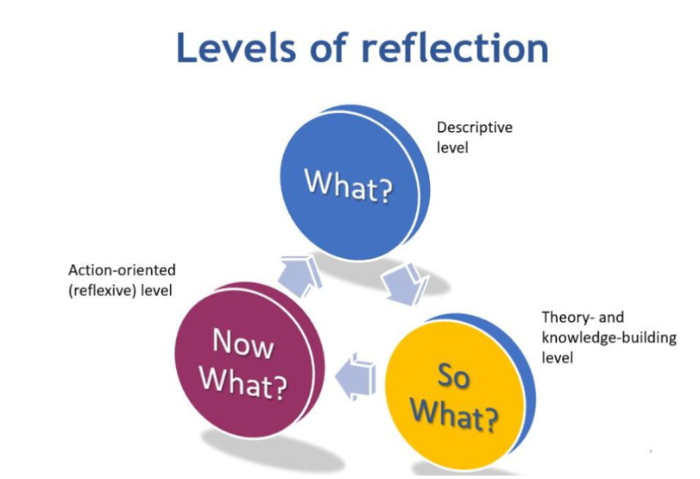
Figure 1. (Levels of reflection ,sourced from https://polgovpro.blog/2019/05/01/what-so-what-and-now-what-your-reflective-practice-guide).

After looking at various models, I have chosen the ERA model as it seems to be more practical for me.

Experience
As a second-year student of Leadership and Management at the University of Wales Trinity Saint David, I have recently completed the ten weeks Level 4 program and achieved the Certificate of Higher Education in Skills for the Workplace. I am currently pursuing Level 5 of Leadership and Management. My new journey began with a module and program called BA Leadership and Management and the module titled Developing Workplace Critical Thinking. The program aimed to help students develop critical thinking skills, understand different management theories and learn about conflict resolution experiences. Throughout the program, I gained valuable experiences that have helped me develop my leadership and management skills.
The program was challenging, and I faced several difficulties in understanding some of the concepts taught, particularly those related to reasoning and conflict resolution. However, the help of my teacher and the way how she tried to find the way to get the most students to understand it, the way how she did it, satisfies me. I was able to overcome these difficulties and learn a great deal. What I think is, whenever you use your brain to make sense of something or solve a problem, you are using reasoning. It is an important skill that helps you learn and understand the world around you. I also know there are two types of reasoning.

Deductive reasoning
All dogs have fur. (premise)
This animal has fur. (premise)
Therefore, this animal is a dog. (Conclusion)

Inductive reasoning
Every time I have gone to the beach, it has been sunny. (observation)
Therefore, every time I go to the beach, it will be sunny. (conclusion)
I also learned how to manage my time better and ask for help when needed. I also learned the importance of collaboration and communication in the workplace.

Overall, the experience has been rewarding. The program has helped me develop critical thinking skills, understand different management theories, and learn how to deal with conflicts in the workplace. By reflecting on my experience, I have identified areas where I need to improve, for instance, I need to conduct more reasoning in future job roles when it comes to problem-solving and critical thinking.

Reflection

During the "Developing Workplace Critical Thinking" program, I was able to develop a better understanding of different management theories and their application in the workplace. I found some concepts and ideas in the program difficult to understand. To overcome these challenges, I tried to stay engaged in class discussions, ask questions and seek clarification when needed. I feel I have gained some kind of self-sufficiently in some way. However, I also found it helpful to work with my classmates on group tasks and seek feedback on my work. I learned about teamwork, communication, and good management for a positive work environment.
Overall, I believe the program was valuable, equipped me with skills for future success.

Action

Going forward, I plan to continue developing my critical thinking skills and applying them to real-world situations. I will continue to seek out opportunities to learn about different management theories and practices, and I will work to apply them in a practical setting. Additionally, I will strive to communicate effectively and collaborate with my colleagues to create a positive and productive work environment.

To improve my understanding of reasoning and conflict resolution, I plan to continue studying and practicing these skills in different scenarios beyond just using a simple example of nature. I also plan to seek out additional resources and training opportunities to further develop my skills.

Finally, I will make sure to maintain a positive attitude and stay focused on my goals as I continue my academic and professional journey. By doing so, I am confident that I can continue to learn, grow, and succeed in my future activities. I am going to apply for the job role which involves understanding managing strategies perfectly and overcoming conflicts.
Additionally, I have decided to take Johari Window and personality tests to be able and see aspects to be improved. Looking back to my Johari Window I need to work on things like I have a good understanding of my strengths and weaknesses, and I am comfortable sharing them with others.
I am also open to feedback and willing to work on improving myself. I believe that being receptive to feedback and having a willingness to improve are valuable traits for anyone in a leadership role. Furthermore, I have observed a connection between reflection and decision-making and its significant impact on the way management leads a business.
However, there are some aspects of my personality that I might not be fully aware of, and others may see me differently than I see myself.
It is important to be open to feedback and to continue to learn about myself and how I interact with others. I may consider seeking out opportunities for personal and professional development, such as workshops, training programs, or coaching, as I have seen many opportunities available online, but mainly I will stay focused on finishing my study.

Recap of the journey

During my ten weeks of the Developing Workplace Critical Thinking course, I gained a lot of valuable knowledge and skills that I can apply in my future career. Each week had a different focus and covered a range of important topics related to leadership, management, and critical thinking.

In the first week, we were introduced to the concept of critical thinking and how we can use it in learning. We also were doing a quiz how to stop strike action. This week gave me a row idea of what I can expect from this module.

In week two, we explored different theories of management and the importance of inductive and deductive reasoning, although I had some difficulties understanding them. We talked about how to analyse and interpret information, and how to use different reasoning techniques to solve problems. I remember our JOHN LEVIS case study. This week was the first in approaching the management concept. This week was challenging for me, but I was able to learn a lot by asking questions and working with my peers, and additionally conduct my own research at home in a quiet environment.
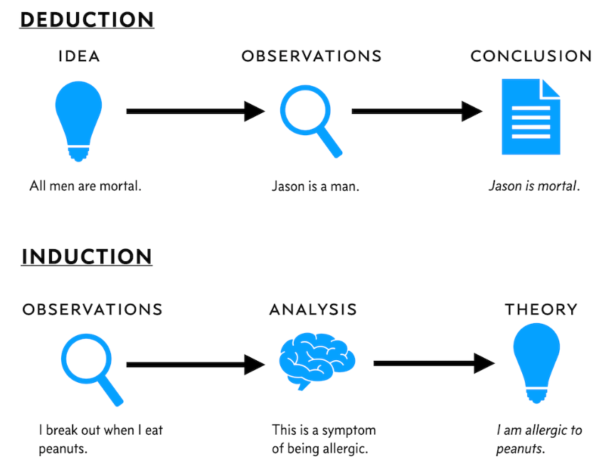
Figure 2. (sourced from https://danielmiessler.com/blog/the-difference-between-deductive-and-inductive-reasoning/ The Difference Between Deductive and Inductive Reasoning
How to tell the difference between these common approaches to problem-solving)

During week three, we focused on classical management theory and the Five Whys approach to problem-solving. It was a good idea to start my assignment about McDonald's restaurants. We learned about the different levels of management and how to use the five whys to get to the root cause of a problem. I think we studied the case of Cadbury. This week was helpful for me, as I gained a better understanding of how to approach problem-solving in the workplace. there were important suggestions on how to implement thoughts into real work environments.
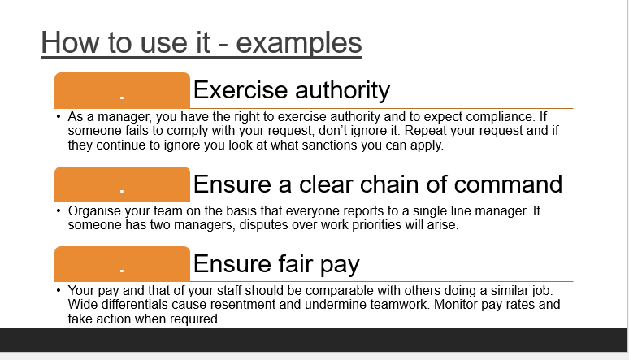
Figure 3. (sourced from UWTSD module program) how to use some of Fayol’s principles )

In week four, in this lesson, we were learning about the importance of workplace critical thinking and were introduced to two critical thinking techniques: the Five Whys and the Seven So Whats?.
The Five Whys asks "why" to find root causes of problems. For example, why did the car battery die? Because it wasn't recharged. Why wasn't it recharged? Because the alternator failed. Why did the alternator fail? Because a belt broke. Why did the belt break? Because it was old and worn. Why was the belt not replaced? Because it wasn't part of the routine maintenance. That is how I explained it in a simple way. Unfortunately, I am not sure if I attended that class.

Week five focused on scientific management and Taylor's theory. I like this theory more than others. We talked about how to optimize processes and increase efficiency in the workplace. I did think the first time ever to use McDonald’s example as my prime example for my report. It has reinforced my belief that choosing this topic was the right decision. This week was interesting for me, as I learned how to identify areas for improvement and optimize processes for better outcomes.

During week six, we participated in a workshop where we mentioned additional pieces of information on how and where we can get our sources from, and what is the concept of reflecting writing model. I remember one nice source from this lesson it was very handy.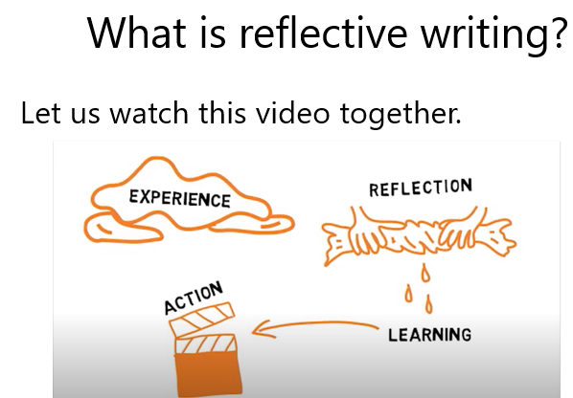
Figure 4. ( sourced from UWTSD What is reflective writing)
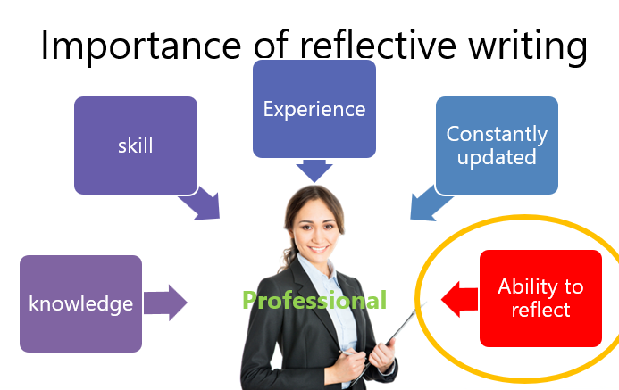
Figure 5 (sourced from UWTSD , importance of reflective writing)

We also talked about different models of reflecting writing.

Week seven focused on organizational conflict theme, what is conflict and how to manage the conflicts.
This week was challenging for me, as it required a lot of critical thinking and analysis, but it was also rewarding to see how much I had learned over the past few weeks and I was sure I can use it in my assignment. We talked about Schmidt who argued that conflicts can have both positive and negative effects on individuals and organizations. They can lead to increased creativity, improved communication, and enhanced problem-solving, but also to decreased productivity and damaged relationships. Therefore, it is important to manage conflicts effectively to maximize their positive impacts while minimizing their negative consequences.
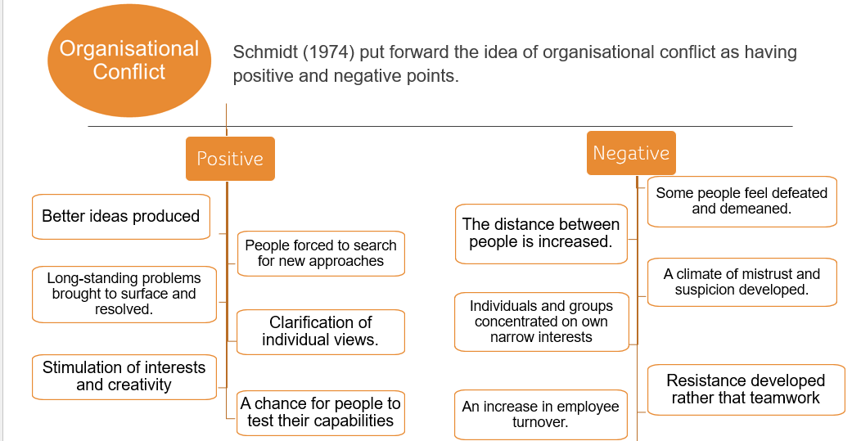
Figure 6. (sourced from UWTSD, Schmidt organizational conflicts).
It is important to know the Source of conflict:
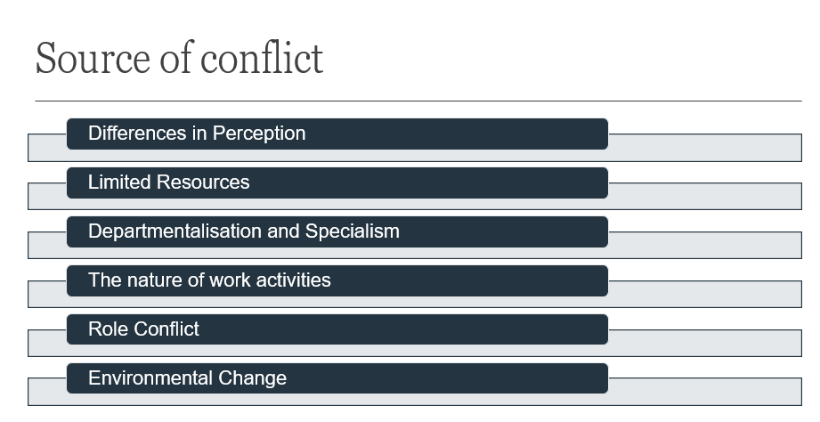
Figure 7. (Sourced from UWTSD, source of conflict)

I think to avoid a conflict when people work together, sometimes people may have different ideas or feelings about things. This can lead to conflict or arguments. Managers can try to prevent this by ensuring everyone knows what they are supposed to do, sharing things fairly, doing fun things as a group, being good leaders, and following rules. This should help everyone work together better and get along.

Week eight focused on HRM and IHRM, Unfortunately, I was not able to attend, I only watched the recording, but the footage was in poor quality. I came up with understand us is managing people who work for companies in different countries, which can be tricky due to language and cultural differences, as well as different laws and regulations in each country.
It is like comparing two different jobs that both involve managing people, but international management has the added challenge of working across borders. To manage people effectively in international settings, it is important to understand cultural differences, communicate clearly, and follow local laws and regulations.

Week nine focused on arrows x or y. I have enjoyed this lesson and I think I have the same point of view as McGregor who had some ideas about how people work. He thought that some bosses believed that people were lazy and did not want to work. But he believed that most people want to work and do a good job. He had two ideas about how bosses could manage people. One idea was to be nice to them and give them rewards when they did a good job. The other idea was to be strict and give them punishments when they did a bad job.

During the final week of the course, we focused on workshops.

Overall, I found the "Developing Workplace Critical Thinking" course to be a valuable learning experience. Each week had a different focus and covered a range of important topics. The module has provided me with an opportunity to enhance my critical thinking and decision-making abilities, while also expanding my knowledge of various management theories. As a result, I have gained a better understanding of the business environment and the principles that guide effective management practices.

References
Adair, J.E. (2016) Decision making and problem solving, Third edition, London: KoganPage, available at: https://librarysearch.uwtsd.ac.uk/discovery/fulldisplay?docid=alma99100169159802421&context=L&vid=44WHELF_UWTSD:44WHELF_UWTSD_VU1&lang=en&search_scope=MyInst_and_CI&adaptor=Local%20Search%20Engine&isFrbr=true&tab=Everything&query=any,contains,Decision%20Making%20and%20Problem%20Solving&offset=0
Anonymous (2019) The Johari Window: A Simple Exercise to Improve Your One-on-One Meetings, Seer Interactive, available online : https://www.seerinteractive.com/insights/the-johari-window-a-simple-exercise-to-improve-your-one-on-one-meetings#:~:text=The%20Johari%20Window%20is%20a%20simple%20technique%20that,from%20a%20list%20they%20feel%20best%20describe%20themselves
Bradford, A. (2023) Deductive reasoning vs. inductive reasoning, Live Science, available at: https://www.livescience.com/21569-deduction-vs-induction.html
Chatfield, T. (2018) Critical Thinking, Sage, page: 271-284.
Fayol, H. (2013) General and industrial management, Mansfield Centre, CT: Martino Publishing, available at: https://librarysearch.uwtsd.ac.uk/discovery/fulldisplay?docid=alma99121911402421&context=L&vid=44WHELF_UWTSD:44WHELF_UWTSD_VU1&lang=en&search_scope=MyInst_and_CI&adaptor=Local%20Search%20Engine&tab=Everything&query=any,contains,General%20and%20Industrial%20Management
Gibbs, G. (2013) Learning by doing: A guide to teaching and learning methods, First Edition, Further Education Unit, Oxford Brookes University, (pp. 30-35) available online: https://thoughtsmostlyaboutlearning.files.wordpress.com/2015/12/learning-by-doing-graham-gibbs.pdf
McGregor, D. and Cutcher-Gershenfeld, J. (2006) The human side of enterprise, Annotated ed. New York: McGraw-Hill, available at: https://librarysearch.uwtsd.ac.uk/discovery/fulldisplay?docid=alma99113142502421&context=L&vid=44WHELF_UWTSD:44WHELF_UWTSD_VU1&lang=en&search_scope=MyInst_and_CI&adaptor=Local%20Search%20Engine&tab=Everything&query=any,contains,The%20Human%20Side%20of%20Enterprise&offset=0
Taylor, F.W. (1947) Scientific management : comprising Shop management, The principles of scientific management and Testimony before the special House committee, New York: Harper. available at: https://librarysearch.uwtsd.ac.uk/discovery/fulldisplay?docid=alma99100469460602421&context=L&vid=44WHELF_UWTSD:44WHELF_UWTSD_VU1&lang=en&search_scope=MyInst_and_CI&adaptor=Local%20Search%20Engine&tab=Everything&query=any,contains,The%20Principles%20of%20Scientific%20Managemen
Wehle, K. (2022) Build Your Logical Thinking Skills. Carpenteria, CA: linkedin.com. available at: https://librarysearch.uwtsd.ac.uk/discovery/fulldisplay?docid=alma99100508299702421&context=L&vid=44WHELF_UWTSD:44WHELF_UWTSD_VU1&lang=en&search_scope=MyInst_and_CI&adaptor=Local%20Search%20Engine&tab=Everything&query=any,contains,Deductive%20and%20Inductive%20Thinking&offset=0

Appendix
Anonymous (2023) Deductive Reasoning vs. Inductive Reasoning, video, available at: https://cdn.jwplayer.com/previews/7sN0CWgE
Miessler, D. (2011) The Difference Between Deductive and Inductive Reasoning, available at: https://danielmiessler.com/blog/the-difference-between-deductive-and-inductive-reasoning/
Polgov (2019) What, So What, and Now What: Your Reflective Practice Guide, PolGovPro, available at: https://polgovpro.blog/2019/05/01/what-so-what-and-now-what-your-reflective-practice-guide


