Name | Jamil Manoga
Module code | LCMB7011
Programme | MBA- Masters of Business Administration.
Module | Managing People.
Lecturer | Terry Walcott
Assignment title | Managing People

- Abstract
- Company Background
- Employment Law
Common Law
Acts of Parliament
European Law
International Law
- Termination of Employment
- Wrongful Dismissal
- Unfair Dismissal.
- Collective Redundancy
- Fire and Rehire policy
- Fire and Rehire UK labour market application
- Impact of ‘fire and rehire on employee engagement.
- Social Exchange Theory.
- Legal Implications.
- Human Resource Involvement in Employment Relations: Fire and Rehire
- Human Resource Models.
- Recruitment and selection
- Training and Development.
- Recommendations
- References.

Abstract.
The purpose of this paper is to review the ‘fire and rehire practices which have become prevalent in United Kingdom labour market particularly during the Covid-19 pandemic. The paper takes a look at the UK employment legal systems, how laws are formulated and implemented with particular emphasis on legal protections at employees’ and employers’ disposal.
It further analyses the legal implications of the fire and rehire practices, changing of contractual employment terms and conditions and previous scenarios and how they can influence the current circumstances.
The paper concludes with evaluation of HR involvement in the hire and rehire issues and consider whether traditional models of HRM provide an adequate framework for managing contemporary employment relations.

Company background- British Gas.
British Gas and its parent company Centrica are the largest and oldest energy supplier in UK with a 3.6 million customer base and a 27,000-work force (1/3 engineers) all of whom either belong to GMB, UNITE, UNISON, or PROSPECT trade Unions, (BBC, 2020) (gmb.org, 2021). The company has experienced a commercial decade long inefficiency and decline that has resulted into tumbling of earnings from £742 to £80, dropping from FTSE 100, and lost close to a million customers. The inefficiency is alleged to have resulted into market share loss to ‘white van’ engineers, and start-ups offering rock bottom prices, subsequent redundancies of over 5000 experienced and dedicated employees, and damaged morale of whole labour force.
For purposes of long-term sustainability and rescuing the company from ruin, British gas started engaging with the four unions to find ways of streamlining workers’ contracts to boost productivity which meant working 3 extra hours a week, on flat rate on bank holidays and weekends. During the negotiations with unions British gas threatened to exploit loopholes in employment law which permit ‘fire and rehire’ of current employees which the unions referred to as ‘bullying’ and ‘immoral’. The workers were given a choice of ‘working for less’ or ‘unemployment’(rehired on inferior terms or dismissed). Throughout the negotiations, many employees who diligently served the company during hard times, some for over 2 decades, felt betrayed, and experienced health damage (mental health). After a while, all unions except GMB recommended to their members to accept the new terms and approximately 90% reluctantly signed the new contracts while a few resigned or continued with the strike.
Employment Law
(Edwards & Robinson, 2012) broadly define ‘employment law’ as “the negotiated relationships between employers and employees”. On establishment of the relationship between an employee and employer (employment contract), which encompasses complex power dynamics (CIPD, 2018) and in which employees are usually greatly disadvantaged, the need for rules of engagement, and management of expectations (psychological contract (Montes, et al., 2015)) arises. This is why governments and regulatory bodies formulate ‘employment laws (Hayes, 2001) which incorporate basic rights relating to for example, contract of employment and its breach, discrimination, payments/renumeration, disputes, recruitment, redundancies and dismissal.
Employment laws formulation, types and execution is determined by numerous factors which may include Industry type, geographical location and Industry associations (national and international laws) (Kamrul, 2016). Countries and companies operating within the European Union (EU) for example are largely governed by the EU laws, and civil servants like in the army and private sector may experience a slight difference in the execution of the employment law because of the nature of their work.
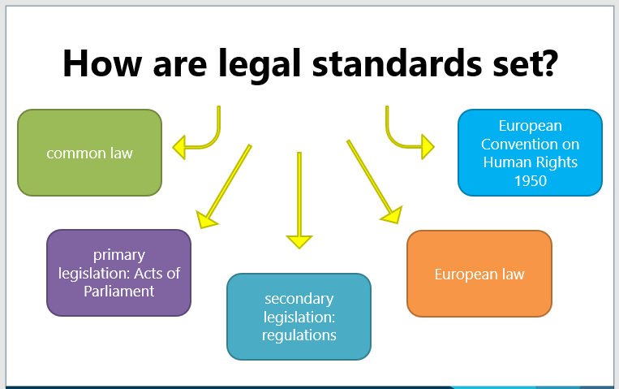
(UWTSD, 2022)
The type of laws and their formulation as summarised in illustration above, varies from country to country and in case of United Kingdom (UK) as illustrated above, it has to cater for international, European and domestic law. UK employment law or standards in particular however, are formulated and upgraded on various fronts which include;
Common law or case law which are initiated by Courts, judges or tribunals (Astra, 2013) are loosely defined by Investopedia (Chen, 2021) as “a body of unwritten laws based on legal precedents established by the courts”. It is in many cases also the catalyst for a good number of laws enacted by parliaments e.g. Supreme Court ruling for Uber’s ‘self-employed drivers’ to be ‘workers’ which has transformed employment law and ‘Gig’ economy (Gov.uk, 2018) in UK (BBC, 2021).
Acts of Parliament: Another source of employment law are the national legislative assemblies, parliaments which pass Primary legislation (statute law) or Acts of parliament which; may originate from common law, can overturn, and amend common law as well as setting new laws e.g. Equality Act 2010 (Keter, 2010).
European Union law: All countries and companies which belong and trade within the European union (Chalmers, et al., 2019) are expected to abide by laws, treaties, directives, rulings and regulations enacted/pasted by the European Court of Justice and other bodies within the union. However, with UK’S exit from the European Union (Brexit) (Govt.uk, 2020) EU laws have been incorporated within the UK laws.
International law. (Deloitte.com, 2022)
The United Nations Organisation (UN) under its various organs like International Labour Organisation (ILO) based in Geneva and World Trade Organisation are responsible for formulating “International employment laws” to help standardise and regulate employment rights at the global level (ILO.org, 2022). The UN can facilitate formation of international and national policies, evaluate countries’ legal structures and provide technical advice regarding labour standards in the current volatile globalised economies.
(UWTSD, 2022) offers several options in case of employer or employee contractual breach, which include: Internal disciplinary procedures, employment tribunals, employment Appeals, Court of Appeal, Supreme court and European Court of Justice.
Termination of Employment.
Termination of employment is part and parcel of HR, Business management, and aligning of business needs in an evolving competitive global environment. In order for businesses to effectively overcome challenges and remain competitive their key asset ‘human resource’ and skills set should align with corporate goals, hence need for regular recruitment and unavoidable termination of employment.
In case of termination of employment, the following legal protections need to be put into consideration:
Wrongful dismissal:
When employers dismiss employees in breach of contract, it is referred to as ‘wrongful dismissal’. It normally occurs when employers deny employees sufficient notice as stipulated in employment contract. Such cases are normally settled in civil courts in which compliance to contractual obligations takes precedence over dismissal fairness (Bowers, 2009).
Unfair dismissal:
The ‘Employment Rights Act 1996’ includes protection of employees who have served organisations for over two or more years against unfair dismissal (UKParliament, 2021). The dismissal becomes unfair unless it is for any of the aforementioned reasons (conduct and capabilities) catered for in section 98 of the Act, and also accompanied by employers’ legitimate reason for decision (Philippa, 2021)(Philippa , 2018). ‘Some other substantial reason’ (SOSR) is another fair dismissal ground employers rely on and a Court of appeal judgement (Hollister v National Farmers Union) upheld as ‘good business reasons’ in case of reorganisation and employee has refused new terms.
Collective redundance:
The law instructs employers who wish to dismiss 20 or 100 plus workers within 90 days at same establishment as redundant to start consulting with employees’ representatives 30 or 45 days respectively before the first firing (Trade Union and Labour Relations (Consolidation) Act 1992 (UKParliament, 2021). In case of a breach, for example dismissal within stated consultation period, employees can apply for a financial penalty against organisation (employers).

Fire and Rehire Policy
Consent of the employee is one of the fundamental prerequisites of basic law principles an employer has to abide by before changing his contract: (Rigby vs Ferodo Ltd (1988) ICR 29) (KCL, 2020). It is the duty of the justice system therefore to uphold the sanctity of employment contracts whenever employers try to downgrade them without their consent (Bogg, 2020). However, following of a dismissal (firing) with rehiring (re-engagement) does not impede there being a ‘dismissal’ as per meaning of Section 95 (1) (a) of the Employment Rights Act 1996 (Gov.uk, 2021) (ire.org, 2021).
Covid-19 pandemic has however brought to public attention, need, the existence and increased practice by employers of firing workers then immediately re-employee them on changed, inferior terms and conditions (acas.org, 2021). Though ‘fire and re-hire’ tactic is not new, and ‘’illegal” (ire.org, 2021) the current trend which employers like British gas and British Airways (BBC, 2020) (GuardianUK, 2020) deployed to force unions and employees to agree to new terms and conditions is considered by many and Labour leader Keir Starmer in particular as totally unacceptable, immoral and unfair (Gov.uk, 2022) (GuardianUK, 2020).
The chief executive of British Airways Willie Walsh however, is quoted to have said, “We are living in a new world environment and the future is going to be very different to the past. The sooner we all embrace that reality, the better for everyone.” (GuardianUK, 2020). Many of his counterparts also voice the need for acting now to level out global volatile business challenges in order remain competitive, and guarantee companies’ sustainability by adapting practices which are relevant to the current prevailing business needs and challenges.
They claim that this can only be done through revisiting, and harmonising contractual terms and conditions (acas.org, 2021) particularly regarding temporally and permanent flexibility (working hours, and shift patterns), redundancies, payments and pensions. It is fundamental that in order for their organisations to carry our necessary strategic changes, negotiations have to be held with stakeholders most especially unions and employees regarding organisational responses to consumer behaviour variations and operational needs.
Though contractual changes in terms and conditions can only happen through consultation and agreement with unions and employees (consent), the negotiations (British Gas/Airways) have experienced a lot of resistance from unions resulting into employers resorting to ‘Fire and Re-hire’ threat as a negotiating tactic and final resort (Bogg, 2020) which happens to be supported by (CIPD, 2022) particularly in exceptional circumstances.
Fire and Rehire UK Labour Market Application.
The usage of fire and rehire in UK labour market has greatly increased during the covid pandemic though a few other companies has earlier employed it. Some of the companies that have so far used it include: Tesco. Clarks, British Airways, and British gas.
There is however some form of uniformity in its application as almost all companies so far use it as a negotiating tactic particularly when negotiations with unions appear to be heading for a deadlock.
British Airways and British gas in particular clearly chose to walk away from negotiations and chose to threaten the employees either to accept the new inferior terms and conditions or get fired (BBC, 2020).

Impact of ‘fire and rehire on employee engagement.
Universal consensus of scholars describes ‘Employee engagement’ as a work related, positive, and fulfilling state of mind characterized by absorption, vigour and dedication (Alberecht, et al., 2015). Many successful organisations are investing a lot of resources and interest in employee engagement because of the strong relationship it has with high productivity, low employee turnover, and organisational success (Bates, 2004). They are banking on employees’ successful engagement which moves hand in hand with motivation to remain competitive in a highly volatile business environment. Ryan & Deci, (2000) cite reward both extrinsic and extrinsic, incentives, trust, and organisational structures, support and culture as some of the key factors which influence successful work engagement and motivation.
‘Fire and Rehire’ practices are generally characterised by offering ‘inferior terms and conditions’ to employees, for example, British gas increased working hours for less pay, and flat rates for weekends and bank holidays (BBC, 2020). As a result of fire and rehire, British gas experienced a damaged morale across the workforce (Ambrose, 2021), some employees were physically affected (mental health), and lost trust in management.
Social Exchange Theory.
The ‘social exchange theory’ asserts that commitments can be initiated among reciprocal groups. Though the relationships can change as time goes on, trust, loyalty and mutual commitment can happen as exchange of certain rules happens (Cropanzano & Mitchell, 2005). The exchange of rules however, is reliant upon reciprocity or repayment meaning one party’s actions cause a reaction with the other.
In case of employees, and organisations, the social exchange theory points towards organisations benefiting from employees’ positive reaction ‘total engagement’ (higher productivity) as a result of their positive in puts (trust, rewards, incentives, corporate support and conducive environment). It is not surprising therefore, that British gas entire workforce’s morale and performance nose divided the moment ‘fire and rehire’ was introduced (Kahn, 1990).
Though social exchange theory is beneficial in predicting workplace behaviour, its assumption that all employees are the same and driven by reward, neglects their psychological, security, belongingness, esteem and self-actualisation needs (Maslow’s theory) (Vinod, 2022).
Legal Implications.
As noted above, ‘Fire and rehire’ practices are not new and illegal, and there is no immediate hope of government banning it (ire.org, 2021) as it has just recently blocked a chance for parliament to outlaw it stopping employers bullying employees with it. Interestingly, even the Labour party championing employers’ fairness and sponsors of the “Employment and Trade Union Rights (Dismissal and Re-engagement) Bill, are not willing to ban it, a testimony to its importance in the current volatile business environment.
Fire and rehire can sometimes turn out to be an expensive route as (Rigby vs Ferodo Ltd (1988) ICR 29) (Bogg, 2020) case testifies. It requires a lot of caution when implementing it and ensuring that all legal requirements particularly required notice is given and have enough grounds for adapting that route (dismissal). Many companies have ended in tribunals and courts, lost their cases and ended up paying fines, damages and exorbitant legal costs for unfair dismissal.
Human Resource Involvement in Employment Relations: Fire and Rehire
Sisson (2010), defines ‘Employment relations’ as the study of ‘the institutions involved in governing of the employment relationship, the people and organisations that make and administer them, and the rule making processes that are involved, together with their economic and social outcomes’. However, on the other hand, Armstrong, (2014) describes ‘Human Resource Management’ an approach, coherent, integrated, and strategic to employment, development and employees’ wellbeing in an organisation.
It is now a common belief, that Human Resource (HR) is a vital corporate tool and organisations’ success (performance) is reliant on way how its utilised via human resource management (HRM) which endeavours to achieve corporate goals through employees regardless of which sector; business, government, charitable or recreation. HRM is an approach composed of four functions namely; Staffing, Development, Training and Motivation.
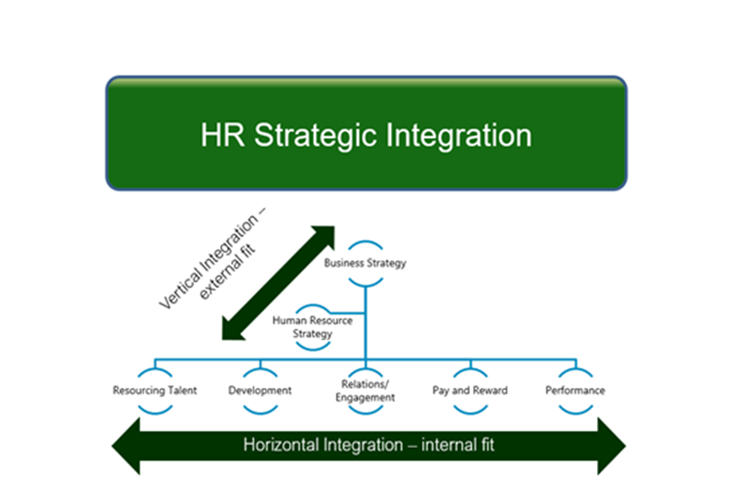
All in all, the fundamental objective of HRM is to ensure corporate success through people normally supported by various HR frameworks (models) like Storey, and Warwick developed over time by various researchers to help practitioners efficiently manage employees.

Human Resource Models.
Storey Model.
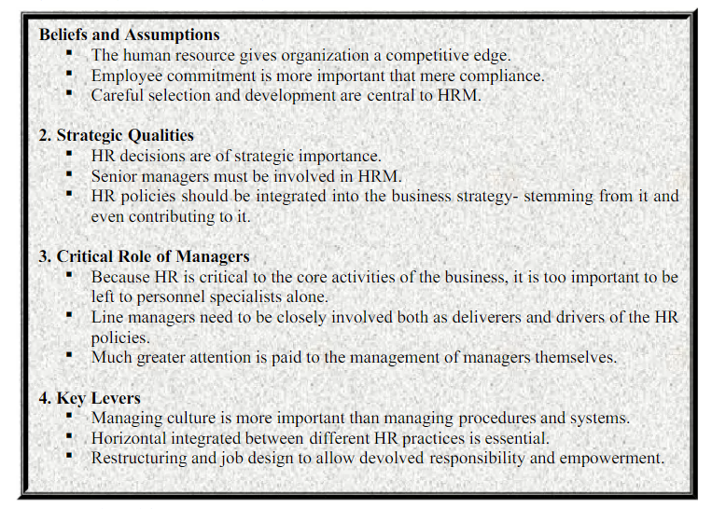
Source: (Storey, 2001)
The Storey model was developed in 1989 by John Storey who viewed HRM as being a more sympathetic (soft) approach to employment management. The model pays less attention to compliance compared to commitment, and suggested human capability as the benchmark that differentiates organisations. John storey’s model is composed of four pillars:
1. Beliefs.
2. Strategic qualities.
3. Role of line managers.
4. Key levers.
Though the storey model is viewed by some as being soft, not realistic and too costly to implement because of its collaborative nature, its a vital tool in human resource management as it advocates for a more collaborative approach particularly commitment rather than compliance. With contemporary HRM practices emphasising employee engagement and motivation the application of storey model is more positioned to improve relationships between management and employees, minimising conflict and enhancing productivity all of which point towards avoiding prevalent ‘fire and rehire’ practices engulfing UK’S economy.
Recruitment and selection
In current highly competitive and challenging business environment, employee performance and engagement are key in ensuring corporate goals particularly high productivity, competitiveness and sustainability are attained. Corporate strategising of HRM and its contemporary practices like recruitment and selection is key in achieving their goals. HRM contemporary research and practices indicate a trend of high-quality job applicants searching for jobs opportunities that offer challenges, growth and engagement. Therefore, for organisations to entice and retain high quality, engaged, committed, productive and high achieving employees, they have to provide working frameworks that offer decent fit amid role expectations of potential employees and subsequent working environment (Alberecht, et al., 2015). HRM and selection processes therefore, have a key role to play in selection and job design which are key in acquiring and retaining a committed and flexible workforce needed to face off contemporary competitive challenges. At a time when British Airways and British gas are losing market share, & cutting down on their workforce, others like Apple, Google and Amazon which have prioritised and adapted contemporary HRM practices are recruiting and experiencing high returns on their investments.

Training and Development.
Training and development are considered as one of the most significant components of human resource. All employees, at all levels require training in order to execute their roles and responsibilities effectively. In the wake of rapidly changing technology, competition, changing consumer expectations particularly high product and serve quality, the need for training and development has assumed greater importance. Training usually pays special emphasis on the acquiring of specific (new) skills necessary for particular duties.
Human resource development (HRD) is made up of processes and procedures which intend to avail learning activities to boost knowledge, capabilities and skills of individual employees, groups and organisation as a whole to facilitate positive change and achieving of intended objectives. Unlike training, HRD is a long-term strategic process, looked at as an investment rather than cost, a vital tool for; cutting costs, improving employee retention, recruitment, company image, loyalty and commitment through unleashing of internal potential (uwtsd, 2022).
Both training and development play a major role in the equipping of employees with vital skills, expertise and confidence needed by organisations to achieve corporate goals (high productivity, sustainability and competitiveness). They enhance trust, employee engagement, retention, and loyalty as well as boosting corporate brand all of which greatly help in minimising conflict and organisations’ poor performance the main reason for ‘fire and rehire.
Recommendations
1. There will always be circumstances when ‘fire and rehire’ may be the most favourable option considering the outcomes of available alternative options particularly to the workers, organisations and economy as a whole. It is however important that the law is tightened up for current lenient ‘fire and rehire’ position particularly the employers’ decision-making process is opened up to be independent scrutinised.
2. Rightly so, the law allows ‘dismissals’ in certain circumstances but as professor Boggs (2021) suggests, the ‘Employment Rights Act 1966’ should be amended to provide that ‘fire and rehire’ are unfair if employers had other viable economic options. It should also include forcing of (UKParliament, 2021) employers to prove they fully engaged/consulted with unions and attained agreement before dismissals.
3. The amending of the Act particularly section 98(2)(b) by narrowing the scope of conduct that employers can rely upon as reason to terminate a contract of employment SOSR.
4. The habitual application of wide contractual powers which favour employers in varying employees’ terms and conditions separately, as in Bateman v ASDA. Unilateral variation clauses subvert the general requirement of reciprocity that underpins all bilateral contracts, and such terms should be treated as void through statute.
5. Collective bargaining: collective bargaining enabled the creation of “the common rule” where through collective representation, workers could lessen the power imbalance with employers. For Freeman and Madoff (1984), collective bargaining was the area where unions could exert their monopoly power the greatest. For much of the 1960s and 1970s trade unions and collective bargaining were the primary focus and the vehicle to achieve this, with more unions and collective bargaining seen as the answer to employment relations issues.
Conclusion.
The Covid-19 pandemic has affected every aspect of humanity and more so the economies of the world. Many organisations/companies collapsed while other narrowly survived and ‘clean up’ process is going to take along time and a lot of effort and resources to return to precovid-19 levels.
Its surprising however that a good number of organisations have doubled their returns during same period and continue to out perform their original standards. A close look at the successful organisations like Apple Plc, Amazon and Google all happen to have adapted the contemporary HRM practices relating to; engagement, recruitment, reward and renumeration, training, development and innovation.
Many of the companies which have adapted the ‘fire and rehire practices’ like British Airways and British gas started struggling well before covid-19 come on the seen a testimony of the relationship between slow adaption of HRM practices and poor performance.

.

References:
acas.org, 2021. Dismissal and re-engagement (fire-and-rehire): a fact-finding exercise. [Online]
Available at: https://www.acas.org.uk/fire-and-rehire-report/html
[Accessed 24 April 2022].
Alberecht, S., Bakker, A. B., Gruman, J. A. & Macey, A. M., 2015. Employee Engagement, Human Resource management practices and competitive advantage: An integrated approach. Journal of Organisational Effectiveness: People and Performance., 2(1), pp. 7-35.
Ambrose, J., 2021. Hundreds of British Gas engineers to lose jobs in ‘fire and rehire’ scheme. [Online]
Available at: https://www.theguardian.com/business/2021/apr/14/hundreds-british-gas-engineers-lose-jobs-fire-and-rehire-scheme-tougher-employment-terms
[Accessed 28 April 2022].
Armstrong, M., 2014. Armstrong's Hand book of Human Resource Management Practice. 13 ed. UK: Ashford Colour Press Ltd..
Astra, E., 2013. Selwyn’s Law of Employment,. 17 ed. Oxford: Oxford University Press.
Barnard, C., 2012. EU Employment Law. 4 ed. s.l.:Oxford University Press.
Bates, S., 2004. Getting engaged. HR Magazine, 49(2), pp. 44-57.
BBC, 2020. British Gas workers told to agree new contracts or risk jobs. [Online]
Available at: https://www.bbc.co.uk/news/business-53433452
[Accessed 23 April 2022].
BBC, 2021. Uber drivers are workers not self-employed, Supreme Court rules. [Online]
Available at: https://www.bbc.co.uk/news/business-56123668
[Accessed 21 April 2022].
Bogg, A., 2020. Firing and Rehiring: An agenda for reform. [Online]
Available at: https://www.ier.org.uk/comments/firing-and-rehiring-an-agenda-for-reform/
[Accessed 26 April 2022].
Bogg, A., 2020. Firing and Rehiring: An agenda for reform. [Online]
Available at: https://www.ier.org.uk/comments/firing-and-rehiring-an-agenda-for-reform
[Accessed 26 April 2022].
Bowers, J. Q., 2009. A practical Approach to Employment Law. 8 ed. s.l.:Oxford University Press.
Chalmers, D., Davies, G. & Monti, G., 2019. European Union Law. 4 ed. Cambridge: Cambridge University Press.
Chen, J., 2021. Common Law. [Online]
Available at: https://www.investopedia.com/terms/c/common-law.asp
[Accessed 21 April 2022].
CIPD, 2018. Power dynamics in work and employment relationships. [Online]
Available at: https://www.cipd.co.uk/knowledge/work/job-quality-value-creation/power-employee-influence
[Accessed 22 April 2022].
CIPD, 2022. Fire and rehire' – guidance for employers. [Online]
Available at: https://www.cipd.co.uk/knowledge/fundamentals/emp-law/terms-conditions/fire-rehire-employer-guidance
[Accessed 27 April 2022].
Cropanzano, R. & Mitchell, M. S., 2005. Social exchange theory: an interdisciplinary review. Journal of Management, 31(1), pp. 874-900.
Deloitte.com, 2022. International Employment Law Guide. [Online]
Available at: https://www2.deloitte.com/global/en/pages/legal/articles/IELG/international-employment-law-guide.html
[Accessed 22 April 2022].
Edwards, K. & Robinson, S., 2012. Labour and Employment Law: A Career Guide, Cambridge, MA.: Harvard Law School.
gmb.org, 2021. British Gas fire & rehire dispute ‘over’ after GMB members back improved pay deal. [Online]
Available at: https://www.gmb.org.uk/news/british-gas-fire-rehire-dispute-over-after-gmb-members-back-improved-pay-deal
[Accessed 23 April 2022].
Gov.uk, 2018. Gig economy research. [Online]
Available at: https://www.gov.uk/government/publications/gig-economy-research
[Accessed 21 April 2022].
Gov.uk, 2021. Employment Rights Act 1996. [Online]
Available at: https://www.legislation.gov.uk/ukpga/1996/18/section/95/data.pdf
[Accessed 27 April 2022].
Gov.uk, 2022. New statutory code to prevent unscrupulous employers using fire and rehire tactics. [Online]
Available at: https://www.gov.uk/government/news/new-statutory-code-to-prevent-unscrupulous-employers-using-fire-and-rehire-tactics
[Accessed 27 April 2022].
Govt.uk, 2020. EU legislation and UK law. [Online]
Available at: https://www.legislation.gov.uk/eu-legislation-and-uk-law
[Accessed 22 April 2022].
GuardianUK, 2020. BA begins to carry out its 'fire and rehire' threat to jobs. [Online]
Available at: https://www.theguardian.com/business/2020/jul/17/ba-begins-to-carry-out-its-fire-and-rehire-threat-to-jobs#:~:text=BA%20is%20looking%20to%20cut,levels%20until%20at%20least%202023.
[Accessed 26 April 2022].
Hayes, A., 2001. Employment Act of 1946. [Online]
Available at: https://www.investopedia.com/terms/e/employmentactof1946.asp#:~:text=The%20Employment%20Act%20of%201946%20was%20a%20piece,low%20inflation%20for%20the%20U.S.%20economy.%201%20%EF%BB%BF
[Accessed 21 April 2022].
ILO.org, 2022. Employment Relationship. [Online]
Available at: https://ilo.org/ifpdial/areas-of-work/labour-law/WCMS_CON_TXT_IFPDIAL_EMPREL_EN/lang--en/index.htm
[Accessed 22 April 2022].
ire.org, 2021. The government has been accused of using parliamentary procedure to prevent MPs voting on a bill to stop fire and rehire. [Online]
Available at: https://www.ier.org.uk/news/govt-blocks-bill-to-stop-fire-and-rehire/
[Accessed 27 April 2022].
Kahn, W. A., 1990. Pyschological conditions of personal engagement and disengagement at work. Academy of Managment Journal, 33(1), pp. 692-724.
Kamrul, H., 2016. A CRITICAL ANALYSIS OF EMPLOYMENT LAW. Global Journal of Politics and Law Research, 4(2), pp. 67-80.
KCL, 2020. Pay and contract rights. [Online]
Available at: https://www.kcl.ac.uk/unions/ucu/pay-and-contract-rights
[Accessed 26 April 2022].
Keter, V., 2010. Issues in employment law. [Online]
Available at: https://www.parliament.uk/globalassets/documents/commons/lib/research/key_issues/key-issues-issues-in-employment-law.pdf
[Accessed 22 April 2022].
Kidner, R., 2012-13 . Blackstone’s Statutes on Employment Law. 22 ed. s.l.:Oxford University Press.
Montes, S. D., Rousseau, M. D. & Tomprou, M., 2015. Psychological Contract Theory. [Online]
Available at: http://dx.doi.org/10.1002/9781118785317.weom110075
[Accessed 21 April 2022].
Muller, M., 2009. The Manager's Guide to HR : Hiring, Firing, Performance Evaluations, Documentation, Benefits, and Everything Else You Need to Know. New York: AMCOM.
Philippa , C., 2018. The Inadequate Protection of Human Rights in Unfair Dismissal Law. Industrial Law Journal, 47(4), pp. 504-530.
Philippa, C. M., 2021. Finding Fault in the Law of Unfair Dismissal: The Insubstantiality of Reasons for Dismissal. Industrial Law Journal, Issue https://doi.org/10.1093/indlaw/dwab018.
Ryan, R. M. & Deci, E. L., 2000. Intrinsic and extrinsic motivations: Classic definitions and new directions. Contemporary educational psychology, 25(1), pp. 54-67.
Storey, J., 2001. Human Resource Management: A critical Text. 2 ed. London: Thomson.
TheObserver, 2021. Fire and rehire’ tactics rife at firms that are in profit and claiming Covid cash. [Online]
Available at: https://www.theguardian.com/law/2021/apr/18/fire-and-rehire-tactics-rife-at-firms-that-are-in-profit-and-claiming-covid-cash
[Accessed 24 April 2022].
Topham, G., 2020. BA begins to carry out its 'fire and rehire' threat to jobs. [Online]
Available at: https://www.theguardian.com/business/2020/jul/17/ba-begins-to-carry-out-its-fire-and-rehire-threat-to-jobs
[Accessed 23 April 2022].
UKParliament, 2021. Fire and rehire practices. [Online]
Available at: https://commonslibrary.parliament.uk/research-briefings/cdp-2021-0066/
[Accessed 28 April 2022].
UWTSD, 2022. Employment Law. [Online]
Available at: https://moodle.uwtsd.ac.uk/course/view.php?id=4067
[Accessed 21 April 2022].
Vinod, K. N., 2022. Hierarchy of needs. [Online]
Available at: https://www.linkedin.com/pulse/hierarchy-needs-cdr-vinod-k-nair/
[Accessed 29 April 2022].

