WORD COUNT – 4,358
A Critical Evaluation focusing on a case study of an individual, based on an observed critical incident
Is it possible to create a learning environment suitable for all learning styles?

Carys Walsh - 1702448

Introduction
Incidents happen, but critical incidents are produced by the way we look at a situation: a critical incident is an interpretation of the significance of an event. (Tripp, 1993, p. 8)

This is the definition of a critical incident; according to David Tripp, the founder of the pedagogical theory that is critical incident analysis, in his book, Critical Incidents in Teaching: Developing Professional Judgement.
We must create critical incidents through analysis, as they are often not obvious at first glance. In fact, most critical incidents are quite routinely occurrences, and it’s not unusual for one to let them pass by without an additional thought or consideration. (Tripp, 1993)

The purpose of this essay is to analyse an incident observed in a classroom - stating why I have deemed the incident critical and discussing it in relation to relevant theories and philosophies. I will then consider how my findings will enhance my pedagogical choices.

The classroom I observed was a year four class taking part in a Literacy, Language and Communications lesson on inferences. There was a table at the back with six girls seated around it, and my focus was drawn to a little girl who never raised her hand to contribute to the lesson, but worked conscientiously alone, seeming to understand the lesson completely. I believe this is down to personality and learning style.
During the literature review, I intend to explore the origins of personality type, and then examine the role of personality type and learning style in relation to education, delving primarily into the writings of Carl Jung, with reference to other prominent thinkers in history.
Further on in the essay, I will also discuss the ideologies of well-known psychologists and psychoanalysts such as David Kolb and Abraham Maslow, etc.

The dominant question I wish to consider throughout this piece of writing is – is it possible to create a learning environment that is suitable for all pupils, and how can one create a learning environment that is suitable for all pupils?

Case Study
I will be utilising David Tripp’s four approaches to the analysis of incidents to aid me in my dissection of my chosen critical incident. It is necessary to perform this style of thorough analysis, firstly because it substantiates what we already supposed, and secondly because it could reveal a new angle that wasn’t previously considered.
Before I interpret my incident through the eyes of Tripp and his four approaches, I will give my description of the circumstance I observed.

As I briefly mentioned in the introduction, the class was a year four class during a Literacy, Language and Communications lesson. The class was made up of twenty-three pupils, fourteen of which were boys and nine of which were girls. The classroom was laid out as such, from the point of view of someone stood at the back of the room: a table parallel to the board with two boys and two girls seated at it, a table to the right of the board containing three boys and one girl (all children with English as their second language), a table to the left of the board, full of six boys and a teaching assistant with them, a table on the back left with only three boys seated at it, and lastly, a table on the back right with six girls occupying it.

My attention was drawn to a girl seated at the back of this last table; for the duration of this essay, we’ll call her Wendy, so as to keep her identity anonymous. I noticed that Wendy never raised her hand to answer questions asked by the teacher, nor did she shout any out, she appeared to have no interest in speaking aloud at all.
Wendy’s engagement was spiked when the lesson took a visual turn; a shoe was placed on the table for them to look at, and the teacher spent a moment in conversation with her table directly. Having said that however, she wasn’t so bold as to ask for a turn with the shoe herself, so she waited patiently for the other girls to have a look first before she allowed herself to pick it up. Once Wendy had inspected the visual aid, she worked diligently alone, observing the other girls but not interacting with them as much as they were interacting with each other.

Now that the finer details my incident have been introduced, I will begin the deeper analysis using Tripp’s four approaches: Thinking Strategies, The Why? Challenge, Dilemma Identification, and Personal Theory Analysis.

Thinking Strategies

A series of approaches that encourage us to challenge the way we usually think. I shall be reflecting on my incident using the Plus, minus and interesting approach from this strategy. Plus, minus and interesting refers to the fact that every situation “has both good (plus) and bad (minus) points about it; there are also points in which are neither good nor bad, but simply appear to be relevant to the situation (interesting).” (Tripp, 1993, p. 45)

Wendy worked very well on the tasks that were given out, she followed instructions and interacted with the visual aid – this is a plus. On the other hand, Wendy did not share her work with the class, nor did she express any desire to participate audibly – this is a minus. Instead of asking her classmates if she could see the shoe, Wendy patiently waited for a turn – this is relevant to the situation without being distinctly good or bad, therefore it is interesting.

The Why? Challenge

The Socratic approach of repeatedly asking the question why. It has the potential to either; confirm an already established view on a situation, or to give definite form to a possible idea or concept. The question I ask myself is – why is it important for Wendy to participate audibly?
Why? Because it indicates she’s been listening. Why? Because it signifies her understanding. Why? Because it shows she’s engaged with the lesson. Why? Because it means she feels comfortable enough in class to share her thoughts. Why? Because it shows that the teacher has created a wholesome environment where the children feel they can express their opinions without judgement.

Dilemma Identification

The conundrum that is knowing when to step in and when to pass over a situation.
One could say that Wendy appears perfectly happy with her quiet school day. She gets on with the work, she doesn’t cause trouble, what more could you want from a child.
However, the Why? Challenge has revealed to us the importance of audible engagement, and what it may signify, which was brought to our attention by the Plus, Minus and Interesting approach, which highlighted Wendy’s “negative” behaviour – her lack of class participation. Therefore, the dilemma here is whether or not Wendy is struggling or thriving, and would an intervening presence help or hinder her progress.

I personally feel that Wendy’s personality has that of a quiet nature, which is not something that ought to be changed, but explored and understood with a positive attitude. That being the said, I believe that Wendy may be struggling in her current environment, and a bit of subtle interference would be advantageous.

Personal Theory Analysis

The outcome of the Dilemma Identification approach enables us to see our own underlying personal values. These are always present in our decision making when it comes to dealing with incidents. (Tripp, 1993)
I intend to elaborate on my interpretation of Wendy’s behaviour in the literature review. As I mentioned in the early paragraphs of this essay, I will primarily be discussing the ideologies of Carl Jung.

Literature Review
Everyone knows those reserved, inscrutable, rather shy people who form the strongest possible contrast to the open, sociable, jovial, or at least friendly and approachable characters who are on good terms with everybody. (Jung, 1971, p, 30)

This is a quote from Swiss psychiatrist and psychoanalyst Carl Gustav Jung. A man who took the age-old concept of personality types and coined the terms introverted and extraverted. (Jung, 1971) (Mcleod, 2023)
Although these two words are the most commonly used terms to describe disposition, it was actually Hippocrates who first suggested that humans are born with different temperaments. In roughly 400 BC, the ancient Greek physician himself spoke of the four humours (humor being the Latin for fluid): blood, yellow bile, black bile, and phlegm. He believed that all illness was a result of an imbalance of these bodily fluids, and a person would only be well again if balance was restored.
One might wonder what the ancient study of bodily fluids has in relation to the concentration levels of a modern primary school child, but worry not, it shall all become clear soon enough.
In approximately 190 AD, the Greek physician and philosopher Claudius Galen, a man who revered Hippocrates work, developed the four humours into four temperaments with comprehensible descriptions.
These four temperaments were labelled as such: the sanguine person, the choleric person, the melancholic person, and the phlegmatic person. Figure 1 below gives a brief outline of how Galen’s four temperaments corresponded to Hippocrates four humours, with a short list of characteristics that Galen found applicable to each temperament. (Prabhu, 2022) (The Colour Works, 2011)

Temperament | Humour | Season | Element | Description
Sanguine | Blood | Spring - Wet and Hot | Air | Optimistic, cheerful, confident, popular, a daydreamer, full of energy.
Choleric | Yellow Bile | Summer - Dry and Hot | Fire | Ambitious, full of energy, dominating, easily bad tempered.
Melancholic | Black Bile | Autumn - Dry and Cold | Earth | Thoughtful, kind, considerate, creative, a perfectionist, easily depressed.
Phlegmatic | Phlegm | Winter - Wet and Cold | Water | Self-content, kind, shy, consistent, relaxed, dependable, reliable.

Figure 1: Galen’s development of Hippocrates’ Four Humours

Fast forward to 1921, where Carl Jung is now ready to share his theory of personality types with the world. He proposed that there are two primary personality types – introverted and extraverted. The introverted type is orientated towards an inner world of ideas and feelings, whereas the extraverted type is orientated towards an external world of other people and things. Jung then developed his own theory and introduced four basic functions of human adaption. (Kolb, 2015, p, 116) Two possible ways of perceiving – sensation and intuition, and two possible ways of making judgements – thinking and feeling. Whilst the sensation type places emphasis on sense perception, facts, details and concrete events, the intuition type places emphasis on possibilities, imagination, meaning and seeing things as a whole. Whereas the thinking type utilises analysis, logic and rationality, the feeling type favours human values, establishing personal friendships, and decisions made on beliefs. (Kolb, 2015)

Jung felt that the way people, especially children, reacted to situations, greatly aided in the differentiation of types. He would utilise the term ‘object’ to encapsulate all manner of nouns. The object could be a thing, an entity, an item, or in the modern age, a device or gadget. For instance, the introverted child has a tendency to establish his or her authority over familiar objects, but if the object is unknown, there is a mistrust and resistance towards it, even a fear. The extraverted child, on the contrary, gives attention to objects, there is no fear of the object and he or she lives confidently among them. (Jung, 1971)

In relation to the nervous school child, Paul Black and Dylan Wiliam write in their book; Inside the Black Box: Raising Standards for Classroom Enquiry, about the children who use the majority of their energy trying to evade difficult tasks due to fear of getting things wrong, rather than asking questions that will enable them to truly learn.
The school room is naturally biased towards children of an extraverted nature, as they thrive in situations that demand contribution, interaction, discussion, and quick, audible thinking - all things that one is faced with in the average classroom.
Susan Wilks, the author of Critical and Creative Thinking: Strategies for Classroom Enquiry, emphasises the importance of classroom discussions. She writes how the process of discussion develops many cognitive skills such as: the tolerance of others’ opinions, problem solving strategies, the discernment of statements, and the recognition of true or false.
Although she encourages the Socratic method for all children; she also recognises the inevitability of conflicting thinking and learning styles in the classroom. In fact, she welcomes the differences, stating that ‘fast’ thinkers (extraverts) often control classroom discussions, and it is more often than not their choice of topic that gets put in the limelight, and the introverted children grow accustomed to being listeners. (Wilks, 1995)

If a child is not interested in what they are learning; if their curiosity is not being inspired, then they will not throw themselves into it.
David Boud, Rosemary Keogh and David Walker speak accurately by stating: “The intentions of the learner are particularly important; often a desire to learn for a particular purpose can assist in overcoming many obstacles and inhibitions.” (Boud, Keogh and Walker, 1985, p. 24)
It is important for teachers to bear in mind all the various personalities that are conglomerated in their classrooms. That being said, the original question of this essay must also be remembered – is it possible to create a learning environment that is suitable for all pupils?

Teaching and Learning Methods
The Theory of Experiential Learning

It is now befitting to delve into the writings of American psychologist David Kolb and his theories of experiential learning. Simply put, experiential learning is learning by doing, in other words, having memorable experiences, learning adventures and opportunities, in and out of the classroom walls. (Western Governors University, 2020)
In his book, Experiential Learning: Experience as the Source of Learning and Development, Kolb cites the likes of John Dewey, Jean Piaget, Lev Vygotsky and Carl Jung…etc. They are what he calls, the Foundational Scholars of Experiential Learning.
Carl Jung has been the cornerstone of this essay so far due to his insight on the differentiation of types, but Kolb has taken this doctrine further and applied it to teaching and learning.

The Learning Style Inventory (LSI) is a test created by Kolb to assess an individual’s orientation towards learning. He deduced four stages to the learning process – concrete experience, reflective observation, abstract conceptualisation, and active experimentation. As seen in Figure 2 below; concrete experience entails having the experience itself, reflective observation is how one reflects on the experience after it has happened, abstract conceptualisation is how one learns from the experience, and active experimentation is trying out what has been learned.

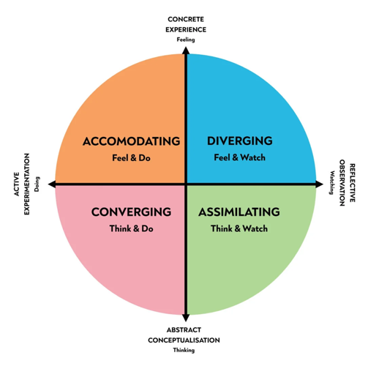

Figure 2: Kolb’s Experiential Learning Cycle (adapted from Mcleod, 2023)

The outcome of the LSI reveals which stage of the learning process an individual is most likened to. He then relates these outcomes to four basic learning styles – convergent, divergent, assimilation, and accommodative. Each basic learning style is an amalgamation of two of the four stages. Concrete experience and reflective observation generate the diverging style, reflective observation and abstract conceptualisation generate the assimilating style, abstract conceptualisation and active experimentation generate the converging style, and active experimentation and concrete experience generate the accommodating style. Figure 3 exhibits this sequel in action.

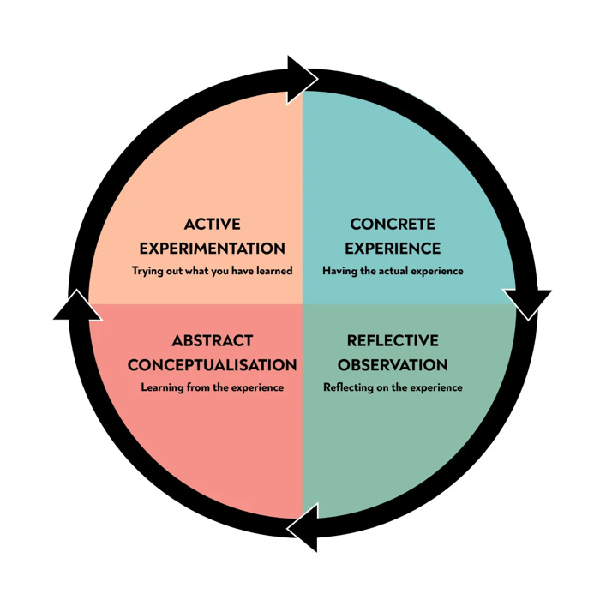

Figure 3: Kolb’s Learning Styles (adapted from Mcleod, 2023)

It was previously mentioned that Kolb built his research upon the foundations of many a great scholar. One of which is our favourite Carl, Mr Jung himself. Kolb has identified the similarities between his learning styles and the psychological types of Carl Jung. He relates the accommodative and convergent styles to extraversion, and the divergent and assimilation styles to introversion.

It is commonly felt that personality type preferences are innate. However, it is also stated by Isabel Briggs Myers, the developer of the Myers-Briggs Type Indicator, that type does not dictate behaviour. (Myers & Briggs Foundation)

Learning styles are conceived not as fixed personality traits but as possibility-processing structures resulting from unique individual programming of the basic but flexible structure of human learning. (Kolb, 2015, p. 135)

To paraphrase this pearl of wisdom that Kolb exquisitely concludes his personality type study with. Learning styles are an important aspect of individuality that need to be kept in consideration when teaching a group of people, especially children. Recognising the differences in your class, and remaining flexible towards these differences, is the first step towards constructing a classroom that’s suitable for all pupils. (Kolb, 2015)

I would like to be presumptuous and label Wendy as an introvert. This entails the possibility of her being partial to either the diverging or assimilating learning styles. From what I observed, I would place her in the divergent category. In the classroom this would mean that she cares deeply about fewer things, she’s faithful to duty, tolerant, flexible, she works harder at jobs she cares about, and wants purpose behind these jobs. Wendy requires lessons that spark her interest and inspire her to get involved.
A quote from Boud, Keogh and Walker was iterated earlier because of its accuracy in stating the importance of the learner’s determination. As well as this, they also wrote about how the past experiences of the learner, whether positive or negative, effect this determination to learn. “Utilising our positive feelings is particularly important as they can provide us with the impetus to persist in what might be very challenging situations.” (Boud, Keogh and Walker, 1985, p. 29)
I speak from personal experience when I insinuate that Wendy, and other introverted children, often have negative feelings towards school due to the lack of choice and freedom when it comes to what is learnt, and how it is learnt.

The Theory of Humanistic Learning

In the critical analysis of Wendy’s behaviour, I used the Plus, Minus and Interesting strategy to draw attention to her lack of audible participation. I then made use of the Why? Challenge to determine the logic that this is a negative thing. (Tripp, 1993)
I came to the conclusion that Wendy would benefit from a change of teaching style in the classroom. This is not intended to pass judgement onto her current teacher, as I feel that the environment in the classroom was very positive for the majority of the children. I only wish to suggest alternative methods that might encourage further involvement from the quieter class members.
Hans Furth and Harry Wachs in their book, Thinking Goes to School: Piaget’s Theory in Practice, talk about children as individuals, and encourage free thinking. They discourage lessons that follow a strict structure of memorisation and learning by rote. (Furth and Wachs, 1974)

Because each child should be viewed as an individual, we have not attempted to describe a rigid curriculum into which all children must fit; we have rather described a philosophy and a program which can be adjusted to fit all children. (Furth and Wachs, 1974, p. 3)

This quotation provides the perfect segue into the philosophy that is humanistic teaching, which I feel is closely related to experiential learning. Humanistic learning theory emphasises teaching the “whole” child. That in order to be at their best, children’s basic and psychological needs must be met first.
The theory was developed by Abraham Maslow in the early 1900s, and very much differed from the popular theory at the time – behaviourism. To Maslow, the behaviourists viewed children as trainable beings, worthy of either reward or punishment. His belief was that all humans are innately good, and if their needs are met, this goodness will thrive. To prove this, he constructed a hierarchy of needs, that began with physiological needs, followed by love, safety and esteem, then topped with self-actualisation.
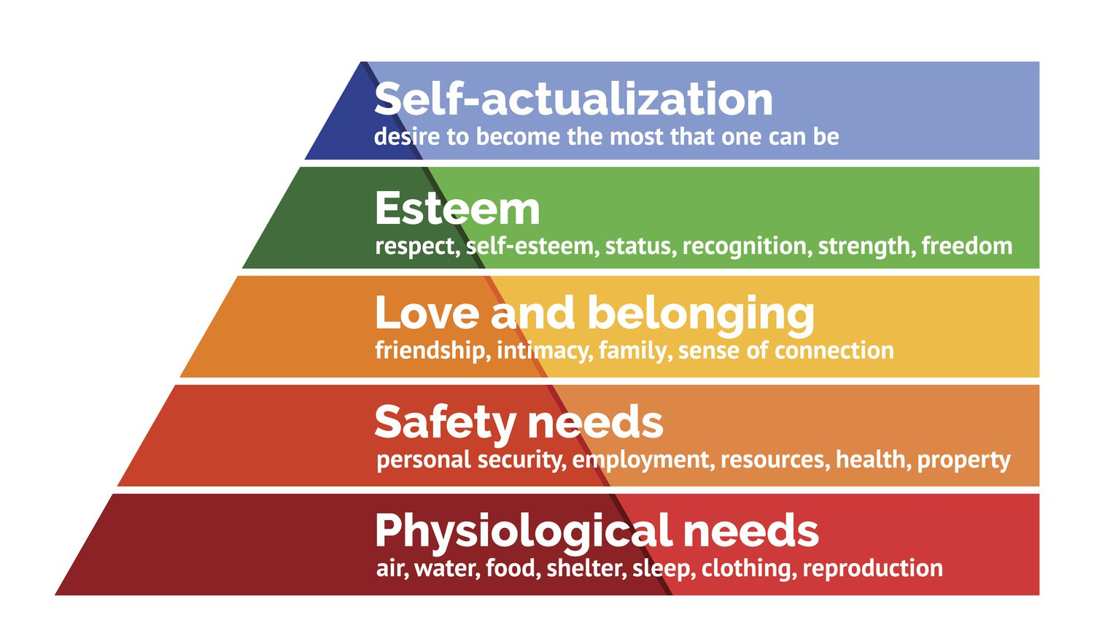

Figure 4: Maslow’s Hierarchy of Needs (adapted from Hopper, 2020)

The supposition of this theory is that we only move onto the next need in the hierarchy when the previous need has been satisfied.

We now move onto the next chapter of this essay – discussions. Here I will be reviewing the strengths and limitations of my chosen methods and putting forward my own pedagogical choices in response to the critical incident.

Discussions
Strengths and Limitations of the Suggested Theories

Beginning with experiential learning, a theory based around proactivity in and out of the classroom. When looking at the curriculum for Wales, experiential learning is well suited. The four core purposes advocate: ambitious and capable learners, enterprising and creative contributors, ethical and informed citizens, and healthy and confident individuals.
As a teaching method, it is adjustable and may be easily adapted depending on who you’re working with. An experiential teacher appreciates the melange of learning styles they have in their classroom and strives to create an environment suitable for all.
Although this assortment of characters is a merit to have in a classroom, it also provides the teacher with some quandary. One cannot hope to satisfy all. However, compromise is a beautiful word is it not? A happy medium, a halfway house, modus vivendi, etc. The children’s voices will still be heard, equal opportunity will still be available – but they will also learn patience and compromise in the classroom.

The strengths and limitations of humanistic learning are not dissimilar to those discussed for experiential learning. Once again, each child is valued as an individual, with needs and opinions. The greatest limitations we face here is the fact that school cannot satisfy every need in Maslow’s hierarchy. Love and Belonging and Esteem are the only stages where the teacher has pertinent influence; so, does this mean that if a child’s basic needs are not fulfilled at home, they have no hope of reaching self-actualisation in school? Well, German American psychologist Erich Fromm developed a theory that suggested there are five fundamental human needs – relatedness, rootedness, transcendence, sense of identity, and frame of orientation. In coordination with Maslow’s hierarchy, I would like to draw your attention to the importance of relatedness, which encompasses the ethos of Maslow’s middle stages. According to Fromm, we as humans seek to overcome our separateness from each other. We desire connection to other people and wish to form meaningful relationships. (Nickerson, 2023) (Boeree, 2006) (Cherry, 2023)
Therefore, perhaps all a child needs in school to reach self-actualisation is fellowship within the classroom.

My Pedagogical Choices

Let us return to the foundations of this essay – psychological types. We have already exhausted my opinion that personality type and learning style play an influential role in education, but now I shall discuss its implementation into my pedagogical practice.

It would be important to me as a teacher to know my children’s orientation towards learning, as well as their preferred subject. I feel that it is not fair for the child to have to change his or her fundamental nature to fit into a broad, impersonal school curriculum. Rather, it ought to be the school’s responsibility to adapt the curriculum and assessment policy as much as possible to suit the learning needs of its children.

We do not strengthen good pronunciation by punishing bad, or skilful movements by punishing awkward. We do not make a student industrious by punishing idleness, or brave by punishing cowardice, or interested in his work by punishing indifference. (Skinner, 1968, p. 149)

Who knew Burrhus Frederic Skinner had such compassionate words in him. The core of this utterance is rooted in patience. Skinner goes on to conclude that punishment may cause the child to pay attention and appear studious, but the child has not been taught. (Skinner, 1968) The presence of a patient and sensitive adult is much more motivational. Positive communication and reinforcement has the power to create the safe environment that would enable an introverted child to share aloud. There is a short booklet, entitled Building Success Through Better Behaviour: The Art of Positive Communication, written by Rob Long. In this booklet, he writes some lines that encapsulate the humanist ideology – “The right sort of encouragement enables a student to feel safe enough to make a contribution.” (Long, 2005, p, 10)
I referred to Susan Wilks’ writings in Critical and Creative Thinking earlier, as she has many insightful strategies for inclusive discussion. For example, to discourage dominant voices and encourage meek ones, enforce respectful rules among the pupils; one person speaking at a time, hands up, once your opinion has been given, it’s time to hear from someone new until all who wish to share have had a chance, etc. It is also important not to fear silence but rather encourage times of introspection and thought. (Wilks, 1995)

I feel that as much as possible, the classroom should be built around mutual respect and understanding of each other’s opinions. Everyone is an individual, everyone learns differently, everyone has a preferred area of study.
As a teacher, I want to remember how it felt to be a child in school, and view children as humans no less important than I, and I will do my best to stay true to the philosophy I have laid out in this essay.

Conclusions

To conclude this piece of writing, I would like to conduct a reflection on myself and my own understanding of the words I have written.
It’s all well and good to write with great enthusiasm about the strategies and theories I plan to implement into my own pedagogical practices as a fully fledged teacher, but I must consider the strengths and weaknesses of my findings.
Once again, I paste in the original question I put forward at the beginning of this essay - how can one create a learning environment that is suitable for all pupils, and is it possible to create a learning environment that is suitable for all pupils?
I truly believe that the answer is yes. However, the word compromise also finds its way to the forefront of my mind. Extraverts will have to compromise when it comes to discussions and topic choosing. Introverts will have to compromise when it comes to groupings and discussions also. Yet, there is equality and inclusivity in this choice, a democracy within the classroom where the pupils know their voice matters and their opinions will be acted upon.

I stand on my desk to remind myself that we must constantly force ourselves to look at things differently. The world looks different from up here. If you don’t believe it, stand up here and try it.
(Dead Poet’s Society, 1989)

Reference List

- Billington, T. and Pomerantz, M. (2004) Children at the margins: supporting children, supporting schools. Staffordshire: Trentham Books Limited.
- Black, P. and Wiliam, D. (1998) Inside the black box: raising standards through classroom assessment. London: GL Assessment.
- Boeree, G. C. (2006) Personality theories: Erich Fromm. Available at: https://webspace.ship.edu/cgboer/fromm.html (Accessed: 28 October 2023)
- Boud, D., Keogh, R. and Walker, D. (1985) Reflection: turning experience into learning. New York: Nichols Publishing Company.
- Dead Poet’s Society (1989) Directed by P. Weir. [DVD]. United States: Touchstone Pictures.
- Faitz, L. M. In defence of introversion: an argument for the other half. Available at: https://www.mckendree.edu/academics/scholars/issue18/faitz.htm#:~:text=In%201921%2C%20psychiatrist%20and%20theorist,of%20personality%20%2D%20introvert%20and%20extravert. (Accessed: 22 October 2023)
- Furth, H. G. and Wachs, H. (1974) Thinking goes to school: Piaget’s theory in practice. New York: Oxford Printing Press.
- Haber, R. A. (1980) ‘Different strokes for different folks: Jung’s typology and structured experience,’ Group and Organisation Studies, 5(1) pp. 113-121. Available at: https://www.proquest.com/docview/232434570?parentSessionId=z75llgdX24HMLNI5gfJY4Abv7xo9bx9qcTbSILvrh9I%3D&pq-origsite=primo&accountid=130472 (Accessed: 15 October 2023)
- Hopper, E. (2020) Maslow’s hierarchy of needs explained. Available at: https://www.thoughtco.com/maslows-hierarchy-of-needs-4582571 (Accessed 29 October 2023)
- Hwb (2021) Introduction to curriculum for Wales guidance. Available at: https://hwb.gov.wales/curriculum-for-wales (Accessed: 30 October 2023)
- Jouanna, J. (2012) Greek medicine from Hippocrates to Galen: selected papers. Netherlands: Koninklijke Brill NV.
- Jung, C. G. (1971) Collected works of C. G. Jung, volume 6: psychological types. New Jersey: Princeton University Press.
- Kolb, D. A. (2015) Experiential learning: experience as the source of learning and development. 2nd edn. New Jersey: Pearson Education Inc.
- Lester, D, (1990) ‘Galen’s four temperaments and four-factor theories of personality: a comment on “toward a four-factor theory of temperament and/or personality”’, Journal of Personality Assessment, 54(1&2), pp, 423-426. Available at: https://www.researchgate.net/profile/David-Lester-3/publication/232883412_Galen%27s_Four_Temperaments_and_Four-Factor_Theories_of_Personality_A_Comment_on_Toward_a_Four-Factor_Theory_of_Temperament_andor_Personality/links/5addea63aca272fdaf87148c/Galens-Four-Temperaments-and-Four-Factor-Theories-of-Personality-A-Comment-on-Toward-a-Four-Factor-Theory-of-Temperament-and-or-Personality.pdf
- Long, R. (2005) Building success through better behaviour: the art of positive communication. London: David Fulton Publishers Ltd.
- Mcleod, S. (2023) Carl Jung’s theory of personality: archetypes & collective unconscious. Available at: https://www.simplypsychology.org/carl-jung.html (Accessed: 15 October 2023)
- Mcleod, S. (2023) Kolb’s learning styles and experiential learning cycle. Available at: https://www.simplypsychology.org/learning-kolb.html (Accessed: 26 October 2023)
- Mohammed, R. (2016) ‘Critical incident analysis: reflections of a teacher educator.’ Research in Teacher Education. 6 (1), pp. 25-29. Available at: https://repository.uel.ac.uk/item/8512y (Accessed: 30 September 2023).
- Myers & Briggs Foundation. Myers-Briggs overview Available at: https://www.myersbriggs.org/my-mbti-personality-type/myers-briggs-overview/#:~:text=According%20to%20type%20theory%2C%20our,development%20of%20certain%20personality%20characteristics. (Accessed: 28 October 2023)
- Nickerson, C. (2023) Erich Fromm: life, theories, and contributions to psychology. Available at: https://www.simplypsychology.org/erich-fromm.html (Accessed: 28 October 2023)
- OpenStaxCollege. (2014) What is personality? Available at: https://pressbooks-dev.oer.hawaii.edu/psychology/chapter/what-is-personality/ (Accessed: 22 October 2023)
- Prabhu, M. (2022) Funny medicine: Hippocrates and the four humours. Available at: https://www.gavi.org/vaccineswork/funny-science-hippocratic-medicine-and-four-humours (Accessed: 28 October 2023)
- Skinner, B. F. (1968) Century psychology series: the technology of teaching. New York: Appleton-Century-Crofts.
- Steiner, R. (1971) Human values in education. London: Rudolf Steiner Press.
- Stoyanov, S. (2017) An analysis of Abraham H. Maslow’s a theory of human motivation. London: Macat International Limited
- The Colour Works (2011) Hippocrates, Galen & the four humours. Available at: https://www.thecolourworks.com/hippocrates-galen-the-four-humours/ (Accessed: 15 October 2023).
- Tripp, D. (1993) Critical incidents in teaching: developing professional judgement. London: RoutledgeFalmer.
- Western Governors University. (2020) Experiential learning theory. Available at: https://www.wgu.edu/blog/experiential-learning-theory2006.html#:~:text=What%20is%20experiential%20learning%3F,retain%20information%20and%20remember%20facts. (Accessed: 26 October 2023)
- Western Governors University. (2020) What is humanistic learning theory in education? Available at: https://www.wgu.edu/blog/what-humanistic-learning-theory-education2007.html#close (Accessed: 29 October 2023)
- Wilks, S. (1995) Critical and creative thinking: strategies for classroom enquiry. Australia: Eleanor Curtain Publishing.

