Maggie Rose Day, 2208488, ECY4002 Word count: 1,823
The importance of reflective practice as a professional practitioner
What is reflection and reflective practice?
Schon (2007, quoted in Hallet, 2012 p. 29) states that the idea of reflective practice and what it means to be a ‘reflective practitioner’ has to do with how professionals think while they are practising. Reflective practice is a process that helps practitioners improve, develop, or change the way they provide for children, and can also expand their understanding of the profession. According to Forde et al (2006, quoted in Brock 2015, p. 8), to deliver a truly inclusive curriculum, early childhood educators must be able to identify not only their educational and psychological goals but also their own personal values. Only then can they reflect on how these values shape their actions and responses. Tarrant (2013, p. 2) believes that the influence of reflection on professionalism is one of its key advantages. Practitioners can better identify their strengths and areas for improvement by reflecting on their practice. This is beneficial to increasing their awareness, control, and ability. Campbell-Barr and Leeson (2015) say that practitioners can reflect on their practice in a variety of ways, and there are many models of reflection that are deeply ingrained in the reflective landscape. Examples include Kolb's (1984) cyclical model of experience, reflect, conceptualise, experiment, experience, and Gibbs' (1988) model, which is also cyclical and includes description, feeling, evaluation, analysis, conclusion, and action plan.
Reflection and Professional Practice
Reflection can have a variety of impacts on practice. It is important for professional practitioners to reflect on their practice to enable them to develop their professionalism. Tarrant (2013, p. 13) suggests that by using reflective approaches in practice, professionals should be able to advance their knowledge and expertise. Reflection can prompt searches for educated opinions through professional reading and it can inspire practitioners to experiment with their own education in order to develop their practice. It can also prompt them to ask a peer, colleague, or senior professional for guidance or support. Hargreaves and Page (2013, p. 21-23) point out that reflecting on one's professional practice can be rewarding. The reflection strategy chosen may aid practitioners in getting through a difficult or stressful period at work and make practice more meaningful and sustainable. Additionally, it will strengthen their interactions with the individuals they work with and those for whom they are responsible. Reflection provides practitioners with a foundation on which to construct future learning. It also frequently enables practitioners to identify their strongest areas of expertise and discover previously unanticipated talents. Daniels et al (2022, p. 5) believe that reflecting on practice can influence the progress of professional development and is used as a strategy to maintain or improve teacher effectiveness across a variety of fields. Professional development can take many different forms, such as participating in classes or workshops, seminars, watching other instructors in action, team projects, or professional learning communities. According to Abou (2007, quoted in Korrko, Kyrö-Ämmälä and Turunen 2016, p. 199), through their reflection on their practicum experiences, practitioners improve their practical theories. Reflection has been regarded as both a necessity for a teacher's thinking and as a goal for programmes of teacher education. In order to better understand their feelings, ideas, and presumptions and to develop an analytical view of their experiences, practitioners s reflect on, assess, and conceptualise their experiences and views (Kolb, 1984, quoted in Korrko, Kyrö-Ämmälä and Turunen, 2016, p. 199).
Reflection within Early Years settings
The importance of practitioners reflecting in groups is covered by Bassot (2016, pp. 105). If reflection were solely a solitary experience, practitioners would lose themselves in their own point of view and only observe things from that perspective, which is typically limited, biased, and narrow. Professionals can learn and challenge their beliefs and behaviours by considering feedback through reflecting with others, such as peers and co-workers. Cowie and Wallace (2000, quoted in Bassot, 2016, p. 106) say that peer support groups are a useful tool for team reflection in Early Years settings. They provide a space where practitioners can interact on an equal basis and talk about their practice. Members arrive prepared to discuss topics with their peers and provide insights rather than solutions. Bassot states some of the benefits of reflecting with others. She believes that having the chance to reflect in groups can help prevent feelings of isolation and burnout by giving one the space to "offload" and communicate thoughts and feelings. It can also aid in the development of a better understanding of practice because talking about problems with others can help one gain a fresh perspective on what constitutes effective work in providing support to people. Skilling (2001) suggests that young children can benefit from developing their reflective learning skills. There are various chances to include reflective learning in the primary curriculum so that children can begin practising it at a young age in a planned and continuous manner. By including them in lessons, practitioners can help students become aware of their value and help them build strong work habits that are both domain-specific and universally relevant. Reflective exercises help students develop self-awareness of their own experiences and help others. Hallet (2013, p. 26) claims that discussing reflections with parents, families, and other professionals can help children grow and develop. Early intervention techniques' integrated approach to working with children and families recognises that each child has unique needs for their well-being. To address these needs, a team of practitioners is assembled around the child to tackle their educational, health, and social requirements.
Theories and models of reflection
Numerous theories and reflective practice models, including those of Schon, Gibbs, and Kolb, will be covered in this section. According to Schon, it is a critical aspect of professional activity to reflect on practice and is required in order to participate in a process of continuous professional development. In Schon's theories of reflection, making meaning of a behaviour or action after it has occurred—possibly as a subconscious activity—as well as reflective discussion in which ongoing modifications and appropriate change occur, analysis, reflection, articulation of understanding, and application are also discussed. Reflection is also seen as a useful tool for enhancing professional performance, and underlying assumptions are challenged (Brock, 2015, p. 11). Atchia (2021) describes Schon’s model and says a reflection cycle rather than a one-time, unidirectional reflection is produced by the model that includes "reflection in action" and "reflection on action," or reflection before and after an occurrence. It enables a critical assessment of the effectiveness of the educational adjustments and the determination of the necessity for additional changes. Making change a continuous component of one's journey to develop as a reflective practitioner helps to improve students' learning engagement. The contextualization of Schon's model is an additional advantage. It places a focus on reflection that begins in one's practice or own context, where professionals are faced with difficult circumstances. Analysis of a critical occurrence places a practitioner in an uncomfortable space that tests their professional identity and, as a result, opens a universe of potential for professional growth. This model also offers options for including professional opinions in the reflection process. An outsider who participates at various stages of the transformative process offers crucial outsider perspectives that validate, clarify, and track developments. Oviawe (2020) points out that another well-liked model employed by practitioners is the cycle model of reflection proposed by Gibbs (1988). In relation to reflective practice as a method of learning and creating a general education approach, Gibb's model particularly refers to the critical steps to carry out within reflection, and its application signifies a clear change from Kolb's thinking (which has a four-staged cyclical framework; concrete experience; observation and reflection; forming abstract concepts and testing in new situations). Gibb's model framework divides the setting of repeating experiential experiences into six essential stages: description of the event, feelings and ideas, evaluation, analysis, a conclusion, and a plan of action. This model is supposedly completed, and it suggests that if the same situation was to reoccur, another round of reflection will be undertaken. The reflective method helps to differentiate between theory and practice. The performance of a practitioner is based on their ability to recognise what is effective and ineffective while teaching. Only structured reflection, such as Gibb's model, may show this. This process will enhance teaching abilities in such a way in the first stage, that the practitioner begins reflecting on such things as who they are as a person, why they want to be in that profession, what the profession entails, and what role they will play, among other things. In the second stage, the practitioner determines what was good or bad in the activity and how they had an impact on it by reflecting on how they felt following the delivery of the instruction (whether satisfied or not). The answers to these queries will aid in concluding the entire experience; the practitioner will understand what was right and incorrect about it. Finally, they will make plans for what they would do differently if this situation arose again, knowing the strengths and limitations. Teacher effectiveness can only be attained through reflection, which is the only way the teacher may consider their practice. Bassot (2016, p. 43-44) states that in order to assist practitioners in learning how to learn from experience, Kolb created his experiential learning cycle in 1984. He was concerned with how people acquire knowledge at work and interpret their interactions in an organisation. The cycle's four stages are portrayed as occurring in order, one after the other. Kolb believes that while the cycle might start at any point, it frequently does so after a concrete event. This is a relatively unremarkable change or difference from what one may typically anticipate. Reflective observation is the next step in the cycle that comes after the experience. At this point, professionals reflect on what has happened and start to analyse it. Following this is the third step, known as abstract conceptualization, where practitioners start to generalise from their experiences and broaden their understanding of certain circumstances and methods. The cycle then restarts when practitioners can start applying the knowledge, they have learned to new circumstances and the subsequent experience in the last stage, known as active experimentation.
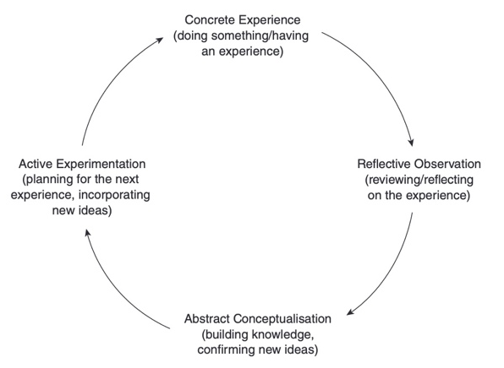
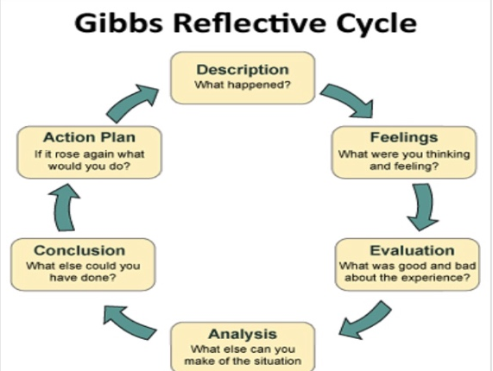

Kolb’s experiential learning cycle
(Bassot, 2016)
Gibbs Reflective Cycle
(Crowe Associates Ltd, no date)

Conclusion
In conclusion, the methods and theories that have been discussed in this briefing paper show many ways how practitioners and professionals can implement reflection into practice. Reflection is an important aspect of professional practice, and by using different methods, a practitioner can develop their knowledge and skills, aiding this professionalism as a result. Many individuals can benefit from active reflection, including children, as it allows the professional to understand the child’s ways of learning and development. By reflecting, it ensures professionals are providing the best care and education available to children, allowing them to progress and develop to their greatest potential possible.

Reference List
Atchia, S. (2021) Integration of ‘design thinking’ in a reflection model to enhance the teaching of biology, Journal of Biological Education, 31(1), pp. 1-15. Available at: https://www-tandfonline-com.ezproxy.uwtsd.ac.uk/doi/full/10.1080/00219266.2021.1909642 (Accessed: 17th October 2022)
Bassot, B. (2016) Reflective Practice Guide: An Interdisciplinary to Critical Reflection. London: Routledge
Bassot, B. (2016) Reflective Practice Guide: An Interdisciplinary to Critical Reflection. [image] London: Routledge
Brock, A. (2015) The early years reflective practice handbook. London: Routledge
Campbell-Barr, V. and Leeson, C. (2015) Quality and Leadership in the Early Years: Research, Theory and Practice. London: SAGE Publications Ltd
Crowe Associates Ltd. (no date) Gibbs’ Reflective Cycle. [image] Oxford
Daniels, L., Chazan, D., Goegan, L. and Farmer, J. (2022) ‘Conventionality and Evidence: two elements of professional development that could matter to teachers’, Professional Development in education, 48(5), pp. 3-22. Available at: https://www-tandfonline-com.ezproxy.uwtsd.ac.uk/doi/full/10.1080/19415257.2020.1763432?scroll=top&needAccess=true (Accessed: 15th October 2022)
Davison, J., Lewis, M. and Arthur, J. (2005) Professional Values and Practice: Achieving the standards for QTS. London: Routledge Falmer
Hallet, E. (2012) The Reflective Early Years Practitioner. London: SAGE Publications Ltd
Hargreaves, J. and Page, L. (2013) Reflective Practice. Cambridge: Polity Press
Jarvis, P. et al. (2016) The Complete Companion for Teaching and Leading Practice in the Early Years. 3rd edn. London: Routledge
Jones, C. and Pound, L (2008) Leadership and management in the early years: from principles to practice. London: Open University Press
Körkkö, M., Kyrö-Ämmälä, O. and Turunen, T. (2016) ‘Professional development through reflection in teacher education’, Teaching and Teacher Education, 48, pp. 198-206. Available at: https://www-sciencedirect-com.ezproxy.uwtsd.ac.uk/science/article/pii/S0742051X16300142#sec3 (Accessed: 15th October 2022)
Oviawe, J. (2020) Application of Graham Gibbs Model of Reflection to Improve Teaching Understanding among Technical Education Students in Ambrose Alli University Ekpoma Edo State, Sumerianz education, linguistics and literature, 3(2), pp. 8-15. Accessed at: https://www.researchgate.net/profile/Jane-Oviawe/publication/342106724_Application_of_Graham_Gibbs_Model_of_Reflection_to_Improve_Teaching_Understanding_among_Technical_Education_Students_in_Ambrose_Alli_University_Ekpoma_Edo_State/links/5ee24e07299bf1faac4b244b/Application-of-Graham-Gibbs-Model-of-Reflection-to-Improve-Teaching-Understanding-among-Technical-Education-Students-in-Ambrose-Alli-University-Ekpoma-Edo-State.pdf (Accessed: 17th October 2022)
Skilling, K (2001) ‘It’s time to reflect on the benefits of reflective practice’, The Primary Educator, 7(3), pp. 7-11. Available at: https://web-p-ebscohost-com.ezproxy.uwtsd.ac.uk/ehost/detail/detail?vid=0&sid=7d256f83-5f2a-439b-849c-41560ddccb56%40redis&bdata=JnNpdGU9ZWhvc3QtbGl2ZQ%3d%3d#db=eue&AN=5791238&anchor=AN0005791238-6 (Accessed: 15th October 2022)
Tarrant, P. (2013) Reflective practice and professional development. London: SAGE Publications Ltd

