Student name: Donna Thompson

Student number: 2117499

Module code: BMSA4001

Module coordinator: Dr Nalda Wainwright

Module title: Developing & Supporting Early Childhood Physical Development

This reflective journal is based on SKIP sessions carried out at Penllergaer Primary School, Swansea. It is a reflection on my knowledge of and ability to support the physical development of young children, with a focus on how these have developed as part of my training with SKIP Cymru.
The setting in which the reflections are taken from are two part-time Nursery classes within a large community primary school. I have divided the reflections into two parts, the first half of my training is reflected in cycle one and the last half in cycle two. Due to the intake process children were joining the sessions at different points in the cycles with the classes gradually increasing in numbers, each having up to 30 children aged between 3 and 4 years.
Cycle One
I thoroughly enjoy what I do. Although teaching the Nursery classes at Penllergaer over the last 8 years has been demanding and ever changing, I feel to have such an important role in the provision of those early experiences as they begin their formal education, is a privilege. Penllergaer is a fantastic school that promotes the health and wellbeing of all pupils. With physical activity and children’s mental health being high on government agendas, as a school we take a holistic approach to supporting the staff and pupils in recognising the whole body and that everything we experience physically affects us socially, emotionally and cognitively.
Staff in Nursery have certainly noticed over the years that the way children are spending their time has changed significantly. Many of our families have parents that both work full time and children are talking more of technology and of sedentary or structured activities rather than opportunities to play freely and explore their natural world with any real frequency. In what is now a society where parents are meeting in coffee houses rather than parks and entertainment is increasingly screen based, it has become apparent that children in our setting aren’t experiencing as many opportunities in their everyday lives for quality movement. They are spending less time outside pushing the boundaries of their physical and imaginative capabilities and increasing amounts of time indoors and on devices. This is a theory that Goddard Blythe reinforces, “We have seen how movement is an essential ingredient for a child’s development and capacity to learn, but children of today have less movement opportunities in their daily lives than any other generation.” (Goddard Blythe 2005: 130).
The first two days of training immediately impacted on my ability to make links between children’s sensorimotor integration and the behaviours that are becoming more apparent within the nursery classroom. Feeling that behaviour is a form of communication, I was more able to identify that some were reflective of a child’s sensory integration. How those pupils who are constantly chewing on toys or clothing, struggling with appropriate force when playing or using equipment, playing roughly, swinging or jumping on furniture were indicating a need for more vestibular and proprioceptive input.
I also considered how children are demonstrating increasing barriers to learning upon entry with more experiencing difficulties in managing their emotions and maintaining attention and concentration. Over time we have noticed more children are presenting with challenging behaviour, lower fine motor skills and communication and language levels. Increasing amounts of children have difficulties with the clarity of their speech and staying focused for longer periods of time with such delays being argued to be suggestive of poor sensory processing (Ayres, 2005; Eeles et al., 2013).
The initial training days contributed to my awareness that the behaviour and responses we are seeing in children is increasingly symptomatic of the society we now live in and are as a result of missed opportunities to experience new sensations and develop new motor functions. As Ayers states, “You do not need professional qualifications to see how a child organizes his sensorimotor processes. All you need to do is look at him and other children during the day. You cannot see the brain, but you can see behaviours that reflect the activity of the brain.” (Ayres, 2005: 13).
As I reflected on the theories from the initial training days I understood that my pupils needed to move even more to enhance brain development, promote academic behaviours and performance as well as positive health. I started to review how and when I would integrate more movement opportunities for the children to engage in gross motor activities, as “Increased physical activity provides more opportunities to promote neuromotor development, which in turn promotes FMS development.” (Stodden et al., 2008, p. 294).

It is fair to say that SKIP training highlighted how, like many others, I leaned towards the common misconception that unless there were obvious signs of difficulty in a child’s motor skills, through play and over time, every child would eventually be able to perform the actions well. As Davies states, “Because movement of young children is seen to be part and parcel of their everyday lives the danger is that it can be taken for granted and overlooked in terms of its importance of the educational spectrum.” (Davies, M, 2003).
I planned for the SKIP sessions to be carried out during our structured P.E. lessons initially. The planning first focused on providing the children with opportunities to develop and apply movement concepts and enable them to begin to build a large movement vocabulary that would underpin later development. Developing these movement concepts would, in turn, contribute to their fundamental movement skill development (FMS) as “FMS are composed of locomotor skills and object control skills. Locomotor skills involve moving the body through space and include skills such as running, galloping, skipping, hopping, sliding, and leaping (Haywood & Getchell, 2005).
Recognising that SKIP is a change of practice not an intervention programme, it was pleasing to know that I was already using some of the suggestions given during the training to promote those early movement concepts e.g. the beans game, ‘Busy Feet’. When introducing a simple traffic lights game most children responded to the stop and go system correctly. Observing their movement more closely I considered their awareness of both their personal space, sometimes known as kinesphere (Laban 1948), and their general space. I noticed the children were either following their friends or moving in circles and although some could maintain a degree of personal space when walking, if another way of traveling was introduced this would change. Although some were able to observe personal space while moving simply, without prompting and support they still used half of the general space available and seemingly struggled to adjust their general spatial awareness to the new environment, from a small classroom to the larger ‘Barn’ hall area.
It became clear very quickly that my understanding of what constituted movement prior to the training had been underdeveloped and, although some elements of what I had planned were similar, I was using newly gained knowledge of Rudolph Laban’s theories of the foundation of movement and thinking in terms of the dynamics, space and relationships. Thinking differently about the way the children were moving and how to support and enrich their experiences, it was clear that pupils needed more experiences to develop both their spatial and body awareness. Not only did I actively participate in the warm up games and model to the children expectations, I pointed out good examples of movement throughout, “I like the way turned your body and changed direction to go a different way when you got too close to....”. I also ensured that the warm-up activities included lots of language and movements that develop their size, zone and extension which supports them in their understanding of personal space e.g. big, little, near, far, in-front behind. Although much of this came naturally to me, the difference was that the training had provided me with a more in-depth understanding of why and how these contribute to the development of movement concepts in young children.
Altering task constraints through the use of coloured spots had a noticeable and positive impact on how children were using and moving within the space during the warm up games. The pupils really responded to the visual support provided by the spots, particularly those pupils with language difficulties or those with English as an additional language. One particular EAL pupil really struggled with spatial and relationship concepts. Although this improved with the introduction of spots, I recognised she needed more visual support and created a visual representation of the personal (bubble) and general spaces to use alongside any verbal instruction which she responded to.
I introduced the concept of a garden to the pupils as well as the warm up games during the first 4 weeks. To provide the children with opportunities for successful practice, once introduced, the base elements of the obstacle course remained with one task variation or constraint adaption each week. This supported engagement and provided appropriate challenge which may have been as simple as changing the direction of stepping stones from straight to zig-zag or perhaps substituting a sensory ball to a bean bag when tracking an object from a to b. As I introduced the obstacle course garden I noticed the motivation and engagement of pupils was immediate. Pupils were much more willing to take part, had positive attitudes towards the sessions and would often ask me the following day, “Are we going to the garden today?” I ensured I used every opportunity for cross-curricular learning during the SKIP sessions by linking movement concepts with learning focuses such as jumping 5 times like the ‘5 Little Speckled Frogs’ rhyme or following a zoo animal obstacle course (Dear Zoo story) that included balancing on the wavy snake, jumping over the camel’s humps or crawling slowly like a lion. Another example would be when learning about feelings and emotions. Even at this early stage, pupils were encouraged to make connections with their body and brains. How our bodies can show how we feel and how moving our bodies in different ways can change the way that we feel. During the sessions pupils changed their movements to demonstrate and connect different body sensations when feeling different emotions e.g. “We want to do heavy stomping like an elephant when we’re angry” or “How we are still and quiet when we are sad and feel small like a mouse”. Cross curricular themes also gave an element of variety to those tasks that provided opportunities for successful practices and kept the children engaged and on task.

When reflecting on the first sessions, I felt they would have gone better if there were less children in the groups at these early stages. I decided to reduce the number of children taking part in each session from half a class to four groups with shorter sessions on a rotation. This allowed me to focus on the skills, intervene and model when necessary with the intention of gradually increasing the sizes and duration as the children became more competent at using the space while moving in different ways. It also meant that the children were queuing less within the obstacle course garden and I could better manage and support those pupils who were joining the classes and SKIP sessions at different points during the cycle. Both factors contributed to the pace and fluidity of the sessions which increased engagement and resulted in the children moving more within the given time.
I also used the warm up games to observe and asses the children and ascertain their individual locomotor stages. It was only when I really focussed on the children’s movements and could analyse them in more detail, that I realized the variation in stages and abilities. Many children were demonstrating vertical stances with a middle arm guard, showing themselves to be stage two runners. I noticed that when hopping, although the foot was in front, a few children seemingly struggled with the balance and leg strength to carry out a sequence of hops. The importance of the pupils experiencing different ways of moving became very apparent and I ensured I encouraged the children to move in different ways not only in the sessions but as part of their school day.

Cycle Two:

In Penllergaer, shared spaces such as the ‘Barn’ building that is used for P.E. is timetabled and class teachers are allocated slots with little flexibility. For five weeks during this cycle my allocation for the space was reduced, this was in order to support our Mother & Toddler group in hosting a physical literacy course for parents of children 0-3, many of which will attend our Nursery classes. This was intrinsically linked to the SKIP training and even though highly supported by me, it did provide some challenges for the delivery of my SKIP sessions. The challenges became environmental/situational constraints and I was able to adapt tasks so that some sessions were delivered in our corridor areas or outside. However, the weather made it difficult to plan and not only did it have an impact on the equipment I used, I noticed a change in the engagement of the pupils; the children were more easily distracted.

As many of the children had started to settle into Nursery and were becoming more familiar with the SKIP sessions, I introduced another garden which focused on object control skills. Knowing that, “Object control skills consist of manipulating and projecting objects and include skills such as throwing, catching, bouncing, kicking, striking, and rolling” (Haywood & Getchell, 2005), I initially focused on catching After the warm up games, with the support of a TA the children moved between the two gardens. I noticed a lot of children had difficulties with tracking and observed a variation in stages with many children demonstrating delayed reaction or hugging stages. Most children’s feet were stationary and very few took one step. As time passed I noticed that some children are using the teaching cues vocabulary, when talking about the letter sound ‘x’ in the classroom, one child stated, “Like the x zone when we play games” then proceeded to make a cross on her chest. During the object control catching gardens some girls were more nervous of the ball than boys. One girl found this particularly difficult and disengaged, after adjusting the constraints and using teddies and soft toys the engagement and participation increased. Even with a few unsuccessful catches her PMC had improved and she responded well to the praise and experience.

It really made me reflect on how important it is to set the level correctly for children, so we don’t set them up to fail but to succeed thus developing a Positive Spiral of Engagement. (Figure 1)

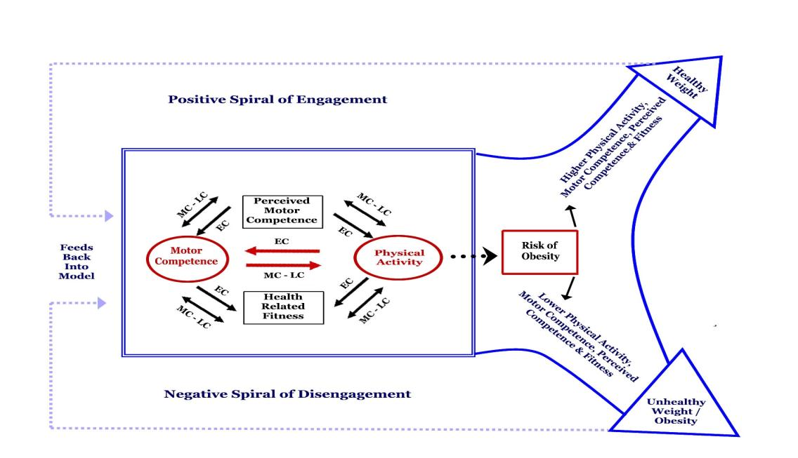
Figure 1: Developmental Mechanisms Influencing Physical Activity Trajectories of Children.

As the SKIP sessions progressed I kept Karl Newell’s Model (1986) in mind. I practiced how to alter constraints such as the space, the task and equipment in order to support the children at their developmental stage and help them develop the actions needed to become more proficient in their skills.
Figure 3: Newell’s Model of Constraints

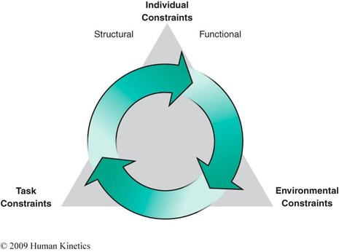
(Stodden et al, 2008: 294).

I was starting to recognise and understand that how interactions in motor development were changing as a result of the way I was beginning to manipulate task constraints during the sessions. I considered, “The individual is always undergoing age related change. This constantly changes the interaction with the environment and task and subsequently changes the way individuals move.” (Haywood and Getchell, 2014:6).

During one week I set a task within the obstacle course garden that required pupils to move a bean bag from one dome to another. Initially I observed many children passed the bag between their hands and didn’t cross the mid-line. Showing the pupils how to put their hand to their side/back enabled more pupils to carry out the task correctly and fewer passed the bag between hands. This improved further as children repeated and practised in subsequent gardens. Knowing children needed lots of successful practices I also provided opportunities for the children to cross the mid-line during classroom dough disco sessions and bean-bag balances on the playground.

I reviewed our learning environment along with aspects of the children’s daily routines. SKIP training provided me with the knowledge that an effective way for children to gain body awareness and an understanding of spatial relationships was through active exploration. Wherever possible I incorporated camouflage activities and body awareness skills into daily routines e.g. wake up wiggles, standing in a line with your body in a small bubble not too close, following and not bumping, walking fast or slow, balancing, hopping, jumping, playing a game of copy this. Weather permitting, I also set up a mini-gardens on our playground as part of our continuous provision in order to build on their experiences during P.E lessons and practice different locomotor or object controls skills

Sharing knowledge and good practice examples with the teaching assistants in the Nursery setting during this cycle has also been a focus. The training modules and required reading have highlighted how gradually over time, as a staff we have developed a ‘too safe’ attitude and this was impacting on play and active exploration. How, when using the outdoors, in fear of injury the children were being discouraged from jumping between logs, were stopped from spinning or swinging and were being deprived of opportunities to map the body and develop sensorimotor integration. Through discussion and highlighting examples of play that boosts the development of the brain, I’ve started to notice that staff are giving more consideration to the importance of these movement experiences and thinking about how and when to intervene.

In conclusion, through the delivery of the SKIP sessions and carrying out the relevant research, the level of importance physical activity has in developing the overall health and wellbeing of children has become extremely clear. With this in mind, SKIP training has inspired me to consider how to further engage parents by creating a physical literacy home school bag with cards and equipment to use at home with their children, just as they would for developing literacy or numeracy skills.
Furthermore, so that our pupils become healthy, confident individuals who take part in physical activity, as staff we need to understand that, “If children cannot proficiently run, jump, catch, throw etc. then they will have limited opportunities for engagement in Physical Activity later in their lives because they will not have the prerequisite skills to be active” Stodden, Goodway, Langendorfer, Robertson, Rudisill, Garcia & Garcia, (2012 p. 291).
In discussions with other teachers who have attended this training, our intention is to deliver a SKIP presentation and feedback session for teachers during one of our ADDs meetings. This will allow us to disseminate the knowledge, skills and good practice with other staff in order develop the physical literacy skills of all of our pupils.

Word count: 3170
References:
Goddard Blythe, S., (2005) The Well Balanced Child (2nd edition) Glouscester, Hawthorn Press.
Ayres, A. J., & Robbins, J. (2005). Sensory integration and the child: Understanding hidden sensory challenges. Western Psychological Services.
Eeles et al., A. L., 2013. Assessments of sensory processing in infants: a systematic review. Developmental Medicine & Child Neurology
Davies, M., 2003. Movement and Dance in Early Childhood. London: Paul Chapman publishing.
Haywood, K. M., & Getchell, N. (2014). Life span motor development. Human kinetics.
Stodden, D., Goodway, J., Langendorfer, S., Roberton, M., Rudisill, M., Garcia, C., and Garcia, L. (2008) ‘A Developmental Perspective on the Role of Motor Skill Competence in Physical Activity: An Emergent Relationship’, Quest, 60(2), pp. 290-306.

