

M6X01290 Operations Analysis

Assignment Title: Operations Management

Subject Area: Eddie Stobart Road Transport Services

Submission date: 11/12/2017

Luke Atherton

P146891

Contents

Abstract.............................................................................................................................................................i
1. Introduction..................................................................................................................................................1
2. Operations Management Overview.............................................................................................................1
2.1 Slack et al., Five Performance Objectives..................................................................................2-3
Figure 1 - Internal and external effects of the five performance objectives........................................3
3. Eddie Stobart Company Vision....................................................................................................................4
4. Measuring Success and Performance – Stobart Group Annual Report 2017..........................................4-5
Figure 2 - Summarisation of identified risks and risk mitigation strategies..........................................5
5. Meeting Environmental Efficiency Needs and Sustainability.......................................................................6
5.1 Eddie Stobart Innovative Vehicle Design....................................................................................6-7
5.2 Eddie Stobart Transport Systems Infrastructure Development.....................................................7
6. Discussion...................................................................................................................................................8
7. Conclusion...................................................................................................................................................8

Abstract

Operations management plays a significant role in the successful creation and delivery of products and services within modern organisations, with the primary function of enhancing performance using specific performance objectives, measuring success and identifying areas for improvement. The Eddie Stobart road transport division provides a current example of an organisation implementing effective methods to measure performance of operations and mitigating potential future risks, with the main objective of sustaining a high level of service quality for customers and driving down operational costs.

i
1. Introduction

‘The amount of goods lifted and goods moved by GB-registered heavy goods vehicles (HGVs) operating in the UK has shown a broadly upward trend since 1990’ (Department for Transport, 2017, p.2).

Established in 1970, Eddie Stobart is now a leading logistics and supply chain organisation in the UK (Eddie Stobart, 2017a) offering a diverse portfolio consisting of multimodal transport, storage, warehousing facilities and handling services throughout both the UK and Europe (CTP, 2014). Eddie Stobart was initially founded with just 8 trucks and 12 employees, and by the turn of the millennium had grown considerably as an organisation, with approximately 1,000 vehicles, 2,000 employees, and numerous depots based throughout the UK (Barford, 2011). According to The Telegraph (2011); ‘The company's rapid growth owes much to deregulation during the Eighties, but Edward Stobart had the vision to exploit the changing times’. The decade saw a development of the motorways and expansion of large out-of-town supermarkets. Eddie Stobart currently operates from its headquarters in Warrington, England, and now boasts a total of 24 distribution centres across the UK and Europe, operating approximately 2,200 vehicles and 3,800 trailer units (Eddie Stobart, 2017a). Renowned as carrying and promoting a ‘super brand’ image (CTP, 2014), Eddie Stobart also boasts a staggering 25,000 dedicated fan club of lorry enthusiasts, and has featured in its own reality TV show showcasing behind the scenes footage of its operations (Wembridge, 2013). It is suggested by Eddie Stobart (2017a), that a key aspect to the success of the organisation and sustained growth is through its reputable high quality level of service, leading to a strong foundation of long term customer relationships, particularly with ‘blue chip’ customers. This report will focus primarily on the road transport division of the Eddie Stobart organisation, identifying how its customers expectations are met in terms of service quality and cost as part of the five performance objectives specified by Slack et al., (2013). Critical analysis of operations management theories and identified performance objectives will highlight areas in which the organisation performs well, as well as highlighting potential operational issues, allowing for any appropriate recommendations to be made in terms of addressing these issues.

2. Operations Management Overview

Operations management plays a vital role in the creation and delivery of products and services within modern organisations (Slack et al., 2013). It is primarily the activity of managing resources within an organisation in order to support the successful delivery of its products or services, and is widely referred to as ‘operation function’ (Slack et al., 2013). How an organisation secures, deploys and utilises its resources is key for meeting specific organisational performance objectives (Cengage, 2017). According to Slack et al., (2004) an organisation’s operations are measured on how they perform, and there are various different methods for determining performance of operations. Slack et al., (2004) further refer to the ‘triple bottom line’ approach used to measure the social, environmental and economic impact of an organisation’s operations, and indentify the following five operation management performance objectives of; quality, speed, dependability, flexibility and cost.
1
2.1 Slack et al., Five Performance Objectives

Quality – Ability to consistently produce services or products in accordance to specification and conforming to customers expectations (Slack et al., 2004). Quality is referred to as the most visible aspect of operations, and is easily identified and judged by customers. According to Slack et al., (2004, p.46); ‘A customer perception of high-quality products and services means customer satisfaction and therefore the likelihood that the customer will return’.

Speed – Elapsed time between customers requesting products or services and receiving them (Slack et al., 2004). The importance of speed within an organisation is the ability to respond quickly to customer demand, therefore offering shorter lead times to its customers for its products or services (Cengage, 2017). According to Slack et al., (2004, p.47); ‘The main benefit to the operation’s (external) customers of speedy delivery of goods and services is that the faster they can have the product or service, the more likely they are to buy it, or the more they will pay for it’.

Dependability – Delivering products or services in accordance to promises made to customers (Slack et al., 2004). It is suggested by Slack et al., (2004, p.49); ‘Customers might only judge the dependability of an operation after the product or service has been delivered’. Dependability is an important factor in the long run for operations, and can impact upon other performance objectives (Slack et al., 2014).

Flexibility – Involves the capability of changing operations, and is comprised of the following aspects:

- Product/service flexibility – ability to innovate and introduce new products or services within the organisation.
- Mix flexibility – ability to generate a wide variety or mix of products or services in relation to market demand.
- Volume flexibility – ability to change output or volume levels, the involvement of activities to process varied quantities of products or services in relation to time.
- Delivery flexibility – ability for an organisation to alter its timing of delivering products or services.
(Slack et al., 2004).

2

Cost - The organisations ability to produce and deliver products or services at low cost (Cengage, 2017). Cost is a crucial aspect of an organisation’s operations, particularly those with the major objective of competing against rival companies (Slack et al., 2004). Slack et al., (2004, p.55) simply state that; ‘The lower the cost of producing their goods or services, the lower can be the price to their customers. Even those companies that do not compete on price will be interested in keeping costs low’. Operations management within an organisation can greatly influence cost, dependent on which area of operations the majority of costs are incurred (Slack et al., 2004). The costs of operations within an organisation will often include employment of personnel, manufacturing and material costs (if producing goods), facilities and equipment (Slack et al., 2004). It is in the interest of all organisations to keep the cost of operations as low as possible, however achieving this without affecting other levels of performance objectives can be particularly challenging for modern organisations. Figure 1 below demonstrates both the internal and external effects of the five performance objectives within an organisation, and illustrates how cost is influenced by the other four performance objectives.

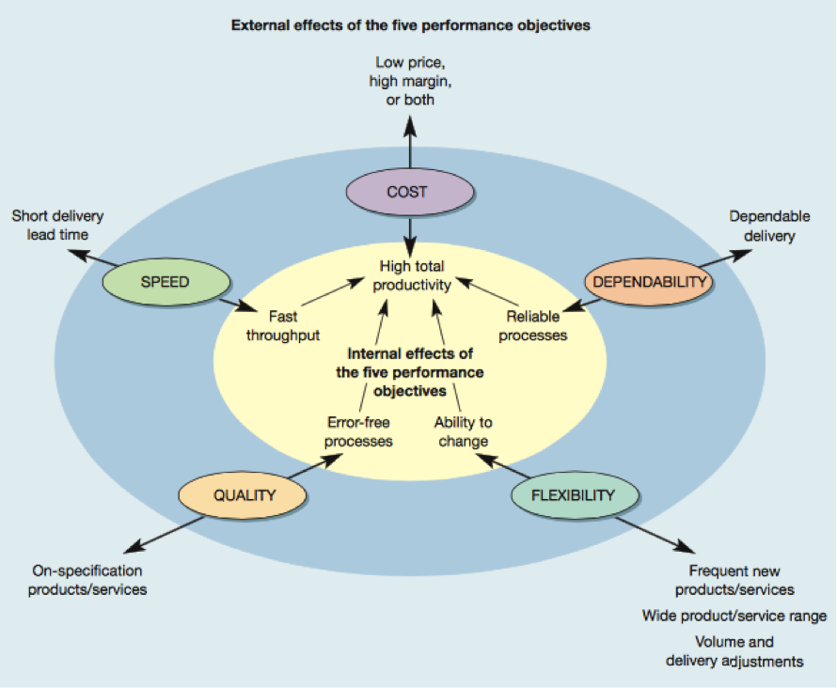
Figure 1 – Internal and external effects of the five performance objectives within an organisation (Slack et al., 2014)

3

3. Eddie Stobart Company Vision

Today Eddie Stobart operates a ‘Pan European’ network, operating 24 hours a day, 365 days a year, supporting major industry sectors such as; retail, consumer, manufacturing, construction and e-commerce (Microlise, 2017). As of 2017, Eddie Stobart has currently secured long term high value contracts in the consumer and retail sector with illustrious industry brands such as Tesco, Britvic and Coca-Cola, and has also secured a recent three year contract with Homebase providing logistics services to over 230 stores nationwide, commencing from January 2018 (White, 2017). Furthermore, according to White (2017); ‘Within its special operations sector, the company said it secured new contracts to provide logistics and technical services to Mercedes Benz and the FIA for the next Formula One season’. The key to the continued success and expansion of Eddie Stobart operations can be associated with their company vision and corporate governance policy. Eddie Stobart is recognised for its pride and professionalism in delivering innovative customer solutions and service excellence (Eddie Stobart, 2017b), and incorporates the following principles in to its company strategy:

- Demonstrating passion and exceptional customer service
- Commitment to a clear future vision and company plan
- Creating a culture of respect within the organisation via implementing an open and honest policy
- Encouraging contribution, innovation and ownership across all areas within the organisation
- Promoting leadership and discovering full potential of personnel
- Recognising success and showing gratitude
(Eddie Stobart, 2017b)

4. Measuring Success and Performance – Stobart Group Annual Report 2017

The Stobart Group identifies the importance of developing a strong level of trust with its customers, suppliers and the public, and implements the use of internal and external auditing to maintain customer relationships to measure the success and performance of its operations (Eddie Stobart, 2017c). Auditing is a formal, systematic and disciplined approach used in organisations to evaluate the effectiveness of processes, whilst identifying and monitoring areas for improvement (Rupert, 2017). According to Eddie Stobart (2017b); ‘The output of this audit allows us to continuously monitor our compliance and performance; helping us to drive continuous improvement and success’. The Stobart Group is externally audited by; KPMG, BDO, ISO, BRC, HMRC, DVSA, and its customers (Eddie Stobart, 2017b).

4

Examination of The Stobart Group 2017 Annual Report identifies how the organisation measures the success of its operations and processes, highlighting potential operational issues and risks to the organisation both current and in the foreseeable future. According to Stobart Group (2017a, p.70); ‘A robust assessment of the principal risks facing the Group, including those that would threaten its business model, future performance, solvency and liquidity has taken place’. The Stobart Group’s business activities, alongside identified factors which could potentially affect the future performance and position of the organisation are assessed using key performance indicators (KPI’s) to assist the board of directors and executive managers with evaluating performance (Stobart Group, 2017a). The ‘Strategic Report’ section of the 2017 Annual Report details an overview of risk identification and how risks are managed using the ‘Stobart Group Risk Management Framework’ (Stobart Group, 2017a). According to Stobart Group (2017, p.27); ‘Having a robust system of internal control with a combination of people, process and technology controls, helps us to mitigate risk’. The report details the following internal attributes for risk mitigation of; a strongly process driven organisation model, stable and long term management structure, and predominantly UK based operations with a strong business culture (Stobart Group, 2017). It is worth noting that The Stobart Group are confident ‘Brexit’ will not pose a risk to its operations (Lowther, 2016). The highlighted potential risks and the impact on operations across the group are summarised in figure 2 below:

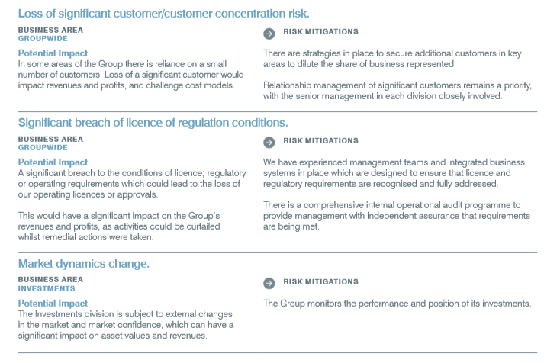

Figure 2 – Summarisation of identified risks and risk mitigation strategies (Stobart Group, 2017a)
5

5. Meeting Environmental Efficiency Needs and Sustainability

‘Stobart Group is committed to reducing the environmental impact of our operations and where possible, builds environmental sustainability into each business function and process’ (Stobart Group, 2017b)

Sustainability was defined by the The Brundtland Report in 1987 as; ‘Development that meets the needs of the present without compromising the ability of future generations to meet their own needs’ (IISD, 2017) and still provides the most recognisable definition of sustainability today. Demonstrating sustainability of operations is key to attracting and retaining customers, employees and investors, which are vital for sustaining growth of an organisation, and whilst it is not a current regulatory requirement for The Stobart Group to provide documentation of emissions and greenhouse gases, the organisation still follows the recommendations and guidelines set out by the Companies Act 2006 (Strategic and Directors Report Regulation 2013), in an attempt to reduce the impact of its operations on the environment, and attract new investors and customers. This has lead to a significant increase in the development of transport systems and innovative vehicle design solutions in recent years resulting in lower operating costs (Stobart Group, 2017a).

5.1 Eddie Stobart Innovative Vehicle Design

Developments in innovative vehicle design have lead to the introduction of Euro VI, ad blue, gas and dual fuel trucks to the Eddie Stobart vehicle fleet in an attempt to drive down emissions and operating costs (Eddie Stobart, 2017d). As of 2016/17 The Eddie Stobart fleet now comprises of 86% of Euro VI compliant vehicles (up 3% from 2015/16), and 14% Euro V compliant vehicles (down 3% from 2015/16) (Stobart Group, 2017a). According to Druce (2012), striving to reduce emissions and increase efficiency of operations spurred on the expansion of vehicle fleet to dual-fuel Volvo trucks, further instigated by Eddie Stobart’s successful winning bid for the Government’s ‘Low Carbon Demonstration Scheme’ funding (Druce, 2012). The use of liquid natural gas as an alternative fuel replaces up to 90% of diesel fuel used to power each truck, diesel produces around 2.6kg of CO₂ per liter burned, whilst of liquid natural gas used in conjunction with diesel is estimated to reduce CO₂ emissions by up to 10-14% (BOC Online UK, 2013).

Further innovative vehicle design solutions include the development of the ‘WR Aerokit’, a collaborative effort between Eddie Stobart and motorsport performance engineering company ‘Wirth Research’, designed to reduce vehicle drag by 33% compared to 10% normally achieved by standard vehicle aero kits (Wirth Research, 2017). Designed with the overall purpose of increasing fuel efficiency, reducing CO₂ emissions and therefore reducing operating costs, development initially began in 2010 and saw over 500,000 miles covered in ‘real world’ testing resulting in a ‘substantial reduction in CO₂ emissions’ in correspondence with predicted calculations of aerodynamic drag (Atherton, 2017). The WR Aerokit was deemed an enormous success, leading to Wirth Research being the chosen winner of The Low Carbon Awards 2015 (SMMT, 2015). 6

More recently, developments in vehicle design include the Transdek UK ‘Tall Boy’ multi-temperature double deck trailer, designed specifically for the Eddie Stobart fleet, and offering an increase of 55% extra loading space in comparison to a single deck trailer (Motorsport Transport, 2017). The Tall Boy trailer is designed with an ultra-low chassis allowing for maximum dimensions and loading space, to transport lightweight, temperatures controlled products, and is estimated to achieve a saving of up to 35% on delivery miles.

5.2 Eddie Stobart Transport Systems Infrastructure Development

Eddie Stobart has developed an advanced road transportation systems infrastructure, aimed at maximising its operational performance, via minimising waste miles, improving fuel economy, increasing driver productivity and strengthening customer relations (Eddie Stobart, 2017d). The infrastructure is comprised of:
- A dedicated team of account managers
- Intelligent network solutions
- Cutting edge telematics systems and communications, GPS and Driverline - connecting the driver to customer services and allowing tracking of issues with deliveries
- Centralised forecasting and dedicated planning team
- Centralised customer support team, offering expertise’s 24/7
- Comprehensive training academy for employees
(Eddie Stobart, 2017d)

7
6. Discussion

After examining and evaluating the five performance objectives of operations management; quality, speed, dependability, flexibility and cost identified by Slack et al., (2004), against the operation processes of the road transport division of Eddie Stobart, it is strongly evident that the most relevant and fundamental performance objectives within the organisation are quality of service and cost of operations. It can be argued that all five performance objectives should be balanced within the organisation to provide a greater level of efficiency, although, as Slack et al., (2004) points out, performance objectives can be ‘traded off’ against each other to improve operational performance, albeit this method is likely to sacrifice performance in other areas. Johnston et al., (2012) however share a different viewpoint when measuring performance of operations in an organisation, and refer to ‘benchmarking’ as a beneficial strategy for improving and measuring performance of operations, stating; ‘Benchmarking is the activity whereby a measure or target of a process or some other aspect of an organisation or operation is compared with a similar aspect of something else in order to learn and improve performance’ (Johnston et al., 2012, p.369). The proclaimed advantage of this strategy is benchmarking practices against rival organisations, allowing the organisation to apprehend how the desired level of performance was achieved, with the aim of mimicking the processes within their own processes (Johnston et al., 2012). Whilst both of the identified strategies may benefit the organisation with improving and measuring performance objectives, a weakness of benchmarking could be associated with its lack of apparent flexibility, whilst the five performance objectives specified by Slack et al., (2004) carry much greater adaptability, allowing for greater scope for changes vital for modern organisations.

7. Conclusion

It is evident after reviewing the The Stobart Group 2017 Annual Report that auditing is used as a principal tool for measuring performance of its operations, identifying areas for improvement, and assessing potential risks or issues which may arise and impact upon the road transport division operations. Identified risks, the potential impact on operations, and appropriate actions to mitigate the highlighted risks are also detailed in the report, with loss of significant customer/customer concentration to competition deemed to be of the highest level due to the nature of tendered contracts and quantity of current tendered contracts and maintaining long running relationships with its customers. The findings from this report further refer to rewarding of tendered contracts to be one of the most reliable methods for measuring performance, a key indicator of successfully balancing the five performance objectives of operations management; quality, speed, dependability, flexibility and cost. However, as the evidence suggests, the aspects of quality and cost to carry greater importance in Eddie Stobart road transport division operations, with considerable focus on continually building and maintaining customer relationships through an unprecedented level of high quality service, and driving down cost via the development of innovative vehicle design solutions and advanced transport infrastructure systems. Recommendations can include future consideration of investing in electric vehicle technology to further promote brand image by meeting challenges of sustainability and mitigating the effects of operations on the environment via reducing carbon emissions. 8
References
Atherton, L. (2017) Extent to which European Environmental Legislation has influenced UK sustainable logistics operations; Influences of directives on road freight vehicle design. Unpublished Manuscript, UWTSD. P.6

Barford, V. (2011). How did Eddie Stobart become so famous?. [online] BBC News. Available at: http://www.bbc.co.uk/news/magazine-12925163 [Accessed 6 Dec. 2017].
BOC Online UK. (2013). Press Releases | BOConline UK. [online] Available at: https://www.boconline.co.uk/en/news-and-media/press_releases/news2013-12-12.html [Accessed 8 Dec. 2017].
Cengage (2017). Chapter 2 - Operations, Strategy And Operations Strategy. [online] Cws.cengage.co.uk. Available at: http://cws.cengage.co.uk/barnes/students/sample_ch/ch2.pdf [Accessed 6 Dec. 2017].
CTP (2014). Focus on Eddie Stobart. [online] Ctp.org.uk. Available at: https://www.ctp.org.uk/focus/job-finding-focus-on-eddie-stobart/461304 [Accessed 9 Dec. 2017].
Department for Transport (2017). Domestic Road Freight Statistics, United Kingdom 2016. Department for Transport, p.2.
Druce, C. (2012). Stobart goes green with dual-fuel Volvos. Commercial Motor, (5499), p.8.
Eddie Stobart (2017a). About | Eddie Stobart. [online] Eddie Stobart. Available at: http://eddiestobart.com/why-eddie-stobart/about [Accessed 6 Dec. 2017].
Eddie Stobart. (2017b). Our Vision & Values | Eddie Stobart. [online] Available at: http://eddiestobart.com/why-eddie-stobart/our-vision-values [Accessed 11 Dec. 2017].
Eddie Stobart. (2017c). Corporate Governance | Eddie Stobart. [online] Available at: http://eddiestobart.com/support/corporate-responsibility [Accessed 10 Dec. 2017].
Eddie Stobart. (2017d). Road Transport & Logistics | Eddie Stobart. [online] Available at: http://eddiestobart.com/our-operations/road-transport [Accessed 11 Dec. 2017].
IISD (2017). Sustainable Development. [online] IISD.org. Available at: http://www.iisd.org/topic/sustainable-development [Accessed 10 Dec. 2017].
Johnston, R., Clark, G. and Shulver, M. (2012). Service operations management. 4th ed. Harlow, England: Pearson, p.369.
Lowther, S. (2016). Stobart Group chief: ‘Brexit won’t have much of an effect’. [online] Proactiveinvestors UK. Available at: http://www.proactiveinvestors.co.uk/companies/stocktube/5205/stobart-group-chief-brexit-wont-have-much-of-an-effect-5205.html [Accessed 11 Dec. 2017].
Motor Transport (2017). BOY OH BOY. Motor Transport, [online] p.10. Available at: https://search-proquest-com.ezproxy.uwtsd.ac.uk/docview/1953345591?accountid=130472&rfr_id=info%3Axri%2Fsid%3Aprimo [Accessed 9 Dec. 2017].
Rupert, M. (2017). Defining the Meaning of ‘Auditing’ and ‘Monitoring’ & Clarifying the Appropriate Use of the Terms. [online] Ahia.org. Available at: https://www.ahia.org/assets/Uploads/pdfUpload/WhitePapers/DefiningAuditingAndMonitoring.pdf [Accessed 10 Dec. 2017].
Slack, N., Brandon-Jones, A. and Johnston, R. (2013). Operations management. 7th ed. Harlow, England: Pearson, pp.6-36
Slack, N., Chambers, S. and Johnson, R. (2004). Operations Management. 4th ed. Harlow: Pearson Education. pp.36-55
SMMT. (2015). Aerodynamic kit for HGVs wins Low Carbon Champions Award. [online] Available at: https://www.smmt.co.uk/2015/09/aerodynamic-kit-for-hgvs-wins-low-carbon-champions-award/ [Accessed 9 Dec. 2017].
Stobart Group (2017a). The journey in action - Stobart Group Limited Annual Report and Accounts 2017. [ebook] Emperor, pp.27-70. Available at: http://www.stobartgroup.co.uk/images/group/reports/2017/26063_Stobart_AR17_AW.pdf [Accessed 11 Dec. 2017].
Stobart Group (2017b). Community and environment. [online] Stobartgroup.co.uk. Available at: http://www.stobartgroup.co.uk/stobart-group/community-and-environment [Accessed 10 Dec. 2017].
The Telegraph (2011). Edward Stobart. [online] Available at: http://www.telegraph.co.uk/news/obituaries/finance-obituaries/8419820/Edward-Stobart.html [Accessed 9 Dec. 2017].
Wembridge, M. (2013). Stobart aims to deliver the goods in the boardroom INDUSTRIAL TRANSPORT. Financial Times, p.16.
White, J. (2017). Eddie Stobart reports good contract progress ahead of Christmas. [online] BOLSAMANIA. Available at: https://www.digitallook.com/news/news-and-announcements/eddie-stobart-reports-good-contract-progress-ahead-of-christmas--2978053.html [Accessed 8 Dec. 2017].
Wirth Research. (2017). THE ALL-NEW WR AEROKIT FROM WIRTH RESEARCH WITH EDDIE STOBART. [online] Available at: http://www.wirthresearch.com/news/the-all-new-wr-aerokit-from-wirth-research-with-eddie-stobart.html [Accessed 9 Dec. 2017].

