Leon Mathias
2013015
Computing (Software engineering)
Student University of Wales Trinity St David, Swansea, Wales
Network Operating Systems and Services (ACCA5023)
Date of submission: 03/03/2022

Table of Contents
Introduction 3
1 Building a virtual LAN using type 2 hypervisor management software 4
1.1 VM creation 4
1.1.1 Creating server1 and client1 4
1.1.2 VM optimisation 5
1.1.3 Operating System installations. 6
1.1.4 Clone the VMs 8
1.2 Virtual Network Configurations 9
1.2.1 Create a public network 9
1.2.2 Create a network between server1 and client1 10
2 Deploying a network directory service and creating and understanding active directory network objects 14
2.1 Pre-requisite 14
2.1.1 Rename server1 16
2.2 Deploying Active Directory 17
2.3 Creating user account 19
2.3.1 Creating new domain admin 19
2.4 Object attributes 21
2.5 Adjoining the domain 23
2.6 Testing user logins 25
3 Observational Tasks 26
3.1 Type 1 and Type 2 Hypervisors 26
3.2 Cloud computing 27
3.3 Domain name system (DNS) 27
3.4 Critical Role or Feature based installations 28
3.5 Network terminologies 28
Reflection 28
References 29

Figure 1: Creating Server1 and Client1 5
Figure 2: Boot order optimisation 6
Figure 3: PAE/NX optimisation 6
Figure 4: Display memory optimisation 6
Figure 5: OS location server1 7
Figure 6: OS location Client1 7
Figure 7: OS install complete 8
Figure 8: Clone VMs 9
Figure 9: All VMs created 9
Figure 10: Public net server1 adapter 10
Figure 11: PublicNet IP server1 10
Figure 12: PrivateNet server1 adapter 11
Figure 13: PrivateNet IP server1 11
Figure 14: PrivateNet IP client1 12
Figure 15: PrivateNet client1 adapter 12
Figure 16: Turn off firewall 13
Figure 17: Ping test Client2 and Server2 14
Figure 18: Ping test Client1 and Server1 14
Figure 19: Check server IP, statically defined 15
Figure 20: Check firewall is off 15
Figure 21: Check no DNS 16
Figure 22: Rename Server1 17
Figure 23: Active Directory Domain services installed 18
Figure 24: Active directory options 18
Figure 25: Login to server1 as domain controller 19
Figure 26: Domain controller list 20
Figure 27: Domain admin list 20
Figure 28: Add user as domain admin 21
Figure 29: New user created 21
Figure 30: New user created and displayed in users list 22
Figure 31: Disallow password change 23
Figure 32: Change logon hours 23
Figure 33: Add new computer in AD 24
Figure 34: Rename client1 24
Figure 35: Set DNS on Client1 25
Figure 36: Client1 connected to nosstask domain 25
Figure 37: User login success 26
Figure 38: User login fail 26
Figure 39: Type1 and Type2 hypervisor 27
Figure 40: DNS steps 28

Introduction
In this paper there is screen shots along with narration that explains building a virtual LAN using type 2 hypervisor from creating virtual machines to creating public and private networks. As well as deploying a network directory service and creating active directory network objects. This will contain creation of user account and domain admins. There will also be a description of relevant research and information in regards to building a virtual LAN.

1 Building a virtual LAN using type 2 hypervisor management software

VM creation

1.1.1 Creating server1 and client1
In order to build a virtual LAN firstly virtual machines (VM) must be created and the correct operating systems installed.
Displayed in the images below Server1 and Client1 VM are being created. Server 1 is created with Windows 2019 while Client1 is created with Windows 10.
Both machines are allocated 4096MB of memory. The memory allocated to the VM’s are subtracted from the host system therefore the memory must be allocated wisely.
A virtual hard drive is created on both machines in order to store the operating system and any data [17]. The storage should be dynamically allocated in order to allow the storage to grow and expand as needed.

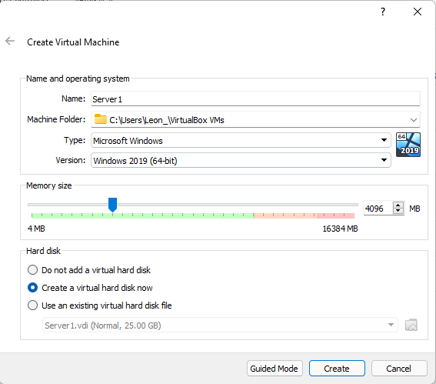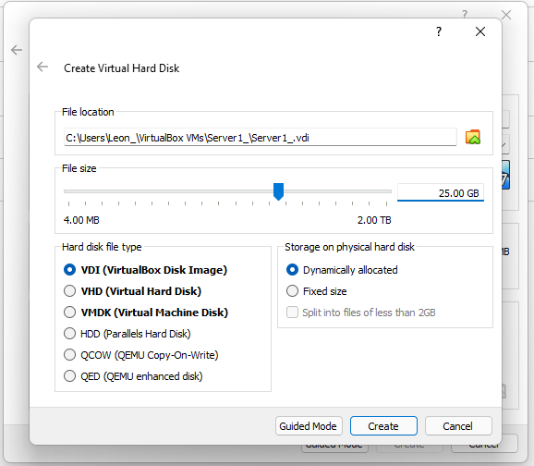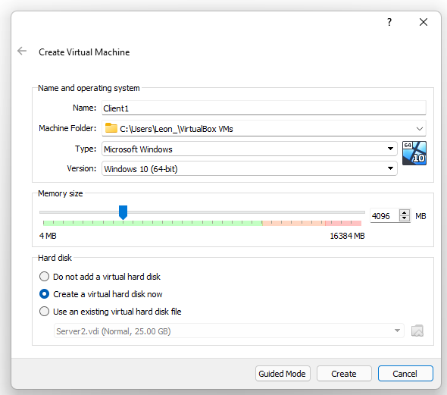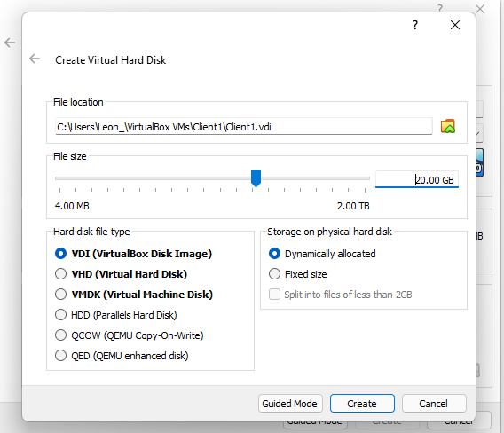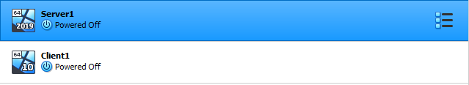
Figure 1: Creating Server1 and Client1

1.1.2 VM optimisation
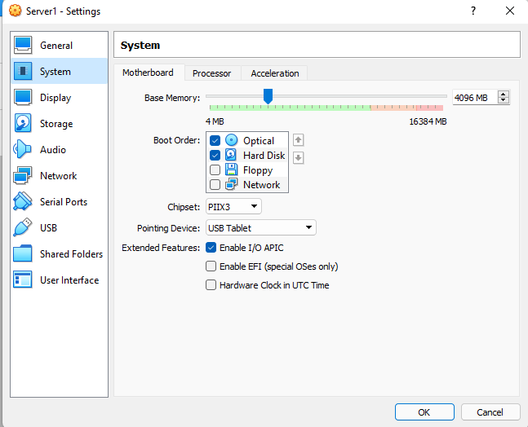
In order to prevent the VMs running slowly there are ways to optimise them in order to help them run quickly and smoothly.
Figure 2: Boot order optimisation
One way of optimising is to change the boot order by moving optical and hard disk up as displayed in figure 2 to speed up boot time.

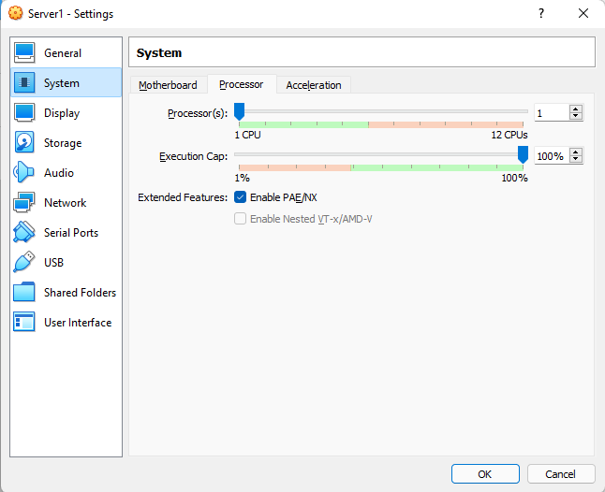
Another optimisation option is to enable PAE/NX seen in figure 3 which makes the VM a priority for the host machines CPU.
Figure 3: PAE/NX optimisation

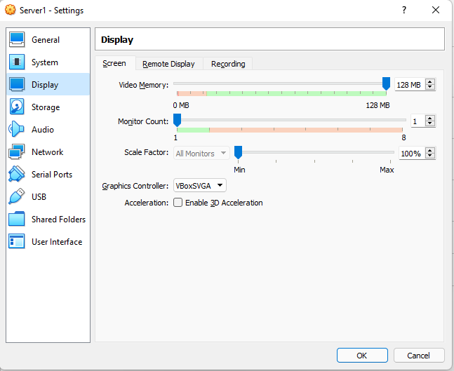
Figure 4: Display memory optimisation
Ensure the maximum display memory is selected shown in figure 4.

1.1.3 Operating System installations.
Once the both the server1 and client one VMs have been optimised the appropriate operating system can now be installed.
In order to install the operating systems onto the VMs the VM must know where the installation file is as displayed in the both figure 5 and figure 6. Once both the VM knows the path location of the file the VM is now ready to start.

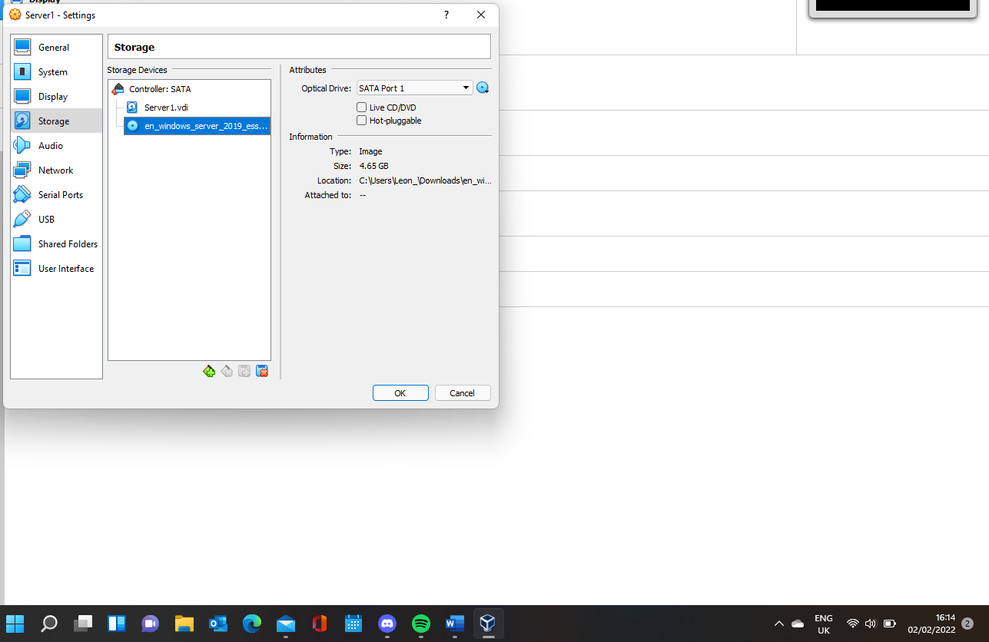
Figure 5: OS location server1
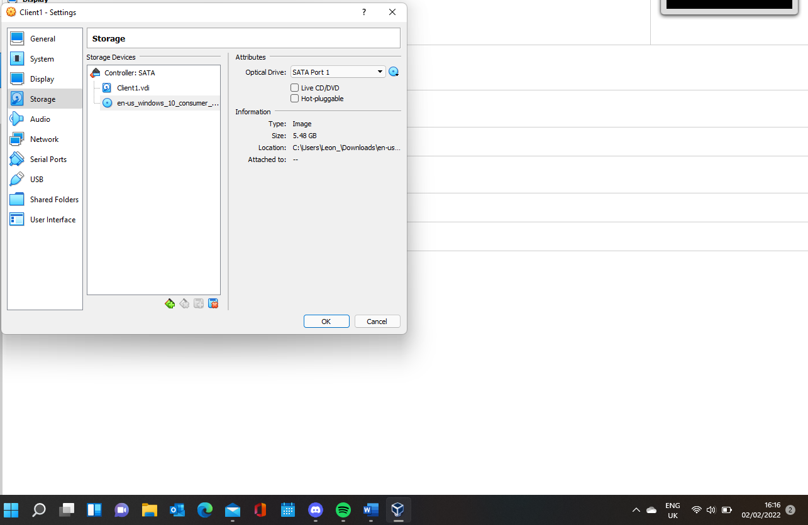
Figure 6: OS location Client1

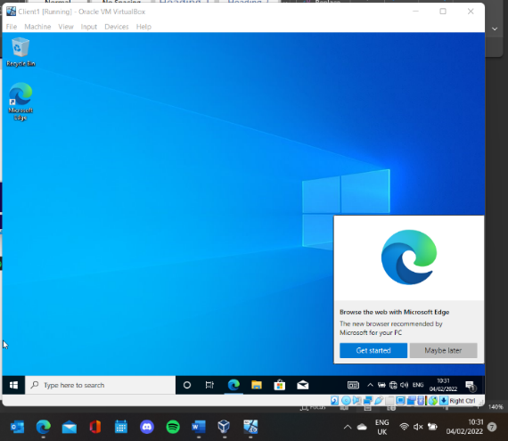
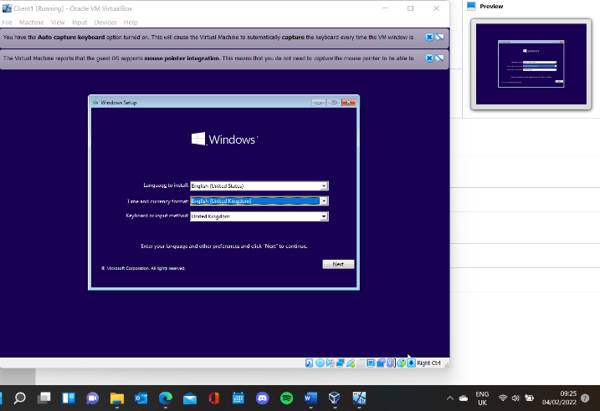
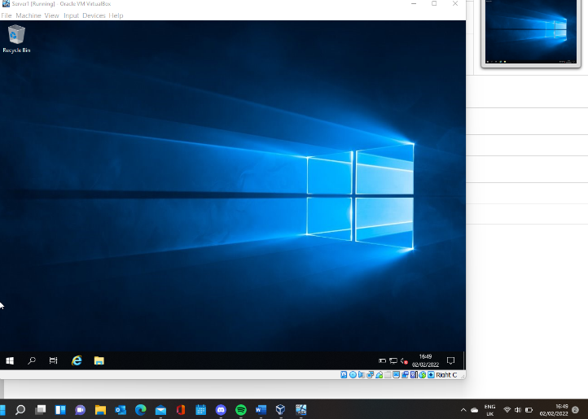
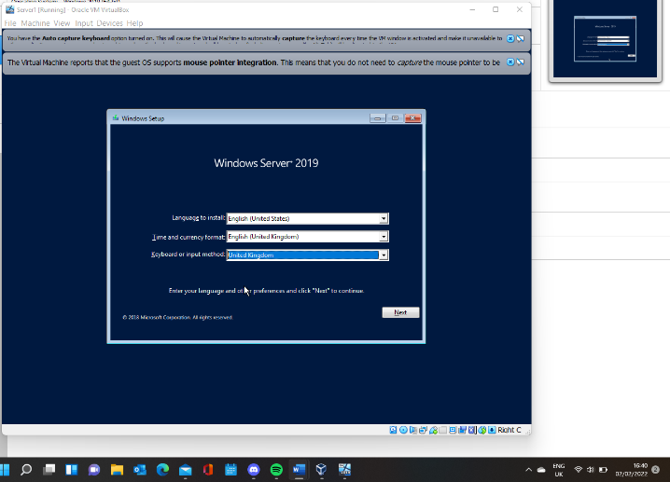
Figure 7: OS install complete
After starting the VMs an installation window will appear displayed in figure 7 below from there the operating system can be installed.

1.1.4 Clone the VMs
In order to save time and ensure consistency both Server1 and Client1 can be cloned in order to create Server2 and Client2.
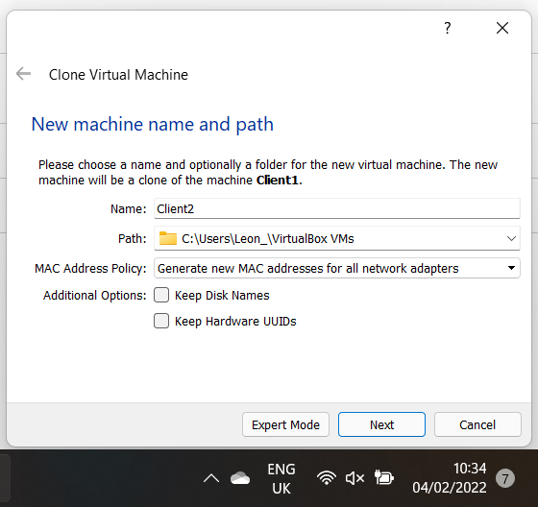
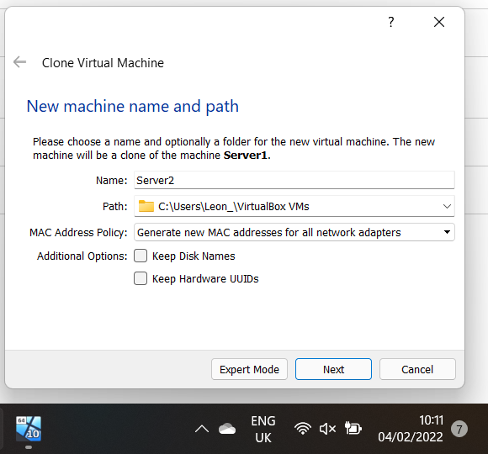
Figure 8: Clone VMs
Ensure the mac address policy setting generates a new MAC address for all networks adapters because in order for a LAN to work the VMs must have a unique MAC address in order for the address resolution protocol [18] to be able to find that MAC address and connect it to the IP address.

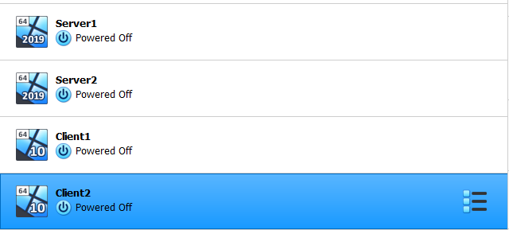
Once this is done all 4 VMs are created being Server1, Server2, Client1 and Client2 displayed in figure 9.
Figure 9: All VMs created

Virtual Network Configurations

1.2.1 Create a public network
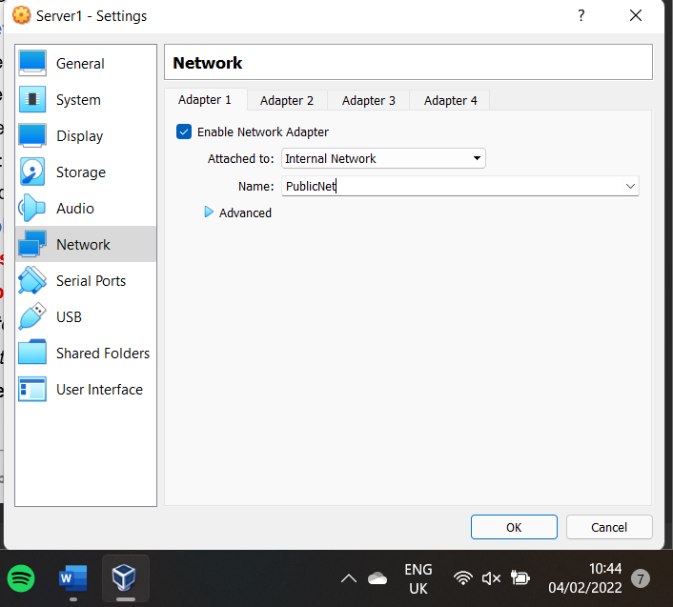
Now the VMs have been created the virtual networks must be configured.
Figure 10: Public net server1 adapter
The servers are attached to a internal network will not allow the networks to be visible to the host system or to the internet [19]. The first network adapter is renamed to PublicNet shown in figure 10.

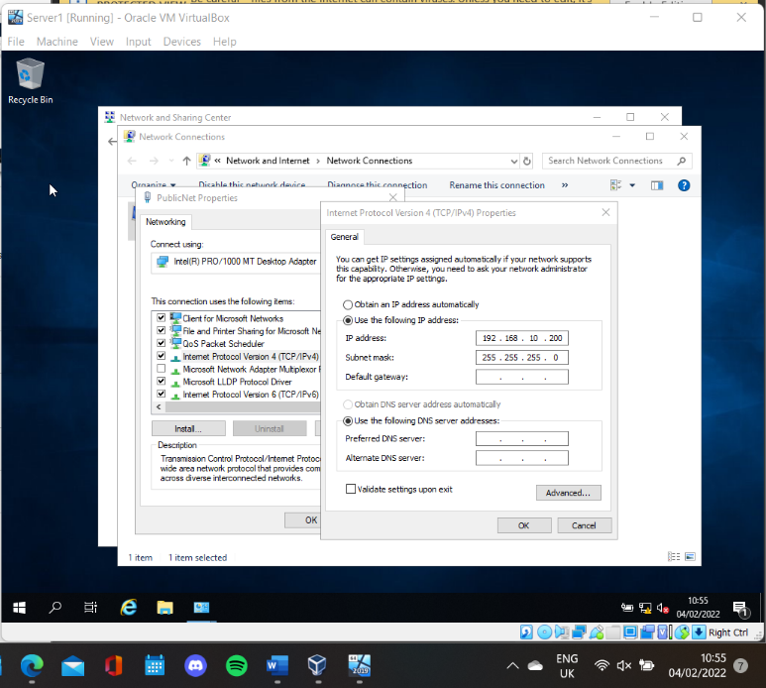
Figure 11: PublicNet IP server1

Now a connection must be made between the server and the network. The images below are example from Server1. The IP address is manually set to 192.168.10.200 in order to connect to the network. The same is done with server 2 but with an IP address of 192.168.10.201.

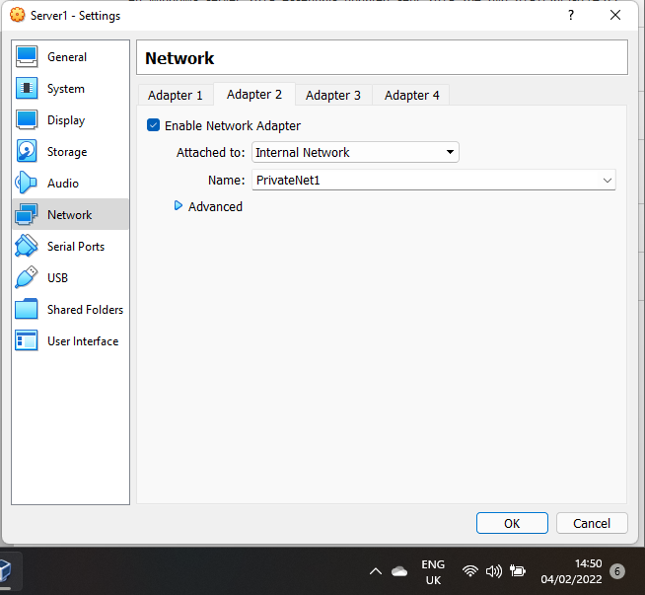
1.2.2 Create a network between server1 and client1
Figure 12: PrivateNet server1 adapter
Once the server is connected to the public server, each server needs a private network to the client. In figure 12 Server1 will create a network adapter to connect to client1 called PrivateNet1.

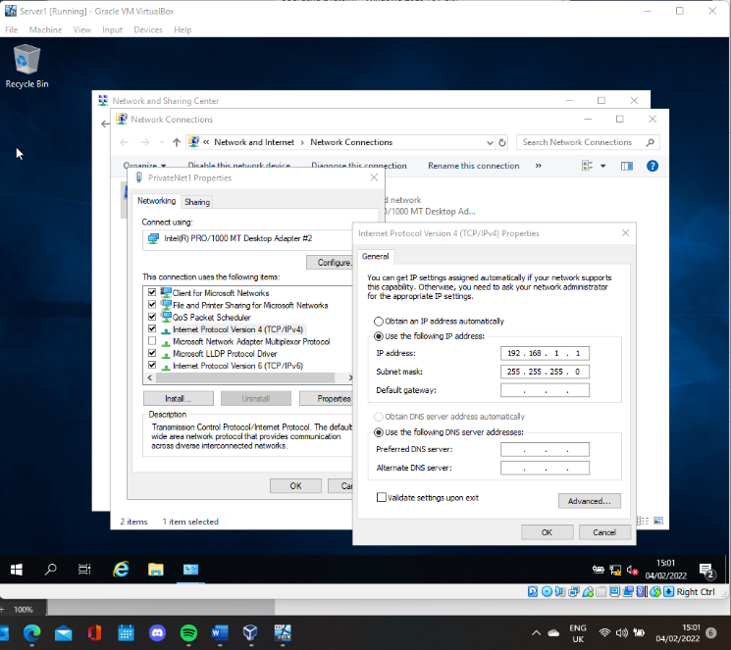
The IP address for PrivateNet1 is manually assigned as 192.168.1.1 on server1.
Figure 13: PrivateNet IP server1
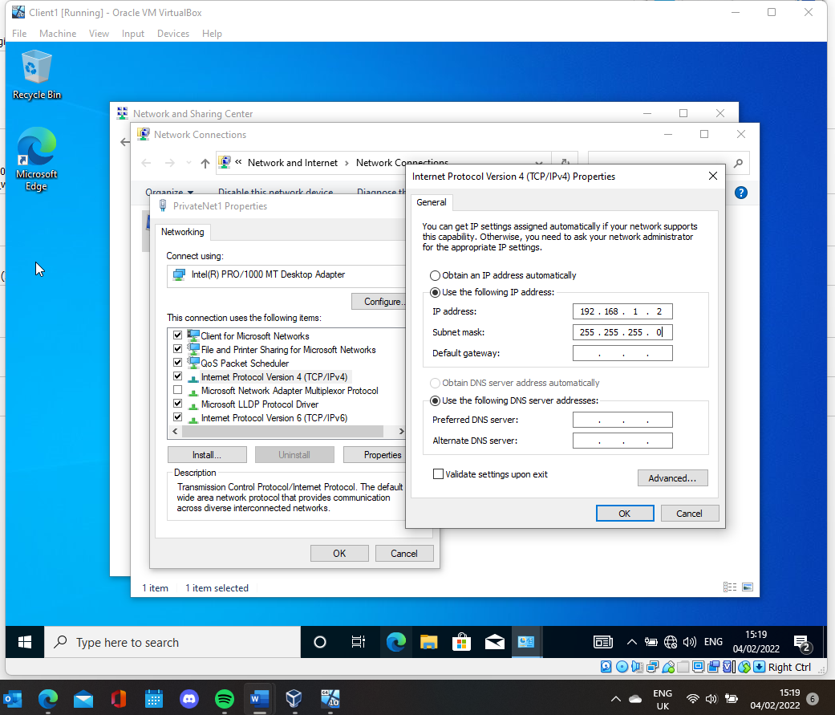
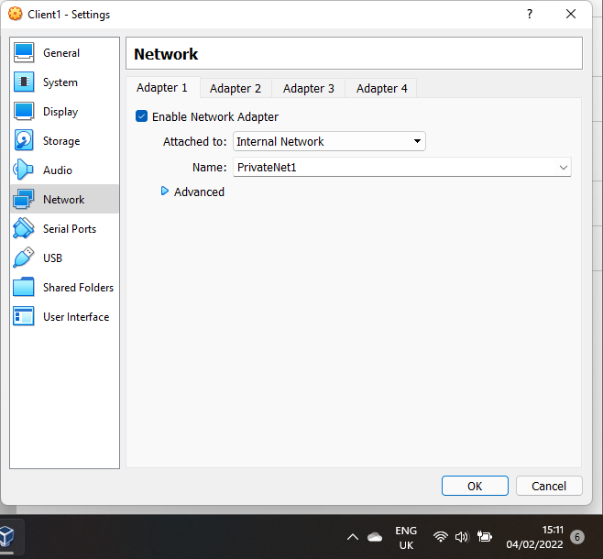
Figure 14: PrivateNet IP client1
The IP address for PrivateNet1 is manually assigned as 192.168.1.2 on client1.
A network adapter must be made on the client1 VM with the same name.
Figure 15: PrivateNet client1 adapter
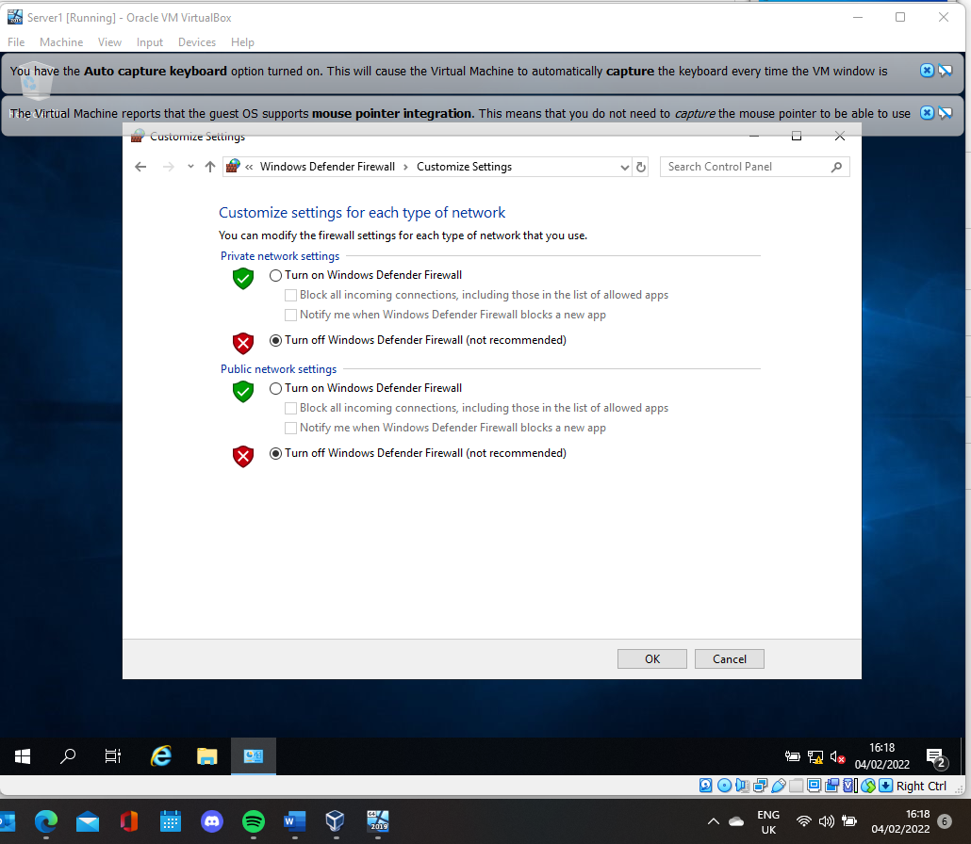
Figure 16: Turn off firewall
Figure 16 shows that the firewall has been turned off, to allow the servers and clients to reach each other.

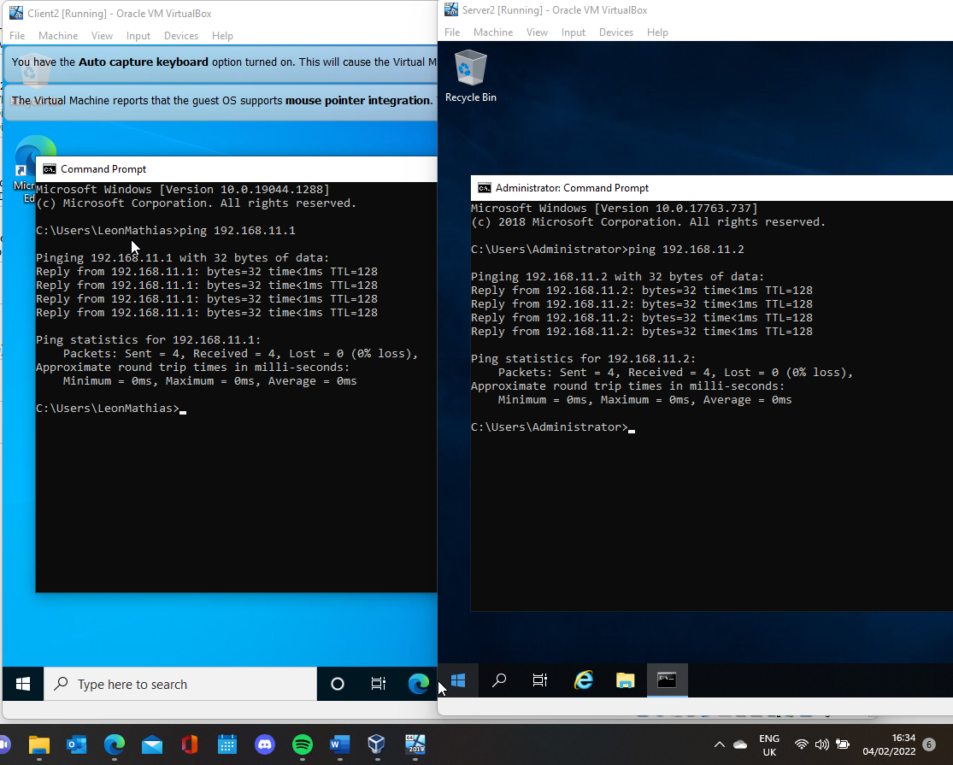
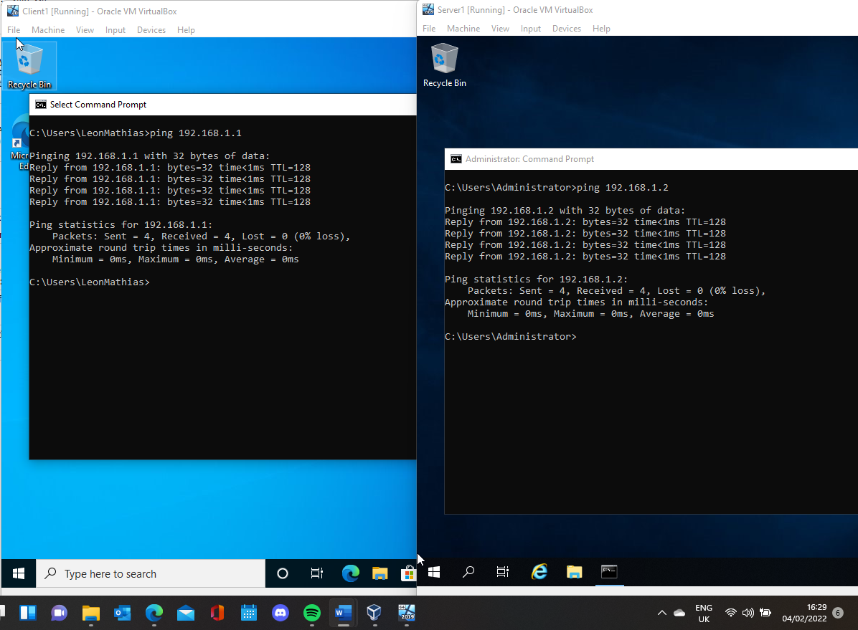
Figure 17: Ping test Client2 and Server2
Figure 18: Ping test Client1 and Server1
After setting up the networks for both servers and both clients. As displayed in figure 17 and 18 they can all have a successful ping showing that they are connected.

2 Deploying a network directory service and creating and understanding active directory network objects

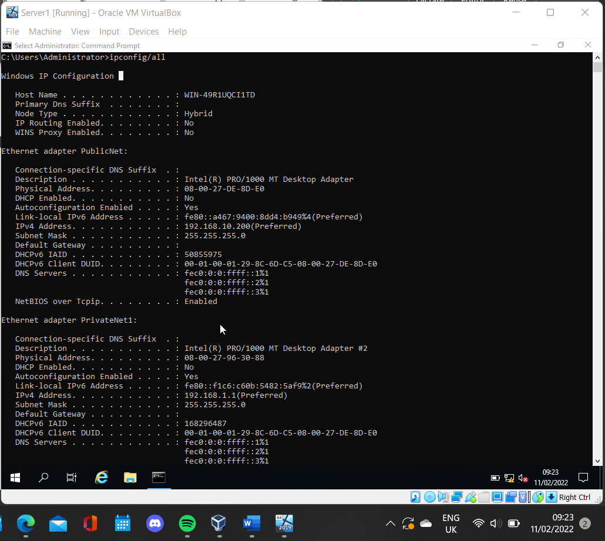
2.1 Pre-requisite
Verify that the Server IP is Statically Defined in figure 19.

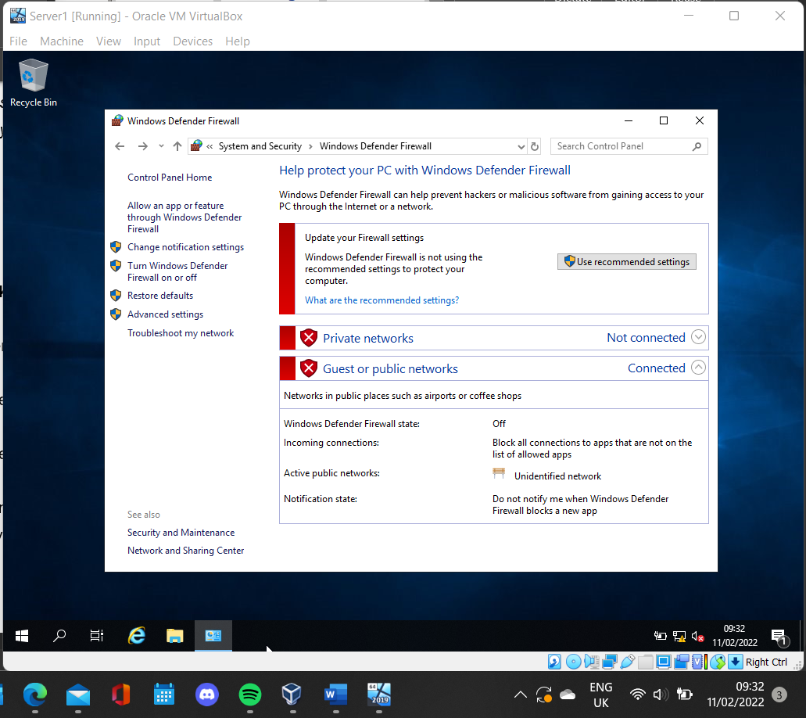
Verify that the Firewall is turned off see figure 20.
Figure 19: Check server IP, statically defined
Figure 20: Check firewall is off
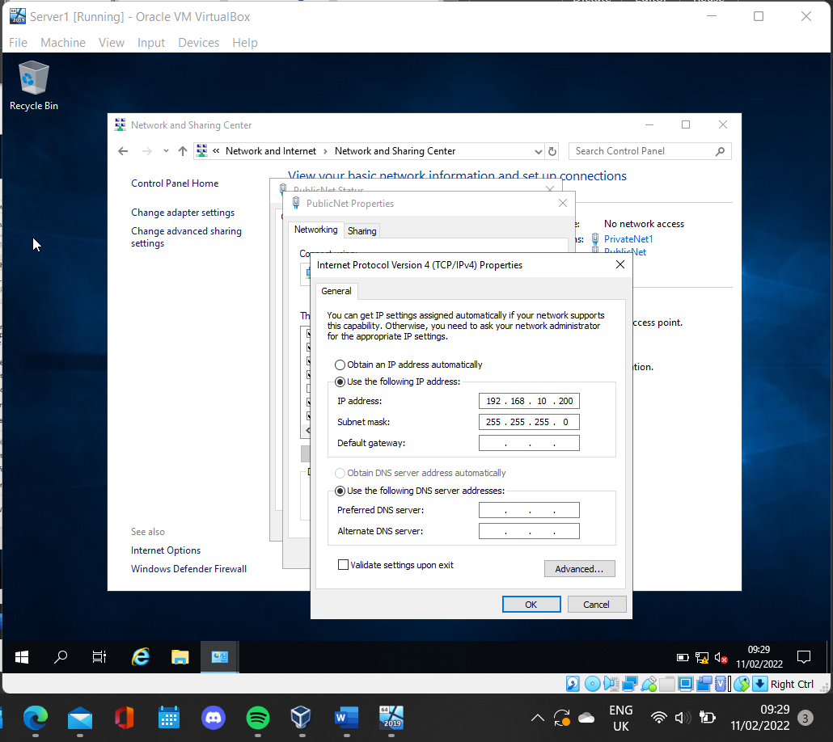
Verify that No DNS is setup on either networks see figure 21.
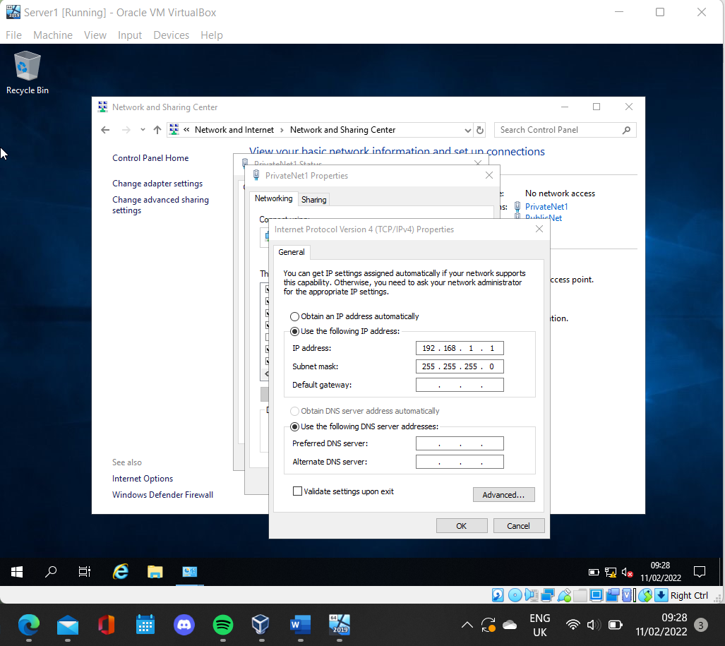
Figure 21: Check no DNS

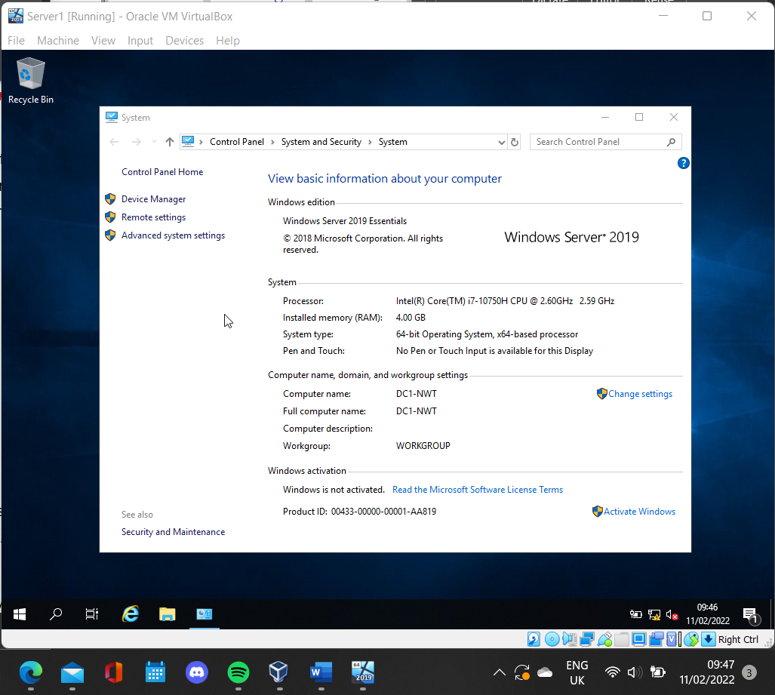
2.1.1 Rename server1
Figure 22: Rename Server1
The computer that is going to be used as the Domain Controller should be renamed, in order to identify what serves it provides in the network. After restarting the computer has now been renamed to DC1-NWT.

2.2 Deploying Active Directory
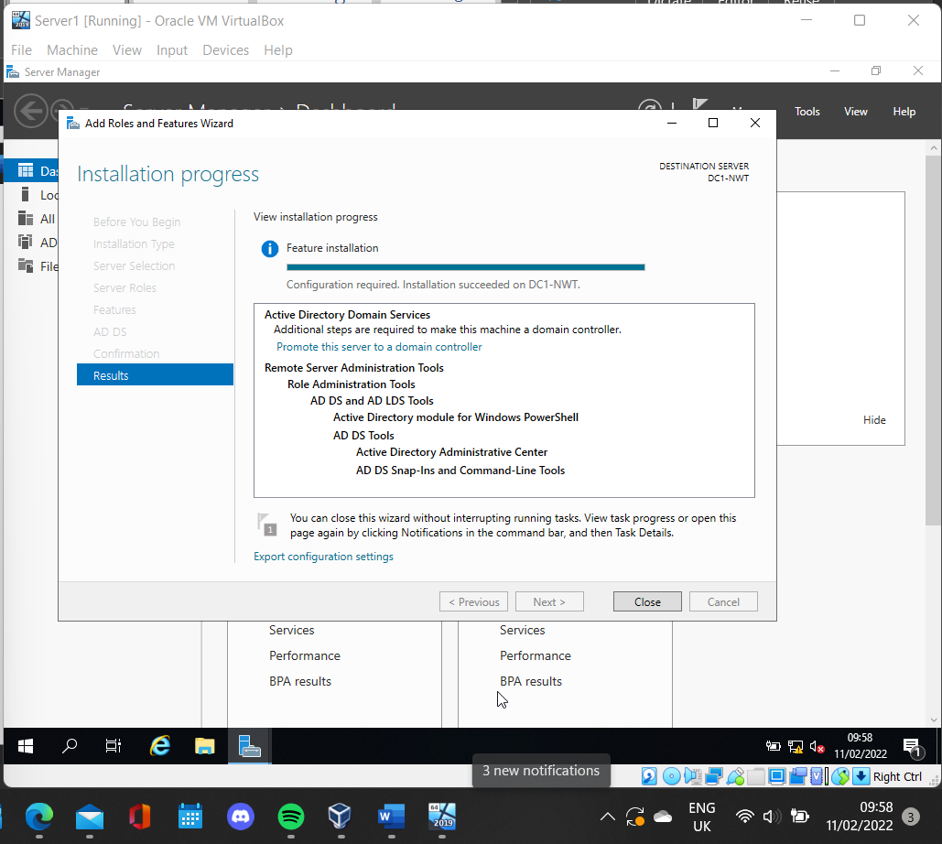
As displayed in figure 23 Active Directory Domain services has been installed on DC1-NWT by using the server manager.
By promoting the server to a domain controller. A new active directory is going to be established.
Figure 23: Active Directory Domain services installed

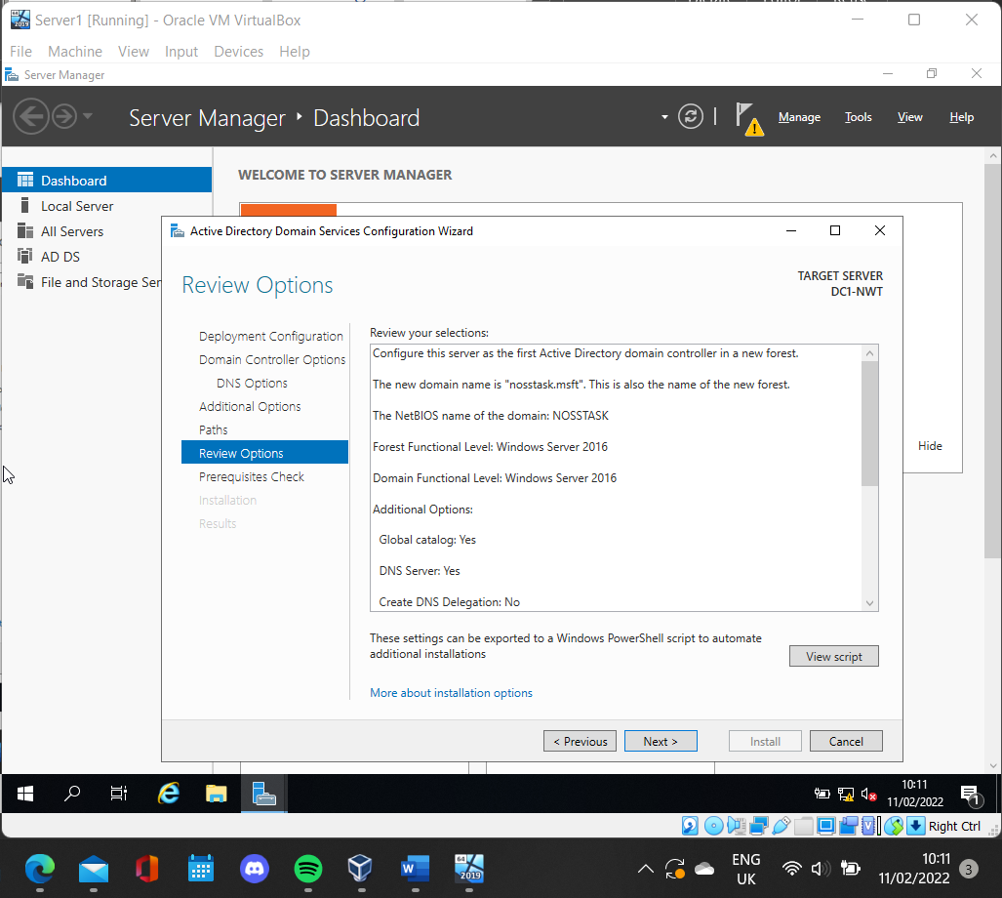
As shown in figure 24, a review of the options selected while establishing a new active directory.
The new domain name and new forest is called nosstask.msft.
Both forest and domain controller links must be using at least Microsoft server 2016.
Because active directory runs on DNS the DNS server option must be selected as yes.

Figure 24: Active directory options

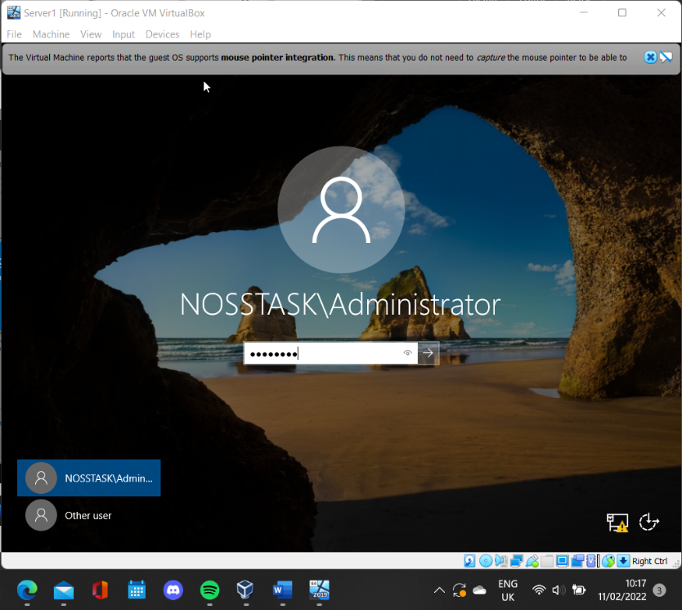
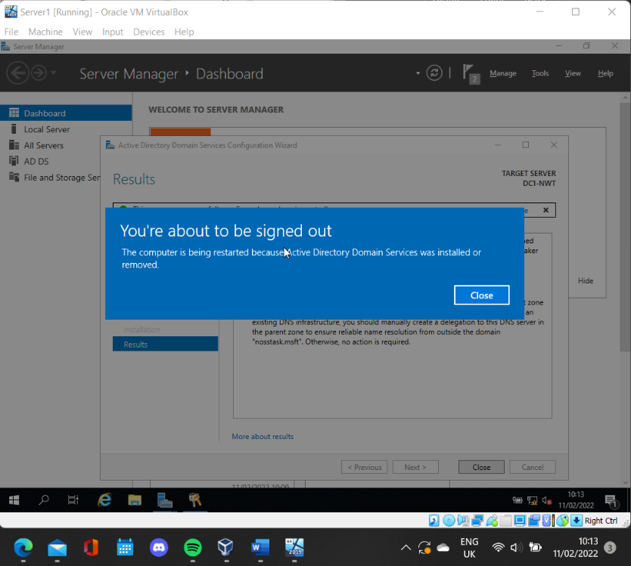
Figure 25: Login to server1 as domain controller
Once the active directory is installed the computer will restart.
In figure 25 the administrator account has now been prefixed with the name of the domain because the server is now a domain controller.

2.3 Creating user account

2.3.1 Creating new domain admin
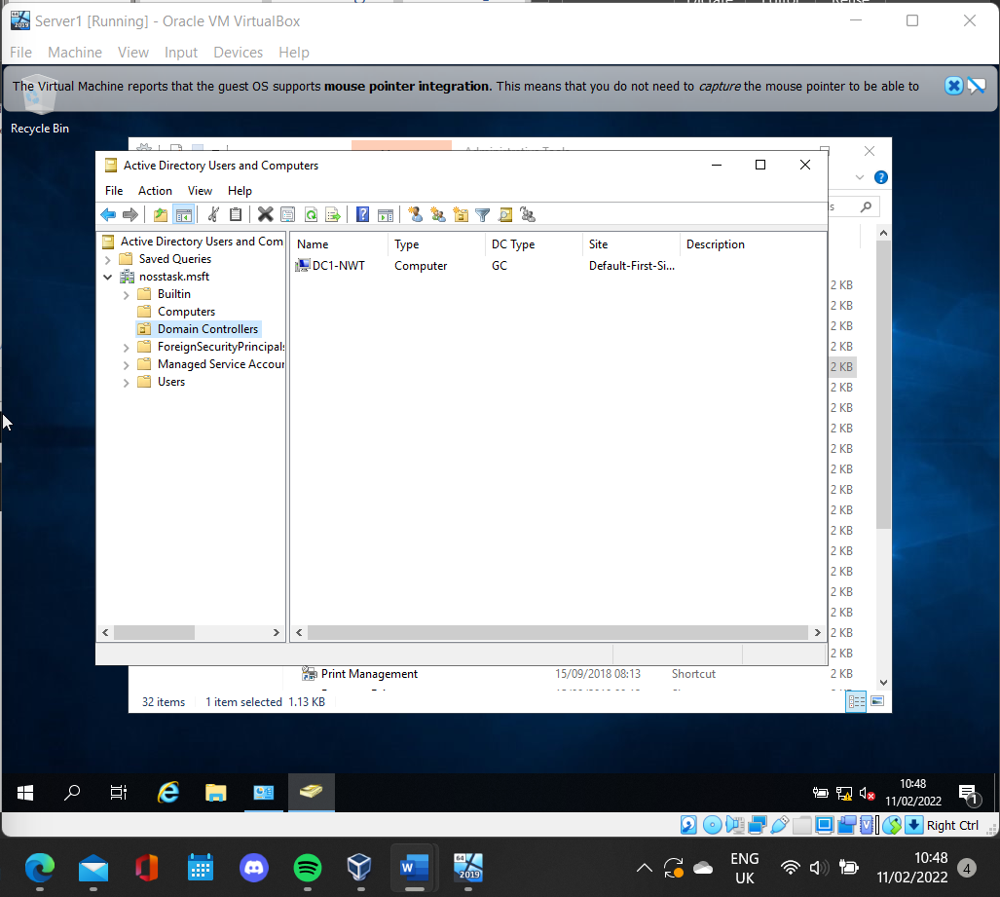
Figure 26: Domain controller list
As shown in figure 26. Server DC1-NWT is listed as a domain controller after successfully adding this.

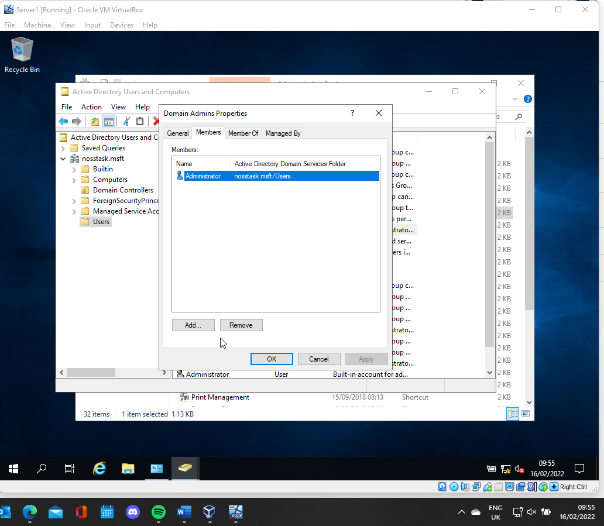
At the moment there is one domain admin account. See figure 27. It is important to create a failsafe incase the user is locked out of the active directory account.
Figure 27: Domain admin list
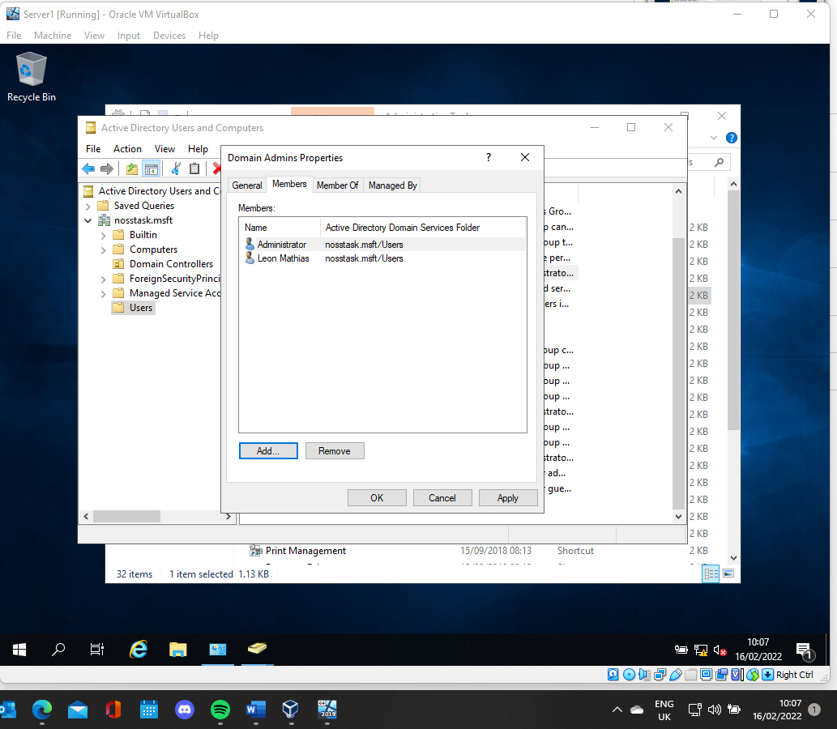
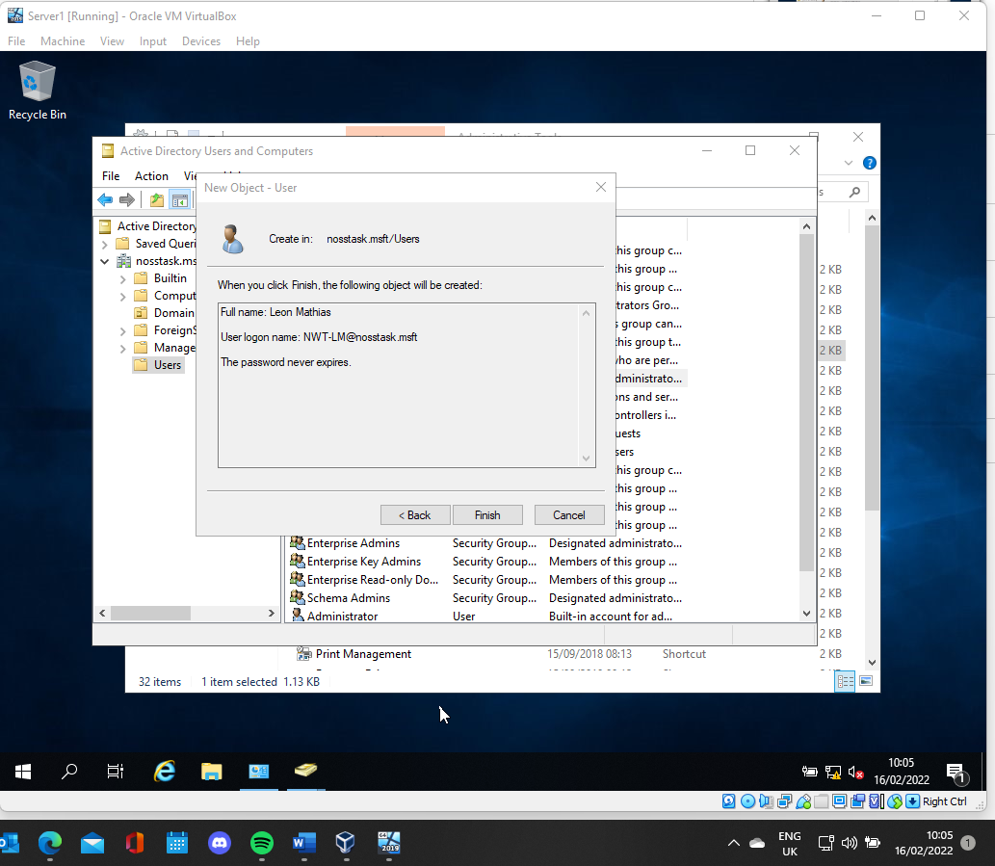
Once the user is created that user is added to the domain admin group displayed in figure 28 . The new user can now logon to the domain controller.
Figure 28: Add user as domain admin
A new user object is created with the username NWT-LM and a strong password.
Figure 29: New user created

2.4 Object attributes
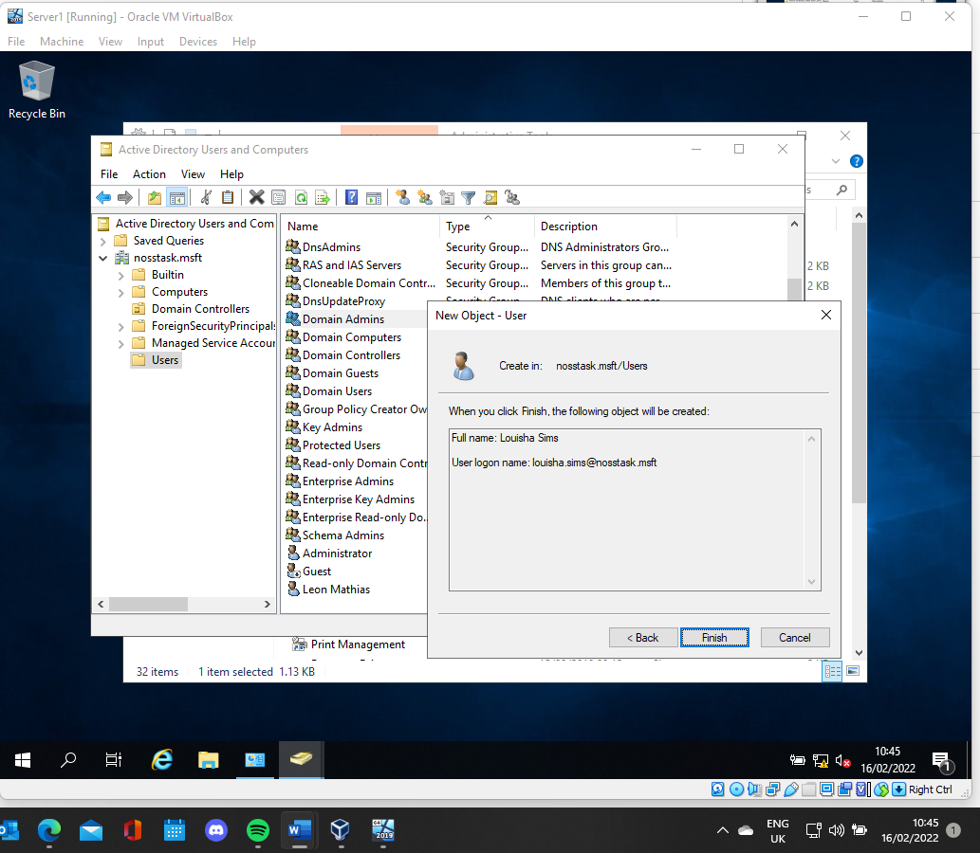
In an active directory, while managing objects there are different attributes available to set.
Firstly a new user called Louisha Sims is created see figure 30.

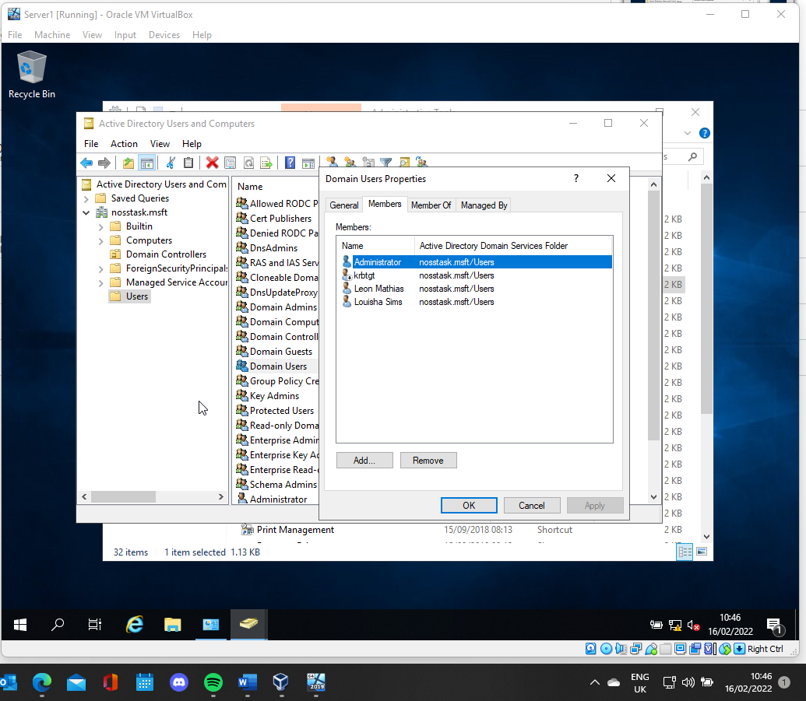
Figure 30: New user created and displayed in users list
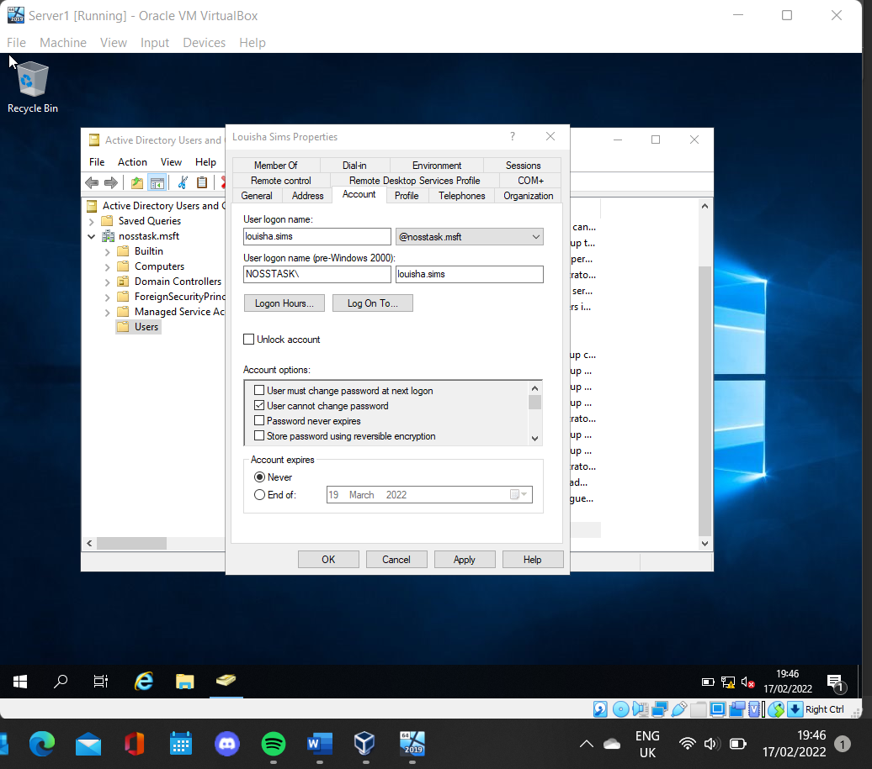
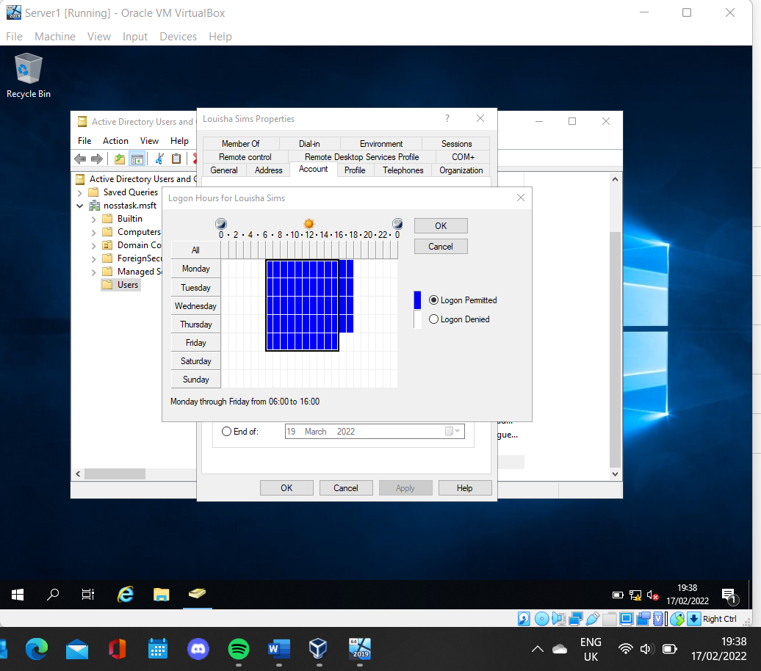
Another attribute of a user object can be seen in figure 33. Here the user cannot change the password.
Figure 31: Disallow password change
A attribute of a user object can be seen in figure 32. The hours of the user can be restricted. In this example the user is only able to logon between 6:00 and 18:00 Monday to Thursday and 6:00 and 16:00 Friday.
Figure 32: Change logon hours

2.5 Adjoining the domain
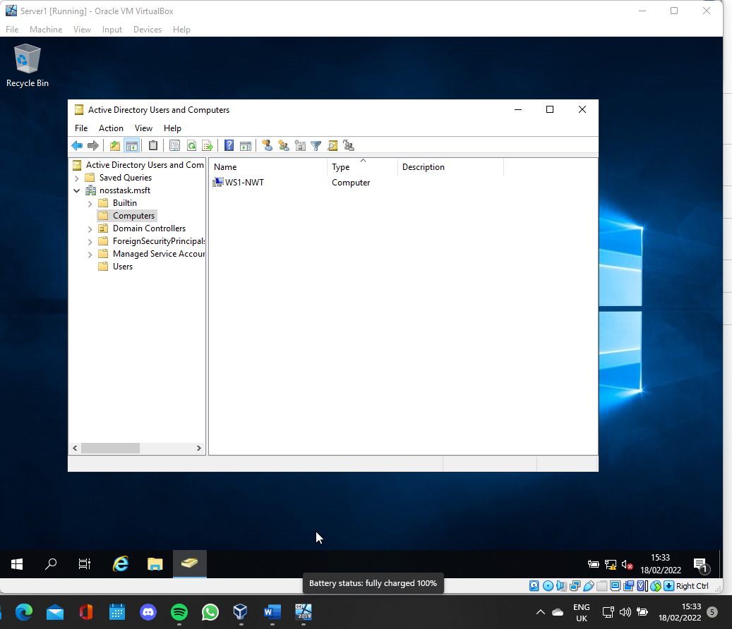
In order to adjoin the client to the domain. The Client1 computer must be made in the active directory. Therefore a new computer named WS1-NWT is created.
Figure 33: Add new computer in AD

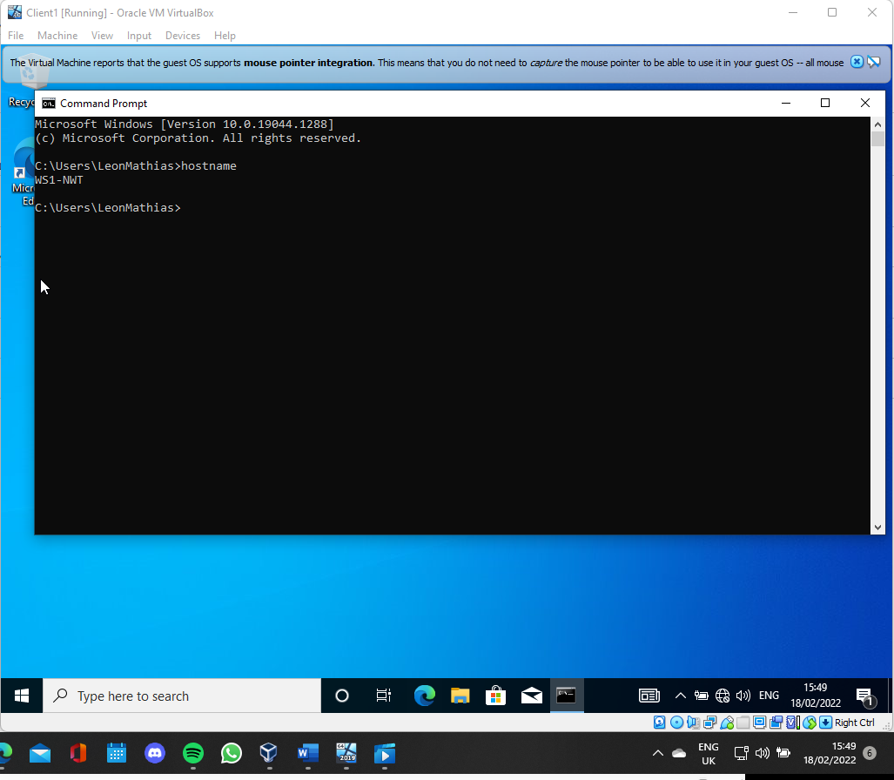
The Clien1 computer must be renamed to match what has been made in the active directory. In figure 34 the name of Client1 computer is displayed.
Figure 34: Rename client1

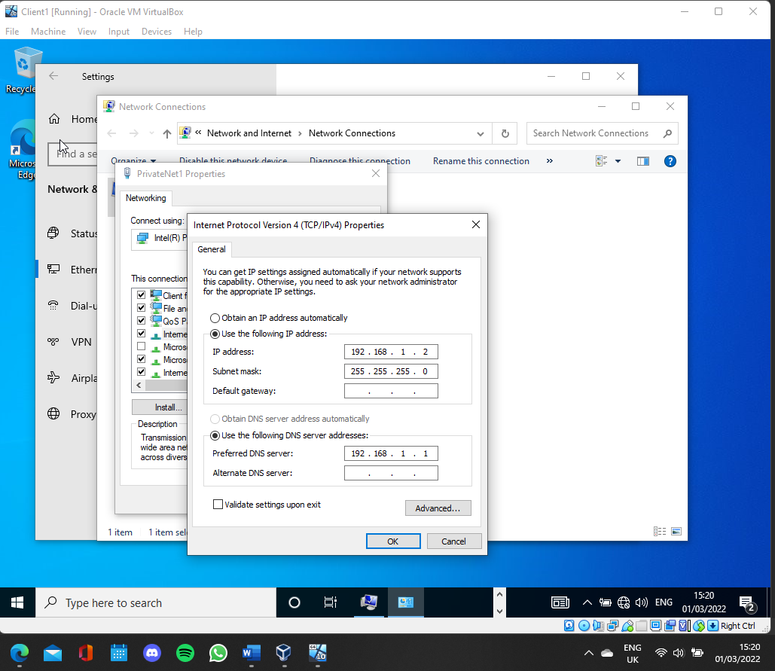
Now this computer will connect to the nosstask.msft domain by using an admin level account. After restarting the Clinet1 machine shown in figure 36 , the machine has joined the domain.
As displayed in figure 35, on the Client1 machine the preferred DNS sever is set to 192.168.1.1 in order to connect to the DNS server on server1 which was added while installing the active directory see figure 24.

Figure 35: Set DNS on Client1
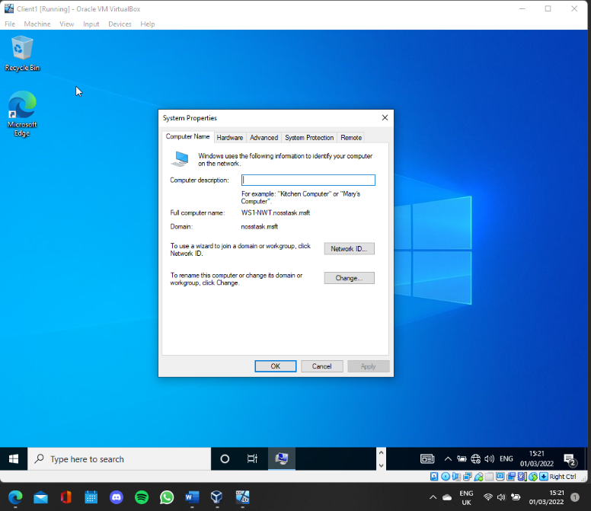

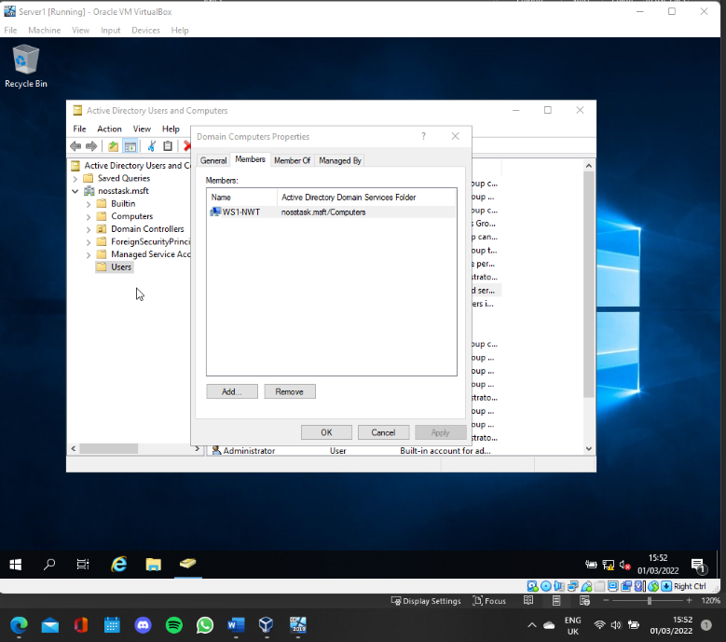
Figure 36: Client1 connected to nosstask domain

2.6 Testing user logins
While attempting to login to server1 which is the domain controller, using the account made earlier that is not a domain admin the login is unsuccessful as displayed in figure 38.
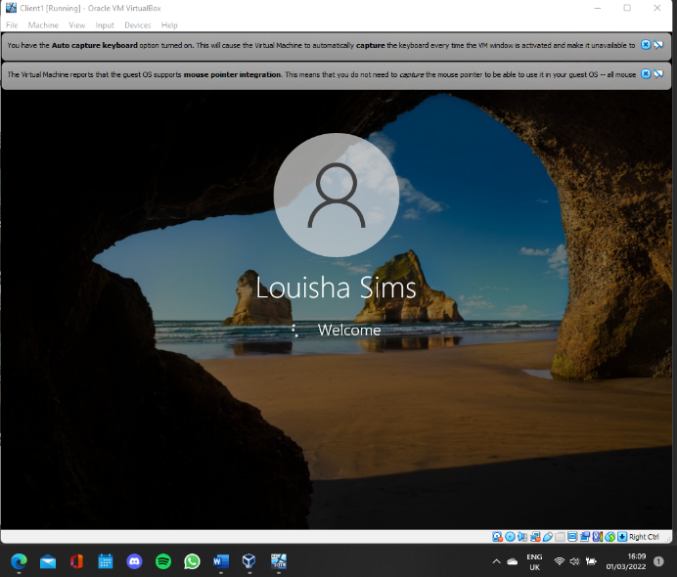
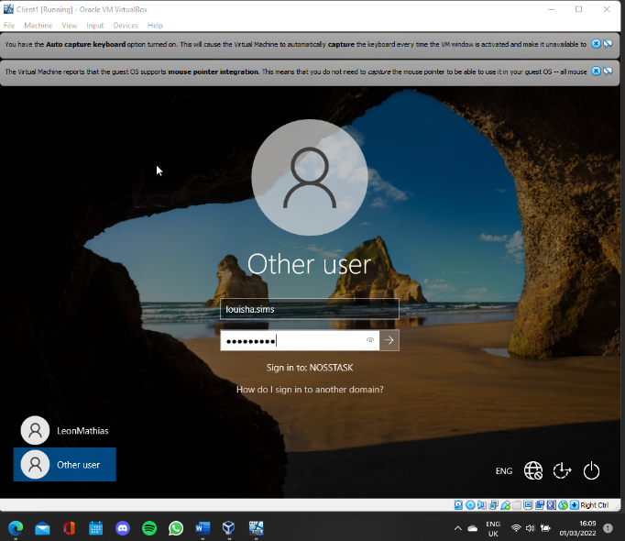
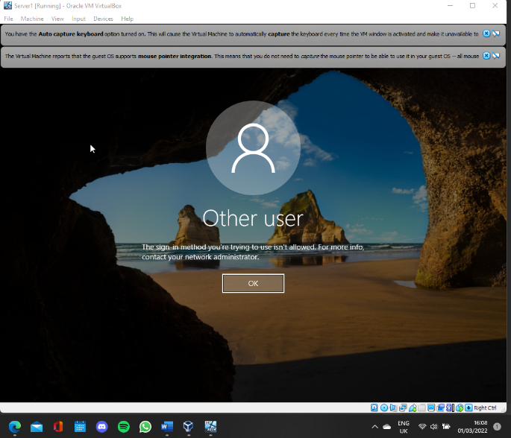
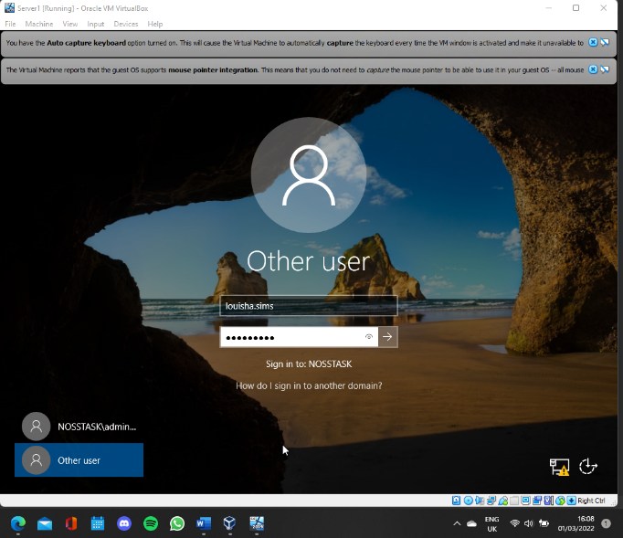
The new account is able to login to Client1 machine because the Client1 machine is now in the active directory.
Figure 37: User login success
Figure 38: User login fail

3 Observational Tasks

3.1 Type 1 and Type 2 Hypervisors
The role of a hypervisor is to use a physical computers resources to run one or more virtual machines (VM). There are to types of virtualization available these are Type 1 and Type 2 hypervisors [1].
The most obvious difference between the two types of hypervisors is, Type 1 also know as “bare metal”, is loaded onto the host systems hardware and then the host operation system runs on top of the hypervisor as well as any VMs.
Where as the Type 2 hypervisor also known as “hosted hypervisor” is installed on the host operating system and any VM that are run are attached to that hypervisor [2]. See figure 39 adapted from [3].
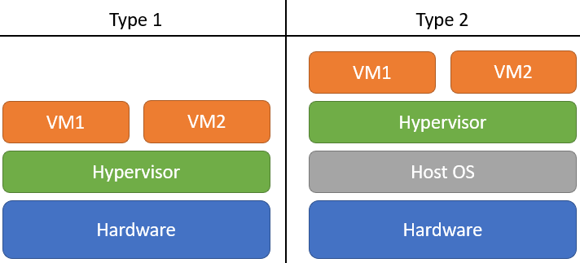
Figure 39: Type1 and Type2 hypervisor
For a virtual machine to access the hardware using a Type 2 hypervisor it must first go trough the hypervisor, which access the operation system which then accesses the hardware. Due to Type 1 being able to communicate with the hardware directly Type 1 is more efficient and has better performance as there is no middle layer.
The reason Type 2 was chosen in this paper is because to setup and installation is simpler as some of the hardware work is covered by the operating system therefore no specific hardware is required [4].
Type 1 are more secure because each VM is isolated meaning any malicious software will only damage that VM and not effect any other VMs or the hypervisor. Due to Type 2 being installed on the operation system anything that affects the operating system will also have an impact on the hypervisor.
Different examples of hypervisors are as follows.
Type 1
- VMware vSphere / ESXi
- Microsoft Hyper-V
- Xen / Citrix XenServer
- KVM
Type 2
- Oracle VM VirtualBox
- Microsoft Virtual PC
- VMware Server

3.2 Cloud computing
Cloud computing allows users to access may different technology services as needed by using remote data centres and the internet. These technology services include databases, storage, networking and much more. There are different types of cloud computing services these are Infrastructure as a service (IaaS), Software as a service (SaaS) and Platform as a service (PaaS) [5].
There are many advantages of cloud computing. One advantage is the reduction of cost because in order to use cloud computing there is no need to purchase the physical hardware or maintain it. Cloud computing also works on a pay per use basis which means the user only pays for what they use [6].
Another advantage is accessibility because the data is accessible at anytime from anywhere. This boosts productivity and allows for better collaboration.
Security can be a disadvantage of cloud computing. As explained here [7] there are many different types of security threats that include Data manipulation and TCP/Session Hijacking.
One other disadvantage to cloud computing can be the lack of control [8]because the provider owns the infrastructure, therefore the user will not have access to all administrative tasks.
There are different cloud computing providers some are listed below.
- Microsoft Azure
- Amazon Web Service (AWS)
- IBM Cloud Services
- Google Cloud Platform
- ServerSpace

3.3 Domain name system (DNS)
Domain name system (DNS) was created to help humans by translating IP addresses into domain name [9], because remembering a domain name is easier than attempting to remember an IP address.
See figure 27 to see the steps taken. The DNS works is by using a query which is a request a users computer sends to a DNS server in order to receive the IP address of the domain name requested. This request is sent to a DNS resolver shown as 1.
Step 2 the DNS resolver will forward the request to a DNS root server which knows information about top level domains (TLD) and their locations which its sends back to the DNS resolver (step 3).
Once again the DNS resolver forwards the request (step 4), this time to a TLD name server that will know the location of the domain names server which it sends to the DNS resolver (step 5).
Step 6 is the resolver will send the request to the Authoritative DNS server of the domain. That server will resolve the domain name and send back the IP address (step 7).
The final step is the resolver will send the user the IP address of the domain requested (step 8).
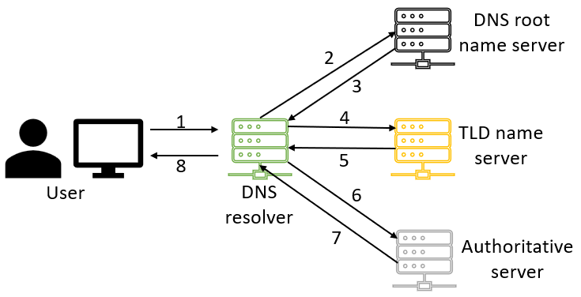
Figure 40: DNS steps
In order for active directory domain services (AD DS) to be able to offer any domain services a DNS infrastructure must be in place. In order for client computers to locate any domain controllers the AD DS must be registered to a DNS [10]. When any operations are preformed DNS is used so that domain controllers can locate each other.

3.4 Critical Role or Feature based installations
Other Critical Role or Features apart from AD that can be installed as part of a enterprise network include Hyper-V and Dynamic Host Configuration Protocol (DHCP).
Hyper-V [11] provides the services that allow users to create and manage VMs by creating virtual comping environments. Hyper-Vs VMs are run in their own space, the Hyper-V role allows for multiple operating systems to be used on a physical host machine because of this.
DHCP is a protocol which assigns IP addresses to hosts automatically. As well as assigning the IP address, DHCP provides other network addresses like the default gateway, subnet mask and the DNS address [12]. In order for any device to be able to connect to a network the IP address must be unique on the network. It is possible to manually assign an IP to each devise but this can become a problem on large networks, this is why DHCP is used.

3.5 Network terminologies
While setting up the Type 2 hypervisor management software and deploying a network directory service and creating active directory network objects. These terminologies are important in successfully using network systems.
Ping – The ping command is a command that is used in order to check if a computer is able to communicate with a network device or another computer [13]. This is used by sending packets to a given IP address in order to get a response. Ping works the same on both Linux and Mac.
PAE/NX - Physical Address Extension (PAE) [14] is feature on the processor that allows some versions of windows to use more than 4GB of RAM on the host machine. This essentially allows the VM to have priority therefore preforming better.
Firewall – Windows server 2019 contains Windows Defender Firewall with Advanced Security. The firewall blocks any unauthorized network traffic reaching the local device. Linux operating systems contain a prebuilt firewall called UFW or Uncomplicated Firewall [15] which is has GUI tools in order to make the system simpler .
OOBE - Out of Box Experience (OOBE) is what users see when they first boot Windows. OOBE in windows asks the user to agree to licences, connect to the internet and sign in to a Microsoft account. Ubuntu [16] has a similar OOBE to Windows but here on the Linux OS there is a setup wizard which helps the user get started with the device.

Reflection
While completing the tasks to successfully build a virtual LAN using type 2 hypervisor. I found that creating server1 and client2 machine first allowed them to be cloned in order to ensure consistency between each side of the network. I also discovered that there are many ways to optimise the performance of the VMs. Once creating a network connection between two VMs it is important to use ping command to ensure they can communicate.
I learnt while working through the second section, that it is important to give appropriate names to all computers and users to avoid confusion. In order to establish a active directory a server must be promoted to a domain controller. In order for another machine to join a domain it must use the DNS of the domain colroller. I also learned that there are many different attributes the domain admin has control over in terms of other users.

References

[1] | S. Lowe, “Mastering VMware VSphere 4,” Wiley, 2010, p. 2.
[2] | C. F. Quentin Docter, “CompTIA Cloud Essentials+ Study Guide,” Wiley, 2020, p. 6.
[3] | M. Portnoy, “Virtualization Essentials,” John Wiley & Sons, Incorporated, 2016, pp. 23-25.
[4] | B. K. Stephen J. Bigelow, “What's the difference between Type 1 vs. Type 2 hypervisor?,” TechTarget, 13 January 2021. [Online]. Available: https://searchservervirtualization.techtarget.com/feature/Whats-the-difference-between-Type-1-and-Type-2-hypervisors. [Accessed 02 03 2022].
[5] | I. Y. N. B. A. S. M. A. G. S. U. K. Ibrahim Abaker Targio Hashem, “The rise of “big data” on cloud computing: Review and open research issues,” Information Systems, vol. 47, pp. 98-115, 2015.
[6] | R. K. Pawan Kumar, “Issues and Challenges of Load Balancing Techniques in Cloud Computing: A Survey,” ACM Computing Surveys, vol. 51, no. 6, pp. 1-35, 2019.
[7] | Y.-S. J. J. H. P. Saurabh Singh, “A survey on cloud computing security: Issues, threats, and solutions,” Journal of Network and Computer Applications, vol. 75, pp. 200-222, 2016.
[8] | J. G. A. Jose M. Alcaraz Calero, “Comparative analysis of architectures for monitoring cloud computing infrastructures,” Future Generation Computer Systems, vol. 47, pp. 16-30, 2015.
[9] | B. R. P. S. D. G. P. Sanjay Adiwal, “Revisiting the Performance of DNS Queries on a DNS Hierarchy Testbed over Dual-Stack,” he Computer Journal, vol. 64, no. 6, pp. 834-859, 2021.
[10] | G. McDonald, P. Papadopoulos, N. Pitropakis, J. Ahmad and W. J. S. Buchanan, “Ransomware: Analysing the Impact on Windows Active Directory Domain Services,” Sensors, vol. 22, no. 3, 2022.
[11] | “Hyper-V on Windows Server,” Microsoft, 29 July 2021. [Online]. Available: https://docs.microsoft.com/en-us/windows-server/virtualization/hyper-v/hyper-v-on-windows-server. [Accessed 02 03 2022].
[12] | T.-C. Huang and K.-C. Chu, “Networking without Dynamic Host Configuration Protocol server in Ethernet and Wireless Local Area Network,” Journal of Network and Computer Applications, vol. 34, no. 6, pp. 2027-2041, 2011.
[13] | S. Henry-Stocker, “Using the Linux arping command to ping local systems: The arping command can ping local systems to find out whether they are responsive, and with the help of scripts, can ping specific IP-address ranges.,” Publisher logo. Links to publisher website, opened in a new window., 2020.
[14] | “Oracle® VM VirtualBoxUser Manual,” Oracle, [Online]. Available: https://docs.oracle.com/en/virtualization/virtualbox/6.0/user/settings-system.html#settings-processor. [Accessed 02 03 2022].
[15] | J. Wallen, “An Introduction to Uncomplicated Firewall (UFW),” Linux.com, October 2015. [Online]. Available: https://www.linux.com/training-tutorials/introduction-uncomplicated-firewall-ufw/. [Accessed 02 03 2022].
[16] | Canonical, “Why the first impression matters,” Ubuntu, 28 September 2015. [Online]. Available: https://ubuntu.com/blog/why-the-first-impression-matters. [Accessed 02 03 2022].
[17] | B. Posey, “Virtual hard drive,” TechTarget, October 2021. [Online]. Available: https://searchservervirtualization.techtarget.com/definition/virtual-drive. [Accessed 22 02 2022].
[18] | G. Song and Z. Ji, “Novel Duplicate Address Detection with Hash Function,” vol. 11, no. 3, 2016.
[19] | virtualbox, “6.2. Introduction to Networking Modes,” [Online]. Available: https://www.virtualbox.org/manual/ch06.html. [Accessed 22 02 2022].

