Shay, Pippa
2417658
Circuit Design
Fundamentals of Electrical and Electronic Systems ACDA4018
Ordnance Munitions and Explosives
Table of Contents
Section 1: Introduction 3
1.1 The Aims 3
1.2 The Background 3
Section 2: The Circuit 3
2.1 Circuit Description 3
2.2 Background to Building the Simulation of the Circuit 4
2.2.1 Proteus Background 4
2.2.2 Calculations 4
2.2.3 Breadboard Background 5
2.3 Creating the Circuit 5
2.3.1 Proteus 5
2.3.2 Tinker cad 6
2.3.3 Breadboard 8
Section 3: Calculations 8
3.1 Breadboard Calculations 8
3.2 Proteus Calculations 9
Section 4: References 11
Appendix A – Proteus Simulation Practices, with Calculations: 11
Appendix B – Tinker Cad Circuits and Schematics 20
Appendix C – Hand Calculations 23
Appendix D – Proteus Tables 26

Table 1 - Voltage at Capacitor Against Time 26

Figure 1 - Names of pins of 555 timer [2] 3
Figure 2 - Drawing of Circuit, Given in Advance 4
Figure 3 – Circuit Schematic in Proteus 6
Figure 4 - Tinker cad Circuit 7
Figure 5 - Breadboard Circuit 8
Figure 6 - Proteus Simulated Graph 10
Figure 7 - Proteus Graphs of Voltage Against Time 10
Figure 8 - Proteus Practice, Resistors in Series 11
Figure 9 - Resistors in Series on Breadboard 12
Figure 10 - Resistors in Parallel on Breadboard 12
Figure 11 - Resistors in Series and Parallel Calculations 13
Figure 12 - Proteus Practice, Resistors in Parallel 14
Figure 13 - Proteus Practice, Combination Circuit 1 14
Figure 14 - Combination Circuit Calculations 15
Figure 15 - Proteus Practice, Combination Circuit 2 16
Figure 16 - Combination 2 Circuit Calculations 17
Figure 17- Proteus Practice, Combination Circuit 3 18
Figure 18 - Combination 3 Circuit Calculations 19
Figure 19 - Tinker Cad Schematic 20
Figure 20 - Tinker Cad Circuit, Red LED Flashing 21
Figure 21 - Tinker Cad Circuit, Green LED Flashing 22
Figure 22 - Hand Calculation 1 23
Figure 23 - Hand Calculation 2 24
Figure 24 - Hand Calculation 3 25
Figure 25 - Hand Calculation 4 26

Equation 1 - Frequency Formula [3] 4
Equation 2 – Rearranged Formula 5
Equation 3 - Frequency Formula [3] 8
Equation 4 - Confirming Resistance of R3 and 4 9
Equation 5 - Correct frequency Calculation for 10k Resistors 9

Section 1: Introduction

1.1 The Aims
The aim of this assignment was to be able design, create and understand a 555-timer circuit. By using the drawing given in the assignment brief the student can then create a schematic in Proteus. If this schematic works, the student can then build this in real life with a breadboard.

1.2 The Background
The 555-timer is an integrated circuit [1] with many different purposes, some of which are a free-running astable multivibrator, square wave generator and a signal source [1]. The 555 timer is essentially a chip with 9 different legs corresponding to different things to integrate it into a circuit. Below is a picture of the different pins and their meanings.
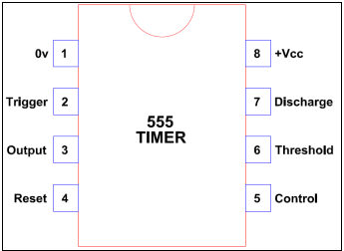
Figure 1 - Names of pins of 555 timer [2]

Section 2: The Circuit

2.1 Circuit Description
The circuit the student needed to build was already given, it looked like this:
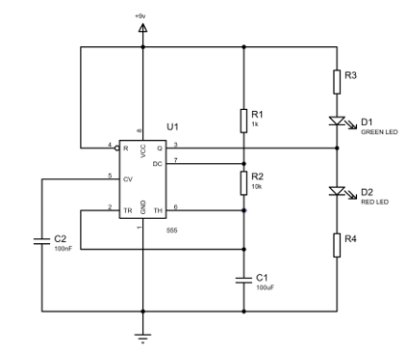
Figure 2 - Drawing of Circuit, Given in Advance
The circuit above contains 4 resistors, 2 LED’s, 2 capacitors, a 555 timer and a power source. The circuit is built so the coloured LEDs will flash in sequence. The higher the capacitance in the capacitors the faster the LEDs will flash, this can be done to the point where it looks like they are both on continuously, so this is something to note. Also, the higher the resistance in resistors 3 and 4 the dimmer the LEDs will be when they flash.

2.2 Background to Building the Simulation of the Circuit

2.2.1 Proteus Background
The student’s main task with Proteus was to replicate the drawing given as a schematic in Proteus 8 Professional Simulations. Before the student started this task as it was their first time using the modelling site they started by creating simpler schematics, starting with simple resistors in series continuing to different combination circuits, these are shown in Appendix A. By creating these circuits, the student could also check their calculations using Ohms law were correct as Proteus can show the total resistance in a circuit.

2.2.2 Calculations
The student started by stating they wanted a on and off time of 1 second. After deciding this the student could then use this formula:
$$f=1/[ln2 ×C ×\left(R1+2R2\right)]$$
Equation 1 - Frequency Formula [3]
It should be noted R1 and R2 in this equation relate to R3 and 4 in the drawing above. With the frequency of 1 and the capacitance of 100 x10⁻⁶ F the formula could be rearranged to
$$14426.95 Ω=R1+2R2$$
Equation 2 – Rearranged Formula
This then shown that R1 could equal 5.0kΩ leaving 9426.95Ω for 2R2, meaning R2 would equal 4.7kΩ. These are both believable sizes as general resistors are sold in both of those sizes. All handwritten calculations from the students Lab Book can be found in Appendix C.

2.2.3 Breadboard Background
With the student having never used a breadboard before it was important they understood how it worked. This meant testing and trying simple things such as resistors in series and resistors in parallel and testing to make sure it was set up correctly using a multimeter to measure the total resistance of the circuit created. Pictures of this can be seen in Appendix A. It was important to use Ohms law to calculate the predicted resistance of a created circuit. For example, if three resistors are connected in series their resistances need to be added to give the predicted total resistance, this way it can be checked that the resistors have been connected in the correct way for them to be in series. It is correct if the multimeter reads the same as the predicted resistance.

2.3 Creating the Circuit

2.3.1 Proteus
The first step to creating the Circuit was to be able to draw it in proteus using everything the student knew from the above. The schematic looked like this:
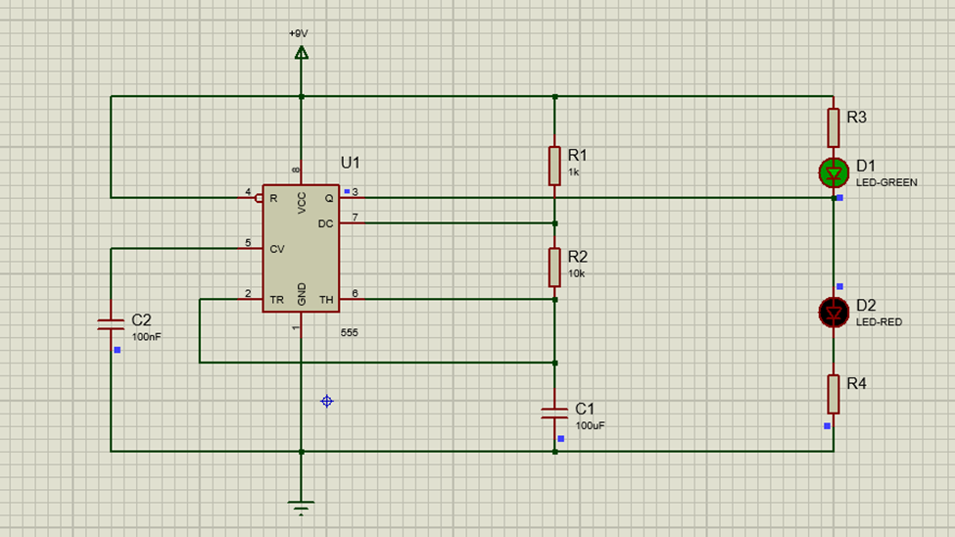
Figure 3 – Circuit Schematic in Proteus
The student originally started with the precalculated resistances for R3 and R4. This was then enough evidence to the student that the set up worked and the LEDs flashed as desired. With the components provided the student would have to use 10kΩ resistors when making the breadboard so the student changed the resistances of R3 and 4 to 10k to match the breadboard they would then make.

2.3.2 Tinker cad
The student then believed the next best step would be to recreate the simulation made on Proteus on Tinker cad. This way the student could ensure all components were working and to easily fiddle with where things were before committing to the breadboard and potentially blowing something if the circuit was wired incorrectly or it not working but being placed correctly due to broken components. The Tinker cad circuit is shown below:
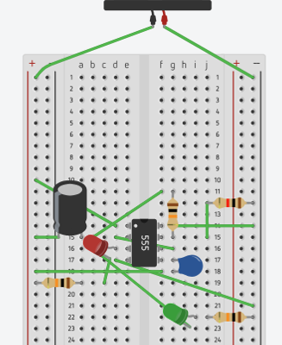
Figure 4 - Tinker cad Circuit

The way the student built this was by working roudn the pins, looking at pin 1 first, what did it connect to, earth, so plugging that into the left hand side then moving onto pin 2, this was supposed to be connected the the 100nF capacitor so the student plugged in the capacitor the correct way round (positive leg towards the 555 timer – the positive leg is a the longer of the two legs of the component) in the same row as pin 2 as the rows in a breadboard are all connected. This same process was completed until all pins of the 555 timer had connected to them the first component or place they came across. Once all the pins had what they were connected to placed correctly into their rows it was then the task of the few components left that were not connected directly to a pin, an example of this being the green LED. This was easily added in using the same process as before, starting with where does it come from, it comes from R3 so the positive end of the green LED was placed into the same row as the end of R3. The problem the student was then left with was where does the green LED go? This could easily be solved by checking the Proteus schematic again, the green LED connects to the red LED, the negative leg of the green LED was then placed into the same row as the positive leg or the red LED. This process was then used for any other missing component on the breadboard until it was complete. It was then time to build the circuit on the real breadbaord. Extra pictures of the Tinker cad circuit and schematic can be found in Appendix B.

2.3.3 Breadboard
The student began connecting the circuit up together on the breadboard using the Tinker cad circuit to base where each component should go. Once the student had placed all the components in the correct place, they checked it back against the Proteus schematic before turning on the power source. Once turning on the power source the student could see the flashing of the LED lights in the desired sequence. The breadboard was connected like this:
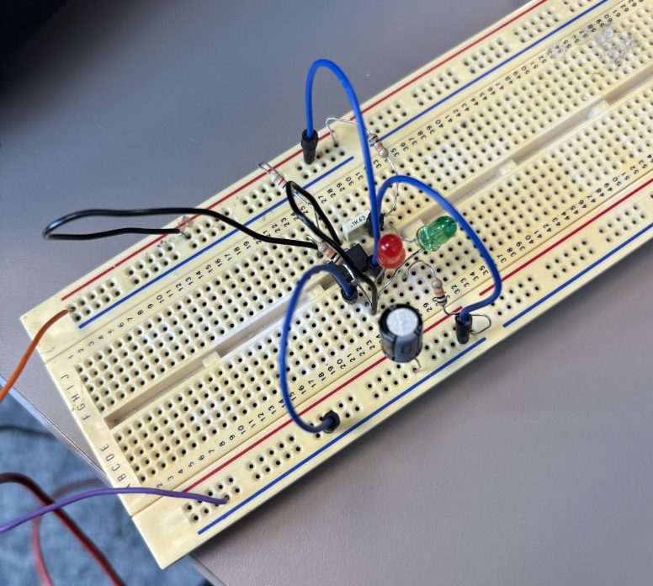
Figure 5 - Breadboard Circuit
This circuit could then be used to calculate the frequency.

Section 3: Calculations

3.1 Breadboard Calculations
Using the breadboard the student made, they counted how many cycles of flashes happened in 20 seconds to then derive how many flashes would be in 1 minute. The total for 1 minute was 45 cycles which equal to 1.33 cycles/ second. Using this knowledge the frequency can be found as 1/1.33 cycles which gives 0.75 as the frequency. The student can now use the same formula as before to prove the resistance of the resistors; the formula is shown below:
$$f=1/[ln2 ×C ×\left(R1+2R2\right)]$$
Equation 3 - Frequency Formula [3]
The formula with all numbers put in looks like this (note R1 and R2 were swapped for 3 and 4 as they were what the resistors were called in the original drawing given):
$$0.75= \frac{1.44}{100×{10}^{-6} ×(R3+2R4) }$$
$$R3+2R4=19200Ω$$
$$R3=R4=6.4kΩ$$
Equation 4 - Confirming Resistance of R3 and 4
As can be seen the calculated resistance of the resistors using the frequency of the flashign lights is calculated to be 6.4kΩ which is incorrect as the student knows they used 10kΩ resistors. This could be down to several factors, most likely due the fact the student filmed 20 seconds of the LEDs flashing to then multiply by three to calculate the number of cycles per minute. This leaves a rather large uncertainty, it would have been more acccurate if the student had filmed for several minutes, meaning there would be a smaller percentage uncertainty, and then divided it to make it one minute rather than film for only 20 seconds, giving the datda a larger percentage uncertainty, and multiplying it to make 1 minutes worth of data. The correct frequency for 10kΩ resistors can be dereived from using the same formular as above but filling in the resistor values and leaving the frequncy as the variable to find, it woul dlook like this:
$$f= \frac{1}{ln2 ×100×{10}^{-6} ×(10,000+20,000)}$$
$$f=0.48$$
Equation 5 - Correct frequency Calculation for 10k Resistors
This then gives a timing of 2.08 seconds per cycle which isn’t vastly different from the original timing which the student had so the error likely was mainly down to large uncertainties. All handwritten calculations from the students Lab Book can be found Appendix C.

3.2 Proteus Calculations
Using Proteus, the student could create resistance and voltage graphs against time, the student just added an oscilloscope to the circuit to create these graphs the schematic looked like the below with the oscilloscope added:
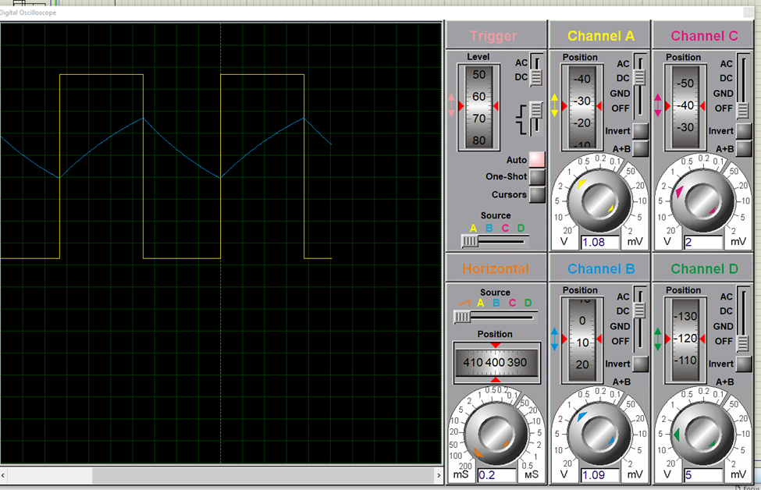
Figure 6 - Proteus Simulated Graph
The graph above is when the resistors are at 10kΩ as that is what the components the student was using on the breadboard were. The student could also plot graphs showing the voltage at different areas on the circuit, this can be seen below:
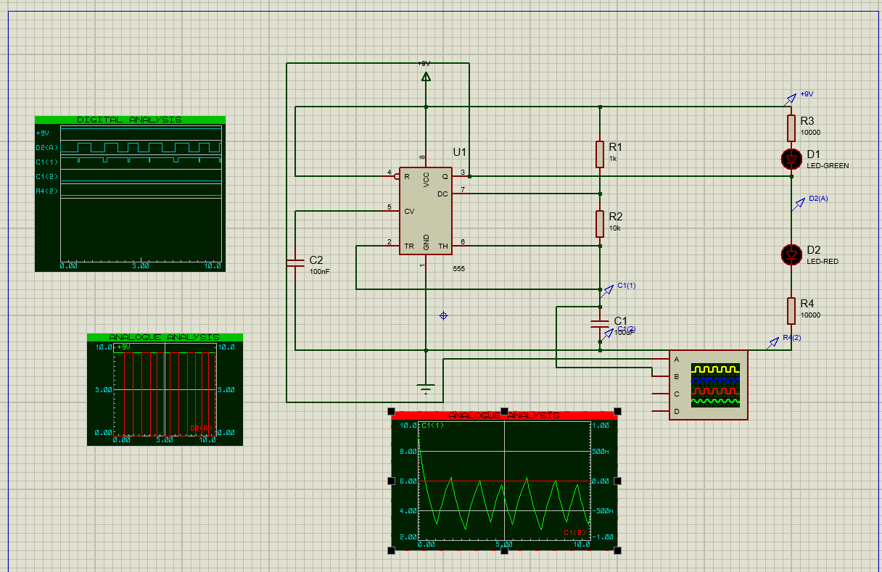
Figure 7 - Proteus Graphs of Voltage Against Time
Using the above markers on the circuit the student could also create a table of 2 seconds worth of data of the voltage either side of the first capacitor, this table can be seen in Appendix D.

Section 4: References
[1] F. Everest, “The characteristics and use of the 555 timer” Electronics Education, Vol; 2000, Issue: 3, page 34, 1st Spetember 2000
[2] M. Abrar, “Desgin and Implementation of Astable Multivibraotr using 555 Timer” Journal of Electrical and Electronics Engineering, Vol; 12, Issue: 1, pages 22-29, January- February 2017
[3] E. Technology. (Unknown Date) IC 555 Timer Calculator with Formulas and Equations [Online]. Available: IC 555 Timer Calculator with Formulas and Equations

Appendix A – Proteus Simulation Practices, with Calculations:
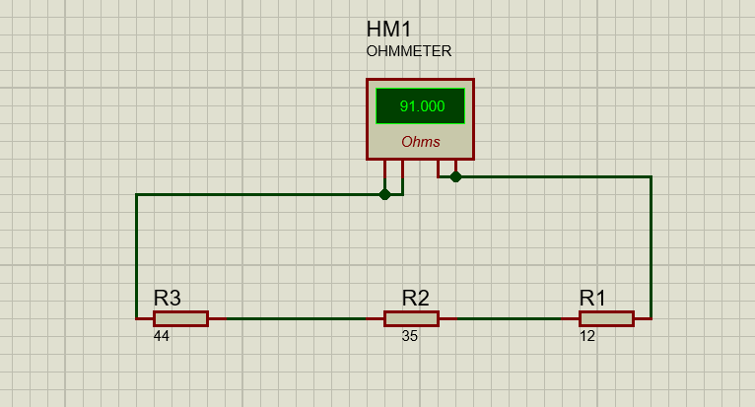
Figure 8 - Proteus Practice, Resistors in Series
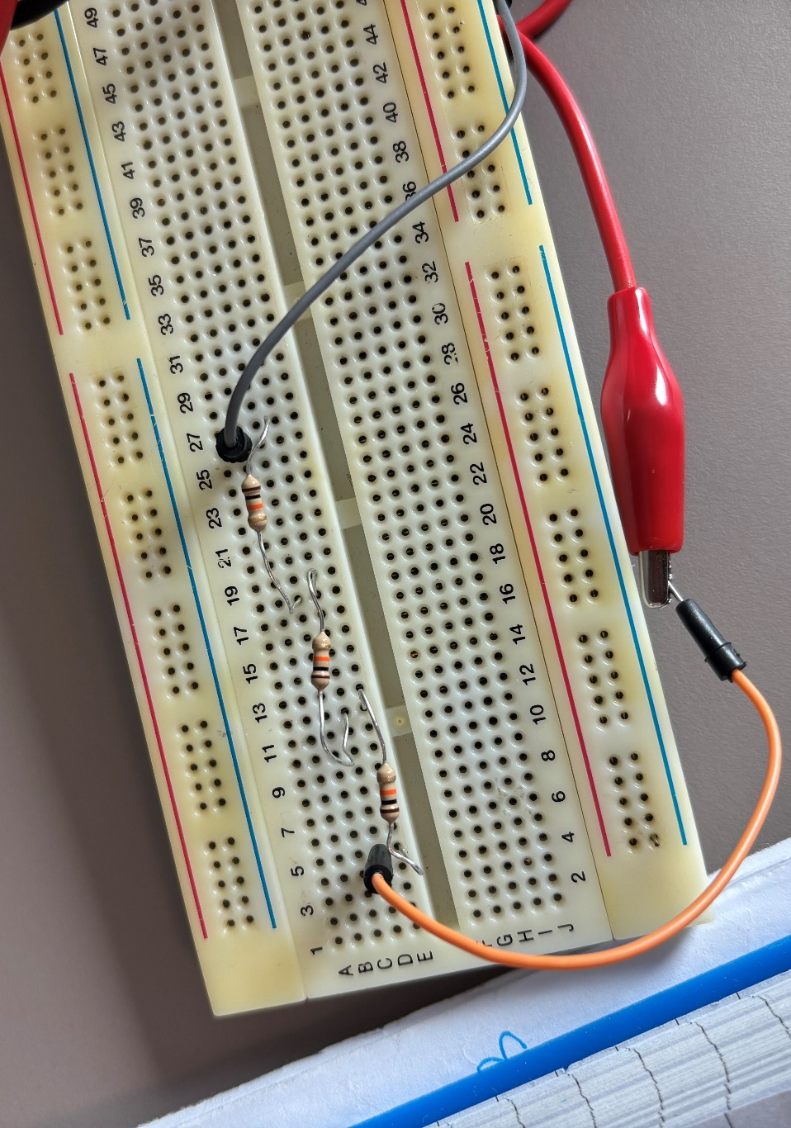
Figure 9 - Resistors in Series on Breadboard
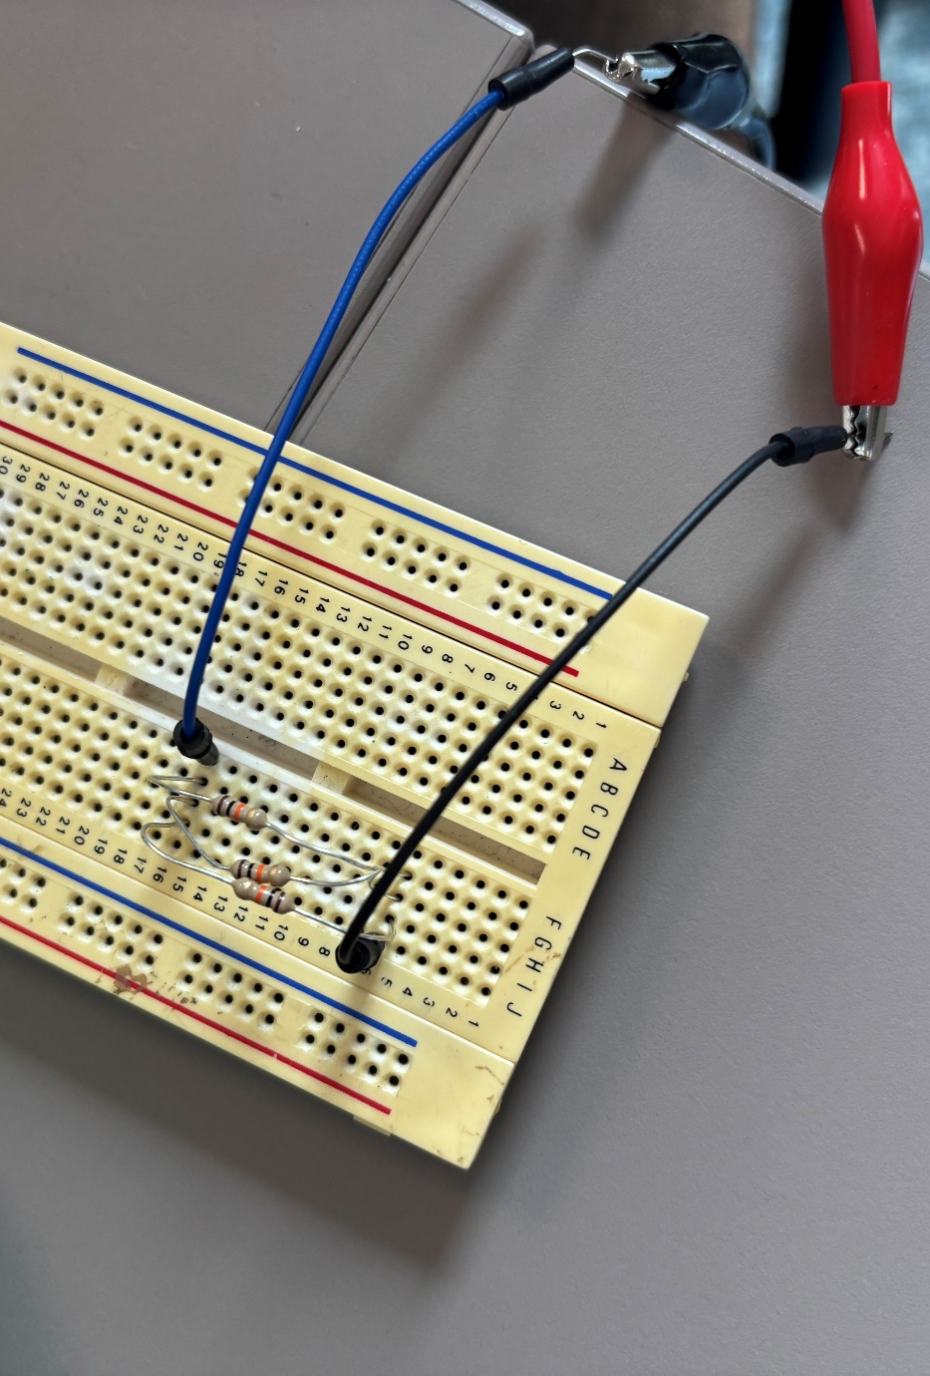
Figure 10 - Resistors in Parallel on Breadboard
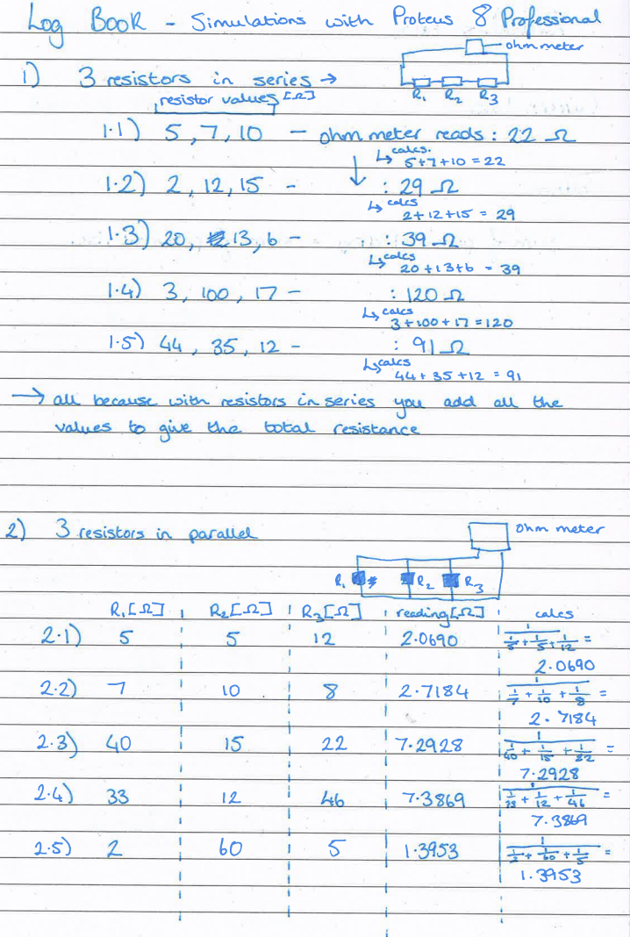
Figure 11 - Resistors in Series and Parallel Calculations
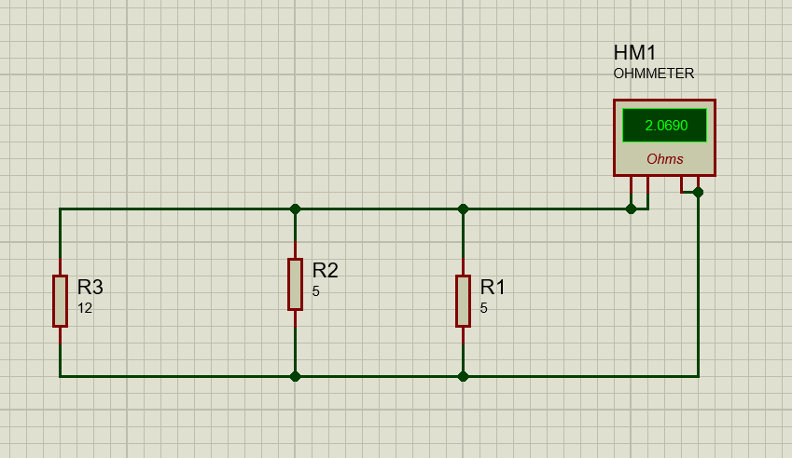
Figure 12 - Proteus Practice, Resistors in Parallel
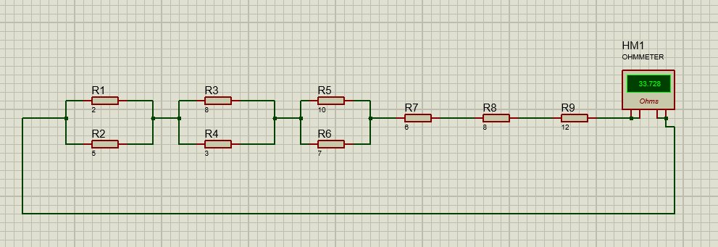
Figure 13 - Proteus Practice, Combination Circuit 1
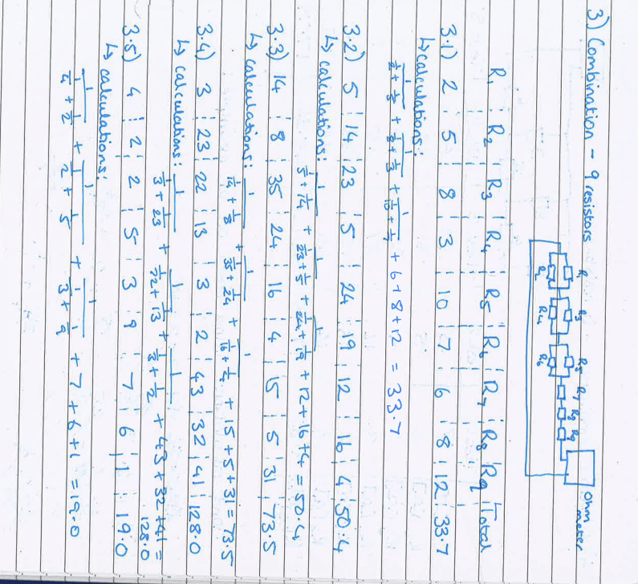
Figure 14 - Combination Circuit Calculations
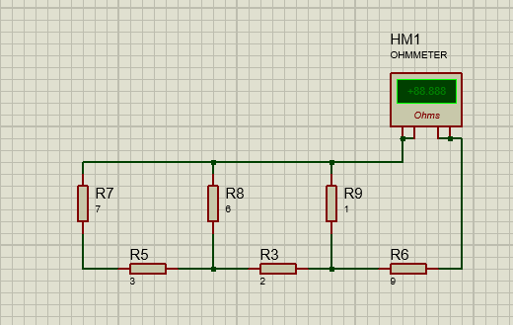
Figure 15 - Proteus Practice, Combination Circuit 2
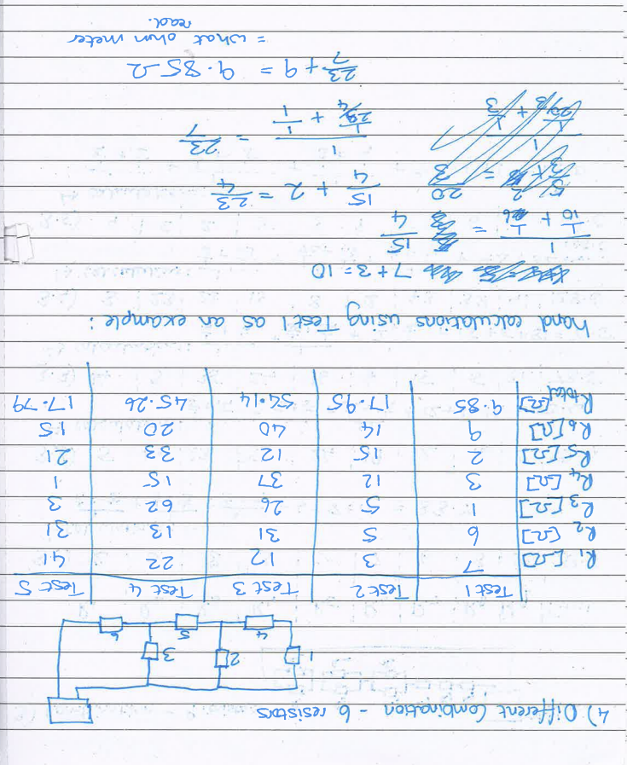
Figure 16 - Combination 2 Circuit Calculations
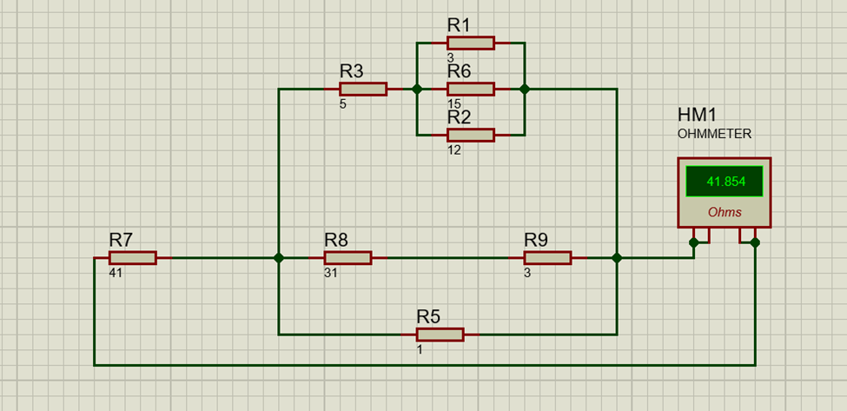
Figure 17- Proteus Practice, Combination Circuit 3
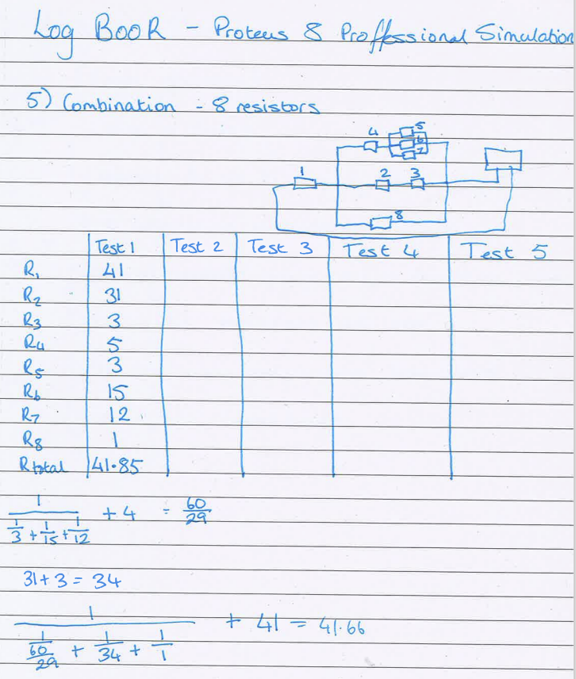
Figure 18 - Combination 3 Circuit Calculations

Appendix B – Tinker Cad Circuits and Schematics
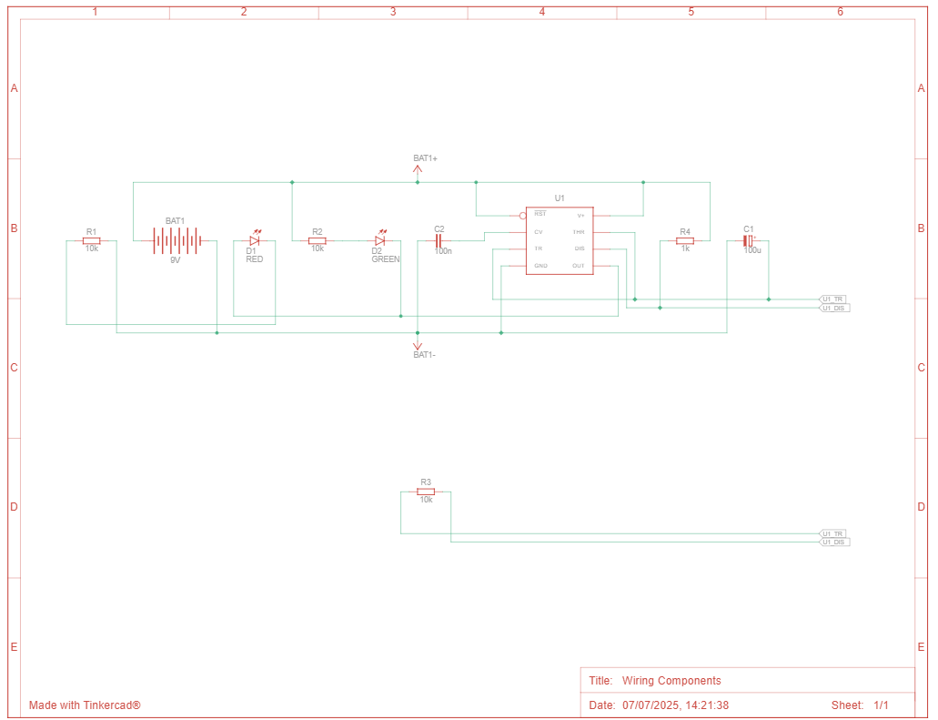
Figure 19 - Tinker Cad Schematic
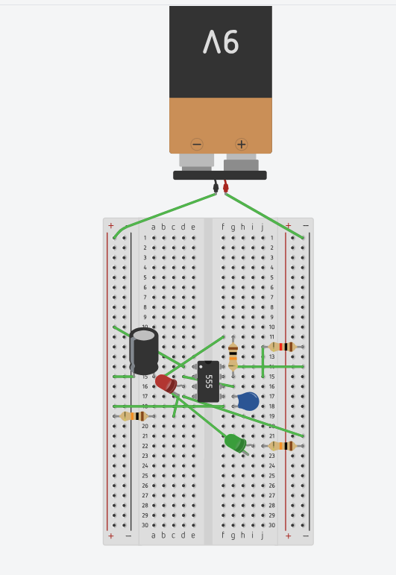
Figure 20 - Tinker Cad Circuit, Red LED Flashing
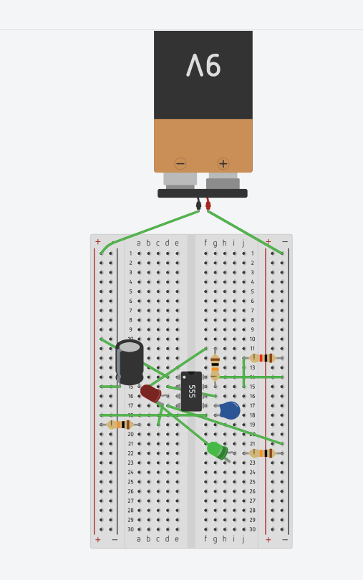
Figure 21 - Tinker Cad Circuit, Green LED Flashing

Appendix C – Hand Calculations
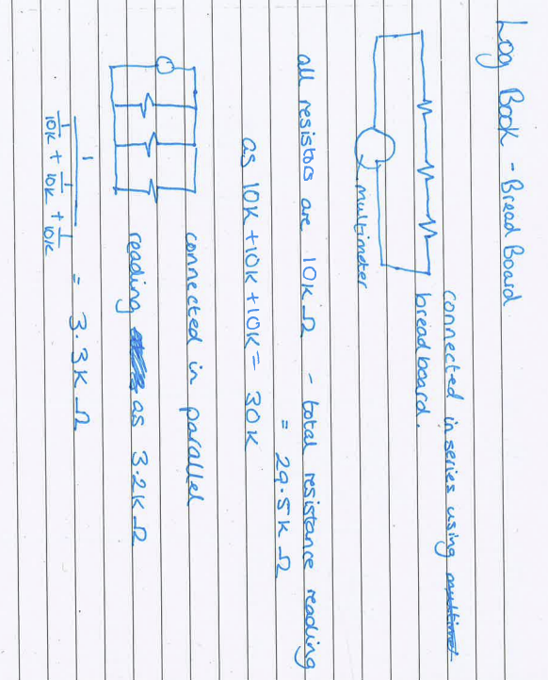
Figure 22 - Hand Calculation 1
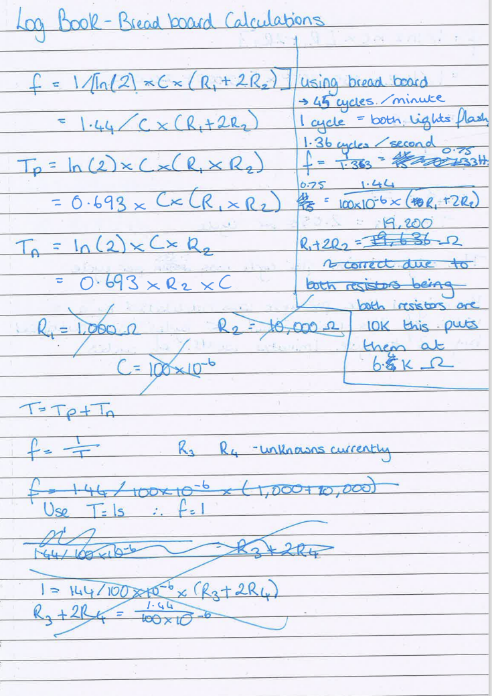
Figure 23 - Hand Calculation 2
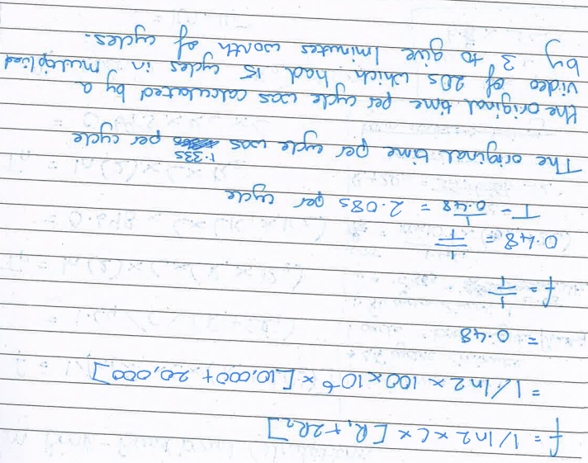
Figure 24 - Hand Calculation 3
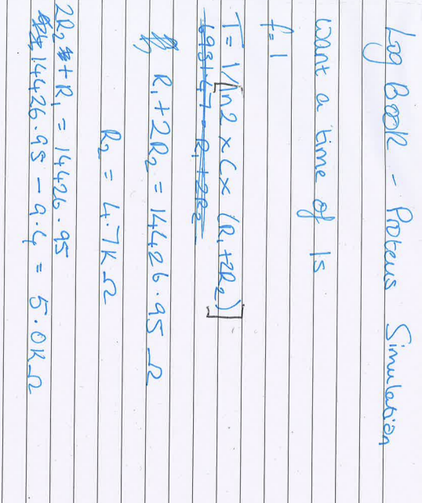
Figure 25 - Hand Calculation 4

Appendix D – Proteus Tables
Table 1 - Voltage at Capacitor Against Time
TIME | C1(1) | C1(2)
0 | 8.99991 | 0
9.99E-09 | 8.99991 | 0
2.00E-08 | 8.99991 | 0
4.00E-08 | 8.99991 | 0
7.99E-08 | 8.99991 | 0
1.60E-07 | 8.99991 | 0
2.51E-07 | 8.99991 | 0
3.62E-07 | 8.99991 | 0
5.80E-07 | 8.9999 | 0
1.02E-06 | 8.9999 | 0
1.89E-06 | 8.99989 | 0
3.64E-06 | 8.99988 | 0
7.13E-06 | 8.99985 | 0
1.41E-05 | 8.99978 | 0
2.81E-05 | 8.99966 | 0
5.61E-05 | 8.99941 | 0
0.000112 | 8.99891 | 0
0.000224 | 8.99791 | 0
0.000447 | 8.99591 | 0
0.000895 | 8.99191 | 0
0.00179 | 8.98392 | 0
0.003579 | 8.96793 | 0
0.007158 | 8.93625 | 0
0.010919 | 8.90296 | 0
0.014567 | 8.87066 | 0
0.018539 | 8.8355 | 0
0.022301 | 8.8027 | 0
0.026208 | 8.76863 | 0
0.029967 | 8.73585 | 0
0.03385 | 8.702 | 0
0.037635 | 8.66949 | 0
0.041507 | 8.63625 | 0
0.045308 | 8.60361 | 0
0.049172 | 8.57043 | 0
0.052988 | 8.53816 | 0
0.056854 | 8.50546 | 0
0.060692 | 8.47301 | 0
0.064573 | 8.44019 | 0
0.068447 | 8.40794 | 0
0.07237 | 8.37528 | 0
0.076313 | 8.34245 | 0
0.080331 | 8.309 | 0
0.084418 | 8.27553 | 0
0.08864 | 8.24096 | 0
0.093025 | 8.20505 | 0
0.097669 | 8.16702 | 0
0.102656 | 8.12687 | 0
0.10815 | 8.08264 | 0
0.114336 | 8.03284 | 0
0.121525 | 7.97589 | 0
0.130144 | 7.90762 | 0
0.140923 | 7.82395 | 0
0.155084 | 7.71403 | 0
0.175086 | 7.56222 | 0
0.206424 | 7.33039 | 0
0.265056 | 6.91559 | 0
0.382319 | 6.15487 | 0
0.582319 | 5.04445 | 0
0.782319 | 4.13583 | 0
0.982319 | 3.39234 | 0
1.082329 | 3.07367 | 0
1.082329 | 3.07367 | 0
1.082329 | 3.07367 | 0
1.082329 | 3.07367 | 0
1.082329 | 3.07367 | 0
1.082329 | 3.07367 | 0
1.08233 | 3.07367 | 0
1.08233 | 3.07367 | 0
1.08233 | 3.07367 | 0
1.082331 | 3.07366 | 0
1.082332 | 3.07366 | 0
1.082335 | 3.07367 | 0
1.082341 | 3.07371 | 0
1.082353 | 3.07377 | 0
1.082376 | 3.07389 | 0
1.082422 | 3.07414 | 0
1.082516 | 3.07464 | 0
1.082702 | 3.07564 | 0
1.083074 | 3.07764 | 0
1.083819 | 3.08165 | 0
1.085308 | 3.08965 | 0
1.088287 | 3.10565 | 0
1.092031 | 3.12557 | 0
1.095783 | 3.14554 | 0
1.099828 | 3.16707 | 0
1.103565 | 3.18695 | 0
1.107466 | 3.20743 | 0
1.111213 | 3.22709 | 0
1.115107 | 3.24752 | 0
1.118887 | 3.26736 | 0
1.122764 | 3.28742 | 0
1.126559 | 3.30706 | 0
1.130426 | 3.32708 | 0
1.134238 | 3.34681 | 0
1.138105 | 3.36654 | 0
1.141937 | 3.3861 | 0
1.145817 | 3.4059 | 0
1.149683 | 3.42562 | 0
1.153599 | 3.44533 | 0
1.157528 | 3.46509 | 0
1.161528 | 3.48522 | 0
1.165588 | 3.50565 | 0
1.169771 | 3.52642 | 0
1.1741 | 3.54791 | 0
1.178666 | 3.57058 | 0
1.183541 | 3.59447 | 0
1.188878 | 3.62062 | 0
1.194842 | 3.64984 | 0
1.201716 | 3.68304 | 0
1.209873 | 3.72245 | 0
1.219953 | 3.7703 | 0
1.232986 | 3.83218 | 0
1.250988 | 3.91607 | 0
1.27823 | 4.04043 | 0
1.326235 | 4.25224 | 0
1.422244 | 4.6493 | 0
1.614262 | 5.34779 | 0
1.814262 | 5.95647 | 0
1.914252 | 6.22107 | 0
1.914252 | 6.22107 | 0
1.914252 | 6.22107 | 0
1.914252 | 6.22107 | 0
1.914252 | 6.22107 | 0
1.914252 | 6.22107 | 0
1.914253 | 6.22107 | 0
1.914253 | 6.22107 | 0
1.914253 | 6.22107 | 0
1.914254 | 6.22107 | 0
1.914255 | 6.22108 | 0
1.914258 | 6.22106 | 0
1.914264 | 6.22102 | 0
1.914276 | 6.22095 | 0
1.914299 | 6.22081 | 0
1.914345 | 6.22052 | 0
1.914439 | 6.21995 | 0
1.914625 | 6.2188 | 0
1.914997 | 6.21651 | 0
1.915742 | 6.21193 | 0
1.917231 | 6.20276 | 0
1.92021 | 6.18443 | 0
1.923954 | 6.16163 | 0
1.927707 | 6.13877 | 0
1.931751 | 6.11414 | 0
1.935488 | 6.09138 | 0
1.939389 | 6.06798 | 0
1.943136 | 6.04551 | 0
1.94703 | 6.02216 | 0
1.95081 | 5.99949 | 0
1.954687 | 5.97659 | 0
1.958482 | 5.95418 | 0
1.962349 | 5.93133 | 0
1.966161 | 5.90882 | 0
1.970028 | 5.88633 | 0
1.97386 | 5.86404 | 0
1.97774 | 5.84147 | 0
1.981606 | 5.81899 | 0
1.985522 | 5.79657 | 0
1.989451 | 5.77407 | 0
1.993451 | 5.75117 | 0
1.997511 | 5.72792 | 0
2.001695 | 5.70437 | 0

