Workshop: Women, business and influence in Pompeii
Pompeii: The life, death and rediscovery of a Roman town (HPAH5078/HPAH6078)

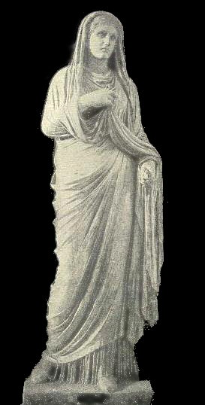

In this short workshop we will explore the varying cultural and economic clout that women could possess in Roman Pompeii. A range of graffiti, inscriptions and some wall-paintings are given below. You should examine these and consider the following questions:

Questions:
- Why might wealthy women have chosen to engage in public benefaction, even if they could not formally hold political offices?
- What can the epigraphic and documentary evidence tell us about women’s involvement in business and financial activities and how they may have been conducted? [Pay attention to the potential status of the women]
- Can we infer anything about potential levels of education for women from wall-paintings?

Translations come from Cooley, A. and M. Cooley (2013). Pompeii and Herculaneum: A Sourcebook (second edition). Routledge.

Wealthy patronesses
‘Eumachia, daughter of Lucius, public priestess, in her own name and that of her son, Marcus Numistrius Fronto, built at her own expense the chalcidicum [vestibule / porch entrance], crypt and portico in honour of Augustan Concord and Piety and also dedicated them.’ – CIL 10.808 + 8348 = ILS 63 [Latin inscription].

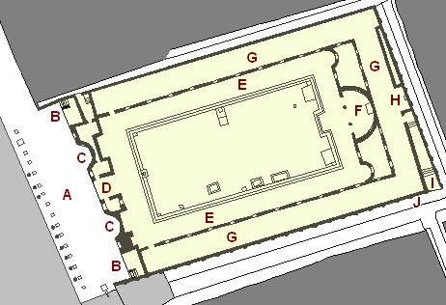
Plan of Eumachia’s building

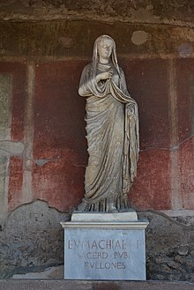
‘To Eumachia, daughter of Lucius, public priestess; the fullers (set this up).’ – CIL 10.813 = ILS 6368 [Latin inscription accompanying Eumachia’s statue]

‘Pomponia Decharcis, wife of Alleius Nobilis, mother of Alleius Maius.’ – D’Ambrosio and De Caro (1983) 11OS no.13 [a herm set up by Pomponia]

Mamia, daughter of Publius, public priestess, [built this] to the genius [of the colony/of Augustus] on her own land and at [her own] expense.’ – CIL 10.816. [Inscription commemorating Mamia’s construction of a temple – the identity of the temple remains in question]

‘To Mamia, daughter of Publius, public priestess, a place for burial was given by decree of the town councillors.’ – CIL 10.998 = ILS 6369.
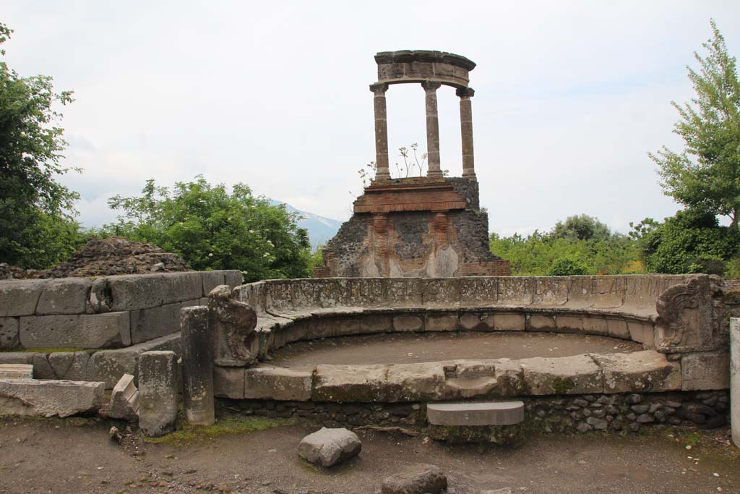
Mamia’s tomb

Women and financial dealings
‘To let, in the estate of Julia Felix, daughter of Spurius: elegant baths for respectable people, shops with upper rooms, and apartments. From 13 August next to 13 August of the sixth year, for five continuous years. The lease will expire at the end of the five years.’ – CIL 4.1136 = ILS 5723.

‘{Pages 2–3} [During the consulship of Q. Volusius S]aturninus and [P. Cornelius Scipi]o, on the 11 November. I, [name missing], slave of Umbricia Antiochis, [have written] that she has received 645 sesterces from L. Caecilius [Iucundus], for the auction [which was performed on her behalf], for the objects removed from a property sold earlier. Out of this sum [she has received] 200 sesterces [in cash], with valuation costs adding up to 20 sesterces, incidental expenses adding up to 13 sesterces, and the banker’s fee of 51 sesterces having been deducted from the price; finally I received today the sum of 360 sesterces. Transacted at Pompeii.’ – CIL IV 3340.23. [Here we have an auction of property in November AD 56, in which certain fees were charged by L. Caecilius [Iucundus] – with the items sold fetching 645 sestertii in value, with seller receiving 560 sestertii of that (i.e., 87%)]

‘{In ink, on the margin of the second tablet} Acknowledgement – for Trophimus. {Pages 2–3} In the consulship of Lucius Duvius Avitus and Publius Clodius, on 10 December. I, Marcus Helvius Catullus, wrote at the request of Umbricia Antiochis that she had received from Lucius Caecilius Iucundus 6,252 sesterces for the auction of her slave Trophimus, less commission. Transacted at Pompeii. {Page 4, next to seals, now missing}
Of Marcus Helvius Catullus
Of Melissaeus Fuscus
Of Fabius Proculus
Of Umbricia Antiochis
Of Catullus
{Page 5} In the consulship of Lucius Duvius [Avitus and Publius] Clodius, on 10 December. I, Marcus Helvius Catullus, wrote at the request of Umbricia that she had received from Iucundus 6,252 [sesterces] for the auction of her slave Trophimus, less commission. Transacted at Pompeii.’ – CIL 4.3340.24.

‘Finest fish sauce from Umbricia Fortunata, belonging to Veturinus Iulianus.’ – CIL 4.5675.

{Pages 2 to 3} ‘8,562 sesterces – the sum of money which is due for payment, as contracted with Lucius Caecilius Iucundus, for the auction of Tullia Lampyris – Tullia Lampyris declared that she has been paid this sum, less commission, by Lucius Caecilius Iucundus. Transacted at Pompeii, 23 December in the consulship of Nero Caesar for the second time and L. Caesius Martialis. {Page 4, next to seals, now missing}
Of Lucius Vedius Ceratus
Of Aulus Caecilius Philologus
Of Gnaeus Helvius Apollonius
Of Marcus Stabius Chryseros
Of Decimus Volcius Thallus
Of Sextus Pompeius Axsioc(hus)
Of Publius Sextius Primus
Of Gaius Vibius Alcimus
{Page 5} In the consulship of Nero Caesar for the second time and Lucius Caesius Martialis, transacted at Pompeii on 23 December. I, Sextus Pompeius Axiochus, have written at the request of Tullia Lampyris, that she has received from Lucius Caecilius Iucundus 8,560 sesterces and 2 asses for her auction, as confirmed on examination of sealed tablets.’ – CIL 4.3340.40. [Undertaken in December, AD 57]

‘8 February. Vettia, 20 denarii: usury 12 asses. 5 February from Faustilla, 15 denarii: usury 8 asses.’ – CIL 4.4528 [graffito found in an inn, in Pompeii (VI.14.28) – in the early Imperial period there were 16 asses to a denarius]

‘4 July. Hooded cloak and small cloak [deposited with Fau]stilla. Per 50 [. . .] usury [. . .] 141 ⁄2 [. . .] 8 asses.’ – CIL 4.8204 [This graffito, discovered in the SE corner of a cublicum in I.8.13 at Pompeii; it records a deposit of clothing as security against a loan received from Faustilla, a form of pawn-broking]

‘15 July. Earrings deposited with Faustilla. Per two denarii she took as usury one copper as. From a total? 30.’ – CIL 4.8203 [found to the right of I.8.13 – this seems to be another example of usury and the securing of the loan against collateral]

TPSulp. 58 [Archive of the Sulpicii]
. . . except the 20,000 sestertii for the account of my domina Priscilla; that the 4,000 sestertii, written above, be given properly and in good coin, asked for faith by Caius Sulpicius Faustus, promised for faith by Pyramus, the slave of Caesia Priscilla.

TPSulp. 60 [Archive of the Sulpicii]
Accounts of Titinia Antracis. Paid out to Euplia the Melian, daughter of Theodorus, HS 1,600, with the authority of her tutor, Epichares the Athenian, son of Aphrodisius. She requested and received in cash from the chest at home. Received for the chest HS 1,600. [HS = sestertius]

Women at work
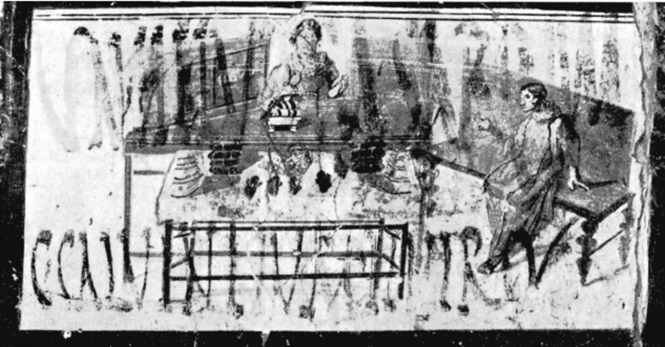
Drawing of a badly damaged fresco from the workshop of the dyer Verecundus appearing to show a woman selling items.

‘Vesbius Tamudianus [CIL IV 1493]
Pottttas X [CIL IV 1494]
Vesbius [CIL IV 1495]
Quibusos [CIL IV 1496]
Felix [CIL IV 1497]
Felix [CIL IV 1498]
Nero Poppaeeses istis [CIL IV 1499]
Vibius [CIL IV 1501]
Mamoe [CIL IV 1502]
Ephesus
Fututor [CIL IV 1503]
Felix [CIL IV 1504]
Xanthus [CIL IV 1505]
Successus [CIL IV 1506]
Maria wool-worker/weaver [CIL IV 1507]
Faustus Felix F[l]oru(s) [CIL IV 1509]
Various men and women named as textores (weavers) and netrices (net-makers) whose names are mentioned in the peristlye of The House of M. Teretius Eudoxous (VI.13.8)

A love triangle
‘– Successus the weaver loves the barmaid of the inn, called Iris, who doesn’t care for him, but he asks and she feels sorry for him. A rival wrote this. Farewell.
– You’re jealous, bursting out with that. Don’t try to muscle in on someone who’s better-looking and is a wicked and charming man.
– I have written and spoken. You love Iris, who doesn’t care for you. Severus to Successus.’ – CIL 4.8259, 8258. [This graffiti exchange has been found in connection with a bar at I.10.2–3. There are three messages, the first and third by Severus, the second the reply of Successus, which is clearly written but contains difficult grammar and spelling].

Education women in wall-paintings
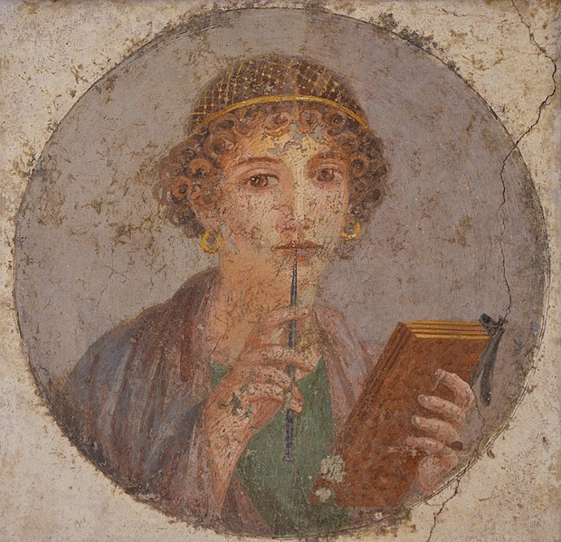
The so-called Sappho fresco – image of a woman with wax tablets and stylus – Naples Archaeological Museum inv. 9084.

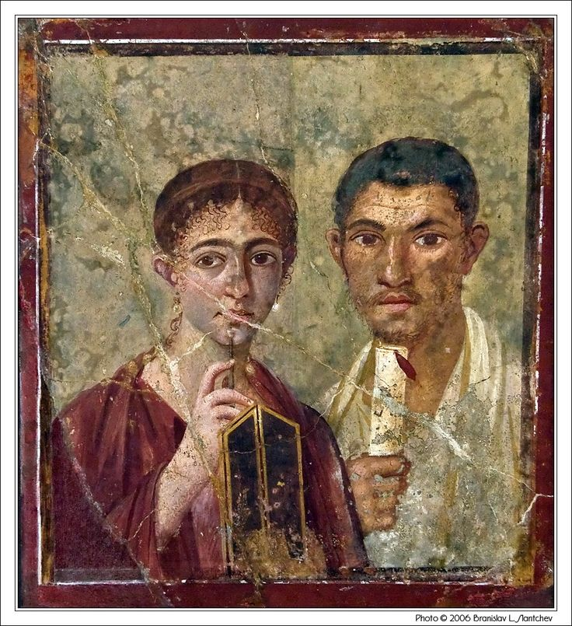
The House of Paquius Proculus (his wife also depicted in the fresco) [VII.2.6] – now in Naples Archaeological Museum

