
LCLM4005 Employability and Career Development

Student name: Nahidur Rahman
Student id 2430028

Lecturer: Jaya Gopalkrishnan

Table of Contents
Introduction 3
Task 1 3
Selection of Job Adverts 3
Identify Key Skills 8
Task: 2 10
Self-Assessment 10
Evidence of Readiness 13
Task: 3 13
Setting Employment Goals 13
Personal Development Plan 14
Conclusion 16
References 17

Introduction
This report focuses on my career gaols. I want to become a Marketing Executive in the future. I have found four job advertisements in Indeed and Compared the skills and knowledge I require to do the job. In this report I will also share my Personal SWOT analysis and Myers–Briggs Type Indicator (MBTI) Test to identify my strengths and weaknesses (Griffith and Hoppner, 2013). I have identified my short term and long-term career gaols. Lastly, I have developed Personal development plan to improve e my weaknesses.

Task 1

Selection of Job Adverts
I have selected four Job Advertainments from Indeed. Following presented the Job Advertainments:

Job Advertainment 1: Marketing Assistant of The City Of London Corporation
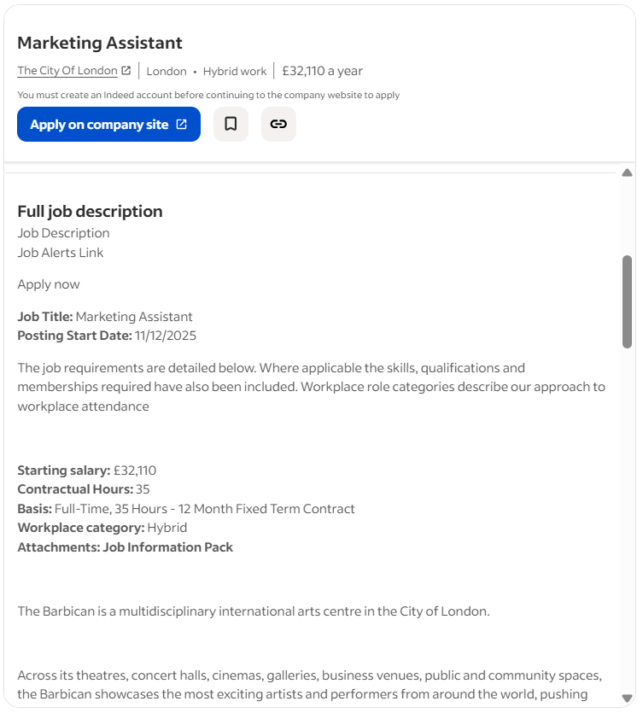
Source: https://uk.indeed.com/q-marketing-jobs.html?vjk=281b58d30b97293a

Job Advertainment 2: Marketing Business Partner of University of Reading
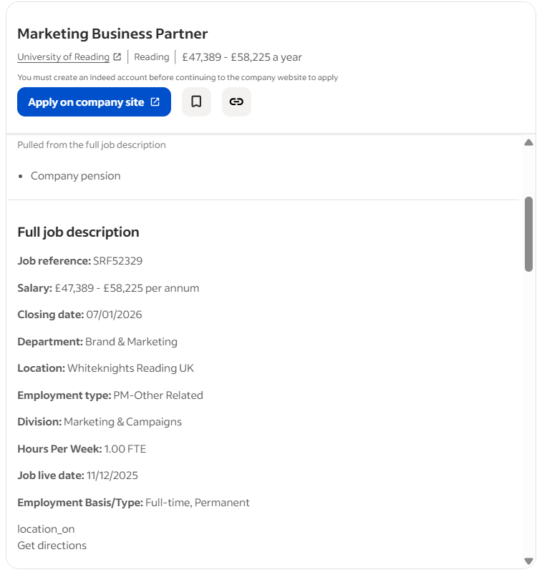
Source: https://uk.indeed.com/q-marketing-jobs.html?vjk=30533a152c268004

Job Advertainment 3: Market Insight & Engagement Coordinator of KaarbonTech
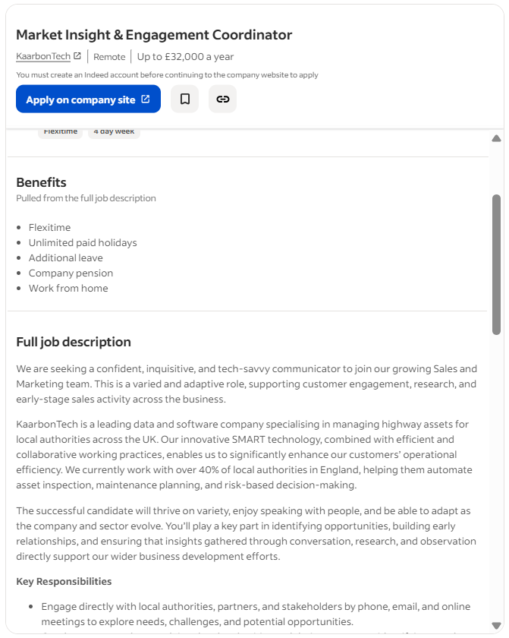
Source: https://uk.indeed.com/q-marketing-jobs.html?vjk=7e9e0c01ab98a874

Job Advertainment 4: Marketing & Digital Specialist of Kids Love Nature Ltd
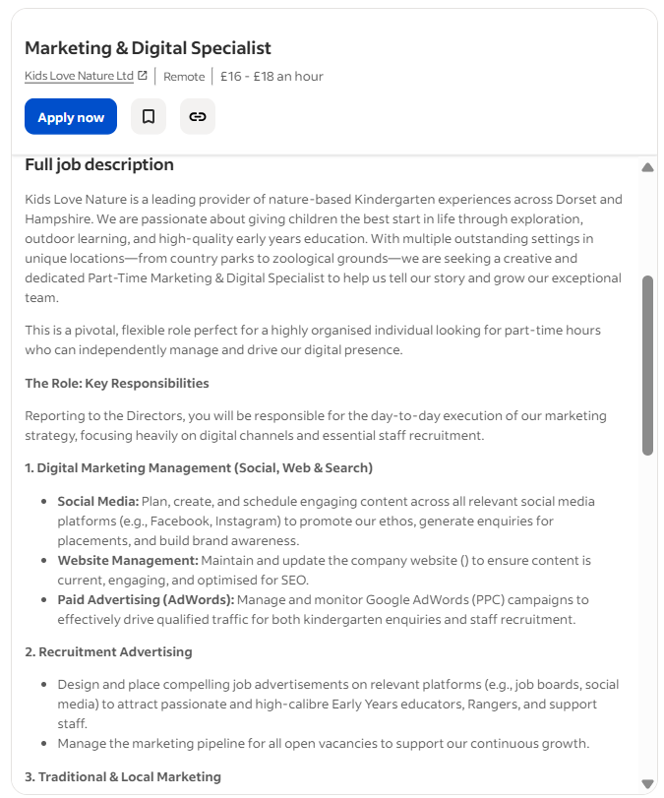
Source: https://uk.indeed.com/q-marketing-jobs.html?vjk=a438a12c915c585e

Identify Key Skills
I have compared the four advertainments and I have identified the knowledge and skills I need for becoming the marketing professionals (Bridgstock, 2019).
The Knowledge Areas
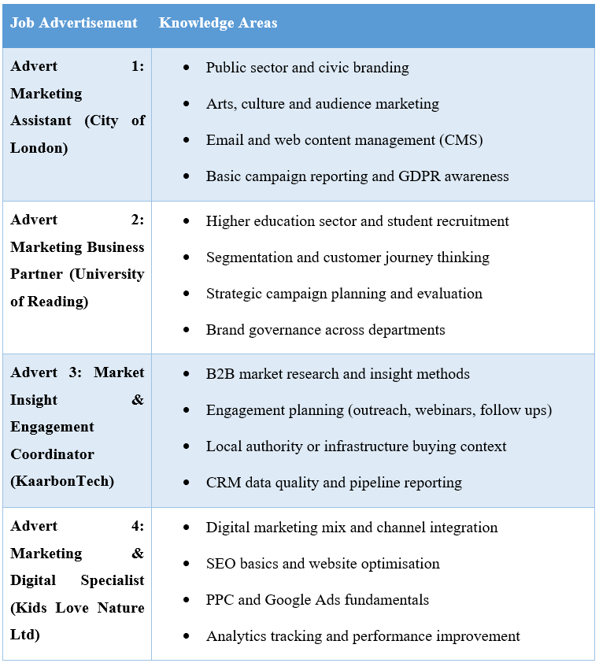

The Common Skills
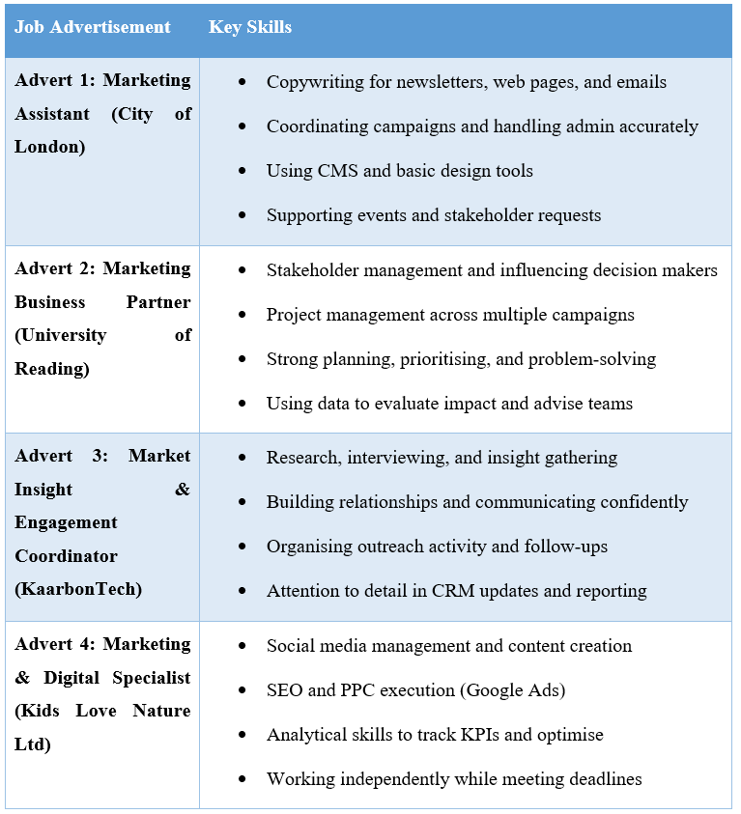
Common Knowledge and skills
In all the four advisements, there are common requirements for delivering marketing campaigns using digital channels like websites, email, and social media and writing clear marketing content. All the for advertainments wants evidence-led marketing using CRM or business analytics, and evaluation results (Carter and Yeo, 2017). There are also demand of communication skills, analytical skills, problem solving skill, teamworking, organising the tasks and meeting deadlines (Healy, Hammer and McIlveen, 2022).

Task: 2

Self-Assessment
I am going to carry out the SWOT analysis and Myers–Briggs Type Indicator (MBTI) test (online) to identify my skills and shortcoming based on my career objectives (Carter and Yeo, 2017). I have provided the evidence of my readiness also.
Personal SWOT analysis
Strengths | Weaknesses
Strong communication: Confident in presenting ideas, writing clearly, and collaborating in group tasks, which supports content creation and campaign coordination (Bridgstock, 2019). | Lower flexibility under sudden change: When priorities shift fast, I take time to adjust and re-plan (Carter and Yeo, 2017)
Leadership and responsibility: Comfortable taking ownership, delegating tasks, and keeping work on track, aligned with my ESTJ-A profile (Griffith and Hoppner, 2013) | Emotional intelligence under pressure: I can sound too direct, so I need to improve tone and active listening in teamwork and client communication (Healy, Hammer and McIlveen, 2022)
Structured and organised: I am good at planning, prioritising, and meeting deadlines, useful for handling multiple campaigns and stakeholder requests. | Limited advanced digital analytics: I have no prior experience of using GA4-style reporting, SEO tools, and paid ads performance analysis (Huang et al., 2022)
Problem-solving and decision making: Prefer practical solutions and can make quick decisions when issues come up during projects (Kline, 2020) | Less creative experimentation: I focus more on “what works” than testing new formats. But I need to be more skilled in becoming creative.
Opportunities | Threats
Build a marketing portfolio: I can create sample campaigns, social content, and KPI reports to show employability (Majid, Eapen and Oo, 2019) | Highly competitive entry roles: Many applicants with strong portfolios and digital tool experience which will impact on my opportunity to get job.
Short courses and certifications: I can complete Google Analytics, SEO, PPC, and Canva/Adobe basics to match job requirements (Kline, 2020) | Fast-changing digital trends: Skills can become outdated without continuous learning (Nghia et al., 2020)
Networking and mentoring: I can use LinkedIn, university career services, and feedback from tutors to sharpen industry readiness (Montana, Petit and McKenna, 2014) | High-pressure deadlines: Risk of stress if I do not manage workload and boundaries well (Tollin and Schmidt, 2015)
Internships/volunteering: I can gain practical marketing experience in student societies or local businesses (Walker et al., 2009) | AI-driven changes: Need to adapt quickly to new tools while keeping quality and ethics.

Myers–Briggs Type Indicator (MBTI) Test
I have completed online test using Myers–Briggs Type Indicator (MBTI) Test. The results shows that I am MBTI Executive ESTJ-A. It also shows 75% Extraverted, 52% Observant, 57% Thinking, 65% Judging, and 61% Assertive. This result means, I have clear goals and practical actions. My personality shows that in marketing field; I can be good in scheduling the marketing campaign. Data-led marketing suits me since KPIs, basic analytics, and performance reports help me better (Huang et al., 2022). My leadership, timelines, and staged effort improve project-based marketing. According to my Assertive score, I can keep calm throughout hectic campaigns and tight deadlines. I prefer testing and continuous improvement versus making final judgements when priorities change. Sympathetic marketing favours customers above tasks (Healy, Hammer and McIlveen, 2022). MBTI helps me think, not label. I can use this profile to demonstrate dependability, leadership, and a strategy to improve flexibility and customer awareness in interviews.
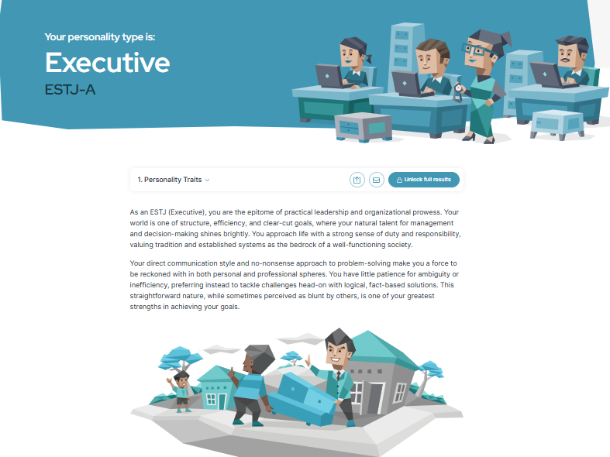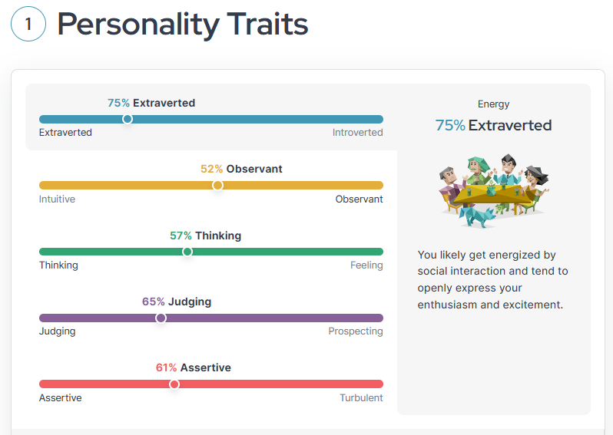

Evidence of Readiness
My education, experience, and transferable skills demonstrate my readiness to start my career as marketing executive. My previous school research, report writing, and organised presentations help me appraise evidence, clarify concepts, and write audience-focused material (Huang et al., 2022). “Group projects” improved my cooperation, leadership, and time-management abilities since I organised assignments, coordinated deadlines, and ensured quality. For example- in “LCLM4004 Problem Solving and Decision Making” module I have created a report on solving the problem for Green Haven Florists, I have an analysed two solutions by using PMI Analysis and Grid Analysis and then I have suggested “Upgrading digital sales” using advanced website, delivery service and monthly subscription. This way, I have developed analytical skill, problem solving skill and decision-making skill. My curricular activities like participating in Debate has increased my communication skills. Online classes and applying what I learn to content development and performance reporting show my proactive attitude to learning new technologies and digital skills (Kline, 2020). My professors and classmates describe me as organised, reliable, and communicative persons which I like about me. I am also studying digital marketing and analytics for the job market.

Task: 3

Setting Employment Goals
I have used SMART criteria for creating my employment gaols.
Short-term goals (next 1 year):
- To develop my flexibility while facing change within 3 months
- To develop my emotional intelligence within 3 months
- To secure a marketing internship or junior role by applying to 10 jobs weekly, tailoring CVs, and completing 2 portfolio projects (social campaign + email/newsletter) with KPI targets.
- To improve digital skills by finishing GA4 + SEO certifications within 6 months and producing 4 performance reports using real or simulated data.

Long-term goals (3 years):
- Completing the BA (hons) marketing with 36 Months
- Progress to Marketing Executive within 36 months by leading at least 6 full campaigns, improving PPC/CRM capability, and achieving measurable impact (e.g., +20% engagement or +10% leads) while developing stronger flexibility and stakeholder communication.
Importance of these gaols:
The short-term goals explain my marketing career ambitions, which I love. I get experience through internships or junior jobs. My communication, planning, and collaboration skills can fill project digital analytics, SEO, and performance reporting gaps (Majid, Eapen and Oo, 2019). Marketing firms value skill over credentials, therefore short-term gaols is crucial. My long-term goal is to develop myself as a Marketing Executive. I will gain my BA (Hons) Degree. Marketing requires outcomes, and I like campaign leadership and results. Flexible and stakeholder-focused communication skills enable me professionally handle fast-changing circumstances and different expectations (Nghia et al., 2020). These goals will increase my opportunity to get jobs.

Personal Development Plan
Weakness to improve | Actions I will take | Time Frame | Resources needed | Progress measures
Low flexibility when priorities change | Using weekly planning with a “priority reset” every Friday, practise re-scoping tasks in 15 minutes, and doing 2 rapid re-plan exercises per week using mock campaign briefs (Okolie et al., 2020) | 3 months  January 2026 to March 2026 | Notion/Trello, sample briefs, calendar routine | 8 re-plan logs, faster task switching, tutor/peer feedback shows improvement
Tone and emotional intelligence under pressure | Practising active listening, record 1 difficult conversation reflection weekly, and role-play stakeholder meetings twice a month (Tollin and Schmidt, 2015) | 3 months  April 2026 to June 2026 | Mentor/peer partner, reflection template (Huang et al., 2022) | 12 reflection entries, improved feedback on collaboration, fewer misunderstandings
Limited advanced digital analytics | Completing GA4 basics and reporting practice, building 4 dashboards, and writing 4 short insight reports from data (Healy, Hammer and McIlveen, 2022) | 3 months  July 2026 to September 2026 | GA4 learning resources, Looker Studio, sample datasets | Certificate completed, 4 dashboards, 4 reports with KPIs and recommendations
Limited SEO and PPC confidence | Learning SEO fundamentals and running 2 mini audits on sample websites, then drafting 2 PPC ad sets with keywords and targeting (Huang et al., 2022) | 3 months  October 2026 to December 2026 | SEO checklist, keyword tools (free), Google Ads learning materials (Healy, Hammer and McIlveen, 2022) | 2 SEO audit documents, 2 PPC plans, improved understanding in mock interview answers
Less creative experimentation | Running 2 A/B tests on content (headlines or creatives), create 20 posts across 2 campaigns, and review performance weekly | 3 months  January 2026 to March 2026 | Canva, content calendar, social analytics | 2 A/B summaries, 20 posts, weekly review notes, clear learning points and improvements
Completing my BA (Hons) Marketing degree | Admitting in a Good University and having good academic results (Majid, Eapen and Oo, 2019) | March 2026 to February 2029 | Admission Fee | Cheeking the semester results

Conclusion
I want to become a Marketing Executive; I have compared 4 Job advertainments to understand my needs of knowledge and skills. I have completed SWOT analysis and MBTI Test to understand my strengths and my shortcomings. I have then developed the short-term and long-term employment gaols and then I have created a personal development plan.

References
Bridgstock, R., (2019). Employability and career development learning through social media: Exploring the potential of LinkedIn. In Challenging future practice possibilities (pp. 143-152). Brill.
Carter, S. and Yeo, A.C.M., (2017). Undergraduate perceptions of the knowledge, skills and competencies required of today’s practicing marketer. Higher Education, Skills and Work-Based Learning, 7(3), pp.240-260.
Griffith, D.A. and Hoppner, J.J., (2013). Global marketing managers: Improving global marketing strategy through soft skill development. International Marketing Review, 30(1), pp.21-41.
Healy, M., Hammer, S. and McIlveen, P., (2022). Mapping graduate employability and career development in higher education research: A citation network analysis. Studies in Higher Education, 47(4), pp.799-811.
Huang, X., Cao, J., Zhao, G., Long, Z., Han, G. and Cai, X., (2022). The employability and career development of finance and trade college graduates. Frontiers in psychology, 12, p.719336.
Kline, T.J., (2020). Teams that lead: A matter of market strategy, leadership skills, and executive strength. Psychology Press.
Majid, S., Eapen, C.M. and Oo, K.T., (2019). The Importance of Soft Skills for Employability and Career Development: Students and Employers' Perspectives. IUP Journal of Soft Skills, 13(4).
Montana, P., Petit, F. and M. McKenna, T., (2014). Marketing executive development in a changing world: the needed executive skills. Journal of Management Development, 33(1), pp.48-56.
Nghia, T.L.H., Singh, J.K.N., Pham, T. and Medica, K., (2020). Employability, employability capital, and career development: A literature review. Developing and utilizing employability capitals, pp.41-65.
Okolie, U.C., Nwajiuba, C.A., Binuomote, M.O., Ehiobuche, C., Igu, N.C.N. and Ajoke, O.S., (2020). Career training with mentoring programs in higher education: Facilitating career development and employability of graduates. Education+ training, 62(3), pp.214-234.
Pavia, T.M., (2006). Educating practitioners to value new marketing knowledge: A case study in executive education. Marketing Intelligence & Planning, 24(3), pp.296-306.
Tollin, K. and Schmidt, M., (2015). Marketing’s contribution from the perspective of marketing executives. Marketing Intelligence & Planning, 33(7), pp.1047-1070.
Walker, I., Tsarenko, Y., Wagstaff, P., Powell, I., Steel, M. and Brace-Govan, J., (2009). The development of competent marketing professionals. Journal of marketing education, 31(3), pp.253-263.
Watts, A.G., (2006). Career development learning and employability (pp. 1-30). York: Higher Education Academy.

