Part one

Soapbox rally project
Ross Vince (1902545)
Jessica Sibley (1901919)
Kieran Gurley (1911026)
Oliver Courtney (1904995)

Contents
0
1 Abstract 3
2 Introduction 3
3 Organisation 3
3.1 Gantt chart 3
3.2 Meeting minutes 4
4 Research 5
4.1 Materials/costing 5
4.2 Dynamics/driveability 5
4.3 Regulations 5
5 Design development 6
5.1 Design 1 6
5.2 Design 2 7
5.3 Design 3 8
5.4 Final Design 10
6 Conclusion 13
7 References 15
8 Figures 16

Abstract

This report investigates the running of a small team and how the design process of a soapbox rally car works. This report goes through the organisational, research and design processes of the car. During the report, it details how each section of a team can affect one another. For example, the costing section of the team directly affects every other section, as it limits things such as materials that can be used and design philosophies.

Introduction
We have been tasked as a group to design and implement a soapbox rally car. During this task, we will be basing our research on past soapbox rallies and considering what has and hasn’t been successful. During this research, we will consider things such as what materials have been used, driveability and costing. We hope to gain valuable teamwork skills during this project, as well as furthering our engineering knowledge. We have assigned roles within our group so that we can work as efficiently as possible. Ross is working on the dynamics and driveability of the car, Jessica is working on the designs for the car, Oliver is researching which materials are available for the car and Kieran is evaluating the cost of each design.

Organisation

During this project, to work as efficiently as possible, we have decided to schedule four team meetings so that we can keep each member of the team fully up to date with progress from each assigned role. This is important, as what is found in each role directly effects the other roles in the team.

Gantt chart

 | Week commencing
Meeting | 02/12/19 | 09/12/19 | 16/12/19 | 23/12/19 | 30/12/19 | 06/01/20 | 13/01/20 | 20/01/20

1

2

3

4

Meeting minutes

Meeting 1:
All members present.
During the first meeting, we assigned each team member their roles for the project. It was decided that Ross would take the role of dynamics and driveability, Jessica would take the role of creating the designs, Oliver would take the role of researching the materials and Kieran would oversee evaluating the cost of materials and each design. The dates of future team meetings were also decided.
Meeting 2:
All members present.
In the second team meeting, we discussed the research that had gone into each role. Jessica had drafted some initial designs for the group to consider, whilst Oliver had gathered information about materials that would be available to the team. This meant that Kieran could evaluate the cost of materials and Jessica’s designs over the Christmas break. Ross had researched previous successful entries and had found previous concepts that had performed well.

Meeting 3:
All members present.
The third meeting was the first time the team had been together since the Christmas break. Jessica had drafted her three final designs that the team were going to choose from after receiving feedback from the rest of the team. The team decided on the final design and what parts of it needed adapting.

Meeting 4:
All members present.
The final meeting was used to evaluate how the task had gone and conclude the first part of the project. Any last adjustments were made, and the team ensured everything would be ready for the deadline.

Research

Materials/costing

The regulations do not prohibit the use of any materials. After reviewing the Redbull soap box website, they recommend the car is as lightweight as possible as well as robust as a result of a harsh course. In previous successful designs steel has commonly been used for the chassis as it has a high tensile strength, therefore is robust and can survive the harsh bumps on the course. Compared to aluminium, steel has a lower young’s modulus (150 – 200 gpa) therefore it is less stiff so is less likely to be damaged due to impact it also has a higher tensile strength (250 – 860 mpa) which would improve handling especially on corners as if the chassis is too stiff you risk understeer.
Wood is commonly used by teams as it is cheap and easily obtainable. Carbon fibre has been used occasionally for body work in the past, however, although the price of carbon fibre has gone down in the last ten years, it is still much more expensive than the common materials used in soap box racing. Aluminium has previously been used by teams with a higher budget, for body work, as it is lightweight, however it is expensive.

Dynamics/driveability

A common body shape in soapbox racing is an oval design. This is because an oval body shape helps with efficiency and speed. This also makes the manufacturing stage a simpler process, as manufacturing an oval shape is easier than manufacturing a more complex shape with potentially more body parts. We also found that it was recommended to have larger wheels at the back and smaller ones at the front as this helps with control and stability. Another aspect that helps with control and stability of the car is the weight. If the car is too heavy, it will likely roll over when trying to aggressively change direction, which is common as a result of the harsh nature of the circuit. However, our team is limited by the budget we can afford. This makes keeping the car as light as possible more difficult, as lightweight materials such as aluminium are less obtainable and come at a high cost.

Regulations

During the design process of our car, we must ensure that each design meets the requirements written in the regulations. Before our car goes into competition, it will go through a process called scrutineering. This is where the scrutineer will ensure the car is safe to run and is in line with the rules written in the regulations.
The main areas in the regulations we will have to focus on while designing our car are as follows:
- The bodywork must have no sharp edges.
- Maximum length of 2500mm from front to back.
- Maximum width of 1500mm from the left-hand side of the car to the right-hand side of the car.
- A brake that can hold the car on the starting ramp. The starting ramp will have a gradient of roughly 1 in 8.
- A clearance under the car of 50mm (recommended).
- The seat must me securely bolted to the frame of the car.
- Car must travel in a feet first direction.
- The driver must not be impeded from any bodywork while getting out the car.

Design development
After researching the best materials to use for the soapbox and considering the costs of these we began to start the design process. In Richard castles soap box derby regulation states 4, 3- and 2-wheel soapboxes are all able to be raced however our team decided to choose the 4 wheeled class. The group also noted that “Soap boxes must be designed to carry one person only, in a feet first direction or in a traditional upright position if on a two wheeled entry” (section 2.7).

Design 1
Our first design is based on a car that had previously won Laredo College soapbox race and is commonly used by soapbox teams. The design is very simplistic and is made entirely from wood as you can see in the diagrams below. While researching we found out that wood is commonly used by teams with lower budgets as it is easily accessible and cheap both to acquire and shape as no expensive equipment is needed to cut it.
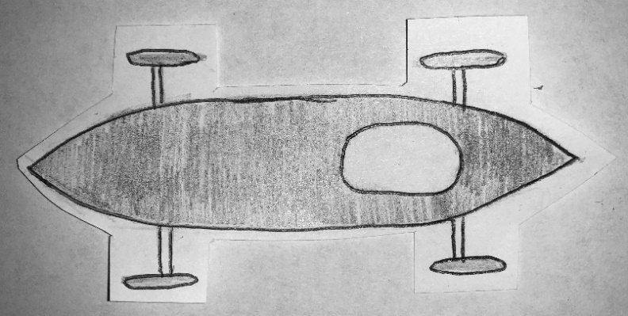
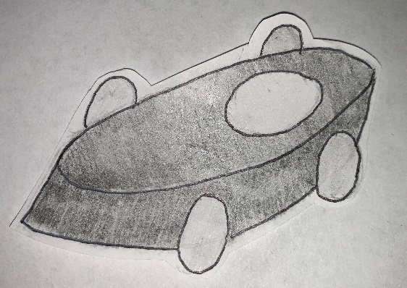

Figure 2 - Design 1 side view
Figure 1 - Design 1 Birdseye view

For this design we used tiller steering as you can see below in figure 3 the chassis of the car is only three beams the front beam has a rod attached which can be turned either to the left or right in order to turn the car. Figure 4 below shows how tiller steering would be implemented in the car.
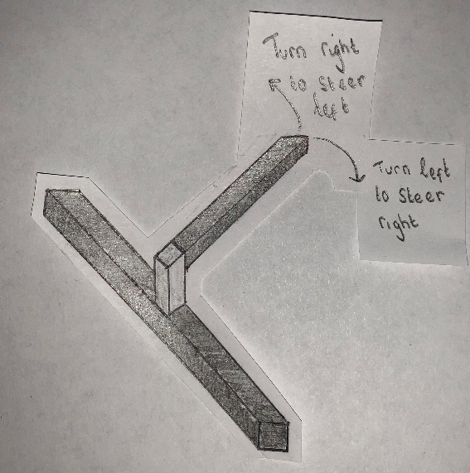
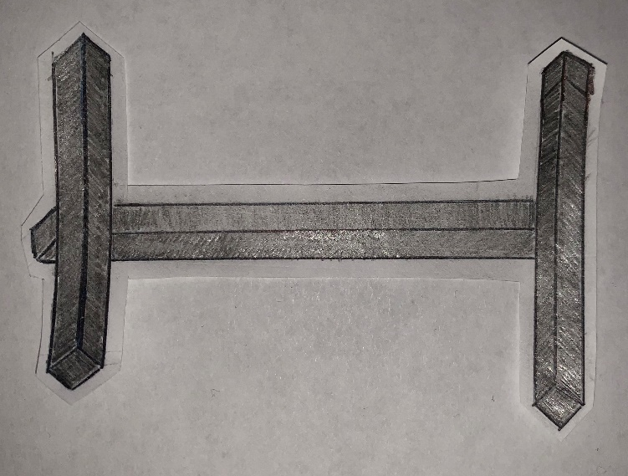

Figure 4 - Design 1 Tiller steering
Figure 3 - Design 1 Chassis

Design 2
For our second initial design we base it on a relatively common shape for soap boxes as you can see in figure 5 the chassis is more complicated and is made up of beams that will them be covered using plastic panels. The beams could be made of wood, steal or aluminium however based on our teams’ budget we decided wood would be the best option for us.
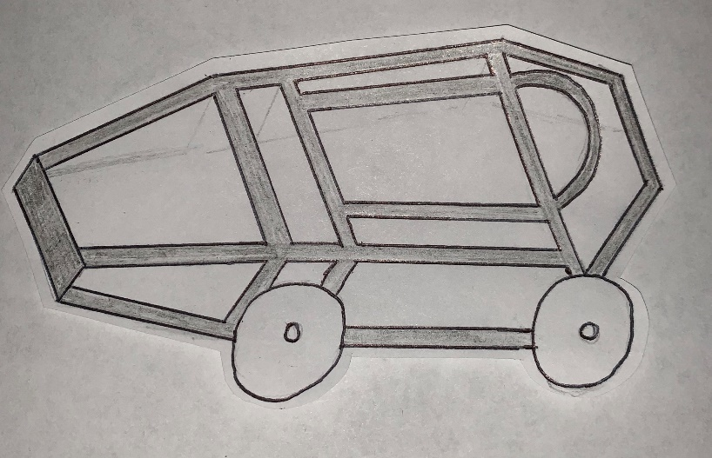

Figure 5 - Design 2 Chassis

The body panels for this design could be made from wood or some form of plastic. In the research section we found out that wooden boards in general are not only heavier than plastic but also cause in general cause more drag so our team decided that for this design the bodywork should be some form of plastic instead.
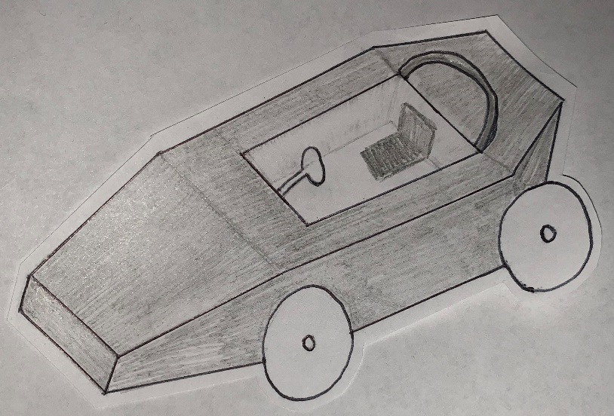

Figure 6 - Design 2 Complete with Bodywork

While doing our research we found out that the vast majority of soap boxes use 18 inch wheels and that having larger wheels at the back generally improves the handling of the car so for this design we decided to put 18 inch bike wheels on the front of the car and 22 inch bike wheels on the rear to improve stability.

Design 3
Our third design is based on a 2015 soapbox winner in comparison to the other initial designs this is by far the most expensive as well as complicated. The cars entire framework and chassis would be made from steel beams, due to this car would be much heavier than the two previous ones. Figure 7 below shows the design from a Birdseye of the chassis and some of the framework which would ensure the driver safety in the event of a crash.
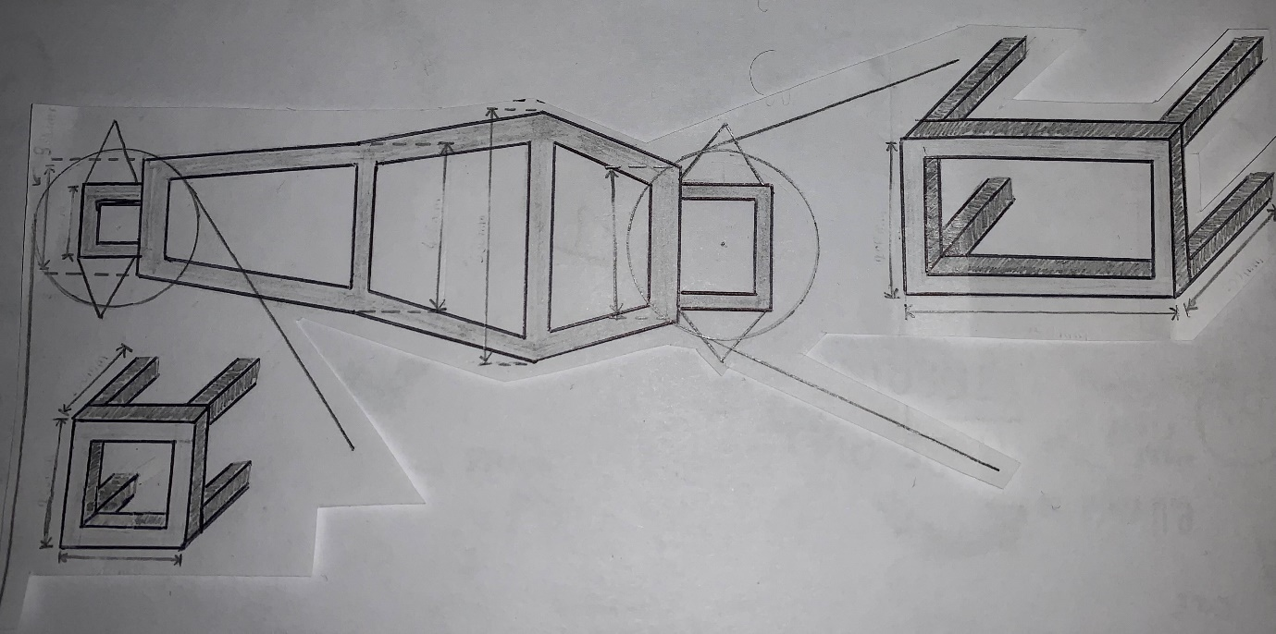

Figure 7 – Birdseye View of Chassis

This car would be made from steel therefore the chassis would be very strong but also stiff which could be a disadvantage while turning resulting in understeer. For this design we would use a vertical shaft steering column which can be seen in Figure 10. Figure 8 below shows the design from a side view of the chassis
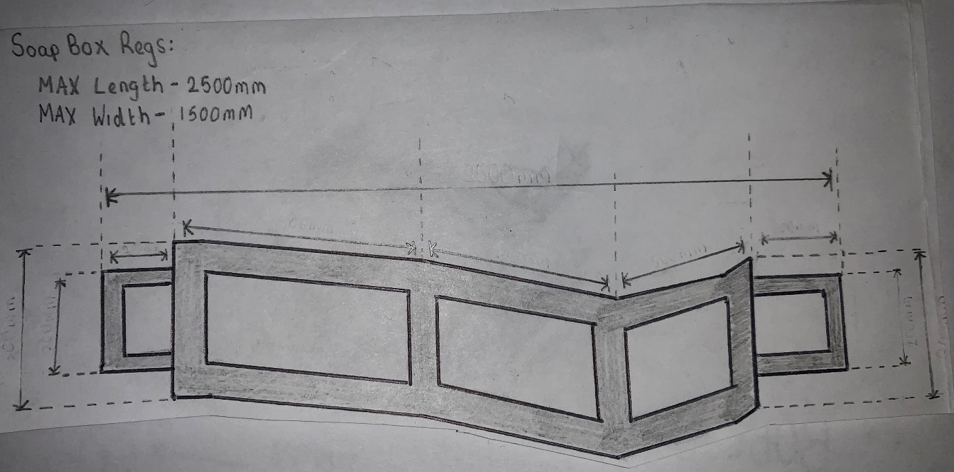

Figure …. Design 3 Side View (chassis) and framework

Figure 8 – Side View of Chassis
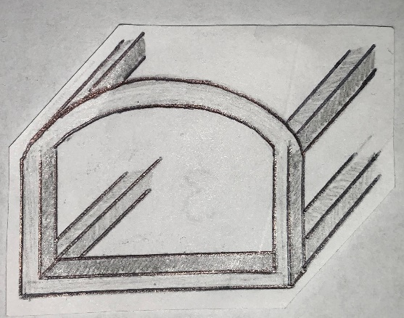
The final design should have smooth body work to improve aerodynamics of the vehicle in order to reduce drag and increase speed. In the research section we count out that oval shaped cars are most effective in reducing drag and increasing drag so for the third design steel beams would be used to make a frame that can be covered over in panels Figure 9 shows these steal beans.
Figure 9 – Steel Framework

Steering
After drawing up the initial designs we conducted further research into different aspects of the car so that we could improve upon our original ideas and create our final design. Figure 10 shows further research into the most effective steering method for our car. In the regulations steering is not overly restricted, however in section 2.8 the regulations state “Any steering column, brake lever or other protrusion must be designed and fitted such that the risk of puncture injuries is minimised. A padded steering wheel/handlebar is recommended. Bar end-plugs are compulsory if handlebars are used”.
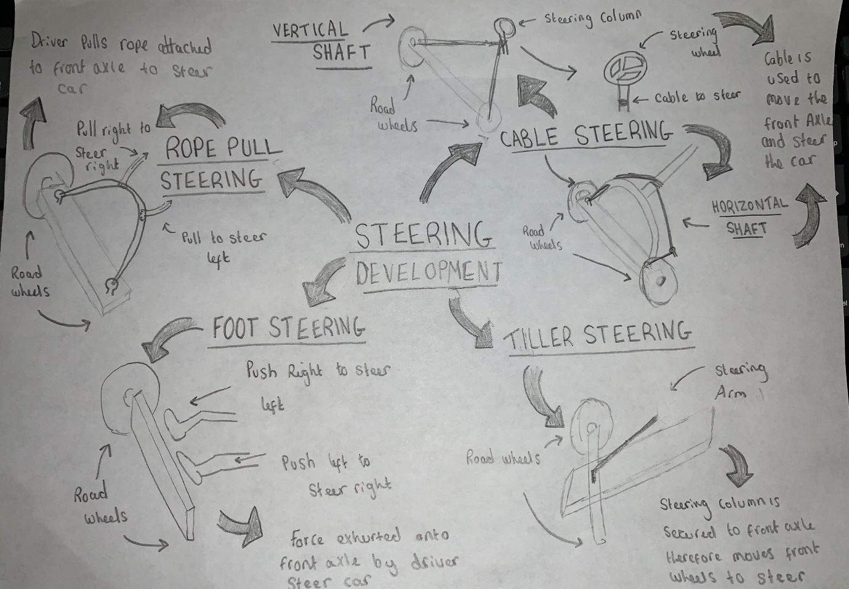

Figure 10 – Steering research

Final Design
We decided to develop our second design because our first design was overly simple, but our third design was very expensive and complex. We decided to keep the chassis and wheel sizes the same for but change the steering and braking systems from our second design.

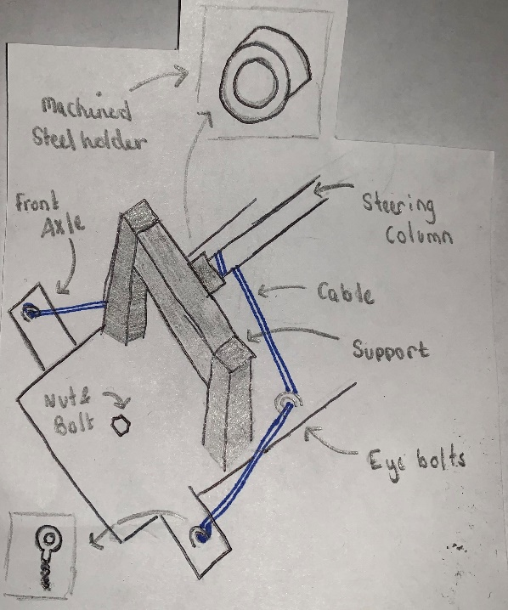
After carrying out this research into steering the car, our team decided to use horizonal cable steering. We chose this because rope pull steering poses a threat to the drivers’ safety is the rope gets caught or wrapped around the driver. We decided against foot steering as well as the driver could accidently apply pressure to the front axle and end up spinning out. Thriller steering wasn’t our first choice as while navigating the bumps and jumps on the course could cause the drivers hand to jolt and therefore the car to change direction as well. Our group decided that cable steering was the safest and most convenient option for the driver as using a steering wheel to change direction is a lot less dangerous than the other methods we researched. Cable steering is also cost efficient due to not many components being used in the system. Figure 11 is a diagram of how the horizontal cable steering works on the car.

Figure 11 – Horizontal Cable Steering

For our final design we used a more complex but effective braking method (as seen in figure 12). Much like the steering system it uses a cable however the driver has a foot pedal to operate the brake as we found this to be the safest and most efficient way to slow and eventually stop the vehicle. The foot pedal is connected to a brake that is attached via hinge to a support structure, when the foot pedal is depressed by the driver the cable pulls the brake forward just below the hinge and the brake shoe contacts the floor. In order to ensure the brake isn’t constantly applied there is a spring that holds the brake shoe in the ground until the pedal is pressed. As shown in figure 12 the Brake shoe is enforced so that when it makes contact with the ground it doesn’t wear at an excessive rate.

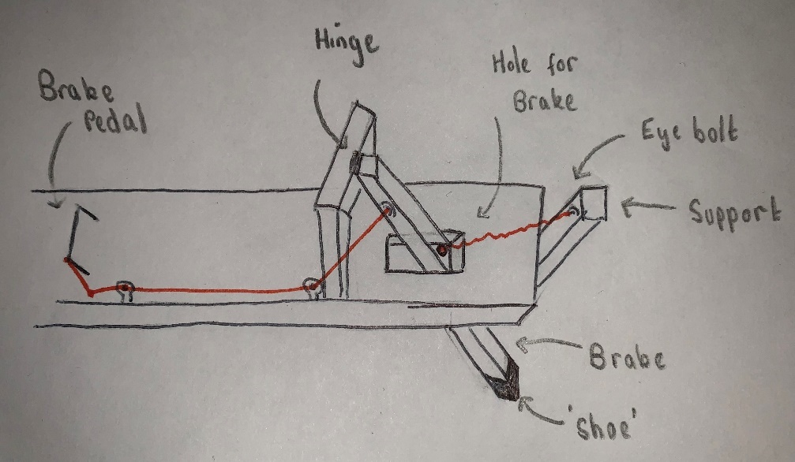

Figure 12 – Braking system

The braking and steering systems of our final design both use cables that are secured to the side of the chassis using eyebolts to ensure they are well out of the driver’s way figure 13 shows the two systems together. Figure 13 also shows the nose cone that will also be at the front of the car in order make the car more aerodynamic.
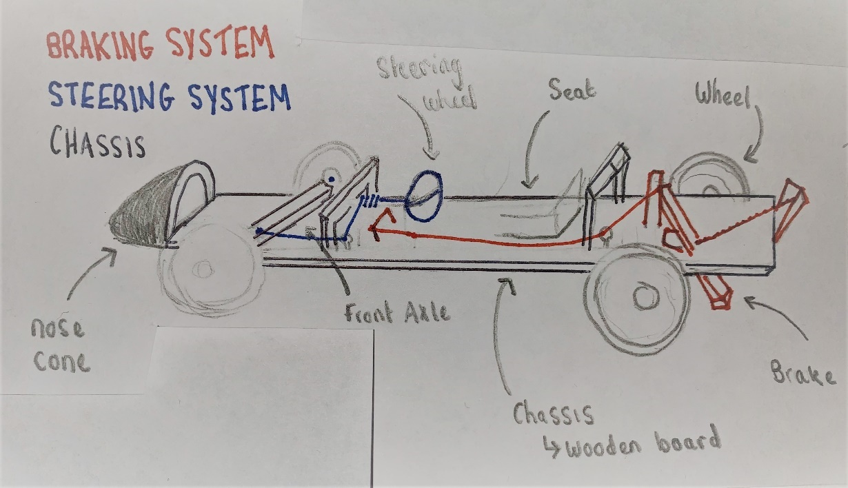

Figure 13 – Braking system, Steering System and Chassis

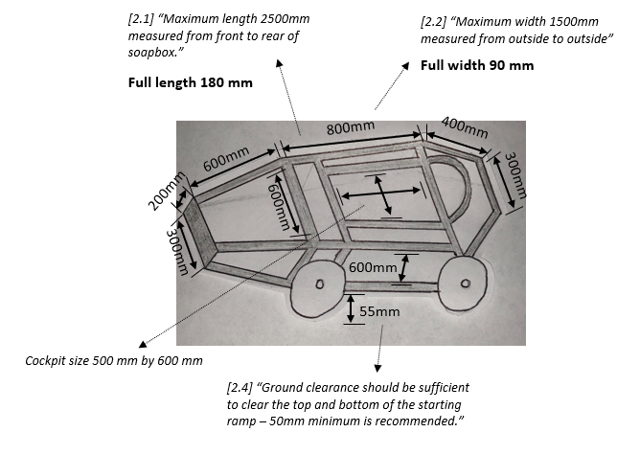

Figure 14 – Final Design Dimensions

The chassis for the final design will be made from steel as steel is strong and therefore able to withstand the bumps and jumps in the course. Recycled steel is very cheap and durable, so we felt this was the best compromise for our chassis. We decided to make the floorboard out of wood to reduce the weight and keep the cost of the design down the wooden board will be bolted to the steel. The floor of the car must be strong as the steering and braking systems are both secured to it therefore, we decided that a thick plywood would be a cheap and ideal material to use as manufactured wood cost less than alternatives. The two axles will also be made from steel and again the wheels will be bolted to the axles. We decided to settle for wooden bodywork as alternatives such as carbon fibre are beyond our reasonable budget and manufactured wood such as thin ply or MDF are cheap to buy.

Conclusion

In this project, we worked as a team with our individual roles to go from a stage of little knowledge about soapbox racing, to having a final design that we hope would be competitive. We were well organised during the process, having set meeting dates right at the start. We stuck to these dates and worked efficiently and effectively towards our final goal.
As a team, we furthered our knowledge about subjects such as materials and the cost running a race team. To conclude, as a team we feel that we furthered our engineering knowledge and skill during the process and look forward to the second part of the project.

References

- Roberts, J. (2017). Red Bull Racing’s ultimate soapbox-building guide. Available: https://www.redbull.com/gb-en/red-bull-racing-rob-marshall-soapbox-design-tips. Last accessed 15th Dec 2019.

- Admin. (2011). Difference Between Young Modulus and Tensile Strength. Available: https://www.differencebetween.com/difference-between-young-modulus-and-vs-tensile-strength/. Last accessed 15th Dec 2019.

- Marie Liberty. (2017). How to Build a Soapbox Racer Car. Available: https://www.ehow.co.uk/how_6873103_build-soapbox-racer-car.html. Last accessed 20th Dec 2019.

- Gallardo, Y. (2017). LCC Holds 3rd Annual Soapbox Race. Available: https://www.kgns.tv/content/news/LCC-Holds-3rd-Annual-Soap-Box-Race-417107523.html. Last accessed 26th Dec 29019.

- Unknown. (2015). Gravity Gran Prix. Available: http://leany.com/derby/archive.html. Last accessed 26th Dec 2019.

- Ashinghurst. J. (2015). Adult Soapbox Kart. Available: https://makezine.com/projects/adult-soapbox-kart/. Last accessed 26th Dec 2019.

Figures

Figure 1 – Birdseye view of design 1
Figure 2 – Side View of design 1
Figure 3 – Chassis design 1
Figure 4 – Triller steering for design 1
Figure 5 – Chassis design 2
Figure 6 – Complete design 2
Figure 7 – Birdseye view of chassis 3
Figure 8 – Side view of chassis design 3
Figure 9 – Steel framework design 3
Figure 10 – Steering research
Figure 11 – Horizontal cable steering for final design
Figure 12 – Braking system for final design
Figure 13 – Braking, steering and chassis for final design
Figure 14 – Final design dimensions

