

Module Name: Enterprise Development and Commercial
Innovation (BMBS5000)

Student Name: Robert Cristian Reidel

Student ID: 1913823

Lecturer: Christopher Wilkin

Deadline: 12/10/2026

Table of Contents:
1. Business Overview……………………….3
2. Business Mind Map………………………3
3. Value Proposition Canvas……………….3
4.Development and Reflection…………3 - 4
5. AI Statement……………………………3 - 4
6. References…………………………….3 - 4

- Business Overview:
Pinch & Sprig is a business concept idea that addresses the gap between the quantity of herbs and spices required for a recipe and the larger quantities typically sold by retailers. The business aims to provide recipe-sized portions of fresh herbs and spices, helping customers reduce food waste while improving convenience and access to specialist ingredients.
The concept targets busy home cooks, students and food enthusiasts who may only need small quantities of ingredients for specific meals. Rather than competing directly with supermarkets or meal-kit providers, Pinch & Sprig focuses on solving the missing ingredient problem by supplying only the ingredients customers need.
- Business Mind Map:
https://mm.tt/map/4101648744?t=fZw6KLPbfO
- Value Proposition Canvas (VPC)
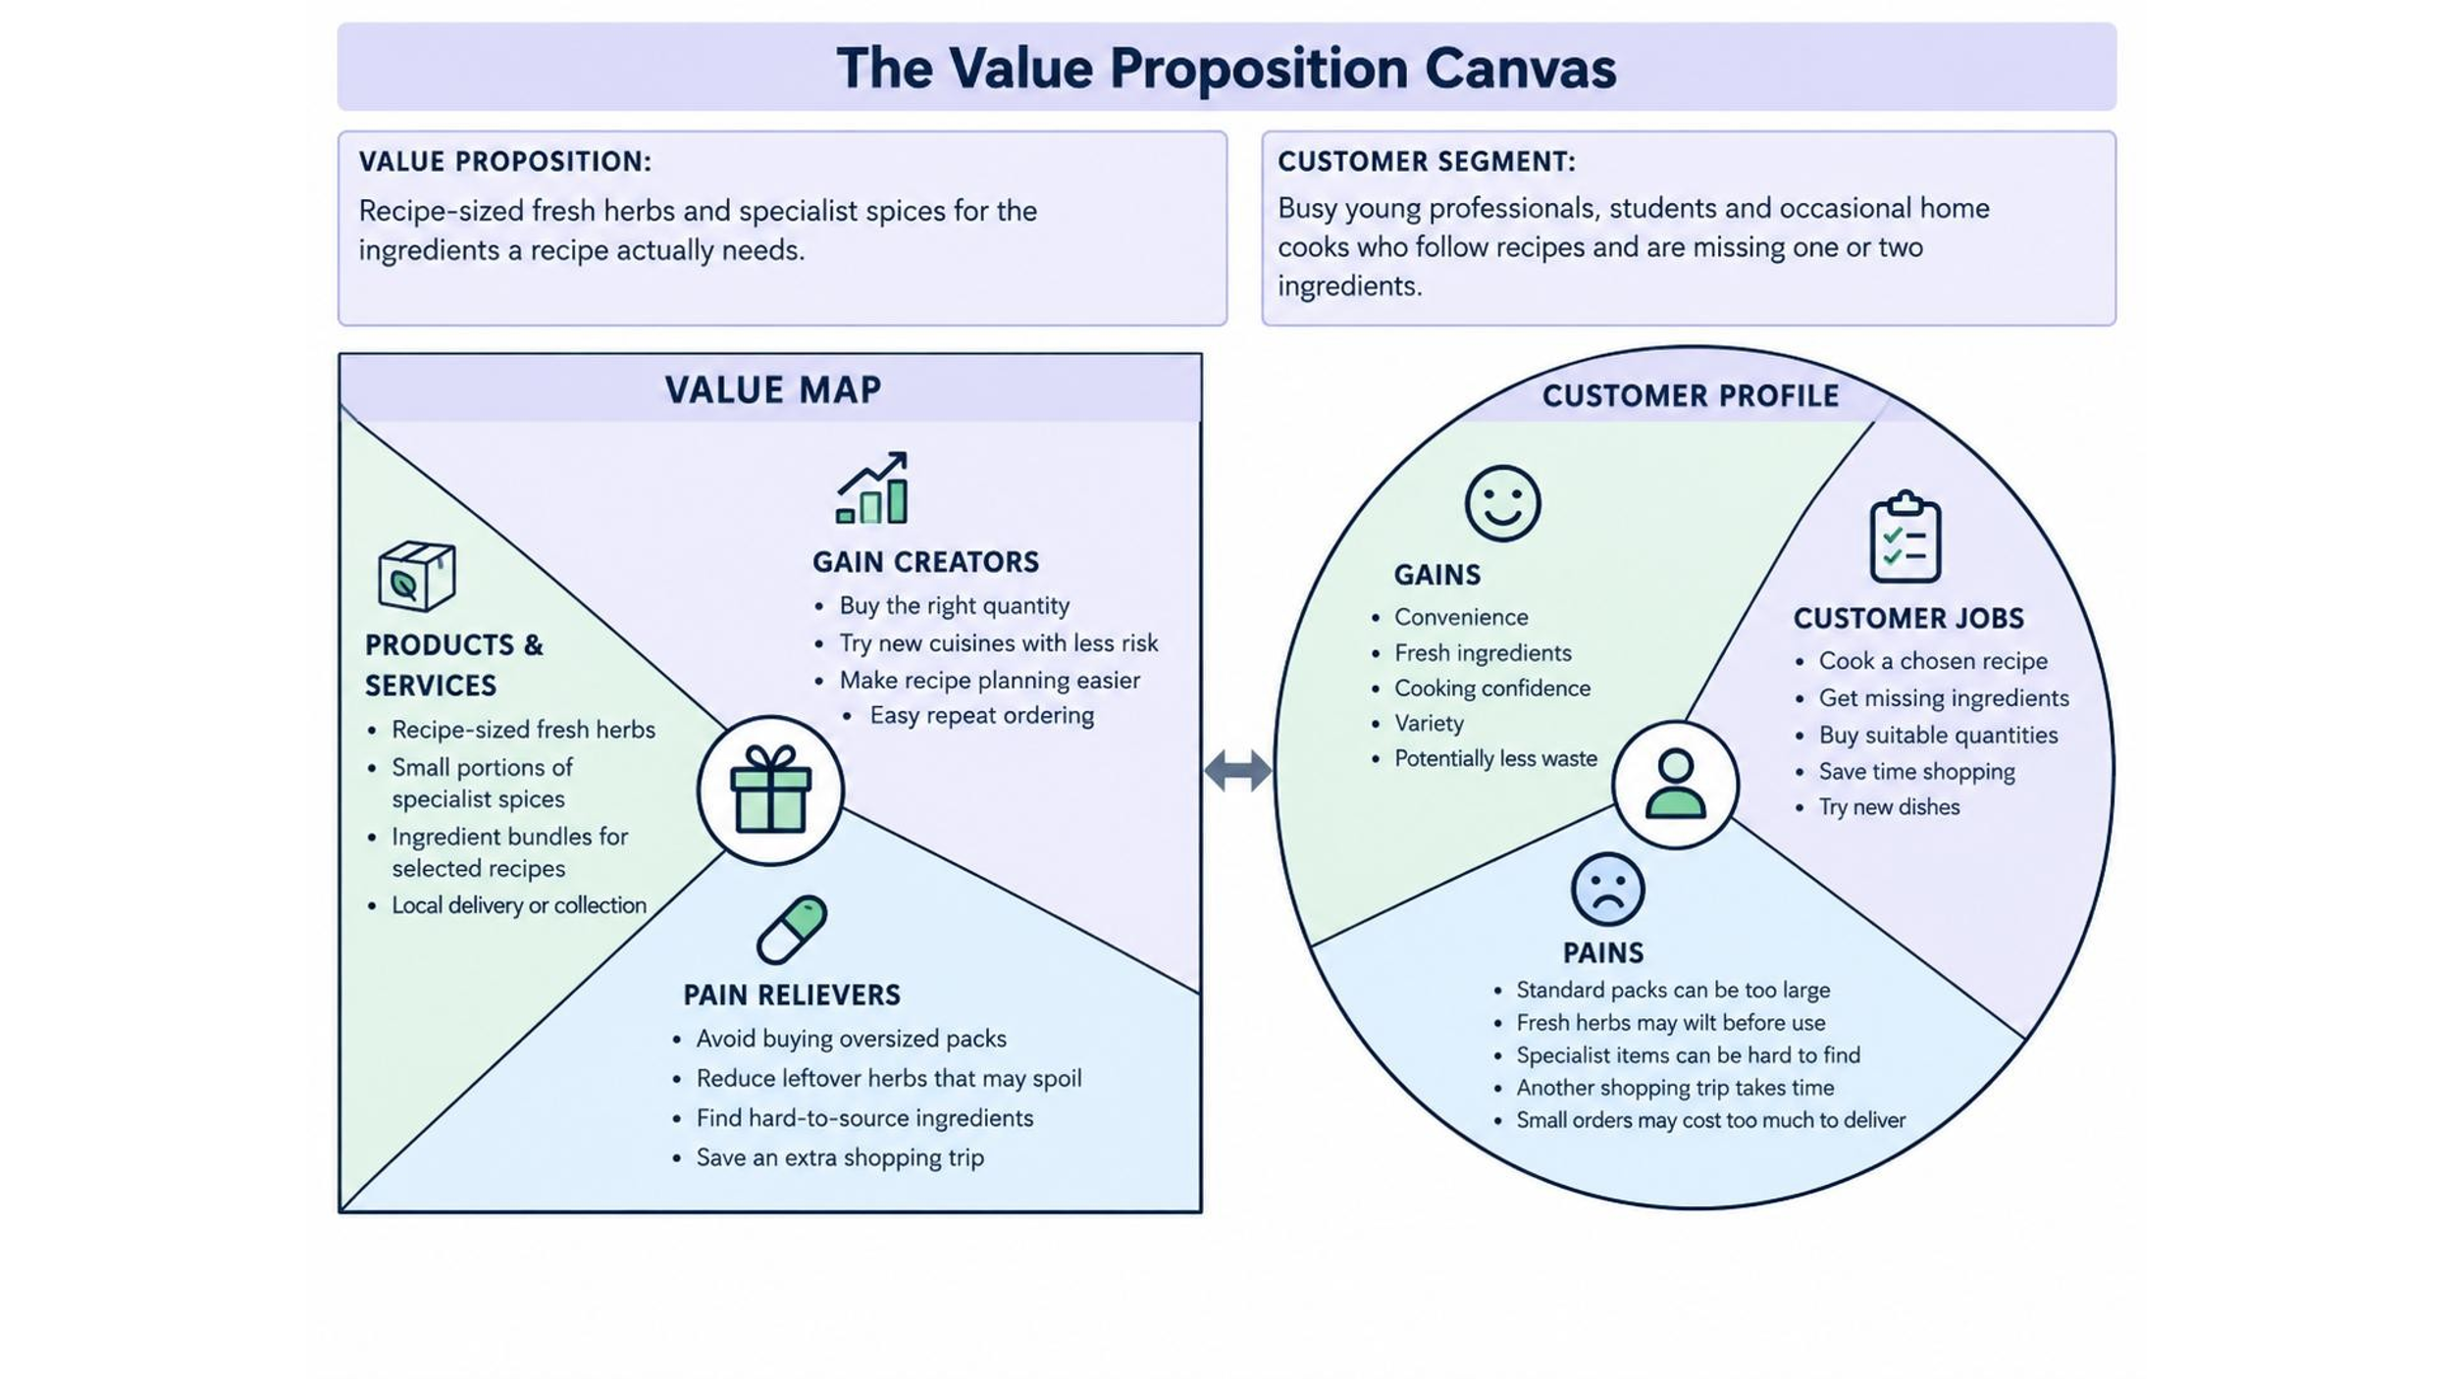
- Development and Reflection:
The idea for Pinch & Sprig was developed by identifying the needs of specific customer groups, particularly students, busy professionals and food enthusiasts who may only require small quantities of herbs and spices for individual recipes. Through researching customer problems, I identified an opportunity to address the ingredient gap between the quantity required for a recipe and the larger quantities usually sold by retailers.
The Business Mind Map and Value Proposition Canvas (VPC) helped me develop and refine the concept by focusing on customer needs, pains and gains. These tools enabled me to identify the target market, evaluate the value proposition and consider how the business could differentiate itself from competitors such as supermarkets and meal-kit providers.
This process showed me that understanding customers is essential for business success. It also highlighted the importance of testing assumptions rather than relying on personal opinions. If I were to develop the idea further, I would conduct customer interviews and launch a small MVP to validate demand, gather feedback and improve the business model before expanding the concept.
- AI Statement
I confirm that I have not used any AI generated text as my own work. The content and ideas in this assessment were developed from my lecture notes, module materials and my own research.
- References:
- Barringer, B.R. and Ireland, R.D. (2024) Entrepreneurship: Successfully Launching New Ventures. 7th edn. Harlow: Pearson.
- Carvalho, R., Lucas, M.R. and Marta-Costa, A. (2025) ‘Food waste reduction: A systematic literature review on integrating policies, consumer behavior, and innovation’, Sustainability, 17(7), pp. 1-31.
- Clement, J. et al. (2023) ‘Exploring causes and potential solutions for food waste among young consumers’, Foods, 12(13), pp. 1-20.
- Hisrich, R.D., Peters, M.P. and Shepherd, D.A. (2020) Entrepreneurship. 11th edn. New York: McGraw-Hill Education.
- Kotler, P., Keller, K.L. and Chernev, A. (2022) Marketing Management. 16th edn. Harlow: Pearson.
- Malhotra, N.K. (2020) Marketing Research: An Applied Orientation. 7th edn. Harlow: Pearson.
- Pilone, V., Di Santo, N. and Sisto, R. (2023) ‘Factors affecting food waste: A bibliometric review on household behaviours’, PLOS ONE, 18(7), pp. 1-23.
- Rintamäki, T. and Saarijärvi, H. (2021) ‘An integrative framework for managing customer value propositions’, Journal of Business Research, 134, pp. 754-764.
- Saunders, M., Lewis, P. and Thornhill, A. (2019) Research Methods for Business Students. 8th edn. Harlow: Pearson.
- Shroff, A., Kumar, S., Martinez, L.M. and Pandey, N. (2024) ‘From clicks to consequences: A multi-method review of online grocery shopping’, Electronic Commerce Research, 24, pp. 925-964.
- Swannell, R. et al. (2023) Evaluation of Consumer Food Waste Prevention Interventions. Luxembourg: Publications Office of the European Union.
- Vittuari, M., Garcia-Herrero, L., Caldeira, C., Bruns, H. and Sala, S. (2023) Literature Review on Drivers of Consumer Food Waste and Levers for Behavioural Change. Luxembourg: Publications Office of the European Union.
- Pandey, R., Gowda, K.R., Bapat, G.S., Kumar, S. and Shashidhar, C. (2023) ‘Online grocery shopping: A study of consumer behaviour on staying and switching between online grocery retailers’, Academy of Marketing Studies Journal, 27(S2), pp. 1-12.

