

Module: Understanding and engaging in the customer experience
Module code: BMSW
Student Name: Vasilica-Madalin Iliuta
Student ID: 2007277
Lecturer’s name:
Assignment title: Customer relationship management emerging themes

Executive Summary
The report focuses on the importance of the customer management relationship of the chosen organization, which is Deliveroo. The organizational background of Deliveroo is discussed from a wider perspective. The customer touch points and customer experience are illustrated in a detailed manner with the help of theories such as Customer Relation Management (CRM) Behaviour Theory and McKinsey’s 7 s Framework. The benefits of enabling effective customer touch points as well as brand experience are also analyzed with the assistance of statistical data. The organization is recommended to improve the customer experience. The literature review discusses the customer experience perspective from the firm as well as co-creation. The advantages of these two concepts faced by information technology companies are explained in detail.
Table of Contents

Part (A) Introduction. 4
1. Deliveroo Company Background. 5
2. Customer Touch Points. 5
3. Customer Experience. 7
4. Brand Experience. 8
Recommendations to improve the company’s customer experience. 10
Conclusion. 11
Part (B) Introduction. 11
1. Two major customer experience perspectives. 11
2. How will understanding these two concepts help shape customer experience for Information Technology firms? 12
Conclusion. 13
References 14

Part (A) Introduction.
Kumar and Reinartz (2018), defined customer relationship management as the combination of practices, plans of action, and technologies, organizations utilize to manage and interpret interactions with customers. In his turn, Bergeron (2002) defined customer relationship management as a process and a technology that identifies the steps regularly needed to achieve a specific result.
Any company needs to ensure systematic customer relationship management because it plays a crucial role in assisting the firm to stay attached to the purchaser, streamlining the procedure, and improving the profitability level. Additionally, customer relationship management plays a crucial role in expanding the standard of purchaser retention and ensuring higher productivity as well as efficiency (Bergeron, 2002). A company can implement efficient customer relationship management by understanding the value of buyers, guiding them about the trademark, and adapting to their changed attitude over time.
The organization chosen to analyze and discuss customer relationship management is Deliveroo. In this context, the company profile, customer touch points, and customer experience are illustrated from a wider perspective with the help of models McKinsey’s Seven S Framework.

Deliveroo Company Background.
The organization selected to illustrate customer relationship management is Deliveroo. It was founded by Will Shu in 2013 in London and at present Deliveroo is working with the biggest grocery retailers attaching regional buyers and restaurants (Iqbal, 2022). It provides quick delivery within 30 minutes to the consumers which have assisted them to grow at a rapid pace. In the present times, the respective company runs in 11 international markets with the involvement of restaurants, grocers, riders, and most importantly serving millions of purchasers (deliveroo.co.uk). Customer relationship management is well maintained by the respective company as they understand the needs of the consumers in every neighborhood from students to professionals, and from city centers to suburbs, commuter belts as well as small towns (deliveroo.co.uk). The main aim of the respective firm in association with customer relationship management is to provide the best availability, selection, and experience to the purchaser to create an emotional connection with the trademark. In the present time, to serve 8 million customers quickly the company operates with 160,000 restaurant partners which resulted in increased gross transaction value at a rate of 70% as per the financial report of 2021 (deliveroo.co.uk).

Customer Touch Points.
A Customer Touch Point is defined as the way a company communicates with purchasers through employees, a website, an advertisement, and an app (Lee, 2018). The customer touch point plays a vital role in knowing the opinions and views of the purchaser towards a particular brand. Additionally, it also guides an organization to attain essential insights into the purchaser’s experience and the way they can improve it. The customer touch point is explained with the help of CRM Behaviour Theory which represents seven interrelated perspectives to managing corporate relationships. For instance, Deliveroo at present has a total of 8 million consumers and the focus has been to provide a better service to them (deliveroo.co.uk). As suggested by Lotz et al. (2018), the customer insights team of Deliveroo engages on daily basis with purchasers through the procedure of feedback regarding the products as well as services. They also utilize consumer applications to interact with the consumers which are possibly shared with others in the form of restaurant ratings to upgrade the experience of the buyer. Apart from that, to understand the behavior of the consumer Deliveroo tests products regularly with various buyers to make assurance that there are alterations in their taste. To maintain an emotional connection with the customers, the 2500 care agents are there to solve the delivery issues (statista.com). The respective company always believes in providing a great consumer experience by ensuring a quality standard of care and frequently improving it.
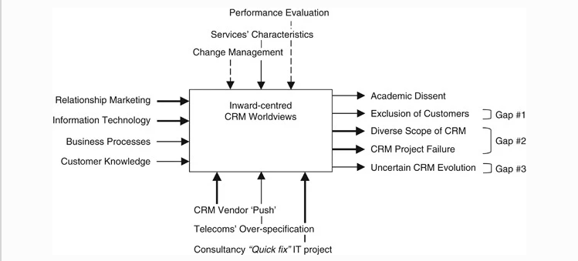
Figure 1: CRM Behaviour Theory
(Source: springer.com)
It also uses Deliveroo Plus which is a subscription program that provides customers with the advantage of unlimited free delivery terms for a fixed monthly fee. As per the financial report in 2021, the organization launched Plus Silver which provides free delivery for a lower price than the original service to assist customers with a high average basket spend (deliveroo.co.uk). To understand the attitude of the customer they also reduced the price of the Original plus Gold Programme. The fresh reward scheme was initiated to honor the loyalty purchasers and recently they have partnered with Amazon Prime to give an advantage to the U.K Amazon prime customers to get free Deliveroo membership for one year as well as unlimited free delivery on orders over £25 (Iqbal, 2022). Additionally, the company has been able to create a strong customer base of 8 million by allowing them to participate in the Company’s IPO making £50 million in shares. As per the annual report in 2021, 2.4 million feedback was received which assisted the company to improve the drawbacks. This up gradation encouraged Deliveroo to attain an increased revenue of £1.824 milion and a revenue take rate of 27.5 % in the year 2021 (statista.com), which is a 50% increase over the three years (Iqbal, 2022).
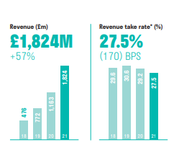
Figure 2: Revenue and Revenue Take Rate for 2021
(Source: statista.com)

Customer Experience.
Customer Experience is denoted as all aspects of a particular company such as the quality of customer care, advertising, packaging, ease of use, and reliability in creating a better customer impression (Hong et al., 2019). It is important because it plays a vital role in promoting a sense of loyalty, retaining buyers, and empowering the advocacy of the brand (Beig and Nika, 2019). For instance, to provide a good consumer experience Deliveroo delivers the food quickly in 30 minutes and a total of 2500 agents are there to solve the issues of delivery (deliveroo.co.uk). Additionally, it also uses the Frank algorithm to connect easily to the purchasers, prepare the meal fast and deliver it 20% faster (Shead, 2017). To reach the customers of new areas and provide food at low cost they have introduced the delivery-only kitchen concept. They are also expanding on-demand grocery service through Deliveroo Hop to provide quick delivery in terms of groceries to the purchasers. To become an aspiration for other buyers, the respective company provides facility of gift cards for birthdays, holidays, and special celebrations for its loyal customers (deliveroo.co.uk). They utilize consumer applications to take feedback from the purchasers which are utilized in the form of restaurant ratings to share as a guide for other people. This way a better customer experience is provided by Deliveroo which becomes an aspiration for others to develop a sense of loyalty towards the company. This resulted in a gross profit of £497.3 million an increase of 43% and the profit margin reached 7.5% (dpd.com).
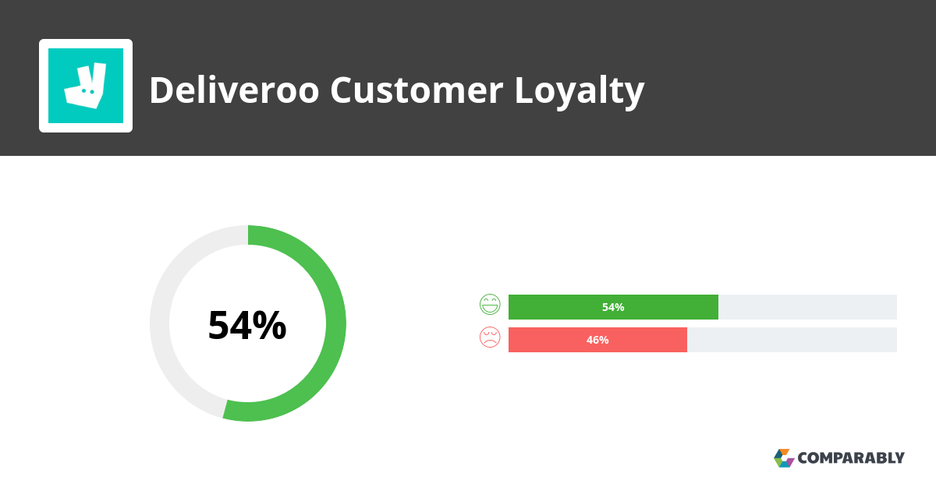
Figure 3: Deliveroo Customer Loyalty Score
Source: comparably.com
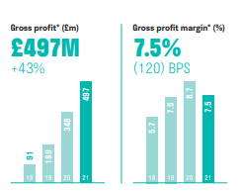
Figure 4: Gross Profit and Profit Margin for 2021
(Source: dpd.com)

Brand Experience.
Brand Experience is illustrated as the way of building an ecosystem all around the brand that buyers fit them into it and hence when they are interacting they find an emotional connection with the company (Schmitt, 2009). As stated by Ong et al. (2018), effective brand experience is essential because it plays a vital role in building deeper connections and motivating audiences. The brand experience can be well illustrated with the assistance of McKinsey’s Seven S Framework which states a change framework based on the organizational design of the company (Jurevicius and Nami, 2022). McKinsey’s seven elements are strategy, structure, system, shared values, style, skills, and staff. Strategy denotes the plan deployed by a company to remain competitive in the market (Waterman Jr, 1982).
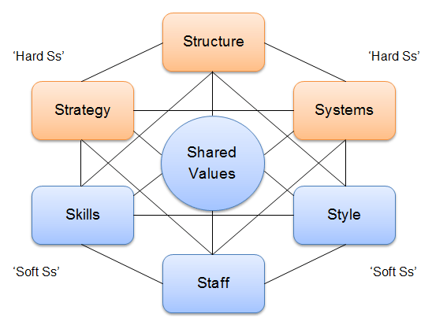

Figure 5: McKinsey’s 7 S Framework
(Source: strategicmanagementinsight.com)

Elements | Company
Strategy | To strengthen competitiveness, Deliveroo follows a strategy of providing quick delivery of food and groceries in 30 minutes to customers.
Structure | It follows a platform-to-consumer structure where the purchaser has the opportunity to choose from a large number of partner restaurants (Shaqrah, 2018).
System | The respective company takes the delivery order of the customers through the system of state-of-the-art technology such as a tablet, Frank algorithm, restaurant hub, and point of sale integration.
Shared Values | The main value of the organization is to provide the best availability, selection, and experience to the customer to build an emotional connection.
Skills | The riders and employees can be result oriented and work under pressure which assists them to reach the purchaser quickly and within the given period.
Style | Deliveroo gives the advantage to the customer of enjoying various styles of delivery services such as restaurant-prepared food, meal kits, and grocery.
Staff | To facilitate a good customer experience, there is a total of 3108 employees working in the company as per the report in 2022.

Hence, the systematic approach towards the implication of these components has helped the company to provide satisfaction to the customers and hence this has been reflected in increased orders by 73% in the year 2021 and GTV per order by 4% (dpd.com).

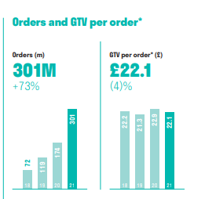
Figure 6: Orders and GTV per order for the year 2021
Source: dpd.com

Recommendations to improve the company’s customer experience.
Deliveroo has probably tried to maintain good customer relationship management through the above-mentioned procedures, but they can improve through the following suggestions. The company is suggested to collect and utilize the information of the customers through demographic characteristics as well as buying preferences to more interpret them. Deliveroo is recommended to comply with General Data Protection Regulation to build an effective marketing strategy to grab the attention of the purchasers (Prentice et al., 2019). The organization needs to strengthen its communication strategy by being more accessible on social media such as Facebook, Twitter as well as Instagram. Deliveroo is recommended to utilize modern technology through the inclusion of artificial intelligence and cloud-based solutions to get a more detailed overview of the buying behavior of purchasers. Hence, these recommendations can help the company to attain an impressive profit margin.

Conclusion.
Henceforth it can be concluded that customer relationship management is important because it plays an essential role in creating a sense of trust as well as loyalty to the brand in the opinion of the purchasers. Additionally, various models and theories such as CRM Behaviour Theory and McKinsey’s 7 S Framework are used to explain customer experience and touch points. It can be assessed that the organization Deliveroo uses the form of feedback to engage buyers and uses gift cards as well as reward schemes for its customers as well as to attract other people. The improved customer relationship management has assisted them to attain more profit as well as revenues as per the annual report 2021.

Part (B) Introduction.
According to Kranzbühler et al. (2018), the Customer Experience Perspective is illustrated as the procedure of examining a firm from the point of view of the individuals who buy as well as utilize its products as well as services. The efficient customer experience perspective is important because it plays a crucial role in increasing the excitement of the buyer, improving revenue growth, and expanding the net promoter score. The three essential pillars of the customer experience perspective are satisfying the needs of buyers, offering a good experience, and being quick in solving issues (Jain et al., 2017). On this basis, a critical illustration of two major customer experience perspectives from the firm as well as co-creation is explained in a detailed manner. Additionally, the way the two concepts assist in shaping the experience of buyers based on information technology firms is also discussed in a detailed manner (Kranzbühler et al., 2018).

Two major customer experience perspectives.
As per the views of Becker (2020), Customer Experience from the perspective of the firm denotes the feelings of the buyers about the nature of interaction with a brand. The firm understands and interprets the perspective of the purchaser by thinking on behalf of them and asking questions about the way they feel in certain situations. As per the opinion of McColl-Kennedy et al. (2019), the organization analyses and understands the perspective of the buyer by concentrating on their sayings as well as developing faith as well as trust, and respect towards each other. For example, Deliveroo interprets the views of its buyers through the concept of feedback and test product changes. The firm can analyze the viewpoint of the consumers by solving the issues as quickly as possible (Hong et al., 2019). For example, IRIS Company has been successful in solving the problem of buyers by founding an application. It helps consumers easily request holidays as well as report illnesses. As suggested by Waqas et al., (2021), another way an organization can well interpret the point of view of shoppers is by strengthening the customer input through surveys, focus group data, and net promoter scores. For example, Zopa helps thousands of buyers flexibly manage money by mitigating their drawbacks with the help of feedback.
On the contrary, customer experience from the point of view of co-creation is explained as the procedure of inviting the shoppers to take part in the problem-solving method to present a mutually valued result. For example, Deliveroo lets its buyers have a voice in their products by allowing them to participate in the firm's IPO making £50 million in shares. As assessed by Bolton et al. (2018), customer co-creation is established by making the brand innovative and creating a particular community. For example, IRIS Software and Solutions can co-create with the shoppers because they include innovations such as cloud applications to smoothly operate their products. Additionally, co-creation customer service can be effectively implemented by increasing the relevance as well as the confidence of the buyers. For example, Zopa has been successful in building a sense of trust among purchasers by creating simple and fair financial products. The respective company has been able to co-create with the shoppers by providing fixed-term savings safeguarded by FSCS and credit cards to supervise their finances.

How will understanding these two concepts help shape customer experience for Information Technology firms?
The two concepts, customer experience from the point of view of a firm and co-creation plays a vital role in helping the information technology firms like Deliveroo, Zopa, and Hopin to strengthen their customer base. The firms like Zopa use digital and social media platforms to acquire more and more buyers and to build a sense of loyalty as well as confidence among them. Apart from this, it is helping the organizations like Deliveroo to provide a better experience to buyers at the initial stage of contact. The customer experience from the perspective of an organization plays an important role in ensuring long-term connection to get suggestions to mitigate their drawbacks (Becker and Jaakkola, 2020). The companies such as IRIS Software and Solutions get the benefit of engaging the buyers more and building an atmosphere where they are willing to share their needs. In this way, the firm can produce more improved products by mitigating the drawbacks and providing them to purchasers to attain more profit. It also assists Information Technology firms like Deliveroo to increase communication with buyers and hence it is easy to convince them to buy which adds to the increased level of revenues. When these firms understand the perspective of the shoppers, it becomes beneficial for them to produce goods accordingly by lowering the cost of the resources and saving their expenses. An effective interpretation of the buyer’s point of view helps firms like Zopa to build trust and hence their purchasers are retained at the time of the crisis because they can well understand their critical situation.
The customer experience from the perspective of co-creation plays a vital role in encouraging organizations like Deliveroo to initiate more unique as well as exclusive ideas (Becker and Jaakkola, 2020). It enables them to develop a more brainstorming and creativity procedure which leads to the true value creation of the products. This encourages firms like Zopa to gain the attention of the purchasers and therefore add to increased sales (Mai Chi et al., 2022). Co-creation with the shoppers plays a vital role in initiating more need-focused products which results in higher satisfaction as well as retention of the purchasers. The co-creation perspective plays an essential role in encouraging the firms such as IRIS Software and Solutions to create stronger relationships with buyers by starting a cooperative dialogue (Iris, 2022). Hence, a strong connection with the customers results in building long-term loyalty and better sales.
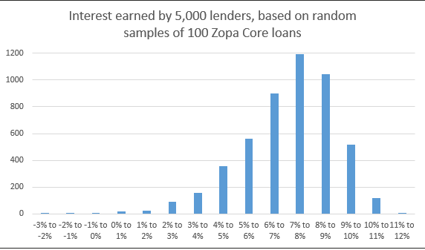
Figure 7: Customer Experience of the company Zopa
Source: (4thway.co.uk)

Conclusion.
Therefore, it can be concluded that the customer experience perspective is essential because it plays a necessary role in building a foundation of customer loyalty as well as retention. The customer experience from the perspective of the firm as well as co-creation is explained in critical terms by giving examples of Deliveroo, Zopa, and IRIS Software Solutions. It can be assessed that these both concepts help Information Technology Organizations to engage shoppers and formulate fresh ideas.

References
- Becker, L. and Jaakkola, E. (2020) ‘Customer experience: fundamental premises and implications for research’, Journal of the Academy of Marketing Science, 48(4), pp.630-648.
- Becker, L. (2020) ‘Toward a Customer-centric perspective of customer experience’, Turku School of Economcis, Turku.
- Beig, F.A. and Nika, F.A. (2019) Brand experience and brand equity. Vision, 23(4), pp.410-417.
- Bergeron, B.P. (2002) Essentials of CRM a guide to customer relationship management. New York: Wiley.
- Bolton, R.N., McColl-Kennedy, J.R., Cheung, L., Gallan, A., Orsingher, C., Witell, L. and Zaki, M., 2018. Customer experience challenges: bringing together digital, physical and social realms. Journal of Service Management, 29(5), pp.776-808. https://www.emerald.com/insight/content/doi/10.1108/JOSM-04-2018-0113/full/html
- Deliveroo (ND) NPS and Customer Reviews/ comparably. Available at: https://www.comparably.com/brands/deliveroo (Accessed: October 28, 2022).
- Deliveroo (ND) About us. Available at: About us - Deliveroo (Accessed: October 28, 2022).
- Hong, K.T., Ng, S.I., Yusof, R.N.R. and Kaliappan, S.R. (2019) ‘Increasing consumers’ hypermarket visit intention through cause-related marketing: a perspective from the theory of planned behaviour’, Revista Brasileira de Gestão de Negócios, 21, pp.435-463.
- Iqbal, M. (2022) Deliveroo Revenue and Usage Statistics (2022). Available at: Deliveroo Revenue and Usage Statistics (2022) - Business of Apps (Accessed: 29 October 2022).
- Iris (2022) Leading IRIS Accountancy Solutions. Available at: Welcome to IRIS (Accessed: 29 October 2022).
- Jain, R., Aagja, J. and Bagdare, S. (2017) ‘Customer experience–a review and research agenda’, Journal of Service Theory and Practice.
- Jurevicius, O. and Nami, A. (2022) ‘McKinsey 7s model: The 7s framework explained - SM insight’, Strategic Management Insight.
- Kranzbühler, A.M., Kleijnen, M.H., Morgan, R.E. and Teerling, M. (2018) ‘The multilevel nature of customer experience research: an integrative review and research agenda’, International Journal of Management Reviews, 20(2), pp.433-456.
- Kumar, V. and Reinartz, W. (2018) Customer relationship management. Springer-Verlag GmbH Germany.
- Labus, M. and Stone, M. (2010) ‘The CRM behaviour theory – managing corporate customer relationships in Service Industries’, Journal of Database Marketing & Customer Strategy Management, SpringerLink. Palgrave Macmillan UK.
- Lee, S.K. (2018) ‘A customer touch point management system for effective service communication’, Business Communication Research and Practice, 1(1), pp.46-49.
- Lotz, S., Raabe, J. and Roggenhofer, S. (2018) ‘The role of customer care in a customer experience transformation’, McKinsey and Company, Insights.
- Mai Chi, V.T., Paramita, W. and Ha Minh Quan, T. (2022) ‘Does customer experience always benefit the company? Examining customers’ epistemic motivation and interaction with service contexts’, Australasian Marketing Journal, 30(1), pp.35-50.
- McColl-Kennedy, J.R., Zaki, M., Lemon, K.N., Urmetzer, F. and Neely, A. (2019) ‘Gaining customer experience insights that matter’, Journal of service research, 22(1), pp.8-26.
- Ong, C.H., Lee, H.W. and Ramayah, T. (2018) ‘Impact of brand experience on loyalty’, Journal of Hospitality Marketing & Management, 27(7), pp.755-774.
- Prentice, C., Wang, X. and Loureiro, S.M.C. (2019) ‘The influence of brand experience and service quality on customer engagement’, Journal of Retailing and Consumer Services, 50, pp.50-59.
- Schmitt, B. (2009) ‘The concept of brand experience’, Journal of brand management, 16(7), pp.417-419.
- Shaqrah, A.A. (2018) ‘Analyzing business intelligence systems based on 7S model of McKinsey’, International Journal of Business Intelligence Research (IJBIR), 9(1), pp.53-63.
- Shead, S. (2017) Deliveroo is using an algorithm called 'Frank' to cut food delivery times by 20%. Available at: Deliveroo Uses 'Frank' Algorithm to Cut Delivery Times by 20% (insider.com) (Accessed: 25 October 2022).
- Statista (ND) Available at: Deliverooo consumers worldwide 2021 | Statista (Accessed: October 28, 2022).
- Track your parcel: Your delivery experts: DPD (2022) DPD Your delivery experts. Available at: https://www.dpd.com/nl/en/receiving/track/ (Accessed: October 28, 2022).
- Waqas, M., Hamzah, Z.L.B. and Salleh, N.A.M. (2021) ‘Customer experience: a systematic literature review and consumer culture theory-based conceptualization’, Management Review Quarterly, 71(1), pp.135-176.
- Waterman Jr, R.H. (1982) ‘The seven elements of strategic fit’, The Journal of Business Strategy, 2(3), p.69.
- Zopa (ND) Review – an Analyst's review of Zopa for investors 4thWay. Available at: https://www.4thway.co.uk/candid-opinion/zopa-review/ (Accessed: October 28, 2022).

