
INDRODUCING THE MODERN WORKPLACE LCBB4003 – Assessment 2
Broad Analysis and Evaluation on the Tesco PLC Organisation

STUDENTS NAMES: EMILIYA GEORGIEVA-1815854
KRASIMIRA TSACHEVA-1917122
LACHEZAR NIKOLOV-1916906
TONKA NIKOLOVA-1914038
YANITSA GOSPODINOVA-1907707

MODULE LECTURERS: DR. JOHN-PAUL OKEKE and DR. GREGORY COWAN

Table of Contents
Introduction 2
Background of Tesco 2
Current State of Tesco PLC in the Retail Industry 2
History of Tesco PLC Since 1919 2
Tesco PLC Development after the 20th Century 3
Goals and Objectives 4
Leadership and Management Behaviours 6
Overview of Tesco Orientation and Values 6
Leadership and Management Style of Work – Analysis 7
Factors which Influence Leadership and Management Behaviours at Tesco 8
Group and Team Behaviours 9
Overview 9
Dynamics of a Teamwork or Group Environment 10
Influences over Team or Group Behaviours at Tesco 10
Assorted variety 10
Correspondence 10
Initiatives 10
Size 10
Obstructive factors and variables 10
Technology and Innovation 11
Motivation and Perception 11
Concept and Theories 11
Effects on Tesco Performance 12
Conclusion 13
Reference List 14

Introduction
The purpose of this report is to examine Tesco PLC which is a large retail business organisation with international links across the globe. The examination will take place on the basis of five distinctive areas for this research which are supported by various types of research. The report will outline the background of the organisation and move on to analyse gaols and objectives, leadership and management, group behaviours, and finally – motivation and perception.

Background of Tesco

Current State of Tesco PLC in the Retail Industry
Tesco plc is arguably the largest retailer on the planet, operating in over 2,300 markets and convenience stores and employing 326,000 people (Wood, Wrigley and Coe, 2016). Tesco's core business is in the UK, where the organization is positioned as the largest private boss in the UK and the largest food retailer, operating in around 1,900 stores. In continental Europe, Tesco operates in the Czech Republic, Hungary, Poland, the Republic of Ireland, Slovakia, and Turkey. In Asia, the organization operates in Japan, Malaysia, South Korea, Taiwan, and Thailand. Through Tesco.com, the organization is positioned as the largest online market on the planet. The organization also offers cash administrations through Tesco Financial Services, which controls 4.6 million customer accounts, typically split between fees and vehicle protection approaches. Through the Tesco Express chain with more than 100 units, the organization is positioned as the largest fuel supplier in the United Kingdom, as argued by Reference for Business (2020).

History of Tesco PLC Since 1919
During John Edward, retail products included everything that could fit with a little delay. In 1919, Cohen made a £ 30 payment from his administration from World War I to the Royal Flying Corps in the reserve for a slightly stagnant delay at the east end of London and began calling as a market dealer. He has long been a prolific broker in other London-based commercials outside the East End and is also widespread among other retailers. In 1932, Cohen authoritatively created Tesco Stores Limited. Originally the name was of the sold private brand Cohen tea, made from the initials of T.E. Stockwell, the freight forwarder from whom he bought tea, and the first two letters of his last name (Wood, Wrigley and Coe, 2016).
Over the next two decades, Tesco spread rapidly over the United Kingdom as a result of its prosperous service and happy customers. This development was cultivated only by obtaining smaller grocery chains, including the 19-store Burnards in 1955, the 70-store Williamsons Ltd. in 1957, the 200-branch Harrow Stores Ltd. in 1959, the 97-unit Charles Phillips and Company Ltd. in 1964, and the Adsega chain with 47 stores in 1965. In 1956, the organization opened its first store in Maldon, Essex, to deliver new foods despite its usual dry products (Wood, Wrigley and Coe, 2016).
The organization's turn fell on the shoulders of Ian MacLaurin, who climbed through Tesco's positions to become head of supervision in 1973. During the main period of its rescue plan, Tesco discontinued the use of the Green Shield for trademark exchange (which was introduced in 1963)), an activity that significant stores in the United States also undertake. This was followed in 1977 by a controversial strategy called Operation Checkout, in which Tesco reduced costs no matter how you viewed it, trying to create deals and part of the overall industry at a time when customers were spending less money on purchases. from food. Despite the fact that the organization achieved these unique goals - a piece of pie rose from seven to 12 percent in one year - Operation Checkout did little to improve Tesco's hanging picture among buyers. Most Tesco stores were closed, difficult to operate, and significantly more difficult for staff. Customer support was weak and product identification in many outlets was limited. Tesco also fuelled a war of values ​​with J. Sainsbury plc, one of his main opponents, who turned into driving various retailers and autonomous food retailers into bankruptcy or into the arms of larger organizations when they proved unable to deal with the costs offered by two belligerent retailers (Fernie and Sparks, 2019).
In 1983, the organization changed its name to Tesco plc. The following year, she partnered with Marx and Spencer, Britain's most modern assortment store, to create stripes in areas outside the country's major urban communities. Their first venture, which became a model for subsequent tricks, was built at the Brookfield Center, near Chesunt, and they set up a 65,000-square-foot Tesco supermarket near a 69,000-square-foot store and Spencer. Supported by 42 cash registers and 900 employees, the Tesco store offers a variety of food and non-food departments, from administrations ranging from bank to service, to parent offices to a kitchen with a warning for customers served by analysts. in the internal market. The Marx and Spencer store focused on non-food stocks in general, but he devoted little space to the well-known claim to the fame of food, which was presented under his own name - St. Michael (Fernie and Sparks, 2019).

Tesco PLC Development after the 20th Century
Lehi rose as the infallible figure leading Tesco as the new century turned. In 1997, the year Lehi was elected CEO, Tesco built a four-tier development system that was powered by its structure. In the years that followed, the organization coordinated its development efforts in its business in the United States, retail, administrations, tasks around the world, and the non-food business (Fernie and Sparks, 2019). The non-food segment in the organization's development system introduced Lehi's most insurmountable test on the grounds that the organization started mainly without any preparation. Moreover, as Lehi's arrangements progressed (Booth and Hamer, 2007), Tesco intended to make his non-food business as solid as his grocery business, which, given the monstrous possible momentum of his food business, required a colossal development measure. In his first years in office, Liehi was not unsuccessful, as Tesco recorded some achievement on each of its four fronts.
In 2000, Tesco launched its online business, Tesco .com, one of several new business improvements that hampered the organization's money-related development in the early long periods of the 21st century. The main food shopping administration immediately became the largest of its kind on the planet. While some of its retail administrations raised money, Tesco began building its own non-food business. The organization began storing electronic items, toys, athletic equipment, cooking utensils and household goods in its stores. In September 2002, the organization added the Cherokee clothing brand to its US stores, giving a generous start to the non-food business. On the global front, Tesco entered Thailand in 1998, South Korea in 1999, Taiwan in 2000, Malaysia in 2002 and China in 2004. The organization's current overseas tasks have been reinforced by several acquisitions, including an acquisition in 2002 of HIT, 13 chain stores located in Poland, the 2003 acquisition of Kipa, a chain of four stores in Turkey, and in 2003 the acquisition of C Two-Network, a chain of 78 grocery stores in Japan (Booth and Hamer, 2007).
As incredible accomplishments were made in retail administrations, universal activities, and the non-food business, Lehi remembered the core of the organization - its business in the United States. The piece of pie grew steadily and stunningly in the UK in Lehi's first decade. Tesco outperformed all its competitors, expanding much of the market from 15.4 per cent in 1998 to 28% in 2004. Characteristics of the organization's progress in the centre's business centre included its rise to become a major retailer of organic products in the UK in 2001 and the excellent quality of its brands, Value, Finest and Tesco. Perhaps the most notable achievement in the organization's business centre was its purchase in January 2003 of the T&S Stores plc comfort chain, in which 870 stores were ordered. Lehi wanted to roll over 450 units in Tesco Express stores by 2007 (Fernie and Sparks, 2019).
On a final note it is important to note the fact that as Tesco plans further development in its four objective territories, the organization has great influence both in the UK and abroad. Lehi's achievements were hailed by many in the industry who failed to find any flaws in the organization's difficult tasks. Tesco remained a true retail monster, whose growth simply promised to develop even more terribly for competitors as the decade progressed. In 2004, when one of the eight pounds spent in the UK went to Tesco's coffers, the organization's expansion program spoke to most of the entire new market space created for the UK.
Reported by :Emiliya Georgieva

Goals and Objectives
An aim or goal is an act that must be achieved in such a way as to distinguish the expressed point. In general, this will be an ordinary person who will pull for a long time and set up to synchronize business activities, to direct activities. Some regular business goals may include: Selling more of your items than a competitor (Woods, 2007). To give more products / benefits this year than a year ago. To create another item / administration. To improve the current element / administration. Organizations have a main or common point that is created in their "Declaration of Objectives". Get huge business for different models Tesco's goals are set so that they can be achieved over a long period of time. Tesco's goal is to contrast with the costs in other grocery stores, so they provide an excellent opportunity for costs. Their destinations are: To expand their deals and win in order to maintain their position as the leading retail organization on the planet. To outperform your competitors and save the market leader. To offer reasonable items and to offer types of help to customers (Nenycz-Thiel and Romaniuk, 2014).
Initially, there were steadfast personalities. These people do not present themselves as customers, but are simply individuals (Nenycz-Thiel and Romaniuk, 2014). This means that this statement of purpose is not exclusively aimed at their customers. This is staff-focused, as they need loyal staff to make a workplace that thrives. No one should shop in a general store where the staff is terrible, so that the support of the staff makes their customers happy and thus their development. In addition, they want to retain their investors. These are the people who support Tesco from the top. Keeping these people happy is actually putting money in your pockets. This is completed by retaining unwavering customers and opening new stores that are even more profitable for customers. These consolidated ones are exceptional to keep your personalized base, but also amazing approaches to maintaining their benefits (Hassan and Parvez, 2013).
More benefits consistently means more development and thus a more fruitful organization. The main destinations of the personnel administrations are experienced and viable specialists and a financial framework receptive to the creation of needs in general with the adaptive compensation framework. These goals can be achieved by working on different modules, for example, cost plans and dedication module, candidate for the next module related to the word welfare and security module, and so on. In addition to this, their other goal is to create an incentive for customers and gain their dedication. This ends with the division of this goal into 4 P. These are Products - with the correct execution of the item for customers. This varies from store to store and region of territory.
- Expenses - keeping their expenses serious.
- Spot - open areas for customers.
- Open - thinking about their open. Their corporate and social commitment is talked about by their PR group as often as possible and they provide a noble cause and a network of their benefits (Woods, 2007).
Tesco can see the behaviour of purchases from their Clubcard data and this gives them knowledge of what people need and what they are looking for, which achieves these customer-oriented goals (Clive Humby, Hunt and Phillips, 2015). In this way, Tesco will gain the respect and trust of its customers. Using insight and innovation will improve the way customers can upgrade in the store. Insight will help the business organisation to give more remarkable offices and more specialized things that will help them later. To be enthusiastic, this will help increase customer rates by running a snappier aid. By gaining the attention of Tesco employees, it can awaken and build its prominence and maintain the business it needs staff. Realizing that wonderful representatives work with them, Tesco can ask more from its representatives.
Tesco's development completely affected its competitors significantly uniquely Sainsbury's and Safeway, as they had trouble supporting their customers. This is due to the fact that grocery stores are not able to be informed about the current changes that Tesco is constantly presenting, such as the cost challenge and the scope of the items they advertise. This is due to various problems, mainly due to the limited benefits of Tesco's opponents, who controlled them in terms of what they could offer to customers, which led to an unfortunate situation (Clive Humby, Hunt and Phillips, 2015).
In light of the current state of the business, Tesco has paid more for fixing the interests of partners, Tesco is currently offering various alternatives to keep the level of their business flowing so that they can do so in other non-food stores, as this will give them help to conclude an increasing number of transactions (Hassan and Parvez, 2013). The natural elements that hold Tesco back is the decline in oil, which has led to an increase in value, a problem that has affected all organizations and cannot be stopped and this definitely needs to be taken into an account (Clive Humby, Hunt and Phillips, 2015).

Reported by:Krasimira Tsacheva

Leadership and Management Behaviours

Overview of Tesco Orientation and Values
Before proceeding forward with analysing the leadership and management behaviour which are established within the business organisation, it is important to outline the fact that Tesco is a customer-oriented business. This means that the company expects to offer items that offer some benefit for money to his customers and to provide excellent assistance (Samantara and Sharma, 2014). Tesco needs to attract new customers, but it also needs to maintain its current customers. Building customer loyalty is a financially sound methodology for business development. This is on the grounds that satisfied customers are a worthy advertisement for the business. Tesco's work ranges from improving the business, flexibly tying on board, and encouraging funding, storage of executives' activities and staff. Each subject requires administration and skills of managers. Tesco plans to build the credibility of its relatives through the association, from managers and assistant clients to senior management. He gets a comparable way to deal with the improvement of staff administration at all levels (Samantara and Sharma, 2014).
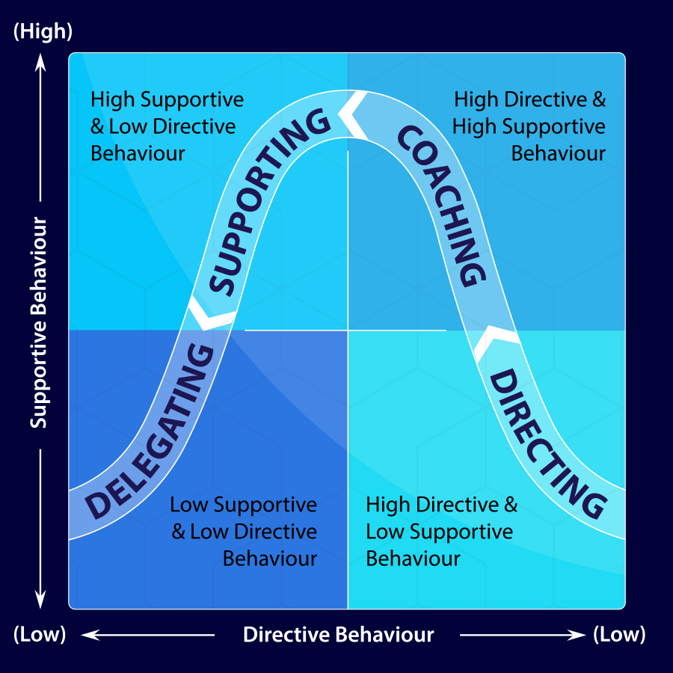
Source: Leighton (2020).
In respect to leadership in an organisational context, this is the board of executives. In respect to management in an organisational context, those are the administration bodies. There is a contrast between the board and the administration. Managers are committed to doing things. Directors organize human and physical assets to achieve business points and goals (Gold, Thorpe and Mumford, 2010). Strength is about influencing, stimulating, and motivating people. He is committed to training and creating people, to treat them with respect as they test. The pioneers try to form solid groups, with people focused on the common goals of the association. The path to supervision begins with the goal or goal that must be achieved. The boss must agree on the appropriate methodology to achieve this goal. The supervisory body then obviously has to pass this methodology on to its group and assign commitments to each colleague. Taking part and assigning responsibilities are part of the work of the administration. As far as possible, the different components will also have an effect on whether the goal is achieved, given the initiative of the hand, the attitudes of the group and the style of power (Gold, Thorpe and Mumford, 2010).
The administration style may differ depending on the order. Several bosses allow groups to take responsibility for their own dynamics for certain orders. The pioneers of the group will set goals, but still commit colleagues to choose how to achieve these goals. This has several favourable circumstances. It helps to convince the people in the group and attracts the mastery of the people in the group (Gold, Thorpe and Mumford, 2010).
Tesco's administrative structure determines the abilities and skills, as well as the individual qualities and practices, that it expects from its pioneers. Tesco is looking for bosses who are safe, secure, and genuine, with the ability to move and empower their groups. A key piece of Tesco's pioneering program is providing opportunities for self-learning and reflection. This allows staff to explore their qualities and find methods for displaying attributes that are essential to the prepared business improvement.

Leadership and Management Style of Work – Analysis
Business scholars Tannenbaum and Schmidt have arranged distinctive administration styles. They suggested that the authorities' styles be clarified on a scale ranging from "authoritarian" to "law-based" to "free enterprise". Authoritarian or tyrannical style is described with "I say" reasoning. Totalitarian pioneers instruct their staff. This can give clear business guides, but it can also lead bosses to underestimate or ignore the contributions of their groups. In any case, a power methodology is appropriate in certain circumstances. It is important when the business is facing emergencies or when a serious problem arises that requires a quick response. In addition to this, there are some movements of power towards those who are among the dictators and are based on votes. These styles allow group collaboration to a limited extent. Nevertheless, the supervisory authority shall maintain all necessary powers to reach a formal conclusion (Gold, Thorpe and Mumford, 2010). Directors who accept the theory of "selling" will try to persuade their groups to recognize their point of view.
Administrators who receive the "Advise" approach will seek subordinates' assessments before making a choice. This is close to the popular style of executives.
The best supervisors are given proactive styles appropriate to the situation. Stephen's chosen authoritative style is to adopt a majority management strategy. He advises widely, as he believes that employees respond better to this methodology. For example, when organizing a significant stockpile reduction program, he urges his superiors to develop thoughts and make plans. This builds group inspiration and sustains the imagination. A few mistakes can be made, but they are used as a learning experience. However, as a senior executive, Stephen manages a wide range of circumstances. Some may be the core business and it is important that it responds to them in the most appropriate way. In such circumstances, it may be necessary to lead a supervisory body to adjust its proactive approach and exercise more power.
Furthermore, free enterprise is at the opposite end of the range from totalitarian. The freelance director in the company uses an approach and trusts the groups to make appropriate choices or activities with extended agreed constraints. For example, Martin may leave a departmental oversight body to prepare a financial plan. This may be on the grounds that he believes that the supervisor has adequate information about the requirements of the department and the business. Directors should be aware of the potential results of using an inappropriate style in a particular circumstance. For example, an administrator will not take a free business approach with another person in the confectionery group. If the worker does not receive legal instructions before working with the heating hardware, the bread can be overcooked. Representatives can also be injured if they do not use the equipment properly. In this circumstance, it is important to adopt a "say" approach.

Factors which Influence Leadership and Management Behaviours at Tesco
People at every level of Tesco - from managers and colleagues from customers to bosses - are faced with different types of choices. Everyone accompanies their own obligations and deadlines. They will influence the most appropriate style of the initiative for a specific job or for a specific endeavour or crowd. Tesco administrators have responsibilities for staff "in front of the house" (in front of the client), as well as "off-camera" as office staff. Before making a selection decision, the administrator will carefully examine the order, the people in question and the people who will be affected (eg customers). The various elements of the interior and exterior can also influence the decision of the authoritative style used. Internal variables include the degree of fitness that workers have. Huge groups can have people with varying degrees of ability. This may require the director to adopt a more mandated style, giving clear correspondence so that everyone can recognize what to do to achieve goals and endeavours. Then again, the pioneers in the group can adopt a more consultative strategy with different equivalent directors to get the job done.
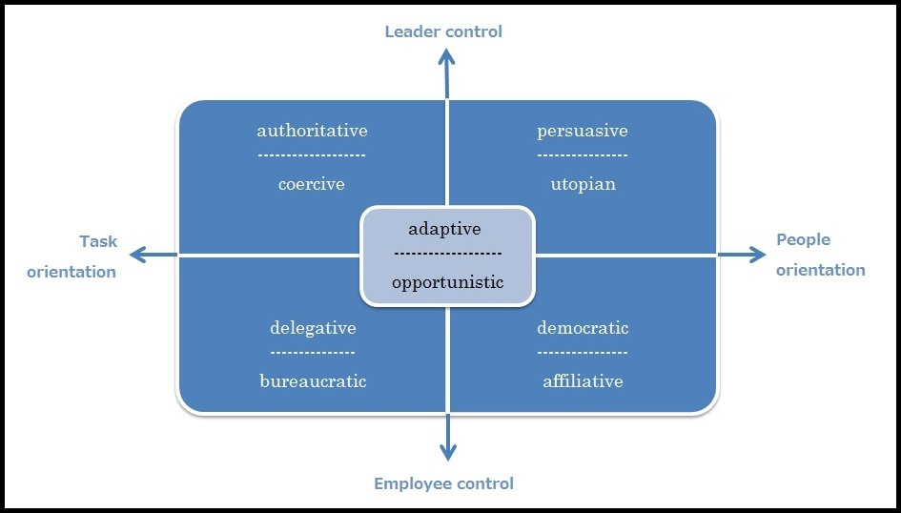
Source: Wordpress (2020).
Finally, it should be stated that outer components may occur during customer management. For example, a Tesco manager may need to use an influential style to persuade a customer to recognize a swap for something that is not happening.

Reported by:Lachezar Nikolov

Group and Team Behaviours

Overview
Everyone in an organization will have a variety of behaviours. They all have an unmistakable character, character, abilities, and as well as that also qualities (Brannen, Moore and Mughan, 2013). This affects the state of the business, as the employee's behaviour will affect profitability, the nature of the work and the obligation to work. While recording, the associations need someone who will add something different from what is expected and significant. The factor that influences individual behaviour is the following aspect (Brannen, Moore and Mughan, 2013).
Supervisors need to monitor and make sense of the various individual behaviours to see if it is appropriate for the association and how they will add to the association if the hierarchy and workers are not in line, the job of both is to coordinate them so that both and the association is fulfilled. Administrators need to be aware of individual behaviour when choosing people who are important to the organization. They also need to look only at behaviour to see who can develop with the organization. In the same way, superiors must take a position on the positive behaviour of the individual and force him to use human capital productively. Supervisors exclude the undertaking as indicated by their inspection of the workers (Brannen, Moore and Mughan, 2013).

Dynamics of a Teamwork or Group Environment
Currently, the Association constantly uses gatherings to perform various tasks. Meetings are framed to develop new thoughts and opportunity or change. To select individuals for the group, administrators must pay special attention to individual contrasts. According to Belbin, the presentation of a gathering relies on the individual behaviour of that gathering. In Belbin's hypothesis, he said that people should perceive their quality and shortcoming. Through his research, he perceives 9 jobs that happen in a group. He also placed these jobs in three Action People and Thought gatherings. The perfect group must have equalization of all 9 jobs.
As indicated by this individual, he must be chosen to form a collection. One person can have several group tasks. In this way, individuals will have a powerful and valuable effect on the group and the relationships within it. Kurt Levin says that the dynamics of the gathering is the way in which each of these jobs and individual behaviours affects different individuals in the group. In a positive way, the person in the group trusts and works successfully for joint choice. Unfavourable unique personalities do not have alliances and will not cope enough in this way, they can deal with unacceptable choices.

Influences over Team or Group Behaviours at Tesco

Assorted variety
Tesco has people from a wide range of foundations and societies. They need to figure out how to recognize and recognize the differences that lead to success in groups. Assorted variety helps Tesco groups in ingenuity and development (Wood, Coe and Wrigley, 2014).

Correspondence
Tesco ensures that each individual in the group feels well contributed. The work is characterized, the purpose and obligations and the course of events are indicated. The more information about the tasks and responsibilities is given, the more viable the group is (Wood, Coe and Wrigley, 2014).

Initiatives
For a group to be full of feelings, there must be a solid authority. The Tesco pioneer must-have information: it should provide guidance and help achieve the organization's goals. He must be aware and tolerant of others (Wood, Coe and Wrigley, 2014).

Size
Tesco makes a small collection to make it more profitable. In the same way, they select the right people with the skills and abilities to make the collection. Colleagues must know about their work and be ready to achieve the goals of the collection. Tesco sets daily standards for behaviour inside the fair (Wood, Coe and Wrigley, 2014).

Obstructive factors and variables
Variables that adversely affect Tesco's collaboration are when the troughs do not provide clear goals and guidelines. The problem with correspondence can arise when a colleague is too scared to even think of expressing his thoughts and worries. Or on the other hand, they do not convey thoughts, as they must be in acceptable books with a pioneer. Probably someone in the council does not trust others all the time. Persons who have problems with responsibility. Conflicts can arise due to conflicting thoughts and characters. Helpless initiative. Freeriding when one leaves all the work to others (Wood, Coe and Wrigley, 2014).

Technology and Innovation
Headway in media transmission and system has changed the entire idea of collaboration. Groups presently do not need to be up close and personal or situated in the primary unit. They can work and impart from their homes, lodgings, or different workplaces. Tesco has made virtual groups since they have stores in 12 nations. These are groups, which comprise of workers who are situated in various nations. They convey through email, Skype videoconference. Tesco needs to utilize the right innovation for the groups to be successful. As indicated by Tesco report investigations ukessays.com it utilizes a wide range of data frameworks like TPS, DSS, and MIS to gather data from deals point, overseeing providers, to social event data about clients and workers. Innovation benefits Tesco by being productive, sparing time, overseeing inner and outside data, and get-together clients shopping propensities (Wood, Coe and Wrigley, 2014).
In addition to this, the chiefs can settle on a better-educated choice. It diminishes cost and builds profitability. New innovation has additionally helped Tesco discuss better with its branches and universal store. Data and strategies currently can be given in a split second due to Tesco individual intranet. Tesco utilizes web-based life like LinkedIn twitter and face book and WhatsApp to associate gatherings. The drawbacks of innovation are that one does not connect with others to watch nonverbal correspondence, thus relationship and trust are not building. Messages are once in a while not read and overlooked. Security is additionally issues; programmers may mutilate data. Broadband speed probably won't quick. Individuals are losing positions because of innovation. No other reinforcement so may free all information if something happens to innovation.

Reported by:Tonka NIkolova

Motivation and Perception

Concept and Theories
Various hypotheses have been proposed to clarify the inspiration of workers in associations. These include Maslow's pernicious order of necessity and Herzberg's purity hypothesis, the expectation hypothesis, the objective hypothesis, and the reasonable procedure hypothesis.
Maslow's chain of control suggests that people's inspiration depends on building a progressive system of needs. In particular, people have physiological, security, social, self-esteem and self-improvement that must be met in the work environment. Physiological needs include a safe home, clothing, food and water and are at the core of the chain of command requirements (Ebert and Griffin, 2019). Welfare needs include protecting people from workplace injuries and creating stressful pressures. Social needs include important relationships in the work environment. Needs are identified with a person's longing for competence, achievement, recognition, fame and status. Finally, cultivation involves striving to reach the highest potential. Maslow recommended that higher needs be met after those at the core were met. Thus, once the representatives have fulfilled their physiological needs, they need their security, sociality, confidence and cultivation in order to be fulfilled in a certain order. Directors can extend the security of employment opportunities, incidental benefits, and pay to meet the security and physiological needs of their employees. To solve social problems, supervisors need to improve cooperation in the association. As far as needs are concerned, they can be met by compensating elite workers by recognizing and building links between efficiency and pay. Finally, the needs for self-realization can be met through test work, opening up progress, preparation and self-management in the performance of the work.
Herzberg's purity hypothesis fights against those people who are inspired to do their job. This hypothesis sees that people are inspired when explicit helpers are found in the workplace. These inspirations include progress, test work, recognition, development, commitment and performance. In addition, the hypothesis depicts the needs identified by the setting or status of the activity. These components include relationships, security, status, permanent learning openings, hierarchical culture, working conditions, and authoritative strategies (Ebert and Griffin, 2019). However, these variables do not inspire representatives, but when absent from the association, representatives are disappointed with the work. In light of this hypothesis, the supervisor can convince workers by ensuring that the purity and inspiration variables are available in the association.

Effects on Tesco Performance
The association with an extremely energetic workforce can achieve its goals by presenting work assignments by representatives. It is recommended that inspired representatives be extremely profitable in order to be radically profitable in contrast to those people who are not awake. It was found that the positive link between the exhibition of representatives and their training and inspiration and expressed that associations that need to build on the performance of their workers should focus on training, as this stimulates the workforce to achieve better levels. . It can be seen that the inspiration among the representatives significantly influences the efficiency and that the bosses have to concentrate on diverting the inspiration to achieve both hierarchical and individual goals. Experts motivated that the inspiring components and inspiration have a positive effect on the performance of the groups.
Another scientist argues that inspiration is one of the main components in the profitability of workers. The Creator recommended that representatives be given legitimate objectives of the activity, a permanent work environment and sufficient skills alone are not sufficient to ensure that the activity is carried out and that workers must have satisfactory levels of inspiration to apply the necessary levels of endeavours for the recognition of specific work destinations (Ebert and Griffin, 2019). Various scholars have found that representative inspiration through recognition, benefits, progress, and contribution encourages higher efficiency. In fact, it has been created that the satisfactory inspiration of the representatives using mounting motivators improves their exhibition and thus ensures the achievement of the goals of the hierarchical implementation.

Reported by:Yanitsa Gospodinova

Conclusion
In conclusion, Tesco is a highly prosperous business organisation in the retail sector with a rich history and means of achieving goals with great ease most of the time. The company has become very conscious of the demands that external as well as internal stakeholders appear to have and aims to balance their needs rather than prioritise one area or another. Nevertheless, the company looks at means by which it will be customer oriented for the purpose of enhancing customer service and provides training and development towards a broader perception for employees who will achieve more in the corporate environment as well as their personal one.

Reference List
Booth, S. and Hamer, K. (2007). Labour turnover in the retail industry. International Journal of Retail & Distribution Management, 35(4), pp.289–307.
Brannen, M.Y., Moore, F. and Mughan, T. (2013). Strategic ethnography and reinvigorating Tesco Plc: Leveraging inside/ out bicultural bridging in multicultural teams. Ethnographic Praxis in Industry Conference Proceedings, 2013(1), pp.282–299.
Clive Humby, Hunt, T. and Phillips, T. (2015). Scoring points : how Tesco continues to win customer loyalty. London: Koganpage.
Ebert, R.J. and Griffin, R.W. (2019). Business essentials. New York, Ny: Pearson.
Fernie, J. and Sparks, L. (2019). Logistics and retail management : emerging issues and new challenges in the retail supply chain. London: Koganpage.
Gold, J., Thorpe, R. and Mumford, A. (2010). Gower handbook of leadership and management development. Burlington, Vt: Gower.
Hassan, A. and Parvez, M. (2013). A Comparative Case Study Investigating the Adoption of Customer Relationship Management (CRM) The Case of Tesco and Sainsbury’s. International Journal of Managing Value and Supply Chains, 4(1), pp.1–10.
Leighton, B. (2020). The four types of leadership styles. Master Start [online]. Available from: https://masterstart.com/blog/business/the-four-styles-of-leadership-and-when-to-adopt-them/ [Accessed: 10/08/2020].
Reference for Business (2020). Tesco plc - Company Profile, Information, Business Description, History, Background Information on Tesco plc. Reference for Business [online]. Available from: https://www.referenceforbusiness.com/history2/56/Tesco-plc.html [Accessed: 10/08/2020].
Nenycz-Thiel, M. and Romaniuk, J. (2014). The real difference between consumers’ perceptions of private labels and national brands. Journal of Consumer Behaviour, p.n/a-n/a.
Samantara, R. and Sharma, N. (2014). Talent Management at Tesco HSC—A Case Study. Management and Labour Studies, 39(4), pp.477–485.
Woods, M. (2007). Linking risk management to strategic controls: a case study of Tesco plc. International Journal of Risk Assessment and Management, 7(8), p.1074.
Wood, S., Coe, N.M. and Wrigley, N. (2014). Multi-Scalar Localization and Capability Transference: Exploring Embeddedness in the Asian Retail Expansion of Tesco. Regional Studies, [online] 50(3), pp.475–495. Available at: https://eprints.soton.ac.uk/371968/. [Accessed: 08/08/2020].
Wood, S., Wrigley, N. and Coe, N.M. (2016). Capital discipline and financial market relations in retail globalization: insights from the case of Tesco plc. Journal of Economic Geography, 17(1), pp.31–57.
Wordpress (2020). Leadership and management styles: the “prêt-à-porter” collection. Wordpress [online]. Available from: https://leadersyndrome.wordpress.com/2012/08/09/leadership-and-management-styles-the-pret-a-porter-collection/ [Accessed: 19/08/2020].

