University of Wales Trinity St Davids
School of Engineering


Electronic circuits testing and analysis
ACHA4010 Electrical Control Systems

Harvey Levell
2300714
24th March 2024

Contents
1 Task 2 0
1.1 Scope Time Division Calculations (4) 0
1.2 Function Generator output sine wave (3) 0
1.3 Unsmoothed Rectifier Wave (3) 1
1.4 Smoothed Rectifier Wave with capacitor (3) 1
1.5 Drop in Voltage Question (4) 2
1.6 Different Voltage Readings Question (5) 2
1.7 Rectifiers use in Automotive applications Question. (4) 2
1.8 Probing Question (4) 2
2 Task 3 3
2.1 Scope Time Division Calculations (4) 3
2.2 Function Generator output square wave (3) 3
2.3 Capacitor charge and discharge wave marked at correct points. (3) 3
2.4 Basic Capacitor Calculations (3) 4
2.5 Capacitor discharge table (4) 5
2.6 Gradient Plot and calculations (4) 5
2.7 Capacitor Uses (5) 5
2.8 Inaccuracies Question (4) 6
3 References 7

Task 2

Scope Time Division Calculations (4)
Frequency = 10Hz
Time period = 1/10 = 0.1 seconds
t/div = tau/ndiv = 0.1/10 = 10ms

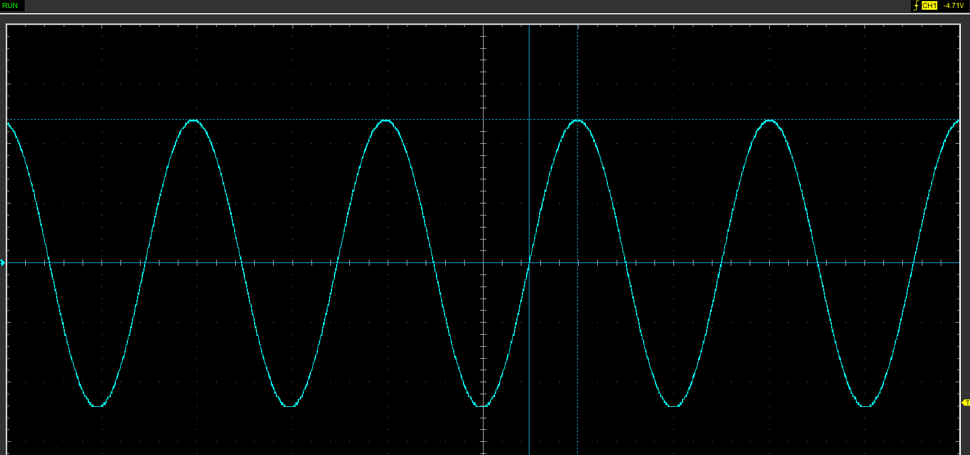
Function Generator output sine wave (3)
Figure 1.1 output Sine wave from function generator

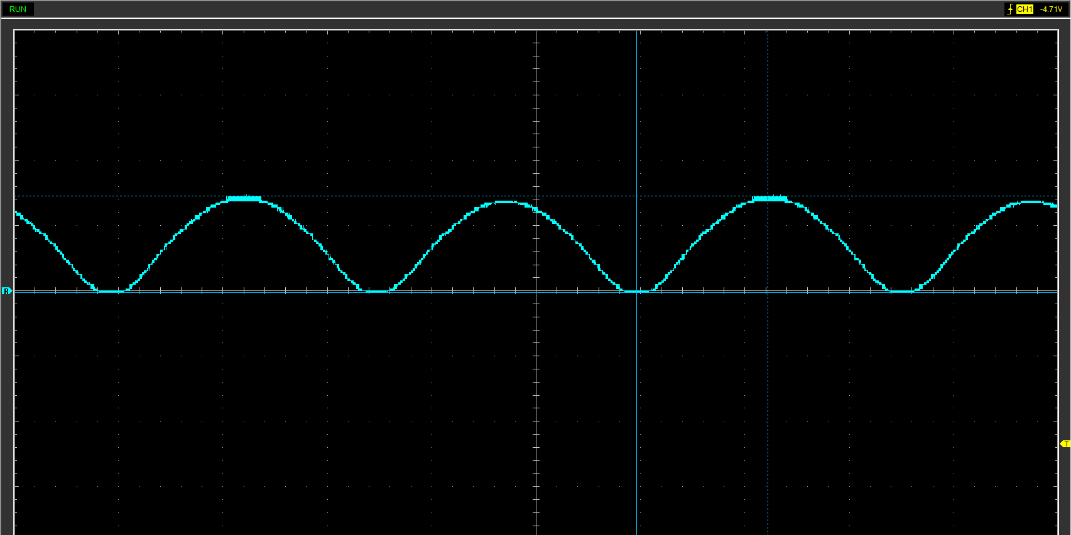
Unsmoothed Rectifier Wave (3)
Figure 1.2 Unsmoothed rectifier wave

Smoothed Rectifier Wave with capacitor (3)
This is inverted should be positive.
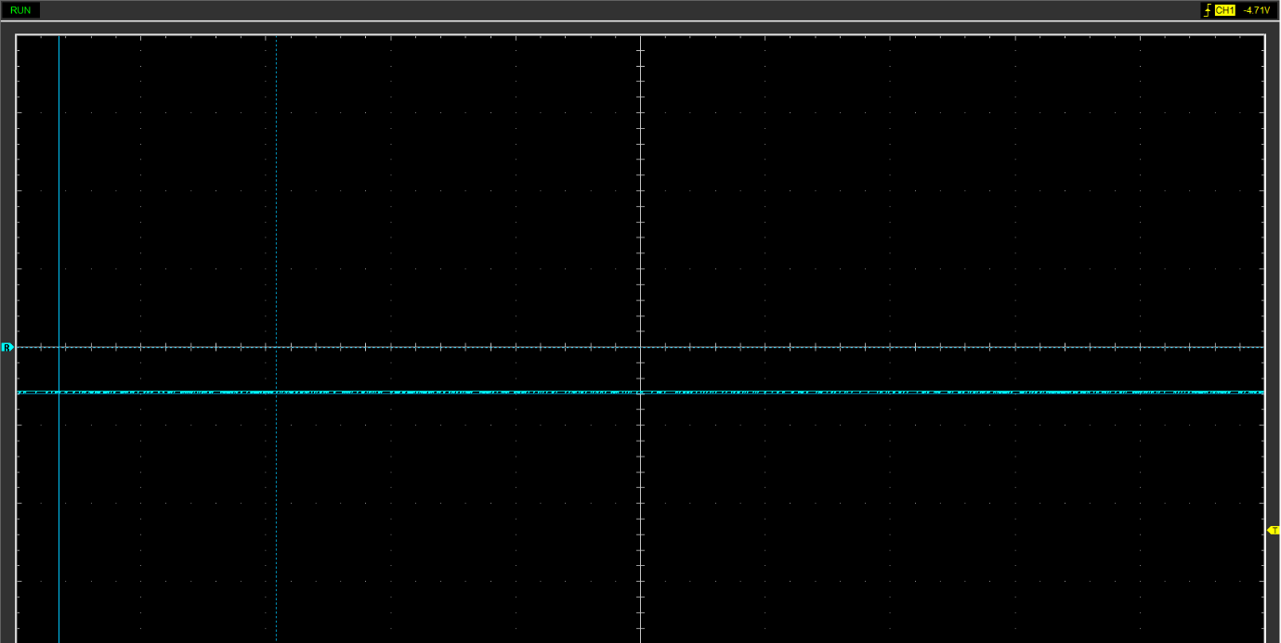
Figure 1.3 Smoothed Rectifier wave

Drop in Voltage Question (4)
A drop in voltage can be caused due to the presence of diodes. Diodes have a voltage drop across them typically around 0.6-0.7V. so after going through the diode cycle the input voltage will be around 0.6v less. At higher current loads there can be voltage drops due to internal resistance of circuit components such as wires and diodes. Furthermore. filtering components designed to smooth the output voltage ie. Capacitors can create a drop in voltage.

Different Voltage Readings Question (5)

Rectifiers use in Automotive applications Question. (4)
Rectifiers are commonly used in alternators that generate AC current. The rectifiers convert this current to DC to charge the battery. Hybrid vehicle systems are focused on the rectifier circuit. AC-DC conversion of electric power is used in many applications such as adjustable speed drivers, switch mode power supplies, uninterrupted power supplies and battery energy storage (K.K.Poongodi, 2020, p1). The rectifiers play a key role in new and developing hybrid vehicles as well as all electric.

Probing Question (4)

Task 3

Scope Time Division Calculations (4)
To calculate scope time divisions, select a capacitor and resistor. In this case a 10kΩ resistor was used and a 225 F capacitor. Calculate 20 time periods of RC.
So, using T = R.C where R = 10k and C = 225uF. T = 10,000 x 0.000225 = 0.225 seconds.
Frequency = 1/T = 1/0.225 = 4.44 Hz.
Next, we calculate for 20 time divisions, so 20 x 0.225 = 4.5 seconds.
Hence the time taken to display 1 complete wave with a duration of 20s has a division of 4.5 seconds.

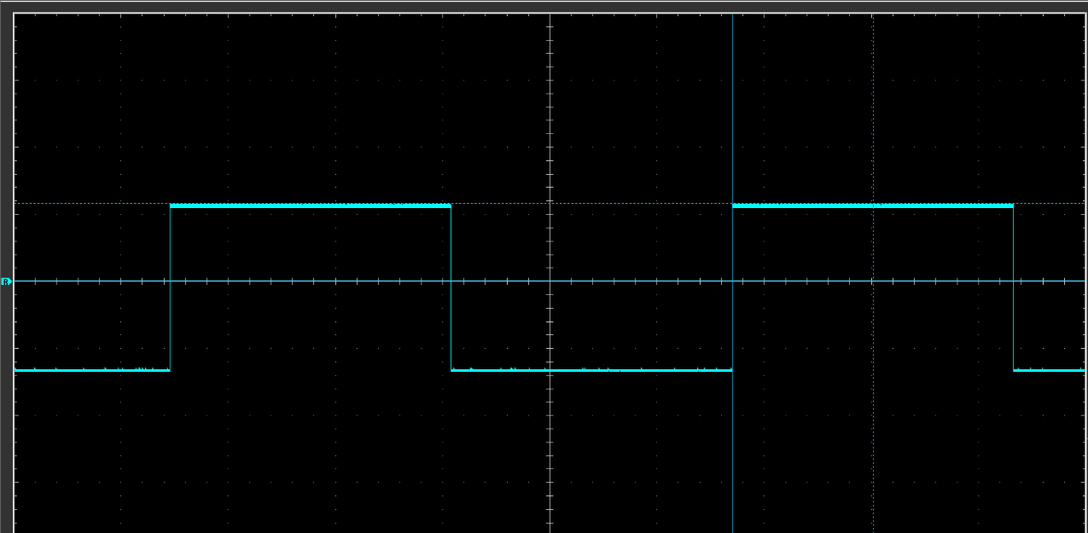
Function Generator output square wave (3)
Figure 2.1 Function generator square wave output

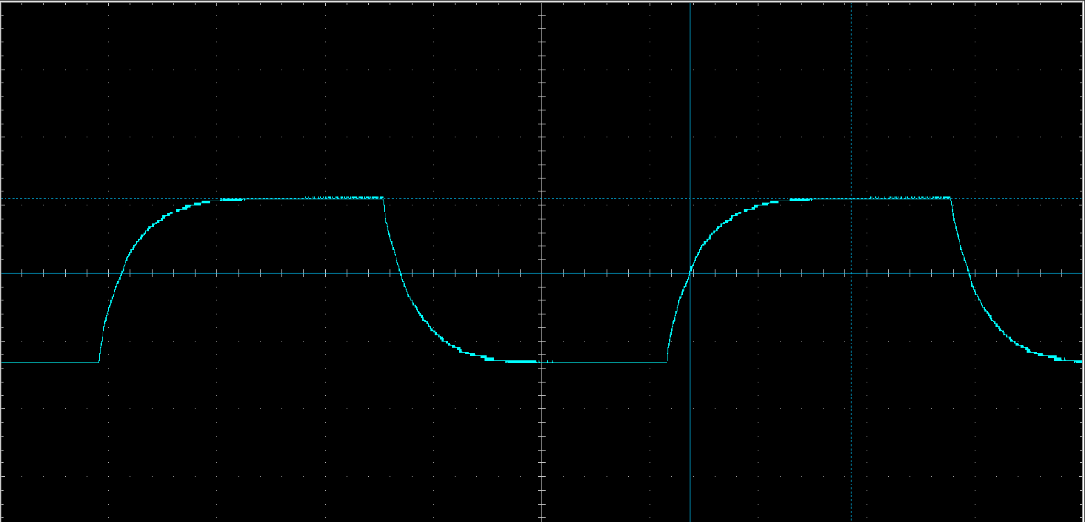
Capacitor charge and discharge wave marked at correct points. (3)
Figure 2.2 Capacitor charge and discharge wave

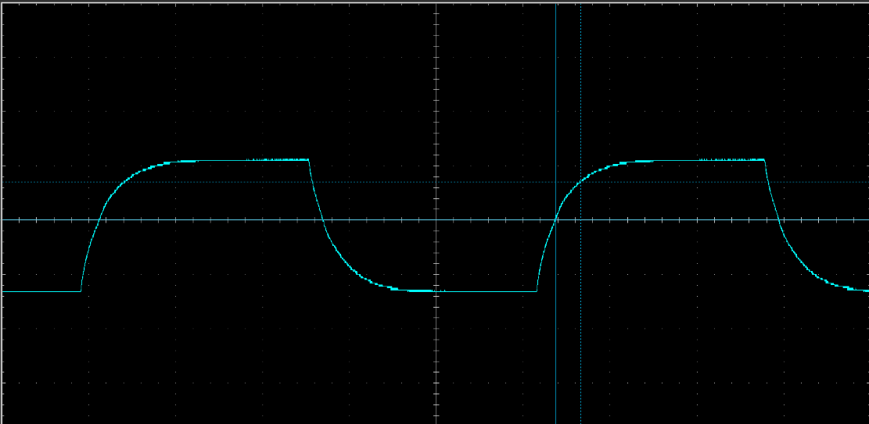
Figure 2.3 Capacitor charge and discharge wave with marked time constant

Basic Capacitor Calculations (3)
To find capacitance use formula Τ = R.C
To find T we find the time constant for a 63.2% rise in voltage. The Graph above shows change from 0 to maximum voltage.
(2.22 – 0) * 0.632 + 0 = 1.40 V
From figure 2.3 we have a time constant of 578x10⁻⁶ seconds
Rearrange T = R.C to get C = T/R
Resistor used had a resistance of 10kΩ.
C = 578x10⁻⁶/10,000 = 578x10⁻¹⁰ Farhads

Capacitor discharge table (4)
Figure 2.4 Table of capacitor discharge values

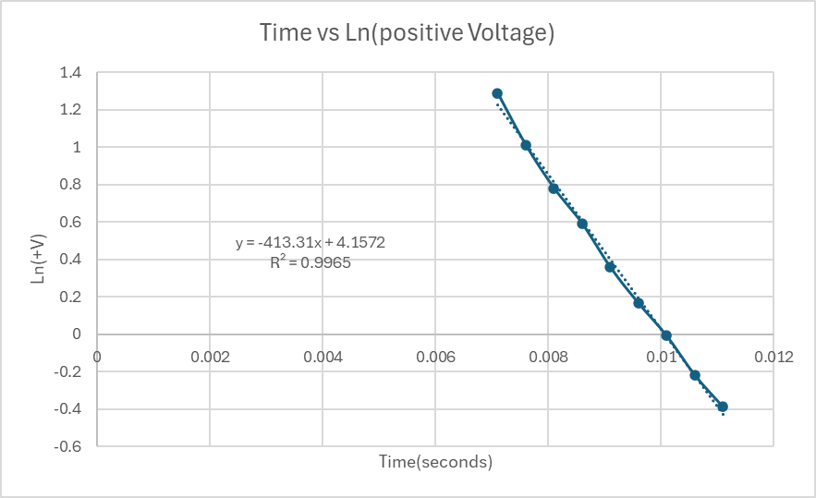
Gradient Plot and calculations (4)
Figure 2.5 Gradient plot of data from figure 2.4
Gradient is -413.31
R² Shows how close the trendline is to the line of best fit. A number nearest to 1 is closest. The value achieved was 0.9965

Capacitor Uses (5)
- Starter motors in high performance engines.
- Ignition systems to store and supply large voltage for reliable spark.
- Stabilise voltage in engine management systems.
- Energy recovery systems in hybrid vehicles.
- Provide voltage boosts in Electrical power steering systems.
- Control boost in turbocharger systems.
- Logging data and telemetry.
- Filter out low frequency noise in audio systems.
- Automotive lighting systems.
- Power conditioning systems.

Inaccuracies Question (4)
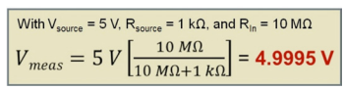
When using a probe it will have a resistance. The user wants this to be as large as possible to reduce the effect on the data. However, this effect is very minimal which can be shown in figure 2.6
Figure 2.6 Equation of Practical Input Resistance Calculation (Test Equity, 2013, p3)
It is important to use a probe with a smaller input capacitance because it is going to cause less disturbance or loading (Test Equity, 2013, p9). Therefore, a scope with increased input capacitance will have caused a disturbance in the output waves.

References
K.K.Poongodi, DESIGN OF AC-DC CONTROLLED RECTIFIER FOR HYBRID ELECTRIC VEHICLE, April 2020 e-ISSN: 2395-0056
Test Equity, How Oscilloscope Probes Affect Your Measurement - Application Note, 2013.

