A STRATEGIC CHANGE PLAN

TITLE: LEADING AND IMPLEMENTING CHANGE (LIC)
STUDENT NAME:
STUDENT ID NUMBER:

STUDENT NAME: Anees Farooq
STUDENT ID NUMBER: 2314658

Programme: BA (Hons) Leadership and Management Skills for the Workplace
Module Code: LCLM6003
Lecturer(s):
Nadeem Mirza
Ivan Rodriguez Hernandez
Assignment Title:
A Strategic Change Plan

TABLE OF CONTENTS
Executive Summary 3
1. Introduction to the Organization 3
2. Organisational History and Environmental Analysis 4
3. Evaluation of Change Management Models 5
4. Leadership, Culture, and Change 7
5. Proposed Change Management Plan 9
6. Reflection and Transferable Skills for Life and Professional Practice 11
7. Conclusion 12
8. References 13

Executive Summary

The modern organisational environment has been described as fast-paced technological, global, digital disruption, and shifting consumer expectations. This report is aimed at critically analysing organisational change in Amazon and proposing a strategic change management plan that can help the organisation to maintain a competitive advantage and long term growth. The report is an analysis of the organisational background and the recent history of Amazon, which has been marked by the effects of digitalization, artificial intelligence (AI), automation, and online retail transformation. It also critically analyzes some of the existing models of change management, such as the Three-Step Model of change management as proposed by Lewin, the Eight-Step Model proposed by Kotter, and the McKinsey 7S Framework, evaluating their applicability to the strategic change at Amazon. The role of leadership styles and organisational culture on the change implementation is examined in detail. The last part suggests a change management plan to be followed to improve the use of ethical AI and make the employees engaged, which should be backed by the clear objectives, the financial strategy, the communication strategy, and the evaluation structure. The report shows that organisational change is not possible without efficient leadership, dynamic culture, and evidence-based change models.

1. Introduction to the Organization
Amazon was founded in 1994 as a small online bookstore, but it has evolved to become one of the most influential multinational organisations in the world that is technologically-driven. The company has over the years diversified its business activities in several areas such as global e-commerce, cloud computing, Amazon Web Services (AWS), artificial intelligence, enhanced logistics and supply chain management, and digital media services. The diversification has helped Amazon to minimize its dependence on one stream of revenues and to build greater competitive advantage in global markets that are becoming more volatile and complex (Morrison, 2025).



Figure 01: Amazon

The organisational culture and strategic decision making of Amazon is based on its corporate mission to become the most customer centric company on the earth. The company highly values innovation, decision making that is data-driven, and operational excellence in order to improve customer experience. The technologies are highly advanced like artificial intelligence, machine learning algorithms, and predictive analytics, which are utilized to personalize customer’s interaction, price optimization, and efficiency of inventory management and delivery. The capabilities enable Amazon to react quickly to shifts in consumer behavior and remain highly attentive to service quality. The organisation is experiencing a highly dynamic and unpredictable business environment where technology is changing rapidly, there is stiff competition in the global market, and there is regulatory scrutiny and the changing expectation of the consumer (Zhong, & Um, 2025).

2. Organisational History and Environmental Analysis

2.1 Internal Environment

The technological skills, high financial potential, and a well-established culture of consistent innovation define the internal environment of Amazon. Amazon has always invested its profits in research and development, which allows the organisation to be in the lead of digital transformation. The key to this ability is its high expenditure on artificial intelligence, automation, and cloud infrastructure, especially using Amazon Web Services (AWS). Those technologies aid in the making of decisions that are data-driven, improving the efficiency of business operations, and promoting rapid scaling of global markets (MAHABUB, & Snigdha, 2025).

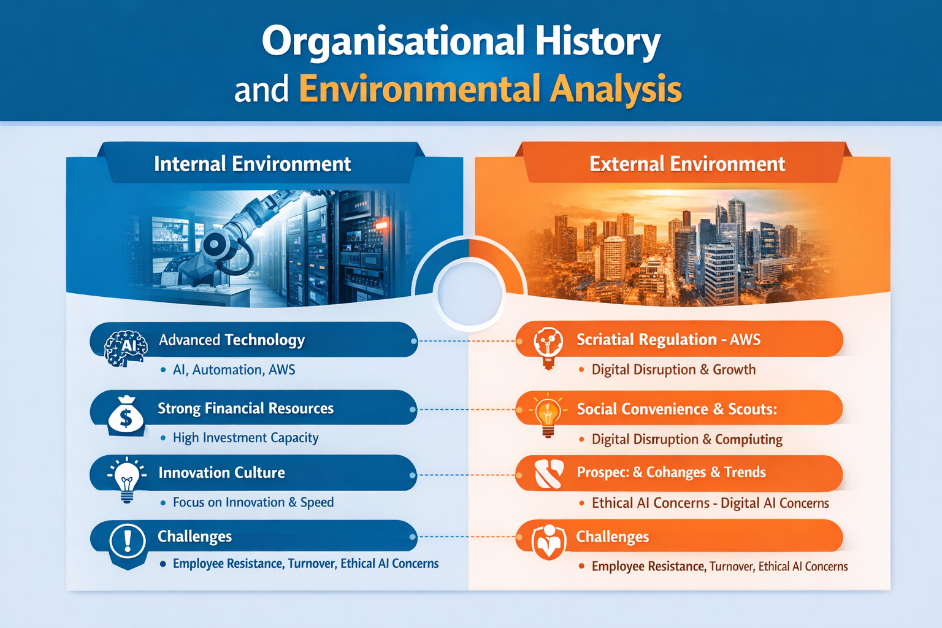

Figure 02: The difference between internal environment and External environment

The internal systems of Amazon are created to maximize the speed, accuracy, and customer satisfaction. The demand forecasting, inventory control, customer personalization and logistics are optimized using sophisticated algorithms. This dependence on technology has led to improved competitive advantage of Amazon, but has also resulted in greater complexity of the organisations. The organisation has grown at a very fast rate and controlling the alignment between the strategies, structure, systems and the people has become more difficult.

Amazon has a number of internal triggers of change, even though it has the technical capabilities (O’Rourke, 2025). The accelerated growth has exerted pressure on employees especially in fulfilment centers where employees have been stressed due to high performance goals and automation that has led to high turnover. Moreover, some ethical issues concerning surveillance, data privacy, and performance evaluation fairness have emerged with the growing application of AI and algorithmic management. Unless addressed well, these problems can destroy employee engagement and organisational trust.

Table 01: PESTLE Analysis of Amazon
Factor | Key Issues for Amazon | Impact on Organisational Change and Strategy
Political | - Governments across different countries impose regulations related to trade policies, labor laws, and international taxation. | - Political regulations require Amazon to adapt its operational strategies, ensure compliance with employment standards, and manage international supply chains effectively.
Economic | - Global economic conditions such as inflation, exchange rates, and consumer purchasing power directly influence online retail demand. | - Economic fluctuations affect revenue generation, pricing strategies, and investment decisions.
Social | - Changing consumer behavior toward online shopping, demand for fast delivery, and expectations for personalized services significantly influence business operations. | - Social expectations drive Amazon to improve customer experience, employee engagement, and sustainability initiatives.
Technological | - Rapid advancements in artificial intelligence, automation, cloud computing, and digital platforms play a central role in Amazon’s operations. | - Technological developments enable operational efficiency, data-driven decision-making, and scalability.
Legal | - Strict legal requirements related to data protection, competition law, taxation, and employment regulations affect business operations. | - Legal pressures force Amazon to strengthen compliance systems, improve transparency, and adjust employment practices.
Environmental | - Increasing concerns about climate change, carbon emissions, packaging waste, and sustainable logistics practices influence organizational operations. | - Environmental pressures encourage Amazon to adopt green logistics, renewable energy usage, and sustainable supply chain practices..

2.2 External Environment
Outside, Amazon exists in a very dynamic and competitive global landscape that has been influenced by a fast-growing technological world, changing consumer demands, regulating forces as well as the social factors. The rising trend of online shopping has essentially changed the consumer behavior where customers want faster delivery services, smooth online experiences and customized services (Pradgna, & Raj, 2025). It has compelled organisations in the retail industry to implement the omnichannel strategies that incorporate the online platforms with effective logistics and customer support systems.
Amazon is a subject of fierce competition with both the international and local competitors, and even traditional retailers that have managed to digitalize their businesses. In its turn, organisational change is a sustained strategic requirement of Amazon which, in its turn, must innovate every time to remain the market leader. Meanwhile, governments and regulators are putting larger technology companies under a greater level of scrutiny, especially in relation to data protection, competition law, taxation, and employment practices. These governmental forces are major external forces of change that affects strategic decisions of Amazon.
The social and environmental expectations are also increasingly becoming more important in influencing the Amazon external environment (Martins, & Cavalcante, 2025). The stakeholders such as customers, employees and investors are also requiring more open initiatives on sustainability, carbon emissions and labor practices. Inability to react well to such expectations can lead to a tainted image and stakeholder mistrust.

3. Evaluation of Change Management Models

Large technological-focused firms that need to undergo organisational change necessitate the use of organized but adaptable models of change management. This is a critical evaluation of the three most popular models, the Three-Step Model of Lewin, the Eight-Step Model of Kotter and the McKinsey 7S Framework, and the appropriateness and pitfalls of applying them to Amazon (Rodriguez Villanueva, & Schwarz, 2025). The analysis of the models shows their contribution to the strategic change understanding and also discloses gaps when these models are implemented in fast-paced digital settings.

3.1 Lewin’s Three-Step Model

One of the most famous and the oldest models of organisational change is the Three-Step Model developed by Lewin that includes the unfreezing, change, and refreezing. The model presupposes that organisations are maintained in the state of equilibrium, and a change involves destabilizing current behaviors and stabilizing new practices accordingly (Taleshi, & Williams, 2025). It is also especially convenient in its simplicity as the means of Conceptualising the process of change and defining major stages of transition.

In the case of Amazon, the unfreezing phase can be seen in the high dependency on data analytics by the organisation to detect inefficiencies, new market trends, and performance gaps. As an illustration, operational metrics and customer data are employed to justify alterations in the logistics systems, AI-driven forecasting, and workforce management practices. This evidence based practice causes a sense of urgency and justifies change programs in the organisation.

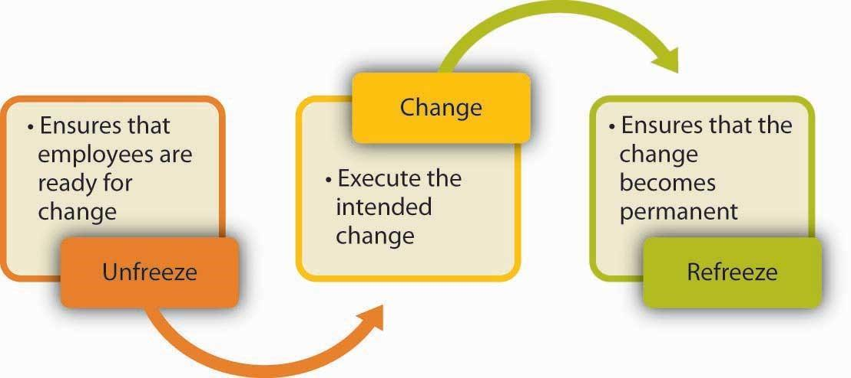

Figure 03: Lewin’s three step model

The change stage is indicated by the introduction of new technologies by Amazon, including the use of automation in fulfilment centers and artificial intelligence in customer personalization and inventory management. The changes are usually implemented in a haste manner with the aid of training programmes and performance monitoring systems (Azmi, & Zhang, 2025). The refreezing step is achieved by introducing new processes into the normal operation procedures, which is supported by performance measures, key performance indicators (KPIs), and organisational routines.

3.2 Kotter’s Eight-Step Model

The Eight-Step Model by Kotter builds on the Lewin model by emphasizing on leadership, communication, and involvement of employees within the change process more. The model presents a systematic sequence of actions, which include the creation of a sense of urgency, a guiding coalition, vision creation and communication, the empowerment of employees, generation of short-term wins, consolidation, and anchoring of a change into the organisational culture (Selvakumar, Sharma, 2025).

This model is especially applicable to Amazon because it is a large and vast scale of strategic changes. Amazon has a tendency of creating urgency through comparisons to competitors and market data to create perception of threats and opportunities. Leadership teams provide well-defined customer obsession, innovation, and operational excellence vision statements that are transmitted by means of internal messaging and leadership briefing.

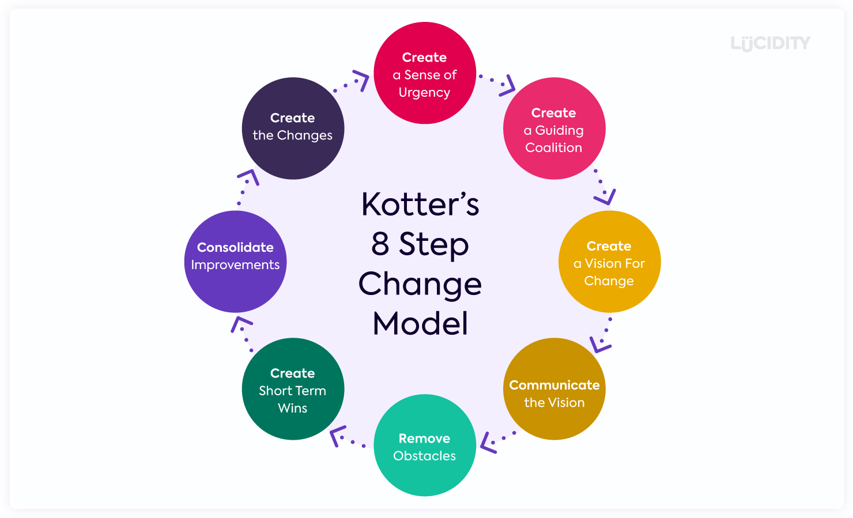

Figure 04: Kotter’s 8 step model

Kotter and his focus on short-term victories can be seen in the way Amazon implements technology projects in small-scale steps, where a positive performance results in an investment that will lead to an increased one( Underage, Rogelio, 2025). Such visible wins keep the momentum of change going and strengthen dedication to change.

Nevertheless, the model of Kotter presents limitations to the performance of the model at Amazon due to the rapid changing nature of the organisation. Although effectively, urgency has been created, the employees might encounter few chances of internalizing the vision of change wholly.

3.3 McKinsey 7S Framework
The McKinsey 7S Framework is a comprehensive model of change implementation due to considering coordination of seven organisational factors; these factors include strategy, structure, systems, skills, staff, style, and shared values. The framework also acknowledges the interrelatedness of organisational entities as opposed to linear models, thus making it quite appropriate in analyzing multinational organizations which are intricate like Amazon.
The systems of Amazon, such as the well-developed IT structure, data analytics, and logistics networks, provide strong support to customer-centricity and technological innovation strategies of the company. The structure of the organisation allows fast decision-making and decentralized innovation, and the employees have highly technical specialization (Blagg, 2025).
Nevertheless, the structure also reflects the warring issues within the inner alignment of Amazon. Systems and leadership approaches driven by performance give greater emphasis on efficiency and productivity, something that might go against the wellbeing of employees and ethical considerations. Unity of values that are customer-focused can dominate the concerns of internal stakeholders, which leads to employee stress and change resistance.

4. Leadership, Culture, and Change

Successful change management strongly depends on effective leadership and a favorable organisational culture. In technology-intensive, complex organizations, leaders have to not only construct strategic change initiatives but also control the perceptions, resistance, and culture fit in the long term of the employees (Demir, & Demir, 2025). This part of the project is a critical analysis of the role of leadership and organisational culture in change management at Amazon, and the strengths and challenges associated with the same.

4.1 Leadership Style

The leadership style of Amazon may be described as the complex of transformational and transactional leadership styles. Transformational leadership is manifested in the high focus of the organisation in regard to vision, innovation and long term strategic ambition. Top executives are always communicating an inspiring vision of being customer obsessive, technologically ahead, and continuously improving. The innovative spirit promoted by this visionary strategy enables risk taking, focus on ambitious organisational objectives, which play a vital role in highly competitive and rapidly changing digital markets (Xin, 2025).

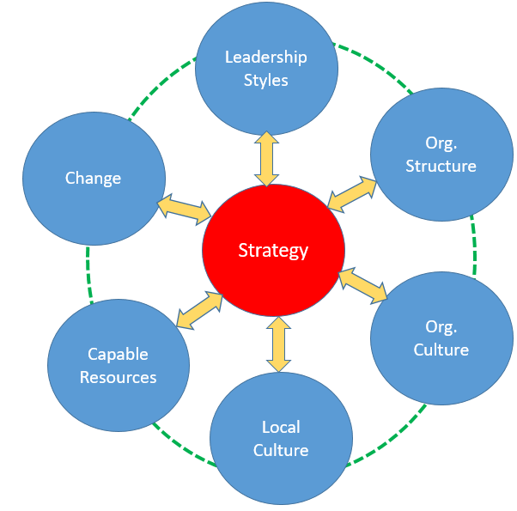

Figure 05: Impact of organizational change on transformational change

At Amazon, transformational leadership has played a significant role in facilitating the change of the organisation on a large scale, especially the adoption of artificial intelligence and automation, and data-driven decision-making. Leaders encourage employees to adopt new technologies and question the current processes thus facilitating organisational flexibility and long term competitive advantage. This is in line with the scholarly writing that indicates that transformational leadership works well in a workplace that is marked with uncertainty and constant change.

Nevertheless, the leadership style of Amazon is also characterized by the elements of strong transnationalism. Algorithms-driven monitoring mechanizations, performance management systems and key performance indicators (KPIs) are extensively applied to impose productivity targets and operational efficiency. Transactional leadership is about crystal cut structures, rewards and sanctions where the organisational goals are achieved at all times regardless of the international activities. It is an approach that has seen Amazon grow exponentially and retain a low level of control on costs and standards of service.

Regardless of these advantages, transformational and transactional leadership styles have a lot of difficulties coexisting (Hoque, 2025). Although the transformational type of leadership promotes innovation and engagement, overdependence on transactional processes can lead to higher levels of employee stress and lower motivation as an incentive. Employees could feel that the leadership is too performance based and do not allow them to participate effectively in the decision making process in fulfilment centers and operational jobs. Consequently, resistance to change programs can develop especially when changes are seen as focusing on efficiency at the expense of employee welfare.

4.2 Organisational Culture
The culture of an organisation is most likely to be at the center of the perception of change initiatives, their acceptance and implementation. The culture of Amazon is highly supported by its own leadership principles that focus on customer obsession, innovation, speed and operational excellence. This culture helps in sustaining betterment and motivates the employees to pursue efficiencies, oppose established practice and adapt to emerging technologies (Kostal, 2025).
This kind of results-oriented culture has been one of the enabling factors of the success of amazon as it has enabled the organization to respond swiftly to changes in the market or change in customer expectations. There is an incentive to experiment, make data-calculated risk and make decisions made by employees. This cultural orientation is consistent with strategic change programs, especially the ones that are based on digital transformation and artificial intelligence.
Nevertheless, the culture of Amazon also has the possible obstacles to the effective change management. The emphasis on efficiency and performance might not allow a free discussion of ethical issues, worker well-being, and sustainability in the long term. Any change programs that emphasize ethical use of AI, employee welfare or regulatory oversight might be met with opposition when seen to limit productivity or raise costs.
Moreover, the Amazon culture of performance-based work can be a cause of change fatigue, especially when employees are subjected to the prolonged change with minimal time to contemplate and integrate the change (Kleszewski, & Kottwitz, 2025). These points out the significance of integrating organisational culture with change goals to make sure those new projects are integrated sustainably as opposed to being enforced through top-down management.

5. Proposed Change Management Plan

5.1 Rationale for Change

The change management plan proposed is aimed at achieving integration of ethical application of artificial intelligence (AI) and improvement of employee engagement throughout the activities of Amazon. This transformation is fueled by a number of factors that interrelate with each other, such as the mounting regulatory pressure on AI technologies, reputational risks of using algorithmic decision-making, and the ongoing problem of workforce sustainability and employee turnover.

With Amazon ever-increasing its application of AI to customer personalization, logistics optimization, and workforce management, ethical issues about the privacy, openness, bias, and responsibility of its data, have grown (Ogbuke, & Mercangoz, 2022). The inability to consider such issues can lead to regulatory fines, loss of reputation and deteriorating employee confidence. At the same time, high rates of staff turnover and pressure jeopardize organisational sustainability and the overall performance of an organization.

As a result, an initiative of strategic change that promotes ethical use of AI and enhances employee participation is critical to ensuring the long-term growth and the retention of stakeholder trust.

5.2 Objectives
The main goals of the offered change management plan are as follows:
- To develop strong ethical governance systems to develop and deploy AI systems.
- To build employee trust and engagement and involvement in change initiatives.
This is to ensure that the company operates efficiently and its customers remain satisfied and that the company meets its ethical and social responsibilities (Barlas,& Brinia, 2023). These tasks are meant to synchronize the organisational performance with the ethical standards and shareholder expectations.

5.3 Financial Plan

Implementation of the proposed change needs direct financial investment to be successful. Some of the primary spending areas may be the creation of ethical AI governance frameworks, employee training programmes, and communication and feedback platforms. The training will invest in enhancing the level of AI literacy of the managers and employees so that they can engage in the ethical decision making processes smartly.

In spite of the initial expenses that are associated with the proposed change, these investments are likely to bring long-term financial gains. Better employee engagement can lead to less staff turnover, which will mean that there is less cost in terms of recruitment and training (Bakunin, & Saxena, 2023). AI governance would allow reducing regulatory and legal risks, including the organization against possible fines and reputational harm. These financial investments should be considered as prevention and value-added and not discretionary costs in a strategic view.

5.4 Communication Plan

Communication is critical in minimization of resistance, as well as successful change implementation. Multi-channel communication strategy will be embraced to involve all stakeholders in all levels of the organization. Leadership briefings and internal communications will be used to communicate to the leaders the rationale, vision and objectives of the change (Salman, & Feisal, 2023). Such messages will be focused on highlighting the congruence between ethical AI practices, employee wellbeing, and long-term organisational success.

Dialogue, feedback and collective learning will be opportunities to be created during the employee workshops and training. Constant updates will be facilitated with the help of digital platforms of communication and will ensure transparency and strengthen trust. Through facilitation of two-way communication, the organization would be in a position to proactively respond to the issues and help the employees feel a sense of ownership.

Clear and open communication plays a major role especially in dealing with fear of change that can be caused by AI, that is, losing jobs and being spied upon. Uncertainty can be minimized through effective communication and the change initiative can be more readily accepted.

5.5 Evaluation Plan

The implementation of the suggested change management plan will be measured in terms of a variety of qualitative and quantitative key performance indicators (KPIs). These will contain the results of the employee engagement surveys, employee turnover rates, AI compliance audit reports, and productivity measures. Frequent assessment will allow the leaders to determine the progress, the aspects of change that require enhancement, and adjust the change strategy using the data.

There will be continuous loops of feedback that will be in place to ensure the adaptability and responsiveness to new challenges (Carreon, 2024). With the inclusion of evaluation into the change process, Amazon will be able to make sure that ethical implementation of AI and enhancement of employee engagement are maintained in the long term instead of being one-time measures.

6. Reflection and Transferable Skills for Life and Professional Practice
This assignment has played a major role in enhancing critical thinking, strategic thinking, leadership assessment, and professional communication competencies that are vital in successful managerial practice. The systematic exploration of organisational change in the context of Amazon has improved the critical assessment of complex business environment and the impact of internal and external pressure on organisational decision-making (Menon, & Thomas, 2025).
An important objective of this module has been to acquire high levels of critical thinking. Instead of describing the concepts of change management, this assignment involved a very critical analysis of theories, models and leadership styles, as applied in the real-life organisational issues. The discussion of models, including Lewin and Kotter Three-Step Model and McKinsey 7S Framework, allowed gaining a better insight into their effective and restricted features. This has enhanced capacity to challenge assumptions, compare different points of view and evidence-based reasons on why strategic decisions have to be made instead of going by intuition.
Strategic analysis skills have also been enhanced through the assignment as it demanded the incorporation of the available tools of environmental analysis like PESTLE with the capabilities of organizations and leadership practices (Margiono, & Prathama, 2026) The assessment of how digital disruption, artificial intelligence, and regulatory demands have affected Amazon revealed the significance of developing a conceptual and organizational fit between strategy and organizational resources, culture and expectation of stakeholders. The strategic viewpoint will come in specifically handy in future managerial work where uncertainty, risk, and long-term sustainability must be taken into consideration during decision making.
Another important field of learning has been leadership evaluation. Through a critical analysis of the two leadership styles transformational and transactional leadership, this assignment led to a better understanding of the role of leadership behavior in employee engagement, resistance to change, and organizational culture. The identification of the weaknesses and advantages of various leadership styles has strengthened the role of adaptive leadership where leaders strike the balance between performance requirements and ethical accountability as well as the health of employees. This knowledge will also guide leadership practice in the future by promoting a more integrative and thoughtful way of change management (Kuran, & Nehme, 2026)

7. Conclusion
This report has critically analyzed both internal and external environmental pressure affecting organizational performance and long term sustainability in Amazon. The discussion has shown that the high rate of technological change, the growing regulatory demands and the changing expectations of the stakeholders of an organization create a situation where a constant and properly managed organizational change is mandatory. Using the accepted models on change management, the report points out that effective change does not only rely on the structural or technological changes, but also on the adaptive leadership style, good cultural fit and design but flexible method of implementation. The suggested change management plan focuses on the introduction of ethical artificial intelligence management and employee engagement as the key elements of the sustainable organizational performance. These investments deal with reputational and operational risks and aid work force stability and confidence. Integrating ethics and people-centered leadership in its strategic framework, Amazon can effectively maintain competitive edge and react pro-actively to the needs of an ever-increasing dynamic and uncertain global business world.

8. References
Azmi, K., Pilling, G., Bell, J., Chang, Y. J., Dustily, A., Frawley, T. H., ... & Zhang, F. (2025). Putting Regional Fisheries Management Organization’s Climate Change House in Order. Fish and Fisheries, 26(6), 1040-1047. https://onlinelibrary.wiley.com/doi/full/10.1111/faf.70015
Bakunin, S., & Saxena, S. (2023). Exploring the link between training and development, employee engagement and employee retention. Journal of Business and Management Studies, 5(1), 173-180. https://al-kindipublishers.org/index.php/jbms/article/view/4865
Barlas, A., Valakosta, A., Cationic, C., Oikonomou, A., & Brinia, V. (2023). The effect of corporate social responsibility on customer trust and loyalty. Sustainability, 15(2), 1036. https://www.mdpi.com/2071-1050/15/2/1036
Blagg, H. (2025). The Role of Centralized Decision-Making and Creativity in Small Technology Organizations: A Qualitative Case Study (Doctoral dissertation, National University). https://www.proquest.com/openview/00df16b92bf04fc16d79d6caf201762f/1?pq-origsite=gscholar&cbl=18750&diss=y
Carreon, A. M. (2024). Building a continuous feedback loop for real-time change adaptation: Best practices and tools. Institute for Change Leadership and Business Transformation.. https://www.researchgate.net/profile/Adolfo-Carreno/publication/385621731_Building_a_Continuous_Feedback_Loop_for_Real-Time_Change_Adaptation_Best_Practices_and_Tools/links/672cd61b2326b47637cf80cc/Building-a-Continuous-Feedback-Loop-for-Real-Time-Change-Adaptation-Best-Practices-and-Tools.pdf
Demir, Ş. Ş., & Demir, M. (2025). Driving AI-enabled transformation in small and medium tourism enterprises: The strategic and investment roles of decision makers. Tourism Management Perspectives, 59, 101428. https://www.sciencedirect.com/science/article/abs/pii/S2211973625000935
Hoque, K. E. (2025). Understanding Leadership Styles, Their Uses and Drawbacks. In The Changing Roles of Educational Managers: Essential Skills in an Era of Rapid Change (pp. 165-202). Singapore: Springer Nature Singapore. https://link.springer.com/chapter/10.1007/978-981-96-1086-0_9
Kleszewski, E., Wehrt, W., Otto, K., Matich, E., & Kottwitz, M. U. (2025). Opening Windows: Effects of an App-Based Mindfulness Intervention on Perfectionistic Concerns and Cross-Domain Functioning. Journal of Business and Psychology, 1-19. https://link.springer.com/article/10.1007/s10869-025-10033-8
Kostal, V. (2025). Restarting entrepreneurial culture, employee motivation, and organizational mindset during SME growth (Doctoral dissertation, Technische Universidad Wien). https://repositum.tuwien.at/handle/20.500.12708/216207
Kuran, O., Khabbaz, L., & Nehme, Z. (2026). Leading change: practical and contextual approaches. International Journal of Organizational Analysis, 34(2), 586-611. https://www.emerald.com/ijoa/article-abstract/34/2/586/1259429/Leading-change-practical-and-contextual-approaches?redirectedFrom=fulltext
MAHABUB, S., Hossain, M. R., & Snigdha, E. Z. (2025). Data-driven decision-making and strategic leadership: AI-powered business operations for competitive advantage and sustainable growth. Journal of Computer Science and Technology Studies, 7(1), 326-336.. https://al-kindipublishers.org/index.php/jcsts/article/view/8928
Margiono, A., & Prathama, F. C. (2026). How AI-assisted scenario thinking develops “agile minds” for a successful digital strategy?. Strategy & Leadership, 1-23. https://www.emerald.com/sl/article-abstract/doi/10.1108/SL-03-2025-0042/1342446/How-AI-assisted-scenario-thinking-develops-agile?redirectedFrom=fulltext
Martins, C. M., Pereira, S. C. F., Scarpin, M. R. S., Quiroz, M. M., & Cavalcante, M. D. S. (2025). The impact of customer pressures and government regulations on the implementation of socio-environmental practices in organic certification in the Amazon region. Benchmarking: An International Journal, 32(3), 1099-1119. https://www.emerald.com/bij/article-abstract/32/3/1099/1243024/The-impact-of-customer-pressures-and-government?redirectedFrom=fulltext
Menon, P., Arjun, K., Nisha, R., & Thomas, K. (2025). Leveraging Artificial Intelligence for Decision-Making and Managerial Effectiveness: A Case Study of Amazon. GRJESTM, 1(4), 166-172. https://www.odaswa.com/index.php/grjestm/article/view/43
Morrison, M. (2025). Amazon’s Competitive Advantage and Strategic Dominance across Markets: An Analytical Review. https://papers.ssrn.com/sol3/papers.cfm?abstract_id=5298032
O’Rourke, D. (2025). Can “Sustaining Innovation” Deliver Sustainability? Amazon’s Innovation Processes on Corporate Decarbonization. California Management Review, 67(2), 58-81. https://journals.sagepub.com/doi/full/10.1177/00081256241300334
Ogbuke, N. J., Yusuf, Y. Y., Dharma, K., & Mercangoz, B. A. (2022). Big data supply chain analytics: ethical, privacy and security challenges posed to business, industries and society. Production Planning & Control, 33(2-3), 123-137. https://www.tandfonline.com/doi/abs/10.1080/09537287.2020.1810764
Pradgna, C., Asha, P., & Raj, S. (2025). E-commerce Evolution: Trends, Innovations, and Consumer Behavior Dynamics in Social Commerce. Advances in Consumer Research, 2(4). https://openurl.ebsco.com/openurl?sid=ebsco:plink:scholar&id=ebsco:gcd:190294196&crl=c
Rodriguez Villanueva, L., & Schwarz, A. H. (2025). Navigating Organizational Transformations: A Single-Case Study on Change Management Frameworks. https://lup.lub.lu.se/student-papers/search/publication/9202765
Salman, S. M., Hammed, S. A., & Faisal, M. Z. (2023). Leadership and internal communication strategies in public organizations: Analytical research. International Journal of Professional Business Review: Int. J. Prof. Bus. Rev., 8(4), 14 https://dialnet.unirioja.es/servlet/articulo?codigo=8956075
Selvakumar, P., Dinesh, N., Gadhafi, S., Sharma, M., & TC, M. (2025). Organizational Culture and Values in Employee-Owned Businesses. In Organizational Models, Cultural Dynamics, and CSR Applications in Employee-Owned Enterprises (pp. 1-30). IGI Global Scientific Publishing. https://www.igi-global.com/chapter/organizational-culture-and-values-in-employee-owned-businesses/373182
Taleshi, N., Kheirandish, A., Brown john, J. M., Lamb, S. E., & Williams, G. K. (2025). Humans self-organize balance control strategies on a dynamic platform. Scientific Reports, 15(1), 24366. https://www.nature.com/articles/s41598-025-09127-3
Underage, J. T., Pokorny, B., Vargas, R., Reyes, M., De Jong, W., & Rogelio, V. (2025). Development pathways in forest frontiers: contextual changes and local responses of small-scale farmers in the Peruvian amazon. Frontiers in Forests and Global Change, 8, 1647001. https://www.frontiersin.org/journals/forests-and-global-change/articles/10.3389/ffgc.2025.1647001/full
Xin, H. (2025). THE CONCEPT AND IMPLEMENTATION OF INNOVATIVE LEADERSHIP. Экономика и социум, (2-1 (129)), 1542-1548. https://cyberleninka.ru/article/n/the-concept-and-implementation-of-innovative-leadership
Zhong, D., & Um, K. H. (2025). How customer integration drives green innovation: exploring the influence of regulatory pressures and market changes. Journal of Manufacturing Technology Management, 36(3), 731-754 https://www.emerald.com/jmtm/article-abstract/36/3/731/1245281/How-customer-integration-drives-green-innovation?redirectedFrom=fulltext

